UNIT 5.5 / CHANGE AND CONFIGURATION MANAGEMENT / STUDY NOTES

Change and Configuration Management
Configuration Management means identifying all components of ICT infrastructure (hardware, software, and procedures) and their properties. Change management means putting policies in place to reduce the risk that changes to these components could mean service disruption (network downtime).

ITIL Configuration Management Model
ITIL® (IT Infrastructure Library) is a popular documentation of good and best practice activities and processes for delivering IT services. Under ITIL, configuration management is implemented using the following elements:
- Service assets are things, processes, or people that contribute to the delivery of an IT service.
- A Configuration Item (CI) is an asset that requires specific management procedures for it to be used to deliver the service. Each CI must be identified by some sort of label. CIs are defined by their attributes, which are stored in a Configuration Management Database (CMDB).
- Baseline - a fundamental concept in configuration management is the baseline. The baseline represents "the way it was". A baseline can be a configuration baseline (the ACL applied to a firewall for instance) or a performance baseline (such as the throughput achieved by a server).
- A Configuration Management System (CMS) is the tools and databases that collect, store, manage, update, and present information about CIs.
One of the goals of the CMS is to understand the relationships between CIs. Another is to track changes to CI attributes (and therefore variance from the baseline) over time.

Implementing Configuration Procedures
The main difficulty in implementing a workable configuration management system is in determining the level of detail that must be preserved. This is not only evident in capturing the asset database and configuration baseline in the first place but also in managing Moves, Adds, and Changes (MACs) within the network infrastructure. In terms of network tasks, a CMS will require that configuration changes be made only when there is a valid job ticket authorizing the change. This means that the activity of all network personnel, whether it be installing new devices or troubleshooting, is recorded in job logs. Consequently, configuration management involves drafting and enforcing policies and procedures (Standard Operating Procedures or SOPs) to govern all levels of network configuration and troubleshooting activity.

Requesting Changes
In order to reduce the risk that changes to configuration items will cause service disruption, a documented change management process can be used to implement changes in a planned and controlled way. The need to change is often described either as reactive, where the change is forced on the organization, or as proactive, where the need for change is initiated internally. Changes can also be categorized according to their potential impact and level or risk (major, significant, minor, or normal for instance).
In a formal change management process, the need or reasons for change and the procedure for implementing the change is captured in a Request for Change (RFC) document and submitted for approval. The RFC will then be considered at the appropriate level and affected stakeholders will be notified. This might be a supervisor or department manager if the change is normal or minor. Major or significant changes might be managed as a separate project and require approval through a Change Advisory Board (CAB).

Implementing Changes
Regardless of whether an organization is large enough to require formal change management procedures and staff, the implementation of changes should be carefully planned, with consideration for how the change will affect dependent components. For most significant or major changes, organizations should attempt to trial the change first. Every change should be accompanied by a rollback (or remediation) plan, so that the change can be reversed if it has harmful or unforeseen consequences.
Changes should also be scheduled sensitively if they are likely to cause system downtime or other negative impact on the workflow of the business units that depend on the IT system being modified. Most networks have a scheduled maintenance window period for authorized downtime.
When the change has been implemented, its impact should be assessed and the process reviewed and documented to identify any outcomes that could help future change management projects.

Documentation
The purpose of documentation in terms of change and configuration management is as follows:
- Identify each component (CI) and label it.
- Capture each CI and its (relevant) attributes in a CMDB.
- Capture relationships between CIs - this is best done using diagrams.
- Capture changes to a CI as a job log and update the CMDB.

Asset Management and Vendor Documentation
It is crucial for an organization to have a well-documented inventory of its tangible and intangible assets and resources. In terms of network management, these will include network appliances (routers, switches, threat management devices, access points), servers, workstations, and passive network infrastructure (cabling and interconnects).
There are many software suites and associated hardware solutions available for tracking and managing assets (or inventory). An asset management database can be configured to store as much or as little information as is deemed necessary, though typical data would be type, model, serial number, asset ID, location, user(s), value, and service information. Tangible assets can be identified using a barcode label or RFID tag attached to the device (or more simply using an identification number). RFID stands for Radio Frequency ID. An RFID tag is a chip programmed with asset data. When in range of a scanner, the chip powers up and signals the scanner. The scanner alerts management software to update the device's location. As well as asset tracking, this allows the management software to track the location of the device, making theft more difficult.
For each asset record there should also be a copy of or link to the appropriate vendor documentation. This would include both an invoice and warranty / support contract and support and troubleshooting guidance.

Network Diagrams
Diagrams are the best way to capture the complex relationships between network elements. They are also the most effective means of locating particular items within the network. Diagrams can be used to model physical and logicalrelationships at different levels of scale and detail.

Blueprint
A blueprint is a detailed diagram of cable runs and wall outlet positions. Blueprints will generally require the assistance of an architect to draw with any accuracy. Building blueprints will also show the architecture of the building along with other services, such as power wiring and plumbing. These may be difficult even to interpret without the help of an architect or electrician!

Schematic / Block Diagram
A schematic is a simplified representation of a system. In terms of the physical network topology, it can show the general placement of equipment and telecommunications rooms plus device and port IDs without trying to capture the exact position or relative size of any one element. Schematics can also be used to represent the logical structure of the network, in terms of zones and subnets. In this sense, schematics can use either representative icons or pictures or drawings of actual product models. Schematics can either be drawn manually using a tool such as Microsoft Visio or compiled automatically from network mapping software.
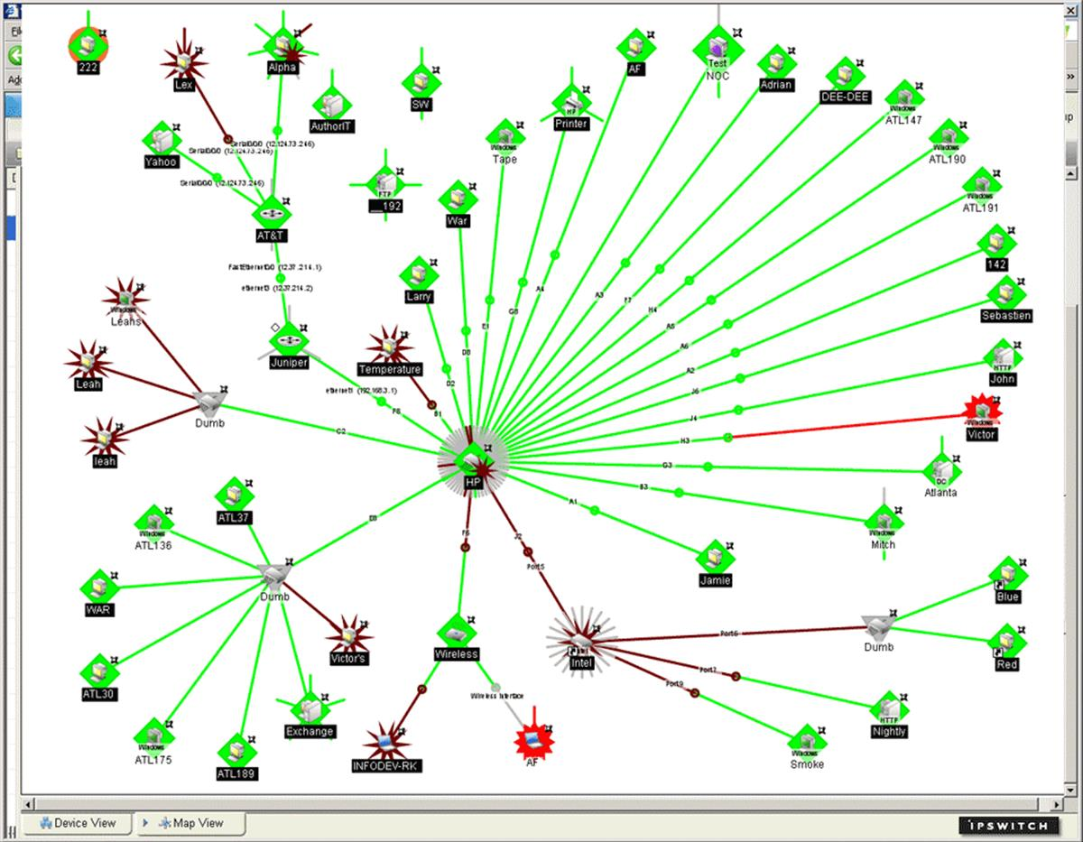
Ipswitch WhatsUpGold network mapping software (www.whatsupgold.com)
As far as icons go, the ones created by Cisco are recognized as standards. These are freely available (without alteration) from Cisco's website (gtsgo.to/16brn). Some of the more commonly used devices are shown below:
Icon | Device | Icon | Device
 | Hub |  | Branch Office
 | Access Point |  | End Office
 | Bridge |  | Cloud
 | Workgroup Switch |  | File Server
 | Layer 3 Switch |  | PC
 | Multilayer Switch |  | Laptop
 | Content Switch |  | Phone
 | Router |  | Cellular Phone
 | Wireless Router |  | IP phone
 | Modem |  | Fax
 | CSU / DSU |  | Printer
 | PBX |  | Firewall
 | Broadband Router |  | Router / Firewall
 | Cable Modem |  | Security Appliance

Wiring Diagram
A wiring diagram (or pin-out) shows detailed information such as the termination of twisted pairs or fiber-optic strands or correlates cables to port IDs.
 You should document the wiring diagrams used to terminate twisted pairs. As discussed in Unit 4.2 / Installing Cable / Study Notes, Ethernet is wired by T568A or T568B and the same standard should be used consistently throughout the network.

Network Mappers
Network mapping means gathering information about the way the network is built and configured and the current status of hosts. The following information is all of use:
- Protocols, services, and applications running on the network.
- Host workstation and server OS types and patch status.
- Network addresses / IP address utilization and host names.
- Network interconnect device types and status.
- Network security appliances and software.
- User accounts and groups (especially administrative / root accounts) and passwords.
This sort of information may be gathered by network management software, such as CiscoWorks, Microsoft's System Center, HP's OpenView, or numerous other third-party products. There are also tools such as Nmap that can perform the same sort of function but are often associated more with attempts to penetrate the network than to maintain it.
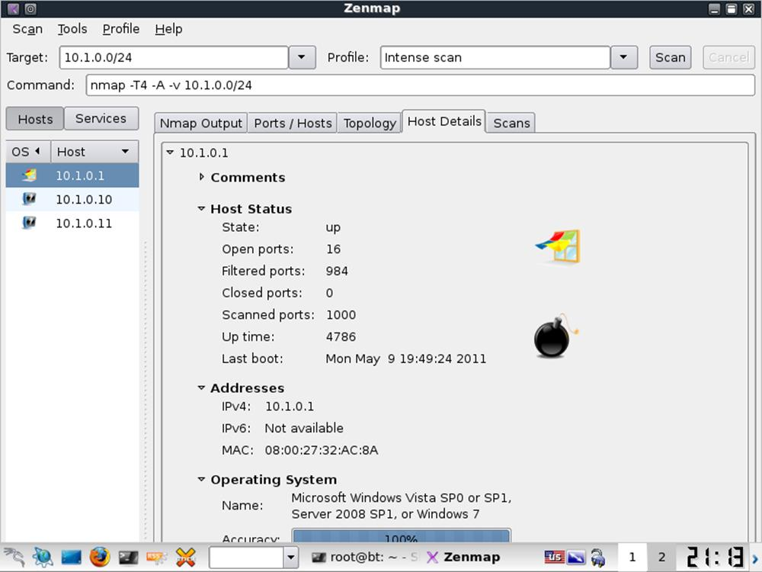
A tool such as Nmap can discover hosts connected to the network and report on their configuration

Implementing a CMS, CMDB, and Job Logs
The implementation of the administration system could be paper-based but computer records are much easier to search and update. The following tools could be used for a configuration management system:
- Spreadsheet - something like Microsoft Excel can quite comfortably store baseline CIs on a small network though it is less suitable for tracking jobs and changes to the configuration.
- Custom database - there are a number of dedicated applications for implementing a CMS. While they are correspondingly expensive and difficult to configure, these provide the best means of preserving accurate information and controlling procedures through job ticketing.
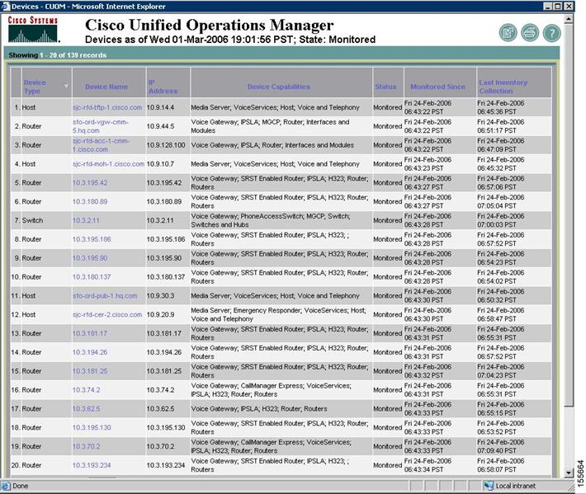
CiscoView Device Manager, part of the CiscoWorks suite (gtsgo.to/3fobq)
- Diagrams - Microsoft Visio is widely used to prepare network schematics. Detailed blueprints would require a Computer Aided Design (CAD) application.
As with any communications, job tickets should be completed professionally, with due regard for spelling, grammar, and clarity. Remember that other people may need to take action using just the information in the ticket and that analysis of tickets will take place as part of quality assurance procedures. It is also possible that tickets will be forwarded to customers as a record of the jobs performed.

Procedures and Standards
As a vital component of a company's IT infrastructure, employees must understand how to use ICT securely and safely and be aware of their responsibilities. To support this, an organization needs to create proper documentation, to help staff to understand and fulfill their responsibilities and follow proper procedures.
The value of a comprehensive policy is that it removes any uncertainty that employees may have about what to do in a given situation. For example, if you work for a large company and meet someone you do not recognize in your work area, should you smile and say hello or smile, say hello, ask them where they want to be, and then escort them to that place? If there is a company policy saying that visitors to the workplace must be escorted at all times, it will be much easier for employees to take it upon themselves to "police" this sort of circumstance.

Standards and Guidelines
Policy is an overall statement of intent. In order to establish the correct working practices, three different mechanisms can be put in place:
- Standard - a standard is a measure by which to evaluate compliance with the policy.
- Procedure - a procedure (often referred to as a SOP [Standard Operating Procedure] or an Internal Operating Procedure [IOP]) is an inflexible, step-by-step listing of the actions that must be completed for any given task. Most critical tasks should be governed by SOPs.
- Guidance - guidelines exist for areas of policy where there are no procedures, either because the situation has not been fully assessed or because the decision-making process is too complex and subject to variables to be able to capture it in a procedure. Guidance may also describe circumstances where it is appropriate to deviate from a specified procedure.

Developing a Management Plan
In a network environment, standards, procedures, and guidelines need to be established for the installation, maintenance, and troubleshooting of network equipment. A management plan for all network servers, devices, and workstations is the central plank in ensuring a secure, efficient, and well-documented network. A management plan should indicate what tasks are to be performed, when, and by whom.
Tasks would include monitoring performance and hardware status, performing backups, resolving and recording errors, cleaning and environmental checks, identifying security threats and countermeasures, detecting and resolving security breaches and intrusions, and so on.
It is essential that the plan sets out clear responsibilities and procedures for auditing action items (that is, ensuring that tasks are carried out properly and securely). Technicians responsible for maintenance may have different levels of access to the system. For example, administrators may have access to all configuration options on a server but backup operators can only access backup software and media. The results of management activities should be reported back and fed into development plans, to identify upgrade requirements. In the event that a problem is discovered during routine maintenance, a proper change management procedure should be followed to ensure that the solution is tested and verified without further impacting performance, reliability, or security.

Standard Business Documents
It is important to remember that although one can outsource virtually any service or activity to a third party, one cannot outsource legal accountability for these services or actions. You are ultimately responsible for the services and actions that these third parties take. This is why it is so important that you vet them thoroughly. Do you trust their hiring practices? Their training practices? Their access controls? If they have any access to your data or systems, any security breach in their organization (for example unauthorized data sharing) is effectively a breach in yours. Issues of security risk awareness, shared duties, and contractual responsibilities can be set out in a formal legal agreement. The following types of agreement are common:
- Memorandum of Understanding (MOU) - usually a preliminary or exploratory agreement to express an intent to work together. MOUs are intended to be relatively informal and not to act as binding contracts. MOUs almost always have clauses stating that the parties shall respect confidentiality however.
- Statement of Work (SOW) - a contractual agreement setting out the detailed terms under which a one-off service or project is provided. An SOW might be used when a contractor is hired to install or upgrade a network for example. The SOW would show in detail what requirements the project will meet, the actions and equipment that will be provided and their costs, timescales for completing the project, plus acceptance criteria for the customer to approve the successful completion of the project.
- Service Level Agreement (SLA) - a contractual agreement setting out the detailed terms under which an ongoing service is provided. Metrics for SLAs are discussed in more detail below.
- Master Service Agreement (MSA) - a master contract governing sub-contracts (often written as SOWs). The MSA will set out standard terms applicable to multiple contracts, such as payment terms, confidentiality agreements, and dispute resolution mechanisms.
A legal agreement is all very well, but it is still up to you to make sure that your suppliers, vendors, and contractors can live up to them. If they can’t, you may successfully sue them, but if they go out of business, you are still accountable for their actions or failure to act.
 Conversely, you need to ensure that you can comply with the requirements and performance standards of any agreements that you enter into as a service provider.

Key Performance Indicators
Any time that an organization's staff spend in the workplace without access to the computer system (downtime) is likely to be time wasted and therefore a significant cost. Similarly, time that customers cannot access a sales site or make enquiries because a system is down represents costs in terms of lost sales opportunities and reputation. If you can quantify these costs, you can provide a cost-based justification for upgrading the network infrastructure to improve reliability.
Key Performance Indicators (KPI) are metrics used in quality and performance management and are also likely to be quoted in an SLA. Some of the main KPIs relating to service availability are as follows.
- Availability (or uptime) can be calculated as the percentage of time that the network is available and working, measured over a defined period (typically one year). The corollary of availability is downtime (that is, the percentage or amount of time during which the system is unavailable). Full availability is usually loosely described as 24x7 (24 hours per day, 7 days per week) or 24x365 (24 hours per day, 365 days per year). For a critical system, availability will be described as "two-nines" (99%) up to five- or six-nines (99.9999%):
Availability | Annual Downtime
99.9999% | 00:00:32
99.999% | 00:05:15
99.99% | 00:52:34
99.9% | 08:45:36
99.0% | 87:36:00
- Availability is not restricted to catastrophic crashes or complete system failures. A system that is slow is also costing time (and probably contributing to stress and low morale in the workplace). Systems also need to be taken offline occasionally for new installs, upgrades, service, and troubleshooting. Downtime can be calculated from the sum of scheduled service intervals plus unplanned outages over the period.
-  Downtime may or may not be defined to include agreed service time. It is important to verify this point when drawing up Service Level Agreements (SLA).
- Response time is a measure of the mean time taken to acknowledge a support request (but not necessarily to fix the problem).
- Mean Time to Failure (MTTF) and Mean Time Between Failures (MTBF) represent the expected lifetime of a product or system. MTTF should be used for non-repairable systems. For example, a hard drive may be described with an MTTF while a server (which could be repaired by replacing the hard drive) would be described with an MTBF. You will often see MTBF used indiscriminately however. For most devices, failure is more likely early and late in life, producing the so-called "bathtub curve".
- Mean Time to Repair (MTTR) is a measure of the time taken to correct a fault so that the system is restored to full operation. This can also be described as mean time to "replace" or "recover".
- Mean Time Between Service Incidents (MTBSI) represents the time between the point of failure of a system and its next point of failure (that is, MTBF + MTTR).

Employee Policies
Employee's behavior and use of the organization's network and equipment should be governed by written policies.

Acceptable Use Policy
An Acceptable Use Policy (or Fair Use Policy) sets out what someone is allowed to use a particular service or resource for. Such a policy might be used in different contexts. For example, an acceptable use policy could be enforced by a business to govern how employees use equipment and services (such as telephone or internet access) provided to them at work. Another example might be an ISP enforcing a fair use policy governing usage of its internet access services.
Enforcing an acceptable use policy is important to protect the organization from the security and legal implications of employees (or customers) misusing its equipment. Typically, the policy will forbid the use of equipment to defraud, defame, or to obtain illegal material. It is also likely to prohibit the installation of unauthorized hardware or software and to explicitly forbid actual or attempted intrusion (snooping). An organization's acceptable use policy may forbid use of internet tools outside of work-related duties or restrict such use to break times.

Network Policies
The equipment used to access the Internet in the workplace is owned by the employer. Many employees expect relatively unrestricted access to internet facilities for personal use. In fact, employees' use of the social networking and file sharing poses substantial risks to the organization, including data breach, threat of virus infection or systems intrusion, lost work time, copyright infringement, and defamation. If an employee breaks copyright laws or libels someone using an organization's equipment, the organization itself could be held liable.
To avoid confusion, an employee's handbook should set out the terms under which use of web browser, email, social networking, and P2P software is permitted for personal use, and what penalties infringements could incur. Employers are within their rights to prohibit all private use of internet tools.
Users should be aware that any data communications, such as email, made through an organization's computer system are liable to be stored within the system, on servers, backup devices, and so on. Consequently, users should not use computers at work to send personal information (for their own security if nothing else).

Use of Personally Owned Devices in the Workplace
Portable devices such as smartphones, USB sticks, media players, and so on pose a considerable threat to data security as they make file copy so easy. Camera and voice recording functions are other obvious security issues.
Network access control / endpoint security and data loss prevention solutions can be of some use in preventing the attachment of such devices to corporate networks. Some companies may try to prevent staff from bringing such devices on site. This is quite difficult to enforce though.

Privacy Policy and Consent to Monitoring
The right to privacy is one expected by citizens of most countries. However the right to privacy has to be balanced against the need for the companies we work for and shop with to receive and process (and in some cases keep) information about us.
For example, a mail order company needs to know your address in order to deliver goods to you. When you tell them your address, you might expect them to use it only for delivering goods that you have ordered and not to use it to contact you about other products or to pass it to another company without your permission.
In order to protect their business, employers claim a responsibility to monitor the way employees put the IT equipment provided to them to use. Employees claim rights deriving from human rights legislation that they should not be treated cruelly or unusually. The balance between these rights and responsibilities is not always clearly defined in law, though as workplace privacy becomes more of an issue, laws and company guidelines are being instituted to account for it. A contract of employment may set out what an employee must agree to as a condition of employment.
Workplace surveillance can be divided into several categories:
- Security assurance - monitoring data communications and employee's behavior to ensure that they do not divulge confidential information or compromise the security of the organization. Employers may also use security systems such as CCTV to prevent theft.
- Monitoring data - analyzing data communications to measure an employee's productivity. For example, a contact management system may record the frequency and duration of telephone contacts.
- Physical monitoring - recording employee's movement, location, and behavior within the workplace, often using CCTV and drugs/alcohol testing.
A good employer will make the procedures for workplace surveillance clear and unambiguous. To this end, a contract of employment or staff handbook should make clear the rules for employee conduct (as regards security, refreshment breaks, and use of equipment) and define prohibited actions and appropriate disciplinary procedures and punishments. Each employee should be given the opportunity to read these guidelines and the employer should check that the employee understands them.
Additionally, some thought needs to be given to guests and callers, where the issue of consent is even more ambiguous.

Patch Management

Patch management refers to the procedures put in place to manage the installation of updates for hardware (firmware) and software.
There are two approaches to applying updates:
- Apply all the latest patches to ensure the system is as secure as possible against attacks against flaws in the software.
- Only apply a patch if it solves a particular problem being experienced.
The second approach obviously requires more work, as the administrator needs to keep up-to-date with security bulletins. However, it is well recognized that updates (particularly service releases) can cause problems, especially with software application compatibility, and so the second approach is wisest.
 Some applications may require the operating system to be patched to a certain level.
It makes sense to trial an update, especially a service release, on a test system to try to discover whether it will cause any problems. Approach the update like a software installation or upgrade (make a backup and a rollback plan). Read the documentation accompanying the update carefully. Updates may need to be applied in a particular order and there may be known compatibility issues or problems listed in the ReadMe.
Most operating systems and applications now support automatic updates via a vendor website, though vendors often also supply larger updates on disc.
 Patches are often released in batches but remember that when testing or troubleshooting a system, it is best to change one thing at a time. If you install many patches at the same time without testing and a problem occurs subsequently, it will be difficult to identify which, if any, of the updates might be linked to the problem.

OS / Software and Vulnerability Updates
Software updates resolve issues that a vendor has identified in the initial release of their product, based on additional testing or customer feedback. The updates are usually provided free-of-charge. Many updates address security vulnerabilities (problems in the software that could allow an attacker to crash the program or OS, run malware, or steal information).
Updates are also referred to as patches, though not by Microsoft. Microsoft categorize updates as Security Update, Critical Update, or just Update. A hotfix is an update designed for and released to particular customers only, though they may be included in later Service Packs. Service packs may also contain product improvements, differentiating them from update rollups, which are simply collections of updates released since the last service pack.
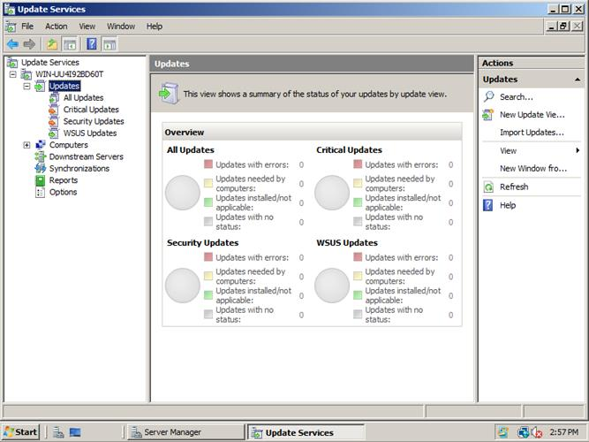
Windows Server Update Services (WSUS) allows administrative control over local deployment of patches

Firmware and Driver Updates
As well as software updates, it is important to keep hardware up-to-date with the latest patches. There are two main types of updates for hardware devices:
- Driver - this is software that provides an interface between the operating system and the device.
- Firmware - this is software instructions stored on a ROM chip or flash memory. This type of chip does not require a power supply so the data does not have to be moved in and out of disk storage.
The firmware on a device such as a router / firewall may be a very sophisticated piece of software. It is quite common for such software to have known vulnerabilities, so it is vital to use a secure version.
Updating firmware is known as "flashing" the chip. This is generally done via a vendor-supplied setup program. It is important to make a backup of the system configuration (especially for a firewall) before performing a firmware update or upgrade.

Major Upgrades and Feature Changes
The version number of software or firmware is used to identify its current state. Different vendors use different version numbering schemes but usually there are major and minor numbers. There may also be build numbers and numbers to indicate service pack or patch status.
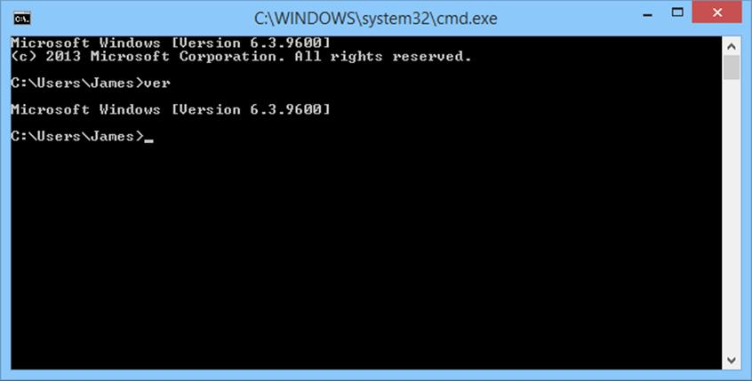
Displaying the current Windows version
A feature change could mean a difference to the user interface (requiring training), new features or settings to configure, or new or changed protocols or interfaces with other systems. While you might hope that minor updates work much the same way as previously, with a major update or feature change you will need to do more planning and testing to find out what is required in terms of configuration management, support, and training.

Downgrading
Most software and firmware changes are upwards, towards newer versions. Downgrading refers to reverting to a previous version of the software or firmware. This might be necessary to fix a problem caused by a recently upgraded or updated device or software. In some circumstances downgrading might not be possible. A network appliance might not support downgrading to an earlier firmware version for instance or an OS might have to be reinstalled completely. When applying a patch or upgrade it is common practice to make a configuration backup, in case settings have to be reapplied after the update. When downgrading, a configuration backup might not work as it may involve settings not included in the earlier version.

Backup Plans and Policies
One of the most important operations in data security is the creation of a secure backup. The execution and frequency of backups must be carefully planned and guided by policies.

Archiving and Backups
You should be aware of a distinction between archiving and backup:
- A backup is made for security - it is a second (or third or fourth) copy of data made with the intention of being able to restore the original should it be lost or damaged.
- Archive material is data that has passed its immediate usefulness and does not need to be accessed "live" but cannot be deleted. It may need to be retained for historical, regulatory, or legal reasons. Generally this means that it is moved from an immediately available storage area, such as a file server, to tape or optical media. An archive therefore is not a copy. It is likely to be important to continue to maintain additional security copies of archive material however, that is, to back up the archive.
Roughly speaking, a backup is a copy operation and archiving is a move operation.

Retention Policy
Data retention needs to be considered in the short and long term:
- In the short term, files that change frequently might need retaining for version control. Short term retention is also important in recovering from virus infection. Consider the scenario where a backup is made on Monday, a file is infected with a virus on Tuesday, and when that file is backed up later on Tuesday, the copy made on Monday is overwritten. This means that there is no good means of restoring the uninfected file.
Short term retention is determined by how often the youngest media sets are overwritten.
- In the long term, data may need to be stored to meet legal requirements or to comply with company policies or industry standards. Any data that must be retained in a particular version past the oldest backup sets should be moved to archive storage.
For these reasons, backups are kept back to certain points in time. As backups take up a lot of space, and there is never limitless storage capacity, this introduces the need for storage management routines and techniques to reduce the amount of data occupying backup storage media while giving adequate coverage of the required recovery window. The recovery window is determined by the Recovery Point Objective (RPO), which is determined through business continuity planning.
A retention policy can either be based on redundancy (the number of copies of each file that should be retained) or on a recovery window (the number of days into the past that should be retained). Advanced backup software can prevent media sets from being overwritten in line with the specified retention policy.
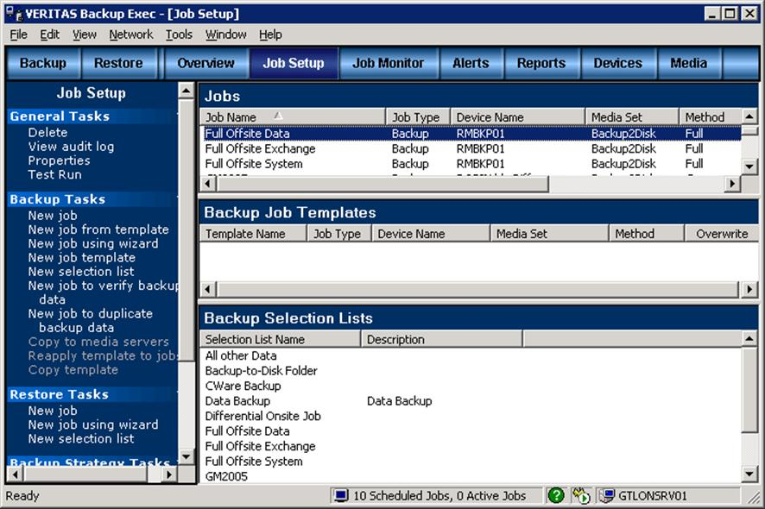
Performing a backup using Veritas BackupExec

Backout Contingency Plan
Another reason for making a backup is to support a backout contingency plan. Backout plans are most closely associated with rolling back OS updates (in the event that they cause some sort of problem with legacy hardware or software). A backout plan should be formulated for any sort of software or hardware upgrade though.
A backout plan allows the system to be restored to the state it was in prior to applying the patch or upgrade. As a scheduledbackup may not be able to reverse only the specific change made during the upgrade, it may be necessary to perform a specific backup before performing the upgrade.

