UNIT 3.2 / NAME RESOLUTION / STUDY NOTES

Host Names and FQDNs
The Internet Protocol uses the binary IP address for locating hosts on an internetwork. The dotted decimal (IPv4) or hex (IPv6) representation of this IP address is used for configuration purposes but is not particularly intuitive for people to remember. For this reason, a unique "friendly" name is also typically assigned to each host. There are two types of names: host names and Fully Qualified Domain Names (FQDN).

Host Names
A host name is assigned to a computer by the administrator. The host name can consist of letters, numbers, and hyphens, though it cannot be all numbers and cannot start with a hyphen. Host names are almost never treated as case-sensitive. Punctuation characters such as period (.) or forward slash (/) are not allowed.

Fully Qualified Domain Name
To avoid the possibility of duplicate host names on the internet, a Fully Qualified Domain Name (FQDN) is used to provide a unique identity for the host belonging to a particular network. An example of a FQDN might be:
mole.riverbank.com.
An FQDN is usually made up of the host name and one or more domain names (a domain suffix). In the example, the host name is "mole" and the domain suffix is "riverbank.com.". This domain suffix consists of the domain name "riverbank" within the top level domain ".com". The domain suffix is appended to the host name to define the location of the host and ensure the uniqueness of the host name.
The domain suffix can also contain subdomains between the host and domain name. The trailing dot or period represents the root of the hierarchy.
Domain names must be registered with a central body to ensure they are unique within a top level domain. Once a domain name has been registered, it cannot be used by another organization. The same domain name may be registered within different top level domains however (riverbank.com. and riverbank.co.uk. are distinct domains for instance).
Numerous hosts may exist within a single domain. For example: mole, ratty, and toad might all be hosts within the riverbank.com. domain. Given that, FQDNs must follow certain rules:
- The host name must be unique within the domain. A DNS host name can contain letter, digit, and hyphen characters only. A label cannot begin or end with a hyphen. A label could consist of a single letter or number. Other domain labels can also contain underscores.
- The total length of an FQDN cannot exceed 253 characters, with each label (part of the name defined by a period) no more than 63 characters (excluding the periods).
- FQDNs are not case sensitive.
 When configuring name records, an FQDN must include the trailing period to represent the root but this can be omitted in most other use cases.
Additionally, internet registries may have their own restrictions.

Domain Name System (DNS)
To make use of these friendly names, there has to be a system for resolving a host name or FQDN to its IP address and also ensuring the names are unique. Name resolution is an application layer service in terms of the OSI model.
Modern networks and the Internet use a system called the Domain Name System but before DNS was available, a HOSTS file was used.

Name Resolution Using the HOSTS File
The first method for resolving host names to IP addresses involved the InterNIC central authority (now operated by ICANN [www.icann.org]) maintaining a text file of host name to IP address mappings. This file was called HOSTS. Whenever a site wanted to add a new host to the Internet, the site administrator sent an email to InterNIC giving the new host name to IP address mapping. This information was manually entered into the file.
An example HOSTS file is shown below.
# Sample
128.103.100.1 toad
178.143.216.47 ratty
12.11.97.104 mole # server
Any text preceded by the # symbol in a HOSTS file is a comment and will not be processed.
Network administrators were required to download a copy of the latest HOSTS file at regular intervals and install this on each host at their site. Each host could then perform name resolution by looking up a host name in the local copy of the HOSTS file and locating the corresponding IP address. The default location under Windows is %SystemRoot%\system32\drivers\etc\ while under Linux it is usually placed in the /etc directory.
The HOSTS file approach to naming became impractical as the number of hosts connected to the Internet grew - maintaining completeness and accuracy of the file became too difficult. Therefore, in the mid-1980s, the Domain Name System (DNS) was developed.
 The HOSTS file is now primarily of use in troubleshooting. See Unit 3.3 / Troubleshooting / Study Notes for notes on this.

Domain Name System
The Domain Name System (DNS) is a hierarchical system of distributed name server databases that contain information on domains and hosts within those domains. The distributed nature of the system has the twin advantages that maintenance of the system is delegated and loss of one DNS server does not necessarily prevent name resolution from being performed.
At the top of the DNS hierarchy is the root, which is often represented by a period (.). There are 13 root level servers (A to M). Immediately below the root lie the Top Level Domains (TLD). There are several types of top level domain, but the most prevalent are generic (.com, .org, .net, .info, .biz), sponsored (.gov, .edu), and country code (.uk, .ca, .de).
The domain name system is operated by ICANN (www.icann.org), who also manage the generic top level domains. Country codes are generally managed by an organization appointed by the relevant government. Each domain name has to be registered with a Domain Name Registry for the appropriate top-level domain.
Information about a domain is found by tracing records from the root down through the hierarchy. The root servers have complete information about the top-level domain servers. In turn, these servers have information relating to servers for the second level domains.
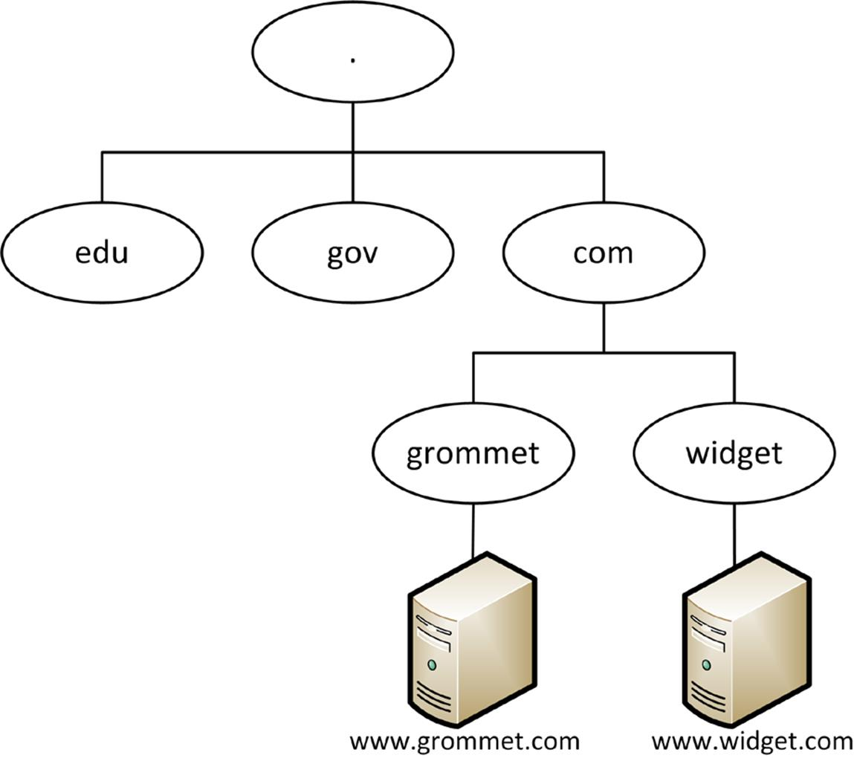
DNS hierarchy
No name server has complete information about all domains. Records within the DNS tell them where the missing information is found.
FQDNs reflect the hierarchy, from most specific (the host) to least specific (the top level domain followed by the root). For example: www.widget.com.

Name Resolution using DNS
The signal for the name resolution process to commence occurs when a user presents a FQDN (often as a URL) to an application program (such as a web browser). The DNS client (referred to as a resolver) sends a query to the local DNS server address (configured in TCP/IP) and requests that the name server translate the FQDN into an IP address. The resolution process then takes place as follows:
- The client (resolver) in grommet.co.uk queries its local name server for the IP address of the host www.widget.com.
- The name server checks its own zone database for the record.
- It is not authoritative for the domain, so the name server queries a root server for the required IP address.
- The root server checks its zone, finds that it is not authoritative for the requested record, and passes the name server in grommet.co.uk the IP address of a name server in the .com domain.
- The originating name server queries the designated name server in .com, which doesn't have the required information.
- However, it does have the IP addresses of name servers in the widget.com domain. It passes these to the originating name server.
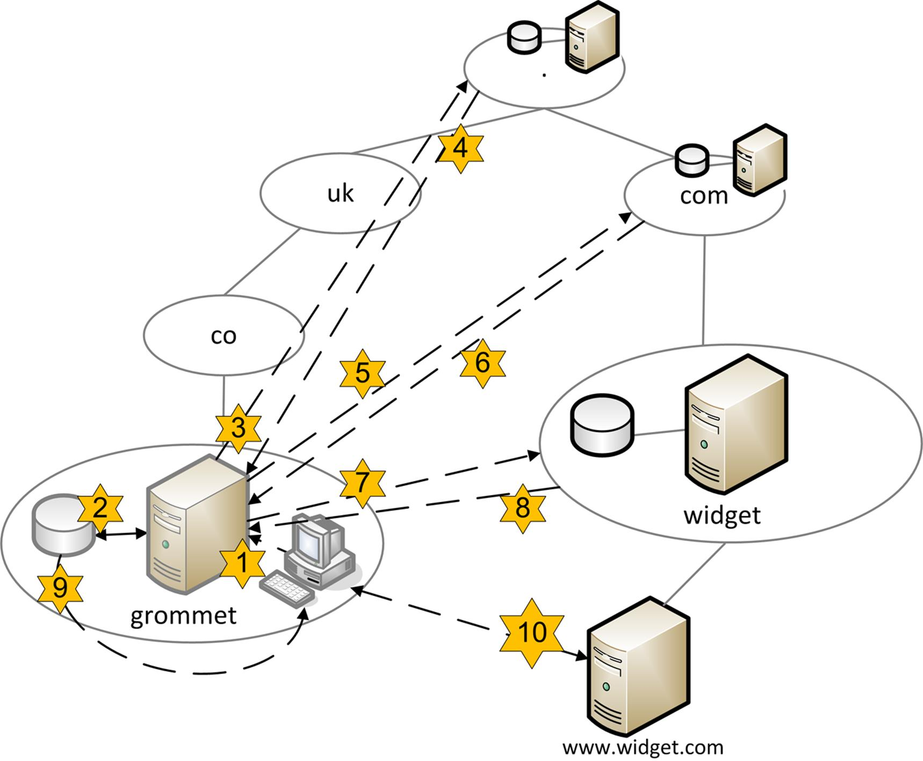
Resolving a name
- The grommet.co.uk name server queries the name server in widget.com.
- Because the name server is authoritative, it passes the required record back to the originating server.
- The server caches the result and passes the requested IP address to the client.
- The client establishes a session with the www.widget.com host.

Configuring DNS Servers
DNS is essential to the function of the Internet. Windows Active Directory and most Linux networks also require a DNS service to be running and correctly configured.

DNS Service Port
A DNS server is usually configured to listen for queries on UDP port 53. Some DNS servers are also configured to allow connections over TCP port 53, as this allows larger record transfers (over 512 bytes). Larger transfers might be required if IPv6 is deployed on the network or if the DNS servers are using a security protocol (DNSSEC).

Zones
Name servers maintain the DNS namespace in zones. A name server can maintain primary and secondary zones:
- Primary means that the zone can be edited.
- Secondary means a read-only copy of the zone. This is maintained through a process of replication known as a zone transfer from the zone master (usually a primary zone). A secondary zone would typically be provided on two or more separate servers to provide fault tolerance and load balancing.
Servers that don't maintain a zone (primary or secondary) are referred to as cache-only servers. They often rely on forwarding to resolve queries for client resolvers.

Iterative and Recursive Queries
Name servers can be configured to provide forwarding. Most queries between name servers are iterative; a name server responds to a query with whatever information it has. In the example above, at steps 4 and 5, the root server and .com name server simply pass the querying server the address of an authoritative name server. They do not take on the task of resolving the original query for www.widget.com.
A recursive query means that if the queried server is not authoritative, it does take on the task of referring to other name servers. This is typically used by a DNS server on a private network to contact the ISP's DNS server(s) to resolve internet domain requests. This is the type of querying performed by the grommet.co.uk name server in the previous example.

Resource Records
A zone will contain resource records, which allow computers and services to be resolved into IP addresses. There are many different resource records, but the main ones are:
Record | Name | Description
SOA | Start Of Authority | Identifies the name server that is authoritative for the zone plus contact information and a serial number (for version control).
A | Address | A host name mapped to an IPv4 address.
AAAA | Address | A host name mapped to an IPv6 address. IPv6 is now enabled on the Internet root DNS servers. As this breaks a DNS over UDP specification (maximum packet size of 512 bytes), this means that network administrators should check that their DNS servers can accept these transmissions and that they are not blocked by firewalls.
NS | Name Server | Identifies name servers in the zone.
PTR | Pointer | An IP address mapped to a host name. This is used for reverse lookups, which are a useful security feature. Reverse name resolution uses a special domain called in-addr.arpa. The name server would hold a zone mapped to the first three octets of the IP address in reverse order; the final octet is a PTR record in this subdomain. For example, the reverse lookup FQDN for gtslearning.com is 15.202.72.77.in-addr.arpa, resolving to the IP address 77.72.202.15. IPv6 uses the ip6.arpa domain; each of the 32 hex characters in the IPv6 address is expressed in reverse order as a subdomain. For example, 2001:0db8:0000:0000:0bcd:abcd:ef12:1234 becomes 4.3.2.1.2.1.f.e.d.c.b.a.d.c.b.0.0.0.0.0.0.0.0.0.8.b.d.0.1.0.0.2.ip6.arpa
CNAME | Canonical Name | Defines an alias for a particular host. For example, the true name of a web server could be masked as the alias www.
MX | Mail eXchanger | Identifies a mail server for the domain. Multiple servers are often provided for redundancy. Each server is given a preference value. The lowest numbered server is preferred.
SRV | Service | Identifies the server hosting a particular service, such as VoIP or media server or a Windows Server Domain Controller. As with MX, records can be configured with a priority value.

Secure Configurations
As well as making sure that resource records for the managed domain(s) are accurate, administrators should ensure that DNS services are fault tolerant and secure (to prevent DNS spoofing, where an attacker is able to supply false name resolutions to clients).

Dynamic DNS
In modern networks, DNS is used not only to resolve the IP addresses of hosts on the Internet, but also those on the local intranet. This presents a challenge, as IP addresses on the LAN are typically assigned by DHCP, so the IP address of any given host cannot be guaranteed to remain the same from one day to the next. Dynamic DNS solves this problem by allowing either individual clients or the DHCP server to notify the DNS server of any IP address changes. In Windows this can be triggered manually using the ipconfig /registerdns command. The DNS server updates its A and PTR records based on the information provided, ensuring that the host name will resolve to the new IP address.
Dynamic DNS is also used by SOHO internet routers. If the ISP does not provide a static IP address, the user can sign up with a Dynamic DNS (DDNS) service then configure the DDNS host and credentials on the SOHO router. Whenever the router IP is changed by the ISP, it will update the records at the DDNS provider so that the router remains addressable by FQDN on the Internet.

nslookup and nbtstat
A number of command line tools are available to troubleshoot name resolution on Windows and Linux hosts and networks.

nslookup
You can troubleshoot DNS with the nslookup command, either interactively or from the command prompt.
nslookup -Option Host Server
Host can be either a host name/FQDN or an IP address. Server is the DNS server to query; the default DNS server is used if this argument is omitted. -Option specifies an nslookup subcommand. For example, the following command queries Google's public DNS servers (8.8.8.8) for information about gtslearning.com's mail records:
nslookup -type=mx gtslearning.com 8.8.8.8
If nslookup is run without any arguments (or with just the argument - Server), the tool is started in interactive mode. You can perform specific query types and output the result to a text file for analysis. When in interactive mode, keep the following points in mind:
- To interrupt interactive commands at any time, press Ctrl+C.
- To view subcommands, type help or ?
- By default, host name (A) records will be returned; use the set type=xx command to display different records (for example, set type=mx returns mail server records for the domain).
- The command line length must be less than 256 characters.
- An unrecognized command is interpreted as a host name. To treat a built-in command as a host name, precede it with the escape character (\).
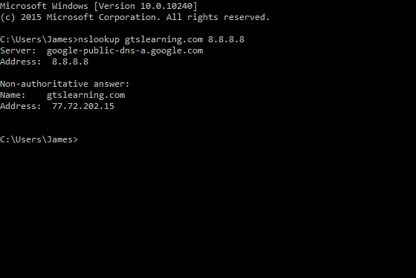
Using nslookup to resolve the gtslearning.com's domain name to an IP address using Google's public DNS servers (8.8.8.8)
 The dig utility is often used as a more up-to-date and flexible alternative to nslookup. dig allows you to query a name server directly and retrieve any of the information known about the domain name. It is helpful in determining if the server is running correctly and if the domain record is properly configured

NetBIOS and nbtstat

Windows networks may also need to take account of NetBIOS. This is a legacy Application Programming Interface (API) designed to provide programmers with an easy means of accessing and utilizing network resources over a Windows network, which originally ran on NetBEUI (NetBIOS Extended User Interface). NetBIOS is still used for some Windows services and applications in legacy environments. To support these services, NetBIOS can be run over TCP/IP. NetBIOS over TCP/IP uses UDP port 137 for name services, UDP port 138 for datagram (connectionless) services, and TCP port 139 for session services. The nbtstat utility (NetBIOS over TCP/IP Statistics) is used to query NetBIOS status information. For example:
- nbtstat -n displays locally registered NetBIOS names.
- nbtstat -r displays how names are being resolved (broadcast or WINS). A Windows Internet Name Service (WINS) server performs the same sort of function for NetBIOS names as DNS does for host and domain names.
- nbtstat -c displays NetBIOS name-to-IP mappings in the local cache.
- nbtstat -R purges the NetBIOS name cache and loads #PRE tagged items from an LMHOSTS file. LMHOSTS provides the same sort of function for NetBIOS as HOSTS does for DNS. LMHOSTS is also stored in %SystemRoot%\system32\drivers\etc.
- nbtstat -s lists current sessions with destination computers represented by NetBIOS names. The -S switch shows sessions by IP address rather than name.
- nbtstat -a RemoteName lists a remote machine's NetBIOS name table. The -A switch can take an IP address for the remote host instead of a name.
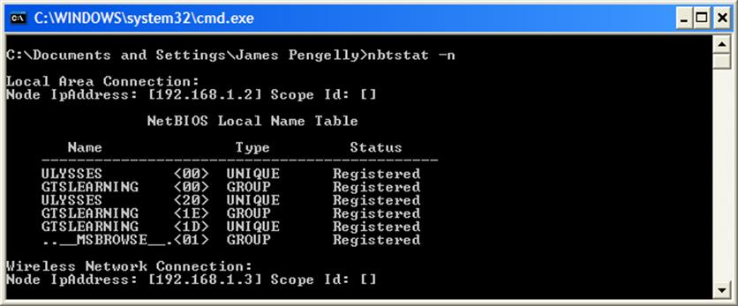
Using nbtstat
NetBIOS uses only 15 character computer names, which must be unique within the network. There is no concept of domain suffixes.
If you are experiencing name resolution problems, then a good test is to create an LMHOSTS file in the appropriate folder with the appropriate entries and then enter the nbtstat -R command to purge items from the cache, and load any #PREtagged entries from the LMHOSTS straight into cache.

