UNIT 1.3 / HUBS, BRIDGES, AND SWITCHES / STUDY NOTES

Hubs and Bridges
Hubs and bridges are no longer widely deployed as standalone appliances but as their role has been taken on by more advanced devices (such as Ethernet switches) it is important to understand what basic functions they provide.

Hubs
A hub is the central point of connection for 10BAST-T Ethernet segments configured in a physical star topology. Hubs act like a repeater so that every segment receives transmissions sent from any other segment; the logical topology is still a bus. Hubs are also known as multiport repeaters. They work at the physical layer of the OSI model.
A hub is internally wired with transmit (Tx) and receive (Rx) pairs for each port. The hub connects the nodes on the network as follows:
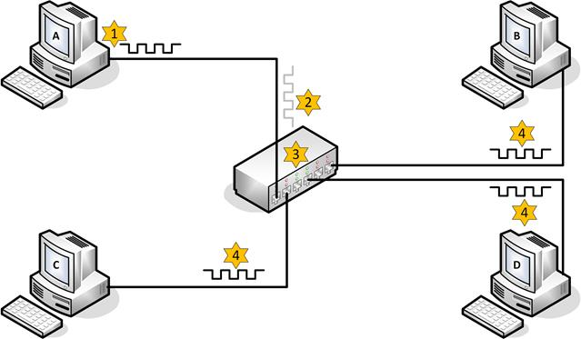
Using a hub to implement a physical star topology
- Computer A sends a transmission using its Tx pair.
- The hub receives a weakened and distorted transmission at port 1 on its Tx pair.
- The hub regenerates the transmission, performs a crossover, and transmits the regenerated transmission out of all its other ports on the receive (Rx) pair.
- Computers B, C, and D receive the transmission on their Rx pairs.
All the ports on a hub are in the same collision domain.
Hubs can also be linked together using a special cable type called crossover cable.
- Computer A sends a transmission using its Tx pair.
- Hub 1 receives a weakened and distorted transmission at port 1 on its Tx pair.
- The hub regenerates the transmission, performs a crossover, and transmits the regenerated transmission out of all its other ports on the receive (Rx) pair.
- Because hub 2 now receives the transmission on its Tx pair on port 6 via the crossover cable, it regenerates the transmission, performs a crossover, and transmits it over the other five ports on the Rx pair.
- Computer B receives the transmission from hub 2 on its receive pair.
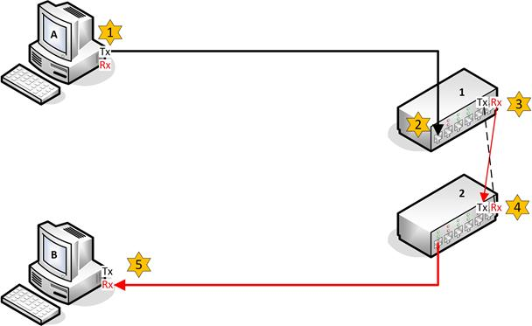
Crossover cable between cascading hubs
 Fast Ethernet is restricted to using two hubs within a single network but this restriction does not apply to a switched network. Gigabit and 10G Ethernet require the use of switches. Hubs are obsolete for most practical purposes.

Bridges
An Ethernet bridge provides communications between two or more segments. Like a hub or repeater, a bridge can extendthe maximum distance of network but it may also be used to segment the network. A network might be divided into two or more segments to reduce the number of collisions caused by having too many nodes. Bridges work at the data link layer since they need to understand the MAC addresses within frames. Segments on different bridge ports are in separatecollision domains but the same broadcast domain. A bridge works as follows:
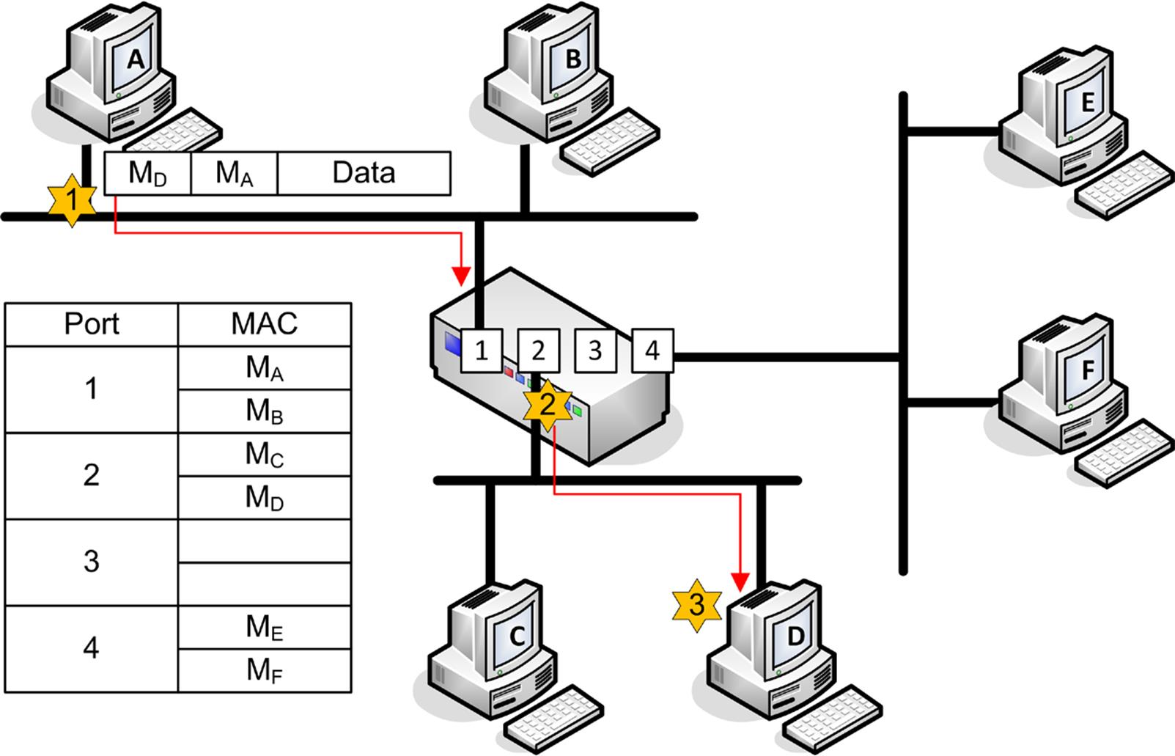
Bridge operation
- Computer A sends a transmission to computer D. Note that the frame contains a source hardware address of MA and a destination hardware address of MD.
- The bridge listens to all traffic on all attached segments and consequently it receives the transmission at port 1.
- The bridge reads the destination in the frame and, using its port address table, determines the port to which the network card with hardware address MD is attached. The bridge is able to locate the hardware address MD in its port:MAC address table and forwards the transmission out of port 2 only.
An Ethernet bridge builds the port address table in memory. When the bridge is initialized, the bridging table is empty but information is constantly added as the bridge listens to the connected segments. Entries are flushed out of the table after a period to ensure the information remains current.
- If no record of the hardware address exists or the frame is a broadcast or multicast, then the bridge forwards the frame to all segments except for the source segment (acting like a hub).
Most bridges are only able to link segments using the same frame type (for example, Ethernet to Ethernet) but can be used to link different segments with different cable types (such as coax and twisted pair).

Switches
Ethernet networks implemented with a bus or hubs rely on a contention-based technology for accessing the media. Nodes can only transmit on the network when it is free. These opportunities become less frequent as more devices are added to the network and the probability of collisions increases.
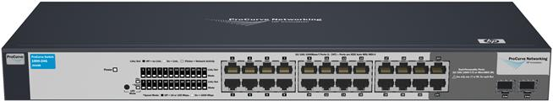
HP ProCurve 24-port switch (Image © 2011 Hewlett-Packard Development Company, L.P)
These problems can be overcome by moving from this "shared Ethernet" system to "switched Ethernet". This move involves the replacement of hubs and bridges with switches. Switches have now almost completely replaced legacy devices such as hubs and bridges. The use of switches is mandatory for Gigabit Ethernet and Ethernet 10G.

Switch Operation
An Ethernet switch performs the same sort of function as a bridge but can provide many more ports (bridges only came with up to 4 ports). Each switch port is a separate collision domain. In effect, the switch establishes a point-to-point link between any two network nodes. This is referred to as microsegmentation. This works as follows:
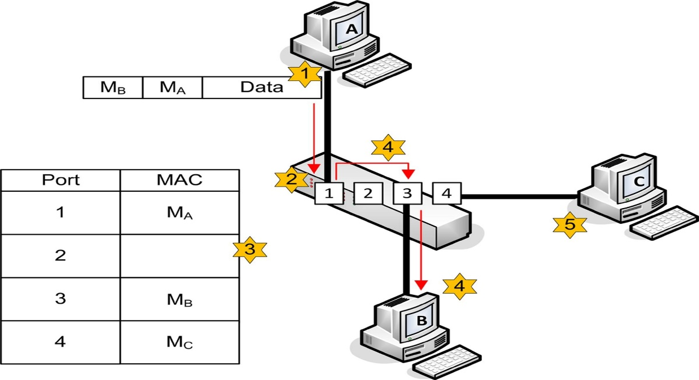
Switch operation
- Computer A transmits a frame intended for Computer B.
- The switch receives the frame into a port buffer and reads the destination MAC address from the Ethernet frame. The port buffer holds frames until they can be processed. The switch can also perform error checking on the frame using the CRC.
- The switch uses its MAC address table to look up the port connected to the destination MAC address.
- The switch uses its high speed backplane to send the frame out on port 3 for computer B to receive (creating a temporary virtual circuit).
- None of the other connected devices (such as, computer C) see any activity on the network while this process takes place. Therefore, these other devices are able to transmit and receive at the same time.
Because each port is in a separate collision domain, collisions can only occur if the port is operating in half-duplex mode (if a legacy network card or a hub is attached to it for instance). Even then, collisions only affect the segment between the port and that adapter; they do not slow down the whole network. As with a bridge though, traffic on all switch ports is in the same broadcast domain, unless the switch is configured to use VLANs (see below).
 There are many types of switches other than Ethernet switches (or "basic switches"). Some are used to implement WANs (ATM and SONET switching for instance) and some are used to forward traffic at OSI layers 3 and above. The functions of these "multilayer switches" are covered in Unit 3.4 / Applications and Services / Study Notes.

Building the MAC Address Table
If a MAC address cannot be found in the MAC address table then the switch acts like a hub and transmits the frame out of all the ports (except for the incoming port). This is referred to as flooding. The switch builds the MAC address table by analyzing incoming frames for a source MAC address. It can then add a MAC address entry against the particular port number. Entries remain in the MAC address table for a period before being flushed. This ensures problems are not encountered when network cards (MAC addresses) are changed. The address table is implemented as Content Addressable Memory (CAM), a special type of memory optimized for searching rather than random access. Consequently the MAC address table is often also referred to as the CAM table.

Switch Models
Switches from different vendors come in a variety of different ranges to support various sizes of network. While a basic model might feature 12-48 ports and little scope for expansion, advanced switches support interconnections via high speed backplanes and expandable capacity through plug-in modules plus power supply redundancy, management consoles, and interface converters for fiber optic connectivity.
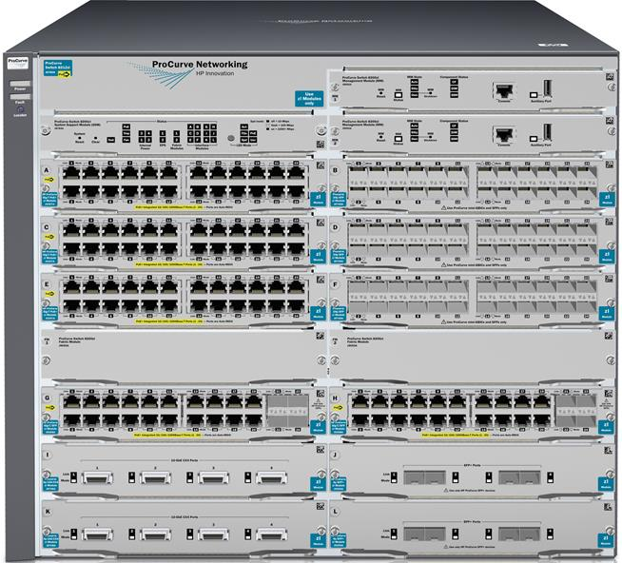
HP ProCurve modular switch (Image © 2011 Hewlett-Packard Development Company, L.P)
The market is dominated by Cisco's Catalyst series (over 70% of sales by port) but other notable vendors include HP (ProCurve), Nortel, Foundry, and 3Com.

Managing Switches
Some switches do not offer any configuration options or interface. These are known as unmanaged switches. You just have to plug them in and they operate automatically. These switches are usually inexpensive and are intended only for home or small office use.
Managed switches support more complex functions, including configuring VLANs, port authentication, load balancing, Quality of Service (QoS), and traffic shaping, and filtering.

In-band and Out-of-Band Management Methods
The functions of a managed switch can be accessed via one of the switch's management interfaces. A switch may support the following interfaces:
- Console port - this requires connecting a terminal (a laptop for instance) to the switch via a separate physical interface using a special console (or rollover) cable. The terminal can then be used to start a Command Line Interface (CLI).
- Management port / virtual terminal - this means configuring a virtual network interface and IP address on the switch to use for management functions and connecting to it via one of the normal Ethernet ports. The port has to be enabled for this function (or some switches come with a dedicated management port). Most switches support a browser-based interface (HTTP/HTTPS) as well as a CLI using Telnet or Secure Shell (SSH). Using a CLI remotely in this way is referred to as a virtual terminal.
A switch may also support autoconfiguration using a DHCP server to obtain addressing information and a TFTP server to obtain a configuration file. It may also be possible to autoconfigure a switch using a network management protocol.
Management methods can be described as either In-Band or Out-Of-Band (OOB). An in-band management link is one that shares traffic with other communications on the "production" network. The console port is a physically out-of-band management method; the link is limited to the attached device. When using a browser-based management interface or a virtual terminal, the link can be made out-of-band by connecting the port used for management access to physically separate network infrastructure. Obviously this is costly to implement but out-of-band management is more secure and means that access to the device is preserved when there are problems affecting the production network.
With an in-band connection, better security can be implemented by using a VLAN (see below) to isolate management traffic. This makes it harder for potential eavesdroppers to view or modify traffic passing over the management interface. This sort of virtual OOB does still mean that access could be compromised by a system-wide network failure however.
Use a secure connection protocol (HTTPS rather than HTTP or SSH rather than Telnet) for the management interface. This applies to OOB too but it is absolutely critical for in-band management. The features of these remote connection protocols are discussed in Unit 3.5 / Management and Monitoring / Study Notes.

Management Accounts
The switch management interface should require the user to authenticate with a password before granting access. A basic switch might only support a single management account (admin) with a password that must be shared between the system administrators who need to access the switch's management interface. This sort of shared account is not very secure as there is a greater chance of the password being revealed and less opportunity to identify the person responsible for any misconfiguration or malicious use.
A more advanced switch will support the creation of multiple user accounts, each protected by its own password. The accounts could also be granted different permissions, restricting access to certain functions or only allowing read access to configuration settings. Connected switches might be able to share details of these account profiles so that the configuration does not have to be repeated on each switch.
Another option for enterprise networks is to use an Authentication, Authorization, and Accounting (AAA) server. With an AAA server, the switch device does not store user names or passwords. When a user attempts to connect, the switch sends the user's credentials to the AAA server. If the AAA server can authenticate the user, it notifies the switch, which then permits access.

Switch Interface Configuration
Once you have established a connection to the switch's management interface, you can configure settings for each of the switch port interfaces. These settings control the network link configured for each client device attaching to the switch.

Speed and Duplexing
Switches normally support a range of Ethernet standards so that older and newer network adapters can all be connected to the same network. In most cases, the port on the switch is set to autonegotiate speed (10/100/1000) and full or half-duplex operation. A static configuration can be applied manually if necessary.
 See the section on Troubleshooting in Unit 3.3 / Troubleshooting / Study Notes for more information about solving problems with switch port configurations.
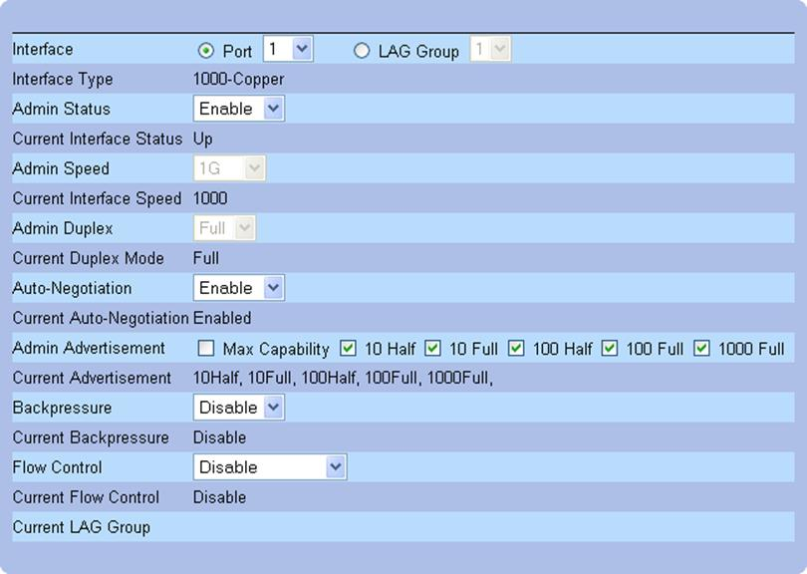
Configuring port settings on a Dell switch

IP Address Assignment and Default Gateway
An IP address is used to identify a host at layer 3 of the OSI model. Normally, when a host connects to a port it will connect to a network where an autoconfiguration service called the Dynamic Host Configuration Protocol (DHCP) will enable the host to obtain a valid IP address and other network configuration information, such as the address of a default gateway (or router) that can be used to connect to other networks.
In some circumstances you might want to configure the switch to assign an IP address to hosts connecting to that port. You can do this if the switch comes with its own internal DHCP server. This sort of configuration might be useful for smaller networks.
See Unit 2.3 / DHCP and APIPA / Study Notes for more information about IP configuration and DHCP.

Port Bonding and LACP
Port bonding refers to aggregating multiple links into a single high-speed connection. For example, a single network adapter and cable segment might support 1 Gbps; bonding this with another adapter and cable segment gives a link of 2 Gbps (adapter teaming). Bonding can also provide redundancy; if one link is broken the connection is still maintained by the other (fail over). It is also often cost-effective; a 4-port Gigabit Ethernet card might not match the bandwidth of a 10G port (4 Gbps compared to 10 Gbps) but will cost less.
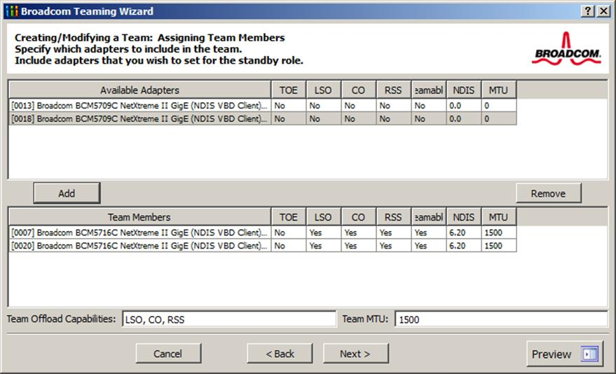
Configuring adapter teaming
There are proprietary port bonding mechanisms but it has been standardized as IEEE 802.3ad / 802.1ax. 802.3ad bonded interfaces are described as a Link Aggregation Group (LAG). 802.3ad also defines the Link Aggregation Control Protocol (LACP), which can be used to detect configuration errors and recover from the failure of one of the physical links.

Port Mirroring
Unlike a hub, a switch forwards unicast traffic only to the specific port connected to the intended destination interface. This prevents sniffing of unicast traffic by hosts attached to the same switch. There are circumstances in which capturing and analyzing network traffic is legitimate activity however and port mirroring provides the facility to do this. Port mirroring copies all packets sent to one or more source ports to a mirror (or destination) port. On a Cisco switch, this is referred to as a Switched Port Analyzer (SPAN).
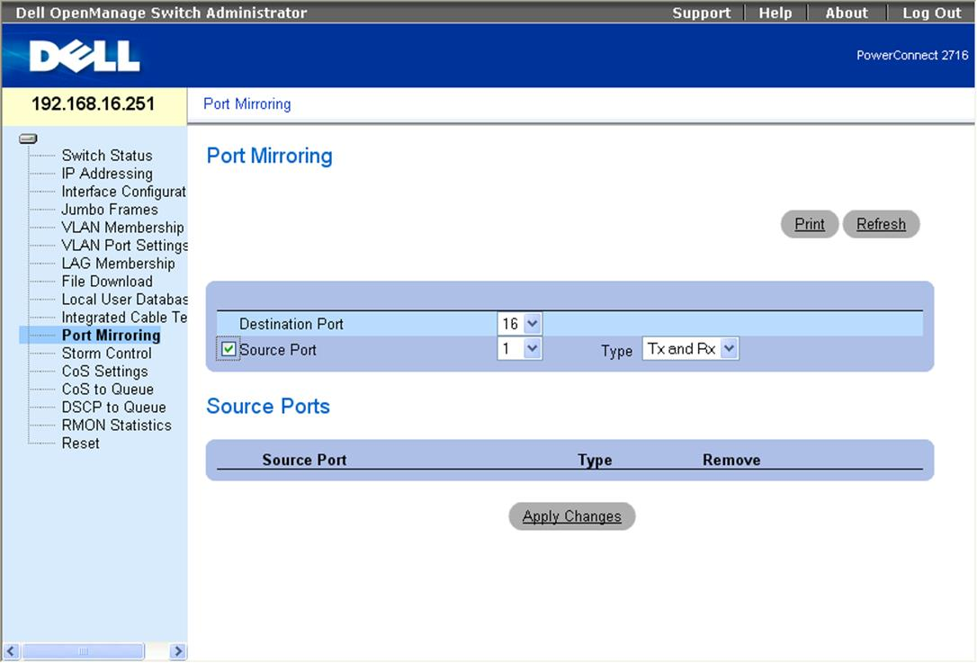
Configuring port mirroring on a Dell switch
The mirror port would be used by management or monitoring software (such as a Network Analyzer or Intrusion Detection System [IDS]). Either ingress or egress traffic or both can be captured. Optionally, in order to avoid overloading the monitoring system, packets may be filtered based on criteria such as protocol ID or TCP / UDP port number.
The above describes local port mirroring where the source and destination ports are on the same switch. On advanced switches it is possible to perform remote port mirroring by making the destination port a port on another switch.
Port mirroring demands a lot of processing and can lead to the switch hardware becoming overloaded and consequently crashing. If possible, trial any security solution that requires port mirroring under typical loads before deploying it on a production network.

Virtual LANs (VLAN)
Where legacy shared Ethernet networks suffered problems with too many nodes in the same collision domain, modern switched Ethernet networks can suffer from having too many nodes in the same broadcast domain. Virtual LANs (VLAN)are a means of addressing this problem. A VLAN means that different groups of computers on the same cabling and attached to the same switch(es) can appear to be in separate LANs. Nodes in each VLAN are in separate broadcast domains.

VLAN Assignment
The simplest means of assigning a host to a VLAN is by configuring the port interface on the switch. For example, from the switch management interface, ports 1 through 10 could be configured as a VLAN with the ID "10" and ports 11 through 20 could be assigned to VLAN 20. Host A connected to port 2 would be in VLAN 10 and host B connected to port 12 would be in VLAN 20. Host A and Host B would not be able to communicate directly, even though they are connected to the same switch.
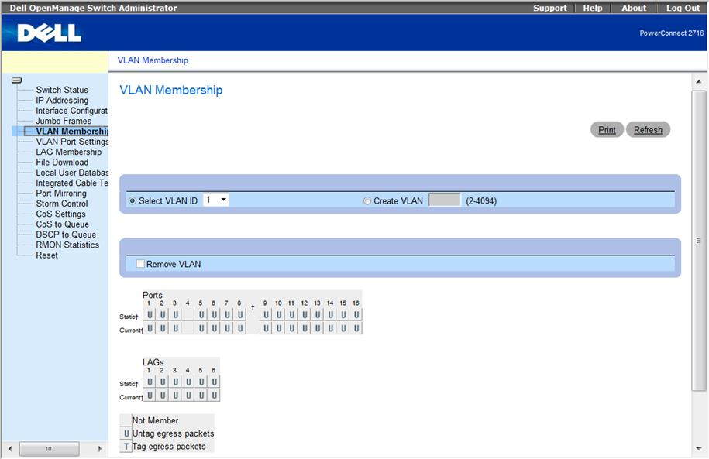
Configuring VLANs on a Dell switch using the web management interface
Each VLAN is typically configured with its own subnet address and IP address range. Communication between VLANs must go through an IP router. The IP router functionality however could be incorporated within the switch (a layer 3 switch) to improve performance.
Subnets and routing are covered in Module 2.
The type of port-based assignment described above is the simplest means of allocating VLAN membership. These can also be described as static VLANs. Dynamic VLAN membership can be configured using the host's MAC address, protocol type, IP address, or even authentication credentials.
As well as reducing the impact of broadcast traffic, from a security point-of-view, each VLAN can represent a separate zone. These zones would typically be configured to protect the integrity and confidentiality of different departments within the organization. If something like a virus or worm were introduced in one VLAN, it should not be able to spread to other VLANs. Also, it is common practice to isolate server-to-server traffic from client-server traffic and to isolate administration / management traffic (channels used for inbound management of appliances and servers). Another standard configuration option is to create a "null" VLAN that is non-routable to the rest of the network. This VLAN is used for any ports that do not have authorized connected equipment.

Trunking and IEEE 802.1Q
On a large network, one switch will not provide enough ports for all the hosts that need to be connected to the network. This means that multiple switches must be interconnected to build the network fabric. Multiple switches may also be deployed to provide redundant links. The interconnections between switches are referred to as trunks. One of the ports on each switch would be configured as a trunk port for this purpose.
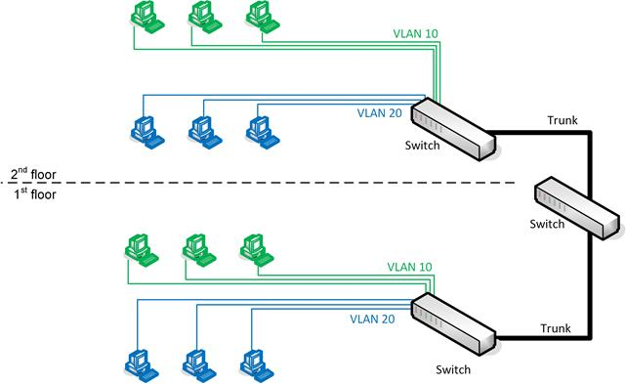
VLAN trunk link
It is possible to connect VLANs on different switches without using a trunk but each VLAN requires its own link port on each switch, so this solution does not scale well.
When frames designated for different VLANs are transported across a trunk, the VLAN ID of each frame must be preserved for the receiving switch to forward it correctly. While Cisco's proprietary Inter-Switch Link (ISL) was once widely used, VLAN IDs are normally defined by the IEEE 802.1Q standard. Under 802.1Q, traffic is identified by a VLAN tag inserted in the Ethernet frame between the Source Address and Ethertype fields. The tag contains information about the VLAN ID (from 1 to 4094) and priority (used for Quality of Service [QoS] functions). The Ethertype value is set to identify the frame as 802.1Q.
Construction of an 802.1Q Ethernet frame

Access Ports (Tag and Untag VLANs)
If a port will only ever participate in a single VLAN, that port can be configured as untagged. This is also referred to as an access port or host port. An untagged / access port uses the following logic:
- If a frame is addressed to a port in the same VLAN on the same switch, no tag will need to be added to the frame.
- If the frame needs to be transported over a trunk link, the switch adds the relevant 802.1Q tag to identify the VLAN then forwards the frame over the trunk port.
- If the switch receives an 802.1Q tagged frame on an access port, it will strip the tag before forwarding it.
Conversely, a tagged port will normally be one that is operating as a trunk; that is, capable of transporting traffic addressed to multiple VLANs. A trunk might be used to connect switches or to connect to a router. In some circumstances, a host attached to a port might need to be configured to use multiple VLANs and would need to be attached to a trunk port rather than an access port. Consider a virtualization host with multiple guest operating systems for instance. The virtual servers might need to be configured to use different VLANs.

Default VLAN and Native VLAN
The VLAN with ID 1 is referred to as the default VLAN. This cannot be changed. Unless configured differently, all ports on a switch default to being in VLAN 1. When implementing VLANs, you should avoid sending user data traffic over the default VLAN. It should be remain unused or used only for inter-switch protocol traffic, where necessary. Make sure that unused ports are not assigned to VLAN 1.
Unused ports should normally be disabled and assigned to a "black hole" VLAN. A black hole is a VLAN ID set up so that the rest of the network is not accessible from it (no route is configured to or from that network). 666 and 999 are popular choices for a black hole VLAN ID.
A native VLAN is one into which any untagged traffic is put when receiving frames over a trunk port. When a switch receives an untagged frame over a trunk, it assigns the frame to the native VLAN. Untagged traffic might derive from legacy devices such as hubs or older switches that do not support 802.1Q encapsulated frames. The native VLAN is initially set with the same VLAN ID as the default VLAN (1). You can (and should) change this however to make the native VLAN ID any suitable ID (this should not be the same as any VLAN used for any other data traffic).
 The traffic assigned to a native VLAN is usually untagged but to improve security newer switches allow the option of tagging these frames.
The native VLAN ID can be configured per-port. Switch ports participating in a trunk link should normally be configured with the same native VLAN ID.

VLAN Trunking Protocol
Trunking means that a VLAN can be configured across more than one switch device without having to configure the VLANs on each device manually. This means that hosts connected to different switches (and perhaps in completely different locations) can be part of the same local network. The VLANs can be used to define organizational boundaries without having to put hosts in the same physical location.
The protocol governing this data exchange would either be Cisco's VLAN Trunking Protocol (VTP) or the standards-based Multiple VLAN Registration Protocol (MVRP). Under VTP, switches can be grouped into management domains, identified by a domain name. Within these groups, switches are assigned the roles of either VTP server or VTP client. Modifications to the VLAN topology of the network can be made on any switch that has been assigned the VLAN server role and these changes are replicated to all switches in the management domain. In a small network with only a few switches, all switches may be configured as VTP servers. However, in a large network it is more efficient to limit the number of switches assigned this role.
Pruning refers to removing transmissions related to particular VLANs from a trunk to preserve bandwidth. If a particular VLAN is not associated with a given trunk link, pruning it from the trunk reduces the amount of broadcast traffic passing over the link. There may also be security reasons for removing a VLAN from a particular trunk link. Pruning can either be done via VTP or by configuring the trunk manually.

Spanning Tree Protocol (STP)
In a network with multiple bridges (implemented these days as switches and routers), there may be more than one path for a frame to take to its intended destination. As a layer 2 protocol, Ethernet has no concept of Time To Live. Therefore, layer 2 broadcast traffic could continue to loop through a network with multiple paths indefinitely. Layer 2 loops are prevented using the Spanning Tree Protocol (STP), defined in the IEEE 802.1D MAC Bridges standard.

Topology Change Notifications
Spanning tree is a means for the bridges to organize themselves into a hierarchy. The bridge at the top of the hierarchy is the root bridge. This can be selected automatically by the protocol but the administrator can pre-determine metrics to make the choice of one bridge over another more likely (unless the designated bridge happens to be offline).
Each bridge then determines the shortest path to the root bridge by exchanging information with other bridges. This information is packaged as Bridge Protocol Data Units (BPDU). A port that forwards "up" to the root bridge, possibly via intermediate bridges, is identified as a root port. Ports that can forward traffic "down" through the network with the least cost are identified as designated ports. A port that would create a loop is identified as a blocking or non-designated port. Subsequently, bridges exchange Topology Change Notifications if devices are added or removed, enabling them to change the status of forwarding / blocked ports appropriately.
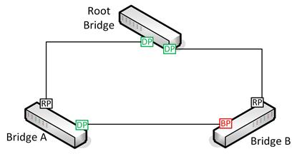
STP configuration
The diagram above shows the minimum configuration necessary to prevent loops in a network with three bridges or switches. The root bridge has two designated ports (DP) connected to Bridge A and Bridge B. Bridges A and B both have root ports (RP) connected back to the interfaces on the root bridge. Bridges A and B also have a connection directly to one another. On Bridge A, this interface is active and traffic for Bridge B can be forwarded directly over it. On Bridge B, the interface is blocked (BP) to prevent a loop and traffic for Bridge A must be forwarded via the root bridge.
The following table shows the different states that a port can be in:
State | Forwards Frames? | Learns MACs? | Notes
Blocking | No | No | Drops all frames other than BPDUs.
Listening | No | No | Port is listening for BPDUs to detect loops.
Learning | No | Yes | The port discovers the topology of the network and builds the MAC address table.
Forwarding | Yes | Yes | The port works as normal.
Disabled | No | No | The port has been disabled by the administrator.
When all ports on all bridges are in forwarding or blocking states, the network is converged. When the network is not converged, no communications can take place. Under the original 802.1D standard, this made the network unavailable for extended periods (10s of seconds) during configuration changes. STP is now more likely to be implemented as 802.1D-2004 / 802.1w or Rapid STP (RSTP). The rapid version creates outages of a few seconds or less. In RSTP, the blocking, listening, and disabled states are aggregated into a discarding state.

STP and VLANs
Where VLANs are implemented, a modified version of STP must be used. If a trunk port to multiple VLANs were to be blocked, all the VLANs on that trunk would be denied access to the rest of the network. Some means must be established to disable links on a per-VLAN basis. Originally, this was accomplished using Cisco's Per-VLAN STP Protocol (PVST) but is now implemented using Multiple Spanning Trees Protocol (MSTP), defined in IEEE 802.1Q.

Flooding
A switch keeps a cache of MAC addresses associated with each port to enable it to forward traffic quickly. This cache is periodically flushed to ensure it is up-to-date. When the switch does not know the correct port to use for a particular destination MAC address (if the cache has just been flushed for instance), it floods the frame out to all ports, even if the frame is unicast not broadcast. Topology changes in STP (and especially RSTP) can cause a switch to flush the cache more frequently and to start flooding unicast traffic more frequently, which can have a serious impact on network performance.
To minimize the effects of unicast flooding, ensure that access ports (a port used to connect a host computer) are excluded from topology change notifications. Configuring port fast on a port causes it to always skip the listening and learning states.

Filtering STP Traffic
In some circumstances you might want to prevent a switch port from using STP. Two commands can be used to filter STP traffic:
- BPDU Guard - this causes a port fast-configured port that receives a BPDU to become disabled. BPDUs are not expected on access ports so this protects against misconfiguration or a possible malicious attack.
- BPDU Filter - this causes the port to drop all BPDUs. This could cause traffic to loop if used improperly. You might configure this on a link between two separately administered switching fabrics or use it when joining physical and virtual switch fabrics.
See Unit 3.6 / Cloud and Virtualization / Study Notes for more information about virtual switches. Note that a virtual switch is a different thing to a virtual LAN. Also note that the principal virtual switch vendor (vmware) implement a BPDU Filter feature (dropping STP traffic without disabling the port) but call it "BPDU Guard".

Power over Ethernet (PoE)
Power over Ethernet (PoE) is a means of supplying electrical power from a switch port over ordinary data cabling to a connected powered device, such as a VoIP handset or wireless access point. PoE is defined in two IEEE standards (now both rolled into 802.3-2012):
- 802.3af - powered devices can draw up to about 13W over the link. Power is supplied as 350mA@48V and limited to 15.4W but the voltage drop over the maximum 100 feet of cable results in usable power of around 13W.
- 802.3at (PoE+) - powered devices can draw up to about 25 W. Note that various proprietary schemes were used prior to the ratification of 802.3at.
PoE switches are referred to as end-span (or end-point) Power Sourcing Equipment (PSE). If an existing switch does not support PoE, a device called a power injector (or mid-span) can be used. Power can either be supplied over pairs 1/2 and 3/6 (referred to as Mode A or "phantom power" as these are the ones also used for data in 10/100BASE) or over 4/5 and 7/8 (Mode B). Gigabit Ethernet only uses the former method.
When a device is connected to a port on a PoE switch, the switch goes through a detection phase to determine whether the device is PoE-enabled. If not, it does not supply power over the port and therefore does not damage non-PoE devices. If so, it determines the device's power consumption and sets the supply voltage level appropriately.
Powering these devices through a switch is more efficient than using a wall-socket AC adapter for each appliance. It also allows network management software to control the devices and apply schemes, such as making unused devices go into sleep states and power capping.

