UNIT 5.4 / INCIDENT RESPONSE / STUDY NOTES

Business Continuity Concepts
Business continuity means planning and testing systems and operations so that they are as little affected by incidents as possible and so that the resources are available to recover from them.

Business Impact Analysis
When setting up a security system (or reviewing an existing one), one of the first steps is to set up a team responsible for risk management. Risk management starts with an initial risk investigation or analysis, often called a Business Impact Analysis (BIA). This has four main components:
- Identify the critical functions or processes of the business or organization.
- Identify the assets and resources on which the functions depend.
- Identify threats to the organization's functions and assets.
- Assess the risk to each function or asset, given the threats.
The results of the BIA are then used to create business continuity plans. The cornerstone of which will be selecting countermeasures (or security controls) to mitigate the risks identified in the BIA.

Identification of Critical Systems
In order to design a security plan, you must know what you want to make secure. It is crucial for an organization to perform the identification of critical systems. This means compiling an inventory of its business processes and its tangible and intangible assets and resources. These could include:
- People (employees, visitors, and suppliers).
- Tangible assets (buildings, furniture, equipment and machinery (plant), ICT equipment, electronic data files, and paper documents).
- Intangible assets (ideas, commercial reputation, brand, and so on).
- Procedures (supply chains, critical procedures, standard operating procedures).
Make sure that the asset identification process captures systems architecture as well as individual assets (that is, understand and document the way assets are deployed and used and how they work together).
 Diagrams are the most useful way to show how systems interconnect or how processes and procedures work. There are a number of tools for doing this, notably Microsoft Visio. See Unit 5.5 / Change and Configuration Management / Study Notes for more information about asset databases and diagrams.
Within the inventory of assets and business processes it is important to assess their relative importance. Which business functions are critical and which are only necessary? In the event of a disaster that requires that recovery processes take place over an extended period, critical systems must be prioritized over merely necessary ones.
For most businesses, the most critical systems will be those that enable customers to find them and for the business to interact with them. In practical terms, this means telecoms and web presence. Following that is probably the capability to fulfil products and services. Back-office functions such as accounting, HR, and marketing are probably necessary rather than critical.
 This is all subject to circumstance. If the disaster strikes the day before the CEO is due to present to the company's most important customers, ensuring that the presentation goes ahead smoothly might be expected to take precedence. If the customers are all going to be there in that room, getting the web server back is not going to be as high a priority.

Vulnerability Assessments and Pentests

A vulnerability assessment is the process of scanning a network (or application) for known vulnerabilities. A vulnerability is a weakness that could be triggered accidentally or exploited maliciously to cause a security breach. An unpatched software application, a host with no anti-virus software, and an administrator account with a weak password are examples of vulnerabilities.
Vulnerability assessments generally use passive techniques. A vulnerability scanner would probe the network or application to try to discover issues but would not attempt to exploit any vulnerabilities found. An assessment would also look at the configuration of security controls and try to identify whether there is a lack of controls that might be considered necessary or whether there is any misconfiguration of the system that would make the controls less effective or ineffective.
Penetration testing (or pentest or ethical hacking) essentially involves thinking like an attacker and trying to penetratethe security systems that have been set up, bypassing security controls using typical hacker methods and tools. The key difference to vulnerability testing is that an attempt is made to exploit any vulnerabilities discovered.
For example, a vulnerability test may reveal that an SQL Server has not been patched to safeguard against a known exploit. A penetration test would attempt to use the exploit to perform code injection and compromise the server.

Vulnerability Scanners
Numerous tools are available to perform vulnerability scanning and penetration testing. Footprinting and fingerprinting tools such as Nmap (and to some extent tools that facilitate attacks such as spoofing and password cracking) are of the "dual-use" kind that make them useful to both attackers and defenders.
 sectools.org is a useful resource for researching the different types and uses of security assessment tools.
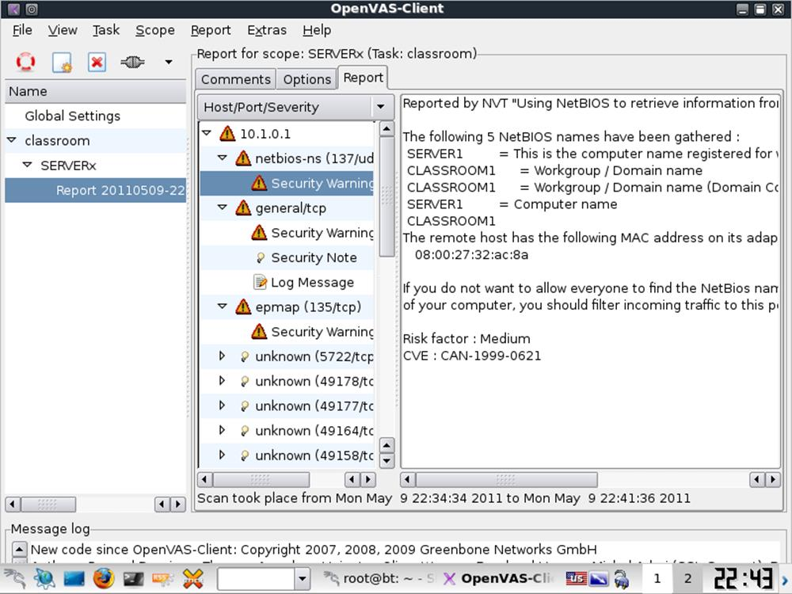
OpenVAS vulnerability scanner
A vulnerability scanner is a type of network mapper that aims to detect whether the network is exposed to any threats. To that end, as well as mapping the network for hosts and detecting running services, they scan for things such as patch level, security configuration and policies, network shares, unused accounts, weak passwords, rogue access points and servers, anti-virus configuration, and so on. The tool then compiles a report and classifies each detected vulnerability with an impact warning. Most tools also suggest current and ongoing remediation techniques.
Active detection scanners work by bouncing packets at a host and examining the replies. A passive scanner works in a way similar to Network Intrusion Detection Systems. The scanner sniffs network traffic to detect packets that would reveal vulnerabilities. This incurs less performance overhead and is not disruptive to the network, as some active scans can be, but careful placement of the scanner is required to ensure that it is monitoring relevant traffic.
A scanner can be implemented purely as software or as a security appliance, connected to the network. One of the best known software scanners is Tenable Nessus. As a previously open source program, Nessus also provides the source code for many other scanners. Some other products include SAINT, eEye Retina, and Rapid7 NeXpose.
As with anti-malware software, a vulnerability scanner needs to be kept up-to-date with information about known vulnerabilities.

IT Contingency Planning
Computer systems require protection from hardware failure, software failure, and system failure (failure of network connectivity devices for instance).
When implementing a network, the goal will always be to minimize the single points of failure and to allow ongoing service provision despite an incident. To perform IT Contingency Planning (ITCP), think of all the things that could fail, determine whether the result would be critical loss of service, and whether this is unacceptable. Then work out how to make the service fault tolerant.

Fault Tolerance
A system that can experience failures and continue to provide the same (or nearly the same) level of service is said to be fault tolerant. Fault tolerance is often achieved by provisioning redundant components. A redundant component is one that is not essential to the normal function of a system but that allows the system to recover from the failure of another component. Where redundancy is provided, the component is said to be n+1, where n is the number of components in use and 1 is a spare to be used in the event of failure.
Examples of devices and solutions that provide fault tolerance and high availability include the following:
- Redundant components (power supplies, network cards, drives (RAID), and cooling fans) provide protection against hardware failures. Hot swappable components allow for easy replacement (without having to shut down the server).
- Battery backups / Uninterruptible Power Supplies (UPS) and Standby Power Supplies. A UPS is always required to provide against any interruption to computer services. A backup generator cannot be brought online fast enough to respond to a power failure. The drawback of a UPS is that it is battery-based and therefore only able to provide power for a limited time; this could range from a few minutes to a few hours depending on the size of the battery bank and the server load. The UPS also obviously only provides power to critical server components, not lighting, HVAC, mains distribution, or other features of buildings power.
- Backup strategies - provide protection for data.
- Routers and switches can provide multiple paths through a network to prevent over-dependence on single critical nodes. Network cabling should be designed to allow for multiple paths between the various servers, so that during a failure of one part of the network, the rest remains operational. Routers are great fault tolerant devices, because they can communicate system failures and IP packets can be routed via an alternate device.
 Note that switches and routers can only be fault tolerant if there are multiple routes to choose from!
- Cluster services are an (expensive) way of ensuring that the total failure of a server does not disrupt services generally. A cluster is a group of servers, each of which is referred to as a node. A cluster provides fault tolerance for critical applications. They do this by being in a position to take over the processing of a failed node in the cluster should a problem occur.
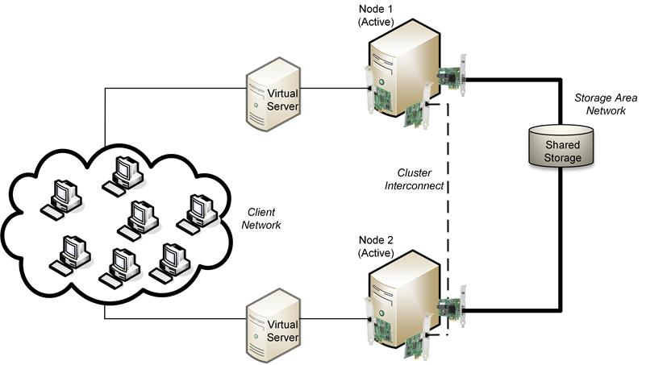
Server cluster
While these computer systems are important, thought also needs to be given about how to make a business "fault tolerant" in terms of staffing, utilities (heat, power, communications, transport), customers, and suppliers.

Disaster Recovery Planning
Business continuity means planning systems and operations so that they are as little affected by incidents as possible and so that the resources are available to recover from them. Disaster recovery plans describe the actual procedures to follow in the event of severe incidents. When planning a network, the administrator must consider the impact of data loss and service unavailability on the organization. If a local plumber loses his email connection for a day, then the chances are he or she will lose little business because of it and he will still be able to function in his primary role of plumber (conversely, losing a cell phone could be catastrophic!). Therefore little consideration would be needed to plan for disasters. Conversely, if a major bank lost its trading floor link to its partners, even for an hour, since the organization's primary function (trading) would be impossible, huge losses may result. Significant thought is required to ensure that a disaster does not cause this kind of loss to what are termed mission critical systems.
A disaster could be anything from a fairly trivial loss of power, or failure of a minor component, through to man-made or natural disasters, such as fires, earthquakes, or acts of terrorism.
An organization sensitive to these risks will develop an effective, documented Disaster Recovery Plan (DRP). This should accomplish the following:
- Identify scenarios for natural and non-natural disaster and options for protecting systems. Plans need to take account of risk (a combination of the likelihood the disaster will occur and the possible impact on the organization) and cost.
For each disaster scenario, a Business Impact Analysis (BIA) is made, identifying risks and vulnerabilities and advising on appropriate countermeasures.
- Identify tasks, resources, and responsibilities for responding to a disaster.
  - Who is responsible for doing what? How can they be contacted? What happens if they are not available?
  - Which functions are most critical? Where should effort be concentrated first?
  - What resources are available? Should they be pre-purchased and held as stock? Will the disaster affect availability of supplies? (see the topic on redundancy below).
  - What are the timescales for resumption of normal operations?
- Train staff in the disaster planning procedures and how to react well to change.

Training
An essential component of a business continuity and risk mitigation strategy is effective user training.

Adherence to Standards and Policies
A security system cannot be too inflexible or users will complain or adopt unsecure behavior. For example, when users have too many passwords to remember, they often start recycling them; also, when users are presented with numerous security warnings, they start to click through without really thinking about what they are doing. It is much better to educate users about security risks and to monitor behavior, to ensure that users are following best practice. This does need to be backed up by a strong disciplinary procedure to sanction users who continue to flout policies and standards.
Training might be the responsibility of HR or of a dedicated training department. Training methods include facilitated workshops, one-to-one instruction and mentoring, plus resources such as online training, books, and newsletters.

End User Awareness Training
Appropriate end user security awareness training needs to be delivered to employees at all levels; including end users, technical staff, and executives. NIST have created a guide to designing security awareness programs, published as SP800-50 (gtsgo.to/5ii1f). Some of the general topics that need to be covered include the following:

Train users to behave securely
- Overview of the organization's security policies and the penalties for non-compliance.
- Incident response identification and reporting procedures.
- Site security procedures, restrictions, and advice, including safety drills, escorting guests, use of secure areas, and use of personal devices.
- Data handling, including document confidentiality, Personally Identifiable Information (PII), backup, encryption, and so on.
- Password and account management plus security features of PCs and mobile devices.
- Awareness of social engineering and malware threats, including phishing, website exploits, and spam plus alerting methods for new threats.
- Secure use of software such as browsers and email clients plus appropriate use of internet access, including social networking sites.
It is necessary to frame security training in language that end users will respond to. Education should focus on responsibilities and threats that are relevant to users. It is necessary to educate users about new or emerging threats (such as viruses and Trojans, phishing scams, or "zero-day" exploits in software such as browser plug-ins) but this needs to be framed in language that users understand.
For example, if you try to inform users about "The threat of Trojan Horse software being used to install rootkits that can launch DoS attacks", their response will typically be either to fall asleep, laugh, or stare at you blankly. Instead, user education should be phrased in terms that are relevant to what they do from day-to-day at work and avoid technical language and jargon. For example, "Don't try to disable security software and don't open email file attachments if you are not sure what they contain."
Similarly, when security alerts are issued, these must be drafted carefully so as not to cause confusion or alarm. It is important to only issue alerts for critical incidents or risks. If users are faced with a continual series of alerts they will start to ignore them.

Role-based Training
As well as general security awareness training, there should be a system for identifying staff performing security-sensitive roles and grading the level of training and education required (between beginner, intermediate, and advanced for instance). Note that in defining such training programs you need to focus on job roles, rather than job titles, as employees may perform different roles and have different security training, education, or awareness requirements in each role.
Advanced security training will be required by job roles such as IT and networking, management, software development, and accounts.
 The NIST publication SP800-16 "IT Security Training Requirements" (gtsgo.to/xf5gh) sets out a role-specific training program in detail.

Incident Response Procedures
Incident management or incident response procedures are the actions and guidelines for dealing with security incidents. An incident is where security is breached or there is an attempted breach; NIST describe an incident as "the act of violating an explicit or implied security policy". Incident management is vital to mitigating risk. As well as controlling the immediate or specific threat to security, effective incident management preserves an organization's reputation.
However, incident response is also one of the most difficult areas of security to plan for and implement because its aims are often incompatible:
- Re-establish a secure working system.
- Preserve evidence of the incident with the aim of prosecuting the perpetrators.
- Prevent reoccurrence of the incident.
The actions of staff immediately following detection of an incident can have a critical impact on these aims, so an effective policy and well-trained employees are crucial. They help to calm nerves in the aftermath of an incident. Incident response is also likely to require coordinated action and authorization from several different departments or managers, which adds further levels of complexity.
The NIST Computer Security Incident Handling Guide special publication SP800-61 (gtsgo.to/fkiu5) identifies the following stages in an incident response lifecycle:
- Preparation - making the system resilient to attack in the first place. This includes hardening systems, writing policies and procedures, and establishing confidential lines of communication. It also implies creating incident response resources and procedures.
- Detection and Analysis - determining whether an incident has taken place and assessing how severe it might be, followed by notification of the incident to stakeholders.
- Containment, Eradication, and Recovery - limiting the scope and magnitude of the incident. The typical response is to "pull the plug" on the affected system, but this is not always appropriate. Once the incident is contained, the cause can then be removed and the system brought back to a secure state.
- Post-incident Activity - analyzing the incident and responses to identify whether procedures or systems could be improved. It is imperative to document the incident.

Computer Security Incident Response Team (CSIRT)
Larger organizations will provide a dedicated Computer Security Incident Response Team (CSIRT) as a single point-of-contact for the notification of security incidents. The members of this team should be able to provide the range of decision making and technical skills required to deal with different types of incident. The team needs a mixture of senior decision makers (up to director level), who can authorize actions following the most serious incidents, managers, and technicians (who can deal with minor incidents on their own initiative).

First Responder
When a suspicious event is detected, it is critical that the appropriate person on the CSIRT be notified so that they can take charge of the situation and formulate the appropriate response. This means that employees at all levels of the organization must be trained to recognize and respond appropriately to actual or suspected security incidents. A good level of security awareness across the whole organization will reduce the incidence of false positives and negatives.
The person dealing with an incident once it has been reported is referred to as the first responder. For the most serious incidents, the entire CSIRT may be involved in formulating an effective response. One of the first tasks of the first responder will be to move to secure the area.
It is important to provide redundancy in terms of personnel that can respond to an incident (succession planning). Consider a scenario in which a key staff member cannot be contacted; is there a backup option? This scenario also illustrates the importance of maintaining documented procedures.

Secure the Area
As incidents cover such a wide range of different scenarios, technologies, motivations, and degrees of seriousness, there is no standard approach to containment or incident isolation. Some of the many complex issues facing the CSIRT are:
- What damage or theft has occurred already? How much more could be inflicted and in what sort of time frame (loss control)?
- What countermeasures are available? What are their costs and implications?
- What actions could alert the attacker to the fact that the attack has been detected? What evidence of the attack must be gathered and preserved? How can the area of the incident be secured and documented to preserve this type of evidence?
If further evidence needs to be gathered, the best approach may be to quarantine or sandbox the affected system or network. This allows for analysis of the attack and collection of evidence using digital forensic techniques (see below). This can only be done if there is no scope for the attacker to cause additional damage or loss however.
There are great practical problems in establishing an effective quarantine however. It may be possible to redirect the attacker into some kind of honeypot or honeynet or to use a firewall or intrusion detection to limit wider access. It may also be possible to restrict the attack by changing account passwords or privileges or to apply patches to hosts not yet affected by the attack.
Another option is to remove an affected device from the system it is attached to ("pull the plug"). This will prevent the attacker from widening the attack but may alert him or her to the fact that the attack has been detected. A sophisticated attacker may have retaliatory attacks prepared to meet this sort of contingency. Also, changing the state of a computer from on to off (or off to on) violates the principles of sound forensic evidence collection (see below).

Escalation
An incident may be judged too critical to continue to be managed by the first responder. The process by which more senior staff become involved in the management of an incident is called escalation. Escalation may also be necessary if no response is made to an incident within a certain time frame.

Data Breach and Notification
A data breach is where an attack succeeds in obtaining information that should have been kept secret or confidential. Once data has been stolen in this way, it is virtually impossible to prevent further copies of it being made, though it may be possible to act against those that try to publish it.
It has to be assumed however that the data stolen is no longer confidential. It is critical to identify precisely what has been stolen, though often this is a difficult enough task in itself. Security systems must be reanalyzed and re-secured, so that things like passwords are changed, even if there is no direct evidence that they have been compromised. Note that in this context the suspicion of data theft may be enough to have to trigger reporting procedures. Even if it is only suspected that customer passwords or credit card numbers have been stolen (for instance), customers must be notified so that they can take steps to re-secure other online accounts or financial accounts.
As well as attempting to identify the attacker, a data breach will normally require that affected parties be notified, especially if Personally Identifiable Information (PII) or account security information is involved. As well as data protection legislation, many industries have strict regulations regarding the safe processing of data and will set out requirements for notifying affected customers as well as the regulator. The regulator will also require evidence that the systems that allowed the breach have been improved.

Forensic Procedures
Computer forensics is the science of collecting evidence from computer systems to a standard that will be accepted in a court of law. It is highly unlikely that a computer forensic professional will be retained by an organization, so such investigations are normally handled by law enforcement agencies.
 Law enforcement agencies will prioritize the investigation of the crime over business continuity. This can greatly compromise the recovery process, especially in smaller businesses, as an organization's key assets may be taken as evidence.
Like DNA or fingerprints, digital evidence - often referred to as Electronically Stored Information (ESI) - is mostly latent. Latent means that the evidence cannot be seen with the naked eye; rather it must be interpreted using a machine or process. Forensic investigations are most likely to be launched against crimes arising from insider threats, notably fraud or misuse of equipment (to download or store obscene material for instance). Prosecuting external threat sources is often extremely difficult, as the attacker may well be located in a different country or have taken effective steps to disguise his or her location and identity. Such prosecutions are normally initiated by law enforcement agencies, where the threat is directed against military or governmental agencies or is linked to organized crime. Cases can take years to come to trial.

Due Process, Legal Hold, and eDiscovery
Due process is a term used in US and UK common law to require that people only be convicted of crimes following the fair application of the laws of the land. More generally, due process can be understood to mean having a set of procedural safeguards to ensure fairness. This principle is central to forensic investigation. If a forensic investigation is launched (or if one is a possibility) it is important that technicians and managers are aware of the processes that the investigation will use. It is vital that they are able to assist the investigator and that they not do anything to compromise the investigation. In a trial, defense counsel will try to exploit any uncertainty or mistake regarding the integrity of evidence or the process of collecting it.
 As mentioned above, the "first response" period following detection and notification is often critical. To gather evidence successfully, it is vital that staff do not panic and act without thinking.
Legal hold refers to the fact that information that may be relevant to a court case must be preserved. Information subject to legal hold might be defined by regulators or industry best practice or there may be a litigation notice from law enforcement or lawyers pursuing a civil action. This means that computer systems may be taken as evidence, with all the obvious disruption to a network that entails.
A forensic examination of a device such as a hard drive that contains Electronically Stored Information (ESI) entails a search of the whole drive (including both allocated and unallocated sectors for instance). eDiscovery is a means of filtering the relevant evidence produced from all the data gathered by a forensic examination and storing it in a database in a format such that it can be used as evidence in a trial. eDiscovery software tools have been produced to assist this process. Some of the functions of eDiscovery suites are:
- Identify and de-duplicate files and metadata - many files on a computer system are "standard" installed files or copies of the same file. eDiscovery filters these types of files, reducing the volume of data that must be analyzed.
- Search - allow investigators to locate files of interest to the case. As well as keyword search, software might support semantic search. Semantic search matches keywords if they correspond to a particular context.
- Security - at all points evidence must be shown to have been stored, transmitted, and analyzed without tampering.
- Disclosure - an important part of trial procedure is that the same evidence be made available to both plaintiff and defendant. eDiscovery can fulfil this requirement. Recent court cases have required parties to a court case to provide searchable ESI rather than paper records.

Collection of Evidence
The first phase of a forensic investigation is to document the scene and collect evidence. A computer system may contain multiple gigabytes (or even terabytes) of data, most of which will not be relevant to the incident. Additionally, evidence may only exist in volatile storage (system or cache RAM). If the computer system or device is not owned by the organization, there is the question of whether search or seizure is legally valid. This impacts on Bring Your Own Device (BYOD) policies for instance. This may also make it difficult for law enforcement agents to begin an investigation. For example, if an employee is accused of fraud you must verify that the employee's equipment and data can be legally seized and searched. Any mistake may make evidence gained from the search inadmissible.
There is an ISOC best practice guide to evidence collection and archiving published as RFC 3227.
There is also the question of "how" ESI should be collected. It is much more difficult to capture evidence from a digital "crime scene" than it is from a physical one. Some evidence will be lost if the computer system is powered off; on the other hand some evidence may be unobtainable until the system is powered off. Additionally, evidence may be lost depending on whether the system is shut down or "frozen" by suddenly disconnecting the power. Best practice is that evidence should be preserved and documented at the crime scene in its original state; that is, computers or other devices that are off should not be switched on and those that are on should not be switched off.

Document the Scene and Capture Evidence
The crime scene must be thoroughly documented using photographs and ideally video and audio. Investigators must record every action they take in identifying, collecting, and handling evidence.
Remember that if the matter comes to trial, the trial could take place months or years after the event. It is vital to record impressions and actions in notes.
If possible, evidence is gathered from the live system (including screenshots of display screens and the contents of cache and system memory) using forensic software tools. It is vital that these tools do nothing to modify the digital data that they capture.
Also consider that in-place CCTV systems or webcams might have captured valuable evidence.
If a computer or network system is seized in a switched on state and the scene has been thoroughly documented, the general principle is to capture electronic evidence in the order of volatility, from more volatile to less volatile. RFC 3227sets out the general order as follows:
- CPU registers and cache memory (including cache on disk controllers, GPUs, and so on).
- Routing table, arp cache, process table, kernel statistics.
- Memory (RAM).
- Temporary file systems.
- Disk.
- Remote logging and monitoring data.
- Physical configuration and network topology.
- Archival media.
Forensic tools are used to make a copy of data on the digital storage media, such as hard drives. This is performed using drive imaging rather than file copy methods, so that the copy is made at sector level. A cryptographic hash is made of the collected data. This can be used to prove that the digital evidence collected has not been modified subsequently to its collection.
 Forensic procedures are assisted by having an appropriate software toolkit. These are programs that provide secure drive imaging, encryption, and data analysis. There are commercial toolkits (such as EnCase, Vogon, and SafeBack) plus free software, though these tend to be oriented to Linux (such as data dumper [dd], md5sum, grep, and The Coroner's Toolkit).

Chain of Custody and Data Transport
Depending on the strength of evidence required, physical drives taken from the crime scene can be identified, bagged, sealed, and labeled (using tamper-proof bags). It is also appropriate to ensure that the bags have anti-static shielding to reduce the possibility that data will be damaged or corrupted on the electronic media by ElectroStatic Discharge (ESD). Any other physical evidence deemed necessary is also "Bagged and Tagged".
A crucial element of the investigation is that each step is documented and (ideally) recorded. This proves that the evidence has been handled correctly and has not been tampered with. Once evidence has been bagged, it must not subsequently be handled or inspected, except in controlled circumstances. A Chain Of Custody form records where, when, and who collected the evidence, who has handled it subsequently, and where it was stored. The chain of custody must show access to, plus storage and transportation of, the evidence at every point from the crime scene to the court room. Anyone handling the evidence must sign the chain of custody and indicate what they were doing with it.
The evidence should be stored in a secure facility; this not only means access control but also environmental control, so that the electronic systems are not damaged by condensation, ESD, fire, and other hazards. Similarly, if the evidence is transported, the transport must also be secure.

Forensics Report
The purpose of a forensic investigation is to produce a forensics report, detailing any matters of interest or potential evidence discovered. All analysis should be performed on a copy of the evidence rather than on the original devices or the secure image created at the crime scene. When analyzing information from hard drives taken as evidence, one of the most significant challenges is dealing with the sheer volume of information captured. Within the thousands of files and hundreds of gigabytes there may only be a few items that provide incriminating evidence. Forensic analysis tools help to identify what could be of interest to the forensic examiner.
"Big Data" analysis techniques can assist in this process. Big data refers to large stores of unstructured information. Big data analysis tools use search query-like functions to identify patterns and information of interest within unstructured files such as documents and spreadsheets. As well as the contents of the file, analysis of the file metadata, including time stamps, can reveal useful information. As well as examining the information on hard drives, big data analysis techniques can also be used to analyze network traffic. Big data analysis tools oriented towards security and computer intrusion detection and forensics will certainly become more widely available over the next few years.
Big data analysis software often includes data visualization tools. Visualization is a very powerful analysis technique for identifying trends or unusual activity. For example, a graph of network activity will reveal unusually high activity from a particular host much more easily than analysis of the raw data packets. A "tag cloud" (a visual representation of how frequently words or phrases appear in a data store) of the information on a hard drive might reveal clues about malicious behaviour that could not be found by examining each file individually.

