UNIT 5.3 / AUTHENTICATION / STUDY NOTES

Authentication Technologies
Authentication is the process of allowing legitimate users through the barriers set up for access control. Accounts on the computer system are configured with permissions to access resources. To access an account, the user must supply the correct credentials, proving that he or she is the valid account holder.

Multifactor and Two-factor Authentication
Authentication factors (the data used to perform an authentication) fall into three categories:
- Something you know (such as a password).
- Something you have (such as a smart card or token).
- Something you are (biometric data such as a fingerprint or retina scan).
A product is considered "strong" if it combines the use of more than one authentication data type (multifactor). Single-factor authentication systems can quite easily be compromised: a password could be written down or shared, a smart card could be lost or stolen and a biometric system could be subject to high error rates.
Two-factor authentication combines something like a smart card or biometric mechanism with "something you know", such as a password or PIN. Three-factor authentication combines all three technologies. An example of this would be a smart card with integrated thumb or fingerprint reader. This means that to authenticate, the user must possess the card, the user's fingerprint must match the template stored on the card, and the user must input a PIN.
 Multifactor authentication requires a combination of different technologies. For example, requiring a PIN along with Date of Birth may be stronger than entering a PIN alone, but it is not multifactor.

Single Sign-On
Single Sign-On (SSO) means that a user only has to authenticate to a system once to gain access to all its resources (that is, all the resources to which the user has been granted rights). An example is the Kerberos authentication and authorization model (discussed below). This means (for instance) that a user who has authenticated with Windows is also authenticated with the Windows domain's SQL Server and Exchange Server services.
The advantage of single sign-on is that each user does not have to manage multiple user accounts and passwords. The disadvantage is that compromising the account also compromises multiple services.
Single sign-on only tends to be implemented on enterprise networks. There have been various initiatives to try to extend the principle to web accounts (Microsoft accounts, Facebook Login, and the PayPal e-commerce model for instance), but no scheme has achieved the sort of critical mass that would force mass acceptance. There would also be serious security concerns about using a common log in for different sites, especially where online banking sites are concerned.
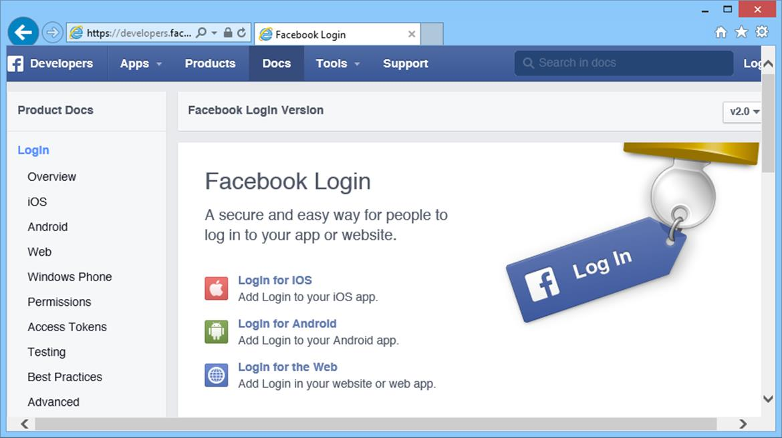
Facebook login allows web and app developers to leverage Facebook accounts and authentication when registering users
 It is critical that users do not re-use work passwords or authentication information on third-party sites. Of course, this is almost impossible to enforce, so security managers have to rely on effective user training.

Cryptographic Hash Functions
Hash functions are widely used in computer programming to create a short representation of data. These functions are used for things like checksums to ensure the validity of data. A cryptographic hash function produces a fixed length hex-encoded string, called a message digest, from a variable length string. The function is designed so that it is impossible to recover the original message from the digest (one-way) and so that different messages are unlikely to produce the same digest (a collision). A small change in the original string should produce a very different digest.
Hash functions are a mechanism for storing and transmitting passwords securely. They are also used to prove file integrity. Two of the most commonly used cryptographic hash algorithms are SHA1 and MD5.

Secure Hash Algorithm (SHA)
The Secure Hash Algorithm (SHA) is one of the Federal Information Processing Standards (FIPS) developed by the National Institute of Standards and Technology (NIST) for the US government. SHA was created to address possible weaknesses in MDA (see below). There are two versions of the standard in common use:
- SHA-1 - this was quickly released (in 1995) to address a flaw in the original SHA algorithm. It uses a 160-bit digest.
- SHA-2 - these are variants using longer digests (up to 512 bits).
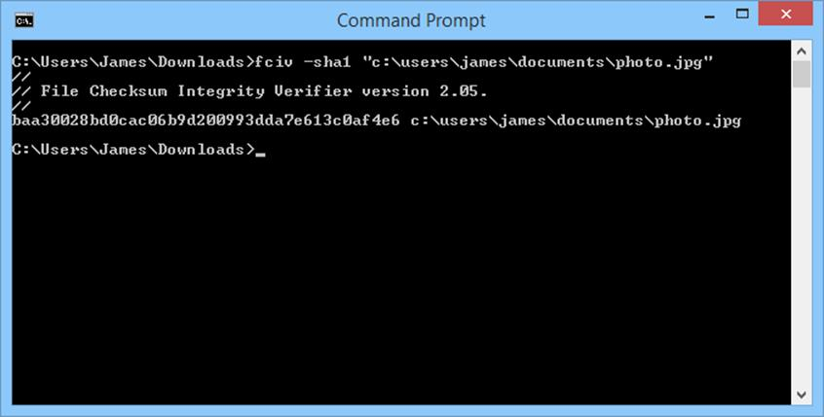
Computing an SHA value from a file

Message Digest Algorithm (MDA / MD5)
The Message Digest Algorithm was designed in 1990 by Ronald Rivest, one of the "fathers" of modern cryptography. The most widely used version is MD5, released in 1991, which uses a 128-bit hash value. MD5 is not as secure as SHA as ways have been found to exploit collisions in the cipher. It is still widely used in operating systems and software applications for password storage.

NTLM and Kerberos
You need to be familiar with the operation of authentication protocols. One set of protocols is used to log on locally to a Windows network; another class of protocols is used to log on across a potentially unsecure channel (a VPN or wireless network for instance).

LAN Manager / NTLM
LAN Manager (LM or LANMAN) was an NOS developed by Microsoft and 3Com. Microsoft used the authentication protocol from LM for Windows 9x networking. This protocol was later redeveloped as NTLM and NTLMv2.
LM is a challenge/response authentication protocol using an encrypted hash of the user's password. This means that the user's password is not sent to the server in plaintext and cannot (in theory) be obtained by an attacker.
The version of LM used for early versions of Windows NT (NTLM) fixed some of the problems in LM. A substantially revised version of the protocol appeared in Windows NT4 SP4 (NTLMv2) and continues to provide local logon for current versions of Windows. While the basic challenge/response process is the same, the responses are calculated differently to defeat known attacks against NTLM.

Kerberos
Kerberos is a network authentication protocol developed by the Massachusetts Institute of Technology (MIT) in the 1980s. The protocol has been ratified as a web standard by the IETF (RFC 4120).
The idea behind Kerberos is that it provides single sign-on. This means that once authenticated, a user is trusted by the system and does not need to re-authenticate to access different resources.
 This flexibility is a drawback in as much as there is no control over access to the workstation. If a user logs on then leaves the workstation unattended, the user's account can be compromised (a "lunchtime" attack).
The Kerberos authentication method was selected by Microsoft as the network logon provider for Windows 2000 (and later). It is based on the Kerberos 5.0 open standard and provides authentication to Active Directory, as well as compatibility with other, non-Windows, operating systems.
Kerberos was named after the three-headed guard dog of Hades (Cerberus) because it consists of three parts. Clientsrequest services from a server, which both rely on an intermediary - a Key Distribution Center (KDC) - to vouch for their identity. There are two services that make up a KDC: the Authentication Service and the Ticket Granting Service. The KDC runs on port 88 using TCP or UDP.
The Authentication Service is responsible for authenticating user logon requests. More generally, users and services can be authenticated; these are collectively referred to as principals. For example, when you sit at a Windows domain workstation and logon to the domain (Kerberos documentation refers to realms rather than domains, which is Microsoft's terminology), the first step of logon is to authenticate with a KDC server (implemented as a domain controller).
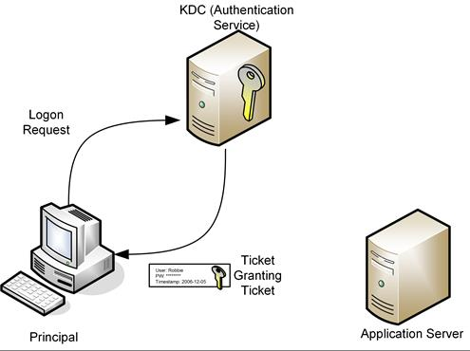
Kerberos Authentication Service
When authenticated, the KDC server presents the user with a Ticket Granting Ticket. To access resources within the domain, the client requests a Service Ticket (a token that grants access to a target application server) by supplying the Ticket Granting Ticket to the Ticket Granting Service (TGS).
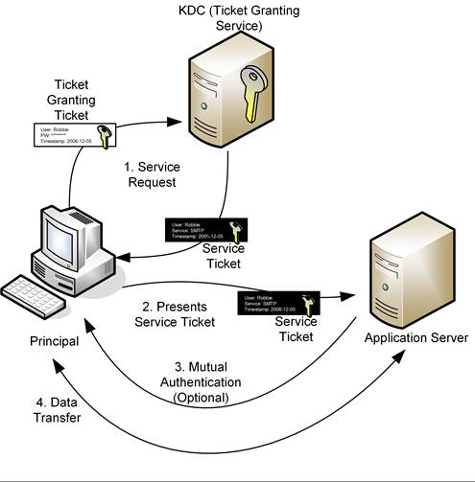
Kerberos Ticket Granting Service
One of the noted drawbacks of Kerberos is that the KDC represents a single point-of-failure for the network. In practice, backup KDC servers can be implemented (for example, Active Directory supports multiple domain controllers, each of which will be running the KDC service).

RADIUS and TACACS+
Enterprise networks and ISPs potentially need to support hundreds or thousands of users and numerous different remote and wireless access technologies and devices. The problem arises that each remote access device needs to be configured with authentication information and this information needs to be synchronized between them.

RADIUS
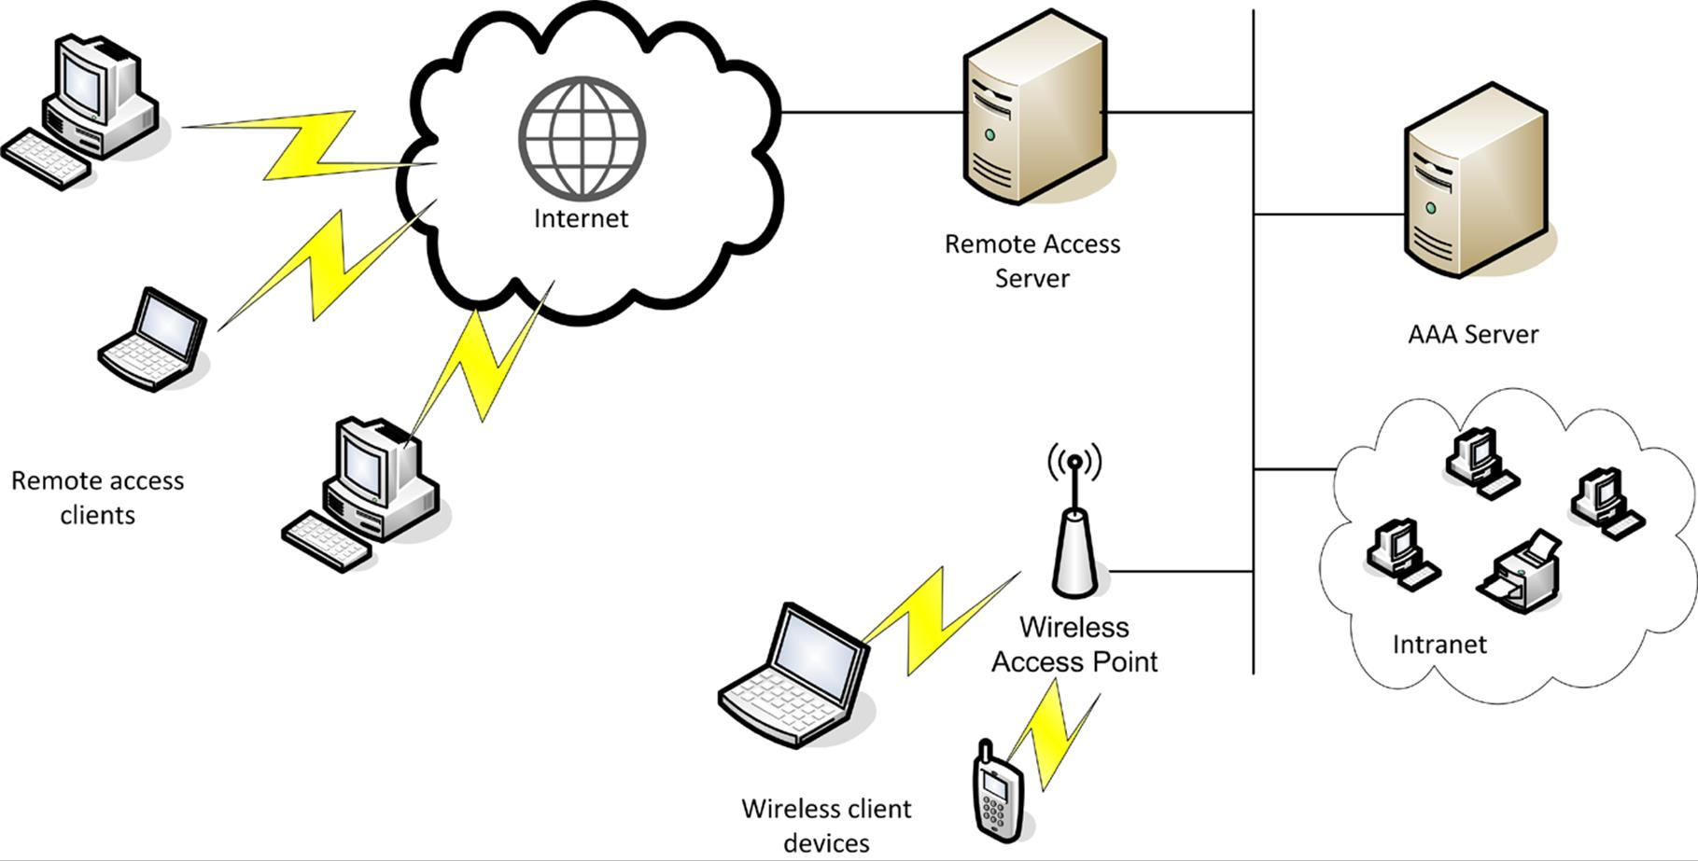
RADIUS
A scalable authentication architecture can be developed using RADIUS. RADIUS stands for Remote Authentication Dial-in User Service. It was published as an internet standard in RFC 2865. Under this protocol, Authentication, Authorization, and Accounting is performed by a separate server (the AAA server). Remote access devices (such as routers, layer 3 switches, wireless access points, or VPN servers and concentrators) function as client devices of the AAA server. Rather than storing authentication information, they pass this data between the AAA server and the remote user.
There are a number of RADIUS server and client products. Microsoft has the Internet Authentication Server (IAS) / Network Policy Server (NPS) for Windows platforms and there are open-source implementations for UNIX and Linux (such as FreeRADIUS), as well as third-party commercial products (such as Cisco's Secure Access Control Server, OSC Radiator, and Juniper Networks Steel-Belted RADIUS). Products are not always interoperable as they may not support the same authentication and accounting technologies (proxy support).

TACACS+
Terminal Access Controller Access Control System (TACACS+) is a similar protocol to RADIUS but designed to be more flexible and reliable. TACACS+ was developed by Cisco but is also supported on many of the other third-party and open source RADIUS server implementations. Where RADIUS is often used in VPN implementations, TACACS+ is often used in authenticating administrative access to routers and switches. Reliability is improved by using TCP (over port 49). TCP provides reliable delivery, making it easier to detect when a server is down. Another feature is that all the data in TACACS+ packets is encrypted (except for the header identifying the packet as TACACS+ data), rather than just the authentication data.

RADIUS / TACACS+ Misconfigurations
If the client device is not configured with the correct authentication server address and security parameters, authentication will fail. You should also ensure that no firewall is blocking communications between the client and server. To avoid the authentication process being hijacked (to allow connections that should be blocked), it is important to ensure that the connection between the RADIUS / TACACS client and server is correctly configured. Both protocols allow for a pre-shared key, which is encrypted in communication. This should be set with a strong value (long with high entropy). It is also possible to secure the authentication server so that it will only respond to requests from known sources.

PAP, CHAP, and EAP
While NTLM and Kerberos are closely associated with use on local Windows networks, there are several authentication protocols suitable for use on mixed networks.

Password Authentication Protocol
The Password Authentication Protocol (PAP) is unsophisticated authentication method developed as part of the Point-to-Point Protocol (PPP), used to transfer TCP/IP data over serial or dial-up connections. It relies on cleartext password exchange and is therefore obsolete for the purposes of any sort of secure connection. It is defined in RFC 1334.

Challenge Handshake Authentication Protocol
The Challenge Handshake Authentication Protocol (CHAP) was also developed as part of PPP as a means of authenticating users over a remote link. It is defined in RFC 1994. CHAP relies on an encrypted challenge in a system called a three-way handshake.
- Challenge - the server challenges the client, sending a randomly generated challenge message.
- Response - the client responds with an encrypted hash, computed from the challenge message and the client's password.
 In theory, the password cannot be recovered from the response because the hash function is one-way. Hashes of weak passwords (those that are short and non-complex) are vulnerable to dictionary and brute-force password cracking tools. The hash function used is MD5.
- The server performs its own hash using the challenge and the password hash stored for the client. If it matches the response then access is granted; otherwise the connection is dropped.
- The Challenge-Response is repeated with a different challenge message periodically during the connection (though transparently to the user). This guards against replay attacks (where a previous session could be captured and reused to gain access).
CHAP typically provides one-way authentication only. Cisco's implementation of CHAP (for example) allows for mutual authentication by having both called and calling routers challenge one another. This only works between two Cisco routers however.

MS-CHAP
MS-CHAP is Microsoft's first implementation of CHAP, supported by older clients, such as Windows 95. An enhanced version (MS-CHAPv2) was developed for recent Windows clients (Windows 2000 and later). MS-CHAPv2 also supports mutual authentication.
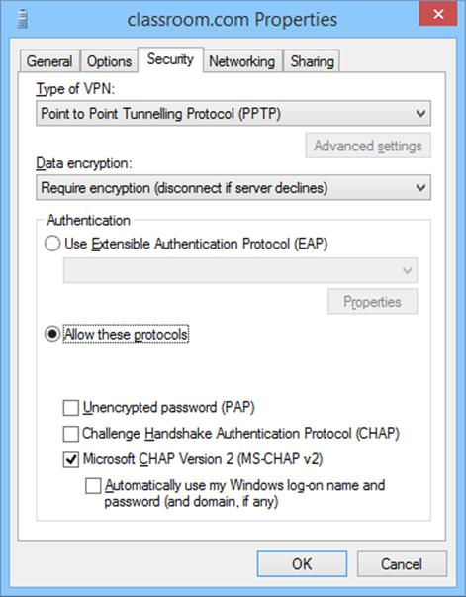
Defining allowed authentication mechanisms on a Windows VPN

EAP / IEEE 802.1X
The Extensible Authentication Protocol (EAP) is intended to replace CHAP. It is defined in RFC 3748. The protocol is designed to support different types of authentication; it defines a framework for negotiating authentication mechanisms rather than the details of the mechanisms themselves. EAP is often implemented as part of the IEEE 802.1X standard. 802.1X defines the EAP over LANs (EAPoL) protocol to encapsulate EAP messages as they are moved over Ethernet and Wi-Fi networks. EAP / 802.1X involves three components:
- Supplicant - this is the client requesting authentication.
- Authenticator - this is the device that receives the authentication request (such as a remote access server or wireless access point). The authenticator establishes a channel for the supplicant and authentication server to exchange credentials using the EAP over LAN (EAPoL) protocol. It blocks any other traffic until authentication is granted.
- Authentication Server - the server that performs the authentication (typically an AAA RADIUS or TACACS server).
Widely adopted now, vendors can write extensions to the protocol to support third-party security devices. EAP authentication mechanisms can include smart cards, one-time passwords, biometric scanning, or simpler user name and password combinations. Some of the most popular implementations of EAP are described below.
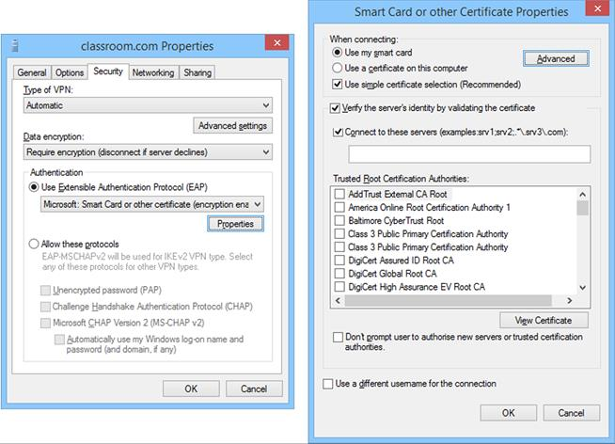
Configuring EAP on a Windows VPN

EAP-TLS
EAP-TLS (RFC 5216) is currently considered the strongest type of authentication and is very widely supported. An encrypted Transport Layer Security (TLS) tunnel is established between the supplicant and authentication server using public key certificates on the authentication server and supplicant.
As both supplicant and server are configured with certificates, this provides mutual authentication. The supplicant will typically provide a certificate using a smart card or a certificate could be installed on the client PC, possibly in a Trusted Platform Module (TPM).

Protected Extensible Authentication Protocol (PEAP)
In Protected Extensible Authentication Protocol (PEAP), as with EAP-TLS, an encrypted tunnel is established between the supplicant and authentication server but PEAP only requires a server-side public key certificate. The supplicant does not require a certificate. With the server authenticated to the supplicant, user authentication can then take place through the secure tunnel with protection against sniffing, password-guessing/dictionary, and Man-in-the-Middle attacks. There are two versions of PEAP, each specifying a different user authentication method (also referred to as the "inner" method):
- PEAPv0 (EAP-MSCHAPv2) - uses MS-CHAPv2 for authentication. This is by far the most popular implementation.
- PEAPv1 (EAP-GTC [Generic Token Card]) - Cisco's implementation.
PEAP is supported by Microsoft as an alternative to EAP-TLS. It is simpler and cheaper to deploy than EAP-TLS because you only need a certificate for the authentication server.

EAP-TTLS
EAP-Tunneled TLS (EAP-TTLS) is similar to PEAP. It uses a server-side certificate to establish a protected tunnel through which the user's authentication credentials can be transmitted to the authentication server. The main distinction with PEAP is that EAP-TTLS can use any inner authentication protocol (PAP or CHAP for instance) while PEAP must use EAP-MSCHAP or EAP-GTC).

Wi-Fi Authentication
A Wireless LAN (WLAN) must be protected by encryption to be able to authenticate users and prevent eavesdropping. There are three types of encryption available for Wi-Fi:
- Wired Equivalent Privacy (WEP) is Wi-Fi's original security mechanism. While it is supported on both legacy and modern devices, the encryption system (based on the RC4 cipher) is flawed.
- Wi-Fi Protected Access (WPA) fixes most of the security problems with WEP. WPA still uses the RC4 cipher but adds a mechanism (TKIP [Temporal Key Integrity Protocol]) to make it stronger.
- WPA2 is fully compliant with the 802.11i WLAN security standard. The main difference to WPA is the use of AES (Advanced Encryption Standard) for encryption. AES is stronger than RC4 / TKIP.
Users attempting to connect to the WLAN can be authenticated using "personal" or "enterprise" authentication mechanisms.

Pre-Shared Key (PSK)
A Pre-Shared Key (PSK) is the key that is used to encrypt communications. It is also referred to as personal authentication. A PSK is generated from a passphrase, which is like a long password. In WPA-PSK, the router administrator defines a passphrase of between 8 and 63 ASCII characters. This is converted into a 256-bit cryptographic hash, expressed as a 64-digit hex value where each hex digit represents 4 bits.
It is critical that PSK passphrases be long (12 characters or more) and complex (contain a mixture of upper and lower case letters and digits and no dictionary words or common names).
The main problem is that distribution of the key or passphrase cannot be secured properly and on a home network, the user acting as the administrator may choose an unsecure phrase. It also fails to provide accounting, as all users share the same key. The advantage is that it is simple to set up. Conversely, changing the key periodically (as would be good security practice) is difficult as the new key must be communicated to all users and updated on all their devices.
PSK is the only type of authentication available for WLANs that use WEP encryption technology. It is also suitable for SOHO networks and workgroups that use WPA or WPA2 encryption.

Enterprise Authentication
Networks with WPA encryption deployed can implement 802.1X / EAP (Extensible Authentication Protocol)authentication. This is also referred to as enterprise authentication.
With 802.1X / EAP, the access point is the authenticator. It takes the credentials given by the supplicant (the wireless client device) and sends them to a RADIUS server on the wired network for validation. This allows WLAN authentication to be integrated with the wired LAN authentication scheme.
The supplicant credentials could be a username and password or could employ smart cards or tokens for device authentication (EAP-TLS or EAP-TTLS for instance). This would depend on the type of EAP deployed (EAP-TLS, PEAP, or EAP-TTLS for instance).
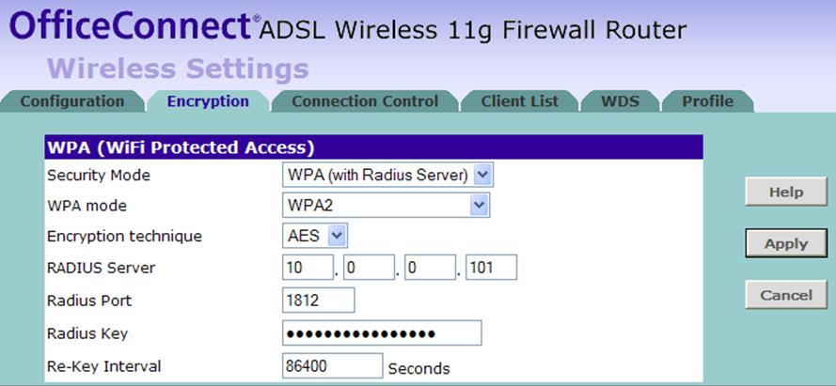
Configuring RADIUS authentication on an access point
Enterprise authentication is not available if the encryption method is WEP.

Firewalling Wireless Connections
MAC filtering means specifying which MAC addresses are allowed to connect to the access point. This can be done by specifying a list of valid MAC addresses but this "static" method is difficult to keep up-to-date and relatively error-prone. It is also easy for a wireless sniffer to discover valid MAC addresses and spoof them. Enterprise-class access points (or wireless controllers) allow you to specify a limit to the number of permitted addresses and automatically learn a set number of valid MAC addresses.
Another option is to put a firewall behind the AP in order to filter traffic passing between the wired LAN and WLAN.

Endpoint Security
Endpoint security is a set of security procedures and technologies designed to restrict network access at a device level. Endpoint security contrasts with the focus on perimeter security established by topologies such as DMZ and technologies such as firewalls. Endpoint security does not replace these but adds defense in depth.
The portability of devices such as removable storage, wireless access points, VoIP phones, cell phones, smartphones, and laptop computers, makes penetrating network perimeter security more straightforward. The security of these devices is often heavily dependent on good user behavior. There is also the eventuality of providing guests with network facilities, such as web access and email.
While training and education can reduce the risks somewhat, new technologies are emerging to control these threats and mitigate the risk that a compromised system could be allowed to attach to the network.

Physical Port Security
With wired ports, access to the physical switch ports and switch hardware should be restricted to authorized staff, using a secure server room and/or lockable hardware cabinets. To prevent the attachment of unauthorized client devices, a switch port can be disabled using the management software or the patch cable can be physically removed from the port. Completely disabling ports in this way can introduce a lot of administrative overhead and scope for error. Also, it doesn't provide complete protection as an attacker could unplug a device from an enabled port and connect their own PC. Consequently, more sophisticated methods of ensuring port security have been developed.

MAC Address Filtering and Limiting
As with an access point, configuring MAC filtering on a switch means specifying which MAC addresses are allowed to connect to a particular port. This can be done by specifying a list of valid MAC addresses or by specifying a limit to the number of permitted addresses. For example, if port security is enabled with a maximum of two MAC addresses, the switch will record the first two MACs to connect to that port but then drop any traffic from machines with different network adapter IDs that try to connect.
Additionally, a security feature such as ARP inspection prevents a host attached to an untrusted port from flooding the segment with gratuitous ARP replies by maintaining a trusted database of IP:ARP mappings and ensuring that ARP packets are validly constructed and use valid IP addresses.
Another option is to configure DHCP snooping. This inspects DHCP traffic arriving on access ports to ensure that a host is not trying to spoof its MAC address. It can also be used to prevent rogue (or spurious) DHCP servers from operating on the network. With DHCP snooping, only DHCP offers from ports configured as trusted are allowed.

IEEE 802.1X
When used with switches rather than wireless networks, the IEEE 802.1X standard defines a Port-based Network Access Control (PNAC) mechanism. PNAC means that the switch (or router) performs some sort of authentication of the attached device before activating the port. In this scenario, the switch is the authenticator. It enables the Extensible Authentication Protocol over LAN (EAPoL) protocol only and waits for the supplicant device to supply authentication data. The authenticator passes this data to an authenticating server, typically a RADIUS server, which checks the credentials and grants or denies access.
If access is granted, the switch will configure the port to use the appropriate VLAN and enable it for ordinary network traffic. Unauthenticated hosts may also be placed in a "guest" VLAN with only limited access to the rest of the network.

Network Access Control
As well as authenticating users, Network Access Control (NAC) allows administrators to devise policies or profiles describing a minimum security configuration that devices must meet to be granted network access. This is called a health policy. Typical policies check things such as malware infection, firmware and OS patch level, personal firewall status, and presence of up-to-date virus definitions. A solution may also be able to scan the registry or perform file signature verification. The health policy is defined on a NAC management server along with reporting and configuration tools.

Admission Control
Admission control is the point at which client devices are granted or denied access based on their compliance with the health policy. Most NAC solutions work on the basis of pre-admission control (that is, the device must meet the policy to gain access). Post-admission control involves subsequently polling the device to check that it remains compliant. Some solutions only perform post-admission control; some do both.
With pre-admission control, supplicant client devices connect to the network via a NAC Policy Enforcer, such as a switch, router, or wireless access point. Other options for the location of the policy enforcer include a VPN remote access gateway or a specially-configured DHCP server. The policy enforcer checks the client credentials with the NAC Policy Server and performs machine and user authentication with a RADIUS AAA Server. The client is allocated a suitable IP address by a DHCP server and assigned to a VLAN by the switch; depending on whether the policy was met, this would allow access to the network or to a quarantined area or captive web portal only.
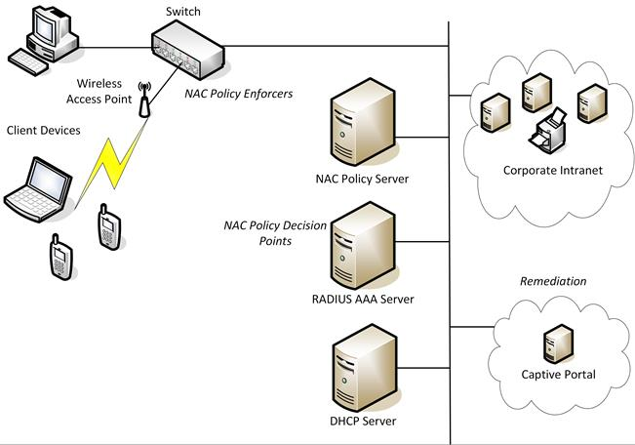
NAC framework
The pre-admission policy enforcers listed above would all count as edge controls. Post-admission controls (or access-based controls) would rely on the NAC policy server polling the client device once access has been granted or performing a policy check if the configuration of a client changes or when a client attempts to access a particular server or service.

Posture Assessment
Posture assessment is the process by which a client device is assessed for compliance against the health policy. Most NAC solutions use client software called an agent to gather information about the device, such as its anti-virus and patch status, presence of prohibited applications, or anything else defined by the health policy.
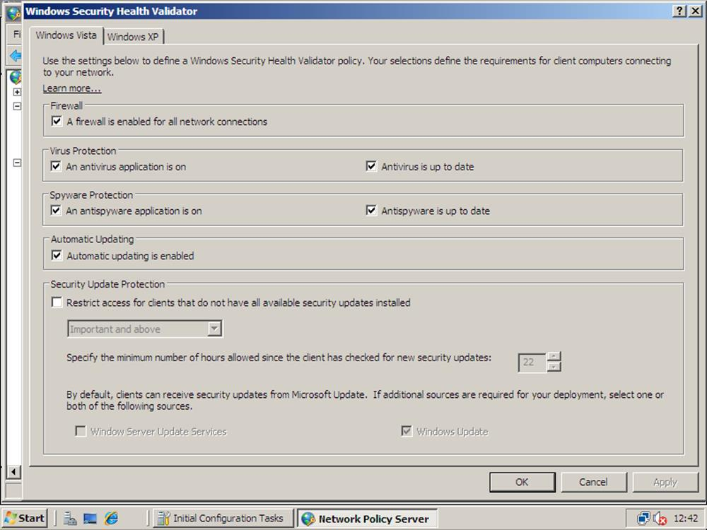
Configuring a health policy on the Windows Server Network Access Protection NAC product
An agent could be persistent, in which case it is installed as a software application on the client, or non-persistent. A non-persistent agent is loaded into memory during posture assessment but is not installed on the device. Some NAC solutions can perform agentless posture assessment. This is useful when the NAC solution must support a wide range of devices (such as smartphones and tablets) but less detailed information about the client is available with an agentless solution.

Remediation
Remediation refers to what happens if the device does not meet the security profile. A non-compliant device may be refused connection completely or put in a quarantined guest network or captive portal.
- Guest network - this would be a VLAN or firewalled subnet (DMZ) granting limited access to network resources. For example, you might allow visitors with non-compliant devices to use your internet routers to browse the web and view their email but not grant them any access to your corporate network.
- Quarantine network - this is another type of restricted network, usually based on a captive portal. A captive portal allows only HTTP traffic and redirects the HTTP traffic to a remediation server. The remediation server would allow clients to install OS and anti-virus updates to make the client machine compliant.

Mobile Device Management
Mobile Device Management (MDM) is a class of management software designed to apply security policies to the use of smartphones and tablets in the enterprise. This software can be used to manage enterprise-owned devices as well as Bring Your Own Device (BYOD). BYOD means allowing employees to use their private smartphone and tablet devices to access corporate data.
A key feature is the ability to support multiple operating systems (such as iOS, Android, BlackBerry, and the various iterations of Windows and Windows Mobile). A few MDM suites are OS-specific but the major ones, such as AirWatch (www.air-watch.com), Symantec (gtsgo.to/gs3rq), and ZenMobile (gtsgo.to/9bluq), support multiple device vendors.

On-boarding Mobile Devices
The core functionality of MDM suites is similar to (and may be integrated with) NAC solutions. The management software logs use of a device on the network and determines whether to allow it to connect or not, based on administrator-set parameters. This process can be described as on-boarding. When the device is enrolled with the management software it can be configured with policies to allow or restrict use of apps, corporate data, and built-in functions such as a video camera or microphone.

Application Control and Storage Segmentation
MDM software can also be used for application control. When the device is joined to the corporate network through enrollment with the MDM software, it can be configured into a corporate "workspace" mode in which only certain whitelisted applications can run. The MDM software may also be able to lock down use of unused features (or features that the enterprise wants to remain unused!), such as Bluetooth or the on-board camera or microphone.
When a device is privately owned and stores a mix of corporate and personal data, the questions of data ownership and privacy arise.
- Data ownership - how can rights over corporate data be asserted on a device that does not belong to the corporation?
- Privacy - how can the corporation inspect and manage a BYOD without intruding on private data and device usage?
At one level, these concerns need to be addressed by policy and guidance, agreed between the employer and employees. These sorts of concerns have also been addressed by MDM vendors in the form of storage segmentation. This allows the employer to manage and maintain the portion of the device that interfaces with the corporate network. When the device is used on the enterprise network, a corporate workspace with a defined selection of apps and a separate storage container is created. The enterprise is thereby able to maintain the security it needs but does not have access to personal data or applications.
Examples of storage segmentation include BlackBerry's "BlackBerry Balance" technology and AirWatch's "Workspace Management" features.

Off-boarding
There must also be a policy for off-boarding, ensuring that devices are brought out of the organization securely. Policies here might include the removal of corporate settings, data, and so on in the following two circumstances:
- When a device is take out of the corporate network when the employee goes home or out-of-office, highly sensitive data or settings might need to be removed to mitigate the risk of loss or theft of the mobile device.
- When an employee leaves an organization permanently any corporate data must be removed from personal devices owned by the ex-employee.
MDM products may have their own Data Loss Prevention (DLP) software or tie in with other DLP products to prevent data files from being copied to unsecure storage areas on a mobile device.

Troubleshooting Authentication and ACLs
Troubleshooting issues of authentication and file access becomes more-and-more product-specific but consider some of the following scenarios.

Troubleshooting Authentication
Technologies such as firewalls, network access control, and intrusion prevention protect a network from attacks but such security mechanisms can sometimes block legitimate traffic as well. If all communications between two hosts do not work, there is likely to be firewall (or two) between them. If two hosts can connect but certain applications do not work, the relevant ports on the firewall need to be opened (or there could be some sort of content filtering going on).
Remember that firewalls can be configured to block ICMP, making connectivity tests with ping and traceroute unreliable. Also remember that firewalls can often be configured to block outgoing (egress) traffic as well as incoming. Finally, be aware that hosts may also be installed with personal firewalls.
If all basic connectivity tests are successful, you need to attempt to establish a session with a remote computer. It is a complex process to connect to a remote server and establish a session.
You will also have verified that the user is attempting to enter the correct password!

Troubleshooting Windows
In a Windows network, for example, the user will need to be authenticated by a domain controller, which is a complex enough process in itself. Windows systems need to access special servers, called global catalog servers and domain controllers. They determine which servers to contact by querying DNS for SRV records. Having logged in and obtained the necessary ticket, the computer attempts to locate the desired application server. Again, the server's IP address is resolved by DNS. Then a negotiation takes place between the client and the server to establish a pipe between the necessary Windows services to establish the session.
- What if those services are unavailable, or not started?
- What if the server didn't register with DNS when it booted?
- What if the Windows domain configuration isn't what it should be?
- What if the DHCP service didn't allocate the client all the configuration information required?
It is hard to identify problems at this level without expertise in troubleshooting that particular operating system (beyond the scope of this course). Most problems will be diagnosed by examining the relevant application or security log.

Troubleshooting non-Windows Networks
If you are using another operating system, such as Linux, the principles remain broadly similar. All networks require name services, so determine that name servers are operational. Most clients obtain IP configuration via DHCP - so verify those services are operational. Failure to establish a session with a server, when you can successfully ping it by name - in any operating system - implies that a server side service is causing a problem (most likely, an authentication service).

Troubleshooting VPNs
Troubleshooting VPN connections starts with examining the log to find out why the connection was refused. This may reveal (for instance) that the user has entered a password incorrectly or that the client does not support the VPN protocols or authentication methods or cipher suites demanded by the VPN server.

Troubleshooting Misconfigured Applications
Some applications will also implement their own user authentication along with a system of permissions to determine what each user is allowed to do within the application. It is possible for these permissions to be incorrectly configured, either access denied when it should be allowed or vice versa. Details of troubleshooting will vary from one application to another, but essentially involve comparing actual permissions reported by the application with the intended permission for each user.

Troubleshooting ACLs and Groups
As well as forming the basis of firewall rulesets, an Access Control List (ACL) is also used to control which users have access to a file, folder, or other object and what level of access each user has. Each entry in the ACL refers to a specific user or group and specifies the level of access that the user or members of the group will be allowed or denied. A misconfigured ACL may lead to users being denied access to resources that they should be able to access, or worse, being allowed access when it should be denied.
To troubleshoot misconfigured ACLs, it is necessary to work out the effective permissions granted to individual users. Because a user can be a member of multiple groups, it is not always easy to tell at a glance the level of access that a particular user will have. In fact, ACLs should not normally refer to individual users. This is because (except in the case of home folders) users are not usually granted permissions to objects based on who they are, but rather due to the roles they perform. Thus, to determine the effective permissions granted to a user by an ACL, we need to take into account all the groups of which the user is a member, either directly or indirectly. To make this process easier, the Windows Advanced Security dialog has an Effective Permissions tab, which can be used to find out what permissions a specific user has to the resource.
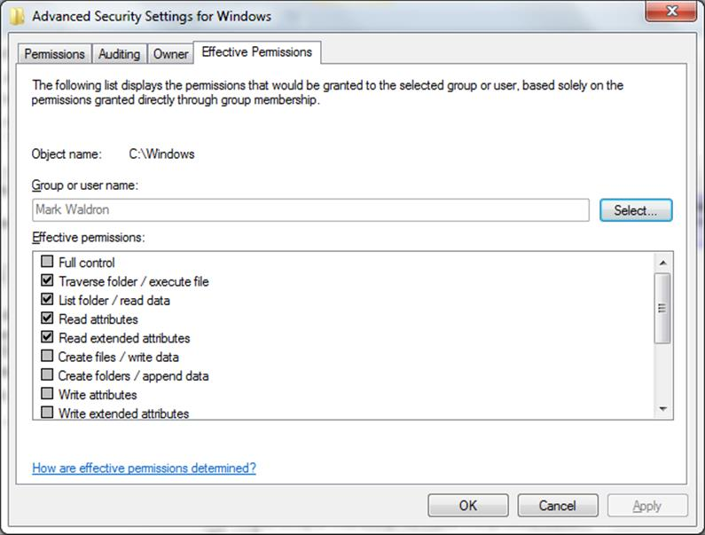
Analyzing effective permissions
In Windows, groups of users can be defined in two different locations, either in the Active Directory database or in the local SAM (Security Accounts Manager) database on individual computers. Groups that are defined in the Active Directory database are known as domain groups and their scope can be defined as universal, global, or domain local. Universal and global groups can be given access to resources anywhere in the Active Directory forest (usually this means the entire organization) while domain local groups can be given access to resources only within the domain in which they are defined. In many cases, this is a trivial distinction, as many Active Directory implementations only consist of a single domain and in these cases the domain and the forest are indistinguishable.
Of more importance though is the distinction between these various domain-based groups and local groups. Local groups are defined in the SAM database of individual computers (workstations or servers) and as such they are only locally significant. In other words, they can only be used to give access to resources on the specific computer on which they reside. Their members can be local users from the same SAM database or domain users. Indeed, they can take users from any domain in the entire forest. However, when giving these groups access to resources, that is, when adding them to an ACL, they can only be used in ACLs on the computer where they are defined.
At first glance, it would appear therefore that domain-based groups are more useful than local groups, in that they can be defined once centrally and then used in multiple locations. However, by applying the principle of least privilege to this situation, we can see that in many cases the use of local groups is more appropriate than domain-based groups. Their limited scope reduces the possibility that an accidental misconfiguration will cause group members to be given unauthorized access to resources on another computer.

