UNIT 5.2 / SECURITY APPLIANCES / STUDY NOTES

Network Segmentation
Network segmentation is the process of determining which bits of the network are accessible to other bits. A highly secure network or single host computer may have to be physically separated from any other network. This is also referred to as an air gap. Air gapping creates many management issues however and so is only done rarely.
 You can read more about some of the configuration issues surrounding air gapping on Bruce Schneier's blog (gtsgo.to/nmj9i).
Many of the technologies that can be used to enforce network segmentation have been covered already. They include VLANs, subnets, VPNs, and virtualization. All these types of system enforce network segmentation by deploying access controls of different types. The networks are not physically separate but they are logically separate. For example, when a host is assigned to a VLAN, the switch restricts it to seeing packets designated for that VLAN. To communicate outside the VLAN, the host must use a router and a router equipped with a firewall can apply additional rules to what it allows in and out.

Importance of Network Segmentation
As well as the methods used to segment a network, you should also consider the reasons to do so. In a majority of cases, the main concern is security, but you should consider some of the specific security issues plus other reasons for restricting access between segments:
- Separate private / public networks - most enterprise LANs allow internet access to client computers on the LAN but communications between the private LAN and public internet are carefully controlled and filtered, often using a Demilitarized Zone (DMZ), discussed below.
- Compliance - while security is always a priority, in some industries there are strict regulations and laws that must be complied with as regards handling data, such as health records or financial information. Compliance regulations may have specific requirements about segmenting this sort of highly confidential information from the overall network. Another requirement may be to have completely separate administrative accounts governing the sensitive data.
- Legacy systems - operating systems or applications software that are no longer supported by their vendor become increasingly vulnerable to malware and other exploits as time passes. If it is not possible to decommission these systems, putting them in a separate network segment can reduce the risk to the rest of the network.
- SCADA / Industrial Control Systems (ICS) - as discussed earlier, the management and data collection of these types of embedded systems is often now being integrated with computer data networks. Hackers have found ways to attack these systems through computer malware. Consequently, the management stations and ICS networks must be protected by access controls.
- Honeypot / honeynet - this is a type of computer or network set up to attract attackers, with the intention of analyzing attack strategies and tools, to provide early warning of attack attempts, or possibly as a decoy to divert attention from actual computer systems. Another use is to detect internal fraud, snooping, and malpractice. Consequently, the honeypot must be carefully separated from the production network, so as not to allow attackers to steal real data.
- Testing lab - a separate network may be used for testing new software or appliances, either because the new systems require substantial reconfiguration of the network or because testing could cause performance problems. Virtualization provides an ideal test environment.
- Load balancing - as well as security, performance is another important reason to consider network segmentation. Complex software applications are often deployed in tiers, with separate systems for the front-end, middleware (processing), and back-end (data storage). In each tier, different kinds of load balancing and clustering solutions can be used.
- Performance optimization - a network with a large number of hosts tends to underperform. On legacy Ethernet networks and wireless networks, this is because of excessive collisions; on modern Ethernet networks, it is usually because of excessive broadcast traffic. Using VLANs to segment the network can minimize the impact of these problems.

Zones and Access Control Lists (ACL)
The main unit of a logically segmented network is a zone. A zone is an area of the network (or of a connected network) where the security configuration is the same for all hosts within it. Network traffic between zones is strictly controlled, using a security device - typically a firewall.
A firewall is software or hardware that filters traffic passing into and out of the network. The firewall bases its decisions on a set of rules called an Access Control List (ACL). For example, a basic firewall can allow or deny a host access based on its IP address or by the port it is requesting or a combination of both. Different types of firewall (and other filtering devices) can apply different - often more sophisticated - criteria in their ACLs.
One of the most important reasons for segmenting networks is to separate public and private networks. The main private and public zones are as follows:
- Private network (intranet) - this is a network of trusted hosts owned and controlled by the organization.
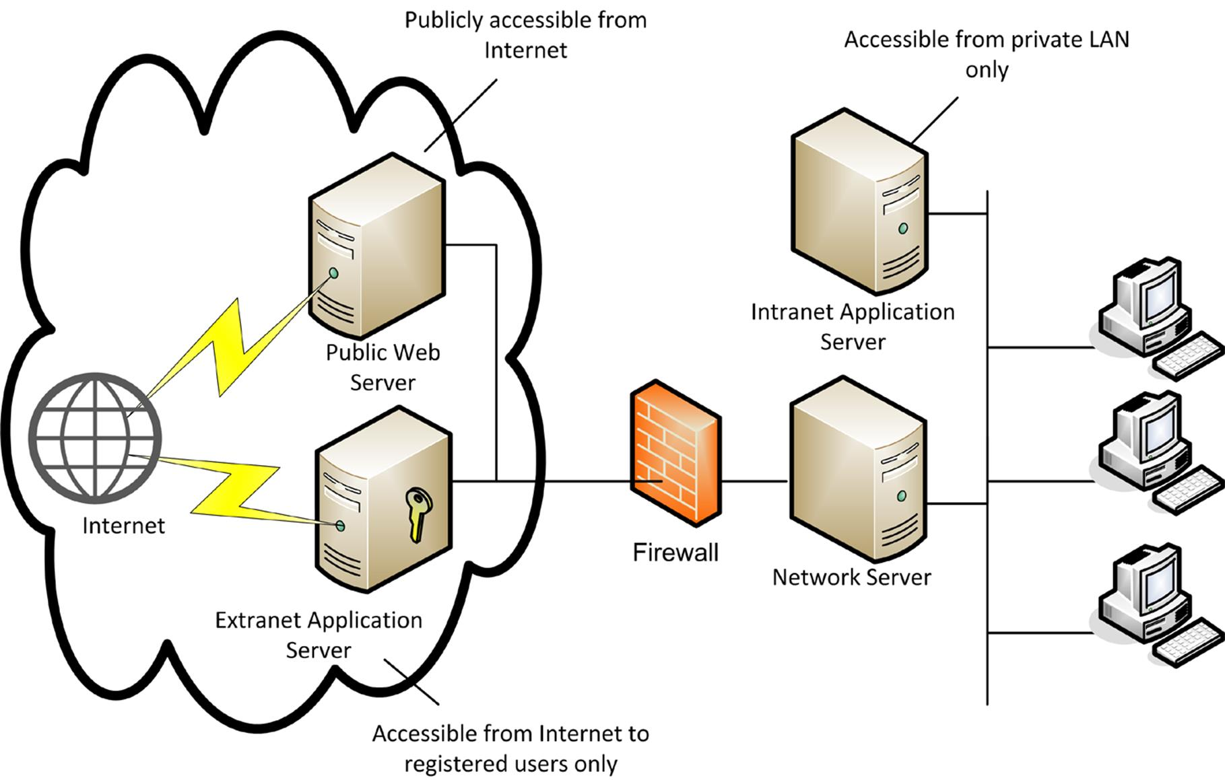
Network security zones
 Hosts are trusted in the sense that they are under your administrative control and subject to the security mechanisms (such as anti-virus software, user rights, software updating, and so on) that you have set up to defend the network.
- Extranet - this is a network of semi-trusted hosts, typically representing business partners, suppliers, or customers. Hosts must authenticate to join the extranet.
- Internet - this is a public zone permitting anonymous access (or perhaps a mix of anonymous and authenticated access) by untrusted hosts over the Internet.

Demilitarized Zones (DMZ)
One important distinction between different security zones is whether a host is internet-facing. An internet-facing host accepts inbound connections from the Internet. These internet-facing hosts are placed in a Demilitarized Zone (DMZ). A DMZ is also referred to as a perimeter network. The idea of a DMZ is that traffic cannot pass through it directly. Everything behind the DMZ is invisible to the outside network.
Servers that provide extranet or public access services should be placed in a DMZ. These would typically include web servers, mail and other communications servers, proxy servers, and remote access servers. The hosts in the DMZ are not fully trusted by the internal network because of the possibility that they could be compromised from the Internet. They are referred to as Bastion Hosts. A bastion is a defensive structure in a castle. The bastion protrudes from the castle wall and enables the defenders to fire at attackers that have moved close to the wall. A bastion host would not be configured with any services that run on the local network, such as user authentication.
There are two ways of implementing a DMZ: screened subnet and triple-homed firewall.

Screened Subnet
In this more secure configuration, two firewalls are placed at either end of the DMZ. One restricts traffic on the external interface; the other restricts traffic on the internal interface.
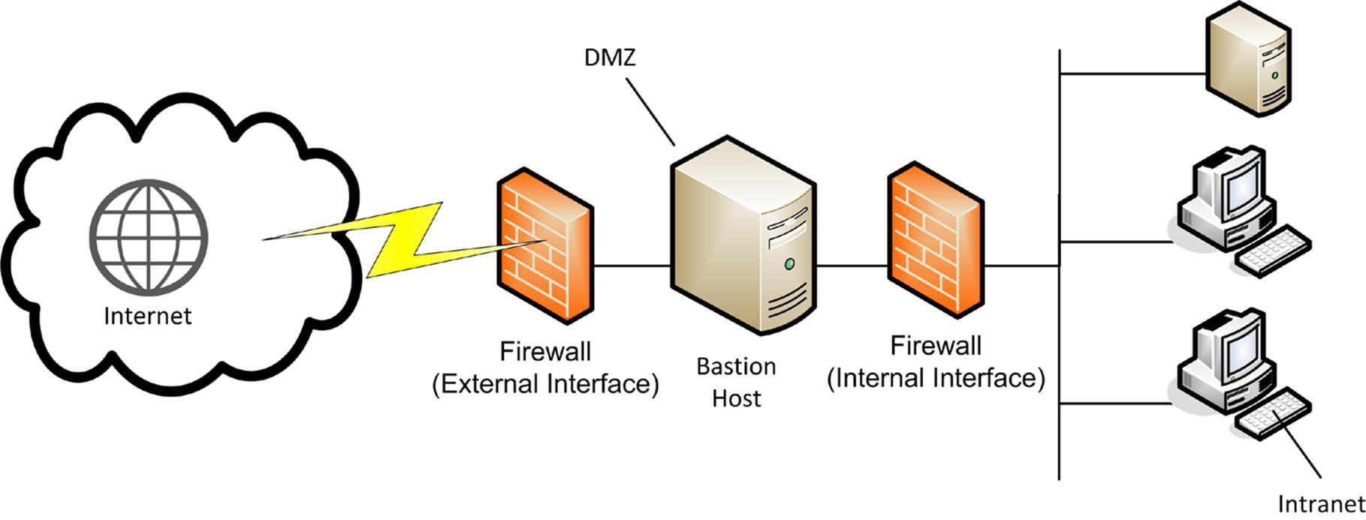
Screened subnet

Three-Legged Firewall
A three-legged (or triple-homed) firewall is one with three network ports:
- One port is the external interface.
- One port is the DMZ.
- One port is the internal interface.
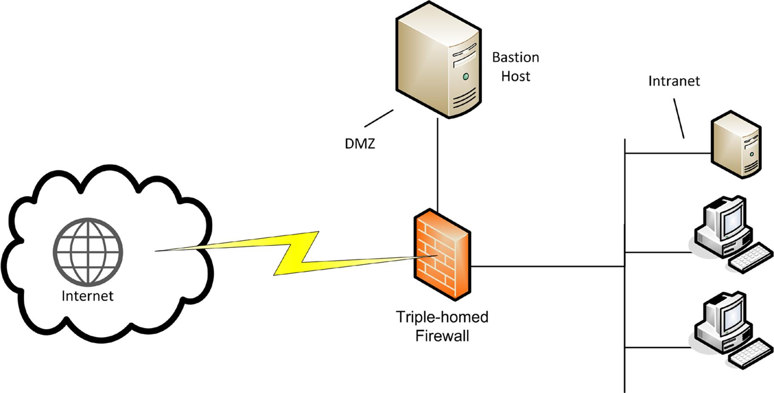
Three-legged firewall
This is more complex to configure than a screened subnet. Also, the firewall represents a single point of failure and is easier to compromise. However, this configuration does save on costs.

Screened Host
Smaller networks may not have the budget or technical expertise to implement a DMZ. In this case, internet access can still be implemented using a dual-homed proxy server acting as a screened host.
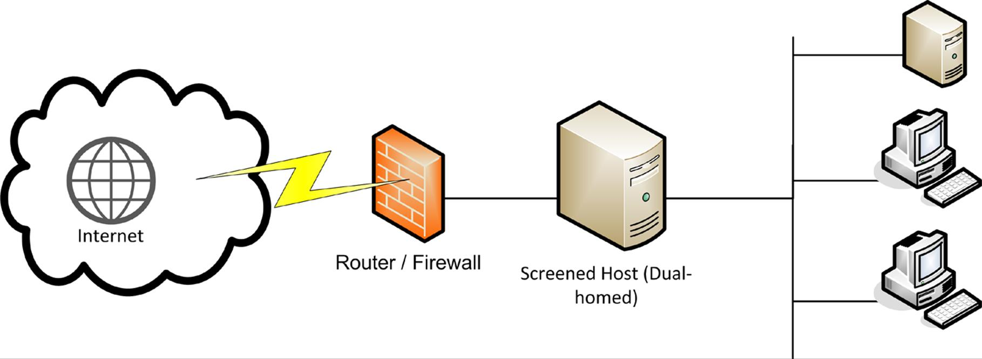
Screened host

Transparent / Virtual Wire Firewalls
Implementing a DMZ with a typical inline firewall appliance or router firewall means that the appliance would be configured with IP addresses for each of its interfaces. Traffic for a subnet would pass through the firewall and be forwarded on if it met the rules. Clients would need to be configured with one of the router interface's IP addresses as a default gateway in order to send traffic through it.
A transparent firewall or "bump in the wire" does not perform this forwarding function. Instead the firewall bridges two ports at layer 2. Palo Alto refer to this as a virtual wire firewall.
This mode allows a firewall to be inserted into a network easily without having to perform any reconfiguration of IP. They are often used in front of systems with complex or mixed addressing schemes, such as data centers, Storage Area Networks, and virtualized servers.

SOHO DMZ
Sometimes the term DMZ (or "DMZ host") is used by DSL router vendors to mean an internet-facing host or zone not protected by the firewall. This might be simpler to configure and solve some access problems but makes the whole networkvery vulnerable to intrusion and DoS. A true DMZ is established by a separate network interface and subnet so that traffic between hosts in the DMZ and the LAN must be routed (and subject to firewall rules). Most DSL routers do not have the necessary ports or routing functionality to create a true DMZ.

Internal Network Firewalls
There is no single way of designing a network. Rather, a network will reflect the business needs of the organization. You may want to define your own security zones to suit business needs. For example, simply deploying firewalls to protect perimeter security ignores the threat of internal malicious users. Consequently, it is also necessary to secure the links between internal systems and you might accomplish this by placing firewalls on the internal network as well as on the external / DMZ interface. Some examples could include:
- A zone containing untrusted or semi-trusted hosts on the local network (for example, computers that are publicly accessible).
- Zones representing departmental functions.
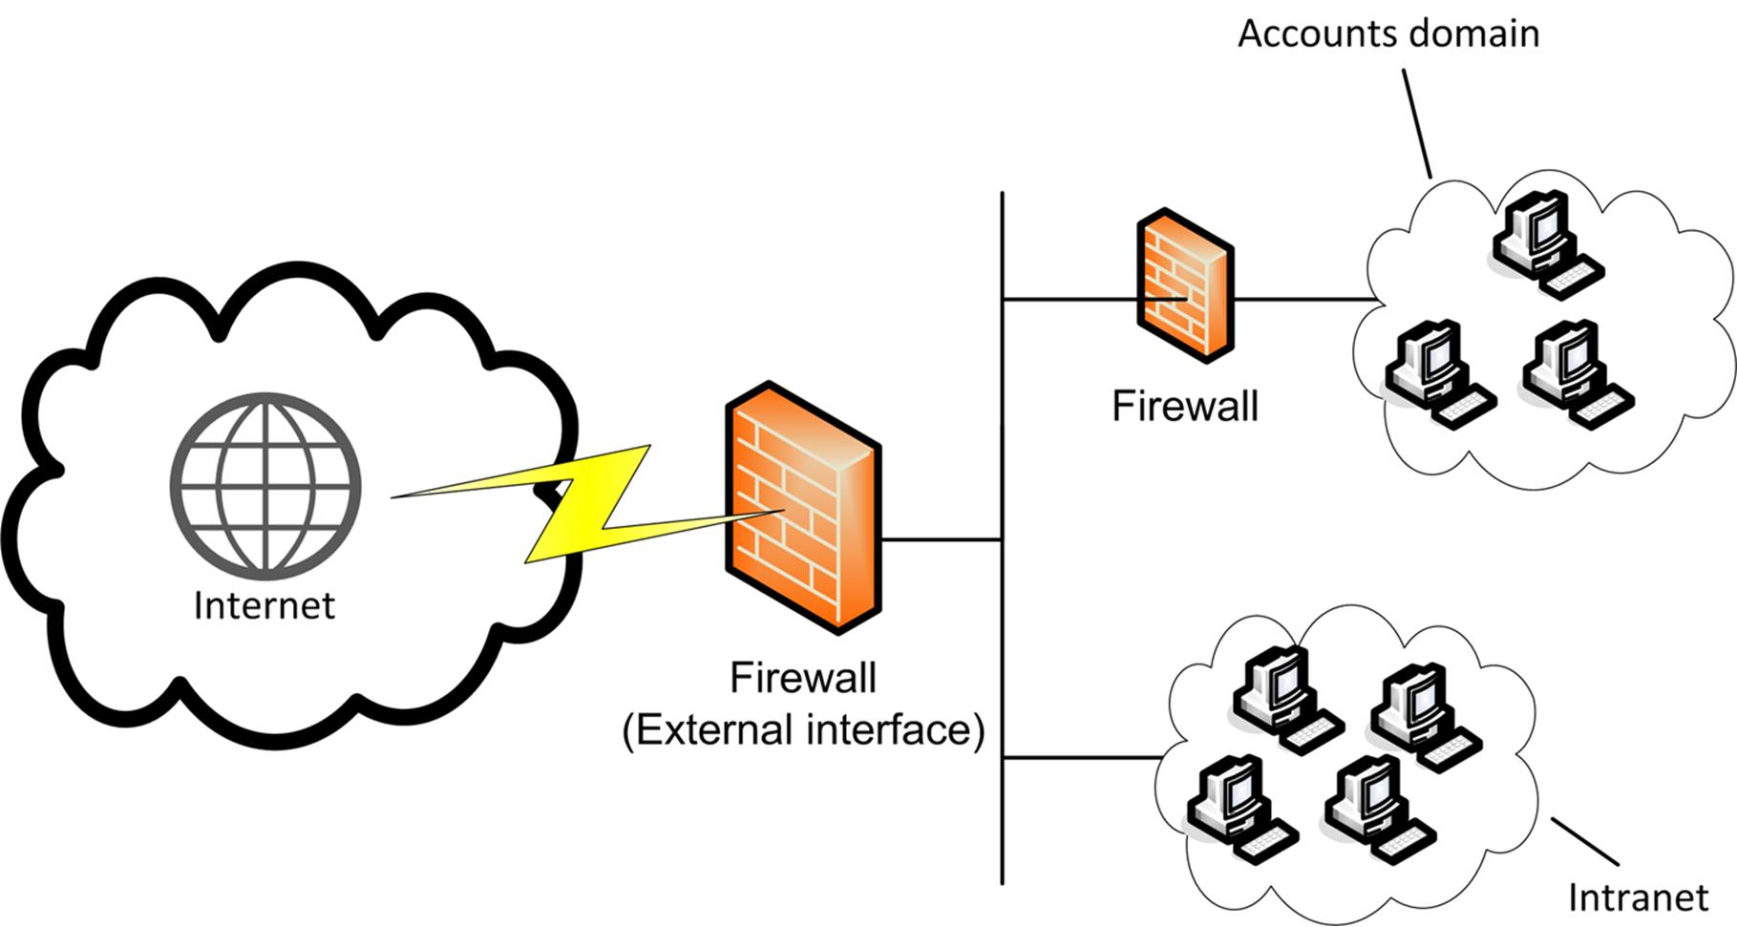
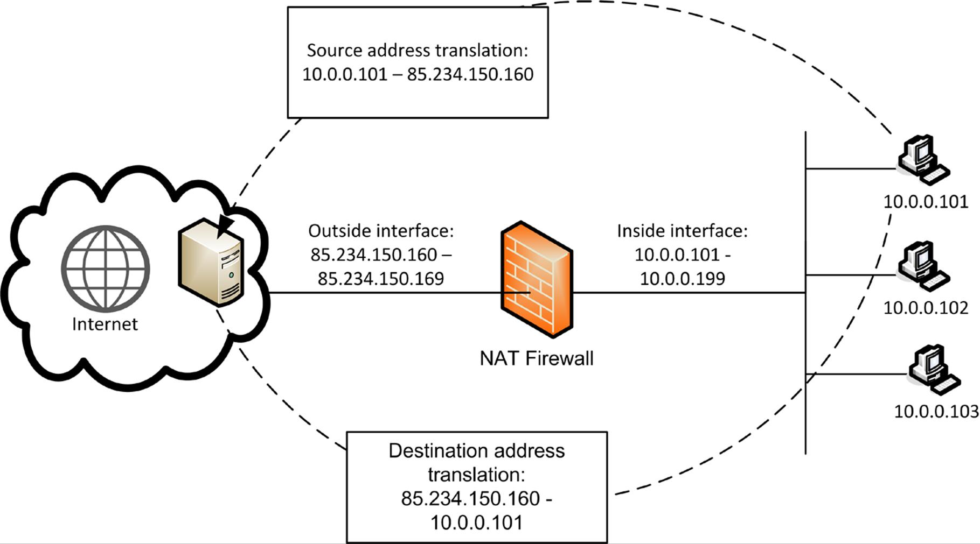

Protecting hosts used by the Accounting department with a firewall

Network Address Translation (NAT)
Network Address Translation (NAT) was originally devised as a way of freeing up scarce IP addresses for hosts needing internet access. However, it also provides a more secure addressing method for private networks connected to the Internet. NAT is defined in RFC 3022. Essentially, NAT is a service translating between a private (or local) addressing scheme used by hosts on the LAN and a public (or global) addressing scheme used by an internet-facing device. NAT is configured on a border device, such as a router, proxy server, or firewall.

Basic NAT (One-to-One NAT)
In a basic NAT static configuration, a simple 1:1 mapping is made between the private ("inside local") network address and the public ("inside global") address. If the destination network is using NAT, it is described as having "outside global" and "outside local" addressing schemes.
Basic NAT is useful in scenarios where an inbound connection to a particular host must be supported. For example, you might position a web server behind a firewall running NAT. The firewall performs 1:1 address translation on the web server's IP address. This means that external hosts do not know the true IP address of the web server but are able to communicate with it successfully. Basic NAT with a static mapping for a single host can be referred to as Static NAT, sometimes with the acronym SNAT, though this is more usually reserved for Source NAT (see below).
 To support a server, the firewall must also perform port forwarding. This means that incoming requests for the service (port 80 for HTTP for instance) are passed on.

Network Address Translation

A single static mapping is not very useful in most scenarios. Under dynamic NAT, the NAT device exposes a pool of public IP addresses. In order to support inbound and outbound connections between the private network and the Internet, the NAT service builds a table of public to private address mappings. Each new session creates a new public-private address binding in the table. When the session is ended or times out, the binding is released for use by another host.
Dynamic NAT can attract the acronym DNAT, though DNAT is more usually taken to mean Destination NAT (see, again, below).
 Just to confuse things further, Cisco use SNAT to mean Stateful NAT, which is a means for routers to share dynamic NAT state tables. It is a good idea to avoid using acronyms when discussing NAT!

Port Address Translation (PAT)
Basic NAT supports multiple simultaneous connections but is still limited by the number of available public IP addresses. Smaller companies may only be allocated a single or small block of addresses by their ISP. In this case, a means for multiple private IP addresses to be mapped onto a single public address would be useful. This function is provided by PAT (Port Address Translation). This can be referred to as Network Address Port Translation (NAPT) or NAT overloading or one-to-many NAT.
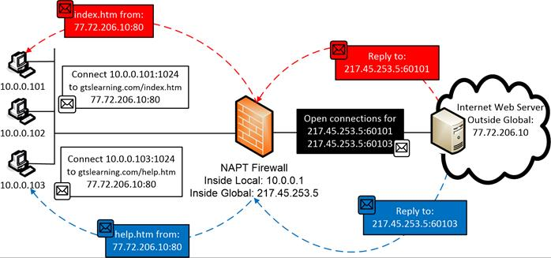
Port Address Translation / NAT overloading
PAT works by allocating each new connection a high level TCP or UDP port. For example, say two hosts (10.0.0.101 and 10.0.0.102) initiate a web connection at the same time. The PAT service creates two new port mappings for these requests (10.0.0.101:61101 and 10.0.0.102:61102). It then substitutes the private IP for the public IP and forwards the requests to the public internet. It performs a reverse mapping on any traffic returned using those ports, inserting the original IP address and port number, and forwarding the packets to the internal hosts.
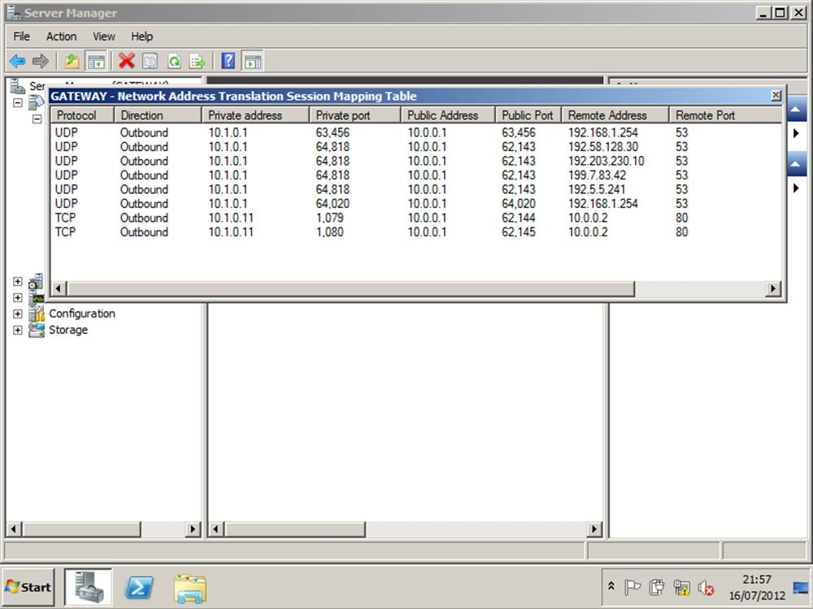
PAT session mappings in Windows Server

NAT Traversal
NAT (and PAT) can disrupt communications for many protocols, especially those that use UDP. If the protocol embeds the source IP address in the payload, the fact that the IP address has been changed by NAT in the header but not in the payload will often break the protocol. Notably, FTP and IPsec are problematic when used with NAT.
In order to support such protocols, the NAT device may be installed with an Application Layer Gateway. This is a service that can inspect and modify the contents of packets. This is referred to as NAT Traversal.

Destination NAT (DNAT) / Port Forwarding
Basic NAT and PAT involve source addresses from a private range being rewritten with public addresses to facilitate client access to internet resources or translation between networks using different IP ranges. Because it modifies the source addresses, both these types of address translation can be called Source NAT (SNAT).
There are also circumstances where you may want to use the router's public address for something like a web server but forward incoming requests to a different IP. This can be achieved with Destination NAT (DNAT), also known as port forwarding. Port forwarding means that the router takes requests from the Internet for a particular application (say, HTTP / port 80) and changes the destination address (and optionally destination port too) to send them to a designated host and port on the LAN.
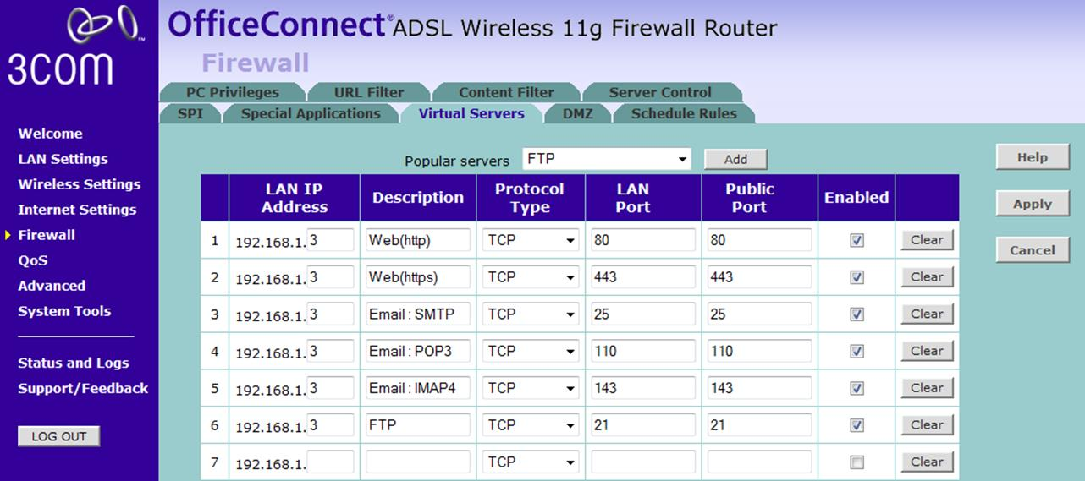
Configuring port forwarding for various applications

Basic Firewalls
The basic function of a firewall is traffic filtering. A firewall resembles a quality inspector on a production line; any bad units are knocked off the line and go no farther. The firewall processes traffic according to rules; traffic that does not conform to a rule that allows it access is blocked. Firewalls are the devices principally used to implement security zones, such as intranet, DMZ, and internet.
There are many types of firewall and many ways of implementing a firewall. One distinction can be made between firewalls that protect a whole network (placed inline in the network and inspecting all traffic that passes through) and firewalls that protect a single host only (installed on the host and only inspect traffic destined for that host). Another distinction is on what parts of a packet a firewall can inspect and operate.

Packet Filtering Firewall
Packet filtering describes the earliest types of firewall. All firewalls can still perform this basic function. A packet filtering firewall can inspect the headers of IP packets. This means that rules can be based on the information found in those headers:
- IP filtering - accepting or blocking traffic on the basis of its source and/or destination IP address.
- Protocol ID / type (TCP, UDP, ICMP, routing protocols, and so on).
- Port filtering / security - accepting or blocking traffic on the basis of source and destination port numbers (TCP or UDP application type).
There may be additional functionality in some products, such as the ability to block some types of ICMP (ping) traffic but not others or the ability to filter by hardware (MAC) address. Packet filtering works mainly at Layer 3 (Network) of the OSI model.
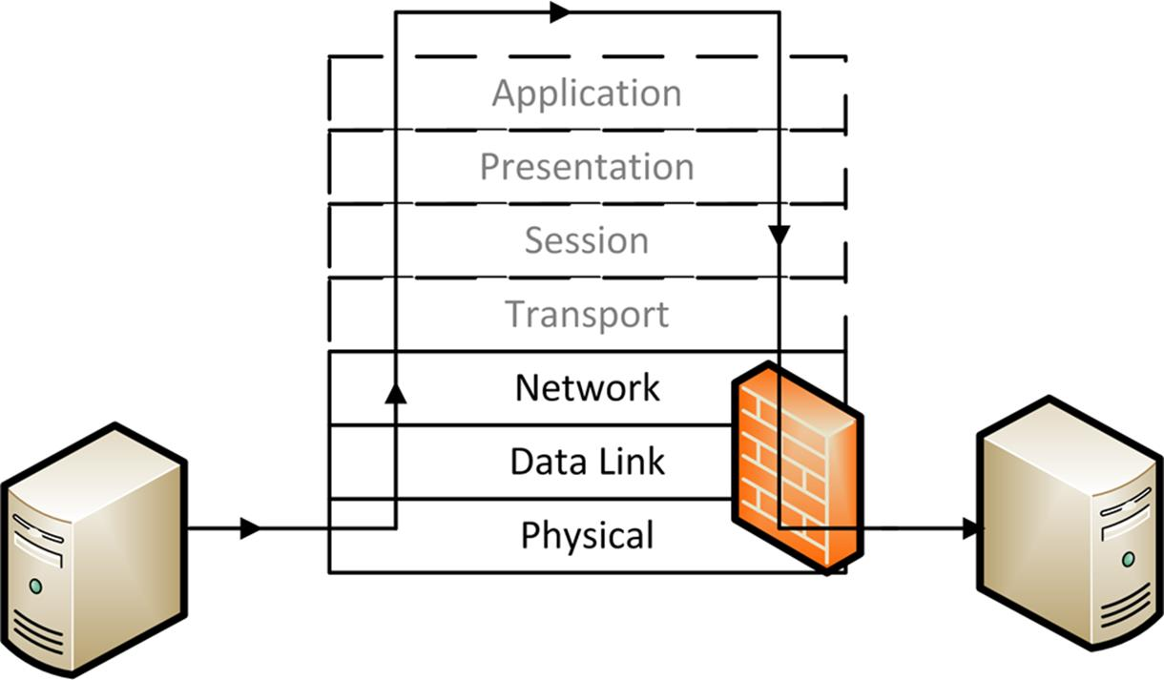
Packet filtering firewall
 Port numbers are contained in TCP or UDP headers (layer 4) rather than the IP datagram header but packet filtering firewalls are still almost always described as working at layer 3. They can only inspect port numbers and not any other layer 4 header information.
Another distinction that can be made is whether the firewall can control only inbound traffic or both inbound and outbound traffic. This is also often referred to as "ingress" and "egress" traffic or filtering. Controlling outbound traffic is useful because it can block applications that have not been authorized to run on the network and defeat malware such as backdoors.
A packet filtering firewall is configured by specifying a number of rules, called an Access Control List (ACL). An ACL is a list of rules, each of which defines a specific type of data packet and the appropriate action to take when packet matches the rule.
Actions can be either block (drop the packet, and optionally log an event) or allow (let the packet pass through the firewall). There are separate rulesets covering inbound and outbound traffic.
Packet filtering firewalls are simple, fast, and inexpensive.
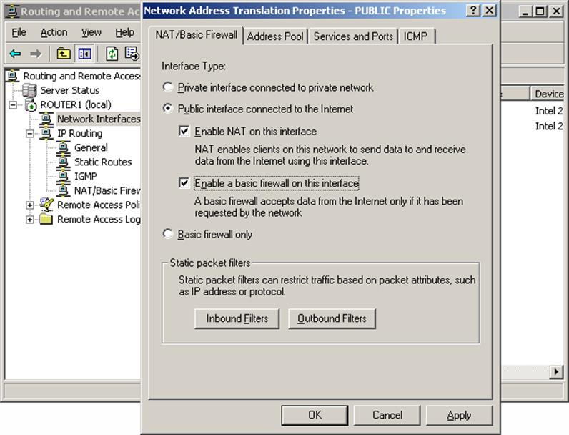
Configuring a packet filtering firewall under Windows Server

Stateful Inspection Firewall
A packet filtering firewall does not maintain stateful information about the connection between two hosts (that is, a packet filtering firewall is stateless). Each packet is analyzed independently with no record of previously processed packets. For example, it cannot defend against the SYN flood Denial of Service attack that can be launched against a TCP/IP network.
A circuit-level stateful inspection firewall addresses this problem by maintaining stateful information about the session established between two hosts (including malicious attempts to start a bogus session). Information about each session is stored in a dynamically updated state table. It operates at Layer 5 (Session) of the OSI model. When a packet arrives, the firewall checks it to confirm whether it belongs to an existing connection. If it does not, it applies the ordinary packet filtering rules to determine whether to allow it. Once the connection has been allowed, the firewall allows traffic to pass unmonitored, in order to conserve processing effort.
A circuit-level firewall examines the TCP three-way handshake and can detect attempts to open connections maliciously (a flood guard). It also monitors packet sequence numbers and can prevent session hijacking attacks. It can respond to such attacks by blocking source IP addresses and throttling sessions.

Configuring a Firewall
A firewall is an example of rule-based management. Firewall rules are configured on the principle of least access. This is the same as the principle of least privilege; only allow the minimum amount of traffic required for the operation of valid network services and no more.
The rules in a firewall's ACL are processed top-to-bottom. If traffic matches one of the rules then it is allowed to pass; consequently the most important and specific rules are placed at the top. The final default rule is typically to block any traffic that has not matched a rule (implicit deny). Each rule can specify whether to block or allow traffic based on a number of parameters, often referred to as tuples (if you think of each rule being like a row in a database, the tuples are the columns). For example, in the screenshot, the tuples include "Program", "Local Address", "Remote Address", "Protocol", "Local Port", "Remote Port", "Authorized Users", and so on.
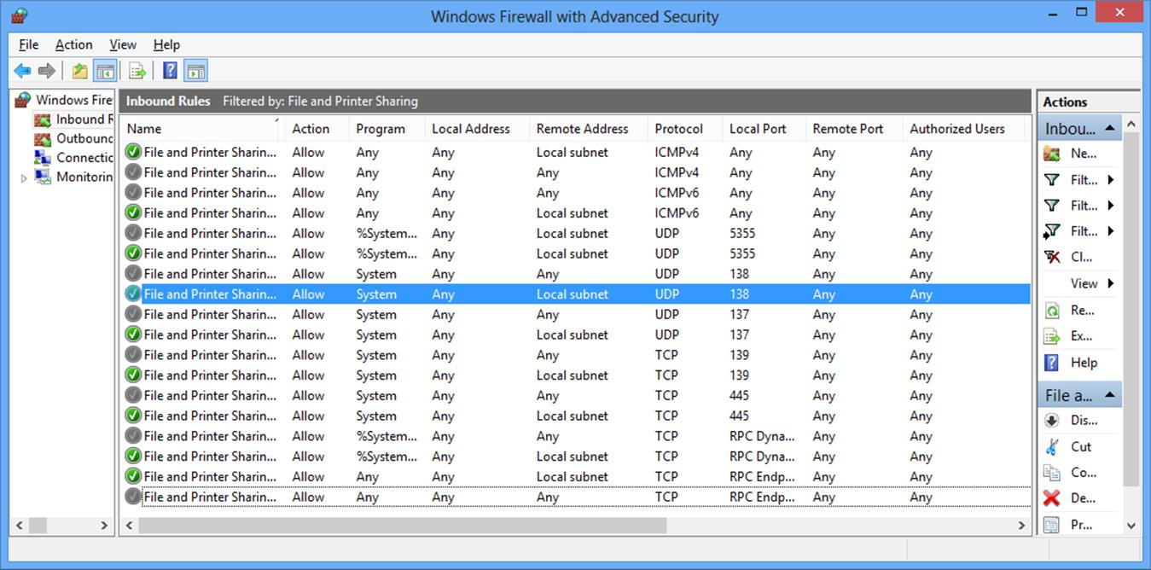
Sample firewall rule set
Even the simplest packet filtering firewall can be complex to configure securely. It is essential to create a written policy describing what the firewall should do and to test the firewall configuration as far as possible to ensure that the ACLs you have set up work as intended. Also test and document changes made to ACLs.

Troubleshooting Misconfigured Firewalls / ACLs
One type of firewall or ACL misconfiguration blocks packets that are supposed to be allowed through. This will cause an application or protocol to fail to function correctly. This type of error will usually be easy to identify, as users will report incidents connected with the failure of the data traffic. With such incidents, firewall configuration will always be a likely cause, so will be high on the list to investigate. Diagnosis can be confirmed by trying to establish the connection from both inside and outside the firewall. If it connects from outside the firewall but not from inside, this would confirm the firewall to be the cause of the issue. You can also inspect the firewall's log files to discover what rules have been applied to block traffic at a particular time.
The other possible outcome of a badly configured firewall is that packets may be allowed through that should be blocked. This is a more serious outcome because the result is to open the system to security vulnerabilities. It is also not necessarily so easily detected, as it does not typically cause anything to stop functioning. As no incidents usually arise from this outcome (except in the case that a vulnerability is exploited), it is not a scenario that is subject to troubleshooting. Rather, it underlines the need for regular firewall audits and thorough change control processes to deal with firewall change requests.

Advanced Firewalls
You should also consider how the firewall is implemented (as hardware or software for instance) to cover a given placement or use on the network. Some types of firewall are better suited for placement at network or segment borders; others are designed to protect individual hosts.

Appliance, Router, and SOHO Router Firewalls
An appliance firewall is a stand-alone hardware firewall that performs the function of a firewall only. The functions of the firewall are implemented on the appliance firmware. This is also a type of network-based firewall and monitors all traffic passing into and out of a network segment. As mentioned above, this type of appliance could be implemented with routed interfaces or as a layer 2 / virtual wire "transparent" firewall.
Nowadays, the role of advanced "firewall" is likely to be performed by an all-in-one or Unified Threat Management (UTM) security appliance, combining the function of firewall, intrusion detection, malware inspection, and web security gateway (content inspection and URL filtering).
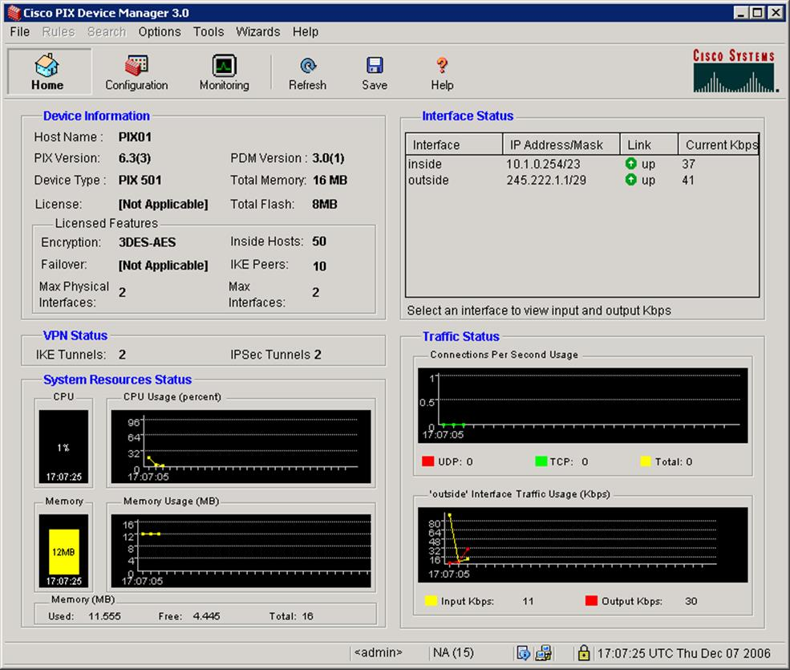
Cisco PIX Firewall management interface
A router firewall is similar, except that the functionality is built into the router firmware. Most SOHO internet router / modems have this type of firewall functionality. An enterprise-class router firewall would be able to support far more sessions than a SOHO one. Additionally, some layer 3 switches can perform packet filtering.
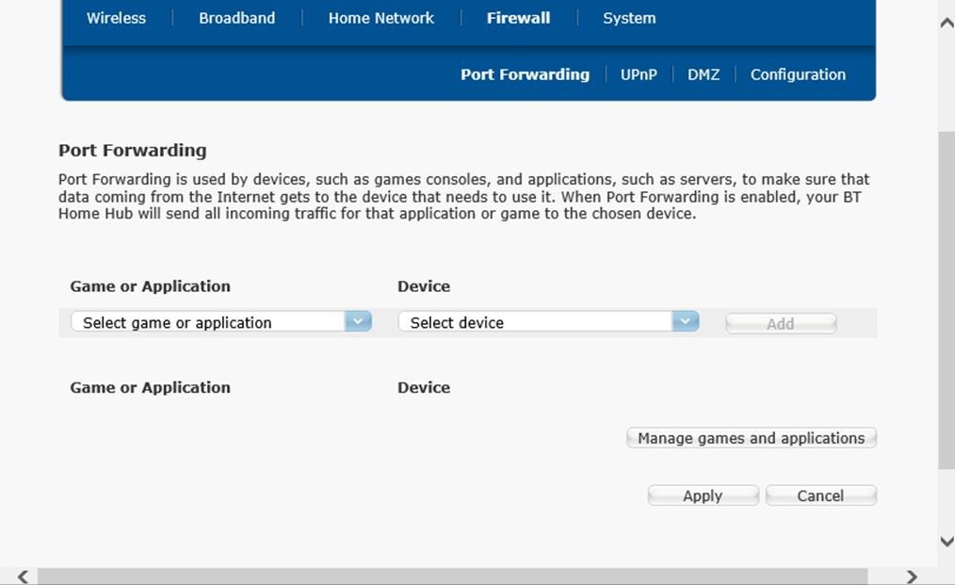
A SOHO router firewall comes with simple tools to configure port forwarding

NOS Firewall
A NetworkOperating System (NOS) firewall is a software-based firewall running under a network server OS, such as Windows or Linux. The server would function as a gateway or proxy (see below) for a network segment.

Application Firewall
An application firewall is software designed to run on a server to protect a particular application only (a web server firewall for instance or a firewall designed to protect an SQL Server database). This is a type of host-based firewall and would typically be deployed in addition to a network firewall.

Personal Firewall
A personal firewall is implemented as a software application running on a single host. While they can perform basic packet filtering, personal firewalls tend to be program- or process-based; that is, when a program tries to initiate (in the case of outbound) or accept (inbound) a TCP/IP network connection, the firewall prompts the user to block, allow once, or allow always.
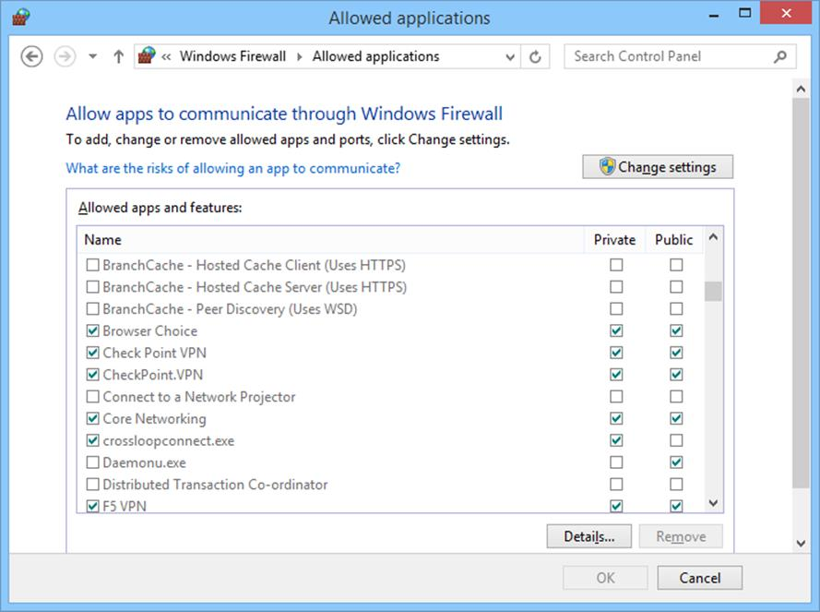
Windows Firewall
 When using a personal firewall on an enterprise network, some thought needs to be given as to how it will interact with network border firewalls. The use of personal firewalls can make troubleshooting network applications more complex.

Application Aware Devices
An application aware / context aware device is one that can inspect the contents of packets at the application layer. For example, a web application firewall could analyze the HTML code present in HTTP packets to try to identify code that matches a pattern in its threat database. Application aware devices (and software firewalls) have many different names, including application layer gateway, stateful multilayer inspection, or deep packet inspection.
Application aware devices have to be configured with separate filters for each type of traffic (HTTP and HTTPS, SMTP/POP/IMAP, FTP, and so on).
When first introduced, this type of firewall was costly and required high specification hardware on which to run. Now all but the cheapest firewalls perform stateful multilayer inspection to some extent.
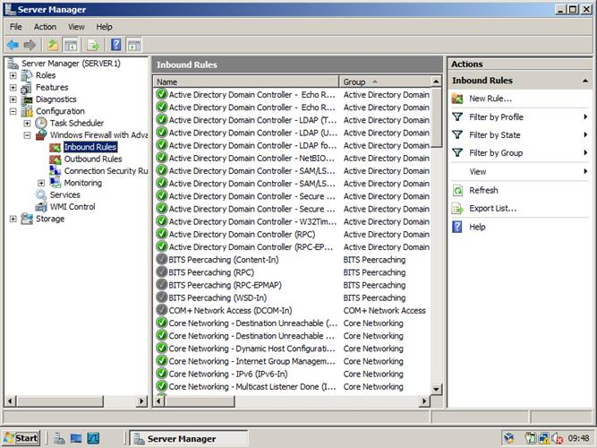
A stateful host firewall ships with Windows Server and Windows client editions
Application aware firewalls are very powerful but they are not invulnerable. Their very complexity means that it is possible to craft DoS attacks against exploitable vulnerabilities in the firewall firmware. Also, the firewall must be specially configured if you want to inspect encrypted traffic. This type of advanced content filtering function is often best implemented as some type of proxy server.

Proxies and Gateways
The basic function of a packet filtering network firewall is to inspect packets and determine whether to block them or allow them to pass. Network traffic passes (or doesn't pass) through the firewall.
Proxy servers work on a "Store and Forward" model. Rather than inspecting traffic as it passes through, the proxy deconstructs each packet, performs analysis, then rebuilds the packet and forwards it on (providing it conforms to the rules). In fact, a proxy is a "Man in the Middle"; but a legitimate one! This is more secure than a firewall because if the original packet had contained anything "suspicious" that a firewall had not noticed, a firewall might allow it through whereas the proxy, even if it did not directly identify the suspicious content, would erase it in the process of rebuilding the packet.
The drawback is that there is obviously more processing to be done than with a firewall.
Many firewalls are implemented as proxies. Not all proxies are firewalls however, as they can have other useful functions.

Proxy Servers
A basic proxy server provides for protocol-specific outbound traffic. For example, you might deploy a web proxy that enables client computers to connect to websites and secure websites on the Internet. In this case, you have deployed a proxy server that services TCP ports 80 and 443 for outbound traffic.
The port on which the proxy server accepts client connections is usually 8080.
Web proxies are often also described as web security gateways as usually their primary functions are to prevent viruses or Trojans infecting computers from the Internet, block spam (see below), and restrict web use to authorized sites.
The main benefit of a proxy server is that client computers connect to a specified point within the perimeter network for web access. This provides for a degree of traffic management and security. In addition, most web proxy servers provide caching engines, whereby frequently requested web pages are retained on the proxy, negating the need to re-fetch those pages for subsequent requests. Some proxy servers also pre-fetch pages that are referenced in pages that have been requested. When the client computer then requests that page, the proxy server already has a local copy.
Proxy servers can generally be classed as non-transparent or transparent. A non-transparent server means that the client must be configured with the server address to use it; a transparent (or "forced" or "intercepting") proxy intercepts client traffic without the client having to be reconfigured.
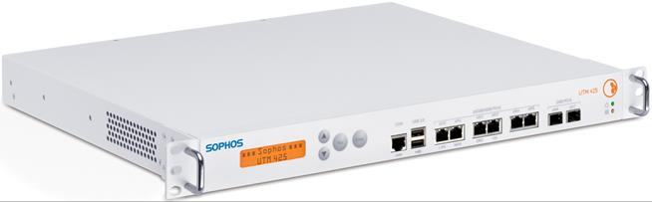
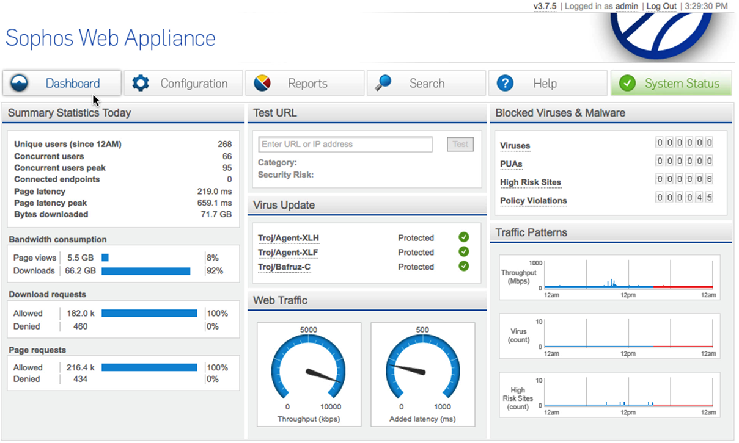
Sophos Unified Threat Management appliance and web security gateway dashboard (images courtesy www.sophos.com)

Internet Content Filters

As firewalls have become effective at blocking unwanted ports, configuring network applications to work with firewalls has become more difficult. Many network applications consequently package all their content as HTTP traffic and send it all over port 80. This means that allowing all HTTP traffic is not particularly secure, as it could be allowing all sorts of malicious applications or management interfaces, in addition to basic web pages.
A web security gateway is designed for corporate control over employees' internet use. It could be implemented as a standalone appliance or proxy server software. Many ISPs implement content filtering as part of their internet access packages.
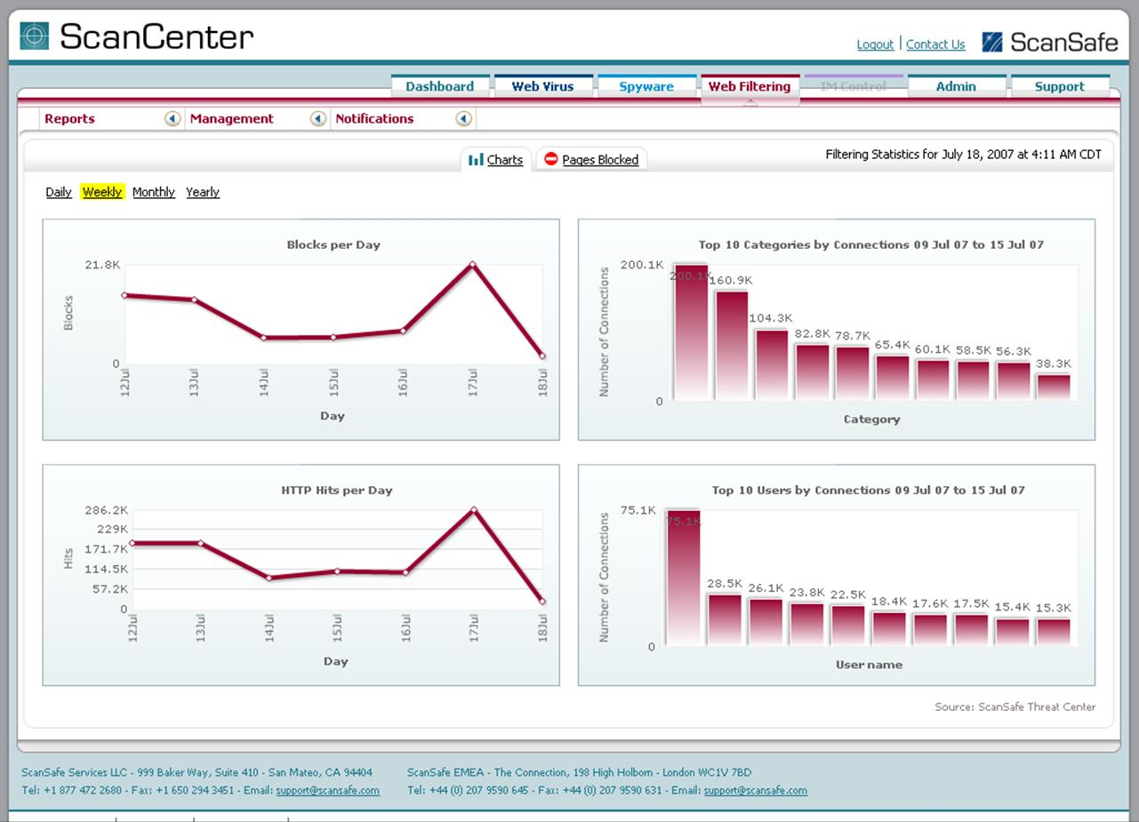
ScanCenter web content filter from www.scansafe.com
Web security gateways would typically apply content restrictions to web, Instant Messaging, email, FTP, and P2P applications. Filtering can be applied to a mix of permitted / restricted URLs, keyword matching, web object matching (looking at usage of plug-ins), time of day use, total usage, and so on. The software may also allow the creation of profiles for different user groups and should feature logging and reporting capabilities.
With an encrypted connection (over HTTPS for instance), the content filter will not be able to inspect the URL or content of the communications unless it is capable of SSL inspection. This means that the content filter intercepts and decrypts encrypted traffic, inspects it for policy violations, and if accepted re-encrypts the traffic and forwards it to the destination.

Reverse Proxy Servers
A reverse proxy server provides for protocol-specific inbound traffic. For security purposes, it is inadvisable to place application servers, such as messaging and VoIP servers, in the perimeter network, where they are directly exposed to the Internet. Instead, you can deploy a reverse proxy and configure it to listen for client requests from a public network (the Internet) and create the appropriate request to the internal server on the corporate network.
Reverse proxies can publish applications from the corporate network to the Internet in this way. In addition, some reverse proxy servers can handle the encryption / decryption and authentication issues that arise when remote users attempt to connect to corporate servers, reducing the overhead on those servers. Typical applications for reverse proxy servers include publishing a web server, publishing IM or conferencing applications, and enabling POP/IMAP mail retrieval.

Anti-malware Software
Firewalls and web content filters restrict traffic based on network policies (rules). Anti-malware software and Intrusion Detection Systems (IDS) on the other hand are designed to prevent malicious software code and attempts to perform packet or protocol abuse from reaching the network or a particular host on the network.

Anti-virus / Anti-malware Software
Anti-virus (A-V) software uses a database of known virus patterns (definitions) plus heuristic (meaning to learn from experience) malware identification techniques to try to identify infected files and prevent viruses from spreading. Typically the software is configured to run automatically when a user or system process accesses a file, but can also be initiated by the user (an on-demand scan). The anti-virus software scans the file and blocks access if it detects anything suspicious. The user can then decide either to try to disinfect the file, quarantine it (block further access), or delete it. The software might be configured with a default action to take that the user can override.
The latest anti-virus software usually includes anti-Trojan software, as well as spam, adware, and spyware blockers. Consequently the term anti-virus software is now generally interchangeable with anti-malware software.
Anti-virus (or anti-malware) software tends to come as either personal security suites, designed to protect a single host, or network security suites, designed to be centrally managed from a server console. A server-based option means that each client runs a lightweight scanning agent. This agent relies on the server for definition updates and policies. The centralized server allows network administrators to initiate remote scans and updates as well as monitor events such as infection outbreaks. A cloud-based solution offers the same sort of options but means that rather than installing the management server on the local network, it is located on the service provider's servers and accessed over the Internet.
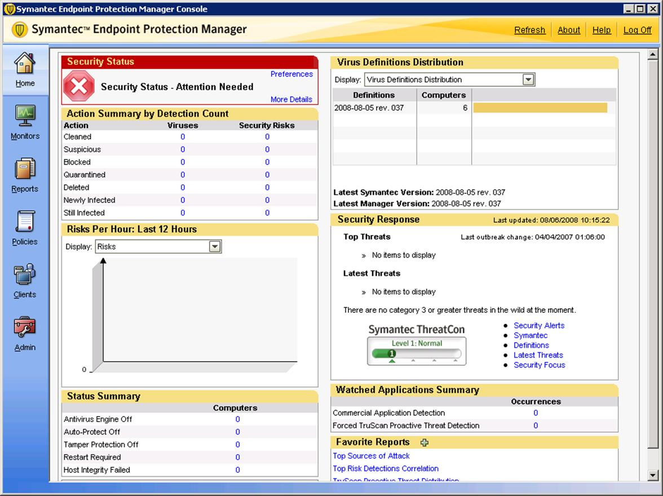
Symantec Endpoint Protection Manager enables centralized monitoring and oversight of anti-virus, anti-spyware, IDS, firewall, and application/device control
Most anti-virus software is designed for Windows PCs and networks, as these are the systems targeted by most virus writers, but software is available for Linux and Apple Mac OS as well.
Some of the major vendors are Symantec (including the Norton brand), McAfee, Computer Associates (CA), Trend Micro, Kaspersky, and BitDefender.
Another option is for malware scanning to be incorporated on a network appliance that combines the functions of firewall and anti-malware. This type of Unified Threat Management (UTM) solution is discussed below.
To work effectively, the virus definitions and scan engine must be kept up-to-date. Such software is typically configured to update every day automatically from the vendor website or company server.

Email Gateways and Spam
Spam is unsolicited email. Dealing with spam wastes resources (computer and people). Most new email application software has spam filtering built-in. This is an appropriate solution for home users but on enterprise networks, if spam has already reached the user's mailbox then it has already wasted bandwidth and taken up space on the server.
Consequently, most companies deploy a gateway server with spam filtering technology (often combined with a file attachment malware scanner). This can either be installed in-house or leased from a cloud provider such as MessageLabs.
 Spam filtering can cause legitimate messages to be blocked. It needs careful configuration to provide the right balance between security and usability.
A secure configuration for email is to install an email relay server in a Demilitarized Zone (DMZ).
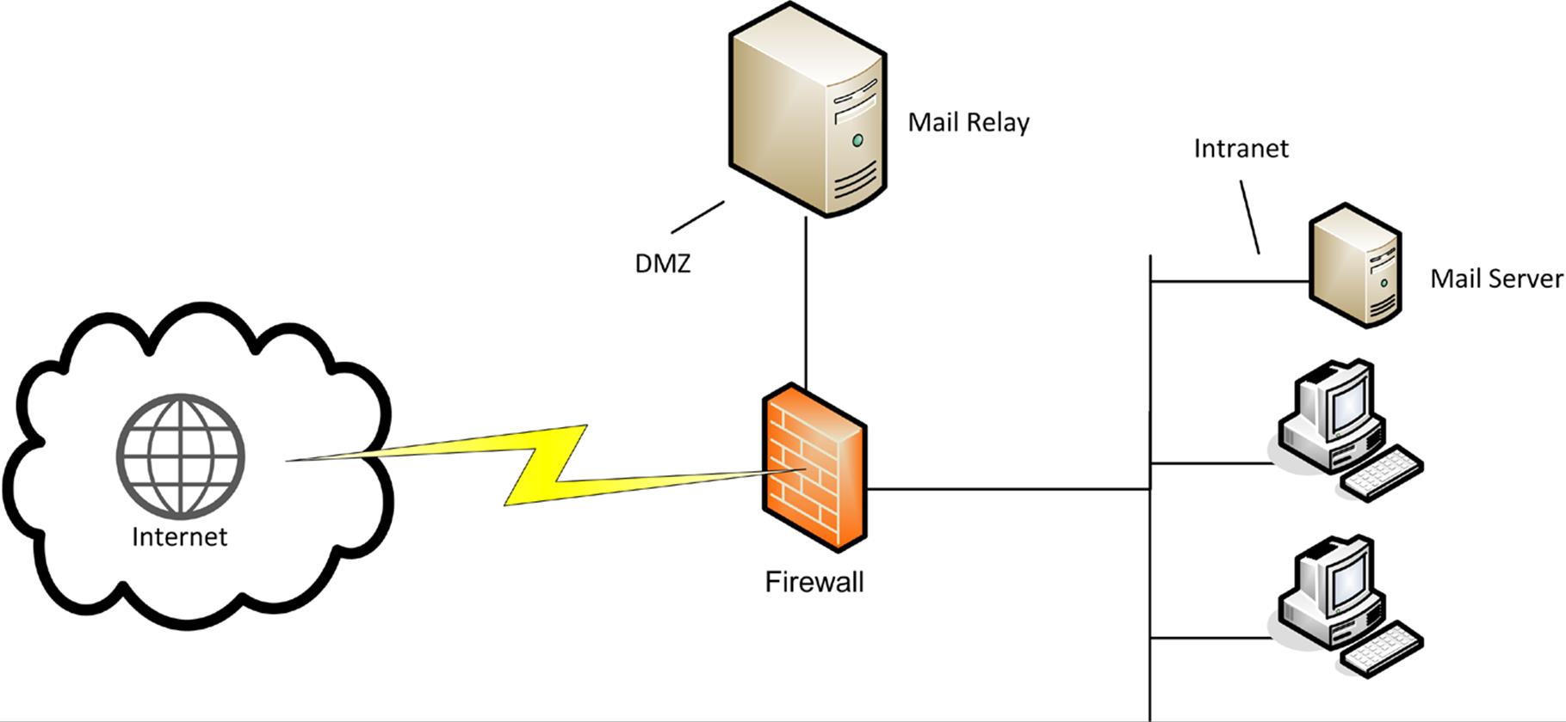
Mail gateway
The mail relay can be installed with software to monitor and filter email traffic, checking for spam and infected file attachments.

