UNIT 5.1 / VULNERABILITIES AND THREATS / STUDY NOTES

Security Basics
In IT security, it is important to distinguish between the concepts of vulnerability, threat, and risk:
- Vulnerability - a weakness that could be triggered accidentally or exploited intentionally to cause a security breach.
- Threat - the potential for a threat agent or threat actor (something or someone that may trigger a vulnerability accidentally or exploit it intentionally) to "exercise" a vulnerability (that is, to breach security). The path or tool used by the threat actor can be referred to as the threat vector.
- Risk - the likelihood and impact (or consequence) of a threat actor exercising a vulnerability.
To understand network security, you need to understand the types of threats and vulnerabilities that a network is exposed to and how they can be used in actual attacks.
Some of the more common forms of attack and examples of such attacks are discussed under the following topics.
 Attacks become less effective when they are well-known so new threats appear all the time. To keep up-to-date, you should monitor websites and newsgroups. Apart from the regular IT magazines, some good examples include www.cert.org, www.sans.org, www.schneier.com, and www.grc.com. The SANS "Top 20" security controls is one of the most useful starting points (www.sans.org/top20).

Trusted and Untrusted Users
Users such as employees and approved partners or contractors are trusted to use network resources. The security system should enforce accountability by identifying these users (requiring them to authenticate to the network) and explicitly authorizing what they can do and possibly auditing (logging) their activities. A network might also be required to provide access to untrusted users. This group might include site visitors, customers, and suppliers. Such users may be authenticated or unauthenticated (guests). Untrusted users will only be granted limited network access.

Malicious Users and Insider Threats
In order to identify security threats and apply appropriate countermeasures, you need to be able to profile different types of attackers successfully.
Malicious users (or attackers) can be categorized in various different ways. It is important to realize that threats can be accidental or malicious and arise from within or without an organization. Within these groups, further distinctions as to motivation can be made (such as whether an attacker is motivated by greed, curiosity, or has some sort of grievance).
It also helps to categorize threats as structured or unstructured (or targeted or opportunistic) depending on the degree to which your own organization is targeted specifically. For example, a criminal gang attempting to steal customers' financial data is a structured, targeted threat; a "script kiddie" launching some variant on the "I Love You" mail virus is an unstructured, opportunistic threat.
The degree to which any given organization will be targeted by external threats depends largely on the value of its assets and the quality of its security systems. For example, a major ecommerce site processes millions of credit card payments but has very effective security systems; a small business site may only process a few hundred credit card payments each year but may be much more likely to have a flawed security system. There are also a lot of Small and Medium Enterprise (SME) sites to target. A strong security system may be a deterrent to thieves; conversely it may be attractive to hackers seeking a challenge. It is important to understand the different motivations for attackers in order to design effective security systems.
Malicious insider threat sources means attacks launched by the organization's own trusted users (employees, partners, or contractors). One of the principal sources of research into computer security is the Computer Emergency Response Team (CERT) at Carnegie Mellon University. CERT's definition of a malicious insider is:
A current or former employee, contractor, or business partner who has or had authorized access to an organization’s network, system, or data and intentionally exceeded or misused that access in a manner that negatively affected the confidentiality, integrity, or availability of the organization’s information or information systems.
Again, the key point here is to identify likely motivations, such as employees who might harbor grievances or those likely to perpetrate fraud. An employee who plans and executes a campaign to modify invoices and divert funds is launching a structured attack; an employee who tries to guess the password on the salary database a couple of times, having noticed that the file is available on the network, is an opportunistic attack.
CERT identify the main motivators for insider threat as sabotage, financial gain, and business advantage.

Security Policies
Security policies ensure that an organization has evaluated the risks it faces and has put in place controls to mitigate those risks. Making a system more secure is also referred to as hardening it. Different security policies should cover every aspect of an organization's use of computer and network technologies, from procurement and change control to acceptable use.
 See Unit 5.5 / Change and Configuration Management / Study Notes for more information about policies and configuration management.

Social Engineering
Most of the focus in computer security is in deterring malicious external and insider threats. Attackers can use a diverse range of techniques to compromise a security system. A pre-requisite of many types of attack is to obtain information about the security system. Social engineering refers to means of getting users to reveal confidential information.

Impersonation

Do you really know who's on the other end of the line?
Impersonation (pretending to be someone else) is one of the basic social engineering techniques.
The classic impersonation attack is for an attacker to phone into a department, claim they have to adjust something on the user's system remotely, and get the user to reveal their password.
Attackers will generally try one of the following methods:
- Intimidate their target by pretending to be someone senior in rank.
- Intimidate the target by using spurious technical arguments and jargon or alarm them with a hoax.
- Coax the target by engaging them in friendly chat.

Phishing
Phishing is a combination of social engineering and spoofing (disguising one computer resource as another). In the case of phishing, the attacker sets up a spoof website to imitate a target bank or ecommerce provider's secure website. The attacker then emails users of the genuine website informing them that their account must be updated, supplying a disguised link that actually leads to their spoofed site. When the user authenticates with the spoofed site, their log on details are captured. Another technique is to spawn a "pop-up" window when a user visits a genuine site to try to trick them into entering their credentials through the pop-up.

Pharming
Pharming is another means of redirecting users from a legitimate website to a malicious one. Rather than using social engineering techniques to trick the user however, pharming relies on corrupting the way the victim's computer performs internet name resolution, so that they are redirected from the genuine site to the malicious one. For example, if mybank.com should point to the IP address w.x.y.z, a pharming attack would corrupt the name resolution process to make it point to IP address a.b.c.d.

Mitigating Social Engineering Attacks
Social engineering is best defeated by training users to recognize and respond to such situations.
- Train employees to release information or make privileged use of the system only according to standard procedures.
- Establish a reporting system for suspected attacks - though the obvious risk here is that a large number of false negatives will be reported.
- Train employees to identify phishing style attacks plus new styles of attack as they develop in the future.
- Train employees not to release any work-related information on third-party sites or social networks (and especially not to reuse passwords used for accounts at work).
Other measures include ensuring documents and information is destroyed before disposal, using multifactor access control, to put more than one or two barriers between an attacker and his or her target, and restricting use of administrative accounts as far as possible.

Network Reconnaissance
Foot printing is a process of information gathering, in which the attacker attempts to learn about the configuration of the network and security systems. Foot printing can be done by "social engineering" attacks (persuading users to give information or locating information that has been thrown out as refuse for instance). There are also many other tools and techniques for gathering information.
 Fingerprinting describes probes that attempt to discover how a particular host is configured.

Open Ports
Network mapping means gathering information about the way the network is built and configured and the current status of hosts. Port scanning specifically aims to enumerate the TCP or UDP application ports that are "open" on a host.
The netstat tool can be used on Windows and Linux to investigate open connections on a local computer. Commonly-used remote port scanning tools include Nmap, Nessus, SuperScan, and Atelier Web Security Port Scanner. These identify which ports are "listening" and therefore which applications are running on the network's external interface.
 insecure.org (developer of Nmap) is a good resource for further information.
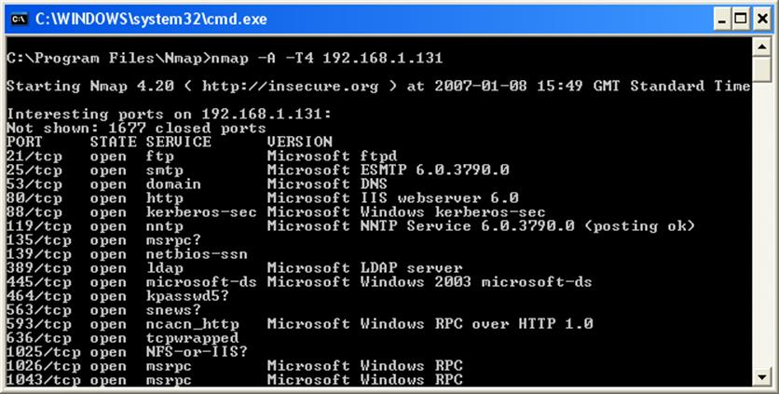
Nmap port scanner output
When a host running a particular operating system responds to a port scan, the syntax of the response might identify the specific operating system. This fact is also true of application servers, such as web servers, FTP servers, and mail servers. The responses these servers make often include several headers or banners that can reveal a great deal of information about the server.
Ports can be closed by disabling unnecessary or unused protocols, services, and applications. If a service must be run, a port can be blocked on a particular interface or restricted to certain hosts using an Access Control List (ACL) enforced by a firewall.
Port scanning tools are also useful defensive tool because a network administrator needs to ensure that unauthorized ports are not open on the network. These could be a sign of some sort of Trojan or backdoor server. Such tools often try to hide themselves from diagnostic port scans however.

Eavesdropping (Packet Sniffing)
Eavesdropping (or sniffing) refers to capturing and reading data packets as they move over the network. When an attacker (for example a malicious user) has gained access to the network, they can use a packet sniffer such as Wireshark to capture live network traffic. Unless the packets are encrypted, the attacker can gain a lot of information about the way the network is designed as well as intercepting any data transmitted in plaintext.
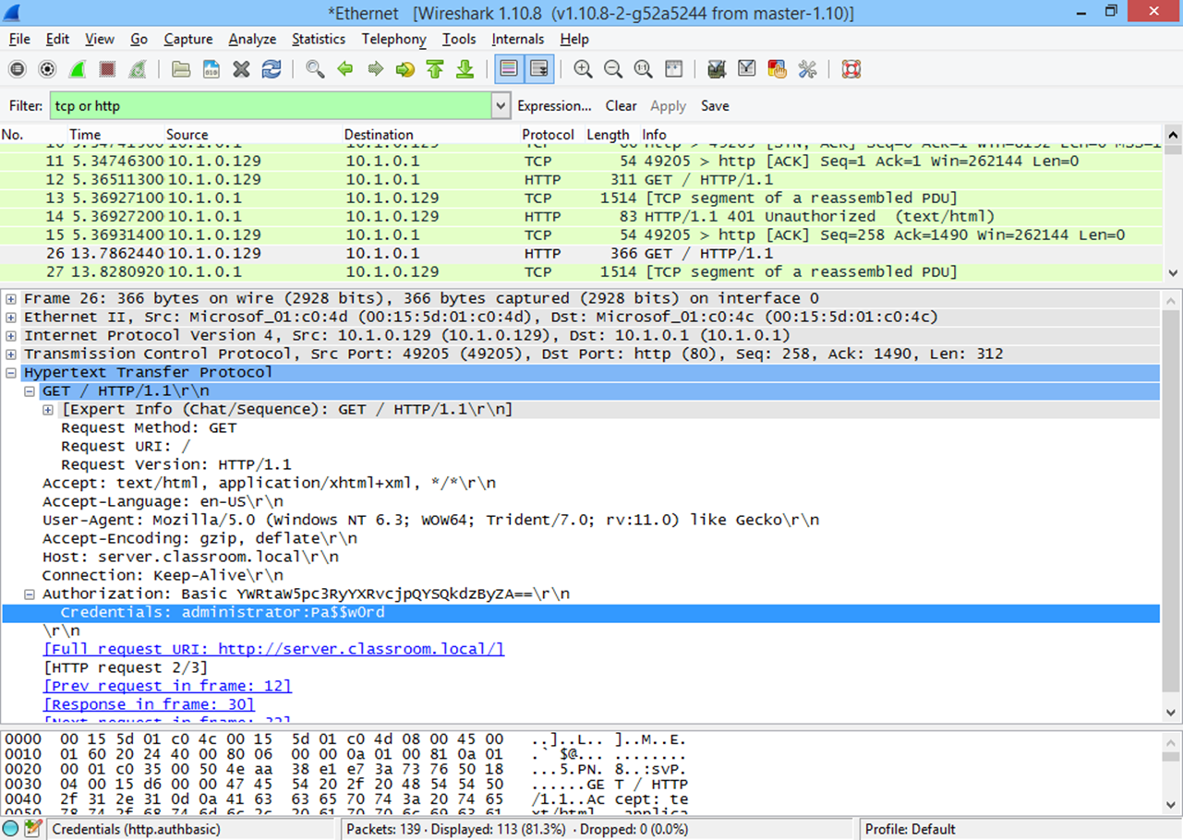
Capturing basic HTTP authentication in Wireshark
In the first instance, an attack would be limited to data traffic to and from the individual user’s computer (as well as broadcast traffic) as network switches will prevent all other traffic from being directed to that computer. However, switches can be subverted by various different types of attack:
- MAC flooding - overloading the switch's MAC cache (referred to as the Content Addressable Memory [CAM] table) using a tool such as Dsniff or Ettercap to prevent genuine devices connecting and potentially forcing the switch into "hub" or "flooding" mode.
- ARP poisoning - the attacker poisons the switch's ARP table with a false MAC-IP address mapping, typically allowing the attacker to masquerade as the subnet's default gateway.
 A packet sniffer is a defensive as well as an offensive tool. It can be used to try to detect network intrusions and unauthorized and malicious traffic.
While packet sniffing is difficult to detect, it is not impossible. If it is suspected, it can be detected by subtle differences in the way a network adapter responds when working in promiscuous mode. A network adapter must be switched to promiscuous mode in order to accept data packets that are not addressed to it. Modern switches come with security features such as ARP inspection / Dynamic ARP Inspection (DAI) to prevent a host from flooding the segment with gratuitous ARP replies. Also, attempts to subvert the MAC tables of switches could easily be detected by monitoring the performance of the switches.

Banner / OUI Grabbing
As mentioned above, when a host running a particular operating system responds to a port scan, the syntax of the response might identify the specific operating system. This fact is also true of application servers, such as web servers, FTP servers, and mail servers. The responses these servers make often include several headers or banners that can reveal a great deal of information about the server.
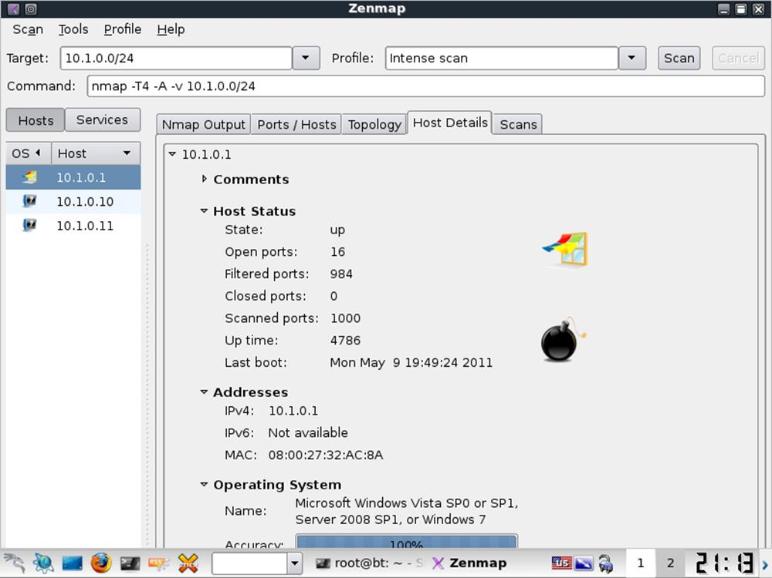
A tool such as Nmap can discover hosts connected to the network and report on their configuration
Banner grabbing refers to probing a server to try to elicit any sort of response that will identify the server application and version number, or any other interesting detail about the way the server is configured. This information allows an attacker to identify whether the server is fully patched and to look up any known software vulnerabilities that might be exposed.
Client applications broadcast information in the same way. For example, a web browser will reveal its type and version number when connecting to a server.
To avoid being targeted through banner grabbing, it is often possible to reconfigure the services affected to modify the information returned, so as to either withhold any information that could potentially be of use to an attacker, or to return plausible false values.
The 24-bit prefix of a network interface's MAC address (known as the OUI or Organizationally Unique Identifier) identifies the manufacturer of the network adapter and thereby the manufacturer of an appliance such as a router, switch, network printer, and so on. An attacker can then target the device with known exploits for devices from this manufacturer, such as default login credentials. There is little that can be done to address this issue, other than to ensure that default credentials have been changed and that firmware is kept up to date so that known issues are addressed.

TEMPEST and RF Emanation
A packet analyzer usually needs to be attached to a hub or switch to capture data packets. A sophisticated attack might try to capture data by attaching a wiretap device directly to network cabling. The leakage of electromagnetic signals (RF emanation) was investigated by the US DoD who defined TEMPEST (Transient Electromagnetic Pulse Emanation Standard) as a means of shielding the signals.
The specifications are vigorous and very few manufacturers have sought TEMPEST classification. Shielded cable from reputable manufacturers should be suitable for most ordinary applications however.
Another possibility is that an attacker could splice a tap into the cable. A physically secure cabled network is referred to as a Protected Distribution System (PDS). A hardened PDS is one where all cabling is routed through sealed metal conduit and subject to periodic visual inspection. Lower grade options are to use different materials for the conduit (plastic for instance). Another option is to install an alarm system within the cable conduit, so that intrusions can be detected automatically.

Unencrypted Channels and Unsecure Protocols
Eavesdropping attacks can also be mitigated by encrypting the channel over which communications take place. This means that even if the eavesdropper can listen to the message, s/he cannot understand it without obtaining the encryption key. It is important to understand which protocols are unsecure in terms of using unencrypted channels.
This is particularly important when using an unencrypted channel to authenticate. The use of cleartext credentials (user name and password) sent over the channel will be easy for an eavesdropper to obtain. Consequently, as part of a process of network hardening, unsecure protocols should be deprecated and secure protocols used instead.
Some examples of unsecure protocols and their secure alternatives are as follows:
- Telnet - all communications are in the clear. Telnet is often replaced by Secure Shell (SSH) but this may not be supported by legacy appliances. Another option for establishing a secure tunnel might be available; using IPsec for instance.
- HTTP - this can be made secure using SSL/TLS (HTTPS), if the appliance supports it.
- SLIP (Serial Line Internet Protocol) - this encapsulation protocol transmits IP over a serial link. On data networks, PPP is more prevalent (and just as unsecure) but SLIP may still be in use on embedded systems networks. IP can be encrypted using IPsec but this is unlikely to be an option for most embedded systems.
- FTP / T(rivial)FTP - FTP can be secured using SSL (FTPS) or SSH (SFTP) but only if both client and server support it. When FTP or TFTP is used for uploading configuration files to legacy devices there may be few effective security precautions that can be taken.
- SNMPv1 and v2 - the original versions of SNMP are unencrypted. SNMPv3 supports encryption. Otherwise a protocol such as IPsec could be used to encrypt SNMP traffic.
See Unit 3.5 / Management and Monitoring / Study Notes for more information about these remote access and management protocols.

VLAN and Switch Exploits
Configuring VLANs on a switch further compartmentalizes network traffic and can be deployed to mitigate against eavesdropping attacks. Attacks on these VLAN mechanisms have been developed to try to subvert this compartmentalization however. Two examples are as follows:
- VLAN hopping / double tagging - an attack designed to send traffic to a VLAN other than the one the host system is in. This exploits the native VLAN feature of 802.1Q. Native VLANs are designed to provide compatibility with non-VLAN capable switches. The attacker (using a device placed in the native VLAN) crafts a frame with two VLAN tag headers. The first trunk switch to inspect the frame strips the first header and the frame gets forwarded to the target VLAN. Such an attack can only send packets one way but could be used to perform a Denial of Service (DoS) attack against a host on a different VLAN. Double tagging can be mitigated by ensuring that the native VLAN uses a different ID to any user-accessible VLAN.
- Switch spoofing - a host that can masquerade as a switch is attached to an access port. If the port is configured to allow the Dynamic Trunking Protocol (DTP) to autoconfigure, the attacker could gain access to all traffic, regardless of VLAN tagging. This attack is relatively simple to counter however, as an access port can be configured not to allow autoconfiguration of DTP.

Wireless Security

As unguided or unbounded media, WLANs are subject to data emanation, or signal "leakage". On a WLAN, there is no simple way to "limit" the signal within defined boundaries. It will propagate to the extent of the antenna's broadcast range, unless blocked by some sort of shielding or natural barrier. Data emanation means that packet sniffing a WLAN is trivially easy if you can get within range.

War Driving and War Chalking
"War driving" is the practice of driving around with a wireless-enabled laptop scanning for unsecure WLANs. "War chalking" is the practice of marking little symbols to advertise the presence of an open and exploitable AP.
War chalking is a bit of an urban legend. The symbols are more likely to be used by internet cafes than by "war drivers" but keep your eyes peeled...
It is straightforward to eavesdrop on WLAN communications that have not been secured by encryption. Therefore, the crucial step in enforcing wireless security is to enable encryption. There are three schemes: WEP, WPA, and WPA2.

Wired Equivalent Privacy (WEP) Attacks
Wired Equivalent Privacy (WEP) is Wi-Fi's original security mechanism. While it is supported on both old and new devices, the encryption system (based on the RC4 encryption cipher) is flawed. These flaws allow attackers using WEP cracking tools such as such as Aircrack-NG or AirSnort to decrypt and eavesdrop traffic.
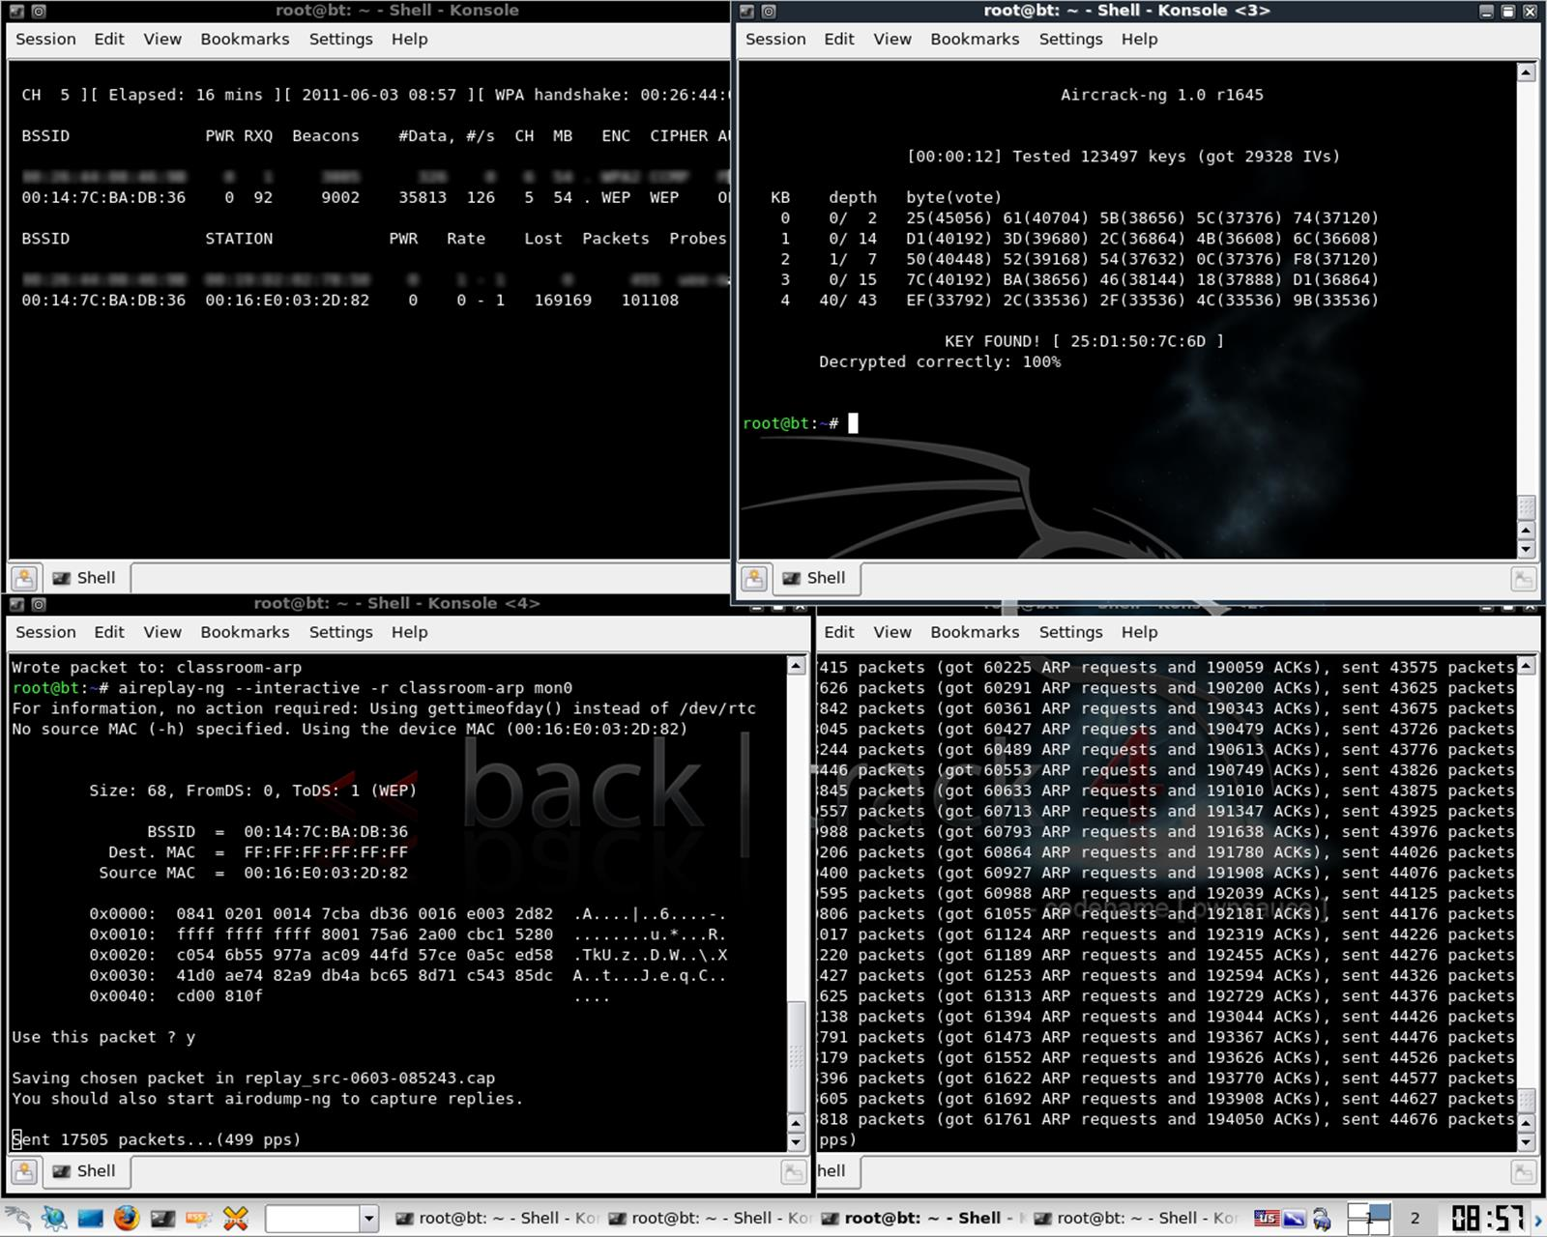
Aireplay sniffs ARP packets to harvest IVs while Airodump saves them to a capture, which Aircrack can analyze to identify the correct encryption key

Wi-Fi Protected Access (WPA) Attacks
Wi-Fi Protected Access (WPA) fixes most of the security problems with WEP. WPA still uses the RC4 cipher but adds a mechanism called the Temporal Key Integrity Protocol (TKIP) to make it stronger.
WPA2 is fully compliant with the 802.11i WLAN security standard. The main difference to WPA is the use of AES (Advanced Encryption Standard) for encryption. AES is stronger than RC4 / TKIP.
WPA / WPA2 is much more secure than WEP and there are few known attacks against the protocol itself. When used in pre-shared key mode (authenticating all devices with the same passphrase), an attacker can obtain the encrypted key by associating with the access point and then subject the key to brute force or dictionary-based password attacks. These may succeed if a weak password was used to generate the key. When enterprise authentication is deployed, there are no known attacks that would enable an attacker to gain unauthorized access to the network.
See Unit 5.3 / Authentication / Study Notes for more information about wireless authentication schemes.

Wi-Fi Protected Setup (WPS) Attacks
As setting up an access point securely is relatively complex for domestic consumers, vendors have developed a system to automate the process called Wi-Fi Protected Setup (WPS). To use WPS, all the wireless devices (access point and wireless adapters) must be WPS-capable.
Typically the devices will have a push-button. Activating this on the access point and the adapter simultaneously will associate the devices using a PIN then associate the adapter with the access point using WPA2. The system generates a random SSID and PSK. If the devices do not support the push-button method, the PIN (printed on the AP) can be entered manually.
Unfortunately, WPS is vulnerable to a brute force attack. While the PIN is 8 characters, one digit is a checksum and the rest is verified as two separate PINs of 4 and 3 characters. These separate PINs are many orders of magnitude simpler to brute force, typically requiring just hours to crack.
On some models, disabling WPS through the admin interface does not actually disable the protocol or there is no option to disable it. Some APs can lock out an intruder if a brute force attack is detected but in some cases the attack can just be resumed when the lock out period expires. To counter this, the lock out period can be increased. However, this can leave APs vulnerable to a Denial of Service attack.
When provisioning an AP, it is essential to verify what steps the vendor has taken to make their WPS implementation secure and the firmware level required to assure security.

Evil Twins / Rogue APs
It is vital to periodically survey the site to detect rogue APs ("white hat" war driving). If connected to a LAN without security, an unauthorized AP creates a very welcoming backdoor through which to attack the network. A rogue AP could also be used to capture user log in attempts.
 A rogue AP masquerading as a legitimate one is called an "Evil Twin" or sometimes "Wiphishing". An evil twin might just have a similar name (SSID) to the legitimate one or the attacker might use some DoS technique to overcome the legitimate AP. This attack will not succeed if authentication security is enabled on the AP (unless the attacker also knows the details of the authentication method). Users should also use encrypted protocols (HTTPS or a secure VPN) for secure data when using any sort of public AP.
One solution is to ensure the use of 802.1X security so that access points and clients must perform mutual authentication. There are also various scanners and monitoring systems designed to detect rogue APs, including NetStumbler and Kismet.

Jamming (Interference) and Signal Strength
A wireless network can be disrupted by interference from other radio sources. These are often unintentional but it is also possible for an attacker to purposefully jam an access point. This might be done simply to disrupt services or to position an "evil twin" AP on the network with the hope of stealing data. A Wi-Fi jamming attack can be performed by setting up an AP with a stronger signal. Wi-Fi jamming devices are also widely available (though they are often illegal to use and sometimes to sell). Such devices can be very small but the attacker still needs to gain fairly close access to the wireless network.
The only ways to defeat a jamming attack are either to locate the offending radio source (it can usually be identified by triangulation using a directional antenna) and disable it or to boost the signal from the legitimate equipment. APs for home and small business use are not often configurable but the more advanced wireless access points, such as Cisco's Aironet series, support configurable power level controls.
Simply increasing power output is not always reliable. As you increase power, you also increase the chance of the signal bouncing, causing more interference, especially if there are multiple APs. Also, the client radio power levels should match those of the AP or they may be able to receive signals but not transmit back. Consequently power levels are best set to autonegotiate. You should also be aware of legal restrictions on power output - these vary from country-to-country.
Conversely, you may want to turn the power output on an AP down and ensure careful AP device placement to prevent "war driving". The main problem with this approach is that it requires careful configuration to ensure that there is acceptable coverage for legitimate users. You also expose yourself slightly to "evil twin" attacks, as users may expect to find the network at a given location and assume that a rogue AP that an attacker has positioned in the gap is legitimate.

Bluejacking / Bluesnarfing
Bluetooth is a short-range (up to about 10m) radio link, working at a nominal rate of up to about 3 Mbps (for v2.0 + EDR). It is used for so-called Personal Area Networks (PAN) to share data with a PC, connect to a printer, use a wireless headset, and so on. Devices must be put into discoverable mode and then paired and often authenticated using a passcode before they can connect. Sometimes the passcode is not configurable ("0000" for instance) but data storing devices can usually generate a unique passcode.
Unless some sort of authentication is configured, a discoverable device is vulnerable to bluejacking, a sort of spam where someone sends you an unsolicited text (or picture / video) message or vCard (contact details). While there are no known instances, this could also become a vector for malware. Bluesnarfing refers to using an exploit in Bluetooth to steal information from someone else's phone. The exploit (now patched) allows attackers to circumvent the authentication mechanism.

Network Attack Strategies
Having gathered information about a network, an attacker may be able to probe or damage it by launching further attacks. Many of the network, transport, and application protocols in use on private networks and the Internet were designed without any regard for security. Protocols such as TCP or UDP are vulnerable to packet sniffing because they were designed to transmit information in plain text. Devices communicating using these protocols do not typically authenticate with one another, making them vulnerable to spoofing, Denial of Service, and Man-in-the-Middle.

Spoofing and Packet / Protocol Abuse
The term spoofing (or impersonation or masquerade) covers a very wide range of different attacks. Social engineering and techniques such as phishing and pharming are types of spoofing attack. It also possible to abuse the way a protocol works or network packets are constructed to inject false or modified data onto a network. The ARP and DNS protocols are often used as vectors for this type of attack. Further examples of spoofing are discussed later in this unit.

Denial of Service
A Denial of Service (DoS) attack causes a service at a given host to fail or to become unavailable to legitimate users. Typically, DoS attacks focus on overloading a service. It is also possible for DoS attacks to exploit design failures or other vulnerabilities in application software. An example of a physical DoS attack would be cutting telephone lines or network cabling. DoS attacks may simply be motivated by the malicious desire to cause trouble. They may also be part of a wider attack, such as precursor to a DNS spoofing attack. Further examples of DoS are discussed later in this unit.
Remember that it is crucial to understand the different motives attackers may have.

Man-in-the-Middle Attack
A Man-in-the-Middle attack is a specific type of spoofing attack where the attacker sits between two communicating hosts and transparently monitors, captures, and relays all communication between them. For example, in an ARP poisoningattack, the attacker sends spoofed ARP messages onto the network to associate his IP address with another (typically the subnet's default gateway). Other hosts will then start communicating with the attacker, who will be able to sniff the packets and either send them on to the genuine host (to try to keep the attack covert), send modified versions of the packets, or drop them (performing a Denial of Service attack).
MITM attacks can be defeated using mutual authentication, where both server and client exchange secure credentials.

ARP Cache Poisoning
The ARP cache poisoning (or spoofing) attack mentioned above is also an example of protocol abuse. It works by broadcasting unsolicited ARP reply packets. Because ARP has no security, the receiving devices trust this communication and update their MAC:IP address cache table with the spoofed address.
An ARP spoofing attack can be launched by running software such as Dsniff, Cain and Abel, or Ettercap from a computer attached to the same switch as the target. An ARP poisoning attack could also be launched by adding static entries to the target's ARP cache.
Obviously the attacker has to compromise the computer to do this. These tools would be recognized as malware by anti-virus software.
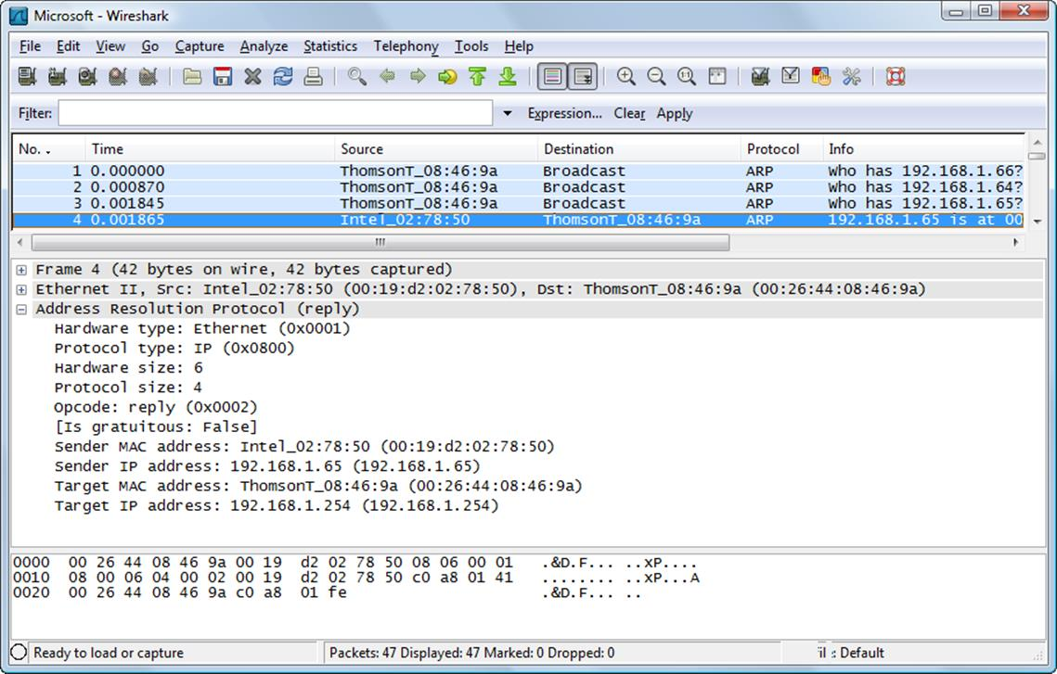
Contents of an ARP reply frame showing fields in the frame header - this is a genuine ARP transaction but hacking software tools can rewrite information in these headers to spoof MAC addresses
The usual target will be the subnet's default gateway (the router that accesses other networks). If the attack is successful, all traffic destined for the remote network will be sent to the attacker. The attacker can then monitor the communications (forwarding them to the router to avoid detection), launch a Man-in-the-Middle attack (modifying the packets before forwarding them), or perform a Denial of Service attack (not forwarding the packets). Such ARP poisoning would be difficult to notice if expertly performed, as for example if the misdirected packets were forwarded to the destination so that their disappearance went unnoticed. However, attempts at ARP poisoning are likely to cause sporadic communication difficulties, such as an unreachable default gateway. In such cases, performing network captures and examining ARP packets may reveal the poison packets as will examining local ARP caches for multiple IP addresses mapping to the same MAC address.
Note that while IPv6 does not use ARP, it is also vulnerable to layer 2 spoofing if the unencrypted Neighbor Discovery (ND) protocol is used.

Vulnerabilities and Zero-day Attacks
Software exploitation means an attack that targets a vulnerability in OS or application software (also called an "exploit"). Typically, applications such as web servers, web browsers, web browser plug-ins, email clients, and databases are targeted. A vulnerability is a design flaw that can cause the application security system to be circumvented or that will cause the application to crash. The most serious vulnerabilities allow the attacker to execute arbitrary code on the system, which could allow the installation of malware.
Typically, vulnerabilities can only be exploited in quite specific circumstances but because of the complexity of modern software and the speed with which new versions must be released to market, almost no software is free from vulnerabilities. There are various vulnerability exploit kits, such as Mpack and Neosploit, that can be installed to a website and actively try to exploit vulnerabilities in clients browsing the site. These kits may either be installed to a legitimate site without the owner's knowledge (by compromising access control on the web server) and load in an iFrame (invisible to the user) or the attacker may use phishing / social engineering techniques to trick users into visiting the site (using Google search results, ads, to "typosquatting" (using a misspelled version of a genuine domain name, such as "amazoon.com") or clicking an email link.
Most vulnerabilities are discovered by software and security researchers, who notify the vendor to give them time to patch the vulnerability before releasing details to the wider public. A vulnerability that is exploited before the developer knows about it or can release a patch is called a zero-day exploit. These can be extremely destructive, as it can take the vendor a lot of time to develop a patch, leaving systems vulnerable for days, weeks, or even years.
While some zero-day attacks can be extremely destructive, they are relatively rare. A greater threat is the large number of unpatched or legacy systems in use. An unpatched system is one that its owner has not updated with OS and application patches; a legacy system is one where the software vendor no longer provides support or fixes for problems.
Note that this issue does not just affect PCs. Network appliances can also be vulnerable to exploits. The risks to embedded systems have become more obvious over the last few years and the risks posed by unpatched mobile devices and the "internet of things" is likely to grow.

Network Device Exploitation and Hardening
It can be tempting to think of network devices such as switches and routers as "self-contained". In fact, these devices often run quite complex firmware and host numerous services to enable remote management and configuration.
- Privilege escalation - driver software and firmware may be exploitable in the same way as applications software. It is important to keep appliances configured with up-to-date patches and firmware.
- Default / weak passwords - devices such as wireless access points, switches, and routers ship with a default management password such as "password" or "admin" or the device vendor's name. These should be changed on installation. Also, the password used should be a strong one - most devices do not enforce complexity rules so the onus is on the user to choose something secure.
It is now standard practice for devices to be shipped with individually configured default credentials, usually placed on a label on the device or in the instruction manual, or for devices to require a change of password as part of their initial setup.
- Backdoor / default account - vendors sometimes deliberately install backdoors on devices such as routers and switches (often as a password reset mechanism). Another possibility is for someone with physical access to the device to reset it to the factory configuration. Devices such as access points attached to the network without authorization are called "rogues". These could create a backdoor through which to attack the network. A rogue device could also be used to capture user log in attempts.
- Unnecessary running services - any services or protocols that are not used should be disabled. This reduces the attack surface of a network appliance or OS. Attack surface means the range of things that an attacker could possibly exploit in order to compromise the device. It is particularly important to disable unused administration interfaces (and to secure those that are used).
- Denial of Service - an attacker able to compromise a network device is also likely to be able to launch a Denial of Service (DoS) attack against the network, either by disabling the device or reconfiguring it.
Most device exploits depend on the attacker having physical access to the unit, though some vulnerabilities can be exploited over a network link.

Malware and Compromised Systems

Malware is software that is written with a malicious purpose, such as to steal data or to cause a computer to malfunction. It is a blanket term, covering types of software such as viruses, Trojan horses, worms, ransomware, and spyware.
- Viruses are pieces of code that insert themselves into executable programs, and are executed along with these programs. When executed, they will take the opportunity to infect other programs, as well as carrying out any other actions that are programmed into their payload, possibly leading to data loss or other performance issues.
- Trojan horses are programs that appear to be useful or innocuous, but that also contain malicious code. Examples include games that contain backdoors, allowing an attacker to gain control of a computer when the game is installed.
- Worms are similar to viruses, except that instead of attaching themselves to other programs, they are programs that actively replicate themselves to other computers on a network, by exploiting known vulnerabilities.
- Ransomware is malware (typically a virus) that makes data unavailable, usually by encrypting it, and demands payment for the return of the data.
- Spyware is malware that steals data from a computer, or observes user action, such as recording keystrokes.
Almost any unexpected behavior could indicate the presence of malware, but in general there will be some indication of process running that are unexpected, or unexplained scheduled tasks, or perhaps services that should not be running. Also, it is worth checking what processes are configured to run at startup or logon, for example by using the msconfig command in Windows.
Malware could be designed to have destructive effects on a network, performing Denial of Service type attacks by crashing servers and appliances or consuming network bandwidth. Some types of malware aim to create compromised systems. A compromised system is one that the attacker can use to gain wider access to the network and launch additional attacks, usually concealing his identity in the process. A system could be compromised because the attacker learns its administrative credentials or it could be compromised by infection with a virus or Trojan that installs backdoor remote access or spyware software.

Password Attacks
A common attack is where a person will attempt to figure out a password or passwords to gain access to a host. Passwords can be discovered via social engineering or because a user has written one down. It is also possible to capture password packets in transit. If the protocol uses cleartext credentials then the attacker's job is done. Most passwords are only sent using some sort of encryption however.
 A password might be sent in an encoded form, such as Base64, which is simply an ASCII representation of binary data. This is not the same as encryption. The password value can easily be derived from the Base64 string.
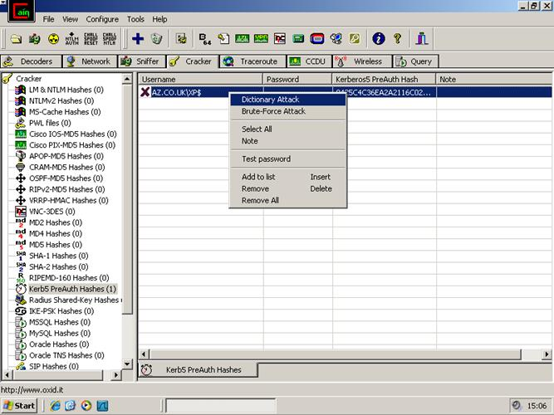
Cain and Abel password cracker
Either the channel can be encrypted or the password can be encrypted (or both). If the channel is encrypted, the attacker has to compromise the encryption keys stored on the server. If the password is encrypted, the attacker might be able to use password cracking software to decipher it. This type of software uses different methods to obtain the password from an encrypted password hash:
- Dictionary - the software matches the hash to those produced by ordinary words found in a dictionary. This could also include information such as user and company names or pet names or any other data that people might naively use as passwords.
- Brute force - the software tries to match the hash against one of every possible combination it could be. If the password is short (under 7 characters) and non-complex (using only letters for instance), a password might be cracked in minutes. Longer and more complex passwords increase the amount of time the attack takes to run.

Session Hijacking
Session hijacking is another type of spoofing or impersonation attack. Rather than obtaining a user's credentials, it exploits the way a server application trusts that a session has been authenticated and is proceeding normally. For example, a browser establishes a session with a web server. The user might logon and the web application on the server might use some information in a text file called a cookie to store information about the session. If an attacker is able to obtain that cookie (by eavesdropping for instance) and the application is not coded in a way to defeat session hijacking attempts, he might be able to re-establish the session and impersonate the user, without actually discovering the user's password. Another technique is to use a compromised website to attack another, referred to as a cross-site scripting attack. Session hijacking does not have to involve users and people and can target any type of protocol, not just HTTP. Effective attacks can compromise sessions established between two servers. DNS session hijacking can be an extremely effective exploit for instance, giving the attacker a huge degree of control over a network.

Denial of Service

DoS attacks may simply be motivated by the malicious desire to cause trouble. They may also be part of a wider attack, such as precursor to a spoofing attack. Network-based DoS attacks are normally accomplished by flooding the server with bogus requests. They rely on the attacker having access to greater bandwidth than the target or on the target being required to devote more resources to each connection than the attacker. There are many different methods of achieving this, often exploiting weaknesses in protocols such as ICMP or the TCP handshake.
One such weakness is in the way that IP handles fragmentation. Fragmentation occurs when a packet crossing a router is too large to be carried by the underlying network technology on the next segment. The packet is broken into fragments, with additional header information so that it can be reconstructed at the destination. However, due to the way this header information is handled, it is possible for fragmentation offsets to be greater than 65,535 bytes, which is the maximum size of an IP packet. This makes it possible to craft a fake ping packet that appears to be larger than the largest possible packet. The target computer will try to store this packet, causing an overflow with unpredictable results, possibly including causing it to crash. This type of attack is known as a ping of death.

Distributed DoS (DDoS) Attacks / Botnets
Most bandwidth-directed DoS attacks are distributed. This means that the attacks are launched from multiple compromised systems (referred to as a botnet). Typically an attacker will compromise one or two machines to use as "handlers" or "masters". The handlers are used to compromise multiple zombie (agent) PCs with DoS tools (bots) forming a botnet. In this way, the attacker can conceal his or her activities. This is also referred to as an asymmetric threat, because the attacker's resources can be far less than those of the victim.
Large botnets are necessary to overcome the high bandwidth of targets, which tend to be organizations with a large internet presence, such as government departments, Microsoft, banks, e-commerce sites, and so on. The increasing use of "always-on" broadband connections means that attackers can target a large base of naïve home users with the aim of compromising their PCs.
To compromise a computer, the attacker must install a backdoor application that gives them access to the PC. They can then use the backdoor application to install DoS software and trigger the zombies to launch the attack at the same time. As well as a single attacker using a botnet, DoS attacks might be coordinated between groups of attackers. There is growing evidence that nation states are engaging in "cyber warfare" and terrorist groups have also been implicated in DoS attacks on well-known companies and government institutions. There are also "hacker collectives" who might target an organization as part of a campaign.
DoS attacks can be diagnosed by analyzing network traffic but can usually only be counteracted by providing high availability services, for example by using cluster services. In some cases, an intelligent firewall can detect a DoS attack that is under way and automatically block the source. However, for many of the techniques used in DoS attacks, the source addresses will be randomly spoofed, making it difficult to detect the source of the attack.

Amplification Attacks (DRDoS)
A SYN flood attack works by withholding the client's ACK packet during TCP's three-way handshake. Typically, the client's IP address is spoofed, meaning that an invalid or random IP is entered so the server's SYN/ACK packet is misdirected. A server can maintain a queue of pending connections. When it does not receive an ACK packet from the client, it resends the SYN/ACK packet a number of times before eventually giving up on the connection after a set timeout. The problem is that a server may only be able to manage a limited number of pending connections, which the DoS attack quickly fills up. This means that the server is unable to respond to genuine traffic.
A more powerful TCP SYN flood attack is a type of Distributed Reflection DoS (DRDoS) or amplification attack. In this attack, the client spoofs the victim's IP address and attempts to open connections with multiple servers. Those servers direct their SYN/ACK responses to the victim server. This rapidly consumes the victim's available bandwidth.
A similar type of amplification attack can be performed by exploiting other protocols. For example, in a Smurf attack, the client spoofs the victim's IP address and pings the broadcast address of a third-party network (one with many hosts; referred to as the "amplifying network"). Each host directs its echo responses to the victim server.
The same sort of technique can be used to bombard a victim network with responses to bogus DNS queries. One of the advantages of this technique is that while the request is small, the response to a DNS query can be made to include a lot of information, so this is a very effective way of overwhelming the bandwidth of the victim network with much more limited resources on the attacker's botnet.
The Network Time Protocol (NTP) can be abused in a similar way. NTP helps servers on a network and on the Internet to keep the correct time. It is vital for many protocols and security mechanisms that servers and clients be synchronized. One NTP query (monlist) can be used to generate a response containing a list of the last 600 machines that the NTP server has contacted. As with the DNS amplification attack, this allows a short request to direct a long response at the victim network.

Routing and Switching Attacks
Routers exchange information using a number of routing protocols. If authentication is not enabled, the routing devices become vulnerable to a variety of attacks though being supplied with corrupted routing information. This can mean that traffic is misdirected to a monitoring port (sniffing) or sent to a blackhole (non-existent address) or looped around the network, causing DoS.

Physical DoS Attack
On a local network, DoS attacks might target the network's physical infrastructure. This might mean vandalizing a cable or piece of equipment. Such attacks can also be described as Permanent DoS (PDoS) because they require the targeted equipment to be completely replaced.
Another potentially effective exploit to damage appliances permanently is to upload faulty firmware (phlashing). This could potentially "brick" the appliance and make it completely unusable. This attack could be launched over an unsecure remote management interface.

Friendly / Unintentional DoS and Traffic Spikes
A friendly DoS event is one where there is no malicious intent ("friendly" derives from "friendly fire"). The typical network administrator's horror story is for a user to plug a legacy hub device into a switched network or a n00b (a person lacking experience or skill) to connect a patch cable from one switch port to another, causing a broadcast storm. Another common example would be a misconfigured firewall or security appliance preventing legitimate users from accessing the network.
It is also possible for there to be friendly DDoS events. This can occur when a website becomes unexpectedly popular, perhaps because of a news story or something going "viral" on social media and generating lots of discussion and interest. Part of a web administrator's job should be to anticipate when press or marketing events will cause a legitimate traffic spike and put resources in place to cope with it. It can sometimes be difficult to distinguish legitimate traffic spikes from an ongoing malicious DDoS attack. Tools that monitor the geographic distribution of clients generating the traffic on a site can be helpful in determining whether an attack is underway.

