UNIT 4.5 / REMOTE ACCESS / STUDY NOTES

Remote Access Services (RAS)
Remote access describes a situation where access to the network does not depend on the user being physically present. Typically, use is made of a public WAN (the Internet) or leased lines. Some of the uses of remote access are:
- Connectivity between different sites, such as between two offices or between a home worker (or "telecommuter") and the office.
- Mobile access to corporate data, such as email, calendaring, and databases.
- Sharing data with customers and suppliers (an extranet).
- Remote administration of servers and workstations.
Providing remote connectivity is referred to as Remote Access Services (RAS). The components of RAS are the network media, RAS protocols, and client and server applications implementing those protocols. Most WAN communication links use serial communications (such as PSTN, ISDN, or leased line). The remote server and client must agree a data link protocol to use to organize serial information into the frames required by the network.

Point-to-Point Protocol (PPP)

The Point-to-Point Protocol (PPP) is the cornerstone of most remote access methods. It is defined by RFC 1661. Its basic function is as a data link (layer 2) transport for network protocols over a variety of communications links, including POTS, DSL, SONET, and cellular. The process of establishing a PPP connection is as follows:
- After the physical connection is made, the Link Control Protocol (LCP) negotiates link parameters, such as frame size and whether to use authentication.
- If specified, the client and server negotiate use of an authentication protocol and exchange authentication messages.
- The appropriate Network Control Protocols (NCP) are then selected to configure the layer 3 protocol(s) to be used on the local network.
- At this point, the link is open and PPP frames are exchanged:
- When the link is to be closed, LCP exchanges terminate packets. The connection could also be closed because the line is dropped or because it times-out.

Multilink PPP (MLPPP)
Multilink PPP (MP, MLP, or MPPP) is a means of bonding multiple circuits into a single connection, providing more overall bandwidth. The circuits could be multiple dial-up connections or ISDN or leased line channels. For example, if a T1 leased line provides insufficient bandwidth, provisioning a T3 line may be considered too much of a step in terms of cost. Multilink PPP would allow the company to bond two T1 lines. The lines must be from the same carrier as the properties of the multilink connection must be configured at both the customer end and the service provider end.
As PPP expects a serial point-to-point link and multilink can make use of multiple lines, the protocol adds sequence numbers to each frame so that they can be reassembled in the correct order by the receiving node.

PPP over Ethernet (PPPoE)
The Point-to-Point Protocol provides encapsulation for IP traffic (amongst others) plus IP assignment, authentication, and a means for an ISP to monitor a connection and bill for time used. However most customers use "broadband" services, such as ADSL, to connect to an ISP. These often use Ethernet as the data link protocol.
PPP over Ethernet (PPPoE) is simply a means of creating PPP connections over an Ethernet connection. The major benefit of PPPoE is that the end-user can just as easily establish these network connections without needing to know more than how to establish a dial-up connection, so neither the telephone company nor the ISP needs to provide any special support. Some ISPs use Point-to-Point Protocol over ATM (PPPoA) rather than PPPoE.

Tunneling / Encapsulation
PPP is an encapsulation protocol. This means that the protocol sits around other protocol data. This allows a virtual tunnelto be created. PPP works at the data link layer of the OSI model (layer 2) and is designed to support layer 3 protocols, notably IP.
Tunneling is a technology used when the source and destination computers are on the same logical network but connected via a different physical networks.
- Computer A is located at a user's home and requires remote access to information on Server C using the TCP/IPprotocol.
- Computer A uses its modem to dial the modem of Server B (a Remote Access Service [RAS] server) and establishes a physical connection.
- The local protocol request (TCP/IP packets) generated by Computer A is encapsulated into PPP frames for transfer across the dial-up serial connection.
- Server B receives the PPP frames and extracts the local protocol request.
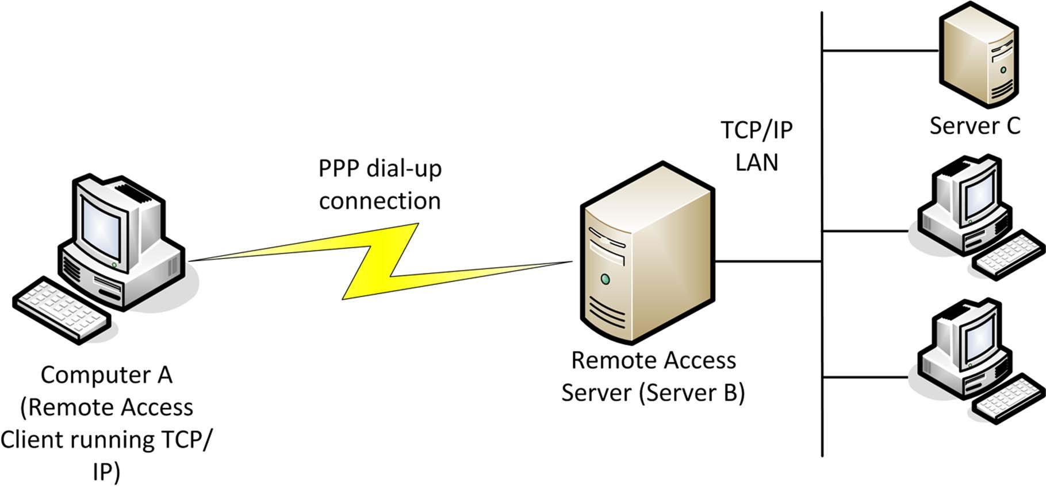
Tunneling (TCP/IP data is tunneled via PPP)
- The TCP/IP packets are placed onto the network in Ethernet frames for Server C to recognize and respond to.
In this scenario however, PPP provides no security for data transmissions. Other protocols have been developed to provide connection security.

Virtual Private Networks (VPN)
Providing secure leased lines is difficult and expensive. A more practical solution is to use internet infrastructure and set up a secure tunnel for private communications through it. This is called a Virtual Private Network (VPN). Most business and domestic sites have internet connectivity, so this solution is very efficient in terms of cost. VPNs can also be deployed in other topologies to suit the type of network access required.

Host-to-Site VPN
In a host-to-site or remote access topology, hosts connect to a VPN gateway (a VPN-enabled router) on the local network. This is the "telecommuter" model, allowing home-workers and employees working in the field to connect to the corporate network. The VPN clients will connect over the Internet.
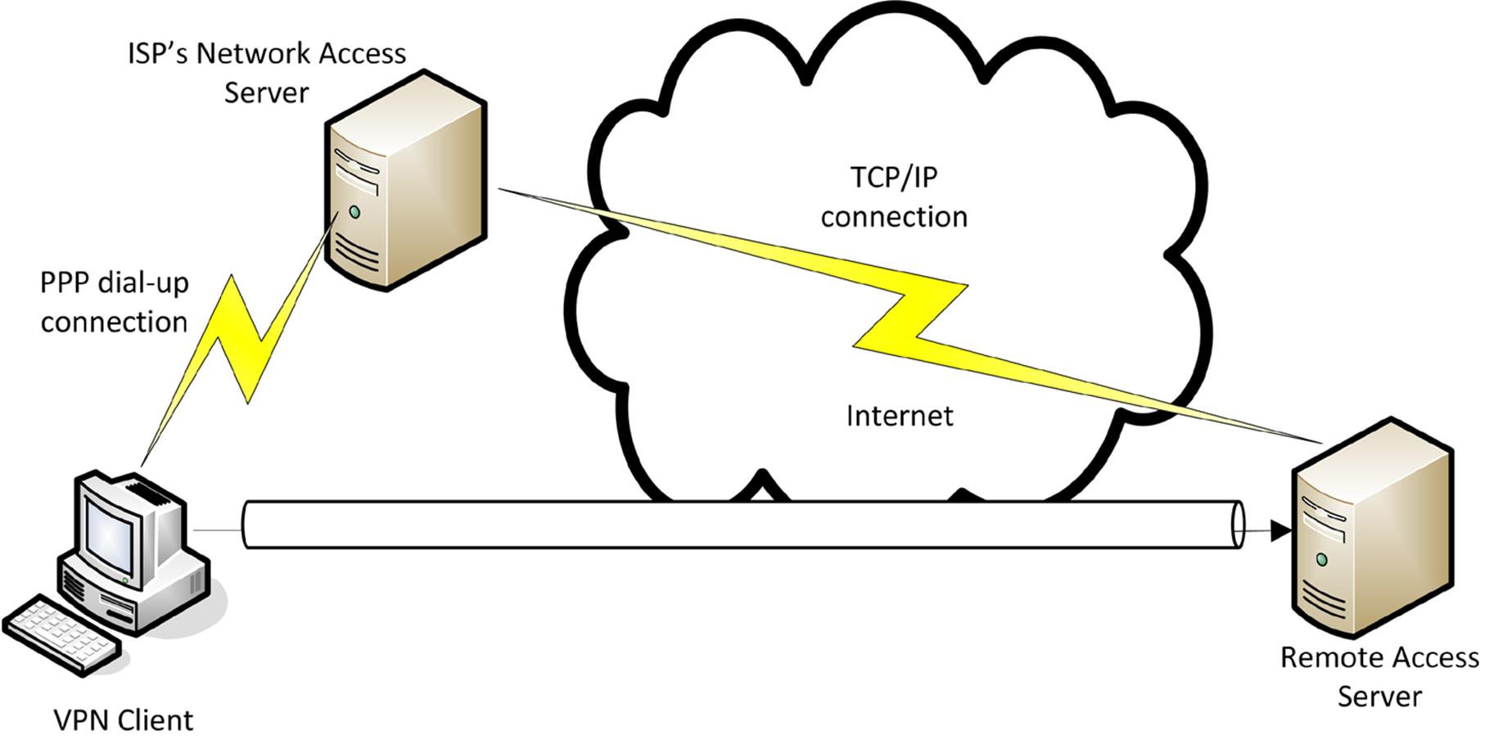
Remote access VPN

Site-to-Site VPN
The site-to-site model connects two or more local networks, each of which runs a VPN gateway (or router). Historically, this type of connection might have been made by ISDN or a leased line. Using a VPN brings significant cost-savings, especially over long distances.
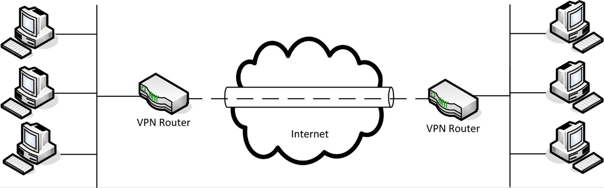
Site-to-site VPN

Host-to-Host VPN
A host-to-host VPN is similar to a site-to-site VPN but rather than connecting two or more subnets, the link is between two hosts only. There might be special security reasons for configuring a secure tunnel between two hosts. It may also be the case that a single host on each network acts as a proxy for other network client computers.
 While VPNs are being covered here as part of remote access, note that they can be just as usefully deployed on local networks. For example, the department for product development might need to provide secure communications with the marketing department.

PPTP and SSL VPNs
To establish a VPN, the client and server must be configured with the same tunneling protocol and security parameters.

Point-to-Point Tunneling Protocol (PPTP)
The Point-to-Point Tunneling Protocol (PPTP), developed by Cisco and Microsoft, runs on top of PPP to provide encryption, with TCP/IP providing the transport protocol. PPTP is documented in RFC 2637. Like PPP, PPTP operates at Layer 2 of the OSI model. The connection process for PPTP is as follows:
- The client and server establish an IP connection. This would typically be facilitated via the connecting to the Internet via a DSL or dial-up link to the ISP's network access server, which routes communications between the client and the organization's PPTP VPN server.
- A control link is then established over TCP port 1723 on the server to negotiate connection parameters. This connection is not secured, and represents one of the weaknesses of PPTP.
  - The client and server exchange Link Control Protocol (LCP) messages to negotiate the creation of a PPP link (the most important point is the selection of an authentication protocol such as CHAP or EAP).
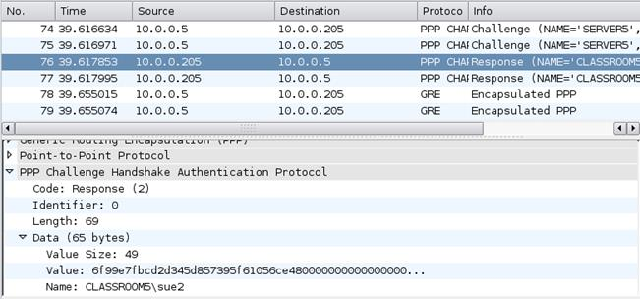
PPTP session establishment
 Authentication protocols and encryption technologies are discussed in Unit 5.3 / Authentication / Study Notes.
  - The client authenticates to the server (and if mutual authentication is configured the server also authenticates to the client).
  - The client and server negotiate use of a network protocol (such as IP).
- With the PPTP link established, the client and server exchange PPP frames securely by re-packaging them using the Generic Routing Encapsulation Protocol (GRE). GRE is a layer 3.5 protocol - it is delivered at the IP layer (it has the IP protocol number 47) but also encapsulates IP traffic. Routers and firewalls must be configured to allow GRE traffic if they are to support PPTP.
PPTP does not define an encryption mechanism itself but can use Microsoft Point-to-Point Encryption (MPPE).
- The VPN server extracts the tunneled IP packets from the PPP frames and route them over the LAN. On an IP network, the client will usually obtain an address from a DHCP server and register with DNS for name resolution. At this point the remote client is part of the local network (though limited by the bandwidth of the remote link).
- The control link on TCP port 1723 remains open to manage the connection.
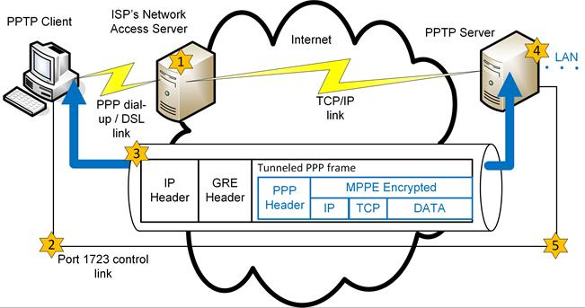
PPTP

Layer 2 Tunneling Protocol (L2TP)
Cisco's Layer 2 Tunneling Protocol (L2TP) is a more robust and flexible protocol than PPTP. There is support for frame types other than PPP (Ethernet, ATM, and Frame Relay) plus support for different transport protocols in addition to IP). As with PPTP, L2TP provides no authentication or confidentiality (encryption) in itself. L2TP is almost always used with IPsec (see below), which enables the encryption of the link negotiation messages from the start, correcting a significant weakness of PPTP. L2TP uses UDP port 1701 for data and connection control.

SSL VPNs and OpenVPN
Secure Sockets Layer (or, more technically going forward, Transport Layer Security [TLS]) provides transmission encryption and (through digital certificates and PKI) authentication for application level TCP/IP services such as HTTP. Where authentication is integrated with the network user database, this can be thought of as a sort of VPN. As well as web applications, this can enable secure access to FTP and Terminal Services.
Compared to some other VPN solutions, an SSL VPN often requires no special client software. Another advantage is that access is restricted to defined services rather than the whole network, protecting the network in the event that remote access clients are compromised.
The main disadvantage of SSL VPNs is just that they do not extend the network to the remote user, which can make management of the remote client more complex and preventing direct access to software that cannot be deployed as a web application. OpenVPN is an open-source SSL VPN solution that does provide a VPN solution for all layers of the network stack. OpenVPN creates an authenticated and encrypted tunnel (over UDP port 1194 by default, though any UDP or TCP port can be used) using SSL then multiplexes network traffic through the tunnel. One of the features of OpenVPN is that it can tunnel Ethernet frames (bridged mode) or IP packets (routed mode).

Secure Sockets Tunneling Protocol (SSTP)
One of the problems with the Point-to-Point Tunneling Protocol (PPTP) is that the initial connection between the client and RAS server is unprotected. An eavesdropper can obtain information about the machines and credentials being used to access the network and in many cases will be able to decrypt the password being used for access.
Microsoft developed the Secure Sockets Tunneling Protocol (SSTP) to replace PPTP. With SSTP, a client establishes a secure connection with the server using HTTPS and digital certificates (over TCP port 443 by default). PPP frames are then tunneled over the secure link. This protects the authentication information (and other VPN traffic) from eavesdropping.

IP Security (IPsec)
The IP Security Protocol (IPsec) is a layer 3 protocol suite providing security for IP packets. IPsec can provide both confidentiality (by encrypting data packets) and integrity/anti-replay (by signing each packet). The main drawback is that it is quite processor intensive, adding a large overhead to data communications.
IPsec is published in RFCs 4301 through 4309 (Security Architecture for IP). It was designed as an integral part of IPv6 but adapted for IPv4 as worldwide adoption of IPv6 capable hardware and software has been slow.
IPsec works over TCP/UDP port 1293. There are two core protocols in IPsec, which can be applied singly or together.

Authentication Header (AH)
AH performs a cryptographic hash on the packet plus a shared secret key (known only to the communicating hosts) and adds the value in its header as an Integrity Check Value (ICV). The recipient performs the same function on the packet and key and should derive the same value to confirm that the packet has not been modified. The payload is not encrypted so this protocol does not provide confidentiality.
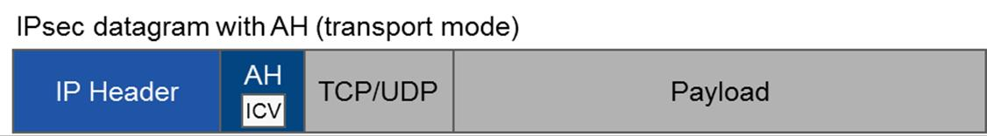
IPsec datagram using AH - the integrity of the payload and IP header is ensured by the Integrity Check Value (ICV) but the payload is not encrypted

Encapsulating Security Payload (ESP)
ESP provides confidentiality and authentication by encrypting the packet as well as calculating an ICV. ESP can use AH to calculate the ICV but this is not commonly implemented.
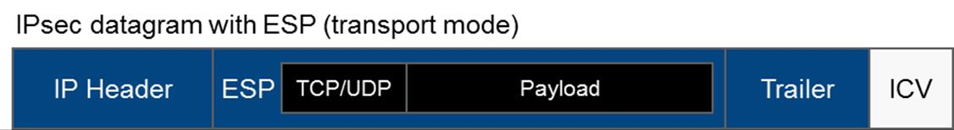
IPsec datagram using ESP - the TCP header and payload from the original packet is encapsulated within ESP and encrypted to provide confidentiality
 The principles underlying IPsec are the same for IPv4 and IPv6 but the header formats are different. IPsec makes use of extension headers in IPv6 while in IPv4 ESP and AH are allocated new IP protocol numbers (50 and 51) and either modify the original IP header or encapsulate the original packet.

Transport and Tunnel Modes
IPsec can be used in two modes:
- Transport mode - the IP header for each packet is not encrypted; the ESP and/or AH header is inserted after the IP header. This mode would be used to secure communications on a private network (an end-to-end implementation).
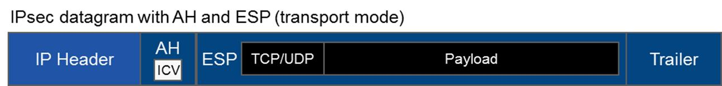
IPsec datagram using AH and ESP in transport mode
- Tunnel mode - the whole IP packet is encapsulated and a new IP header added. This mode is used for communications across an unsecure network (creating a VPN). This is also referred to as a router implementation as it is normally deployed on a host-to-host link between two router gateways across a third-party network.
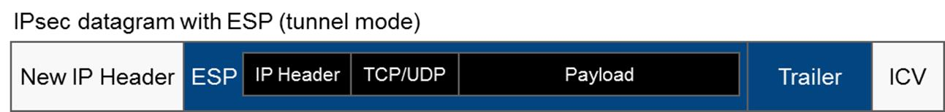
IPsec datagram using ESP in tunnel mode

Internet Key Exchange
AH and ESP both depend on the idea of a shared secret; that is, a key known only to the two hosts that want to communicate. For this to happen securely, the secret must be communicated to both hosts and the hosts must confirm one another's identity (mutual authentication).
The Internet Key Exchange (IKE) protocol is the part of the IPsec protocol suite that handles authentication and key exchange, referred to as Security Associations (SA). IKE negotiations use UDP port 500. Authentication can take place using digital certificates or pre-shared keys configured on both hosts.

Remote Access Servers
Most NOS support remote access. A Remote Access Server is also referred to as a Network Access Server. A related device is a Remote Access Concentrator, which can handle high call densities. In Windows, the service is called Routing and Remote Access (RRAS).
Remote servers can be configured to allow access to the entire network or just to the server itself. In the first case, the remote server forwards requests to other servers on the network.
A remote access server can be configured in two ways:

Dial-in RAS
A dial-in server has a physical connection (via the telephone network or leased line) to a dedicated WAN link and one or more modems. The management of security for remote connectivity involves carefully considered remote access policies:
- Providing users with permission to use the remote connectivity facility ("dial-in" rights).
- Setting predetermined telephone numbers from which the remote clients must connect. This facility is sometimes known as callback. When a remote client connects to the server to check the credentials of the remote user, it then breaks the connection and the server dials the remote user using a preset number.
- The user name and password supplied by the remote user are used for authentication. It is important to prevent third parties from obtaining these credentials and impersonating a user. Encryption of passwords is often used to foil such attempts.
- The remote server can enforce the use of an encrypted authentication protocol such as CHAP or EAP. Strong, multi-factor authentication, such as using smart card or biometric recognition, can further enhance security. Encrypted protocols can also be used for data.
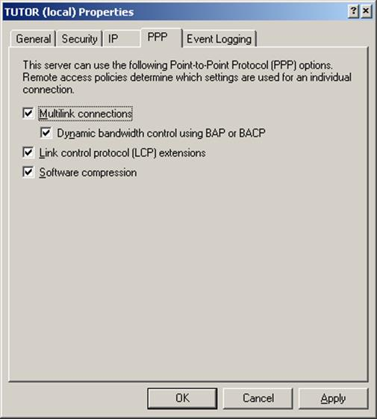
Configuring multilink properties for a connection
- To increase connection speed, a multilink (or bonded) connection can be used to combine serial connections to improve bandwidth.

VPN RAS
An RAS configured for VPN access is simply connected to the Internet, using any appropriate media. The server is then configured to use the appropriate protocols and users are granted "dial-in" rights.
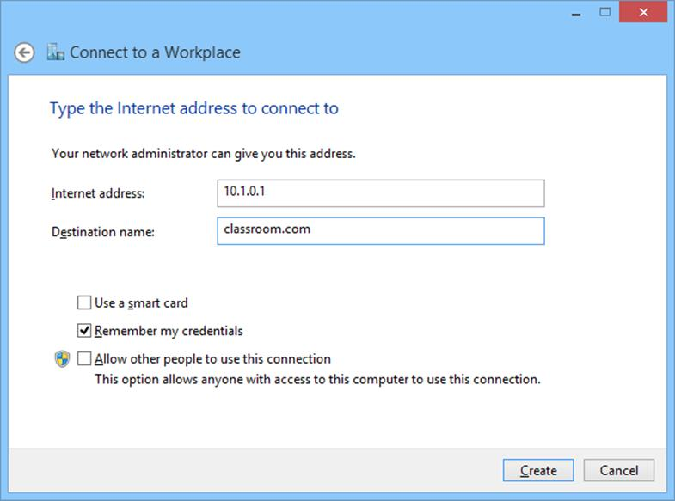
Configuring a VPN client
Once the client has been authenticated, it can be assigned a local network address. To all intents and purposes, the client becomes part of the local network.
Another option is to provide a hardware solution (a VPN-enabled router); this is generally more costly but provides better performance and security.
A VPN can be implemented using a variety of protocols, such as PPTP or L2TP/IPsec, but it is important to realize that all nodes in any particular VPN must use the same protocol and settings.

VPN Concentrators
All the major NOS are bundled with software supporting VPNs. The drawbacks of using a software solution for VPN are security (the server is exposed to the Internet) and performance (if the server is performing other tasks). A hardware or appliance-based solution overcomes these problems and a range of devices is available to meet different performance requirements at different price points.
Many SOHO routers support IPsec and / or SSL VPNs with tens of simultaneous connections. These are "all-in-one" type boxes combining the functions of VPN, internet router, firewall, and DSL "modem".
There are also dedicated SSL VPN concentrator appliances, such as those from Netgear, again aimed at the SME market. These are intended to be installed alongside a router / firewall / IPsec VPN to enable secure access to web applications on the corporate intranet or extranet.
Heavyweight dedicated VPN concentrator appliances, such as Cisco's 3000 and 5000 series, provide scalable performance for hundreds or thousands of users. This type of product is no longer marketed however (both the 3000 and 5000 series have been discontinued) as the same functionality is more economically incorporated into enterprise-class routers.

Installing Remote Access Links
Establishing a WAN or remote access link means terminating the access provider's cabling at some point in your premises then attaching modem and/or routing equipment to that line.

Demarc
The point at which the access provider's network (the Local Exchange Carrier) terminates is called the demarcation point(or demarc for short). Access equipment that is provided or leased by the customer and installed at their site is referred to as Customer Premises Equipment (CPE).
The demarc point represents the end of the telco's responsibility for maintaining that part of the network. Any problems arising from the other side of the demarc point are the responsibility of the customer.
 The demarc need not end at cabling. Some companies provide the connectivity equipment and retain ownership of it, meaning that the demarc would be positioned at the CSU/DSU or managed router.
A demarc extension refers to cabling that has to be run through the customer premises. A telco will run cabling to the Minimum Point of Entry (MPOE), which is the most convenient place for the cabling to enter the building.

Installing Leased Lines
A Channel Service Unit / Data Service Unit (CSU/DSU) describes equipment used to terminate leased or dedicated digital lines, such as T-carrier, ISDN, Frame Relay, and so on. The function of a CSU/DSU is to provide voice and data services over these links.
For T1 links, the line from the telco is usually terminated at a smart jack or Network Interface Unit (NIU), which contains line testing facilities (loopback) for the telco to use. The smart jack has an RJ-48C or RJ-48X interface on the customer side which is used to connect to a CSU/DSU. The RJ-48X jack has a shorting bar to provide loopback on the connection if the equipment on the customer side is unplugged. This allows the service provider to test the line remotely. The connection from the smart jack to the CSU/DSU can use an ordinary Cat 5e / RJ-45 patch cord (up to 3m / 10 feet in length) but a shielded 2-pair 22 AWG cable with connectors wired for RJ-48 is required for any distance longer than that. T3 links typically use coax cable with BNC connectors.
The DSU encodes the signal from Data Terminal Equipment (DTE) - that is, a PBX or router - to a signal that can be transported over the cable. The CSU is used to perform diagnostic tests on the line. The devices can be supplied separately but more typically they are combined as a single interface card which can be plugged into a compatible router or PBX. These devices are known as WAN Interface Cards (WIC).
A Private Branch Exchange (PBX) is a telephone system serving the local extensions of an office.

Line Drivers and Repeaters
If the routing equipment cannot be installed at the MPOE, extension cabling has to be run through the building to the appropriate communications space. Depending on the contract offered, the telco may offer to install and maintain this cabling or may require the customer to do it. A T1 demarc extension can be up to 655 feet and must use shielded 2-pair cable. A longer extension can be deployed using copper line drivers / repeaters. Repeaters (or extenders) are powered devices that can regenerate the signal and boost the supported range 1000 feet or more. Line drivers use a fiber optic segment to extend the link. Extenders and line drivers are used in pairs (one at each end of the extension).

Installing Modems
The term "modem", meaning Modulator / Demodulator, originally referred to a device that converts between analog and digital signal transmissions (modulation and demodulation). The term "modem" is now widely used to refer to any type of Small Office Home Office (SOHO) remote connectivity appliance, even when such appliances do no actual modulation. These include ISDN, DSL, cable, and satellite "modems".

Analog Modems
Some laptops still come with built-in modems and they are also widely available either as PCI cards for PCs or external devices, connected via a serial or USB port. The modem is connected to an analog phone point by 2-pair cable (typically a flat "silver satin" cable) with RJ-11 connectors. In the UK, the phone jack uses a BT connector (BS 6312) rather than RJ-11.
Regardless of the physical interface, the modem must be installed to one of the computer's software COM ports. The modem must also be configured with the local dialing properties, such as tone or pulse dial, access prefix for an outside line, area code, and so on. Connections to remote modems can then be configured by entering the remote modem's telephone number and other connection properties, such as protocol and authentication information.

ISDN Adapters
An ISDN connection would typically be facilitated through a Terminal Adapter (TA). The terminal adapter may be an external appliance or a plug-in card for a PC or compatible router. The TA is connected to the ISDN network via an NT1device (Network Terminator). The NT1 would either be incorporated into the TA or provided as an external device (in which case the TA and NT1 are connected via the "S/T" port). The "U" port on the NT1 is connected to the ISDN wall jack. The ISDN-enabled router may then either be connected to a hub or switch or support direct connections from ISDN devices. A separate NT1 appliance can provide a connection for up to 7 devices (referred to as Terminal Equipment [TE]). TE1 devices can connect directly to the NT1; TE2 devices require a Terminal Adapter, as described above.

DSL Modems
A DSL adapter is installed as customer premises equipment, typically as some sort of combined router and hub/switch (and generally with a wireless AP built in too). These multifunction network devices are now ubiquitous in the SOHO market. They provide Ethernet ports for connection to computers and switches on the LAN and a WAN port for connection to the phone line (utilizing a short length of silver satin cable with RJ-11 connectors). Alternatively, a USB adapter can be installed to make the connection for a single PC.
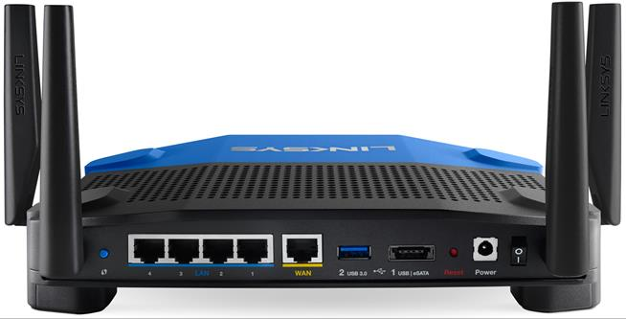
WAN port to the right of 4xEthernet ports on a Linksys wireless router/DSL modem
A filter (splitter) must be installed to separate voice and data signals. These can either be installed at the demarc point by the telco engineer or (more commonly) self-installed on each phone point by the customer.
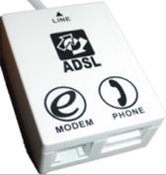
Self-installed DSL splitter
The ISP may supply a setup program to configure the connection. Alternatively, the 3Com DSL modem shown below provides a wizard-driven browser interface for configuring the relevant settings:
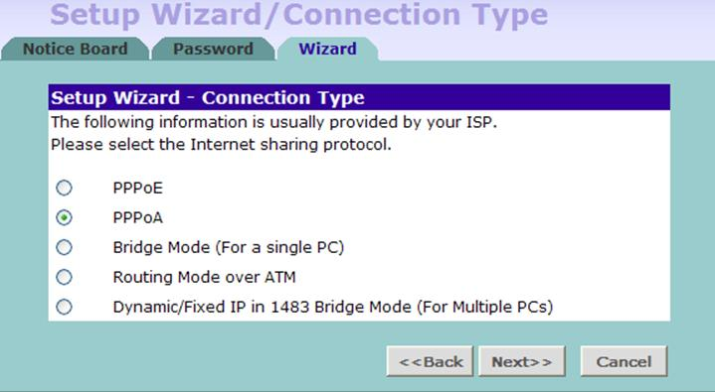
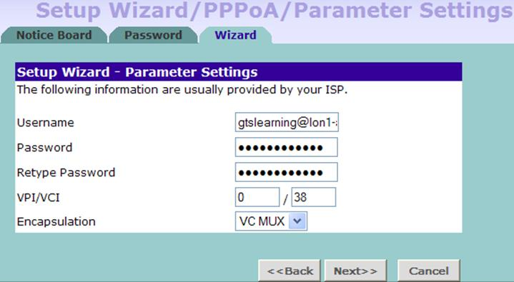
Configuring ADSL connection settings for an ISP using PPPoA (ATM)
An enterprise router could also be fitted with a DSL WAN Interface Card. This provides redundant access in the event that the main leased line fails or allows for out-of-band remote management.

Hybrid Fiber Coax (HFC) / Cable Modems
Installation of a cable modem follows the same general principles as for a DSL modem. Generally, the cable modem is interfaced to the computer through an Ethernet or USB adapter and with the access provider's network by a short segment of coax.

Troubleshooting WAN Issues
Since WAN links are widely used to provide internet access, either directly or indirectly via a link to another site with an internet connection, one of the first reported symptoms of a WAN issue is often loss of internet connectivity. Many different technologies and protocols are involved in successfully establishing an internet connection successfully. The failure of any one of these may lead to a dropped connection.
Taking a bottom-to-top troubleshooting approach (starting at the OSI model physical layer), we need to ensure basic device and cable connectivity and the presence of a signal. Are all devices powered up? Are all connectors firmly connected in place? Is there any sign of damage to cables? Are the correct cables being used (e.g. straight-through vs. crossover)? Do the physical interfaces or connectivity devices have indicator LEDs to show that a signal is detected? If so, do these confirm the presence of a signal? Do the connectivity devices feature troubleshooting tools that can report on common issues, such as low signal-to-noise ratio?
When basic physical connectivity has been confirmed, the next step is to ensure that data link connectivity is in place; that packets are being exchanged. There is some overlap here with the previous step as again there may be indicator LEDs to confirm this. If not, are there reporting tools in the connectivity devices that can confirm the number of packets sent and received. Do the devices provide error stats? Are the interface settings correct for the WAN link’s presentation? For example, if the link is presented as RJ-45 Ethernet, are the speed and duplex settings correct? For a serial connection, are baud rate, parity, and flow control correct?
Once it has been confirmed that packets are being exchanged across the link, we can move up to layers 3 and 4, to check that we have IP routing in place and can achieve connectivity with remote hosts. Again, approach this methodically, starting at the local host and working outwards. Use the ping command to test network layer connectivity. Can we ping the loopback address (127.0.0.1)? Can we ping the local host’s IP address? The default gateway? How about the IP address of the router at the remote end of the WAN link? Other remote IP addresses?
If at any point a ping fails, then we can use routing troubleshooting tools (tracert/traceroute or pathping, for example) to diagnose the issue. This may identify routing loops or black holes, for example. Resolution of routing issues would involve examining the configuration of routing protocols or of routing tables at the point where the trace fails or goes astray.
When we have determined that routing is in place and functioning correctly, we then need to consider the upper layer functions. Is name resolution working properly? If we can ping a remote host by IP address but not by FQDN, this would suggest a DNS issue, which we can troubleshoot using tools such as nslookup. If pinging by name works, is the service responding? Try using telnet to connect to the target server on the appropriate port to check whether a connection can be established. If not, this may suggest a firewall configuration issue or a failure of the service on the target server. Does your site use a proxy server for internet access? If so, are the proxy settings configured correctly? Is the proxy server responding? Again, try using telnet to verify basic connectivity with the appropriate port.

Interface Errors
WAN interface errors can often be diagnosed by means of indicator LEDs. There is normally at least one LED to indicate link status. For more detailed information, log into the device to query error statistics and the status of the interface. Sometimes, reinitializing the interface can clear an issue. This can be achieved by disconnecting and reconnecting the cable or through software by disabling and re-enabling the interface (the software equivalent of turning it off and on again). This is sometimes known as bouncing the interface.
 Do not try bouncing a WAN interface on a device to which you’re remotely connected via the WAN link, otherwise your connection will drop and you won’t be able to reactivate the link.

Interference
Running a continuous ping across a WAN link can be used to determine that interference may be present. Interference will be suggested by unusually high (possibly variable) round trip times, in comparison with the baseline for the link, along with occasional dropped packets. As these can also be symptoms of high bandwidth usage, it is necessary to confirm that interference is present. This can be diagnosed by checking the link’s signal-to-noise ratio, either by disconnecting the link and using cable testers or by using reporting tools built into the connectivity devices at either end of the link.

Satellite Issues
Satellite links use geostationary satellites to bounce signals between points on the ground. To be in geostationary orbit, the satellite must be a little more than 22,000 miles above the equator. This gives the signal a significant distance to travel and even at the speed of light the round trip can take at least 250ms, which leads to severe latency on the connection. This makes satellite links unsuitable for real-time applications. It must also be taken into account in troubleshooting satellite WAN links. On any other technology, we would usually consider ping times in excess of 500ms to be indicative of a major problem; with satellite links, they may well be considered normal.

Customer Premises Equipment (CPE)
Faults in the devices used to connect to the WAN link, collectively known as Customer Premises Equipment (CPE) may also cause issues with WAN connectivity. The term CPE can technically denote any equipment located behind the demarcation point (demarc). Depending on the WAN technology used, the CPE may also have sufficient self-diagnostic capability that it may be able to report on any detected faults. If a fault with the CPE is suspected, one approach is to swap it out with a known good replacement. However, it is important to note that these devices are often individually configured with parameters specific to the WAN link and therefore the configuration may need to be applied to the replacement unit before testing.
Another approach to CPE testing is to use a loopback cable. This is a short single-ended cable where the individual pins are looped back, such that transmit pins are connected back to receive pins in the same connector. This enables testing of the device while removing from consideration any possible issues with the WAN link itself or with the terminating device at the other end of the link.

Router Configurations
Where routing problems are present, these can normally be detected by using the tracert command. The most common problems are routing loops (indicated in the results by the same series of hops repeating over and over), or black holes (indicated by no returns beyond a given point). Either of these conditions can be further diagnosed and resolved by connecting to the last router that was returned along the expected route, just before the point where the results diverge from those expected and checking its routing table for the incorrect route. Depending on the type of route, this can either be resolved by manually reconfiguring the route, or by checking the configuration of the routing protocols and correcting any issues.
 You might be able to use a Looking Glass Server to inspect routing information in third-party networks. Refer back to Unit 2.5 / Routing / Study Notes for more information about troubleshooting routing issues.

DNS Issues and DNS Split Horizon
An inability to connect to a resource by FQDN usually indicates a problem with DNS. First, check the local settings to ensure that the client has the correct address for the DNS server. Check the DNS cache on the client for any incorrect cached data and flush the cache if necessary. Use nslookup to submit queries to the DNS server and verify the results. Within nslookup, use the server command to specify an alternate DNS server to submit the queries to for comparison, for example Google’s public facing DNS service on 8.8.8.8.
Where an organization uses a common DNS namespace for internal resources and for external internet-based resources, it is often necessary to present two different views of the DNS namespace, one for internal clients and another for external clients. This is partly because internal clients will use private IP addresses to access the resources, while external clients must use the NAT-based public IP addresses. Also, there will typically be many resources within the network that should not be exposed to external clients and for security reasons it is preferable not to resolve these names to IP addresses when queried from outside the network. This DNS configuration is known as split horizon. When it is used, it is important to ensure that clients are being correctly identified as either internal or external as appropriate and the correct view presented. Again, this can be tested using nslookup.

Security Policy
If WAN connectivity issues are suspected, it is important to check that the symptoms reported are in fact faults, rather than expected behavior of the system. In some instances, restrictions enforced by the security policy (either internal company policy or enforced externally by the service provider) may be misinterpreted as faults. For example, if the terms of the service provider’s contract include a fair use policy or download limit, then the available bandwidth may be limited (throttled) if usage is considered excessive or the link may drop completely (blocked) when the download limit is reached. While these effects may appear to be faults to the user, they are actually within the normal performance criteria for the link.
Likewise, in troubleshooting internet connectivity issues, it may prove impossible to use ping or tracert to check routing if the firewall is set to block ICMP traffic. This is a common security policy, due to concerns about the security of the protocol. Similarly, if a connectivity issue only affects specific websites, it is possible that those sites have been specifically blocked by the proxy server.

