UNIT 4.4 / WAN TECHNOLOGIES / STUDY NOTES

Wide Area Networks (WAN)
Wide Area Network (WAN) technologies support data communication over greater distances than LANs. Remote connectivity methods often involve the use of "public networks". WAN connection services are often leased from a service provider, typically, a telecommunications company (telco) because dedicated links are too expensive and complex for most organizations to implement and maintain. Service providers often have rights of access to locations that are not available to other organizations (for example, under roads). The term enterprise WAN is used to describe a WAN that is used and controlled by a single organization.

Circuit Switching versus Packet Switching WANs
Just like on a LAN, switching is the process used to connect source and destination nodes and the process by which the data is forwarded at intermediary points.
Circuit switching enables a temporary dedicated path to be established between two locations such as two routers. The routers negotiate a link then once the connection is established, all communications are forwarded along the same path. At the end of the communication, the connection is broken down and the path becomes available for another connection to utilize.
Circuit switched networks provide guaranteed bandwidth. The overall level of network utilization has no effect on performance because the connection is dedicated. Predictable levels of bandwidth are important for time-sensitive data such as voice and video. On the downside, circuit switched networks make inefficient use of the media as, by definition, a dedicated channel cannot be shared even when it is not being utilized. The technology is also impractical for some applications because they time-out before a circuit is established.
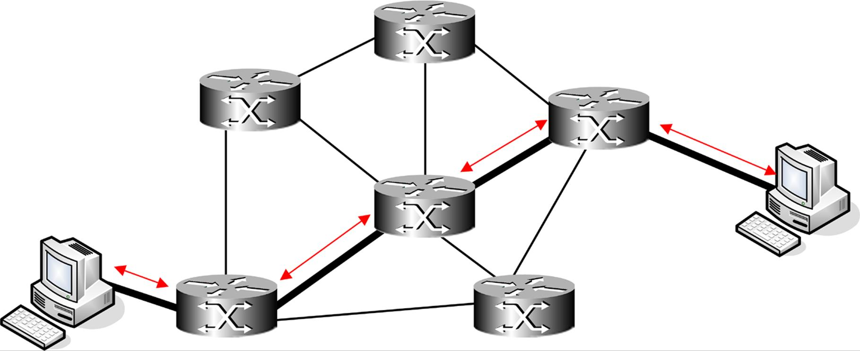
Circuit switched networks provide a dedicated path between nodes
Packet switching technology was developed on the basis that subscribers share the network infrastructure and pay only for the bandwidth they consume. It is a cost-effective alternative to dedicated lines and provides more efficient use of the network infrastructure than circuit switched technology.
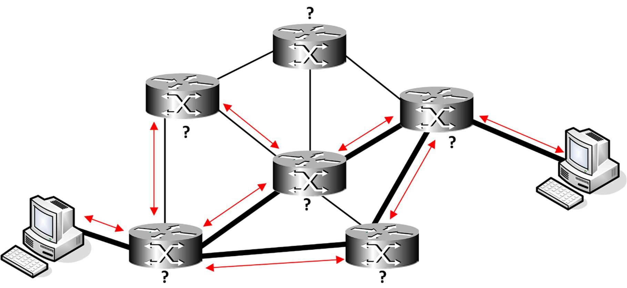
Packet switching networks generally allow data to take multiple paths
With connectionless packet switching, the individual packets are routed to their destination using media shared with other data so there is normally no guarantee of bandwidth. Packet switched networks provide optimal use of available bandwidth. There is no connection setup delay and the packets can be routed around link problems. The cost is spread across all network users.
Connection-oriented (or Virtual Circuit Packet Switching) establishes a specific path for all packets to follow. This is known as a logical connection or virtual circuit. The connection is established once the source and destination machines agree on communication parameters. This is less flexible than connectionless packet switching but does allow more control over the link properties. This technology is often used for time-sensitive services such as video and voice.

WAN Topologies
Many WAN links are point-to-point; that is a single link to connect two sites.
There may be circumstances in which an organization needs links between more than two sites. This can be implemented by creating a full mesh (each site has a link to every other site) or a partial mesh (each site has a link to some of the other sites). This arrangement offers redundancy but is likely to be costly in terms of the number of links that have to be provisioned.
A cheaper alternative is a hub and spoke topology. This can function like a star topology, where all communications are channeled via the hub network (so each site has one link to the hub). In this scenario, the hub represents a Single Point of Failure however; if the hub becomes inoperable, no site can communicate with any other site.

Telecommunications Networks
Public networks are owned by telecommunications companies and provide WAN services to organizations. Organizations often choose to use public networks as the cost is far less than implementing a private solution. There are many public networks offering a variety of different services.
The development of telecommunications and data networks varies from region-to-region but is typically promoted by a mixture of state and market-driven initiatives. Interoperability between international telcos is often guided by standards set by the International Telecommunication Union (ITU) [www.itu.int].
The Internet Engineering Task Force (IETF) [www.ietf.org] develops standards for communications over the Internet but is mostly focused on network, transport, and application layer protocols.

Public Switched Telephone Network (PSTN)
National telecommunications systems have evolved and combined over the years to create a global (and indeed extra-terrestrial) communications network. This is referred to as the Public Switched Telephone Network (PSTN) but it is capable of carrying more than voice call services. The basis of PSTN is a circuit switched network but the infrastructure can also carry packet switched data services.
PSTN was designed for transferring voice information. It works by establishing a temporary dedicated circuit between two locations when the conversation commences and then "tears down" the connection when the conversation ends. The Signaling System # 7 (SS7) protocol suite provides these functions.
The PSTN can be conceived as a number of zones:
- Customer Premises Equipment (CPE) - termination and routing equipment placed at the customer site. Some of this equipment may be owned or leased from the telco; some may be owned by the customer.
- Local loop - cabling from the customer premises to the local exchange. The point at which the telco's cabling enters the customer premises is referred to as the demarcation point (often shortened to "demarc").
- Local exchange - switches links between local access subscribers and provides transports to trunk exchanges. The local exchange is also referred to as a Class 5 office or Central Office (CO) while in the US a local telephone company is called a Local Exchange Carrier (LEC).
- Trunk offices - provide switching and interconnections between local exchanges within a metropolitan area or nationally and to international gateway services. Trunk offices are also referred to as Class 4 or toll offices.
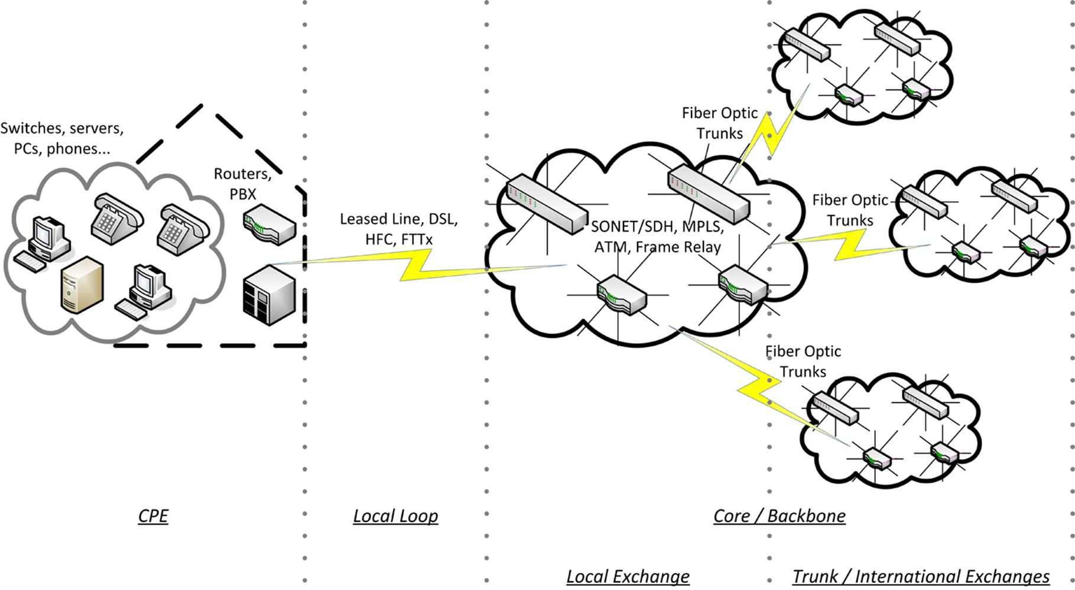
Telecommunications networks
While the trunks between the infrastructure parts of the telephone network (the "core" or the "cloud") have been upgraded to fiber optic links, the "local loop" between the local telephone office and a customer's premises often remains voice-grade copper wire, not capable of supporting high bandwidth applications. This part of the network is referred to as the Plain Old Telephone Service (POTS).

The Internet
The major infrastructure underpinning the Internet is the fiber optic trunks maintained by the telecommunications providers. These trunks provide connections within and between metropolitan areas and continents. The interconnections between these trunk lines are referred to as Network Access Points (NAP). The NAPs are administered by first tier Network Service Providers (NSP).
Tier 2 Internet Service Providers (ISP) connect to the NAPs then provide downstream transit to tier 3 ISPs or directly to customer networks or to lower tier ISPs and resellers. Customers connect to the ISP's network via a local Point of Presence (PoP) and their communications are then switched or routed to the appropriate destination.
Tier 2 and 3 ISPs are also likely to pool services within an Internet eXchange Point (IXP). This means that communications within the ISPs' networks can be switched efficiently and the ISPs all share the costs of routing communications to the wider internet (peering arrangements).
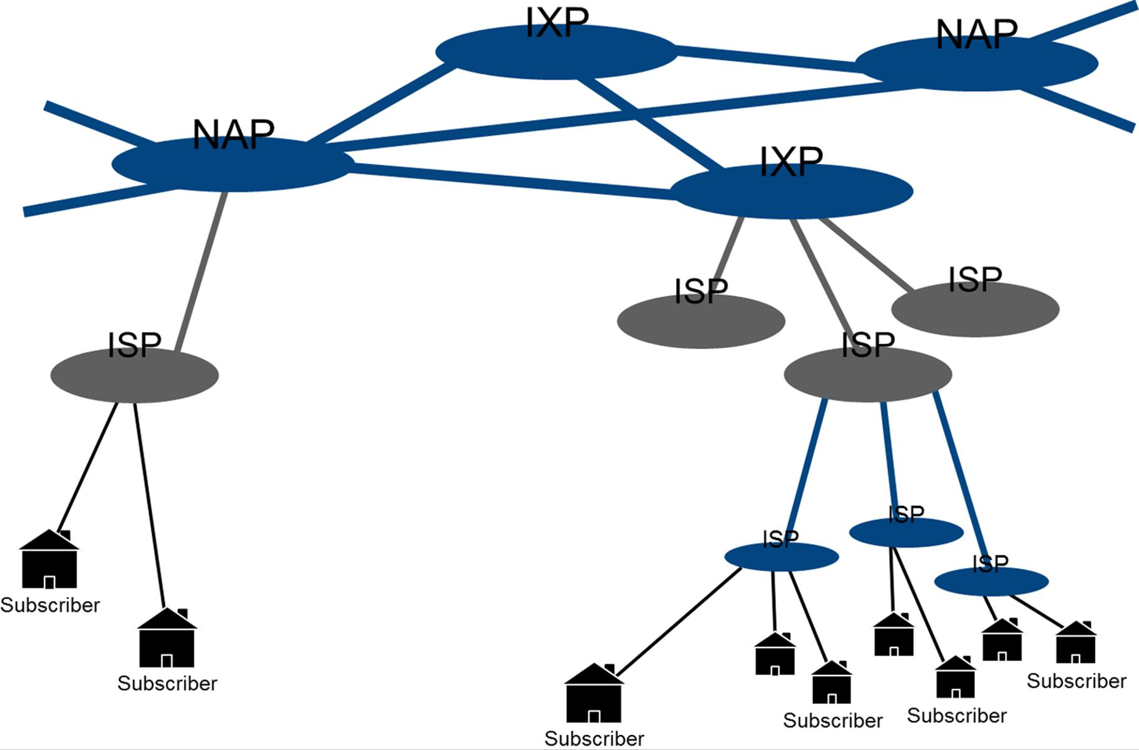
Internet access services

PDH / DSx (or T-Carrier) and Leased Lines
The first generation of Digital Signaling (DS) to be implemented on telecommunications networks was the Plesiochronous Digital Hierarchy (PDH) or T-carrier system. It was developed by Bell Labs to allow multiple calls to be placed on a single cable. PDH enabled voice traffic to be digitized for transport around the core network. It also enabled other types of digital data to be transported.
PDH is based on Time Division Multiplexing (TDM). This enables multiple circuits to be carried over the same media. The protocol assigns each circuit (or channel) a time slot. PDH is an asynchronous version of TDM, meaning that timing signals from the various components are not accurately synchronized ("plesiochronous" or "small timing differences").
Each channel provides enough bandwidth for a voice communication session, digitized using Pulse Code Modulation (PCM). A single 64 Kbps channel is known as a DS0 or narrowband link. For leased line data services however, the foundation level of T-carrier is the DS1 or T1 digital signal circuit. This service comprises 24 channels of 64 Kbps time multiplexed into a single digital connection that can be used for voice, video, and data signals. The devices performing the multiplexing are often referred to as muxes.
The T1 lines themselves can be multiplexed to provide even more bandwidth.

US and Japanese Designations
DSx | Bandwidth | Channels | T1 Units
DS0 | 64 Kbps | 1 | -
DS1 (T1/J1) | 1.544 Mbps | 24 | 1
DS3 (T3) | 44.736 Mbps | 672 | 28
J3 | 32.064 Mbps | 480 | 20

European and Rest of World Designations
T-carrier is a US designation. In Europe, the system is based around the CEPT / E-carrier equivalent. The E-carrier standards specify 32 channels per unit rather than 24, though two are used for connection control rather than data transport.
CEPT | Bandwidth | Channels | E1 Units
CEPT0 | 64 Kbps | 1 | -
CEPT1 (E1) | 2.048 Mbps | 32 | 1
CEPT3 (E3) | 34.368 Mbps | 512 | 16

Modern Telecommunications Networks
The second generation of digital transmission standards is known as the Synchronous Digital Hierarchy (SDH) as standardized by the ITU or Synchronous Optical Network (SONET), as standardized by ANSI.

Synchronous Optical Network
SDH/SONET was developed principally to provide a standard transport mechanism for the various proprietary PDH fiber optic networks that had been installed over the years. As such, SDH/SONET is principally a physical layer standard, defining infrastructure, line speeds, and so on. There is an SDH/SONET frame format, but this is designed to transport frames from higher level protocols rather than provide any sort of addressing capability.
Like PDH, SHD/SONET uses Time Division Multiplexing but unlike PDH it is synchronous, meaning that all elements in the network are precisely synchronized to the same time signal. This allows data to be transported very efficiently with little control information required.
The service offers a hierarchy of bandwidth levels based on a basic transmission rate of Synchronous Transport Signals(STS-1) that provides 51.48 Mbps of bandwidth, of which 50.84 Mbps is available to the payload (the remainder is used for control information). The SONET standard refers to STS while SDH calls the frames Synchronous Transport Modules (STM). Higher rates are multiples of the basic rate, achieved by multiplexing. Optical Carrier X (OCx) is another way of designating this speed. That is, OC-3 is the equivalent of STS-3, and OC-12 the equivalent of STS-12.
SONET | SDH | Data Rate
STS-1 / OC-1 | STM-0 | 51.84 Mbps
STS-3 / OC-3 | STM-1 | 155.52 Mbps
STS-12 / OC-12 | STM-4 | 622.08 Mbps
STS-48 / OC-48 | STM-16 | 2.488 Gbps
STS-96 / OC-96 | STM-32 | 4.876 Gbps
STS-192 / OC-192 | STM-64 | 9.953 Gbps
STS-768 / OC-768 | STM-256 | 39.813 Gbps
SDH/SONET supports the mesh architecture but is more typically installed in a dual counter-rotating ring topology. Each node is connected by a fiber optic pair with data travelling around the network in a clockwise direction. A second, redundant ring transports data in a counter-clockwise direction and can be "cut-in" in the event that the main cable between two nodes suffers a failure.
The sets of cables could be installed separately from one another to provide redundancy in the event of some physical catastrophe (construction workers cutting the cable, earthquake, and so on).
The nodes in the SDH/SONET infrastructure are usually Add-Drop Multiplexers (ADM). These devices allow inputs from lower bit rate streams to be added and removed (for example, adding or dropping T1 or T3 traffic from an OC-192 trunk).
SDH/SONET is now the mainstream standard for telecommunications trunk lines. However, the future may well see converged voice and data networks based entirely on 10G Ethernet (and better) and IP standards.

Wavelength Division Multiplexing
Wavelength Division Multiplexing (WDM) is a means of making more use of the bandwidth available in a fiber optic cable. Rather than allocating each channel a time slot (as in TDM and SONET), WDM involves transmitting multiple wavelengths (colors) of light down the same fiber (and also allowing for bidirectional communication across the same fiber). There are two types of WDM:
- Coarse Wavelength Division Multiplexing (CWDM) uses up to 16 (one-way) or 8 (bi-directional) channels with capacity up to 10 Gbps, depending on link length. CWDM is better suited to city-size metro WANs.
- Dense Wavelength Division Multiplexing (DWDM) uses more densely packed frequencies than CWDM and can support over 100 channels. DWDM is best suited to long range regional links.
The telcos have used WDM to maximize the capacity of long distance fiber optic trunks and the technology underpins the higher OCx rates. This use of both SONET and WDM is referred to as the overlay model. This is being standardized by the ITU as the Optical Transport Network (OTN).
Another use for WDM is to obtain more bandwidth from existing fiber backbone links in enterprise and campus networks. WDM transceivers are available as plug-in modules for enterprise switches and routers. A fiber link consisting of a single cable supporting 10 Gbps could be leveraged to provide many multiples of that using WDM without any need to run new cabling.

10G Ethernet WAN PHY and Metro Ethernet
The WAN PHY specifications in the Ethernet 10G standard are designed to be interoperable with SONET OC-192 and WDM, meaning that an Ethernet frame can be encapsulated within an STM-64 frame (making the usable data rate 9.29 Gbps rather than 10!).
Specification | Cable | Maximum Distance
10GBASE-SW | MMF / 850nm | 26-300m
10GBASE-LW | SMF (9/125) / 1310nm | 10km (6.2 miles)
10GBASE-EW | SMF (9/125) / 1550nm | 40km (25 miles)
For some applications, the use of WDM can make the over layering of SONET seem unnecessary. An alternative architecture consists of 10G Ethernet / IP running directly on WDM links, where each wavelength channel is a 10G Ethernet link. This is referred to as the peer-to-peer model. A city-wide Ethernet network based on this model is referred to as Metro Ethernet.

Packet Switched WAN Services
Standards such as PDH and SDH/SONET provide the physical infrastructure and protocols such as SS7 deliver circuit switching for telecommunications networks. Data services must also use OSI model layer 2 protocols (data link) to mediate factors such as media access and switching.
The principal packet switched technologies in use in WANs are:
- Frame Relay.
- Asynchronous Transfer Mode (ATM).
- Multiprotocol Label Switching (MPLS).

Frame Relay
Frame relay evolved from the earlier packet switching protocol X.25 in the 1990s. It provides data packet forwarding for services running over T-carrier lines, ISDN, or even dial-up. The advantage when used with T-carrier is that the customer can select an appropriate bandwidth level (the Committed Information Rate [CIR]) rather than having to incur the full cost of a T1 leased line. Its principal use now is to interconnect LANs where DSL or HFC services (see later) are not available.
Frame relay uses variable-length packets of up to 4096 bytes. It can encapsulate data from higher-level protocols, including TCP/IP.
X.25 was based on the use of analog equipment and therefore required error checking and correction information to be transmitted and calculated at each node, creating a substantial overhead. Frame relay takes advantage of reliable digital lines and terminal equipment and leaves error detection to the communication endpoints. Frame relay also makes use of connection-oriented virtual circuits that avoid fragmentation or reassembling of packets. Virtual circuits are either permanent (PVC) or switched (SVC). PVCs are more prevalent. In a PVC, the connection information (call setup) is permanently available; in an SVC it is established dynamically when needed (analogous to dial-up connections). The actual path through the network is not fixed (hence "virtual circuit") but can be managed by the telecoms provider using its switches. This process is transparent to the end user. All these factors mean that the overhead on the network is reduced (compared to X.25), resulting in a more efficient network with far higher throughput.
Frame relay provides mechanisms for the service provider to perform congestion control and maintain available bandwidth to an agreed service level, providing Quality of Service (QoS) for latency-sensitive applications such as Voice over IP (VoIP).

Asynchronous Transfer Mode (ATM)
Asynchronous Transfer Mode (ATM) is a type of packet switching that provides a high-speed transport mechanism for all types of data including voice and video. It is standardized as part of the ITU's Broadband ISDN standard and was maintained by a consortium called the ATM Forum. The ATM Forum has now been merged, along with the Frame Relay Alliance, into the IP/MPLS Forum (www.ipmplsforum.org).
ATM uses a cell switching (or cell relay) technology. An ATM cell is a small (53 byte), fixed-length packet that contains 48 bytes of data and 5 bytes of header information. The combination of a consistent cell size, which reduces processing overhead during switching, and the use of faster hardware-based switches (working at up to OC-192) means high levels of capacity can be achieved. The small size of the cells and their fixed length mean traffic is predictable so time-sensitive data is readily accommodated.
ATM was designed for use in both LAN and WAN environments. In the event, it never displaced Ethernet as the dominant LAN product but it remains much more popular as a WAN transport. ISPs use ATM running over SDH/SONET to aggregate disparate services such as DSL, Ethernet, PPP, and Frame Relay. ATM can make use of a variety of physical media but in most implementations runs over either T1/T3 links or SDH/SONET.
ATM is designed to make highly efficient use of the available bandwidth, with switches used to multiplex data simultaneously from multiple sources onto the network. The header information identifies the virtual circuit required for the cell to reach its destination and also allows bandwidth to be dedicated to particular data. The use of a virtual circuit means the packets arrive in order and can be quickly processed.
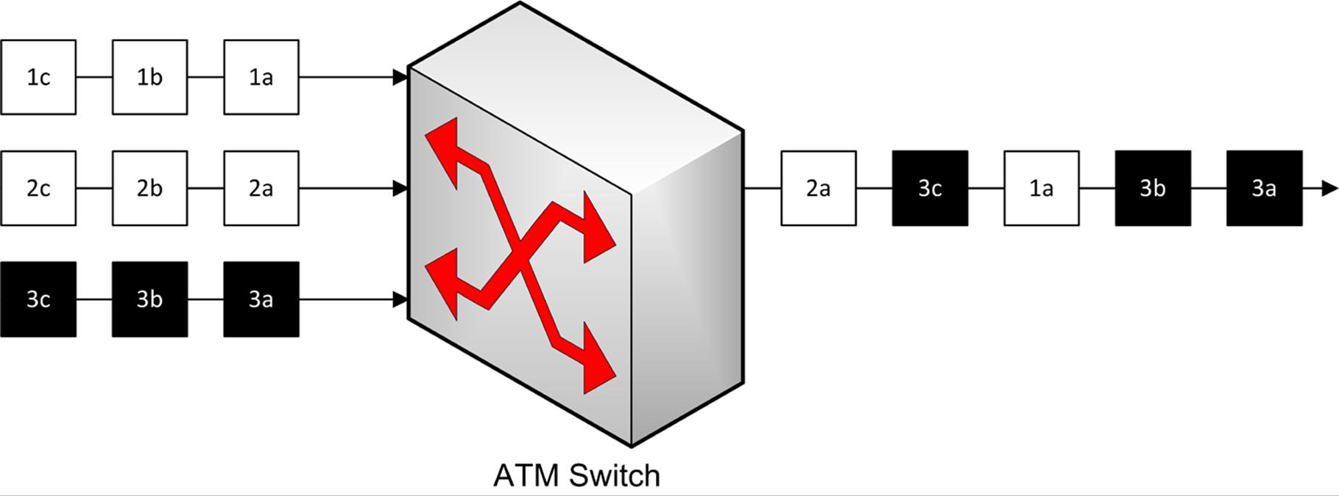
ATM
The figure above shows an example of a switch allocating additional bandwidth to data source 3 while continuing to provide some bandwidth to the other data sources (1 and 2). ATM combines the bandwidth guarantee of circuit switching with the efficient use of bandwidth provided by packet switching.
ATM has been widely implemented by telecommunication companies and ISPs because it provides mechanisms for traffic shaping and policing and Quality of Service (QoS) and the ability to aggregate different types of traffic. However, as the use of fiber optic and WDM makes more bandwidth available, ATM becomes less efficient when transporting protocols with large frame sizes or PDUs (such as Ethernet / IP), as the small cell size means that a substantial overhead is introduced in disassembling and reassembling packets. Consequently, the market is developing towards the use of native IP solutions with MPLS providing traffic shaping and QoS.

Multiprotocol Label Switching (MPLS)
IP is almost universally deployed on LANs and is the basis for the Internet. However IP has not been deployed on telecommunications networks because it has no real means of providing traffic shaping or QoS. These functions have been provided by ATM but the use of small cell sizes that makes ATM highly suitable for carrying voice traffic also make it inefficient when carrying packet data such as IP. Multiprotocol Label Switching (MPLS) was developed by Cisco from ATM as a means of providing traffic engineering (congestion control), Class of Service, and Quality of Service within a packet switched, rather than circuit switched, network. MPLS has subsequently been standardized by the IETF (RFC 3031).
In effect, MPLS achieves a marriage of layer 3-based routing with layer 2-based switching. Where Frame Relay and ATM provide connection-oriented transfer by establishing a virtual circuit / channel, MPLS establishes connections via Label Switched Paths (LSP) enabled by a mesh network of Label Switched Routers (LSR). One of the benefits of MPLS is that ATM switches can usually be re-engineered to act as LSRs, reducing initial deployment costs by retaining existing hardware.
For example, in the diagram below the Customer Premises Equipment (CPE) router at site 1 wants to communicate with site 4. The router is attached to the service provider's MPLS cloud via a Label Edge Router (LER). This router inserts or "pushes" a label or "shim" header into each packet sent from CPE1 then forwards it to an LSR.
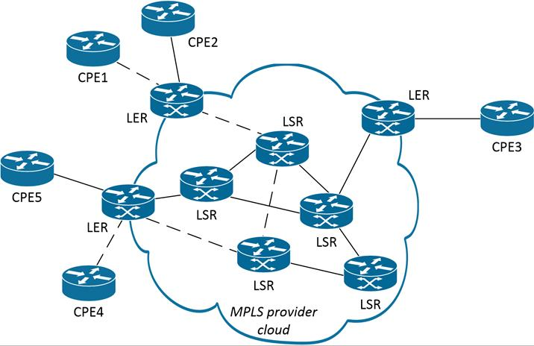
MPLS topology
Each LSR examines the shim and determines the Label Switched Path (LSP) for the packet, based on the type of data, network congestion, and any other traffic engineering parameters determined by the service provider. The shim is removed (or "popped") by the egress LER and delivered to CPE4.
Where an IP router uses best-effort delivery to find the shortest available path to a given destination, the MPLS signaling protocols allow constraint-based routing, which enables the network manager to add congestion, class of service, application type, and QoS to the criteria used for path selection.

Local Loop Services
While technologies such as SDH/SONET, ATM, and MPLS enable traffic to be carried over telecommunications trunks, the trickiest part of providing services to subscribers tends to be the connection over the "local loop". For a traditional telco, the local loop is likely to be a voice-grade twisted pair network. Cable TV companies have more widespread fiber optic networks but even these are traditionally connected to customer premises by coax cabling. Both sets of companies are investing in infrastructure to provide fiber optic connections directly (or at least more directly) to customer premises. In the meantime, various technologies have been developed to provide fast "broadband" connections over the local loop.

Dial-up Services
The most basic means of establishing a data network connection over the POTS is the dial-up modem. While this offers only very low bandwidth, it remains an almost universally supported fallback option when no other means of making a connection is available.
To implement dial-up link, a modem installed on the user's computer is connected to a phone line (1-pair or 2-pair copper cable). To initiate a connection, the modem dials the telephone number of the Internet Service Provider's access concentrator, which is a server installed with a modem pool.
The connection is typically established using the Point-to-Point Protocol (PPP), which allows for the user to be authenticated and TCP/IP packets to be tunneled over the connection and routed over the wider internet.
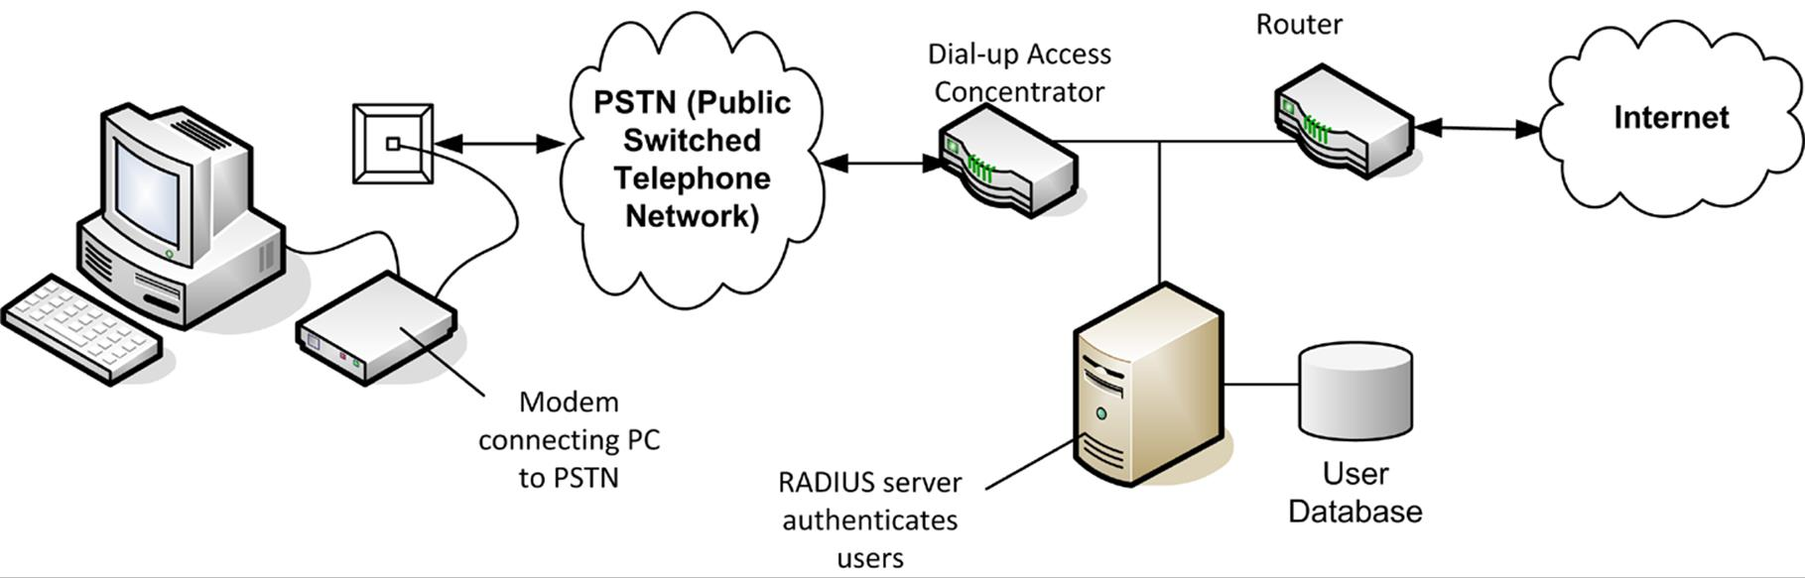
Legacy dial-up Small Office / Home Office (SOHO) internet access topology
To be transferred over the phone line, data must be converted from digital to analog using a modem at each end of the connection. Modem is short for modulator/demodulator; modulation is the process of converting digital signals to analog, and demodulation is the reverse process (analog to digital).
The main disadvantage of this system is low data transfer rates and error prone links. A low quality connection can result in high errors, and consequently reduced speed and throughput. This means that the fastest modems can only work at 33.6 Kbps (V.34+) and this speed is reaching the limitations of analog lines. Using the V.90 or V.92 protocol, where the ISP's modem pool has a digital connection to the PSTN (as it usually will), downlink speeds of up 56 Kbps are possible in theory, though rarely achieved in practice.
The slow establishment of the circuit can also cause problems with some applications.

Dedicated / Leased Lines
A dial-up line provides a temporary, circuit switched connection using the telephone network. Each transmission using a dial-up line must establish a circuit between the source and destination machines. A dedicated (or leased) line, on the other hand, provides a permanent connection that links two locations using any one of a variety of technologies.
Digital leased lines use devices called Channel Service Units or Data Service Units (CSU/DSU) instead of the modems used for analog systems. These convert the Ethernet frames from the router to the frame format and digital signaling supported by the WAN environment. They can also provide protection for the service provider's network and line test facilities. Typically, a T0 or T1 (E0 or E1) link is used to link locations within an organization. The figure below shows two LANs connected using a dedicated digital line. The router or bridge on the LAN connects to the leased line through the CSU/DSU device.
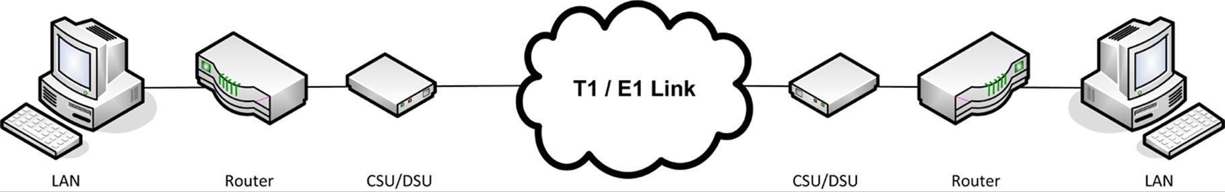
Leased lines connecting two sites
Often a customer may not require a full T1 or T3 service. The service provider can provide a cheaper fractional T1 (FT1) or fractional T3 (FT3) service, which provides a portion of the total bandwidth. For example, a T1 line can be divided into increments of 64 Kbps.

ISDN
ISDN (Integrated Services Digital Network) is a fully digital version of the local loop, standardized by the ITU. It has been provided by telecommunication companies since the 1980s. ISDN is a digital circuit switched technology for voice, video, and data (hence "integrated services"). Although ISDN makes use of existing copper telephone wiring (if the wiring is of sufficient quality), its implementation was complicated by the requirement to upgrade analog equipment to digital equipment.
ISDN is a dial-up service billed for by line rental and usage. The most common uses of ISDN are for interconnection of LANs and remote users (teleworkers) to businesses.
There are two classes of ISDN:
- Basic Rate Interface (BRI) provides two 64 Kbps B channels for data and one 16 Kbps D channel for link management control signals. It is sometimes called 2B+D. It is common to use one B channel for data and leave the other for voice or fax but can also provide a 128 Kbps connection by concatenating the two B channels. This form of ISDN is intended for Small Office Home Office (SOHO) use.
- Primary Rate Interface (PRI) provides either T1 or E1 capacity levels (23B or 30B channels, depending on location in the world) and one 64 Kbps D channel. This form of ISDN is intended for larger companies and is commonly used to provide a leased line between two company locations.
Although ISDN is a dial-up technology, it is capable of establishing a circuit connection in less than 1 second. This means that many applications that time-out when using the analog modems can be used with ISDN.
Much of the switching technology of ISDN remains in use in terms of the telecommunications core network but in terms of a WAN access method for subscribers it has largely been superseded by DSL and HFC (see below). It remains a good solution outside metropolitan areas where these other services are not available. ISDN also still remains popular as an underlying technology for implementing Video Teleconferencing (VTC) applications over wide area networks. Such implementations involve bonding multiple BRI channels to provide sufficient bandwidth to stream simultaneous audio, video, and data connections between participants.

DSL (Digital Subscriber Line)
Digital Subscriber Line (DSL) is a technology for transferring data over voice-grade telephone lines. DSL uses the higher frequencies available in a copper telephone line as a communications channel. The use of a filter prevents this from contaminating voice traffic with noise. The use of advanced modulation and echo cancelling techniques enable high bandwidth, full-duplex transmissions.
A DSL modem is installed as customer premises equipment, typically as some sort of combined router and LAN switch. This provides network ports for connection to computers and switches on the LAN and a WAN port for connection to the phone line. The phone line then makes the connection to a bank of DSL modems in the exchange, called a DSL Access Multiplier (DSLAM). The DSLAM channels voice and data traffic to the appropriate network. Depending on the equipment used by the ISP, the data link protocol used for DSL may be PPP over ATM (PPPoA) or PPP over Ethernet (PPPoE). The connection is "always on", meaning that there is no need to dial to initiate access and no call charges are incurred.
The main drawback of DSL is that as a copper-wire technology it suffers from attenuation. The maximum range of a DSL modem is typically about 3 miles (5 km) but the longer the connection, the greater the deterioration in data rate. Domestic cabling may also be relatively poor quality and pass through "noisy" environments.
There are various "flavors" of DSL, notably SDSL, G.SHDSL, ADSL, and VDSL. Of these, G.SHDSL, ADSL, and VDSL are standardized by the ITU in a series of recommendations coded G.991 through G.993.

Asymmetrical DSL (ADSL)
Asymmetrical DSL (ADSL) (G.992.1) is a "consumer" version of DSL that restricts upload speeds dramatically (from a half to an eighth of the download speed). ADSL is also packaged in a number of bandwidths, with downlink rates from 256 Kbps up to about 8 Mbps and uplink rates between 64 Kbps and 800 Kbps. Often service providers impose usage restrictions to limit the amount of data downloaded per month. Actual speed may be affected by the quality of the cabling in the consumer's premises and between the premises and the exchange and also by the number of users connected to the same DSLAM (contention).
ADSL2 (G.992.3/4) supports higher data rates (up to 12 Mbps downstream and 1 Mbps uplink) and slightly greater range (about 5% extra). ADSL2+ (G.992.5) offers downlink speeds up to about 24 Mbps but this sort of bandwidth can only be expected from within a mile or so of the exchange.

Very High Bitrate DSL (VDSL)
Very High Bitrate DSL (VDSL) (G.993.1) achieves higher bit rates at the expense of range. It allows for both symmetric and asymmetric modes. Over 300m (1000 feet), an asymmetric link supports 52 Mbps downstream and 6 Mbps upstream while a symmetric link supports 26 Mbps in both directions. VDSL2 (G.993.2) also specifies a very short range (100m / 300 feet) rate of 100 Mbps (bi-directional).
VDSL supports Fiber to the Curb (FTTC), where the fiber optic network is extended from exchanges to much closer to customer premises. In this scenario, the section linking customer premises equipment to the fiber loop (a DSLAM installed in the telco's equipment cabinet in the nearby street) only requires the sort of range associated with local networks. This enables the telcos to develop "triple play" networks that can compete with the cable and satellite TV operators. "Triple play" means delivering TV (specifically High Definition TV), broadband internet, and voice simultaneously over the same link.

Hybrid Fiber Coax (HFC) / Broadband Cable
A cable internet connection is usually available along with a cable telephone/television service (Cable Access TV [CATV]). These networks are often described as Hybrid Fiber Coax (HFC) as they combine a fiber optic core network with coax links to customer premises equipment, but are more simply just described as "broadband cable". The cable operators and telcos are competing with one another to provide "triple play" networks and the investment in fiber optic links has given the cable operators something of an advantage.
Generally, the cable modem is interfaced to the computer through an Ethernet adapter and with the cable network by a short segment of coax. More coax then links all the premises in a street with a Cable Modem Termination System (CMTS), which routes data traffic via the fiber backbone (typically a SONET ring) to the ISP's Point of Presence (PoP) and from there to the Internet. Cable based on the Data Over Cable Service Interface Specification (DOCSIS) supports downlink speeds of up to 38 Mbps (North America) or 50 Mbps (Europe) and uplinks of up to 27 Mbps. DOCSIS version 3 allows the use of multiplexed channels to achieve higher bandwidth

FTTx
As mentioned above, the traditional phone companies and the cable TV operators want to provide the same sort of converged "triple play" services to consumers. The major obstacle to doing this is bandwidth in the "last mile", where the wiring infrastructure is generally not good. The projects to update this wiring to use fiber optic links are referred to by the umbrella term "Fiber to the X" (FTTx).
The most expensive solution is Fiber to the Premises (FTTP) or its domestic variant Fiber to the Home (FTTH). The essential point about both these implementations is that the fiber link is terminated on Customer Premises Equipment. Other solutions can variously be described as Fiber to the Node (FTTN) or Fiber to the Curb (FTTC). These retain some sort of copper wiring (twisted pair or coax) while extending the fiber link to a communications cabinet servicing multiple subscribers. One of the significant difficulties of this approach, apart from laying the cable, is locating and securing the cabinet.

Wireless WAN Services
Wireless technologies are now well established in terms of local and "personal" area networking. There are three main technologies involved in providing Wireless WANs (WWAN): cellular radio, packet radio, and microwave satellite.

Cellular Radio (GSM and CDMA)
A cellular phone makes a connection using the nearest available transmitter (cell or base station). Each base station has an effective range of up to 5 miles (8 km). The transmitter connects the phone to the mobile and PSTN networks. Transmitter coverage in many countries is now very good, with the exception of remote rural areas. Signals can also be blocked by thick walls and devices that cause radio interference. Cellular radio works in the 850 and 1900 MHz frequency bands (mostly in the Americas) and the 900 and 1800 MHz bands (rest of the world).
Cellular digital communications standards are described as belonging to a particular "generation". 2G typically describes GSM (Global System for Mobile Communication)-based phones or, in the Americas, the TIA/EIA standard IS-95 (cdmaOne [Code Division Multiple Access]). GSM allows subscribers to use a SIM (Subscriber Identity Module) card to use an unlocked handset with their chosen network provider. CDMA locks the handset to the original provider.
In both cases, the cell network was built primarily to support voice calls, so 2G data access was provided "on top", using Circuit Switched Data (CSD). CSD is somewhat similar to a dial-up modem, though no analog transmissions are involved. CSD requires a data connection to be established to the base station (incurring call charges) and is only capable of around 14.4 Kbps at best.

Packet Radio
Cellular radio systems have been developed by both traditional landline telcos and mobile-only operators. To these operators, circuit switched voice is the primary application and data / internet access is (or was) secondary. Broadband WWAN and WMAN (Wireless Metropolitan Area Network) packet radio systems are being developed by the "network data" community and formulated as IEEE standards. While emphasizing data over voice, these standards are also intended to capture packetized voice (and video) market share from the telcos. Consequently, the newer standards build in mechanisms to support Class of Service and Quality of Service that are essential to running time-sensitive network services.
One of the main obstacles to adoption of WWAN broadband is the allocation of frequencies in the microwave spectrum by different national and regional agencies. Frequencies above 5 GHz are largely available for use but require Line-Of-Sight (LOS) installation, use more power, and are adversely affected by atmospheric conditions (rain and fog).
The lower part of the frequency spectrum is more crowded and there is greater scope for different technologies to interfere with one another.
In the last decade however, improved methods of modulation have resulted in the development of high bandwidth services that do not require line-of-sight.

WiMAX
WiMAX is the brand name for the IEEE 802.16 standards series. This defines various uses of fixed and roaming broadband wireless technologies. The goal is to provide Wi-Fi-like services with much greater range. WiMAX is also able to deliver both point-to-point (individual subscriber) and point-to-multipoint (broadcast) services. Radio spectrum allocation for WiMAX is not agreed internationally, though the WiMAX forum proposes the 2.3, 2.5, or 3.5 GHz frequency bands.
- Fixed WiMAX - a base station provides non-line-of-sight services to subscriber stations (Customer Premises Equipment). These could be indoor or outdoor access points. Each base station should support a 40 Mbps downstream service for an area of about 6 miles (or 10 km).
- Mobile WiMAX - provides services to and between roaming devices, moving at speed, such as passengers on a train or broadcasts from a moving emergency vehicle.
WiMAX 2 (802.16m) is being developed to support 4G (International Mobile Telecommunications [IMT] Advanced) data rates (see below).

3GPP
The 3rd Generation Partnership Project (www.3gpp.org) largely represents the interests of the cellular providers and is developing its own standards to compete with those proposed by IEEE.
- GPRS / EDGE (General Packet Radio Services / Enhanced Data Rates for GSM Evolution) is a precursor to 3G (2.5G) with GPRS offering up to about 48 Kbps and EDGE about 3-4 times that. Unlike CSD, GPRS and EDGE allow "always on" data connections, with usage billed by bandwidth consumption rather than connection time.
- Evolved High Speed Packet Access (HSPA+) is a 3G standard developed via several iterations from the Universal Mobile Telecommunications System (UMTS) used on GSM networks. HSPA+ nominally supports download speeds up to 168 Mbps and upload speeds up to 34 Mbps. HSPA+-based services are often marketed as 4G if the nominal data rate is better than about 20 Mbps.
- CDMA2000 / Evolution Data Optimized (EV-DO) are the main 3G standards deployed by CDMA network providers (3GPP2). EV-DO can support a 3.1 Mbps downlink and 1.8 Mbps uplink.
- Long Term Evolution (LTE) is a converged 4G standard supported by both the GSM and CDMA network providers. LTE has a maximum downlink of 300 Mbps in theory but no provider networks can deliver that sort of speed at the time of writing.
- LTE Advanced (LTE-A) is intended to provide "true" 4G mobile data rates, as defined by the International Telecommunications Union (ITU). According to this specification, a 4G service is supposed to deliver 1 Gbps for stationary or slow-moving users (including pedestrians) and 100 Mbps for access from a fast-moving vehicle.
 At the time of writing, unless you are in an LTE-A test network area, the best rate that can be expected of any service badged as "4G" is around 50 Mbps. LTE-A is likely to end up being described as "5G".

Microwave Satellite
Satellite systems provide far bigger areas of coverage than can be achieved using other technologies. The microwave dishes are aligned to orbital satellites that can either relay signals between sites directly or via another satellite. The widespread use of satellite television receivers allows for domestic internet connectivity services over satellite connections. Satellite services for business are also expanding, especially in rural areas where DSL or cable services are unlikely to be available.
Satellite connections experience quite severe latency problems as the signal has to travel over thousands of miles more than terrestrial connections, introducing a delay of 4-5 times what might be expected over a land link. For example, if accessing a site in the US from Europe takes 200ms over a land (well, undersea) link, accessing the same site over a satellite link could involve a 900ms delay. This is an issue for real-time applications, such as video-conferencing, VoIP, and multi-player gaming.
To create a satellite internet connection, the ISP installs a satellite dish (antenna) at the customer's premises and aligns it with the orbital satellite. The satellites all orbit the equator, so in the northern hemisphere the dish will be pointing south. The antenna is connected via coaxial cabling to a DVB-S (Digital Video Broadcast Satellite) modem. This can be installed in the PC as a PCI card or as an external box connected via a USB or Ethernet port.

