UNIT 4.3 / INSTALLING WIRELESS NETWORKS / STUDY NOTES

Wireless Standards (IEEE 802.11)
The Wireless LAN (WLAN) standard that dominates business networking is IEEE 802.11 (Wi-Fi [gtsgo.to/b09uu]). Data is encoded into a radio carrier signal by using a modulation scheme. Wi-Fi uses a number of modulation schemes, most of which are variations on either Quadrature Amplitude Modulation (QAM) or Phase Shift Keying (PSK). As well as modulation schemes, Wi-Fi standards use different carrier methods to provide sufficient resistance to interference from noise and other radio sources. Wi-Fi networking standards and products operate in the radio frequency bands 2.4 GHz and 5 GHz.
The original 802.11 Wi-Fi standard worked at only 1 Mbps but like the 802.3 Ethernet standard, there are a number of revisions, specifying different signaling and transmission mechanisms. Products conforming to the various standards can be certified by the Wi-Fi Alliance (wi-fi.org).

CSMA/CA
Wireless radio is a shared access medium (a physical bus). The 802.11 Wi-Fi standard uses CSMA/CA (Collision Avoidance)to cope with contention. CSMA/CD (Collision Detection) is unsuitable because wireless stations cannot detect whether a collision has occurred. Under CSMA/CA, when a station receives a frame, it performs error checking and if the frame is intact responds with an acknowledgement (ACK). If the ACK is not received, the transmitting station resends the frame until timing out. 802.11 also defines a Virtual Carrier Sense flow control mechanism to further reduce the incidence of collisions. A station broadcasts a Request to Send (RTS) with the source and destination and the time required to transmit. The receiving station responds with a Clear To Send (CTS) and all other stations in range do not attempt to transmit within that period.

IEEE 802.11a
The IEEE 802.11a specification was released in 1999 and operated in parallel with 802.11b, though the latter proved more commercially successful. 802.11a specified use of the 5 GHz frequency band and a multiplexed carrier scheme: Orthogonal Frequency Division Multiplexing (OFDM). The 5 GHz band is subdivided into 23 non-overlapping channels each ~20 MHz-wide to avoid interference from other radio sources (such as other Wi-Fi networks) operating within the same frequency band. Restrictions on power output and antenna design are designed to prevent interference between different networks. The exact use of channels is subject to different regulation in different countries.
 Initially there were 11 channels but the subsequent 802.11h standard added another 12. 802.11h also adds the Dynamic Frequency Selection (DFS) method to prevent access points working in the 5 GHz band interfering with radar and satellite signals.
OFDM splits these channels into 52 x 312.5 kHz sub-carriers. The sub-carriers are used to transmit multiple signals simultaneously. The precise spacing of the different frequency sub-carrier bands minimizes interference. 802.11a has a nominal data rate of 54 Mbps.
Note that the use of the relatively inefficient collision avoidance mechanisms means that actual useful data transferred (called goodput) is much less than the rated transfer speeds. The rate is also affected by range and interference.

IEEE 802.11b
802.11b standardized the use of Direct Sequence Spread Spectrum (DSSS), along with Complementary Code Keying (CCK) signal encoding. DSSS divides the data into chips. Each chip is transmitted using a different frequency. The sequence of frequency changes is predetermined and the receiver must be aware of this sequence so that it can reassemble the data correctly. While in some ways it was an inferior technology (with a nominal data rate of just 11 Mbps), 802.11b products were quicker to market and became better established than 802.11a.
 Some equipment is fully compatible with all three standards; some is only 802.11b/g compatible.
Unlike 802.11a, 802.11b works in the 2.4 GHz band. The band is subdivided into up to 14 channels, spaced at 5 MHz intervals from 2412 MHz. Consequently, 802.11b channels overlap quite considerably (officially to about ±11 MHz, giving each channel 20 MHz bandwidth) meaning that co-channel interference is a real possibility unless widely spaced channels are chosen (1, 6, and 11 for instance). In the Americas, regulations permit the use of channels 1-11 only, while in Europe channels 1-13 are permitted, and in Japan all 14 channels are permitted.

IEEE 802.11g
The introduction of 802.11g in 2003 offered a relatively straightforward upgrade path from 802.11b, with backward-compatibility. Like 802.11a it uses OFDM, but in the 2.4 GHz band used by 802.11b and with the same channel layout. It has a nominal data rate of 54 Mbps. When in 802.11b compatibility mode it drops back to using DSSS.

IEEE 802.11n
The 802.11n standard increases bandwidth by multiplexing the signals from 2-4 separate antennas in a process called Multiple-Input-Multiple-Output (MIMO). The configuration of 802.11n devices is identified by AxB:C notation, where A is the number of transmit antennas, B is the number of receive antennas, and C is the number of simultaneous transmit and receive streams. The maximum possible is 4x4:4 but common configurations are 2x2:2 or 3x3:2. Both the transmitter and receiver must support the same number of streams.
802.11n can obtain more bandwidth with the option to use two adjacent 20 MHz channels as a single 40 MHz channel (channel bonding). 802.11n products can also use channels in the 2.4 GHz band or the 5 GHz band, though the 5 GHz band is preferred for optimal bandwidth and to avoid interference with existing 2.4 GHz networks and devices. Channel bonding is only a practical option in the 5 GHz band. Assuming the maximum number of spatial streams and optimum conditions, the nominal data rates for 802.11n are 288.8 Mbps for a single channel and 600 Mbps for bonded channels.
 Cheaper adapters may only support the 2.4 GHz band. An access point or adapter that can support both is referred to as dual band. A dual band access point can support both 2.4 GHz and 5 GHz bands simultaneously. This allows legacy clients to be allocated to the 2.4 GHz band.
802.11n can work in High Throughput (HT) / greenfield mode for maximum performance or HT mixed mode for compatibility with older standards (801.11a-ht, 802.11b-ht, and 802.11g-ht). Mixed mode reduces overall WLAN performance as it involves the transmission of legacy identification and collision avoidance frames (HT protection) but not to the extent that 802.11n devices are reduced to (say) 802.11g data rates. Operating in greenfield mode is likely to cause substantial interference if there are legacy WLANs operating nearby on the same channel(s). There is also a legacy (non-HT) mode in which 802.11n's HT mechanisms are disabled completely. You might use this mode if you have an 802.11n-capable access point but don't have any 802.11n client devices.

IEEE 802.11ac
The 802.11ac standard continues the development of 802.11n technologies. The main distinction is that 802.11ac works only in the 5 GHz band. The 2.4 GHz band can be used for legacy standards (802.11g/n) in mixed mode. The aim for 802.11ac is to get throughput similar to that of Gigabit Ethernet or better. It supports more channel bonding (up to 80 or 160 MHz channels), up to 8 spatial streams rather than 4, and denser modulation (at close ranges).
As with 802.11n, only high-end equipment will be equipped with sufficient antennas to make use of up to 8 streams. At the time of writing no devices actually support more than 4x4:4 streams. The maximum theoretical data rate with 8 streams and 160 MHz channel bonding is about 6.93 Gbps. Cisco's Aironet 3700 4x4:3 access points support up to 1.3 Gbps with 80 MHz channels.

Wireless Network Topologies
There are three main topologies used to implement wireless networks: ad hoc (peer-to-peer), infrastructure, and mesh.

Ad hoc Topology
In an ad hoc topology the wireless adapter allows connections to and from other devices (a peer-to-peer WLAN). In 802.11 documentation, this is referred to as an Independent Basic Service Set (IBSS).

Infrastructure Topology
In an infrastructure topology the adapter is configured to connect through a base station or Access Point (AP) to other wireless and wired devices. In 802.11 documentation, this is referred to as a Basic Service Set (BSS). The MAC address of the AP is used as the Basic Service Set Identifier (BSSID). More than one BSS can be grouped together in an Extended Service Set (ESS).
Wireless network devices are referred to as stations (STA); similar to a node on a wired network.
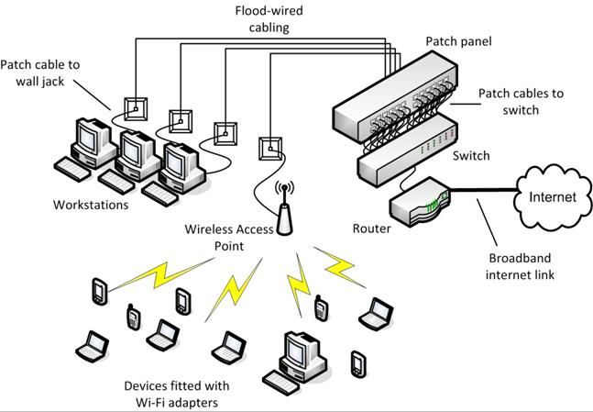
WLAN configuration in infrastructure mode
The access point is normally attached to the LAN using standard cabling and transmits and receives network traffic to and from wireless devices (acting as a bridge). Each client device requires a wireless adapter compatible with the standard(s) supported by the AP.

Mesh Topology
The 802.11s standard defines a Wireless Mesh Network (WMN). Unlike an ad hoc network, nodes in a WMN (called Mesh Stations) are capable of discovering one another and peering, forming a Mesh Basic Service Set (MBSS). The mesh stations can perform path discovery and forwarding between peers, using a routing protocol such as the Hybrid Wireless Mesh Protocol (HWMP).

Wired and Wireless Access Points / Wireless Bridges
As described above, normally access points are connected to the LAN (cabled). This is also referred to as a distribution system. In some circumstances it might not be possible to run data cabling to the access point. In this case, you can configure a Wireless Distribution System (WDS). This can involve up to three types of access point base stations:
- A main base station is cabled to the cabled distribution system and can move traffic between the WDS and the cabled network.
- A remote base station is uncabled (not connected to a cabled network) and accepts connections from stations (clients) to forward to the main base station.
- A relay base station is also uncabled and can be used to move traffic between remote and main base stations to extend the range of the network.
The APs must use the same channel and security configuration but may be configured with different SSIDs or the same SSID. The choice of whether to use different SSIDs would be based on how roaming between the base stations works.
A WDS can also be configured as a wireless bridge to connect two separate cabled LANs. For example, if you had two buildings where it was not possible or economic to run cable between the buildings, you could use two access points wired to each cabled network to join the networks wirelessly. The APs would be configured to communicate with one another only and not to accept connections from wireless stations.

Wireless Controllers
An enterprise network might require the use of tens or hundreds of access points, wireless bridges, and antennas. If access points are individually managed, this can lead to configuration errors on specific access points and can make it difficult to gain an overall view of the wireless deployment, including which clients are connected to which access points and which clients or access points are producing the most traffic.
Rather than configure each device individually, enterprise wireless solutions such as those manufactured by Cisco, Ruckus, or Ubiquiti allow for centralized management and monitoring of the access points on the network. This may be achieved through use of a dedicated hardware device (a wireless controller), which typically implements the required functionality through additional firmware in a network switch. Alternatively, some implementations use a software application to centralize the management function, which can be run on a server or workstation.
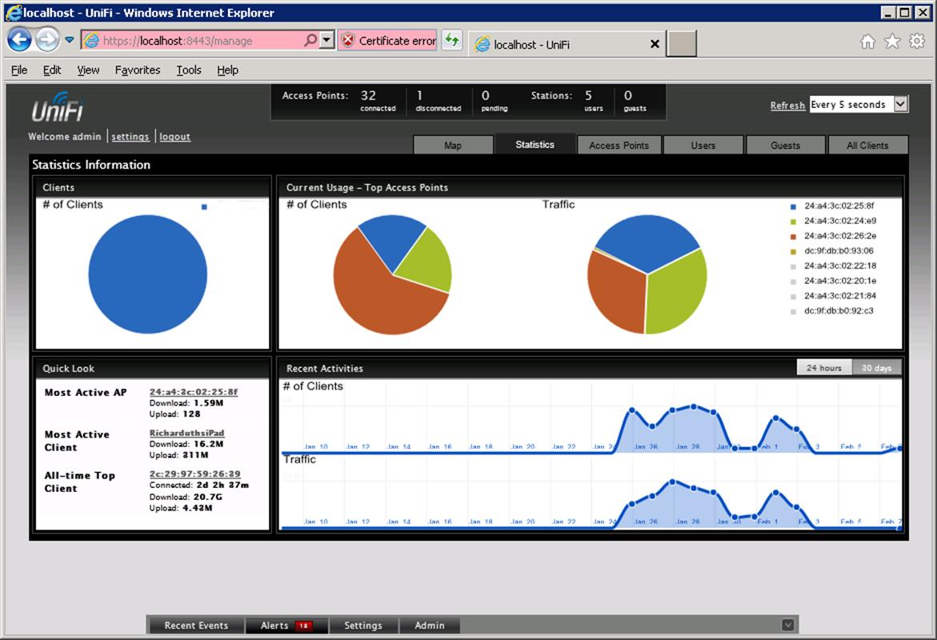
UniFi Wireless Network management console
An access point whose firmware contains enough processing logic to be able to function autonomously and handle clients without the use of a wireless controller is known as a fat AP while one that requires a wireless controller in order to function is known as a thin AP. Cisco wireless controllers usually communicate with the access points using the Lightweight Access Point Protocol (LWAPP). LWAPP allows an AP configured to work in lightweight mode to download an appropriate SSID, standards mode, channel, and security configuration. Alternatives to LWAPP include the derivative Control And Provisioning of Wireless Access Points (CAPWAP) protocol or a proprietary protocol.
As well as autoconfiguring the appliances, a wireless controller can aggregate client traffic and provide a central switching and routing point between the WLAN and wired LAN. It can also assign clients to separate VLANs. Automated VLAN poolingensures that the total number of stations per VLAN is kept within specified limits, reducing excessive broadcast traffic. Another function is to supply power to wired access points, using Power over Ethernet (PoE).

Wireless Site Design
Clients join a WLAN through the network name - the Service Set Identifier or SSID. In infrastructure mode, when multiple access points are grouped into an extended service set, this is more properly called the Extended SSID (ESSID). This just means that all the APs are configured with the same SSID. The area served by a single access point is referred to as a cell.

SSID Broadcast and Beacon Frame
Many WLANs advertise their presence by broadcasting the SSID to any listening clients. This allows a user to connect to a named network. If SSID broadcast is suppressed, the user must configure the connection to the network manually.
A beacon is a special management frame broadcast by the AP to advertise the WLAN. The beacon frame contains the SSID (unless broadcast is disabled), supported data rates and signaling, plus encryption / authentication requirements. The interval at which the beacon is broadcast (measured in milliseconds) can be modified. The default is usually 100ms. Increasing the interval reduces the overhead of broadcasting the frame but delays joining the network and can hamper roaming between APs.
 Even if SSID broadcast is suppressed, it is fairly easy for a network sniffer to detect it as clients still use it when connecting with the AP.

Roaming
Clients can roam between access points with the same SSID when the APs are connected by a wired network (or distribution system). When the client detects that it is no longer receiving a good signal, it checks for another signal with the same SSID on other channels.
Roaming is supposed to be seamless but in practice re-establishing the connection can often cause time-out problems for applications. To improve mobility there needs to be a balance between determining what constitutes a "good" signal and the frequency with which a client tries to associate with different APs. Many adapters support a roaming "aggressiveness" setting that can be configured to prevent a Wi-Fi adapter "flapping" between two APs or (conversely) to prevent a client remaining associated with a more distant AP when it could achieve better bandwidth through one closer to it.

Device Density and Mobile Device Types
Device density refers to the number of devices expected to connect to the network at a particular location. In a stable office environment, this may be quite easily predictable. For example, if you have an office floor with a number of desks, you can usually assume that each user (or desk) may have two devices; a laptop and smartphone for instance.
Areas such as meeting rooms or lecture halls might experience greater density and use as users congregate closer together. As well as the number of devices, the fact that they are closely spaced will pose additional problems. For public networks, such as guest WLANs, device density might be much harder to predict and plan for.
Another of the challenges in supporting a modern wireless network is the wide variety of devices that may have to be supported. As well as laptops, users with cell phones or smartphones, tablets, gaming devices (such as the Xbox or PlayStation), and media streaming devices (for playing audio or video wirelessly) or smart TVs may have to be configured to connect to the network. Very often these devices may only support operation in the 2.4 GHz band, which is narrower and more susceptible to interference than the 5 GHz band. Also, the antennas used in such devices are likely to be weaker than those used on PCs and laptops.
As well as the number of devices and their spacing and type, you also need to plan for the bandwidth requirements of each device in a given area. To do this you need to work out the average per-device bandwidth requirement based on the applications in use on the network. A single access point will be able to support a given number of clients at "normal" data usage rates or a reduced number at "heavy" usage. The capabilities of access points vary widely, with enterprise-class devices supporting much higher device density than SOHO wireless routers. If signals are particularly weak or the WLAN must cover a large area, you can obtain booster antennas or add multiple APs to the network.

Signal Strength and Data Rates
Each station determines an appropriate data rate based on the quality of the signal (Dynamic Rate Switching / Selection [DRS]), which is mainly determined by signal power, range, and interference. If the signal is strong, the station will select the highest available data rate; if the signal is weak, the station will reduce the data rate. 2.4 GHz can support better data rates over longer ranges than 5 GHz. With both however, rates start to drop off quickly at over about 30m (100 feet). Another factor affecting the perceived speed of a network connection is latency. This is a measure of the round trip time of individual packets. Wireless networks exhibit higher latency than wired connections. This is due to a number of factors, including the half-duplex nature of communication and the CSMA/CA access control mechanism.

Antenna Types and Signal Strength
Most wireless devices have simple omnidirectional vertical rod-type antennas, which can receive and send a signal in all directions. This gives good all round coverage but limits the range. To extend the signal range, you can use an antenna focused at a particular point (such as Yagi [a bar with fins] or parabolic [dish or grid] antennas). This is referred to as a unidirectional antenna. These are useful for point-to-point connections (a wireless bridge). The increase in signal strength obtained by focusing the signal is referred to as the gain and is measured in dBi.
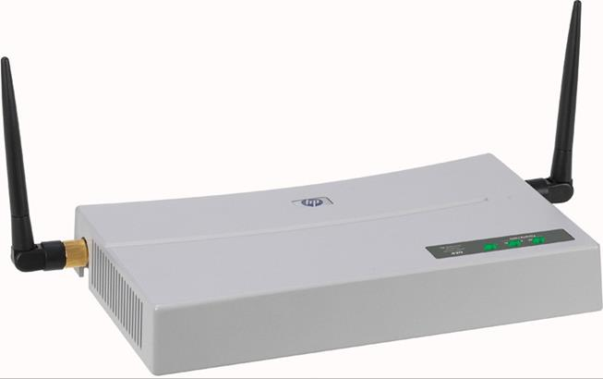
Omnidirectional antennas on an HP ProCurve wireless access point (Image © 2011 Hewlett-Packard Development Company, L.P)
Note also that antennas vary from device-to-device. Access points and USB wireless adapters for PCs have external antennas. A laptop will feature antenna wires running around the lid while a smartphone or tablet will have a much smaller and less powerful antenna located within its case.

Multiuser MIMO
With the 802.11 standards, bandwidth is shared between all users because of the CSMA/CA contention protocol. While not available at the time of writing, second generation (or wave 2) 802.11ac products will address this problem using beamforming or Multiuser MIMO (MU-MIMO).
MU-MIMO allows the access point to send a particular signal more strongly in the direction of a particular client using an array of antennas. This means that clients on a different alignment can also receive a stronger signal. For example, if four clients are positioned north, south, east, and west of an access point, the AP should be able to allow each of them to connect at close to the maximum speed. If another client is added to the north, those two northern clients will share the available bandwidth along that beam path.
Both clients and access point must support MU-MIMO. Only the access point can initiate beamforming, so it is only available on the downlink from AP to client (not client to AP).
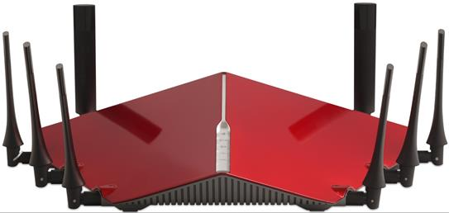
D-Link AC5300 access point with MU-MIMO support (Image © 2014 D-Link Corporation)

Site Surveys and Antenna Placement
When considering access point and antenna placement, a device supporting the Wi-Fi standard should have a maximum indoor range of up to about 30m (100 feet), though the weaker the signal, the lower the data transfer rate. Radio signals pass through solid objects, such as ordinary brick or drywall walls, but can be weakened or blocked by particularly dense or thick material and metal. Other radio-based devices can also cause interference as can devices as various as fluorescent lighting, microwave ovens, cordless phones, and (in an industrial environment) power motors and heavy machinery. Bluetooth uses the same frequency range as Wi-Fi but a different modulation technique, so interference is possible but not common.
 Conversely the signal can also travel much further than 30m. You might want to consider reducing signal strength to deter "war driving".
 802.11ac delivers much better data rates as range increases and also copes much better with obstructions, such as internal walls.

Coverage and Antenna Placement
Coverage means that the WLAN delivers acceptable data rates to the supported number of devices in all the physical locations expected. To maximize coverage and minimize interference, position the AP as high as possible and set the channels of other nearby APs to different settings. At least 25 MHz spacing should be allowed between channels to operate without Co-Channel Interference (CCI). In practice therefore, no more than three nearby 802.11b/g access points can have non-overlapping channels. This could be implemented, for example, by selecting channel 1 for AP1, channel 6 for AP2, and channel 11 for AP3.
When using the 5 GHz band for 802.11a or 802.11n/ac, more non-overlapping channels are available and the best option is usually to allow the AP to auto-detect the best channel.
On the device, point the antenna towards the AP if possible. Under Windows, you can check signal strength by pointing to the WLAN icon on the Taskbar or use the adapter's driver software.
On a SOHO network, there is likely to be a single SOHO wireless router serving a home or small office. Very often placement of this type of router is limited to the position of the demarc (the point where the telephone company's wiring enters the property). On a larger WLAN, placement of multiple access points to obtain optimum coverage is worked out by performing a site survey. This will identify which locations require wireless access and the optimum location for each AP.

Site Surveys and Heat Maps
A site survey is performed first by examining the blueprints or floor plan of the premises to understand the layout and to identify features that might produce Radio Frequency Interference (RFI).
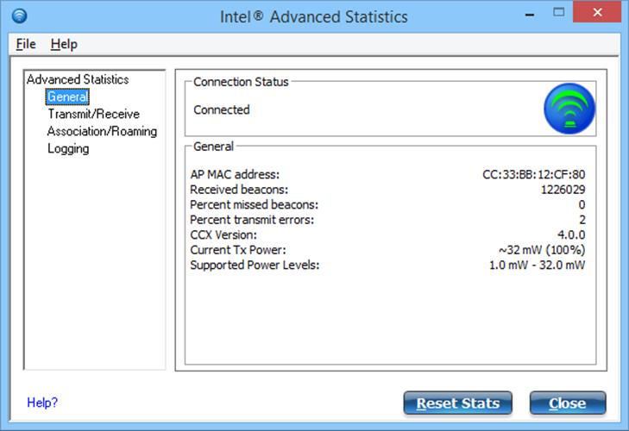
Checking signal strength using Intel's PROSet Wi-Fi configuration utility
This can be backed up by a visual inspection that may reveal things that are not shown on the blueprints (such as thick metal shelving surrounding a room that you want to have WLAN access). Each AP mounting point needs a network port and power jack, so it will help to obtain plans that show the locations of available ports.
 A switch that supports Power over Ethernet (PoE) can be used to power a PoE-compatible access point.
The next step is to create a new plan on which you will mark the WLAN zones or cells and associated APs and booster antennas. The idea here to is to place APs close enough together to avoid "dead zones" (areas where connectivity is difficult or data transfer rates are below an acceptable tolerance level) but far enough apart that one AP does not interfere with another or that one AP is over-utilized and a nearby one under-utilized.
Position an AP in the first planned location then use a laptop with a wireless adapter and a wireless survey tool (such as Cisco Aironet or Metageek inSSIDer) to record signal strength and supported data rate at various points in the intended WLAN zone. Many tools can show the signal strength obtained in different locations graphically using a heat map. The heat map would show areas with a strong signal in greens and yellows with warning oranges and reds where signal strength drops off (or conversely red may indicate a strong signal, depending on the software). This step is then repeated for each planned location.
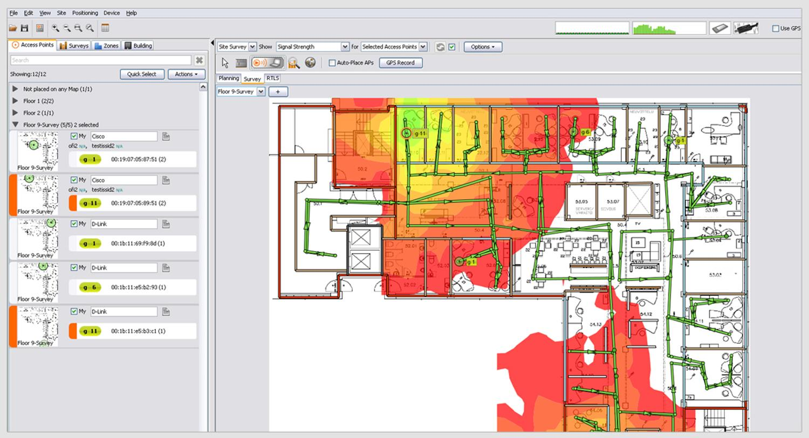
Heat map generated by Ekahau Site Survey (Image © 2014 Ekahau Inc. [www.ekahau.com])
Next, you need to review the information gathered so far and determine whether the plan is fit for purpose: are there enough APs and are they in the best locations?
The final step is to install the APs and connect them to the network. Then you should perform a final site survey and write up the baseline signal strength and transfer rates onto your WLAN plan. This gives you resource documentation that will help with the design of any extensions or modifications to the WLAN and assist with troubleshooting. For example, technicians can easily find out whether a user is actually within a zone intended for WLAN access or get them to move to a spot where signal strength is known to be good.

Troubleshooting Wireless Links
Wireless issues can be broadly divided into issues with signal strength or interference (like cabling issues in a wired LAN) and configuration issues.

Troubleshooting Signal Loss
The signal from radio-based devices weakens considerably as the distance between the devices increases. In case of signal loss, or if the data rate is low, try moving the devices closer together. If you still cannot obtain a connection, check that the security and authentication parameters are correctly configured on both devices.
As the distance from the antenna increases, the strength of the signal decreases in accordance with the inverse-square rule. For example, doubling the distance decreases the signal strength by a factor of four. Meanwhile, the interference sources outlined above collectively overlay a competing background signal, referred to as noise.
The comparative strength of the data signal to the background noise is known as the Signal-To-Noise Ratio (SNR). This figure should be at least 25 dB or higher. This can be diagnosed using a Wi-Fi analyzer or site survey tool.
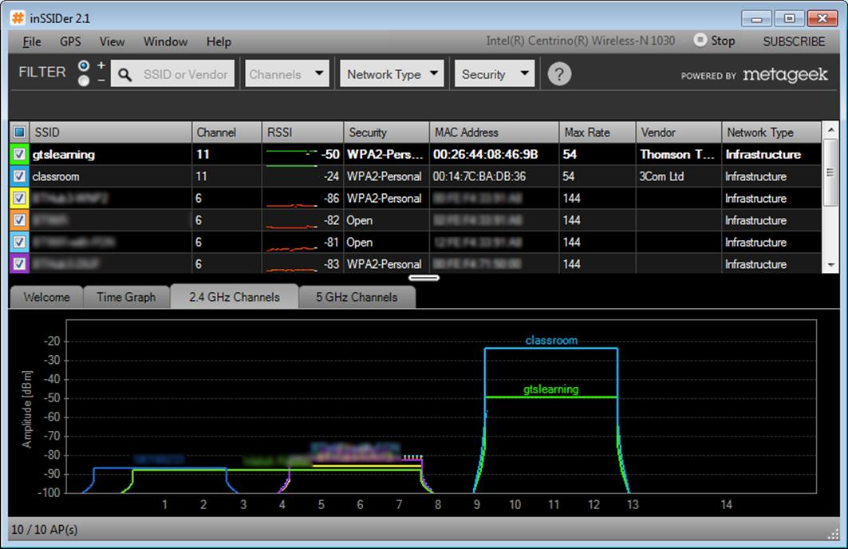
Surveying Wi-Fi networks using inSSIDer - the chart shows which channels are active and the signal strength of different networks in each channel
Also, using the wrong antenna type may adversely affect the signal strength at any given point. A unidirectional antenna is only suitable for point-to-point connections, not for general client access. The internal antennas built into access points may also be optimized to transmit and receive in some directions more than others. For example, an access point designed for ceiling mounting may produce a stronger signal in a cone directed downwards from its central axis, whereas the signal from a similar access point designed for wall installation is more likely to be angled outwards. Consult the documentation for your specific model of access point, or use site survey software to produce a heat map.

Device and Bandwidth Saturation
Device saturation occurs when too many client devices connect to the same access point. The maximum number of clients that an access point can support varies, depending on the Wi-Fi standard used and the type of network traffic generated. For example, web browsing will typically place a lighter load on the network than local client-server traffic or is likely at least to move any bottleneck further upstream to the WAN rather than the wireless network. While individual circumstances must be considered, a maximum of 30 clients per access point is generally accepted as a rule of thumb. In designing the network, enough access points should be provided in appropriate locations to support the expected client density at this ratio. Access points can usually be configured to enforce a maximum number of connections, so that additional clients will connect to the next nearest access point.
Even with a relatively low number of clients, the wireless network can suffer from bandwidth saturation. Since wireless is a broadcast medium, the available bandwidth is shared between all clients. Thus, if one client is a bandwidth hog, others may find it difficult to maintain a reliable connection.
In an enterprise Wi-Fi solution, a controller will normally provide reporting tools to diagnose bandwidth issues and to report on which clients are consuming the most bandwidth. It could also report on wireless channel utilization and configure access points and clients to reassign channels dynamically to reduce overutilization. If a traffic shaper is deployed it may work automatically to throttle bandwidth to overactive nodes.
The quality of wireless connections can be affected by latency. The nature of the medium, as well as additional layers of security, leads to increased round trip times for frames on a wireless connection compared to a wired network. This may cause reliability issues for time-sensitive network traffic, such as VoIP.

Firmware / Untested Updates
If all other factors have been verified, but issues persist with the wireless connection, it may be necessary to update the firmware in the access points or wireless controller or the driver software in the clients. A simple web search will usually confirm if there are known issues with a specific combination of access points and wireless adapters and whether these issues can be resolved by means of a software or firmware update. However, it should be noted that such upgrades can introduce new issues, particularly if they have not been fully tested. For this reason, it is not generally advisable to upgrade firmware or drivers unless there is an actual issue that the update is known to address or a security vulnerability has been identified.
If a software or firmware update is required, it is always preferable to install the update in a limited test environment if possible. For example, update the wireless adapter driver on only one client initially and confirm that this resolves the issue being experienced and that no new issues have been introduced before rolling out the update to all clients. Likewise, it may be possible to trial a firmware upgrade on a single access point before rolling it out to all access points on the network. Where possible, have a rollback plan in place in case it proves necessary to back out of an update. Some access points and wireless controllers will allow for this as part of their management interface, while for others it may be a more complex operation.

Troubleshooting Wireless Interference
If a device is within the supported range but the signal is very weak or you cannot get a connection, there is likely to be interference. There are several sources of interference to consider:
- Adjacent / co-channel interference - signals from another Wi-Fi network operating at the same frequency on the same or an overlapping channel. Try adjusting the channel or repositioning the access points.
- Bounce (multipath interference) - mirrors or shiny surfaces cause signals to reflect, meaning that a variable delay is introduced. This causes packets to be lost and consequently the data rate to drop.
 Note that 802.11n actually uses bounce (multipath) as a means of optimizing throughput.
- ElectroMagnetic Interference (EMI) - interference from a powerful radio or electromagnetic source using the same frequency (such as a Bluetooth device, cordless phone, or microwave oven).
- Environmental factors - the signal is being blocked by something. Radio waves do not pass easily through metal (such as filing cabinets, metal wall studding, metalized window film) or dense objects (such as a concrete wall or a crowd of people). Try angling or repositioning the device or antenna to try to get better reception (generally speaking, positioning the access points as high as possible will give the best reception). The 2.4 GHz frequency has better penetration than the 5 GHz one, given the same power output.
 Also consider that signal problems could be a result of someone trying to attack the network by jamming the legitimate access point and making clients connect to a rogue AP. Jamming, power levels, and rogue access points are covered in more detail in Unit 5.3 / Authentication / Study Notes.

Troubleshooting Configuration Issues
While signal loss and interference are factors on larger networks, if there is a basic connectivity problem then you will probably want to investigate the configuration of the client and / or access point first.

Wrong SSID
Check that the clients are configured with the correct SSID / ESSID. Remember that this is case sensitive. Technically, an SSID can contain spaces but this can cause problems in both man and machine so is best avoided. Check that the authentication settings are the same on all devices. If a Pre-Shared Key (PSK) is used, make sure it is entered correctly. On the access point, ensure the authentication type is not set to open, unless the intention is to provide unrestricted public access.
It is possible that two APs are operating with the same SSID. If authentication is required, the connection with the wrong SSID will fail. If there is no authentication (open network) then the host will connect but take care as this may be an attempt to snoop on the host's traffic using a rogue AP. Also, if a user is joining a WLAN for the first time, it may be the case that there are SSIDs from overlapping WLANs with very similar default names and the user may be confused about which to choose.
 Administering keys is difficult as they have to be manually reconfigured if changed. A RADIUS server is a better option if supporting more than 10 clients. PSK and RADIUS are discussed in Unit 5.3 / Authentication / Study Notes.

Standards Mismatch / Wireless Standard Issues
If the user is definitely supplying the correct key or credentials, check that the client can support the encryption and authentication standards configured on the access point - a driver update or OS patch may be required. Using the wrong encryption mode will cause the connection to fail, even if the correct credentials are supplied.
Choosing a compatibility mode for an access point will reduce the features available (no WPA for 802.11b compatibility for example). If a device is not operating in compatibility mode it will not be able to communicate with devices that only support older standards. Also, when an older device joins the network, the throughput of the whole WLAN can be affected. To support 802.11b clients, an 802.11b/n access point must transmit legacy frame preamble and collision avoidance frames, adding overhead. If at all possible, upgrade 802.11b devices rather than letting them join the WLAN. 802.11g and 802.11n are more compatible in terms of negotiating collision avoidance. In a mixed 802.11g/n WLAN, performance of the 802.11n devices operating in the 2.4 GHz band is only likely to be severely impacted when 802.11g devices perform large file transfers. As these take longer to complete, there is less "airtime" available for the 802.11n clients.
 With 802.11n dual-band APs operating in mixed mode, it is typical to assign the 2.4 GHz frequency band to support legacy clients. The 5 GHz band can be reserved for 802.11n clients and bonded channels can be configured. With 802.11ac deployed, all legacy clients (including 802.11n) should be assigned to the 2.4 GHz band.
Check that the client is configured to use the correct channel. Normally this is auto-detected by the client, but verify that the configured channel/frequency is available for the chosen Wi-Fi standard and remember that not all channels are available in all countries. For 802.11n/ac, if a client device is not achieving the expected throughput or distance, check that the client and access points support the same MIMO configuration.

