UNIT 4.2 / INSTALLING CABLE / STUDY NOTES

Twisted Pair Cable (UTP / STP / ScTP)
Twisted Pair is a type of copper cable that has been extensively used for telephone systems and data networks.
One pair of insulated wires twisted together forms a twisted pair and two or four twisted pairs are themselves twisted around one another to form a twisted pair cable. The pairs are twisted to reduce external interference and crosstalk. Crosstalk is a phenomenon whereby one wire causes interference in another as a result of their close proximity. Twisting the wires ensures the emitted signals from one wire are cancelled out by the emitted signals from the other and also protects the wires from external interference. Each pair is twisted at a different rate to ensure the pairs do not interfere with one another.
There is a distinction between solid and stranded cabling. Solid cabling uses a single thick wire per conductor and is used for cables that run behind walls or through ducts. Stranded cabling uses thin wires wrapped around one another and is used to make flexible patch cords for connecting computers to wall ports and switch ports to patch panel ports. Copper wire thickness is measured using American Wire Gauge (AWG). Increasing AWG numbers represent thinner wire. Solid cable uses thicker 22-24 AWG while the stranded cable used for patch cords is often 26 AWG.

Unshielded Twisted Pair (UTP)
Most twisted pair cable currently used in networks is unshielded (at least in the US and UK). A major reason for UTP's popularity is because this form of cabling is used in many telephone systems. Modern buildings are often "flood-wired" using UTP cabling. This involves cables being laid to every location in the building that may need to support a telephone or computer. These cables can then be used for either the telephone system or the data network.
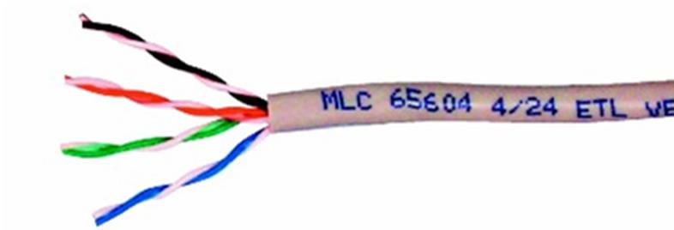
Unshielded Twisted Pair (UTP)

Shielded Twisted Pair (STP)
When twisted pair cabling was first used in networks based on IBM's Token Ring product, it was usually shielded to make it less susceptible to interference and crosstalk. Each pair was surrounded by a braided shield (STP). Some modern twisted pair cabling installations use screened cables. A screened cable has one thin outer foil shield around all pairs. Screened cable is usually designated as ScTP or F/UTP or sometimes FTP. Modern fully shielded cabling (with both a braided outer screen and foil-shielded pairs) is referred to as S/FTP. Legacy STP cable could be more complex to install as it required bonding each element to ground manually but modern F/UTP and S/FTP solutions (using appropriate cable, connectors, jacks, and patch panels) reduce this complexity by incorporating grounding within the design of each element.
 Using screened cable means that you must also use screened connectors and jacks. Screened cable elements should not be mixed with unscreened elements.

TIA/EIA Cat Standards
The American National Standards Institute (ANSI) and the Telecommunications Industry Association (TIA) / Electronic Industries Alliance (EIA) have created categories for twisted pair to simplify selection of a suitable quality cable. These categories, along with other aspects of telecommunications wiring best practice, are defined in the ANSI/TIA/EIA 568 Commercial Building Telecommunications Cabling Standards (www.tiaonline.org).
Cat | Frequency | Capacity | Max. Distance | Network Application
1 | - | 1 Mbps | - | Voice only
3 | 16 MHz | 10 Mbps | 100m (328ft) | 10BASE-T
5 | 100 MHz | 100 Mbps | 100m (328ft) | 100BASE-TX
5e | 100 MHz | 1 Gbps | 100m (328ft) | 1000BASE-T
6 | 250 MHz | 1 Gbps | 100m (328ft) | 1000BASE-T
6 | 250 MHz | 10 Gbps | 55m (180ft) | 10GBASE-T
6A | 500 MHz | 10 Gbps | 100m (328ft) | 10GBASE-T
Cat 5 cable is no longer available. Cat 5e is tested at 100MHz (like Cat 5 was) but to higher overall specifications for attenuation and crosstalk, meaning that the cable is rated to handle Gigabit Ethernet throughput. Note that with Gigabit Ethernet, all four pairs are used for bidirectional data transfer. Cat 5e would still be an acceptable choice for providing network links for workstations.
Cat 6 can support 10 Gbps but over shorter distances (nominally 55m but often less if cables are closely bundled together). Cat 6A is an improved specification cable with the ability to support 10 Gbps over 100m. It is mostly deployed in data centers or as backbone cabling (links between servers, switches, and routers). 6A cable is bulkier than Cat 5e and the installation requirements more stringent so fitting it within pathways designed for older cable can be problematic.
 Cabling is not the only part of the wiring system that must be rated to the appropriate category. For faster network applications (Gigabit Ethernet and better) the performance of connectors becomes increasingly critical. For example, if you are installing Cat 6A wiring, you must also install Cat 6A patch panels, wall plates, and connectors.
Cabling is also rated at a particular characteristic impedance, measured in ohms (Ω). Most UTP, F/UTP, and S/FTP cabling is 100-ohm but 120-ohm and 150-ohm are also available as shielded types. It is important that all parts of a segment (including connectors) use the same type.

PVC versus Plenum Cable
A plenum space is a void in a building designed to carry Heating, Ventilation, and Air Conditioning (HVAC) systems. Plenum space is typically a false ceiling, though it could also be constructed as a raised floor. As it makes installation simpler, this space has also been used for communications wiring in some building designs. Plenum space is an effective conduit for fire, as there is plenty of airflow and no fire breaks (such as walls and doors). If the plenum space is used for heating, there may also be higher temperatures. Therefore, building regulations require the use of fire-retardant plenum cable in such spaces. Plenum cable must not emit large amounts of smoke when burned, be self-extinguishing, and meet other strict fire safety standards.
General purpose (non-plenum) cabling uses PVC (polyvinyl chloride) jackets and insulation. Plenum-rated cable uses treated PVC or Fluorinated Ethylene Polymer (FEP). This can make the cable less flexible but the different materials used have no effect on bandwidth. Data cable rated for plenum use under the US National Electrical Code (NEC) is marked CMP/MMP. General purpose cables are marked CMG/MMG or CM/MP.
Cabling that passes between two floors is referred to as riser. Conduit for riser cabling must be firestopped. This means that fire cannot spread through the opening created by the conduit. Riser cabling (in conduit or in spaces such as lift shafts) should also conform to the appropriate fire safety standards. These are similar to the requirements for plenum spaces but not quite as strict. Data cable rated for riser use under the NEC is marked CMR/MPR.

Twisted Pair Connectors
Twisted pair copper cabling uses Registered Jack connectors. There are many different types of RJ connector, identified by numbers (and sometimes letters). Some are physically different while others are identical but wired differently for different applications.

RJ-45 / RJ-48C Connectors
RJ-45 connectors are used with 4-pair (8-wire) cables. The connectors are also referred to as 8P8C, standing for 8-position / 8-contact. This means that all eight "potential" wire positions are supplied with contacts, so that they can all carry signals if needed. RJ-45 is used for Ethernet twisted pair cabling.
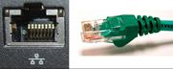
RJ-45 port and connector
RJ-48C connectors are physically identical to RJ-45 connectors but wired differently. They are used for WAN links, such as ISDN or T1 leased lines.
 See Unit 4.5 / Remote Access / Study Notes for more information about WAN links.

RJ-11 Connectors
The smaller RJ-11 connectors are used with 2- or 3-pair UTP. Typically one pair carries the dial tone and voice circuit (also called the Tip and Ring wires after the way older phono plugs were wired). The other pair is usually unused but can be deployed for a secondary circuit. RJ-11 connectors are used for telephone systems (for example, to connect a modem to a phone jack). Note that in the UK, BT 631A connectors are used to connect equipment to analog telephone points. Modems designed for UK use come with a cable with an RJ-11 connector at one end and a BT connector at the other.
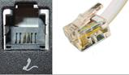
RJ-11 port and connector
An RJ-11 connector only has two contacts (6P2C). To use more pairs, the jack can be wired as RJ-14 (6P4C) or RJ-25 (6P6C).

Wiring Standards
Each conductor in 4-pair data cable is color-coded. Each pair is assigned a color (Blue, Orange, Green, or Brown). The first conductor in each pair has a predominantly white insulator with strips of the color; the second conductor has an insulator with the solid color. The ANSI/TIA/EIA 568 standard defines two methods for terminating Ethernet connectors: T568A and T568B. The wiring for T568B is shown below:
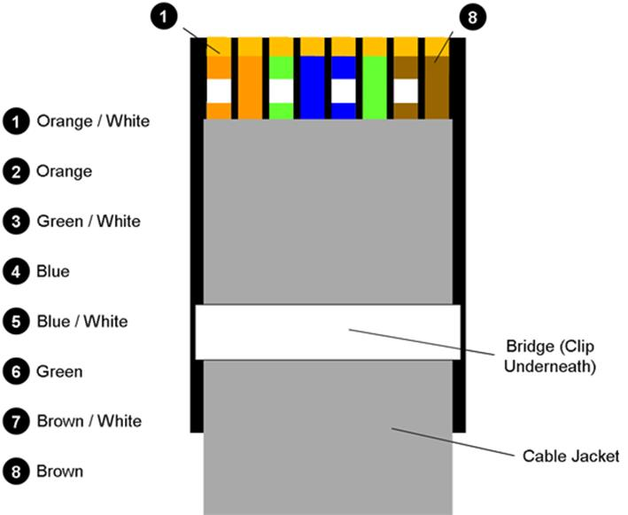
T568B wiring diagram
In T568A, pin 1 is wired to Green / White, pin 2 is wired to Green, pin 3 is wired to Orange / White, and pin 6 is wired to Orange or, put another way, the orange and green pairs are swapped over. Organizations should try to avoid using a mixture of the two standards. T568A is mandated by the US government premises and by the residential cabling standard (TIA 570) but T568B is probably the more widely deployed of the two.
Pin | Wire Color (T568A) | Wire Color (T568B) | 10 / 100 Mbps | 1 / 10 Gbps
1 | Green / White | Orange / White | Tx+ | BixA+
2 | Green | Orange | Tx- | BixA-
3 | Orange / White | Green / White | Rx+ | BixB+
4 | Blue | Blue |  | BixC+
5 | Blue / White | Blue / White |  | BixC-
6 | Orange | Green | Rx- | BixB-
7 | Brown / White | Brown / White |  | BixD+
8 | Brown | Brown |  | BixD-
Ethernet and Fast Ethernet use only two pairs in the cable; one to transmit (Tx) and the other to receive (Rx). Gigabit and 10G Ethernet use all four pairs, transmitting and receiving simultaneously (Bix) through the use of improved signal encoding methods.
A patch panel may be wired either to T568A or T568B - make sure you use the same wiring scheme for all the other connectors on your network.

Crossover Cable
Ethernet and Fast Ethernet cables and connectors carry data over Transmit (Tx) and Receive (Rx) pairs. Normally, an end system would be linked to an intermediate system, such as a hub or a switch, using straight-through (or standard) cabling and connectors. The hub receives a signal from a host over the Tx pair, performs a crossover, and repeats it over the other ports, for receipt by connected interfaces over their Rx pairs.
A crossover cable is created by wiring the connectors at each end differently, so that Tx on one connector goes directly to Rx on the other connector and vice versa (TX/RX reverse). The cable itself is ordinary UTP. A crossover cable can therefore be used to connect the same type of network device together directly. This could mean either to connect two end systems (sometimes useful for troubleshooting) or to connect two hubs or switches.
In fact, crossover cable is no longer required for this type of application as many switches either have an uplink port for this purpose or can autodetect and select between an uplink and straight-through connection. This is referred to as auto-MDI/MDI-X; MDI means Medium Dependent Interface and MDI-X means a crossover interface. All Gigabit Ethernet ports support auto-MDI/MDI-X.
Using T568A wiring on one end of a patch cable and T568B on the other creates a crossover cable, connecting pins 1 and 2 on one end of the cable with pins 3 and 6 on the other end, and vice versa.
 Make sure crossover patch cords are clearly labeled. It's not that easy to distinguish a crossover cable from a straight-through one just by inspecting the termination. If you accidentally use a crossover patch cord where a straight-through one is required (or vice versa) and the network ports do not support auto-MDI/MDI-X, the link will not work.

Wiring Tools and Techniques
Installing fixed cable from a bulk spool is referred to as "pulling cable" because the cable has to pulled, carefully, from the telecommunications closet to the work area. Cable is normally routed through conduits or wall spaces, avoiding excessive bends and proximity to electrical power cables and fittings (such as fluorescent lights) as these could cause interference.
The main fixed cable run can be up to 90m (295 feet); stranded-wire patch cords (between the PC and wall port) and jumpers (a stranded-wire cable without connectors used on cross-connects) can be up to 5m each (16 feet) and no more than 10m (33 feet) in overall length. This is because the attenuation of stranded cable is higher than solid cable.
Starting at the patch panel, label the end of the cable with the appropriate jack ID then run it through to the work area. This is also referred to as a "drop" as in most cases you will be dropping the cable from the ceiling space through a wall cavity. If several cables are going to roughly the same place, you can bundle them and pull them together. There are various tools and techniques for pulling cable through difficult to reach areas, such as ceiling spaces.
Leaving enough slack at both ends (a service loop) to make the connection, cut the cable, and label the other end with the appropriate ID. Electrician's scissors (snips) are designed for cutting copper wire and stripping insulation and cable jackets. Alternatively there are dedicated wire stripper tools that have replaceable blades for different data cable types. Cable cutting blades should be rounded to preserve the wire geometry. Stripping tools should have the correct diameter to score a cable jacket without damaging the insulation wires. Heavy duty cutters are required for armored cable.

Termination Tools
Fixed cable is terminated using a punch-down tool. These tools fix conductors into an Insulation Displacement Connector (IDC). There are different IDC formats (66 Block, 110 Block, and Krone) and these require different blades. Many punch-down tools have replaceable blades though. Blades are double-sided; one side pushes the wire into the terminal while the other side cuts the excess. Make sure the blade marked "cut" is oriented correctly to cut the excess wire.
A patch cable is created using a cable crimper. This tool fixes a jack to a cable. The tools are specific to a particular type of connector and cable, though some may have modular dies to support a range of RJ-type jacks.
You must untwist the ends of the wires to make the contacts but you must not untwist them too much. Cat 6 is demanding in this respect and requires no more than 0.375" (1 cm) of untwisting. It is best to use prefabricated patch cords where possible. These are far less likely to create problems.

UTP Couplers
If only short patch cables are available for some reason, these could be joined using a UTP coupler. This is a passive device with two RJ-45 ports. Plugging a patch cable into each port creates the equivalent of a single cable. Note however that the use of a coupler introduces a degree of additional signal loss compared to a single length of cable.

Cable Testing and Troubleshooting
The best time to verify wiring installation and termination is just after you have made all the connections. This means you should still have access to the cable runs. Identifying and correcting errors at this point will be much simpler than when you are trying to set up end user devices. A number of tools are available to perform tests on the physical characteristics of a cable link.
TIA 568 distinguishes between permanent and channel links. A permanent link runs between the ports on the patch panel and wall outlet; a channel link runs between the patch cord used to connect to a port on a hub or switch and the patch cord used to connect to a port on a PC (but does not include the end user devices themselves).

Multimeters and Wire Map Testers

Multimeters are the most basic of cable testing tools. They are used to check physical connectivity. The primary purpose of a multimeter is for testing electrical circuits but they can test for the continuity of any sort of copper wire, the existence of a short, and the integrity of a terminator. To perform useful tests, you need to know the readings that are expected from a particular test. For example, if the resistance measured across UTP Ethernet cable is found to be 100 ohms, then the cable is OK, but if the resistance between the two ends of a cable is infinity, the cable has a break. Many multimeters designed for ICT use incorporate the function of a wire map tester. These are also available as dedicated devices. Wire map testers can identify the following problems:
- Continuity - a conductor does not form a circuit (open) either because of cable damage or the connector is not properly wired.
- Short - two conductors are joined at some point, usually because the insulating wire is damaged or a connector is poorly wired.
- Incorrect termination / mismatched standards - the conductors are incorrectly wired into the terminals at one or both ends of the cable. The following transpositions are common:
  - Reversed pair - the conductors in a pair have been wired to different terminals (for example, from pin 3 to pin 6 and pin 6 to pin 3 rather than pin 3 to pin 3 and pin 6 to pin 6).
  - Crossed pair (TX/RX reverse) - the conductors from one pair have been connected to pins belonging to a different pair (for example, from pins 3 and 6 to pins 1 and 2). This may be done deliberately to create a crossover cable but such a cable would not be used to link a host to a switch.
 If you have problems with a patch cord, check that it has not been wired for crossover rather than straight through use. Remember the "known good" technique for troubleshooting easily replaceable parts.
Another potential cable wiring fault is a split pair. This is where both ends of a single wire in one pair are wired to terminals belonging to a different pair. This type of fault can only be detected by a wiremap tester that also tests for excessive crosstalk. This is generally the kind of functionality associated with a cable tester or certifier (see below).

Tone Generator and Probe
A network tone generator and probe are used to trace a cable from one end to the other. This may be necessary when the cables are bundled and have not been labeled properly. This device is also known as a "Fox and Hound" or "toner and probe". The tone generator is used to apply a signal on the cable to be traced where it is used to follow the cable over ceilings and through ducts.
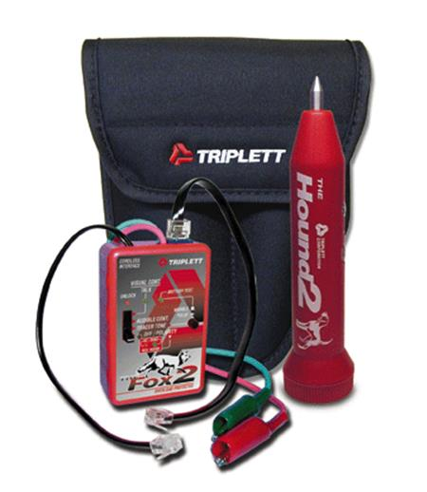
Triplett "Fox and Hound" (Image © 2014 Triplett / Jewell Instruments)

Time-Domain Reflectometer (TDR)
Time-Domain Reflectometers (TDR) are used to measure the length of a cable run and are able to locate open and short circuits, kinks/sharp bends, and other imperfections in cables that could affect performance.
A TDR transmits a short signal pulse of known amplitude and duration down a cable and measures the corresponding amplitude and time delay associated with resultant signal reflections. A TDR analyzes these reflections and can display any problems found and their location.
Problems can be identified because they bounce the signal back at different amplitudes depending on the type of problem. The TDR measures the amount of time taken for the signal to bounce back and can therefore calculate the distance to the cable fault to within a meter, which makes isolating the problem simpler.

Line Tester
An analog line tester (or butt set) is a telephone handset that connects to telephone wires using crocodile clips rather than a modular jack. Butt sets can only be used to test analog phone lines but most have digital circuit detectors and cut-outs (as well as high voltage / current safety protection) and built-in DSL filters. More advanced line analyzers can be used to troubleshoot problems with DSL and leased lines.

Cable Testers and Cable Certifiers
More advanced cable testers provide detailed information on the physical and electrical properties of the cable. For example, they test and report on cable conditions, crosstalk, attenuation, noise, resistance, and other characteristics of a cable run.
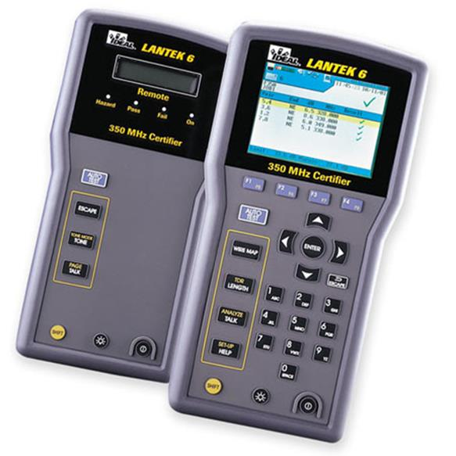
LANTEK Advanced cable certifier (Image © 2015 IDEAL INDUSTRIES, INC)
Devices classed as certifiers can be used to test and certify cable installations to a particular performance category (for example, that a network is TIA/EIA 568B Category 6A compliant). They use defined transport performance specifications to ensure an installation exceeds the required performance characteristics for parameters such as attenuation and crosstalk.
The price of network test equipment can be prohibitive, especially given the limited use the equipment may receive. In this case, hiring the equipment may be an alternative.

Troubleshooting Distance Limitations
If a cable link is too long, attenuation (insertion loss) may mean that the link experiences problems with high error rates and retransmissions (frame or packet loss) resulting in reduced speeds and possibly loss of connectivity. Attenuation is measured in decibels (dB); the maximum value allowed depends on the link category (for example, Cat 5e at 100 MHz allows up to 24 dB while Cat 6 allows up to 21.3 dB). Higher grade or shielded cable may alleviate the problem; otherwise you will need to find a shorter cable run or install a repeater or additional switch.

Troubleshooting Crosstalk
Crosstalk usually indicates a problem with bad wiring (poor quality or damaged or the improper type for the application), a bad connector, or improper termination. Check the cable for excessive untwisting at the ends and for kinks or crush points along its run. Crosstalk is also measured in dB but unlike insertion loss, higher values represent less noise. Again, the expected measurements vary according to the cable category and application. There are various types of crosstalk that can be measured:
- Near End (NEXT) - this occurs close to the transmitter and is usually caused by excessive untwisting of pairs.
- Attenuation to Crosstalk Ratio (ACR) - this is the difference between insertion loss and NEXT. ACR is equivalent to a Signal-to-Noise Ratio (SNR). A high value means that the signal is stronger than any noise present; a result closer to zero means the link is likely to be subject to high error rates.
- ACRF (Attenuation-to-Crosstalk Ratio, Far End) - Far End Crosstalk (FEXT) is measured at the recipient end. The difference between insertion loss and FEXT gives ACRF, which measures cable performance regardless of the actual link length.
- Power sum - Gigabit and 10G Ethernet use all four pairs. Power sum crosstalk calculations (PSNEXT, PSACR, and PSACRF) confirm that a cable is suitable for this type of application. They are measured by energizing each three of the four pairs in turn.

Troubleshooting EMI/RFI
Electromagnetic Interference (EMI) is something that should be detected when the cable is installed so you should suspect either some new source that has been installed recently or some source that was not taken into account during testing (machinery or power circuits that weren't activated when the installation testing took place for instance). Interference from nearby data cables is also referred to as alien crosstalk.
Radio Frequency Interference (RFI) is EMI that occurs in the frequencies used for radio transmissions.
Careful cable placement is necessary during installation to ensure that the wiring is not subject to interference from sources such as electrical power cables, fluorescent lights, motors, electrical fans, radio transmitters, and so on.
Complete loss of connectivity indicates a break in the cable (or a completely faulty installation) while intermittent loss of connectivity is more likely to be caused by attenuation, crosstalk, or noise.

Other Copper Cable Types

Twisted pair predominates in terms of modern networking applications but there are a couple of other copper wire cable and connector types that you should be aware of.

Coaxial Cable and Connectors
Coaxial (or coax)cable is made of two conductors that share the same axis, hence the name ("co" and "ax"). The core conductor of the cable is made of copper wire (solid or stranded) and is enclosed by plastic insulation (dielectric). A wire mesh (the second conductor), which serves both as shielding from EMI and as a ground, surrounds the insulating material. A tough plastic sheath protects the cable.
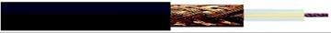
Coax cable
Coax cables are categorized using the Radio Grade (RG) "standard". The Radio Grade (or Radio Guide) classifications were developed by the US military but are no longer actively maintained by any sort of standards body. They do not prescribe the quality of coax cabling but categorize it by the thickness of the core conductor and the cable's characteristic impedance.
RG | Core | Impedance | Applications
RG-8 | 50 AWG | 50 ohms | 10BASE-5 / "Thicknet"
RG-58 | 50 AWG | 50 ohms | 10BASE-2 / "Thinnet"
RG-6 | 18 AWG | 75 ohms | Drop cable for modern Cable Access TV (CATV) and broadband cable modems
RG-59 | 20 AWG | 75 ohms | Drop cable for older CATV / cable modem installs and CCTV network cabling
Coax cabling is also available with tri- or quad-shielding for better resistance to EMI and eavesdropping.
In most cases BNC (alternately Bayonet-Neill-Concelman, British Naval Connector, or Barrel Nut Connector) connectors are crimped to the ends of the cable. A BNC coupler (a connector with female BNC ports at either end) allows two cables terminated with BNCs to be connected to one another. The impedance of the connector must match the cable type (50 or 75 ohm).
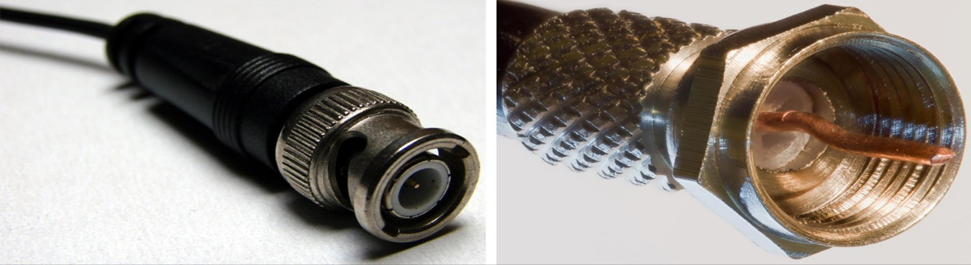
BNC connector on the left (created by Krzysztof Burghardt and reproduced under the Creative Commons Attribution ShareAlike 3.0 license) and F-connector on the right (created by Colin and reproduced under the Creative Commons Attribution ShareAlike 3.0 license)
Some coax installations use screw-down F-connectors (for example, a broadband cable service is likely to use this connector).
As an Ethernet LAN media product (10BASE-5 / Thicknet and 10BASE-2 / Thinnet), coax could support 10 Mbps with cable lengths of up to 500m and 185m respectively. Coax is considered obsolete in terms of LAN applications but is still widely used for CCTV networks and as drop cables for cable TV (CATV) and internet access, where it can support higher bandwidths but at reduced range. In a Hybrid Fiber Coax (HFC) network, coax cable links the fiber optic trunk serving the whole street to the cable "modem" installed in the customer's premises. Coax suffers less from attenuation than twisted pair but is generally bulkier and more difficult to install.

Serial Cable and Connectors

All network technologies transfer data in serial, but "serial cable" generally refers to the original asynchronous serial transmission standard; one of the oldest and simplest in computing. Asynchronous means there are no timing signals. Each byte of data is identified by start and stop signals. It was used on PCs to connect peripheral devices and the same technique is used by analog dial-up modems. It can also be deployed as a rudimentary type of network connecting two hosts. Devices with serial ports are defined in two categories:
- DTE (Data Terminal Equipment) - a PC is classed as DTE equipment, as are most data terminals and other devices that interact with users.
- DCE (Data Circuit-terminating Equipment) - DCE equipment is defined as those items that provide an interface between DTE equipment and other communication systems or networks (for example, modems).
DTE equipment is connected to DCE equipment with a straight-through wired cable (pin 1 on one end of a cable joins to pin 1 on the other end, pin 2 to pin 2, and so on.). This cabling works because DTE equipment uses pin 2 (TD) to transmit data and DCE equipment uses pin 2 (RD) to receive data.
Where two pieces of DTE equipment (perhaps two PCs) are to be linked together, a special cable or adapter is needed to compensate for both ends having identical serial port connections. An adapter or cable that is cross-wired to allow two DTE devices to communicate is called a null modem cable
The serial port on the original IBM PC was a 25-pin male "D" connector (DB25), which followed the RS-232 standard defined by TIA/EIA. In practice, most PCs used a male DB9 9-pin connector. The 9-pin connector supports the major data and handshake (data flow control) lines needed for peripherals such as modem or mice but does not include the "advanced" signals required for some more specialist devices.
The PC serial port is obsolete but the use of a serial connection remains current in networking as a means of establishing an "out-of-band" connection to the console port of a network appliance (a switch or router for instance). On older devices, the console port may be labeled the "management" or "admin" port. The console port connection on the appliance can use either a DB9 / DB25 port or a standard RJ-45 jack (but wired in a different way to Ethernet). In this latter scenario, a rollover or console cable featuring an RJ-45 plug on one end and a 9-pin serial connector on the other is used for connection to the terminal (PC).
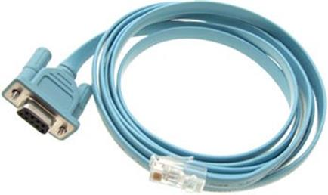
Rollover / console cable
One additional complication here is that most engineers would prefer to use laptops for this sort of task and very few laptops feature serial ports anymore. In this scenario, a serial-USB converter can be used. On newer network appliances, a USB console port is likely to be available anyway.
You may also need to configure the link speed, parity, and flow control settings. Usually these are 9,600 bps (baud), 8 data bits / 1 stop bit, and no parity or flow control.
Serial interfaces are also used for WAN links such as leased lines. These serial interfaces are typically synchronous and can use a variety of different cabling and connectors.

Fiber Optic Cable and Connectors
Copper wire carries electrical signals, which are subject to interference and attenuation (the reduction of signal quality over distance). Fiber optic cable uses pulses of infrared light for signaling, which are not susceptible to interference, cannot easily be intercepted (eavesdropped), and suffer less from attenuation. Consequently, fiber optic cabling supports much higher bandwidth (multiple gigabits per second) and cable runs (measured in kilometers rather than meters). A single optical fiber is constructed from three elements:
- Core - provides the transmission path for the light signals (waveguide).
- Cladding - reflects signals back into the waveguide as efficiently as possible so that the light signal travels along the waveguide by multiple internal reflections. The core and cladding can be made from glass or plastic.
- Buffer - a protective plastic coating. It may be of a "tight" or "loose" configuration, with the loose format using some form of lubricant between the strand and the sheath.
Each fiber optic strand can only transfer light in a single direction at a time. Therefore, multiple fibers are often bundled within a cable to allow simultaneous transmission and reception of signals or to provide links for multiple applications.
 Multiple bidirectional signals can be transmitted over a single fiber using a technique called Wavelength Division Multiplexing. This is covered in Unit 4.4 / WAN Technologies / Study Notes.
There are many different outer jacket designs and materials suited for different installations (indoor / plenum, outdoor, underground, undersea, and so on). Kevlar (Aramid) strands and sometimes fiberglass rods (strength members) are often used to protect the fibers from excessive bending or kinking when "pulling" the cable to install it. For exposed outdoor applications, a steel shield (armor) may be added to deter rodents from gnawing the cable.

Categories of Fiber Cable
Fiber optic cables are specified using the mode, composition (glass/plastic), and core/cladding size. For example, 8.3 micron core/125 microcladding single-mode glass or 62.5 micron core/125 microcladding multimode plastic. Fiber optic cables fall into two broad categories: single mode and multimode.

Single-Mode (SMF or Monomode)
Single-Mode (SMF) has a small core (8 - 10 microns) and a long wavelength, near infrared (1310nm or 1550nm) light signal, generated by a laser. Single mode cables support data rates up to 10 Gbps or better and cable runs of many kilometers, depending on the quality of the cable and optics.

Multimode (MMF)
Multimode (MMF) has a larger core (62.5 or 50 microns) and shorter wavelength light (850nm or 1300nm) transmitted in multiple waves of varying length. MMF uses less expensive optics and consequently is less expensive to deploy than SMF. However, it does not support such high signaling speeds or long distances as single-mode and so is more suitable for LANs than WANs.
MMF is graded by Optical Multi-mode (OM) categories. 62.5 micron cable is OM1 while early 50 micron cable is OM2. OM1 and OM2 are mainly rated for applications up to 1 Gbps and use LED transmitters. OM1 and OM2 can run 10GBASE-SR but only over distances of 33m and 82m respectively. OM3 is also 50 micron cable but is manufactured differently, designed for use with 850nm Vertical-Cavity Surface-Emitting Lasers (VCSEL). It supports 10 Gbps at up to 300m range. OM4 supports 10G at 400m range or 100 Gbps at up to 150m.

Installation of Fiber Optic Cable
Fiber optic can be installed in a star topology with the use of a switch. Long distance cables are typically laid as trunks or rings with repeaters or amplifiersbetween cable segments to strengthen the signal. Where there are multiple strands within a single cable for a LAN installation, the strands are usually color-coded (TIA/EIA 598) to differentiate them. Also, by convention MMF jackets are color-coded orange (OM1 and OM2) or aqua (OM3 and OM4) while SMF jackets are yellow. The two strands required at each device may be connected using a variety of connectors (see below). When cables need to be spliced(that is, joined) there are various methods, including an electric fusion process and mechanical connectors (fiber couplers).

Fiber Optic Connectors
The core of a fiber optic connector is a ceramic or plastic ferrule that holds the glass strand and ensures continuous reception of the light signals. The tip of the ferrule can be finished in one of three formats:
- Physical Contact (PC) - the faces of the connector and fiber tip are polished so that they curve slightly and fit together better.
- Ultra Physical Contact (UPC) - this means the cable and connector are polished to a higher standard than with PC.
- Angled Physical Contact (APC) - the faces are angled for an even tighter connection. APC cannot be mixed with PC or UPC. These connectors are usually deployed when the fiber is being used to carry analog signaling, as in Cable Access TV (CATV) networks. They are also increasingly used for long distance transmissions.
Fiber optic connectors are available in many different form factors. Some types are more popular for multimode and some for single-mode; also some types support duplex operation. Connectors for MMF are usually color-coded beige while those for SMF are blue. Connectors with APC finishing are green.
- ST (Straight Tip) - a bayonet-style connector that uses a push-and-twist locking mechanism; used mostly for multimode networks.
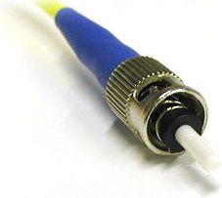
ST connector
- FC (Ferrule Connector) - older type of single-mode connector with screw-in attachment.
- SC (Subscriber Connector) - this push/pull design allows for simpler insertion and removal than FC. There are simplex and duplex versions, though the duplex version is just two connectors clipped together. It can be used for single- or multi-mode. The LC (Lucent or Local Connector) is similar to SC but half the size.
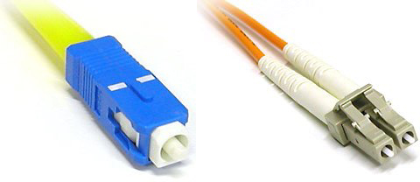
SC format connector (left) and duplex LC connector (right)
- Mechanical Transfer Registered Jack (MTRJ) - a small form-factor duplex connector with a snap-in design; used for multimode networks.
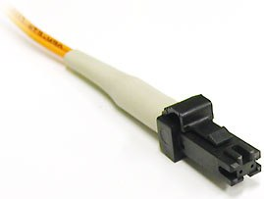
MTRJ connector
Patch cables for fiber optic can come with the same connector on each end (ST-ST for instance) or a mix of connectors (ST-SC for instance).

Interface and Media Converters
Enterprise switches and routers are available with modular, hot-swappable transceivers for different types of fiber optic patch cord connections. Historically these were based on the Gigabit Interface Converter (GBIC) form factor but this has largely been replaced by Small Form Factor Pluggable (SFP), also known as mini-GBIC. SFP+ is an updated specification to support 10G.
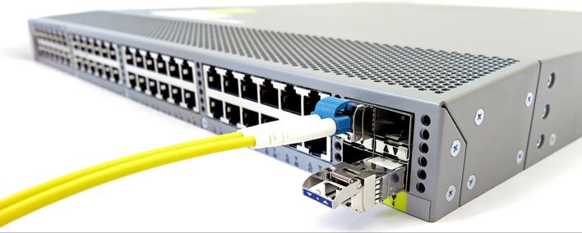
Switch with hot-pluggable fiber transceivers (right)
Standalone media converters are used to convert one cable type to another. These components alter the characteristics of one type of cable to match those of another (that is, make one cable type look like another). Media converters work at the physical layer of the OSI model. They are usually "transparent" with regard to the rest of the network infrastructure (the link is treated as one length of cable). They may be supplied as standalone appliances or rack-mounted appliances. The following media conversions are typical:
- Single mode fiber to Ethernet - these powered converters change light signals from SMF cabling into electrical signals carried over a copper wire Ethernet network (and vice versa).
- Multimode fiber to Ethernet - a different media converter model is required to convert the light signals carried over MMF media.
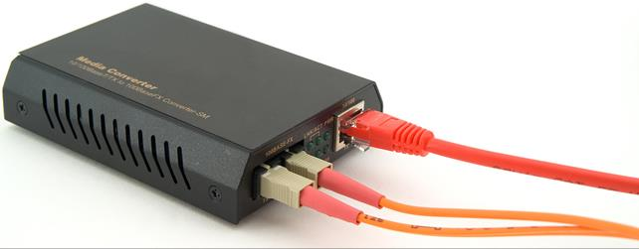
Multimode fiber to Ethernet media converter
- Fiber to Coaxial - this type of converter is often used in Hybrid Fiber Coax (HFC) networks to deliver broadband internet to offices and homes. As with Ethernet, models for SMF and MMF are not interchangeable.
- Single mode to multimode fiber - these passive (unpowered) devices convert between the two fiber cabling types.

Troubleshooting Fiber Cable Issues
There are a number of issues to check when troubleshooting faulty fiber connections.

Attenuation
Although fiber optic cable does not suffer from attenuation in the same way as copper cable, or to the same extent, there will still be some loss of signal strength from one end of the connection to the other. This is due to microscopic imperfections in the structure of the glass fiber and in the smoothness of the edge of the core, leading to some small fraction of the light within the core being scattered or absorbed. As with attenuation in copper cables, the signal loss is increased with increasing cable length. The EIA/TIA 568 specification for fiber allows for a signal loss of between 0.5 dB/km and 3.5 dB/km, depending on the type of fiber used and the wavelength of the light.
Attenuation can be tested using an optical source and optical power meter (or light meter), which may be purchased together as a fiber testing kit.

Distance Limitations
Attenuation (along with an effect known as modal dispersion) leads to limitations on the maximum length of a fiber optic connection. Maximum lengths vary widely, depending on cable type and data rates and can be anything from 33 meters (in the case of 10 Gigabit Ethernet over OM1 cable) up to 80km. Greater distances can be achieved (up to thousands of km), but only with the use of active repeaters.

Cable and Fiber Type Mismatches
The transceivers used in each optical interface (whether SFP, GBIC, or other media converter) are designed to be used with a specific type of optical fiber. For example, transceivers designed for single mode fiber use lasers while multimode fiber transceivers typically use LEDs. This means it is important to check the manufacturer's documentation for the interface to ensure the correct fiber type is used, not only for the fiber optic cable, but also for the fiber patch cords used to connect to it at each end. Mismatches between cable, patch cords, and interfaces may lead to significant signal loss.

Faulty SFP/GBIC
When troubleshooting a switch or router, check that any plug-in modules (SFPs / GBICs) installed in the appliance are correctly seated. If the modules are hot-swappable, you can perform this check with the switch powered-up; otherwise, turn off the switch and reseat all modules.
The transceiver in an optical interface may suffer a hardware failure. The simplest way to test for this is to swap the bad SFP/GBIC for a known good component, to check whether this resolves any issues.

Wavelength Mismatch
Different transceivers are designed to work at different optical wavelengths (typically 850nm, 1300nm, or 1550nm). Check manufacturer documentation to ensure that the interfaces used at each end of the connection are compatible.

Connector Mismatch
In principle, a connector mismatch is easy to diagnose with fiber, as none of the connector types available will fit properly in the adapter for a different connector type. In this respect, remember not to try to mix UPC and APC connectors.
Another issue is to remember that each fiber optic connection consists of two separate signaling paths, one to transmit and the other to receive. In patching the connections at each end, it is necessary to ensure that the transmit connection from one end is connected to the receive connection on the other, and vice versa. A common installation error involves incorrectly patching the connections such that the two transmitters are directly connected as are the two receivers. If in doubt, an optical power meter can be used to determine whether an optical signal is being received from a particular fiber.
 Although the wavelengths of light used are in the infrared range, and thus invisible to the human eye, the CCD cameras built into most modern smartphones are sensitive to light of these wavelengths. Transmitted optical signals are visible as bright white sports when viewed through a smartphone camera. This can be used to identify which adapter on an optical interface is transmitting and which fiber patch cord is receiving a signal from the other end of the cable.
 Never look directly into an optical transceiver or optical fiber with the naked eye. Although infrared light is invisible, it can cause damage to the retina.

Bad Fiber Cable
Fiber patch cords and fiber optic cables can be tested for breaks using an optical source and optical power meter. In the case of a fiber patch cord, this can be easily swapped out with a known good patch, either as a testing measure or as a fault resolution once a patch fault has been diagnosed. If a break is identified in an installed cable, the location of the break can be found using an Optical Time Domain Reflectometer (OTDR). This sends light pulses down the cable and times how long it takes for any reflections to bounce back from the break. A broken cable will need to be repaired (spliced) or replaced.

Bend Radius Limitations
Bending a fiber optic cable too tightly can damage the fiber, leading to signal loss or degradation. There are two separate limits on the bend radius, known as the short term limit and the long term limit. The short term limit is applicable during cable installation and determines how tightly the cable can be bent during the installation process. The long term limit determines how tightly it can be bent when in its permanent location. The long term limit is actually smaller, meaning that the cable can be left in tighter curves when in place than during installation. Check the cable documentation for these limits. If none are explicitly stated, then assume that the short term limit is twenty times the cable diameter and the long term limit is ten times the cable diameter. Inspect the cable run for any tight turns that exceed the long term limit, as these may indicate possible damage to the cable.

Dirty Connectors
As the area from which an optical signal emerges at the end of the fiber is so small (approximately 50&<56;m2 in the case of single mode fiber), any dust, lint, or other obstruction on the surface can seriously affect the signal strength. Thus, it is important that the connectors are kept clean. The ends should always be sealed with dust caps when not in use. Before connecting, both the adapter and the connector should be cleaned. Isopropyl alcohol can be used for this purpose, applied to a swab for cleaning the adapter and a lint-free cloth for cleaning the end of the connector, which should then be wiped with a dry lint-free cloth to remove any alcohol residue. Cleaning tools are also available to automate this process. To inspect the connector, a magnification scope can be used.

