UNIT 4.1 / NETWORK SITES / STUDY NOTES

Wiring Distribution
The main components of a (simplified) structured wiring scheme are as follows:
- The computer has a network adapter installed with a socket for an RJ-45 connector.
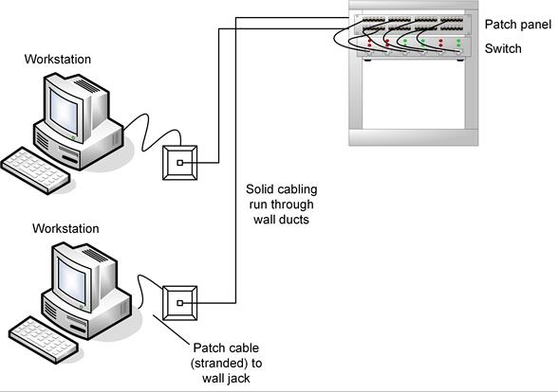
Structured wiring system
- A patch cable is used to link the network card into a wall outlet with an external RJ-45 port. This must be stranded cable so that it is flexible.
- Behind each wall jack is an Insulation Displacement Connector (IDC). Solid cabling punched down to the IDC then passes into the wiring ducts (or conduits) and is routed to the main computer room. Solid core cable is used as it has lower attenuation and repeated flexibility is not required.
- In the computer room, the cable is wired into more IDCs at the back of a patch panel.
- Finally, another patch cable connects the RJ-45 port on the front of the patch panel to a free port on the switch.

Wiring Standards
Most premises have a more complex cabling structure than that described above. In 1991, the Electronic Industries Association introduced the EIA 568 specification. The standard is called the Commercial Building Telecommunications Wiring Standard and was the first non-proprietary networking scheme for network designers. The document has been subjected to a variety of revisions and updates culminating in the latest version ANSI/TIA/EIA 568-B (www.tiaonline.org).
The purpose of wiring standards is to enable businesses to apply best practices and to plan their infrastructure requirements and ensure Return On Investment (ROI). A standard is generally designed to be valid for about 10 years; that is, a particular class of network installation will support applications using that class for 10-15 years following publication of the standard. An "application" in this sense is a data link protocol, such as Ethernet or SONET. Applications tend to develop faster than infrastructure can be replaced so it is important that the infrastructure installed now be capable of meeting the requirements of applications 10 years in the future.
Wiring work is also likely to be subject to legal regulations governing safety in commercial and residential property (building codes). The main requirements are electrical safety (including proper insulation, grounding, and bonding of electrical wire to reduce the risk of electric shock) and fire safety. In the US, these regulations are typically based on the National Electrical Code (NEC) but can vary from state-to-state, county-to-county, or city-to-city. The international standard is IEC 60634, which also forms the basis of the UK's BS 7671.
 Ensure any non-trivial wiring work is supervised by a qualified electrician who knows the local building codes.
Furthermore, communications cabling and broadcasting equipment may be subject to regulation, depending on the frequency in which it operates and power output. In the US, these regulations are formulated by the Federal Communications Commission (FCC).

Structured Cabling System
TIA 568 identifies the following subsystems within a structured cabling system:
- Horizontal Cabling - connects user work areas to the nearest horizontal cross-connect. A cross-connect can also be referred to as a "distribution frame". This is wired in a star topology. Horizontal cabling is so-called because it typically comprises the cabling for a single floor and so is made up of cables run horizontally through wall ducts or ceiling spaces.
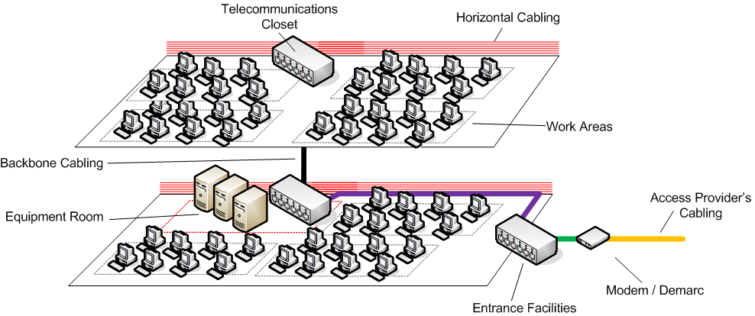
Wiring distribution components
 See Unit 4.2 / Installing Cable / Study Notes for descriptions of commonly used types and categories of network cabling and connectors.
- Backbone Cabling - connects horizontal cross-connects to the main cross-connect (optionally via intermediate cross-connects). These can also be described as vertical cross-connects (backbone cabling is more likely to run up and down between floors). This is also wired in a star topology.
- Work Area - the space where user equipment is located and connected to the network, usually via some kind of wall port.
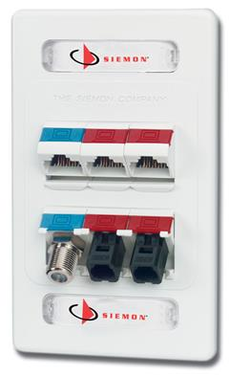
Siemon modular wall plate (Image © 2015 Siemon [www.siemon.com])
- Telecommunications room - houses horizontal cross-connects. Essentially, this is a termination point for the horizontal cabling along with a connection to backbone cabling. An equipment room is similar to a telecommunications room but contains the main or intermediate cross-connects. Equipment rooms are also likely to house "complex" equipment, such as switches, routers, and modems.
- Entrance Facilities / Demarc - special types of equipment rooms marking the point at which external cabling (outside plant) is joined to internal (premises) cabling. These are required to join the access provider's network and for inter-building communications. The demarcation point is where the access provider's network terminates and the organization's network begins.
- Administration - schemes are described in the TIA 606 standard. This defines a system of identifiers to use to describe the elements of the network and manage configuration changes. These are often referred to as MACs (Moves, Adds, Changes).

Distribution Frames
A distribution frame is another way of describing a cross-connect. It is a passive device allowing the termination and cross-connection of cabling. As described above, these can be installed in a hierarchy:
- Main Distribution Frame (MDF) - terminates external cabling and distributes backbone cabling to intermediate or horizontal cross-connects.
- Intermediate Distribution Frame (IDF) - optional level of hierarchy for distributing backbone cabling. Note that the TIA 568 standard allows for only one such intermediate level. IDFs would typically be used in a multi-building (campus) network. An MDF in the main building would connect to IDFs in outer buildings, which would connect in turn to horizontal cross-connects on each floor.

66 Blocks and 110 Blocks
Wiring is terminated using a punch-down block. A number of different punch-down block formats have been used for telecommunications and data cabling.
- A 66 block is an older-style distribution frame used to terminate telephone cabling and legacy data applications (pre-Cat 5). A 66 block comprises 50 rows of 4 IDC terminals. The 25-pair cable from the access provider is terminated on one side of the block. On the other side of the block, the terminals terminate the wiring from the PBX. A jumper (bridging clip) is installed over the middle two terminals to complete the connection.
 A Private Branch Exchange (PBX) is a telephone system serving the local extensions of an office.
- The 110 block is an updated type of IDC supporting 100 MHz operation (Cat 5) and better. "110 block" can describe both a punch-down format and a distribution frame (or wiring block). In the case of distribution frames, these are available in a variety of configurations, supporting between 25 and 300 pairs. A 110 wiring block is arranged horizontally rather than vertically, offering better density than a 66 block. There is also more space for labeling the connectors and each column of connectors is color-coded, making management simpler. The incoming wire pairs are fed into channels on the wiring block then a connector block is installed to terminate the incoming wiring. Outgoing wire pairs are then punched into the terminals on the connector blocks to complete the circuit.
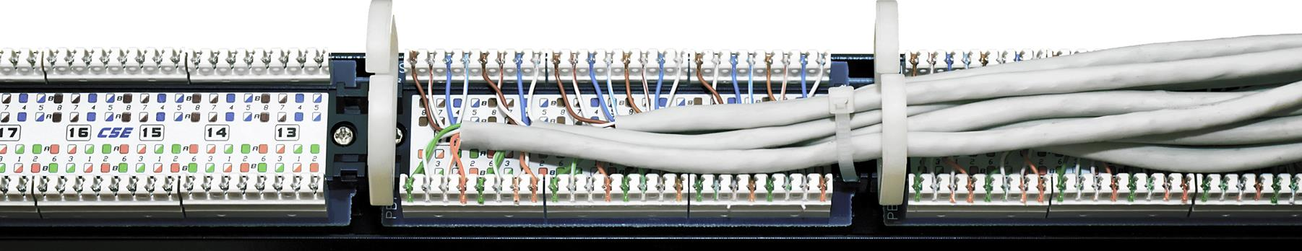
110 block IDCs at the rear of a patch panel

Patch Panel
A patch panel is a type of cross-connect that utilizes modular jacks and connectors. A patch panel has 110 block IDCs on one side and pre-wired RJ-45 jacks on the other side. This greatly simplifies wiring connections and is the most commonly installed type of wiring distribution where connections need to be changed often.
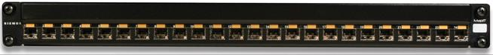
Siemon patch panel (Image © 2015 Siemon [www.siemon.com])

Labeling
The ANSI/TIA/EIA 606 Administration Standard for Commercial Telecommunications Infrastructure sets out a basic scheme for documenting a typical office network installation. It includes suggested identifiers for different subsystems and elements of the installation, including cables, distribution frames / patch panels, ports, circuits, and systems (appliances or computers).
A typical type of port naming convention is for alphanumeric identifiers for the campus (for multi-campus networks), building (for campus networks), telecommunications space, and port. For example CB01-01A-D01 could refer to a cable terminating at Main Campus Building (CB01), telecommunications space A on floor 1 (01A), data port 1 (D01). Structured cable and patch cords should be labelled at both ends to fully identify the circuit. A similar convention can be adopted for infrastructure and systems, such as distribution frames, patch panels, switches, routers, access points, and servers. It can be more complex to use location-based identifiers as hardware may get moved around during its service life, requiring the tag to be changed. The naming convention might also try to encode other information, such as the type and function of a device or its service/warranty support code. It is also helpful to use color-coding for cable types. One suggested scheme is as follows:
Color | Usage
Orange | Demarc / access provider
Green | Demarc / CPE
Purple | Router / PBX links
Red | Work area telephone links
White | MDF / 1st level backbone
Gray | IDF / 2nd level backbone
Brown | Campus backbone
Blue | Work area data links
Yellow | Other (alarm systems)
As well as identifying and labeling local network circuits, you should also ensure that WAN links to the Internet or to remote offices are clearly labeled and documented. The WAN provider will assign a circuit ID and you will need to quote this if raising any sort of support issue.
See Unit 4.5 / Remote Access / Study Notes for notes on installing WAN interfaces and devices.

Rack Systems
A rack is a specially configured steel shelving system for server and network equipment. Using a rack allows equipment to be stored more securely and compactly than ordinary desks or shelving would allow for.

Rack Specifications
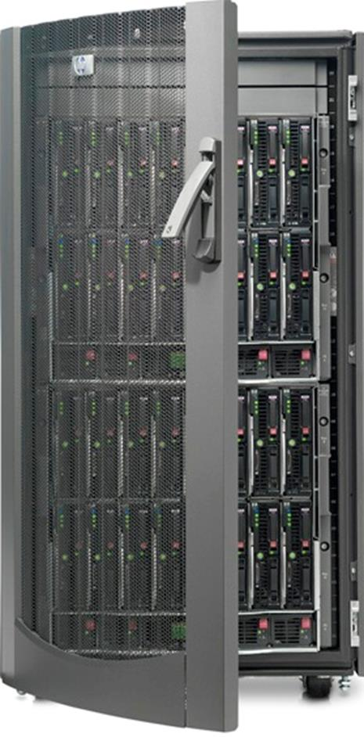
HP rack for blade server enclosures (Image © 2011 Hewlett-Packard Development Company, L.P)
Rack or blade servers and network equipment are EIA standard width (19" / 48cm), allowing them to be screwed into the rack directly.
Racks can be purchased with varying depths (from 30-40" / 75-100cm) and heights. Rack height is measured in EIA units of 1.75" / 4.45cm called U. Racks are sold in heights from 8U to 48U. Rack-compatible equipment is designed with a vertical height quoted in U so you can plan exactly how much vertical space you require. The equipment screws either directly into the frame or into rails positioned up the posts. Sliding rails allow a server to be pulled free of the rack for maintenance.
Non-standard components, such as a tower server or monitor, can be installed on shelves.
Racks have a maximum weight capacity. Racks are available in either 2-post or 4-post form factors, referring to whether the rack has vertical posts at the front and back or not. A 4-post rack allows both the front and back of an appliance to be secured. A 2-post rack is only suitable for light equipment (patch panels or 1U switches for instance) as the rear of the device is unsupported. Rack accessories such as shelves will also have a maximum weight capacity.
Most racks are designed to be free-standing, though smaller wall-mounted cabinet units are also available. Free-standing racks can be bolted together in rows. Some racks can be wheel mounted; others require stabilization or leveling. It is also possible to add ballast; weight to balance a rack where the weight of devices in the rack cannot be distributed evenly.
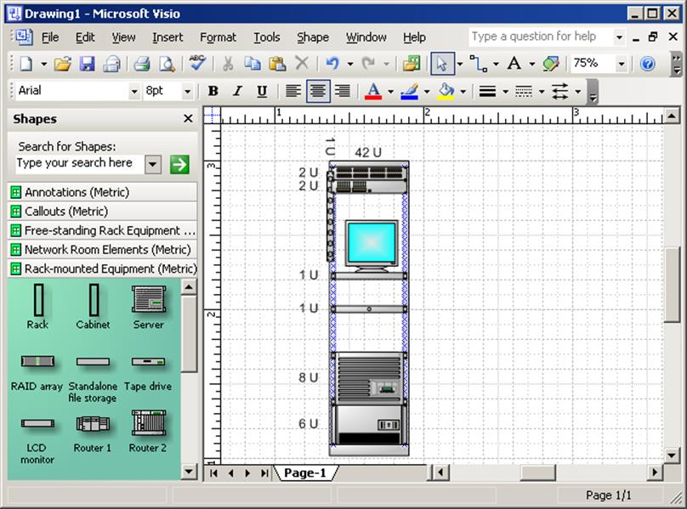
Designing rack layout in Microsoft Visio

Rack Security and Monitoring
Lockable doors (front and rear) enforce rack security to prevent unauthorized access to the equipment. These can be supplied with key-operated or electronic locks.
A rack controller appliance can be used to consolidate different monitoring mechanisms. This sort of device communicates status updates and alerts to monitoring software over the network. A rack controller might come with built-in functions for monitoring temperature and humidity and support extra plug-in functions, such as camera monitoring.

Rack Installation
The first step is to place the racks in the correct location in the server room. Multiple rows should be placed back-to-back not front-to-back to maximize cooling and there should be about 3' (1 meter) clearance for service access and air flow. If necessary, bolt the racks together and check that they are stable, adjusting leveling bolts if necessary. Generally speaking, large and heavy items should be placed lower in the rack. Weight distribution is probably the main factor in determining device placement within the rack.
Check cable lengths and plan ahead for any devices that need to be connected, as removing and re-inserting equipment is time-consuming.
Keep cables tidy within the rack using brackets and ties, taking care not to pinch the cabling too tightly. Do not allow cables to hang in front of devices; make sure the cabling is led to one side of the rack. Cable trays can be used to channel cabling from and between racks. A cable tray is usually made of metal, with holes for ventilation. They provide easier access to cables than conduits.
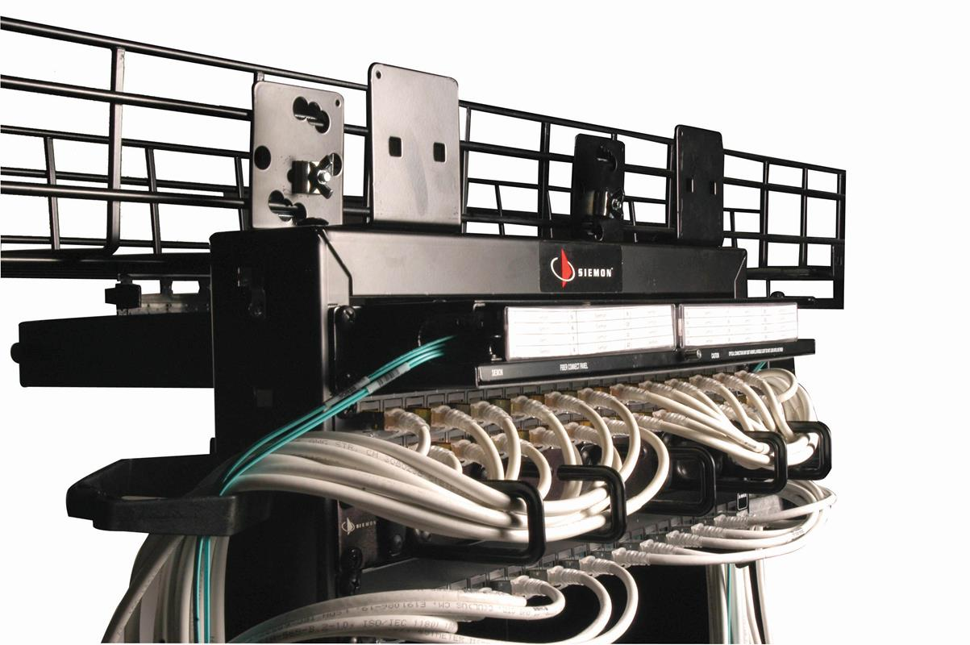
Siemon equipment rack and cable management showing cable management brackets carrying patch cable to sides of rack and overhead cable trays routing cables to racks (Image © 2015 Siemon [www.siemon.com])
Ensure that equipment on pull-out rails does not cause the rack to tip. If there is any sign of instability, add ballast to compensate. Also check that pulling the tray out does not dislodge any connectors. Leave enough slack in the cable for an item to be pulled out along the length of its rail.

Safety and ESD
It is imperative that electrical equipment be handled and installed safely.

Tool Safety
When handling tools, you must be aware of risks that could arise from carelessness or improper use.
- Do not work on electrical systems (especially an energized circuit) unless you have a good understanding of the risks and appropriate safety procedures.
- Disconnect the power to a circuit if you must handle it and always test live parts with a multimeter to ensure that no voltage is present.
- Always use properly insulated tools and never grip a tool by its metal parts.
- Take care not to touch any part of a circuit with both hands to reduce the risk of a serious shock (the "hand in pocket" rule - this reduces the chance that the current will pass through your chest and cause a heart attack).
- Be aware that the tools used to prepare cables and connectors can have sharp edges or could crush your fingers if used carelessly.

Grounding
A connection to ground (or earth) provides a return path for electrical current. This is usually a safety feature; if an electrical connection short circuits into the metal chassis, a ground wire ensures that the current flows to earth rather than electrocuting someone handling the faulty device.
Some power circuits contain a ground wire. If the circuit does not contain a ground wire, any electrical devices with metal cases (or any metal objects that could come into contact with electrical wires) must be bonded to the building's earth system. This particularly includes rack systems and cable trays. Do not disconnect the ground wire. If it has to be removed, make sure it is replaced by a competent electrician.

Lifting Equipment
Lifting a heavy object in the wrong way can damage your back, but lifting and manual handling risks are not limited to particularly heavy objects. An object that is large or awkward to carry could cause you to trip over or walk into something else. An object that has sharp or rough edges or contains a hot or corrosive liquid could cause you to cut or hurt yourself. If necessary, you should obtain protective clothing (gloves and possibly goggles).
To lift a heavy object safely, plant your feet around the object with one foot slightly toward the direction in which you are going to move. Bend your knees to reach the object while keeping your back as straight as is possible and comfortable and your chin up. Find a firm grip on the object then lift smoothly by straightening your legs - do not jerk the object up. Carry the object while keeping your back straight. To lower an object, reverse the lifting process; keep your chin up and bend at the knees. Take care not to trap your fingers or to lower the object onto your feet.
If you cannot lift an object because it is too awkward or heavy, get help. If you need to carry an object for some distance, make sure that the route is unobstructed and that the pathway (including stairs or doorways) is wide and tall enough.

Material Safety Data Sheet (MSDS)
Suppliers of chemicals or materials treated with chemicals are required to identify the hazards (or dangers) of the substances they supply. If a chemical is dangerous, the supplier must provide information about the hazards that it presents; some hazard information will be provided on labels, but the supplier must also provide more detailed hazard information on a Material Safety Data Sheet (MSDS). An MSDS will contain information about ingredients or composition, health hazards, precautions, fire-fighting measures, and first aid information, and how to recycle any waste product or dispose of it safely. You may need to refer to an MSDS in the course of installing cabling.

ElectroStatic Discharge (ESD)
An ElectroStatic Discharge (ESD) occurs when a surface with low potential difference is brought near a surface with high potential difference. This can cause a spark to leap between the two surfaces. The spark is not dangerous to human health (it is high voltage but low current) but can cause serious damage to electronic circuits, such as CPUs and system memory modules.
Where possible, handle vulnerable components by holding the edges of the plastic mounting card and avoid touching the surfaces of the chips themselves. Using an anti-ESD wrist strap can dissipate static charges more effectively. The wrist band should fit snugly around your wrist to maximize contact with the skin. Do not wear it over clothing. The wrist strap ground is made either using a grounding plug that plugs into a wall socket or a crocodile clip that attaches to a grounded point or an unpainted part of the computer's metal chassis. An anti-ESD service mat is also useful. Sensitive components can be placed on the mat safely.

Power Management
Network appliances and servers require a stable power supply to operate. Electrical events such as voltage spikes or surges can crash computers and network appliances while loss of power from brownouts or blackouts will cause equipment to fail. Power management means deploying systems to ensure that equipment is protected against these events and that network operations can either continue uninterrupted or be recovered quickly.

Power Converters
Computers and network appliances require Direct Current (DC) voltages to run. One of the functions of the Power Supply Unit (PSU) in such appliances is to convert the incoming AC supply circuit to 3V, 5V, and 12V DC. An enterprise-class server or appliance is likely to feature two or three PSUs, providing load balancing and redundancy. A hot plug PSU can be replaced (in the event of failure) without powering down the system.

Power Distribution Units
The power circuits supplying mains power to a rack, network closet, or server room must be sufficient to meet the load capacity of all the installed equipment (plus room for growth). Consequently, circuits to a server room will typically be higher capacity than domestic or office circuits (30 or 60 amp as opposed to 13 amp for instance). These circuits may be run through a Power Distribution Unit (PDU). These come with circuitry to "clean" the power signal, provide protection against spikes, surges, and brownouts and can integrate with Uninterruptible Power Supplies (UPS).
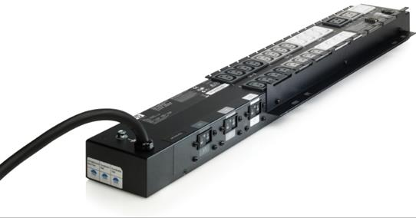
HP rack-mounted PDU with monitoring functionality (Image © 2011 Hewlett-Packard Development Company, L.P)
On a smaller scale, PDUs are also available as "strip" sockets that can take a higher load than a typical 13 amp rated strip. Such sockets are rack mounted and can be oriented horizontally or vertically to allow for different cabling and layout options.
PDUs also often support remote power monitoring functions, such as reporting load and status, switching power to a particular socket on and off, or switching sockets on in a particular sequence.

Uninterruptible Power Supplies (UPS)
An Uninterruptible Power Supply(UPS) will provide a temporary power source in the event of a blackout (complete power loss). This may range from a few minutes for a desktop-rated model to hours for an enterprise system. The time allowed by a UPS is sufficient for an alternative power source to kick in (such as a standby generator) or at least to allow the administrator to shut down the server or appliance properly (users can save files and the operating system can complete the proper shut down routines). In its simplest form, a UPS comprises a bank of batteries and their charging circuit plus an inverter to generate AC voltage from the DC voltage supplied by the batteries.
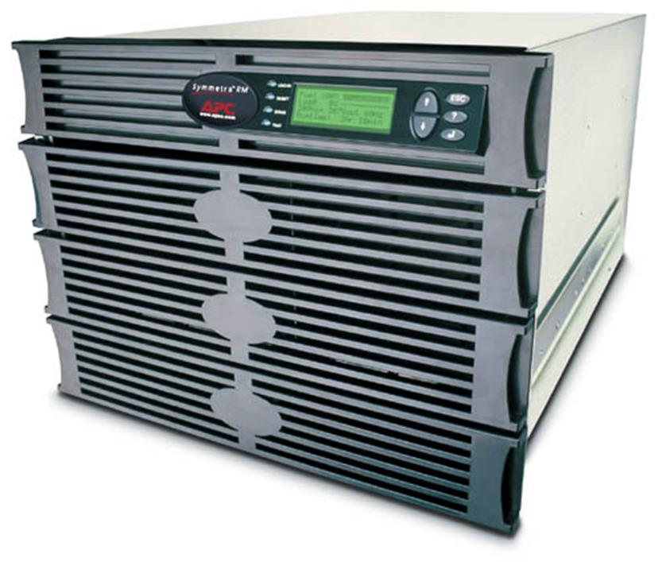
APC enterprise UPS (Image © 2012 APC by Schneider Electric)

Installing a UPS
Different UPS models support different power outputs and form factors - from desktop to rack mounted depending upon your needs.
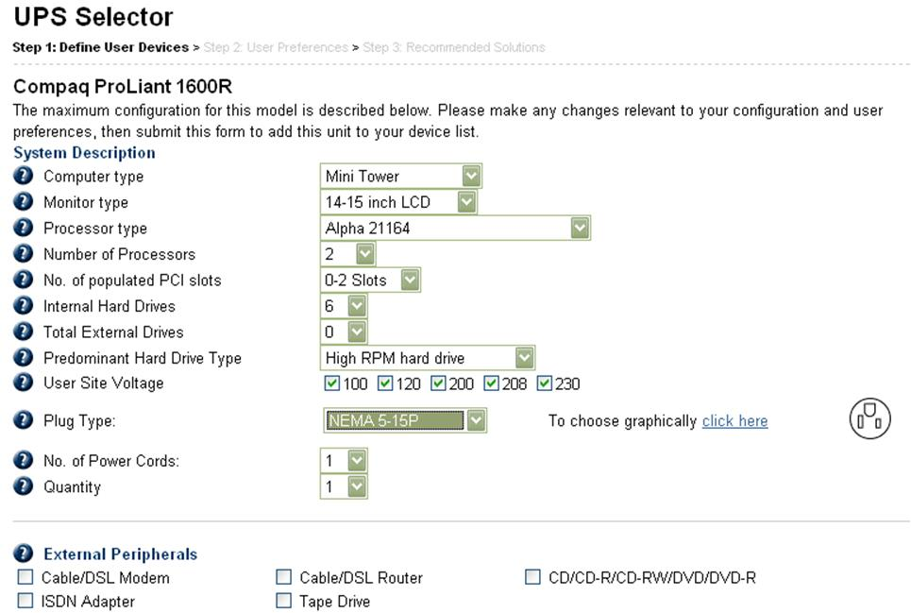
Choosing the UPS - defining the server and peripherals
The maximum load (and hence cost) of a UPS is determined by the battery specification and the power handling of the inverter and other circuitry. Each UPS is rated according to the maximum VA (power) it can supply without overloading. To calculate the required VA rating for a UPS, simply add up the VA ratings of all the equipment to be connected to the unit. These may be calculated by taking the number of watts used by each device and multiplying by 1.6.
 These days, most UPS vendors will state cumulative power consumption in both VA and Watts. The Watt rating is generally more accurate.

Configuring a UPS
Proper monitoring of a UPS is vital to ensure that it is doing the job it is supposed to. If the power fails it will be a bit late to discover that your UPS also has a flat battery! A standalone UPS is connected to the server via a monitoring port - traditionally over a serial port, but more recently over USB. A rack-mounted UPS might be monitored via a PDU, as described above.
The complexity of this connection and the software provided to monitor it varies depending on the make and model of UPS specified and the user's needs. The monitoring software should be able to report the load attached to the UPS and record any events, such as power failures or low battery states.
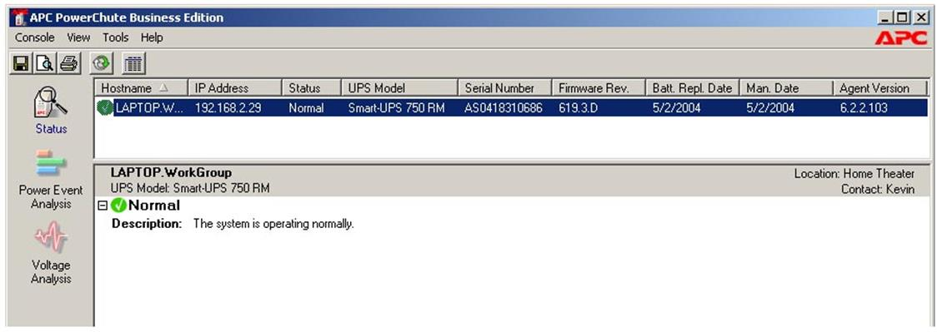
Monitoring software - events
As the UPS can only provide power for a short period, there will come a point when the UPS battery is exhausted, and the server will still not shut down cleanly. To avoid this, the administrator can configure the shut down behavior, so that if power is still not available after a defined period, then the UPS monitor will close down all active files cleanly and shut off the server.
In any case, the software must record events, such as a switch to battery power, and back again, because the administrator will not always be around to observe this. Hence, UPS monitoring software will write events to the OS log files. Some UPS can communicate with monitoring software such as SNMP (Simple Network Management Protocol) via a network connection.

Heating, Ventilation, Air Conditioning (HVAC)
A Heating, Ventilation, Air Conditioning (HVAC) system ensures adequate cooling and humidity and dust control within a room or other enclosed space. All air flow into and out of the room is run through ducts, fans, and filters and warmed or cooled to the correct temperature and humidity.

Temperature and Humidity
It is highly beneficial to install servers and network equipment in a dedicated room or area. This can be isolated from the rest of the premises for security and also helps to control the environmental conditions around the server equipment. Servers and other networking equipment are often housed in a purpose-built building (a data center).
An environment that is too warm will raise the chances of system components overheating and failing. An environment that is too cold can cause stress on components with moving parts (such as hard drives and fans) and is more susceptible to static damage (ESD).
Also, the temperature in the server room should not be allowed to vary by too much. Temperature variations could cause condensation and, if extreme enough, cause components to expand or contract. Over time, connectors can work free from their sockets (chip creep) and cause errors.
A humid environment runs the risk of condensation forming on components, which can lead to short circuits or corrosion. A low humidity environment greatly increases the chance of ESD.

Environmental Monitoring
Spaces housing data equipment and cabling should be kept at an ambient temperature of between 18-24°C (64-75F) and at a relative humidity of 30-55%.
 Some data centers (notably those operated by Google) are allowing higher temperatures (up to around 26ºC / 80ºF). This can achieve significant energy cost savings and modern electronics is proving reliable at this temperature.
This would normally be maintained by the building HVAC system with environmental monitors to measure temperature and relative humidity in each space. Network-enabled monitors can be connected to switches or connected to a PC via USB and integrated with network management software to provide an alert if environmental conditions change. Monitors connected to rack controllers can provide feedback on the conditions within a single rack.
When using an air conditioning system, ensure that it is inspected and maintained periodically. Systems may be fitted with alarms to alert staff to problems. Highly mission-critical systems may require a backup air conditioning system.
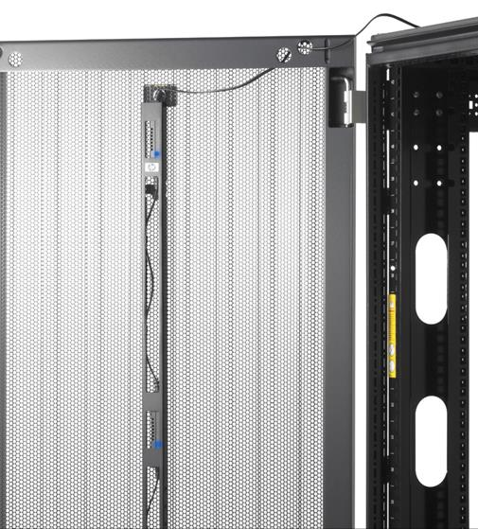
HP Dynamic Smart Cooling sensors integrate with the air conditioning system to target cooling to a particular rack (Image © 2011 Hewlett-Packard Development Company, L.P)
Use a portable monitor to verify that the HVAC's temperature and humidity sensors are returning the correct readings.

Device Placement and Air Flow
The room should also provide decent air flow around the network equipment. Air flow is provided by ensuring enough space (at least 3 feet or 1 meter) around the server or rack. Obviously, air conditioning vents should not be blocked by racks or equipment. Where possible, the space should not be exposed to direct sunlight.
If multiple racks are used, install equipment so that servers are placed back-to-back not front-to-back, so that the warm exhaust from one bank of servers is not forming the air intake for another bank. This is referred to as a hot aisle / cold aisle arrangement. In order to prevent air leaks from the hot aisle to the cold aisle, ensure that any gaps in racks are filled by blank panels and use strip curtains or excluders to cover any spaces above or between racks.
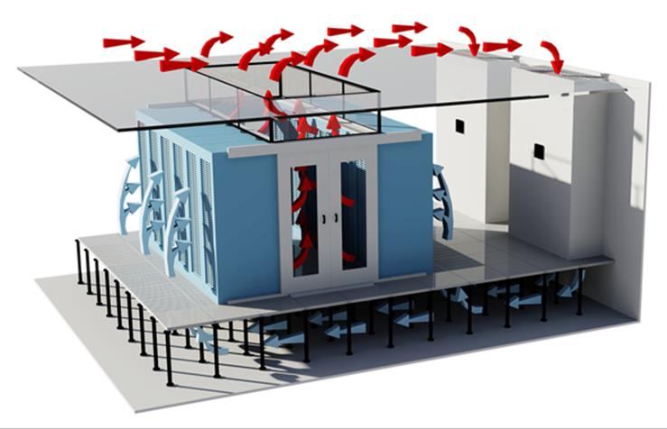
Hot aisle containment design by www.keyzone.com - cold air circulates from the air conditioner under the floor and around the rack while hot air is drawn from between the racks through the ceiling space (plenum) to a heat exchanger; in this design it is very important that hot air does not leak from the ceiling or from the floor space between the racks
An equipment room should not be used as storage space. Do not leave boxes or unused equipment in it. Also, do not install unnecessary devices that generate a lot of heat, such as printers.
The heat generated by equipment per hour is measured in British Thermal Units (BTU) or KiloWatts (KW). 1 KW is 3412 BTU. To calculate the cooling requirement for an air conditioning system, multiply the wattage of all equipment in the room (including lighting) by 3.41 to get the BTU/hour. If the server room is occupied (unlikely in most cases), add 400 BTU/person. The air conditioner's BTU-rating must exceed this total value.
Low-end air conditioning systems are usually rated between 5,000 and 10,000 BTU. Larger units may be rated by tonnage. One ton of load is 12,000 BTU/hour.
Fans can also be installed on the server racks themselves to provide adequate air flow and cooling within the rack. Additional sensors may also be provided to direct cooling where it is most needed, reducing energy costs (air conditioning and high speed fans use a lot of power).
It is also essential to insulate the room properly and to stop any potential air leaks. Allowing cold air to leak will cause the HVAC system to have to work harder to maintain the correct climate, using more energy. Air leaks may be caused by obvious things like open doors or windows or by missing wall or floor tiles or holes punched for cabling.

Physical Security Controls
Physical site security can be thought of in terms of zones. Each zone should be separated by its own barrier(s). Access points through the barriers need to be controlled by one or more security mechanisms. Progression through each zone should be progressively more restricted.
The number of zones will depend on the size of the site and the type of operations that take place there, but you could categorize the following general areas:
- External - the areas outside the premises. It may be difficult to control these areas, with security mechanisms limited to surveillance.
- Perimeter - for a single site, this will be the walls of the building itself. A large site with many buildings will have an outer perimeter (fencing) and then inner perimeters for each building. Many businesses will share premises with other companies, in which case access to the building and monitoring of common parts is likely to be the responsibility of the landlord or building management company. A critical point in the perimeter is any location where voice and data cabling enter.
- Public - these are areas of the building where guests are invited, deliveries accepted, and so on. Public zones are typically high traffic (that is, people move through them frequently).
- Restricted - these are areas where most employees work. Guests may be invited into these zones, if they are subject to the proper controls. Depending on the level of security, it may or may not be appropriate to control the movement of employees between restricted zones.
- Secure - these are areas where access is strictly limited because they contain critical systems or confidential data. A typical example would be a network closet or equipment room housing servers and switch and router appliances.
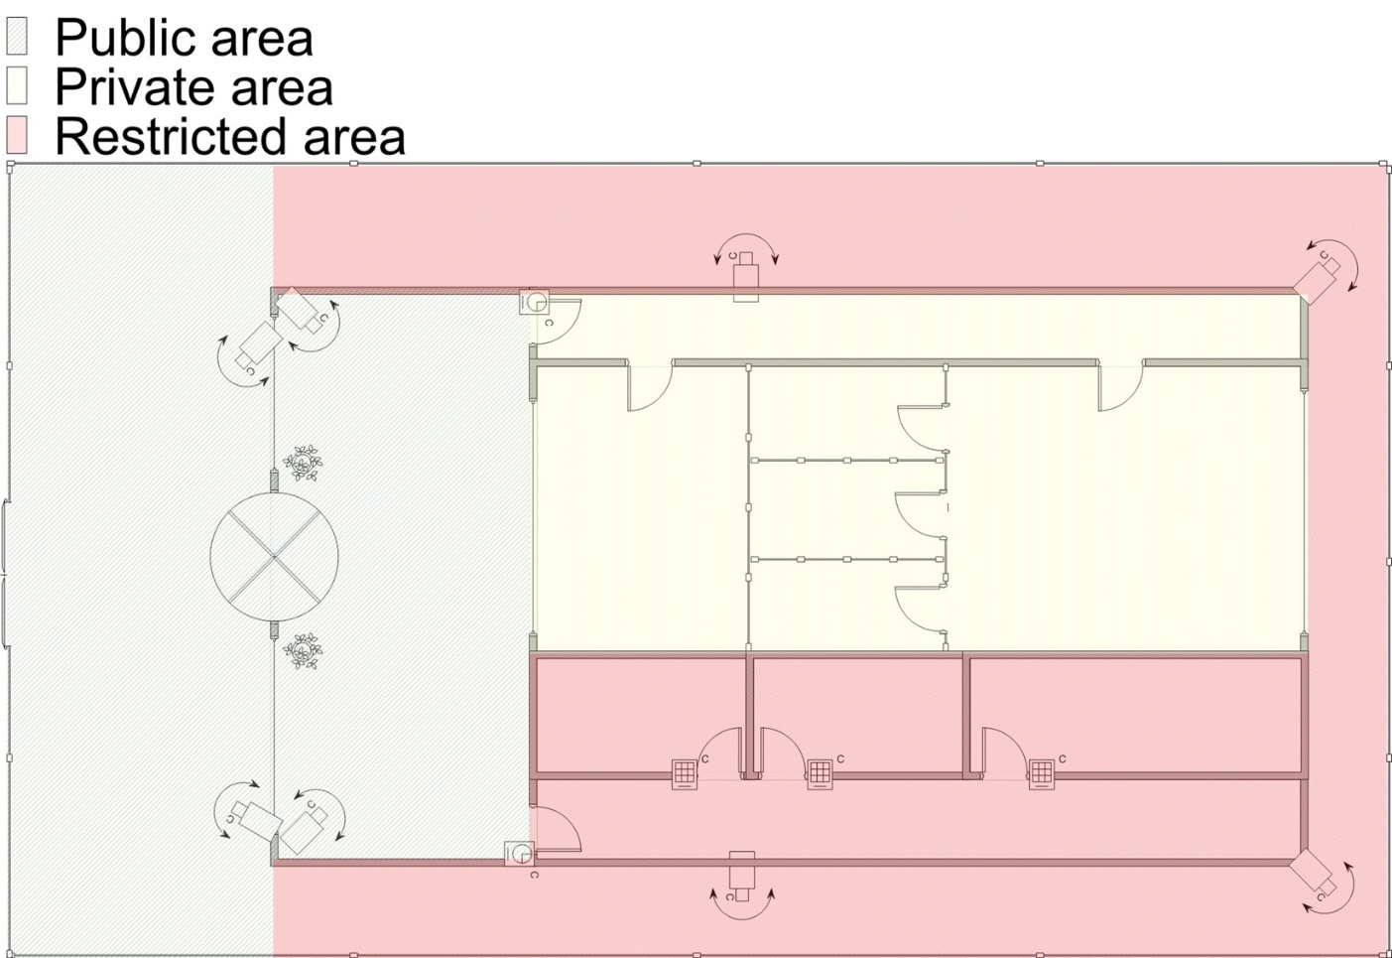
Defining security zones

Door Access Controls
A barricade is something that prevents access. As with any security system, no barricade is completely effective; a wall may be climbed or a lock may be picked, for instance. The purpose of barricades is to channel people through defined access points. Each access point should have an authentication mechanism (or door access control) so that only authorized persons are allowed through.
Most door access controls depend on some type of lock mechanism. Locks can be categorized as follows:
- Conventional - a conventional lock prevents the door handle from being operated without the use of a key. More expensive types offer greater resistance against lock picking.
- Deadbolt - this is a bolt on the frame of the door, separate to the handle mechanism.
- Electronic - rather than a key, the lock is operated by entering a PIN on an electronic keypad. This type of lock is also referred to as cipher, combination, or keyless.

CodeLock combination digital lock
- Token-based - a smart lock may be opened using a magnetic swipe card or feature a proximity reader to detect the presence of a wireless key fob or one-time password generator (physical tokens) or smart card.
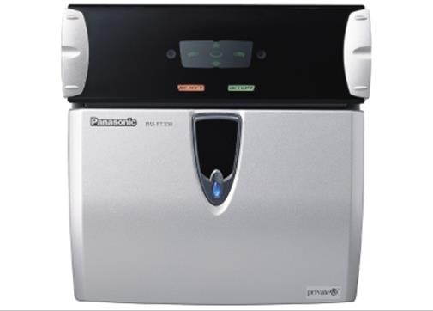
Panasonic Iris Recognition Camera System
- Biometric - a lock may be integrated with a biometric scanner.
- Multifactor - a lock may combine different methods (for example, smart card with PIN).
A secure gateway will normally be self-closing and self-locking, rather than depending on the user to close and lock it.

Turnstiles and Mantraps
Apart from being vulnerable to lock picking, the main problem with a simple door or gate as an entry mechanism is that it cannot accurately record who has entered or left an area. Multiple people may pass through the gateway at the same time; a user may hold a door open for the next person; an unauthorized user may "tailgate" behind an authorized user.
This risk may be mitigated by installing a turnstile (a type of gateway that only allows one person through at a time). Where security is critical and cost is no object, a mantrap could be deployed. A mantrap is where one gateway leads to an enclosed space protected by another barrier. Mantraps can operate in a number of modes:
- All doors normally unlocked - opening one door causes the other to lock.
- All doors normally locked - unlocking one door prevents the other from being unlocked.
- One door locked / other unlocked - when one door is open the other cannot be unlocked.

Fail-safe and Fail-secure Locks
A traditional mechanical lock is operated using a key. An electromagnetic lock requires a power-source to operate. Some locks are battery-powered but most run from mains power.
Electromagnetic locks may be designed to be either fail-safe (fail-open) or fail-secure (fail-close). A fail-safe lock means that the gateway will be open if the lock fails; a fail-secure lock means that the gateway will not be openable. For example, if the power fails, then a door with a fail-safe lock will become open.
An example of a fail-secure lock is that of a safe that "deadlocks" in the event of an alarm being triggered or the power being lost. This should not present any hazard to human health as the safe should not be occupied. Gateways for any sort of occupied area of a building can only be made one-way fail-secure (that is, they may prevent entry but they must not prevent egress) as otherwise they would be lethal in the event of an emergency such as fire, flood, or earthquake.
Fail-secure locks for occupied areas (designed for use on fire doors) would come with a manual bypass on the inside. Of course, in an emergency fire teams need to be able to access all areas of a building safely so fail-secure locks must still be deployed with care. The use of locks must conform to local fire codes and expert advice should be sought when designing the building security system.

Security Guards
Surveillance is typically a second layer of security designed to improve the resilience of perimeter gateways. Effective surveillance mechanisms ensure that attempts to penetrate a barricade by other means are detected. Surveillance may be focused on perimeter areas or within security zones themselves.
The visible presence of guards is a very effective intrusion detection and deterrence mechanism, but is correspondingly expensive. It may also not be possible to place security guards within certain zones because they cannot be granted an appropriate security clearance. Training and screening of security guards is imperative.

Video Monitoring and CCTV
Video monitoring is a cheaper means of providing surveillance than maintaining separate guards at each gateway or zone, though still not cheap to set up if the infrastructure is not already in place in the premises. It is also quite an effective deterrent.
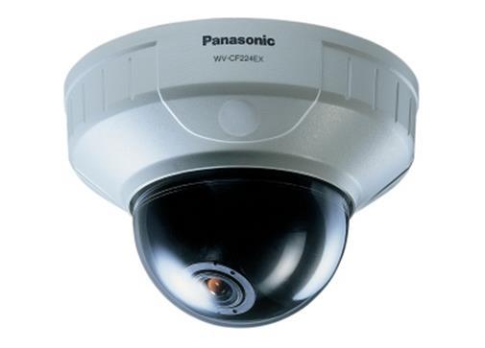
Panasonic mini-dome CCTV
The other big advantage is that movement and access can be recorded. The main drawback is that response times are longer and security may be compromised if not enough staff are in place to monitor the camera feeds.
A camera is either fixed or can be operated using Pan-Tilt-Zoom (PTZ) controls. Different cameras suit different purposes. If you want to record the image of every person entering through a door, a fixed, narrow focal length camera positioned on the doorway will be perfectly adequate. If you want to survey a large room and pick out individual faces, a camera with PTZ is required.
The cameras in a CCTV (Closed Circuit Television) network are typically connected to a multiplexer using coaxial cabling. The multiplexer can then display images from the cameras on one or more screens, allow the operator to control camera functions, and record the images to tape or hard drive. Newer camera systems may be linked in an IP network, using regular data cabling. Small IP cameras can use Power Over Ethernet (PoE), avoiding the need to provision a separate power circuit.

Fire Prevention and Suppression
Fire can be catastrophic to a business, not to mention the danger it poses to people.

Fire Prevention
The essential point about fire prevention is that flammable materials should be kept away from sources of ignition. Office spaces should be kept clear of flammable materials, such as boxes or polystyrene, and ignition sources (no smoking!). Most countries require businesses to commission a fire inspection annually, during which an inspector will advise of any risks and check safety procedures and equipment. It is also wise to carry out your own checks monthly, to ensure that fire detectors and alarms work.

Building Layout and Emergency Alert Systems
Health and safety legislation dictates what mechanisms an organization must put in place to detect and suppress fires. At the very least each building must have well-marked fire exits and a fire escape plan that is tested and practiced regularly. Building layout in larger premises needs to be designed in such a way that fire cannot be allowed to spread quickly, by separating different areas with fire-resistant walls and doors (which must be kept shut).
Buildings also need to be fitted with automatic smoke or fire detection emergency alert systems, as well as alarms that can be operated manually. There are several types of detector:
- Photoelectric smoke detector - measures the integrity of an internal beam of light. The alarm will sound if the beam degrades (for example, if it is obscured by smoke).
- Ionization smoke detector - a radioactive source creates a regular movement of ionized particles, which can be disrupted by smoke.
- Heat detector - these alarms sound if heat rises to a certain point or if the rate of temperature increase exceeds the defined limit.
- Flame detector - these use infrared sensors to detect flames, and are the most effective (and expensive) type.

Escape Plans, Routes, and Drills
Every building requires a fire escape plan (or evacuation plan) for use in emergency. The plan instructs staff on how to leave the building safely and assemble at a designated marshal point outside. The plan assigns the persons responsible for ensuring that the building has been cleared and that everyone (staff and visitors) has been accounted for.
Safety/emergency exits from the building must be clearly signed and keep unobstructed. The plan should also set out the procedure to follow should an escape route be blocked; usually this will be to find an opening window and close the doors to the room.
The escape plan should be tested by performing an evacuation drill periodically. This ensures that all staff are familiar with the plan and with escape routes and marshal points.

Fire Suppression Systems
Fire suppression systems work on the basis of the Fire Triangle. The Fire Triangle works on the assumption that a fire requires heat, oxygen, and fuel to ignite and burn. Removing any one of those elements provides fire suppression (and prevention).
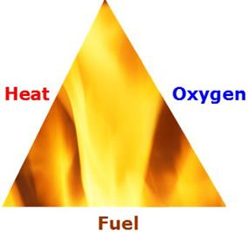
Fire triangle
 The fire triangle has been updated in most firefighting literature to the fire tetrahedron (or pyramid). This is because some fires involving chemicals can be sustained by the chain reaction of the chemicals involved and cannot safely be extinguished by normal means.
In the US (and most other countries), fires are divided by class under the NFPA (National Fire Protection Association) system, according to the combustible material that fuels the fire. Fire extinguishers come in several different types; each type being designed for fighting a particular class of fire. Using the wrong type of extinguisher on a fire can have catastrophic effects.
Class | Color | Symbol | Pictogram | Usage
A | Silver | Green Triangle |  | Ordinary combustible materials such as paper, wood, cardboard, and most plastics.
B | Red | Red Square |  | Flammable or combustible liquids, solids (notably oils, paints, alcohol), and gases.
C | Red | Blue Circle |  | Electrical equipment.
D | Yellow | Yellow Star |  | Combustible metals, such as those found in a laboratory.
K | Silver | Black Hexagon |  | Highly flammable materials, such as cooking oils or fats.
Under the European classification system, "electrical" fires are Class E and cooking oil fires are Class F.
Firefighting equipment requires adequate training to use properly. In an office workspace, this equipment will normally consist of a number of fire extinguishers. A fire extinguisher should only be used to tackle a small fire. The first consideration should be to identify a clear route to an emergency exit.
Premises may also be fitted with an overhead sprinkler system. Most sprinklers work automatically, are triggered by heat, and discharge water. These are referred to as "wet-pipe" systems. Wet-pipe poses a problem for areas containing sensitive equipment or materials, such as network communications rooms and library or museum archives. Wet-pipe systems constantly hold water at high pressure, so there is some risk of burst pipes and accidental triggering, as well as the damage that would be caused in the event of an actual fire. There are a number of alternatives to wet-pipe systems that can minimize the damage that may be caused by water flooding the room.
- Dry-pipe - these are used in areas where freezing is possible; water only enters this part of the system if sprinklers elsewhere are triggered.
- Pre-action - a pre-action system only fills with water when an alarm is triggered; it will then spray when the heat rises. This gives protection against accidental discharges and burst pipes and gives some time to contain the fire manually before the sprinkler operates.
- Halon / clean agent - gas-based systems have the advantage of not short circuiting electrical systems and leaving no residue. Up until a few years ago, most systems used Halon 1301. The use of Halon has been banned in most countries as it is ozone depleting. Alternatives to Halon are referred to as "clean agent". Examples include INERGEN (a mixture of CO2, Argon, and Nitrogen), FM-200 / HFC-227, and FE-13.

