UNIT 3.5 / MANAGEMENT AND MONITORING / STUDY NOTES

Performance Monitoring
When you install network infrastructure and applications for a given purpose, you will have tried to anticipate user demand for the service you wish to provide and will have installed a network with the appropriate link bandwidth, appliances, and servers.
As time goes by, users' demands on the system will increase, making additional demands on the network's resources until a point is reached where service availability and/or throughput is compromised to such an extent that users begin to experience problems. You then add resources to the network and the cycle begins again. Performance monitoring allows the administrator to determine that resources are being stretched before the point is reached where service function is impaired.

Establishing a Baseline
From time-to-time, you may have experienced a situation where a network suddenly stops performing well. Perhaps it takes an age to access a website or a document that previously took a few moments to copy down from a file server now takes several minutes. This is (informal) performance monitoring, with comparison to a baseline. In this case, the baseline is your personal experience of the responsiveness of the network under a given load.
An administrator needs to establish a more accurate baseline for comparison, in order to measure system responsiveness at a later date. A good time to do baselining is prior to the system going live. Build your network, choose the appropriate resource configuration, and then place a simulated load on the network (for which third-party and vendor specific tools exist). Then collect statistics for resource usage and network performance for future analysis.
Changes to the system require a new baseline to be taken. Some examples when this should be done are:
- Hardware or software upgrade.
- Reconfiguration of network.
- Installation of new devices / services.
- Changed user access volume or patterns.
- Changed server role.

Establishing Thresholds and Bottlenecks
Thresholds are points of reduced or poor performance that generate an administrative alert. Examples include packet loss, link bandwidth drops, number of sessions established, delay / jitter in real-time applications, and so on. Setting thresholds is a matter of balance. On the one hand you do not want performance to deteriorate to the point that it affects user activity; on the other you do not want to be overwhelmed by performance alerts.
A bottleneck is a particular point of poor performance that reduces the productivity of the whole network. A bottleneck may occur because a device is underpowered or faulty. It may also occur because of particular user or application behavior. To identify the cause of a bottleneck, you need to identify where and when on the network overutilization or excessive errors occur. If the problem is continual it is likely to be device-related; if the problem only occurs at certain times it is more likely to be user- or application-related.

Network Monitoring Utilities
There are various classes of utilities available to monitor the health and performance of a network or particular network link.

Health Monitoring
Tools can be used to alert administrators to (and provide early warning of) problems with servers or appliances such as device temperature, fan speeds, voltage fluctuations, disk failure, chassis intrusion, component failure, network link failure, and so on.
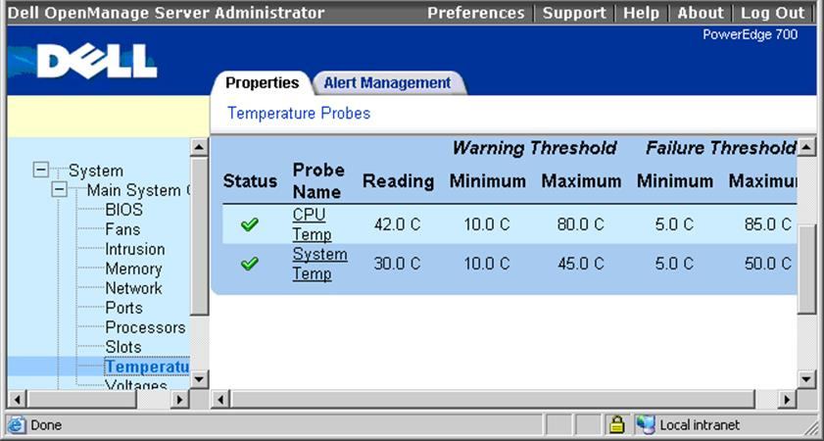
Dell OpenManage Server Administrator utility

Performance Monitors and Network Analyzers
A Performance Monitor can be used to provide real-time charts of server system and network resources or can be used to log information to a file for viewing at a later date. By monitoring different resources at different times of the day, you can detect when performance is stretched and why.
It may be that a particular server providing some kind of database service is having problems coping with the number of queries being sent to it during the day. This could be caused by a number of things. Perhaps it is that the processor is too slow, which would cause the requests to take longer. Perhaps the hard disk is too slow, which would mean that it takes too long for the server to pull the database files from the disk. The performance of this server could be increased by upgrading any or all of these components, but Performance Monitor will help you decide which is critical.
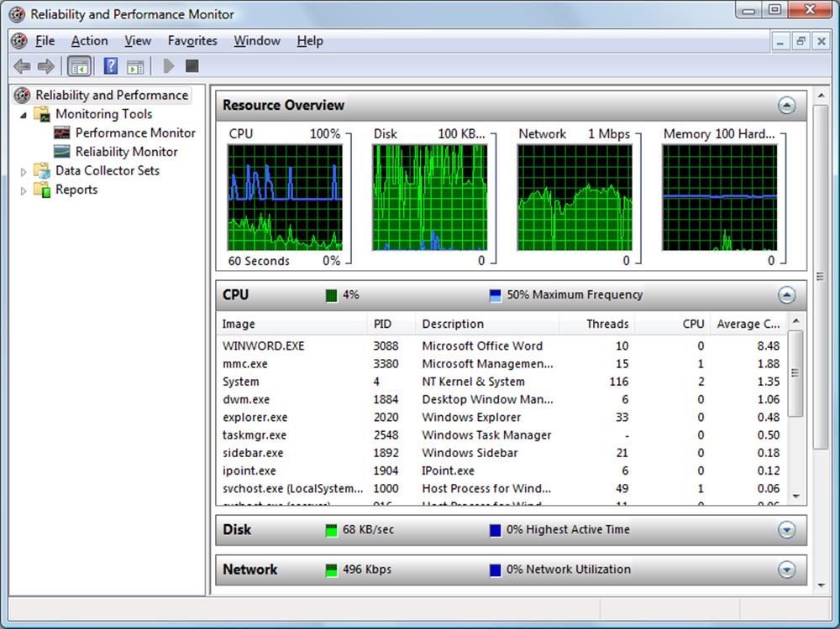
Using Performance Monitor for system monitoring in Windows
Statistics can also be gathered from network appliances. Stand-alone devices may have a web console to use for monitoring. Devices may also have the ability to report performance metrics to a management console using the Simple Network Management Protocol (SNMP).
Finally, you can gather statistics (or metadata) about network traffic, perhaps by attaching a network monitor or packet analyzer to a mirrored port. Collecting just the packet metadata rather than the whole packet payload greatly reduces the bandwidth required by the monitoring application. The statistics can be collated by software such as Cisco's NetFlow Analyzer to perform packet flow monitoring. This allows the administrator to identify routes, applications, and interfaces that might be over-utilized or that are creating bottlenecks. An enterprise network might deploy traffic shapers to provide advanced control over network utilization.
 Refer back to Unit 1.2 / Ethernet / Study Notes for more information about packet and network analyzer software. See Unit 3.4 / Applications and Services / Study Notes for topics on traffic shapers and load balancers.

Top Talkers / Listeners
One of the functions of a network analyzer may be to identify the most active interfaces on the network. "Top talkers" are interfaces generating the most outgoing traffic (in terms of bandwidth) while "top listeners" are the interfaces generating the most incoming traffic. Identifying these hosts and the routes they are using is useful in identifying and eliminating performance bottlenecks. Most network analyzer software comes with filters or built-in reporting to identify top talkers or top listeners.

Port Scanner
While a network analyzer or performance monitor looks at traffic flow and packets in detail, a port scanner reveals a snapshot of how applications are using the network. You can use a port scanner to show which applications have open ports on a server, how many client sessions are open, and how much bandwidth each port is consuming.
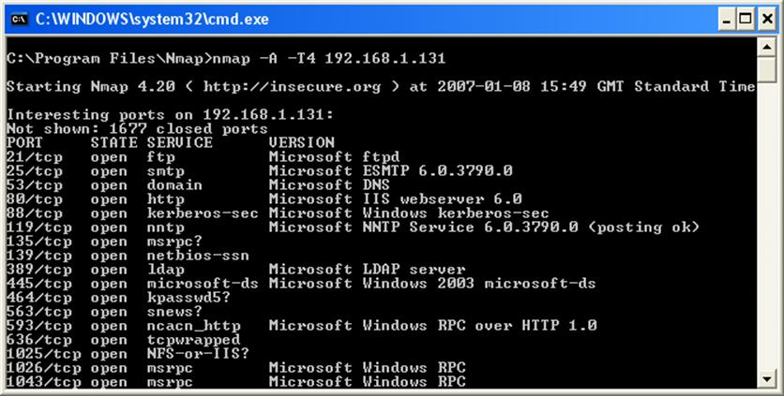
Nmap port scanner output
 insecure.org (developer of Nmap) is a good resource for further information.

Load Testing
Network administrators must be able to test their systems under load to simulate working conditions or test higher loads for assessing likely future problems. This can also be described as a stress test.
Test frame and packet generator systems allow frames or packets for a variety of networking technologies (such as Ethernet or Wi-Fi) and protocols (TCP/IP) to be defined and placed on the network at a desired level. The frames or packets are used to test network devices such as servers, switches, and routers. The generators collect the results of tests and analyze network device performance.
 Reserve stress testing for out-of-hours periods only!

Throughput Testers
One fairly simple way to measure network throughput is to transfer a large file between two appropriate hosts. Appropriate in this sense means an appropriate subnet and representative of servers and workstations that you want to measure. It is also important to choose a representative time. There is not much point in measuring the throughput when the network is carrying no other traffic.
To determine your network throughput using this method, simply divide the file size by the amount of time taken to copy the file. For example, if you transfer a 1 GB file in half an hour, the throughput can be calculated as follows:
- 1 gigabyte is 10243 bytes (1,073,741,824 bytes or 8,589,934,592 bits).
- 8,589,934,592 bits in 1,800 seconds is 4,772,186 bits per second or 4.55 Mbps.
This method derives a value that is different from the nominal data rate. Because two hosts are transferring the files between one another, it is the application layers that handle the file transfer. All of the intervening layers on both hosts add complexity (headers) and introduce inaccuracy (corrupt frames that have to be retransmitted).
 The value recorded using this method (ignoring overhead introduced by packet headers) is often referred to as the "goodput" of the network.
A number of software utilities (such as iperf, Ttcp, and bwping) can be used to measure network throughput.

Speed Test Sites
As well as testing performance on a local network, you may also want to test internet links. There are many internet tools available for checking performance. The two main classes are:
- Broadband speed checkers - these test how fast the local broadband link to the Internet is. They are mostly designed for SOHO use. The tool will test downlink and uplink speeds, test latency using ping, and can usually compare the results with neighboring properties and other users of the same ISP.
- Website performance checkers - these query a nominated website to work out how quickly pages load. One of the advantages of an online tool is that you can test your site's response times from the perspective of customers in different countries.

Logs
Logs are one of the most valuable sources of performance, troubleshooting, and security (auditing) information. A single logged event will comprise metadata, such as the date and time, category, and event ID, plus a description and possibly contents of error output.
Logs can be categorized into the following sorts of function:
- System logs record the initial configuration (setup) and subsequent changes to the configuration.
- Application (or General) logs record system- or application-initiated incidents.
- History (or Security or Audit) logs record user activity.
Audit logs typically associate an action with a particular user. This is one of the reasons that it is critical that users not share log on details. If a user account is compromised, there is no means of tying events in the log to the actual attacker.
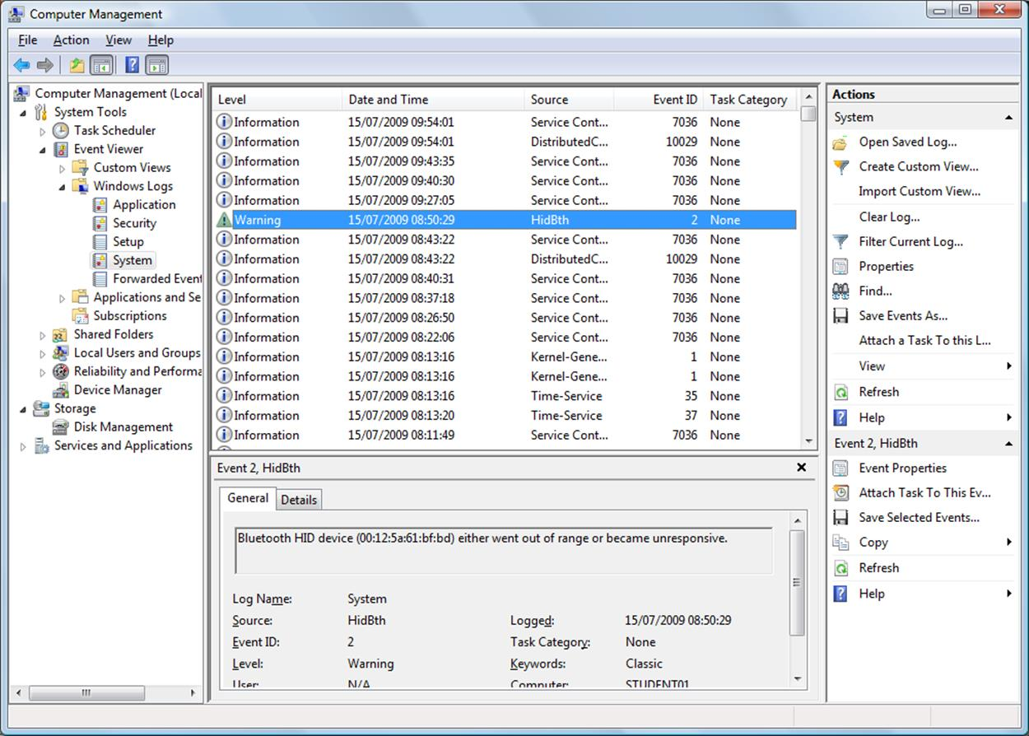
Viewing Windows logs in Event Viewer
- Performance logs record defined metrics over a period of time.
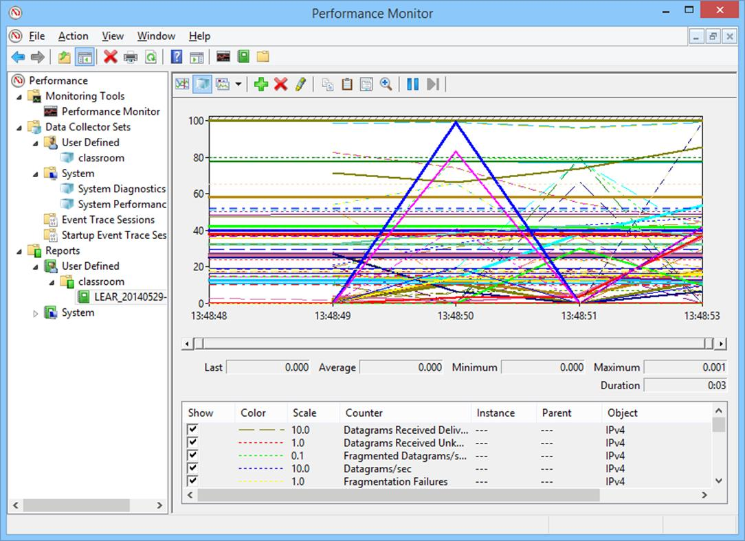
Data retrieved from a performance log file
A network logging system may be able to aggregate the logs from numerous devices into a central control panel, using a protocol such as SNMP (see below). Alternatively, the logs from appliances such as switches and routers can typically be transferred using FTP, TFTP, or SSH.
Windows operating systems store system logs internally and these logs can be viewed through Event Viewer. The standard logs (System, Application, and Security) may be supplemented by other software-specific logs, as additional services and applications are installed.

Log Management
If left unmonitored and set to append only, logs can grow to consume a large amount of disk space. Most logs are set to overwrite older events automatically to forestall this. The old events can be written to an archive log but obviously these must be moved to secure long-term storage to avoid filling up the server's disk. An enterprise network might use a dedicated storage disk array or even a network-based Storage Area Network (SAN) to retain logs.
Logs can also be optimized through a process called data rollup. This means that the logs for a certain period are summarized by averaging out individual sample values. For example, the raw logs for CPU utilization might contain a sample for each minute of the day. This can be referred to as the raw resolution. A rollup might average this out over 5 minutes, reducing the number of samples stored fivefold. Additional levels of rollup could be configured based on a retention policy. For example, the logs for the last week could be stored at raw resolution. Logs older than 1 week could have a 5-minute resolution applied. A 1-hour resolution could be applied to logs older than one month, for long-term archiving.
 It is important to secure logs against tampering by rogue administrative accounts as this would be a means for an internal attacker to cover his or her traces. Log files should be writable only by system processes or by secure accounts that are separate from other administrative accounts. Log files should be configured to be "append only" so that existing entries cannot be modified.

SYSLOG and SIEM
Prior to Windows Vista / 7, one limitation of Windows logs was that they only logged local events; that is, each computer was responsible for logging its own events. This meant that third party tools were required in order to gain an overall view of messaging for the entire network. However, the development of event subscriptions in Vista / 7 allows logging to be configured to forward all events to a single computer, enabling a holistic view of network events.
The equivalent system in UNIX and Linux is usually SYSLOG. This was designed to follow a client-server model and so allows for centralized collection of events from multiple sources. It also provides an open format for event logging messages and as such has become a de facto standard for logging of events from distributed systems. For example, syslog messages can be generated by Cisco routers and switches, as well as servers and workstations, and collected in a central database for viewing and analysis.
Software designed to assist with security logging and alerting is often described as Security Information and Event Management (SIEM). SIEM is designed to consolidate security alerts from firewalls, anti-malware, intrusion detection, audit logs, and so on. It can be configured to look for correlations between events to try to detect attacks as well as providing alerting and reporting features.

Reporting Alerts and Alarms
If a threshold is exceeded, some sort of alert or alarm notification must take place. A low priority alert may simply be recorded in a log. A high priority alarm might make some sort of active notification, such as emailing a system administrator, sending a text message (SMS) to a phone, or triggering a physical alarm signal.
 Someone should be reviewing logs continually. Only referring to the logs following a major incident is missing the opportunity to identify threats and vulnerabilities or performance problems early and to respond proactively.

Analyzing Performance Metrics
Not all performance incidents will be revealed by a single event. One of the features of log analysis and reporting software should be to identify trends. A trend is difficult to spot by examining each event in a log file. Instead, you need software to chart the incidence of particular types of event and show how the number or frequency of those events changes over time.
Plotting data as a graph is particularly helpful as it is easier to spot trends or spikes or troughs in a visualization of events rather than the raw data. Most performance monitors can plot metrics in a graph.
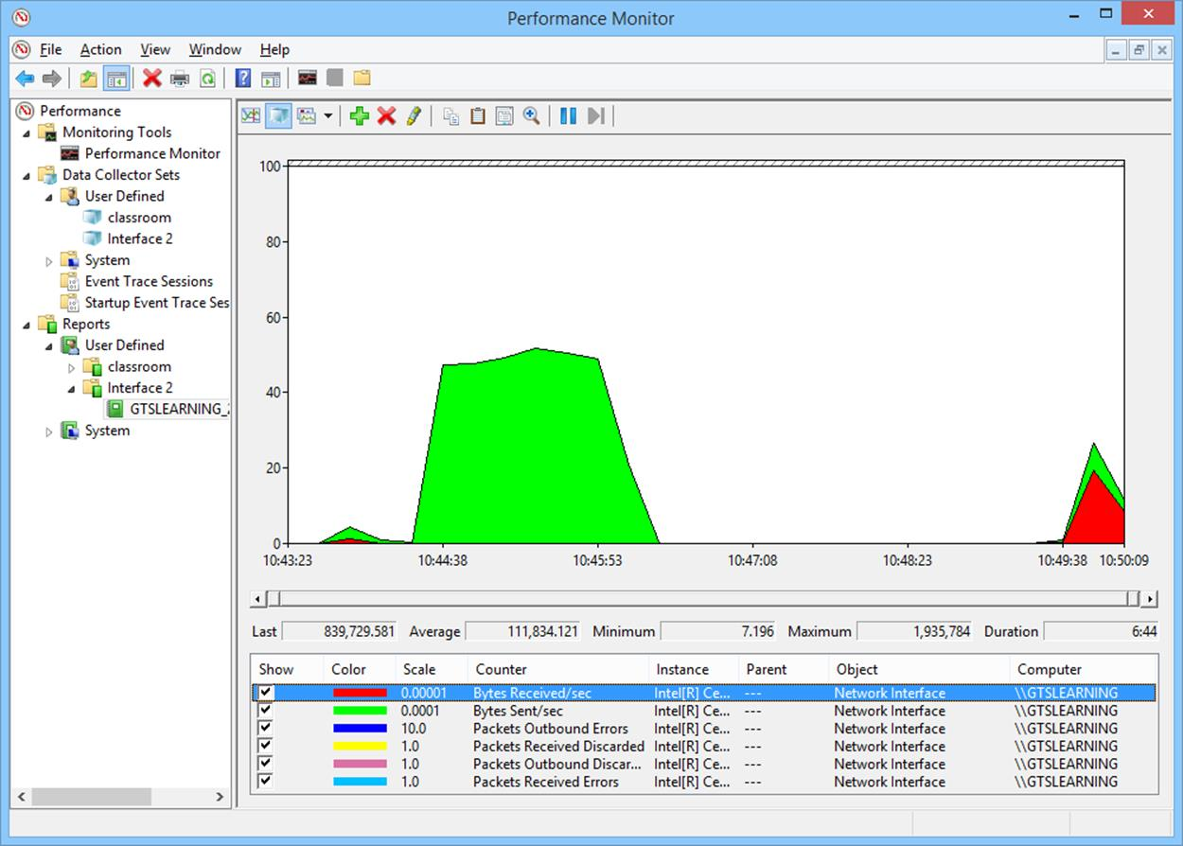
Graphing performance information

Device Monitoring Metrics
When monitoring a network device, such as a network adapter, switch, or router, you will want to track a number of different parameters.
- Bandwidth - this is the rated speed of all the interfaces available to the device, measured in Mbps or Gbps. For wired Ethernet links this will not usually vary but the bandwidth of WAN and wireless links may change over time.
- CPU and memory - devices such as switches and routers perform a lot of processing. If CPU and/or system memory utilization (measured as a percentage) is very high an upgrade might be required. High CPU utilization can also indicate a problem with network traffic.
- Storage - some network devices require persistent storage (typically one or more flash drives) to keep configuration information and logs. Storage is measured in MB or GB. If the device runs out of storage space it could cause serious errors.

Interface Monitoring Metrics
You can also collect data and configure alerts for metrics related to a particular interface, whether on a network adapter or switch or router port.
- Link Status - measures whether an interface is working ("up") or not ("down"). You would want to configure an alert if an interface goes down so that it can be investigated immediately. You may also want to track the uptime percentage so that you can assess a link's reliability over time.
- Resets - the number of times an interface has restarted over the counter period. Interfaces may be reset manually or could restart automatically if traffic volume is very high or a large number of errors are experienced. Anything but occasional resets should be closely monitored and investigated. An interface that continually resets is described as "flapping".
- Speed - this is the rated speed of the interface, measured in Mbps or Gbps. For wired Ethernet links this will not usually vary but the bandwidth of WAN and wireless links may change over time. For Ethernet links, the interface speed should match at both the host and switch ports.
- Duplex - most ports now operate in full-duplex mode. If an interface is operating in half-duplex mode there is likely to be some sort of problem (unless you are supporting a legacy device).
- Utilization - the data transferred over a particular period. This can either be measured as the amount of data both sent and received (measured in bps or a multiple thereof) or calculated as a percentage of the available bandwidth.
 You also need to differentiate between overall utilization and peak utilization. If overall utilization is around 80% it may appear that there is sufficient bandwidth. However, if peak utilization often spikes to 100% then that will manifest as delay and packet loss and may require that the link be upgraded.
- Errors - the number of packets per second that caused errors. Errors may occur as a result of interference or poor link quality. In general terms error rates should be under 1%; very high error rates may indicate a driver problem.
- Discards / drops - an interface may discard (drop) incoming and/or outgoing frames for a number of reasons, including checksum errors, mismatched MTUs, packets that are too small (runts) or too large (giants), high load, or permissions (the sender is not on the interface's Access Control List [ACL] or there is some sort of VLAN configuration problem). Each interface is likely to class the type of discard or drop separately to assist with troubleshooting the precise cause of high discard rates.
Some vendors may use the term "discard" for frames that are rejected because of errors or security policies and "drop" for frames that are lost due to high load but often the terms are used interchangeably.

Simple Network Management Protocol
The Simple Network Management Protocol(SNMP) is a widely used framework for management and monitoring remote devices. It is part of the TCP/IP protocol suite (operating at the Application layer of the OSI model).
SNMP consists of a management system and agents.

SNMP Agents
The agent is a process (software or firmware) running on a switch, router, server, or other SNMP-compatible network device. This agent maintains a database called a Management Information Base(MIB) that holds statistics relating to the activity of the device (for example, the number of frames per second handled by a switch). Each parameter stored in a MIB is referred to by a numeric Object Identifier (OID). OIDs are stored within a tree structure. Part of the tree is generic to SNMP while part can be defined by the device vendor.
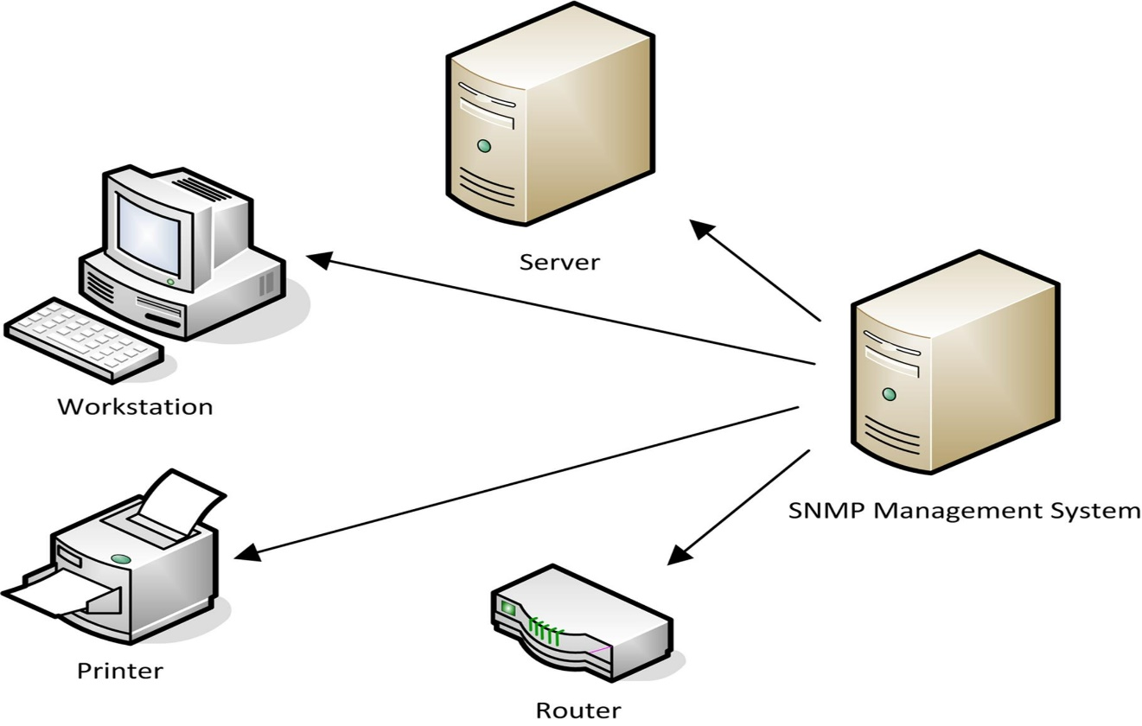
SNMP agents and management system

SNMP Management Software
The SNMP management software provides a location from which network activity can be overseen. It monitors all agents by polling them at regular intervals for information from their MIBs and displays the information for review. It also displays any trap operations as alerts for the network administrator to assess and act upon as necessary.
The management software can retrieve information from a device in two main ways:
- Get - the software queries the agent for a single OID. This command is used by the management software to perform regular polling (obtaining information from devices at defined intervals).
- Trap - the agent informs the management system of a notable event (port failure for instance). The threshold for triggering traps can be set for each value.
The management software can be used to change certain variables using the Set command. It can also "walk" an MIB subtree by using multiple Get and Get Next commands. This is used to discover the complete layout of a particular MIB. Device queries take place over port 161 (UDP); traps are communicated over port 162 (also UDP).
The current SNMP specification is version 3.0 (see www.snmplink.org for details). Examples of management systems include IBM's Tivoli software suite, CiscoWorks, HP's OpenView, Computer Associate's Unicenter, Novell's ZENworks, and Microsoft's Systems Management Server.

Configuring SNMP Agents
The method of configuring the SNMP Agent on a particular device or component depends on the software or firmware installed on the device. On a Windows Server, you configure the agent via SNMP Service Properties (open the Services applet from Computer Management, alt-click the SNMP Service, and select Properties).
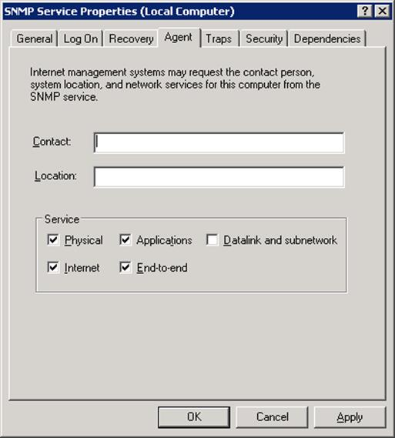
SNMP Service - Agent properties
You can input a contact name and physical location for the computer and choose what services are running on the machine. On the Traps tab, you should input the Community Name of the computers allowed to manage the agent and the IP address or host name of the server running the management system. The community name acts as a rudimentary type of password. An agent can only pass information to management systems configured with the same community name. There are usually two community names; one for read-only access and one for read-write access (or privileged mode).
On a device such as a hardware router, UPS, or RAID controller you would use the device's management interface to set agent properties.
Thresholds for triggering trap alerts are configured using the management system.
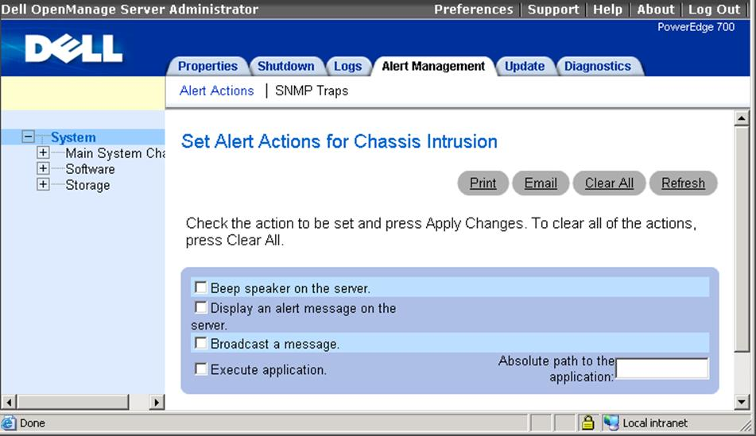
Configuring SNMP traps using Dell OpenManage

SNMP Security
If SNMP is not used, you should remember to change the default configuration password and disable it on any SNMP-capable devices that you add to the network. If you are running SNMP version 1 or 2, keep to the following guidelines:
- SNMP community names are sent in plaintext and so should not be transmitted over the network if there is any risk that they could be intercepted. It might be possible to secure the traffic using an encrypted tunnel, such as IPsec.
- Use difficult to guess community names; never leave the community name blank or set to the default.
- Use Access Control Lists to restrict management operations to known hosts (that is, restrict to one or two host IP addresses).
SNMP v3 supports encryption and strong user- or group-based authentication.

Remote Administration Tools
A number of protocols and connectivity software tools have been developed to allow administrators to configure hosts remotely, either over a LAN or over a WAN connection. Generally speaking, older protocols have no security mechanisms for authenticating the user or encrypting traffic. These make them vulnerable to a variety of attacks and therefore should not be used.

Telnet
Telnet is a command-line terminal emulation protocol and program. The host server runs a Telnet Daemon listening for connections on TCP port 23. The client system runs a Telnet program to send commands to the Daemon. When you connect, your computer acts as if your keyboard is attached to the remote computer and you can use the same commands as a local user.
One potential downside to Telnet is that you must know how to issue commands to the computer you have logged on to. The remote computer must also grant you access.
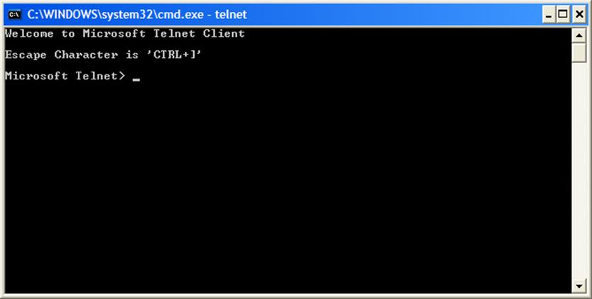
Telnet client
A Telnet interface can be password protected but the password and other communications are not encrypted and therefore could be vulnerable to packet sniffing, replay, Man-in-the-Middle, and so on.
Historically, Telnet has provided a simple means to configure switch and router equipment. Telnet is sometimes still used for troubleshooting services such as SMTP or HTTP.
 See Unit 5.1 / Vulnerabilities and Threats / Study Notes for more detail on the use of secure and unsecure protocols.

Secure Shell (SSH)
Secure Shell (SSH) is a secure alternative to the UNIX remote administration and file copy programs (rsh [Remote Shell], Telnet, rlogin, and FTP). The original version of SSH was redeveloped as SSH-2 and published as RFC 4251. The two versions are not compatible.
The main uses of SSH are remote administration and secure file transfer (SFTP). Clients can connect securely to a command line interface hosted by the SSH server, running on TCP port 22 (by default).
SSH also supports port forwarding, which can be used to implement a limited type of VPN. Port forwarding means that communications over a particular port are channeled through SSH, which provides authentication and encryption for that application.
There are numerous commercial and open source SSH products available for all the major NOS platforms (UNIX, Linux, Windows, and Mac OS). The OpenSSH server and PuTTY client are very widely used.
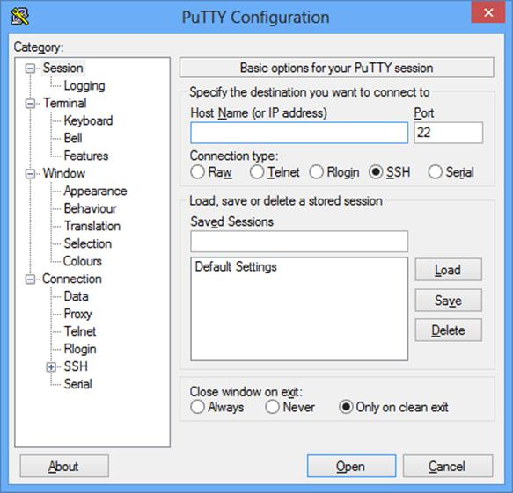
PuTTY SSH client for Windows
Windows can use a proprietary alternative to SSH called Remote Shell. The server component is WinRM while the client is WinRS.

Remote Desktop Protocol (RDP)
There are also GUI remote administration tools. The programs send video and audio data from the remote server to the client and transfer mouse and keyboard input from the client to the remote host. This means that the tools are accessible not just to experienced administrators but also to ordinary users (allowing a teleworker to access a desktop PC in the office for instance).
Remote Desktop Protocol (RDP) is Microsoft's protocol for operating remote connections to a Windows machine. Under Windows NT and 2000, these are referred to as Terminal Services but under later versions of Windows they are referred to as Remote Desktop. RDP uses TCP port 3389.
Authentication is performed as though the user were logging on locally (that is, either against the local machine accounts or the domain). The administrator can specify permissions to connect to the server via RDP and also configure encryption on the connection.
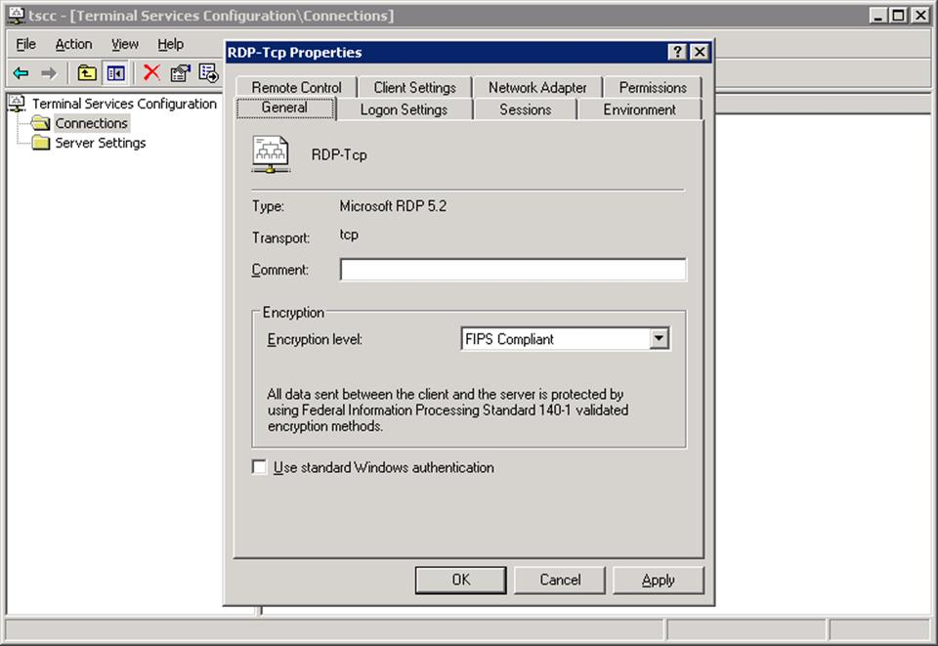
Configuring terminal services on Windows Server 2003
The version of RDP released with Windows Vista/7 and Windows Server 2008 introduces Network Level Authentication (NLA). This requires the client to authenticate before a full remote session is started. An RDP server that does not enforce NLA can be subject to Denial of Service (DoS) attacks as the server uses resources to prepare for each requested session. It also sends information about the server to an attacker (such as the computer and domain names) regardless of whether they have valid authentication credentials.
RDP is mainly used for the remote administration of a Windows server or client but another function is to publish software applications on a server rather than installing them locally on each client (application virtualization).

