UNIT 3.4 / APPLICATIONS AND SERVICES / STUDY NOTES

Web Services
So far, we have looked at lower layer services that enable basic connectivity between nodes. Above these are the services that provide useful functions to users, such as email and web browsing. The services that form part of the TCP/IP protocol suite are mostly client-server protocols and applications. Client-server applications are based around a centralized server that stores information and waits for requests from clients.

Web Services (HTTP / HTTPS)

The World Wide Web is a TCP service running over the Internet. Web services can also be used on other TCP/IP networks, such as intranets and extranets. Web services are the basis for ecommerce sites and "cloud" applications. The foundation of web technology is the HyperText Transfer Protocol (HTTP).

HTTP
HTTP enables clients (typically web browsers) to request resources from an HTTP server. A client connects to the HTTP server using an appropriate TCP port (the default is port 80) and submits a request for a resource, using a Uniform Resource Locator (URL). The server acknowledges the request and returns the data.
HTTP is usually used to serve HTML web pages, which are plain text files with coded tags (HyperText Markup Language) describing how the page should be formatted. A web browser can interpret the tags and display the text and other resources associated with the page (such as binary picture or Flash video linked to the HTML page).

SSL / TLS
One of the critical problems for the provision of early e-commerce sites was the lack of security in HTTP. Under HTTP, all data is sent unencrypted and there is no authentication of client or server. Secure Sockets Layer (SSL) was developed by Netscape and released as version 3.0 in 1996 to address these problems. SSL proved very popular with the industry and is still in widespread use. Transport Layer Security (TLS) was developed from SSL and ratified as a standard by the IETF.
TLS is now the version in active development but SSL 3.0 is still very widely supported; SSL 2.0 contains known weaknesses and should not be used. SSL 1.0 was never used commercially. TLS 1.2 is now widely supported, following well-publicized attacks against SSL / TLS products. The most notable changes between TLS 1.0, 1.1, and 1.2 are improvements to the cipher suite negotiation process (the means by which server and client agree to use the strongest ciphers available to both) and protection against known attacks. TLS 1.2 also adds support for the strong SHA-256 cipher.
SSL and TLS versions are not interoperable; that is, a client supporting only SSL 3.0 could not connect to a server supporting only TLS 1.0. A server can provide support for legacy clients, but obviously this is less secure. For example, a TLS 1.2 server could be configured to allow clients to downgrade to TLS 1.1 or 1.0 or even SSL 3.0 if they do not support TLS 1.2.
SSL/TLS works as a layer between the application and transport layers of the TCP/IP stack (in OSI terms, at the session layer, roughly speaking). It is typically used with the HTTP application (referred to as HTTPS or HTTP Over SSL or HTTP Secure) but can also be used to secure other TCP-based application protocols, such as FTP, SMTP, POP3, or IMAP. TLS can also be used with UDP-based applications. This usage is standardized as Datagram TLS (DTLS).

HTTP Secure (HTTPS)
HTTP Secure (HTTPS) is a subset of HTTP that allows for a secure dialog between the client and server using SSL/TLS. To implement HTTPS, the web server is assigned a digital certificate by some trusted Certificate Authority (CA). The certificate proves the identity of the server, assuming that the client also trusts the Certificate Authority. The certificate is a wrapper for a public / private encryption key pair. The private key is kept a secret "known" only to the server; the public key is given to clients via the digital certificate.
The server and client use the key pair in the digital certificate and a chosen cipher suite within the SSL/TLS protocol to set up an encrypted tunnel. The type of asymmetric encryption cipher used means that even though someone else might know the public key, they cannot decrypt the contents of the tunnel without obtaining the server's private key. This means that the communications cannot be read or changed by a third party.
It is also possible to install a certificate on the client so that the server can trust the client. This is not often used on the web but is a feature of VPNs and enterprise networks.
Encrypted traffic between the client and server is sent over TCP port 443 (by default) rather than the open and unencrypted port 80. A web browser will open a secure session to a server providing this service using a URL starting with HTTPS:// and also show a padlock icon in the address to indicate that the connection is secure. A website can be configured to require a secure session.
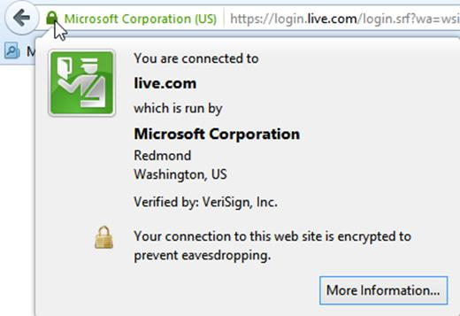
SSL padlock icon

File Transfer Services (FTP/TFTP/SMB)
The File Transfer Protocol (FTP) was one of the earliest protocols used on TCP/IP networks and the Internet. It is a connection-oriented protocol utilizing TCP that is especially useful for transferring files between hosts (especially when the hosts run different operating systems). While HTTP-based web services and web applications can now offer simpler file transfer services to end users, FTP is still often used to perform administrative upload of files to and from servers and appliances. For these uses, it is important to secure the FTP session.

FTP Clients
The FTP client may take a number of forms:
- Most installations of TCP/IP include a command line client interface. The commands PUT and GET are used to upload and download files respectively.
- Dedicated GUI clients allow you to connect to servers, browse directories and upload and download files.
- Internet browsers allow you to connect to an FTP service and download files. You use a Uniform Resource Locator (URL) to connect to an FTP server; for example, ftp://ftp.microsoft.com/.

Active Versus Passive FTP
A client connects to TCP port 21 on an FTP server and opens a chosen dynamic client port number (N). The TCP port 21 control port is used to transfer commands and status information, but not for data transfer.
Data transfer can operate in one of two modes: active or passive.
In active mode, the client sends a PORT command specifying its chosen data connection port number (typically N+1) and the server opens the data connection between the chosen client port and TCP port 20 on the server.
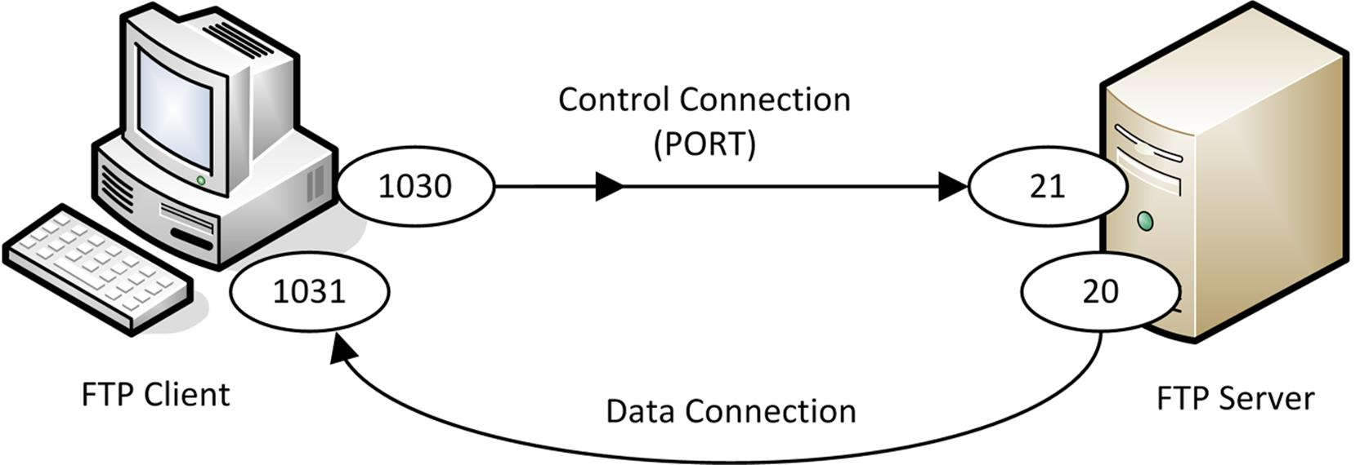
FTP in active mode
In passive mode, the client opens a data port (again, typically N+1) and sends the PASV command to the server's control port. The server then opens a random high port number and sends it to the client using the PORT command. The client then initiates the connection between the two ports.
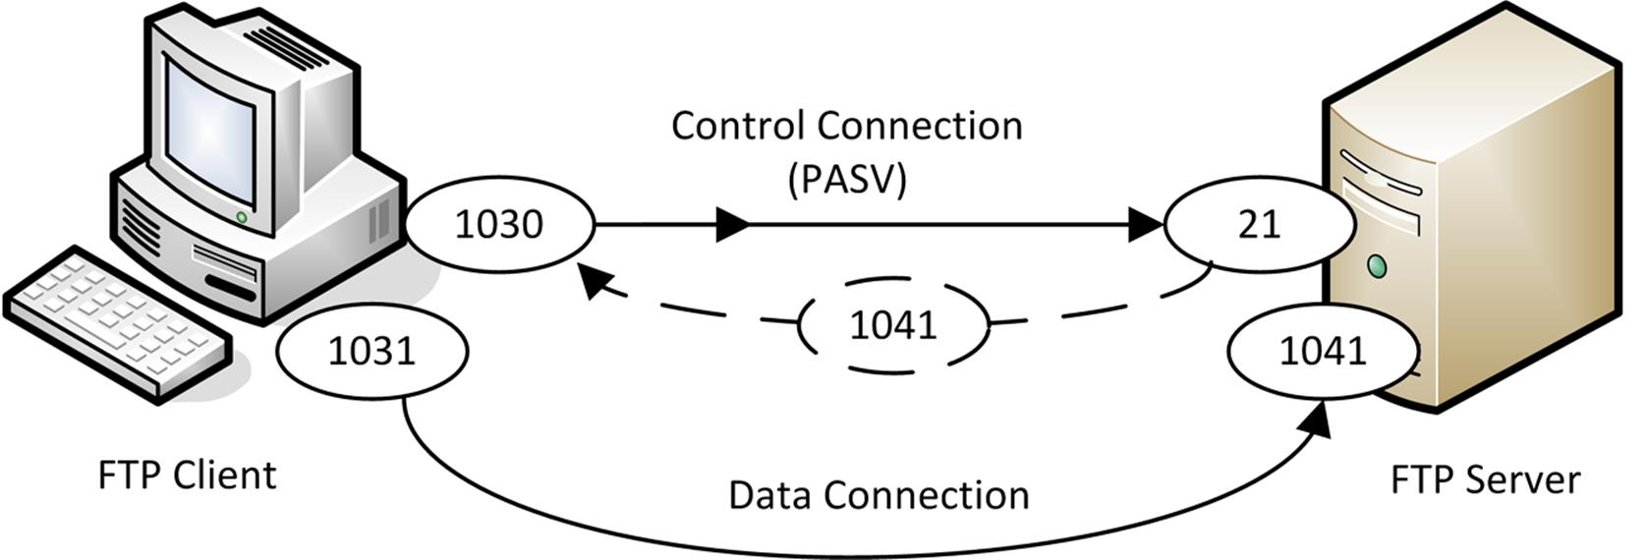
FTP in passive mode
Active FTP poses a configuration problem for some firewalls, as the server is initiating the inbound connection but there is no way of predicting which port number will be utilized. However, not all FTP servers and clients can operate in passive mode. If this is the case, check that firewalls installed between the client and server can support active FTP (stateful inspection firewalls).
 Another problem is that the control connection can remain idle when the data connection is in use, meaning that the connection can be "timed out" by the firewall (or other routing device).
 You should check that users do not install unauthorized servers on their PCs (a rogue server). For example, a version of IIS that includes HTTP, FTP, and SMTP servers is shipped with client versions of Windows, though it is not installed by default.

Trivial File Transfer Protocol (TFTP)
The Trivial File Transfer Protocol (TFTP) is another file transfer service but unlike FTP it is a connectionless protocol running over UDP port 69. Consequently, TFTP does not provide the guaranteed delivery offered by FTP and is only suitable for transferring small files. Also, it only supports reading (GET) and writing (PUT) files not directory browsing, file deletion, or any of the other features of FTP. TFTP is not often deployed but could be used by a switch or router to download configuration files.

Server Message Block (SMB)
On a Windows network, the File/Print Sharing Service is provided by the Server Message Block (SMB) protocol. SMB allows a machine to share its files and printers to make them available for other machines to use. Support for SMB in UNIX or Linux-based machines is provided using the Samba software suite, which allows a Windows client to access a UNIX host as though it were a Windows file or print server.
On legacy networks, SMB ran as part of the NetBIOS API on TCP port 139. If no legacy client support is required however, SMB is more typically run directly over TCP port 445. SMB should be restricted to use on local networks. It is important that any traffic on the NetBIOS port ranges (137-139, 445) be blocked by a perimeter firewall.

Email (SMTP / POP / IMAP)
Electronic mail enables a person to compose a message and send it to another user on their own network (intranet) or anywhere in the world via the Internet.

SMTP Protocol
The Simple Mail Transfer Protocol (SMTP) specifies how mail is delivered from one system to another. It is a relatively straightforward protocol that makes the connection from the sender's server to that of the recipient and then transfers the message. The SMTP server of the sender discovers the IP address of the recipient SMTP server using the domain name part of the email address. The SMTP server for the domain is registered on the DNS using a Mail Exchanger (MX) record. SMTP servers are configured to listen on TCP port 25.
SMTP is not used for transferring the message from the recipient's SMTP server to its email client because it requires that both source and destination are online to make a connection. The SMTP server retries at regular intervals before timing out and returning a Non-Delivery Report (NDR) to the sender.

Post Office Protocol (POP)
SMTP is only useful to deliver mail to hosts that are permanently available. Mail users require the convenience of receiving and reading their mail when they choose. The Post Office Protocol (POP) is designed to allow mail to be downloaded to the recipient's email client at his/her convenience.
 POP is often referred to as POP3 as the active version of the protocol is version 3.
A POP client application (such as Microsoft Outlook or Mozilla Thunderbird) establishes a TCP connection on TCP port 110 to the POP server. This is generally a different service running on the same machine as the SMTP server. The user is authenticated (by user name and password) and the contents of his or her mailbox are downloaded for processing on the local PC. Generally speaking, the messages are deleted from the server when they are downloaded, though some clients have the option to leave messages on the server.
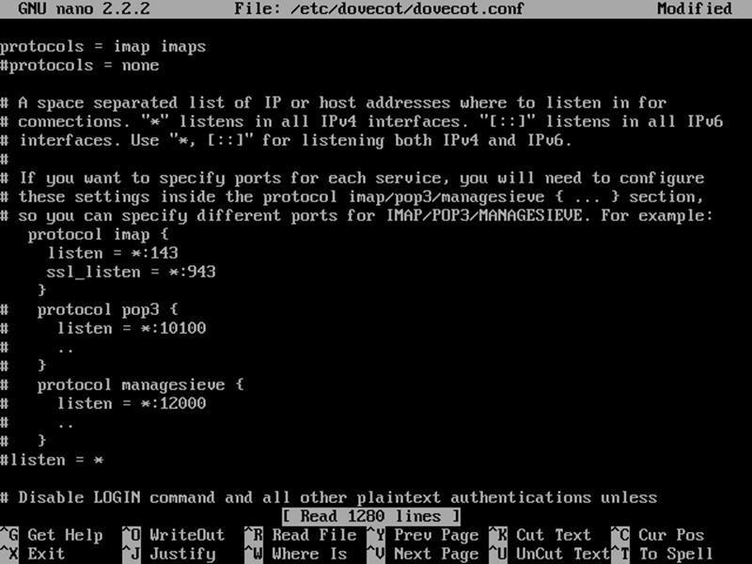
Configuring mailbox access protocols on a server
Like other TCP application protocols, unless an encryption service is configured, POP transfers all information as cleartext. This means anyone able to monitor the session would be able to obtain the user's credentials. POP can be secured using SSL/TLS. The default TCP port for secure POP is port 995.

Internet Message Access Protocol (IMAP)
While POP is widely used, it does have limitations, some of which are addressed by the Internet Message Access Protocol (IMAP). Clients connect over TCP port 143 (993 for SSL). They authenticate themselves then retrieve messages from the designated folders. SMTP is still needed to support mail delivery. Like POP, IMAP is a mail retrieval protocol only.
There are however a number of differences between POP and IMAP. POP is primarily designed for dial-up access; the client contacts the server to download its messages then disconnects. IMAP supports permanent connections to a server and connecting multiple clients to the same mailbox simultaneously. It also allows a client to manage the mailbox on the server (to organize messages in folders and control when they are deleted for instance) and to create multiple mailboxes.

Voice Services (VoIP and VTC)
Voice over IP (VoIP), web conferencing, and Video Teleconferencing (VTC) solutions are becoming more popular as the technologies that support them have become viable. The main challenges that these applications have in common is that they transfer real-time data and must create point-to-point links between hosts on different networks. Real-time servicesare those that requires real-time playback. This type of data can be one-way, as is the case with video streams such as Internet TV (IPTV), or two-way, as is the case with VoIP and VTC.

Medianets
Networks implementing technologies that are designed specifically to meet these challenges are known as medianets. Their designs may be optimized for media transmission either at the hardware layers (as for example in the case of ISDN) or by overlaying upper layer protocols (such as SIP) on common network technologies (such as IP) in order to provide the required functionality.
 See Unit 4.4 / WAN Technologies / Study Notes for more information about ISDN.

Voice over IP (VoIP)
IP Telephony solutions, often referred to as Voice over IP (VoIP) or unified voice services, can be a cost-effective way of providing telephony services to end users over corporate IP networks or public IP networks such as the Internet. IP telephony provides integration with the fixed and mobile telephone networks, allowing calls to be placed from PC to landline or from mobile phone to laptop.
VoIP can also be accessed directly via a VoIP handset, negating the need for a PC.

Video Teleconferencing
Video TeleConferencing (VTC) allows users to configure virtual meeting rooms, with options for voice, video, and instant messaging. Other features often include screen sharing, presentation / whiteboard, file sharing, and polls and voting options. Most conferencing suites also provide a fallback teleconference option, to be used in conjunction with the presentation features, in case some participants cannot get a good enough connection for an IP voice or video call.

Unified Communications (UC)
Unified Communications (UC) solutions are messaging applications that combine multiple communications channels and technologies into a single platform. These communications channels can include VoIP, VTC, Instant Messaging (IM), text messaging (SMS), interactive whiteboards, data sharing, email, and social media networks (such as Twitter, LinkedIn, and Facebook).
Unified communications applications allow users to establish connections with one another using any available channels and to modify the communication method as required. For example, a conversation may start as text-based instant messaging, then change to voice or video. Users may also choose to share data as part of the communication (possibly including shared screen access) or to expand the conversation to include other users.
The components of a unified communications solution are as follows:
- UC servers centralize the presence information and coordinate the communication channels.
- UC gateways provide interfaces between the various communications technologies.
- UC devices provide end user access. Different devices may provide different communication capabilities. For example, more options may be available to a user on a desktop PC with headset than to a smartphone user.

Presence and Telepresence
The concept of presence is central to unified messaging. This is the idea that a user can see at a glance which of their contacts are available, their current status (busy, away, etc), and the methods of communication that are currently available to connect.
Telepresence is a term used to refer to particularly sophisticated video conferencing solutions. The idea is that the participants have a real sense of being in the same room. This can be achieved by a number of video technologies, including HD or 4K resolutions, large and/or curved flatscreens, and 3D. Emerging technologies might make use of virtual reality headsets, holograms, and robotics.
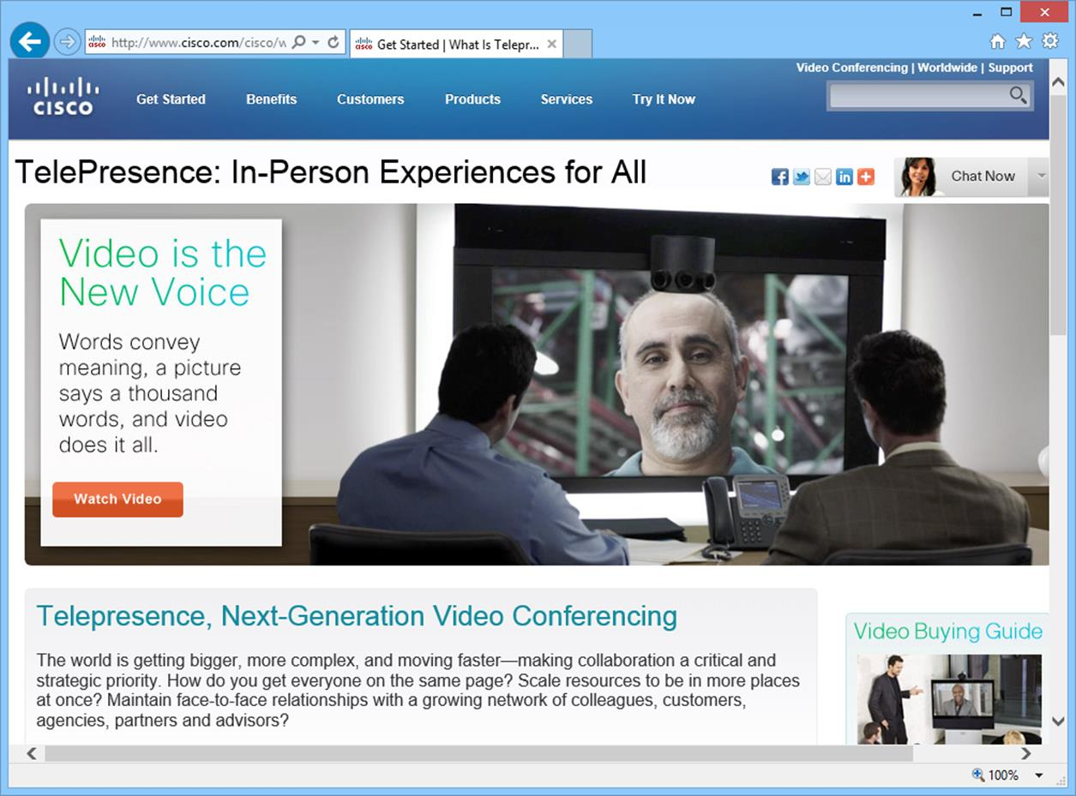
Telepresence products from Cisco

Multicast versus Unicast
Multicast transmission may be used to deliver voice or video packets more efficiently. The principle of multicast is "transmit once, receive many". For example, when delivering a video stream, it is more efficient for the server to multicast the stream to client devices (one-to-many) than it is to establish separate one-to-one unicast sessions with each device. Similarly, in a VoIP conference with tens or hundreds of users, multicast (many-to-many) will reduce the load on the network. The main drawback of multicast is that it works best in a controlled environment, with switches and routers that are multicast-capable.
See Unit 2.2 / IPv4 Addressing / Study Notes for more information about multicast.

Real-time Services Protocols
The protocols designed to support real-time services cover one or more of the following functions:
- Session control - used to establish, manage, and disestablish communications sessions. They handle tasks such as user discovery (locating a user on the network), availability advertising (whether a user is prepared to receive calls), negotiating session parameters (such as use of audio / video), and session management and termination.
- Data transport - handles the delivery of the actual video or voice information.
- Quality of Service (QoS) - provides information about the connection to a QoS system, which in turn ensures that voice or video communications are free from problems such as dropped packets, delay, or jitter.

Session Initiation Protocol (SIP)
The Session Initiation Protocol (SIP) is one of the most widely used session control protocols. SIP endpoints are the end-user devices (also known as User Agents), such as IP-enabled handsets or client and server web conference software. Each device, conference, or telephony user is assigned a unique SIP address known as a SIP Uniform Resource Indicator (URI). Examples of SIP URIs include:
- sip:andy.warren@bootkamp.co.uk
- sip:5551231234@bootkamp.co.uk
- sip:andy.warren@5551231234
- meet:sip:organizer@bootkamp.co.uk;ms-app=conf;ms-conf-id=abba1234
SIP endpoints can establish communications directly in a peer-to-peer architecture but it is more typical to use intermediary servers and directoryservers. A SIP network may also use gateways to provide an interface between the VoIP network and external voice networks, such as the ordinary Public Switched Telephone Network (PSTN).
SIP typically runs over TCP ports 5060 and 5061. Some vendors implement SIP over TCP, whilst others implement SIP over UDP. Although there are claims that this means less overhead than with TCP implementations, there are reliability issues relating to using UDP. Given the fact that conferencing and telephony solutions require high levels of reliability, TCP seems a more logical choice. Some vendors also implement SIP over TLS providing security for the link.

Media Gateway Control Protocol (MGCP)
The Media Gateway Control Protocol (MGCP) provides similar functionality to SIP in establishing and controlling sessions, but uses a more centralized architecture in which the bulk of the processing is performed at the central media gateway controller, known as a call agent. The call agent uses MGCP to communicate with and control one or more media gateways. These media gateways provide an interface between the VoIP network and external voice networks. MGCP uses UDP port 2427 for packets from the call agent to the gateway and UDP port 2727 for packets from the gateway to the call agent.

H.323
Another widely used session control protocol is H.323. This predates both SIP and MGCP, having been first standardized by the ITU-T in 1996, although the current version was published in 2009. H.323 uses a more distributed architecture than MGCP. In the H.323 model, endpoints (known as terminals) connect to gatekeepers in order to request services.
When used for standard VoIP communication, the respective gatekeepers of the two endpoints communicate to establish whether the connection will be allowed and then the endpoints communicate directly with one another to establish the session. When used in videoconferencing, devices known as Multipoint Control Units (MCU) provide conference facilities, such that one or more gatekeepers can enable sessions from multiple terminals to be established to a multipoint conference on a single MCU.
The H.323 architecture also allows for gateways. As with MGCP, these gateways enable non-H.323 networks, such as the telephone network, to connect to the H.323 network and access the services provided.
H.323 primarily uses TCP port 1720, although UDP ports 1718 and 1719 are used for associated functions.

Real-time Transport Protocol and RTP Control Protocol
While SIP, MGCP, or H.323 provide session management features, the actual delivery of real-time data uses different protocols. The principal one is Real-time Transport Protocol (RTP). RTP enables the delivery of a stream of media data via UDP, while implementing some of the reliability features usually associated with TCP communication. The data is packetized and tagged with control information (sequence numbering and time-stamping).
UDP is used to minimize overhead and because some of the reliability features of TCP could actually adversely affect the quality of a media stream. For example, if a single packet from a voice stream is lost, the effect of simply ignoring the lost data (which may only correspond to a small fraction of a second) is less noticeable than pausing the entire stream while waiting for a retransmit.
RTP does not guarantee reliability or real-time delivery. Indeed, depending on the underlying network technology, this may be impossible to achieve. Instead, RTP works closely with the RTP Control Protocol (RTCP). Each RTP stream uses a corresponding RTCP session to monitor the quality of the connection and to provide reports to the endpoints. These reports can then be used by the applications to modify codec parameters or by the network stacks to tune QoS parameters.
RTP and RTCP use a sequential pair of UDP ports, with RTP using an even numbered port and the corresponding RTCP session using the next higher (odd) port number. UDP ports 5004 (RTP) and 5005 (RTCP) are reserved for this purpose, although in practice RTP typically uses an even-numbered ephemeral UDP port, with RTCP again using the next higher port number. This is to allow for multiple streams on a single endpoint, which would not be possible with a fixed port number.

Quality of Service
Quality of Service (QoS) protocols and appliances are designed to support real-time services on packet-switched networks.

Real-time Services
Applications such as voice and video that carry real-time data have different network requirements to the sort of data represented by file transfer. With "ordinary" data, it might be beneficial to transfer a file as quickly as possible, but the sequence in which the packets are delivered and variable intervals between packets arriving do not materially affect the application. This type of data transfer is described as "bursty".
Problems with the timing and sequence of packet delivery are defined as latency and jitter. Many networks are being pressed into service to provide real-time and/or two-way communications, with applications such as Voice over IP (VoIP) and Unified Communications. Latency and jitter are not significant problems when data transfer is bursty but real-time applications are much more sensitive to their effects, because they manifest as echo, delay, and video slow down. While streaming video applications (and especially High Definition video) can have a high bandwidth requirement in terms of the sheer amount of data to be transferred, bandwidth on modern networks is typically less of a problem than latency and jitter.
 Bandwidth required for video is determined by image resolution (number of pixels), color depth, and the frame rate, measured in frames per second (fps). Bandwidth for audio depends on the sampling frequency (Hertz) and bit depth of each sample. Bandwidth can be reduced by compressing the data stream but most effective compression routines reduce quality.

Latency (Delay)
Latency is the time it takes for a transmission to reach the recipient. A video application can support a latency of about 80ms, while typical latency on the Internet can reach 1000ms at peak times. Latency sensitivity is a particular problem for 2-way applications, such as VoIP and VTC.

Jitter
Jitter is defined as being a variation in the delay - often caused by congestion at routers and other internetwork devices, or by configuration errors. Jitter manifests itself as an inconsistent rate of packet delivery.
When packets are transmitted, the sending host uses a steady, constant rate to stream the packets onto the network. If packets are delayed, or arrive out of sequence, or are lost, then the receiving host must buffer received packets until the delayed packets are received. If packet loss or delay is so excessive that the buffer is exhausted, then noticeable audio or video problems (artifacts) are experienced by users. You can measure the degree of latency and jitter experienced over a link by using vendor-specific tools.

DiffServ / IEEE 802.1p
If you are running VoIP over your network and someone decides to copy a 4 GB file down from a server, the file transfer has the potential to wreak havoc with VoIP call quality. Without QoS, switches and routers forward traffic on the basis of "best effort" or "first-in, first-out", meaning that frames or packets are forwarded in the order in which they arrive. A QoS system identifies the packets or traffic streams belonging to a particular application, such as VoIP, and prioritizes them over other applications, such as file transfer.
The Differentiated Services (DiffServ) framework [RFC 2474] classifies each packet passing through a device. Router policies can then be defined to use the packet classification to prioritize delivery. DiffServ is an IP (layer 3) QoS mechanism. It uses the Type of Service field in the IPv4 header (Traffic Class in IPv6) and renames it the Differentiated Services field. The field is populated with a 6-byte DiffServ Code Point (DSCP), either by the sending host or by the router. Packets with the same DSCP and destination are referred to as Behavior Aggregates and allocated the same Per Hop Behavior (PHB) at each DiffServ-compatible router.
Where DiffServ works at layer 3, IEEE 802.1p can be used at layer 2 (independently or in conjunction with DiffServ) to classify and prioritize traffic passing over a switch or wireless access point. 802.1p defines a tagging mechanism within the 802.1Q VLAN field (it also often referred to as 802.1p/q). The 3-bit priority field is set to a value between 0 and 7. 7 is reserved for network infrastructure (routing table updates), 6-5 for 2-way communications, 4-1 for streaming multimedia, and 0 for "ordinary" best-effort delivery.
 As well as invoking the priority tag, VLAN infrastructure is often used for traffic management on local networks. For example, voice traffic might be allocated to a different VLAN than data traffic.
While DSCP allows for far more traffic classes (64) than 802.1p (8), most vendors map DSCP values to 802.1p ones.

Resource Reservation Protocol (RSVP) / IntServ
The Integrated Services (IntServ) framework (RFC 1633) uses the Resource Reservation Protocol (RSVP) to signal that a particular traffic stream has a bandwidth requirement and to require all devices along the path to reserve sufficient bandwidth for it. To implement RSVP, each host, switch, and router within the RSVP domain must support the protocol and be configured with appropriate QoS policies and traffic classifications.

Multiprotocol Label Switching (MPLS)
Multiprotocol Label Switching (MPLS) supports QoS by adding a label to packets passing over the network to tag the traffic class and works with traffic engineering and bandwidth reservation protocols (MPLS RSVP) to predetermine link parameters. MPLS also supports a variety of network technologies other than Ethernet/IP.
 See Unit 4.4 / WAN Technologies / Study Notes for more information about MPLS.

Quality of Service versus Class of Service
There is a distinction to be made between Quality of Service (QoS) and Class of Service (CoS). True QoS allows fine-grained control over traffic parameters, of the sort available to circuit switched traffic management. DiffServ and 802.1p really provide CoS while RSVP and MPLS provides QoS. For example, if a network link is congested, there is nothing that DiffServ and 802.1p can do about it, whereas MPLS can reserve the required bandwidth and pre-determine statistics such as packet loss and delay when setting up the link.
In terms of QoS, network functions are commonly divided into three "planes":
- Control Plane - makes decisions about how traffic should be prioritized and where it should be switched.
- Data Plane - handles the actual switching of traffic.
- Management Plane - monitors traffic conditions.
Protocols, appliances, and software that are capable of applying these three functions can be described as traffic shapers or bandwidth shapers.

Packet Shapers
Packet (or bandwidth or traffic) shapers enable administrators to closely monitor network traffic and to manage that network traffic. The primary function of a packet shaper is to optimize network media throughput to get the most from the available bandwidth.
Simpler devices, such as traffic policing or simple management appliances, do not offer the enhanced traffic management functions of a shaper. For example, typical traffic policing devices will simply fail to deliver packets once the configured traffic threshold has been reached (this is often referred to as tail drop). Consequently, there will be times when packets are being lost, whilst other times when the network is relatively idle and the bandwidth is being under-utilized. A smoothing device will store packets until there is free bandwidth available. Hopefully, this leads to a fairly consistent usage of the bandwidth and few lost packets.
It is essential that the selected device is capable of handling the situation when high traffic volumes occur. As these devices have a limited buffer, there will be situations when the buffer overflows. Devices can either drop packets, and in essence provide traffic policing, or else they must implement a dropping algorithm. Random Early Detection (RED) is one of several algorithms that can be implemented to help manage traffic overflow on the shaper.
Traffic shapers delay certain packet types - based on their content - to ensure that other packets have a higher priority. This can help to ensure that latency is reduced for critical applications. This traffic management function can take place on the originating host, or source, but is more usually implemented at the network edge - that is, the perimeter network.
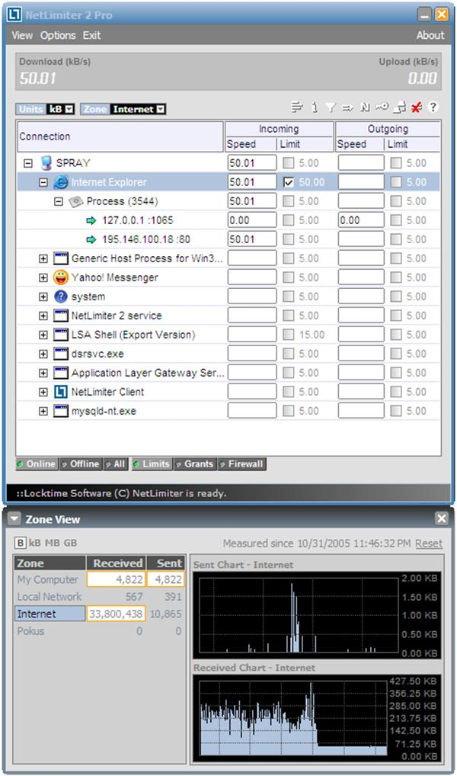
NetLimiter bandwidth shaping software (image courtesy www.netlimiter.com)
Bandwidth shapers provide the following functions:
- Classification - identify the type of traffic based upon its protocol and port.
- Self-limiting - the originating host never exceeds a defined level of traffic.
- Optimization - shaping enables network administrators to manage the network traffic on their networks to optimize the bandwidth.
- QoS - traffic shaping enables administrators to better deliver on QoS guarantees by providing more bandwidth for applications that demand low latency.
ISPs implement traffic shaping in order to provide premium services to consumers, such as low-latency gaming or a guarantee of a defined QoS. Shaping can also be used to help identify undesirable traffic and drop those packets. This will reduce the overall load on the network. Shaping can help ISPs manage file sharing download activities, for instance. These high throughput activities can be detrimental to applications that require low-latency. By implementing bandwidth shaping, ISPs can reduce excessive bandwidth consumption during peak times and allow for more download bandwidth during less busy times.

Load Balancers
There are two reasons to implement load balancing technologies. The first reason is to provide for a higher throughput or to support more connected users. You might implement a server farm and place a load balancer in front of the farm. The load balancer distributes client requests across available server nodes in the farm. Clients use the single name/IP address of the load balancer to connect to the servers in the farm.
The second reason is to provide stateless fault tolerance. If there are multiple servers available in a farm, all addressed by a single name/IP address via a load balancer, then if a single server fails, client requests can be routed to another server in the farm.
Most load balancers need to be able to provide for some or all of the following features:
- Configurable load - the ability to assign a specific server in the farm for certain types of traffic or a configurable proportion of the traffic.
- TCP offload - the ability to group HTTP packets from a single client into a collection of packets assigned to a specific server.
- SSL offload - when you implement SSL / TLS to provide for secure connections, this imposes a load on the web server (or other server). If the load balancer can handle the processing of authentication and encryption/decryption, this reduces the load on the servers in the farm.
- Caching - as some information on the web servers may remain static, it is desirable for the load balancer to provide a caching mechanism to reduce load on those servers.
- Prioritization - to filter and manage traffic based on its priority.
- Content switching - a mechanism that routes traffic based on its header and/or payload (see below).
You can use a load balancer in any situation where you have multiple servers providing the same function. Examples include web server farms, front-end email servers, and web conferencing, conferencing, or streaming media servers.

Round Robin DNS
There are other techniques that can be employed to avoid the need for load balancing hardware. One example is Round Robin DNS (RRDNS), which is where a client enters a web server name in a browser and the DNS server responsible for resolving that name to an IP address for client connectivity will return one of several configured addresses, in turn, from amongst a group configured for the purpose. This can be cost-effective but load balancing appliances provide better fault tolerance and more efficient algorithms for distribution of requests than RRDNS.

Server Load Balancing Technologies
Another method of providing load balancing without additional hardware is to implement load balancing protocols in the server operating systems. For example, Windows servers can use Network Load Balancing (NLB) Clustering services to allow multiple servers to share a single IP address. All servers within a cluster use the same algorithm to determine which of the cluster members should accept each packet. The resulting server accepts the packet, while all others in the cluster ignore it. The algorithm is designed to maintain sessions with individual hosts and to evenly distribute multiple incoming sessions across all members. Like Round Robin DNS, this service is only suitable for stateless applications, as it has no mechanism for sharing state information between members.
A similar technology, known as Common Address Redundancy Protocol (CARP), allows multiple BSD (a UNIX variant) hosts to share a single IP address. CARP uses multicast messages between cluster members to maintain cluster membership information. Again, this technology only supports load balancing of stateless applications.

 The load balancing solutions discussed above can only provide for stateless fault tolerance. If you need fault tolerance of stateful data, you must implement a server cluster where the data that any server within the group is processing can be made available to another server (or group of servers) quickly, seamlessly, and transparently in the event of a server failure. See Unit 5.4 / Incident Response / Study Notes for notes on redundancy and IT co Multilayer Switches
The basic function of an Ethernet switch is microsegmentation; that is, putting each port in its own collision domain so that the effect of contention on the network is eliminated and two hosts can in effect establish point-to-point, full-duplex links. Microsegmentation describes switching at layer 2 of the OSI model. Many switches can perform a range of more advanced functions, operating at layer 3 and higher. Such switches are often described as multilayer switches.

Layer 3 Switches
Where Virtual LANs (VLAN) are deployed to segment large networks, a lot of bandwidth can be wasted pushing traffic from the switches to a router and back again. Layer 3 switches address this problem using hardware optimized for this specific routing job. They work on the principle of "route once, switch many", which means that once a route is discovered, it is cached with the destination MAC address and subsequent communications are switched without invoking the routing lookup.
Whilst a router uses a generic processor and firmware to process incoming packets, a layer 3 switch uses Application-Specific Integrated Circuits (ASIC). This can have an impact on the relative performance of the two types of device. Layer 3 switches can be far faster but are not always as flexible. Layer 3 switches cannot usually perform WAN routing and work with interior routing protocols only. Often layer 3 switches support Ethernet only.

Load Balancers and Content Switches
Load balancing switches and content switches provide switching functionality higher up the OSI model, at layer 4 or at layers 4-7 respectively. In TCP/IP terms, these are the transport (TCP) and application (HTTP) layers. A content switch may also be referred to as a web or application switch.
Layer 4 or 4-7 switches are used for load balancing applications, typically for the web (HTTP and HTTPS) or SSL-based VPNs, although they can be used to switch for any specified TCP or UDP port. The operation of the switch is typically transparent to the clients and servers.
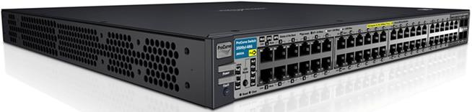
HP ProCurve Intelligent Edge switch with layer 4 load balancing (Image © 2011 Hewlett-Packard Development Company, L.P)
In a typical scenario, a multilayer switch would be the interface for a server farm. The switch facilitates connections between clients and servers to optimize performance. This load balancing can take place using defined metrics and rule sets.
A layer 4 switch applies these rules by inspecting the TCP segment while a layer 4-7 switch can be configured with rules relating to the headers and possibly content of application-layer packets. For example, rich media such as pictures or Flash video could be served from a separate server pool than the basic HTML. Layer 7 switching allows more fine-grained control but is consequently more difficult to configure, slower, and requires more expensive hardware.
To ensure that the client workstations connecting through a content switch are unaware of which server they are connected to, most content switches perform some sort of address translation (NAT). Additionally, content switches can be configured to provide encryption and decryption operations, compression, caching services, URL rewriting, and TCP multiplexing.
URL writing can be performed to disguise the actual location of content, make a complex URL more readable, perform Search Engine Optimization (SEO), and disguise active content to make attacking the server more difficult (rewriting .php file extensions to .html for instance).
Where layer 2/3 switches are measured by frame or packet throughput, L4 and content switches deal with sessions. The key performance criteria are the number of sessions per second that can be set up and the number of simultaneous sessions that can be supported. As sessions tend to be short-lived, the first factor is typically more important.
Remember that a connection is usually established for the transfer of a single file, so downloading a typical web page would require several connections to be established by a single client. However, many content switches can perform TCP multiplexing to consolidate multiple connection requests from individual clients.
A content switch may be implemented as a standalone appliance or as a plug-in module for an enterprise-class layer 2/3 switch.

