UNIT 3.3 / TROUBLESHOOTING / STUDY NOTES

Troubleshooting Procedures
When you encounter a network problem, you must try to get it resolved as quickly as you reasonably can. However, you must also take enough time to determine what has caused the problem, so that you can avoid a recurrence.
You should make sure you familiarize yourself with the order of the steps in the CompTIA Network+ troubleshooting model:
- Identify the problem:
  - Gather information
  - Duplicate the problem, if possible
  - Question users
  - Identify symptoms
  - Determine if anything has changed
  - Approach multiple problems individually
- Establish a theory of probable cause
  - Question the obvious
  - Consider multiple approaches
  - Top-to-bottom / bottom-to-top OSI model
  - Divide and conquer
- Test the theory to determine cause:
  - Once theory is confirmed determine next steps to resolve problem
  - If theory is not confirmed, re-establish new theory or escalate
- Establish a plan of action to resolve the problem and identify potential effects.
- Implement the solution or escalate as necessary.
- Verify full system functionality and if applicable implement preventive measures.
- Document findings, actions, and outcomes.
These steps are explained in more detail in the following topics.

Identifying the Problem
The first step in the troubleshooting process is to establish what the best sources of information about the problem may be.

Gather Information
At the outset, define the scope of the problem (that is, the area affected). This is helpful in two ways - firstly, if it's a single user then it's not as urgent as the other outstanding call you have. But if it's the whole ninth floor, then it's more urgent. In addition, the fact that the problem affects a wider area means that it is unlikely to be a problem with one user's workstation. Knowing the scope of the problem can help to identify its source and also prioritize the issue in relation to other incidents.
As well as the information gathering techniques discussed below, consider what indirect sources of information there may be:
- Check the system documentation (such as installation or maintenance logs) for useful information.
- Check recent job logs or consult any other technicians that might have worked on the system recently or might be working at the moment on some related issue.
- Use vendor support sites (knowledge bases) and forums.

Question Users
The first report of a problem will typically come from a user or another technician and they will be one of the best sources of information, if you can ask the right questions. The basis of getting troubleshooting information from users is asking good questions.
Questions are commonly divided into two types:
- Open questions invite someone to explain in their own words. Examples are, "What is the problem?" or "What happens when you try to switch the computer on?" Open questions are good to start with as they help to avoid making your own assumptions about what is wrong and encourage the user to give you all the information they are able to.
- Closed questions invite a Yes/No answer or a fixed response. Examples include, "Can you see any text on the screen?" or "What does the error message say?" Closed questions can be used to "drill down" into the nature of the problem and guide a user towards giving you information that is useful.

Information gathering is the first step in troubleshooting

Identify Symptoms and Duplicate the Problem
Of course, you cannot always rely on the user to let you know everything that has happened. To diagnose a problem, you may also need to use the following techniques:
- Make a physical inspection; look for something out of the ordinary.
- Duplicate the problem on the user's system or a test system. Issues that are transitory or difficult to reproduce are often the hardest to troubleshoot.
- Check system logs or diagnostic software for information.

Determine If Anything Has Changed
There are two key questions to ask when trying to identify the cause of a problem:
- Did it ever work? Hopefully your users will answer the question truthfully, because the correct answer is important. If the system worked before 9 am, you must ask what happened at 9 am. If the system never worked, then you are not looking for something that stopped working, but for something which was never done in the first place. Two different approaches required.
- What has changed since it was last working? The change that caused the problem may be nothing obvious. Maybe the window cleaners were in the building, and one of them tripped over a cable and now the user can't login. Maybe someone has moved the user's workstation from one end of his desk to another and plugged the cable into a different port.

Approaching Multiple Problems
When you start to investigate symptoms, you might discover symptoms of more than one problem. Perhaps a user has reported that a machine has lost internet connectivity and you discover that it has also not been receiving maintenance updates. The issues could be related or one might be incidental to the other.
If the problems do not seem to be related, treat each issue as a separate case. If they seem to be related, check for outstanding support or maintenance tickets that might indicate existing problems.
It may also be the case that a user reports two different problems at the same time (often preceded by "While you're on the line…" sort of statements). Treat each problem as a separate case. In most cases you should advise the user to raise a separate support ticket.

Establishing a Probable Cause
If you obtain accurate answers to your initial questions, you will have determined the severity of the problem (how many are affected), a rough idea of where to look (workstation or server end), and whether to look for a recent change or an oversight in configuration.
You diagnose a problem by identifying the symptoms. From knowing what causes such symptoms, you can test each possible cause until you find the right one. Sometimes symptoms derive from more than one cause; while this type of problem is rarer, it is much harder to troubleshoot.
A network system comprises a number of components. Fault finding needs to identify which component is faulty. For difficult problems, be prepared to consider multiple approaches. If one approach does not identify the problem, use a different one. For example, you could consider two different styles of approaching troubleshooting:
- Question the obvious - step through what should happen and identify the point at which there is a failure or error. This approach can quickly identify obvious oversights, such as a network cable not being plugged in.
- Methodically prove the functionality of each component in sequence. This approach is more time consuming but may be necessary for a difficult problem.

Top-to-Bottom / Bottom-to-Top OSI Model Approach
Troubleshooting network components can be approached by testing at each OSI model layer in turn. There are many components which go to make up a network:
- Cabling / wireless media.
- Network adapters and modems.
- Layer 1 and 2 appliances (hubs, switches, and access points) and protocols (ARP, MAC addressing, Ethernet and Wi-Fi, and tunneling protocols).
- Layer 3 appliances (routers and Layer 3 switches) and protocols (IP).
- Security appliances (firewalls and IPS).
- Transport (TCP and UDP) and "Application" layer (HTTP, DNS, and so on) protocols.
- Operating systems and end-user applications.
- End users.
Some, or several, of these components may be at fault when a problem is reported to you. It is important that you tackle the problem logically and methodically. Start from either end - but note that problems occur more often at the top (with users) than the bottom! Unless a problem is trivial, break the troubleshooting process into compartments or categories. For example, when troubleshooting a client workstation you might work as follows:
- Decide whether the problem is hardware or software related (Hardware).
- Decide which hardware subsystem is affected (NIC or cable).
- Decide whether the problem is in the NIC adapter or connectors and cabling (cabling).
- Test your theory (replace the cable with a "known good" one).
When you have drilled down like this, the problem should become obvious. Of course, you could have made the wrong choice at any point, so you must be prepared to go back and follow a different path.
 If you are really unlucky, two (or more) components may be faulty. Another difficulty lies in assessing whether a component itself is faulty or whether it is not working because a related component is broken.

Divide and Conquer Approach
In a "divide and conquer" approach, rather than starting at the top or bottom you start with the layer most likely to be causing the problem and then work either down or up depending on what your tests reveal. For example, if you start diagnosis at layer 3 and cannot identify a problem, you would then test at layer 4. Conversely, if you discovered a problem at layer 3, you would first test layer 2. If there is no problem at layer 2, you can return to layer 3 and work from there up.

Test a Probable Cause and Escalate a Problem
Hopefully you will have gathered sufficient data to come to an initial theory about the probable cause. Remember that you might be wrong! Without jumping to conclusions, set out to prove or disprove your suspicions by using your troubleshooting skills and toolkit.
If you can prove the cause of the problem, you can start to investigate the most appropriate solution. If you cannot prove the cause of the problem, you will need either to develop and test a new theory or decide to escalate the problem. Escalation means referring the problem to a senior technician, manager, or third-party. You may need to escalate a problem for any of these reasons:
- The problem is beyond your knowledge or ability to troubleshoot.
- The problem falls under a system warranty and would be better dealt with by the supplier.
- The scope of the problem is very large and / or the solution requires some major reconfiguration of the network.
- A customer becomes difficult or abusive or demands help on an unsupported item.
Some of the alternatives for escalation include:
- Senior staff / Knowledge Experts / Subject Matter Experts / technical staff / developers / programmers / administrators within your company.
- Suppliers and manufacturers.
- Other support contractors / consultants.
When you escalate a problem, you should have established the basic facts, such as the scope of the problem and its likely cause and be able to communicate these clearly to the person to whom you are referring the incident.

Establishing a Plan of Action
Assuming you choose not to escalate the issue, the next step in the troubleshooting process is to establish an action plan. An action plan sets out the steps you will take to solve the problem. There are typically three solutions to any problem:
- Repair - you need to determine whether the cost of repair / time taken to reconfigure something makes this the best option.
- Replace - often more expensive and may be time-consuming if a part is not available. There may also be an opportunity to upgrade the device or software.
 A basic technique when troubleshooting a cable, connector, or device is to have a "known good" duplicate to hand (that is, another copy of the same cable or device that you know works) and to test by substitution.
- Ignore - as any software developer will tell you, not all problems are critical. If neither repair nor replace is cost-effective, it may be best either to find a workaround or just to document the issue and move on.
When you consider solutions you have to assess the cost and time required. Another consideration is potential effects on the rest of the system. A typical example is applying a software patch, which might fix a given problem but cause other programs not to work. This is where an effective configuration management system comes into play as it should help you to understand how different systems are interconnected and cause you to seek the proper authorization for your plan.

Implement the Solution
If you do not have authorization to implement a solution, you will need to escalate the problem to more senior personnel. If applying the solution is disruptive to the wider network, you also need to consider the most appropriate time to schedule the reconfiguration work and plan how to notify other network users. When you make a change to the system as part of implementing a solution, test after each change. If the change does not fix the problem, reverse it then try something else. If you make a series of changes without recording what you have done, you could find yourself in a tricky position.

Verify Full System Functionality and Implement Preventive Measures
When you apply a solution, test that it fixes the reported problem and that the system as a whole continues to function normally (that is, identify the results and effects of the solution). Ensure that you were right and that the problem is resolved. Can the user now login properly? Is there any way you can induce the problem again?
Before you can consider a problem closed, you should both be satisfied in your own mind that you have resolved it and get the customer's acceptance that it has been fixed. Restate what the problem was and how it was resolved then confirm with the customer that the incident log can be closed.
To fully solve a problem, you should try to eliminate any factors that may cause the problem to reoccur. For example, if a user plugs their laptop into the wrong network jack, ensure that the jacks are clearly labeled to help users in the future. If a faulty server induces hours of network downtime, consider implementing failover services to minimize the impact of the next incident.

Document Findings, Actions, and Outcomes
Most troubleshooting takes place within the context of a ticket system. This shows who is responsible for any particular problem and what its status is. This gives you the opportunity to add a complete description of the problem and its solution (findings, actions, and outcomes).
This is massively useful for future troubleshooting, as problems fitting into the same category can be reviewed to see if the same solution applies. It also helps to analyze IT infrastructure by gathering statistics on what type of problems occur and how frequently.
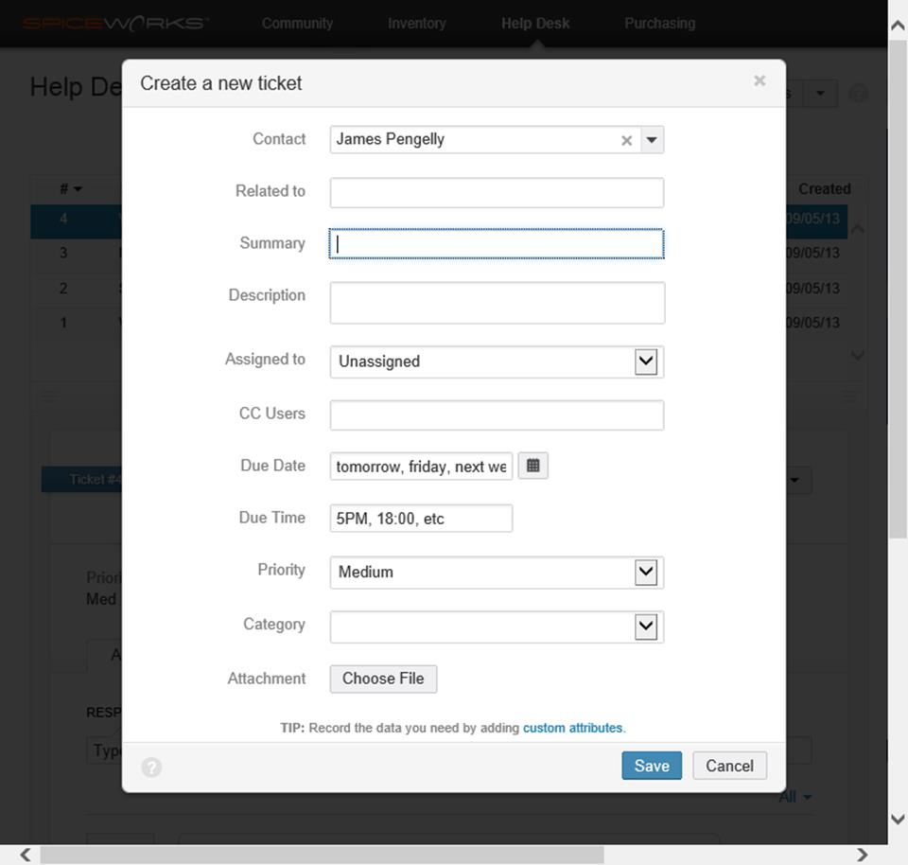
Creating a ticket in the Spiceworks IT Support management tool
When you complete a problem log, remember that people other than you may come to rely on it. Also, logs may be presented to customers as proof of troubleshooting activity. Write clearly and concisely, checking for spelling and grammar errors.

Troubleshooting Connectivity Issues
The following notes illustrate how you would set about determining the cause and scope of the problem, faced with different connectivity or performance troubleshooting scenarios.

Troubleshooting End-to-End Connectivity
When troubleshooting end-to-end connectivity between two hosts, you need to consider the topology of the network between them. Most LANs are wired in a star configuration these days, perhaps with switches connected in some cascading backbone structure. You should be aware that different topologies generate potentially different symptoms when there are low-level network problems.

Star-wired Topologies
Generally a failure in a star-wired topology will manifest itself either with one client unable to connect or with all clients unable to connect. This usually makes the location of the problem quite simple to identify. Star-wired topologies tend to be reasonably fault tolerant. If one system is affected, then check the link from switch to host for that system. If more than one system is affected, check the backbone wiring between switches or the switch itself.

Backbones
These segments connect switches and routers together; consequently, failures are far more noticeable. Many hosts will have connection problems. Isolating where is a question of determining which hosts can see which other hosts.

Mesh Topologies and Routing
Mesh topologies are difficult to troubleshoot because all hosts have connections to all others. Your knowledge of routing should help you troubleshoot issues here. If host A and B can communicate using three routes and they used to have four routes, then troubleshoot the fourth route - there may be a wiring problem there or a routing device might be down.

Troubleshooting Power Failures and Anomalies
Like any computer system, networks require stable power to operate properly. Power anomalies such as surges and spikes can damage devices, brownouts (very brief power loss) can cause systems to lockup or reboot, while power failures(blackouts) will down everything, including the lights. Enterprise sites have systems to protect against these issues. Uninterruptible Power Supplies (UPS) can keep servers, switches, and routers running for a few minutes. This provides time to either switch in a secondary power source (a generator) or shut down the system gracefully (hopefully avoiding data loss).
Most power problems will have to be escalated to an electrician or to the power company, depending on where the fault lies.
 See Unit 4.1 / Network Sites / Study Notes for more information about installing network devices and implementing power supplies and redundancy.

Troubleshooting Cable Placement
When you suspect a problem with bad wiring or bad connectors in cabled links, the first step is to isolate the issue with a number of tests. How can you prove that there is a cable problem? Attempt to ping a known working system on the local subnet (such as the router). If you can ping another local system, the problem is not in the cabling (at least, not this cable). If you can't ping anything then, assuming you've physically checked the back of the machine for the cable's presence, verify that the patch cord is good. The easiest thing to do is swap the cable to the wall socket with another - known working - cable.
Can you ping anything now? If not, verify the patch cable between the patch panel and the switch. Swap with another known good cable and test again. If you still haven't isolated the problem, try plugging the problem computer into a different network socket (if there is another computer local, just switch their cables over). If there is a cable problem somewhere, then the problem should manifest itself on the other system.
Problems with patch cords are simple to resolve as you can just throw the broken one away and plug in a new one. If the problem is in the structured cabling however, you will want to use cable testing tools to determine its cause. The solution may involve installing a new permanent link but there could also be a termination or external interference problem.
A permanent link is the cable in the wall and its termination blocks while a channel link includes the patch cords.
See Unit 4.2 / Installing Cable / Study Notes for more information about installing and troubleshooting cabled links.

Troubleshooting Network Adapters
If a single host cannot connect to the network and you have ruled out a problem with the cable, it is possible that there is a complete hardware failure in the network adapter. This is quite rare however. If you are sure there is no cabling problem, then verify the driver. Perhaps it has become corrupted. You could use packet monitoring software to record the number of interface errors generated. The easiest thing to do is to replace the driver (in Windows, use Device Manager to do this).
Next you should verify the settings on the switch port and NIC. Most adapters and switches successfully autonegotiate port settings. If this process fails, the adapter and port can end up with mismatched speed or duplex settings. In the vast majority of cases, this will be because either the adapter or the switch port has been manually configured. If a host is set to a fixed configuration and the switch is set to autonegotiate, the switch will default to 10 Mbps / half-duplex because the host isn't trying to negotiate with it! So if the host is manually configured to 100 Mbps / full-duplex the link will fail. Setting both to autonegotiate will generally solve the problem. A speed mismatch will cause the link to fail while a duplex mismatch will slow the link down (it will cause high packet loss and late collisions).
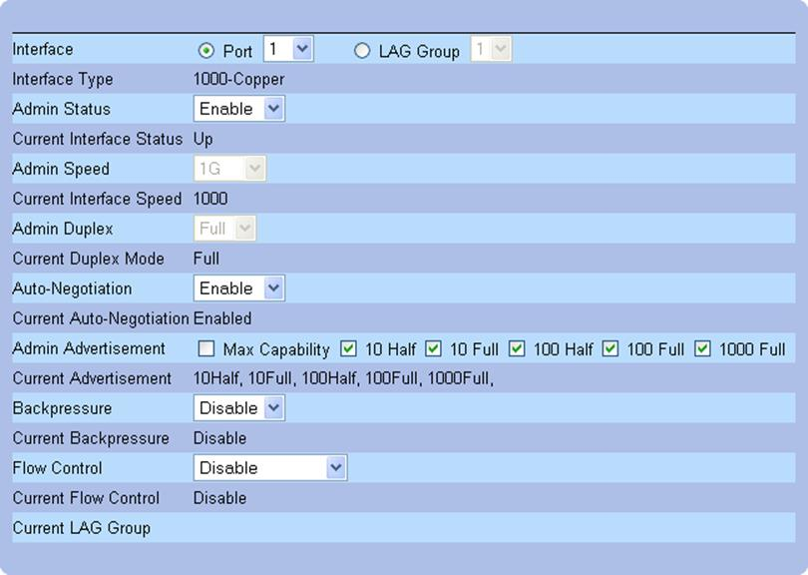
Configuring port settings on a Dell switch via the web management interface

NIC Teaming Misconfiguration
NIC or adapter teaming means that multiple adapters in the host are connected to ports on the switch and the bandwidth of the ports is aggregated to provide a single link. For example, teaming four 1 Gbps NICs gives an aggregate link speed of 4 Gbps. NIC teaming is usually only configured on server computers. NIC teaming can be configured in either active-active or active-passive modes:
- Active-active - all adapters participate in the link consequently link performance will be degraded if one of the adapters fails.
- Active-passive - at least one adapter is configured for standby use only, so link performance is not affected during failover.
Misconfigurations might arise because a port is incorrectly allocated to a teaming group. Check which ports should be used and that the corresponding switch port settings and patch cord connections are correct. When configuring adapter teaming, you have to consider whether MAC addresses remain assigned to each port or whether a MAC and IP address is assigned to the teamed interface and be alert to any misconfigurations that could arise.
Another potential issue is that the adapter team may use multicast or broadcast "heartbeat" probes to test that each port is active. If this traffic is blocked or misdirected it could cause the team to fail or perform poorly.
Another possibility is for NIC teaming to be configured on the host but for the switch not to support LACP. If this is the case (teaming is working in "switch independent" mode), the host could receive duplicated multicast and broadcast packets on each port in the team.

Troubleshooting Configuration Issues
If you can rule out a problem at the physical and data link layers, the next thing to check is basic addressing and protocol configuration.

Troubleshooting IP Configuration
If a host cannot perform neighbor discovery to contact any other nodes on the local network (and you can discount cable issues), first use ipconfig / ifconfig and route to check for an interface misconfiguration:
- IP Address.
- Subnet Mask (IPv4) / Network Prefix (IPv6).
- Default Gateway.
- Any routes in the routing table of a host.
- DNS server IP addresses
If there are errors, either correct them (if the interface is statically configured) or investigate the automatic addressing server.
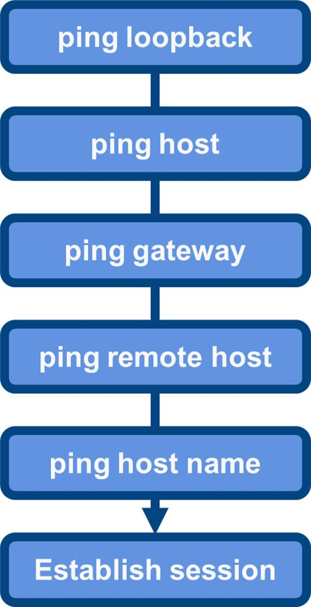
ping
If the interface IP configuration seems correct, ping the local loopback address. If that works you can be sure that IP is installed (although it doesn't prove much else).
Next, test that the machine can discover neighboring devices or nodes by pinging a local IP address - perhaps the nearest router interface. Remember, choose something in the same subnet that you know is online and available. If unsuccessful, then view the error carefully.
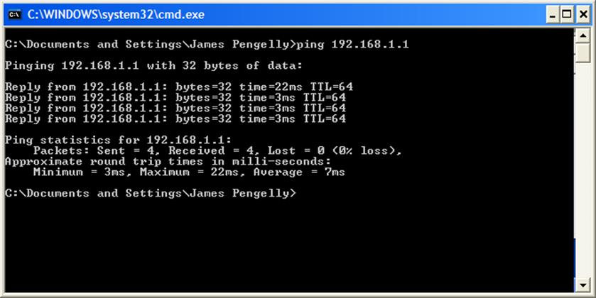
Pinging a local host
If the error returned is "Request Timed Out", this might suggest that the local computer is configured correctly, but cannot access the host. If the error returned is "Destination Unreachable", this suggests a routing problem. As you are pinging a host in the same subnet, it is likely that either the IP address of this host is wrong or the subnet mask is wrong (or both), leading IP to believe that the target host is in a different subnet. Check the IP configuration on the host (if IP is configured statically) or the lease obtained from a DHCP server.
If the subnet mask is wrong, the host will typically be able to receive communications but will misroute its replies (thinking that the hosts communicating with it are on a different subnet). The replies may still get through even, though they may go via the default gateway [router] rather than directly. If the IP address is wrong the host will probably not receive any communications as no other hosts will be able to locate a route to it.
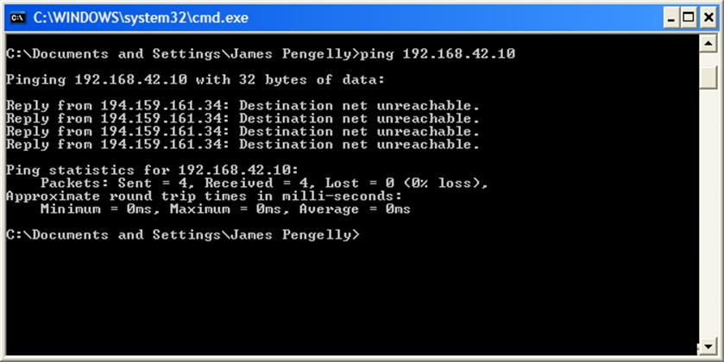
Pinging a remote host
You may also want to use the arp utility to verify the MAC addresses recorded for each host in case there is some sort of problem there. Also, when performing tests using ping, be aware that ICMP could be blocked by a firewall.

Troubleshooting the Default Gateway
If you can ping a local address, try pinging a remote host. If that doesn't work, check that the default gateway parameter is correct. If the default gateway is correct and you can ping it, start investigating the router.

Troubleshooting Duplicate IP Address Issues
Two systems could end up with the same IP address because of a configuration error; perhaps both addresses were statically assigned or one was assigned an address that was part of a DHCP scope by mistake. If Windows detects a duplicate IP address, it will display a warning and disable IP. Linux does not typically check for duplicate IP addresses. If there are two systems with duplicate IPs, a sort of "race condition" will determine which receives traffic. Obviously this is not a good way for the network to be configured and you should identify the machines (obtain the MAC addresses of both interfaces using ping and arp -a or using a scanning tool such as Nmap) and set them to use unique addresses.

Simultaneous Wired / Wireless Connections
Most computers and laptops support both wired and wireless connections. Furthermore, both adapters may be enabled and connected simultaneously. If there is a choice of connection, Windows should use the interface with the highest rated connection speed. However, if a computer has been connected wirelessly then the user plugs in a network cable, the connection may not be changed automatically. If the computer is using the incorrect interface it could cause the user problems accessing resources on the wider network. If you suspect a problem, disable the wireless adapter (or unplug the wired connector) to force the use of one link only. You can also adjust the binding order of network interfaces to try to prevent the problem from reoccurring.

Wrong DNS / Name Resolution
If you can ping a local and a remote IP address, then basic connectivity is not the issue. The next step may be to try pinging by name, so testing name resolution.
A client will perform name resolution in a prescribed order. For example, Windows machines check in the order shown in the diagram. NetBIOS is a protocol used for Microsoft workgroup networking. NetBIOS names (the computer name) have a different syntax to TCP/IP host names (they are shorter but accept some punctuation characters). A TCP/IP-compatible host name is generated automatically from the computer name, if necessary. WINS is a server that can provide name resolution for NetBIOS clients along the same lines as DNS. The precise NetBIOS name resolution order depends on the client or server configuration.
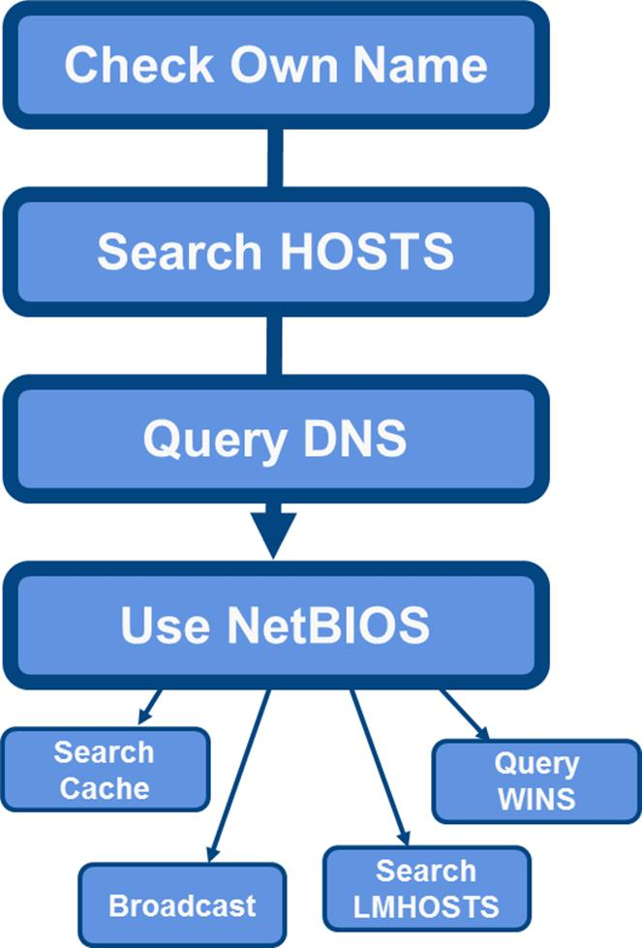
Name resolution order for a Windows client
It is important that you know what the order is for the operating system that you are troubleshooting; otherwise you cannot determine which step failed. Bear in mind that different operating systems do things differently.
To verify a name resolution problem, edit the HOSTS file and place the correct name and IP address record in the file for the test host. When you ping, if that is successful, it suggests a name resolution problem. Check that the correct name server IP address is defined within your TCP/IP configuration. If the parameters are correct, and you still cannot resolve the name, then suspect the name service itself.

Troubleshooting Internetworking
Having eliminated cabling, the network interface card and driver, and a particular host's IP configuration as potential sources of the problem, you need to know who else experiences the problem. If several users are affected, try connecting them to another switch. If this works, check the suspect switch's connections to other switches, and verify obvious things like power, complete hardware failure, and so on.
If you suspect a device like a switch or a configuration issue (such as VLANs), look at the logical topology of your network. You should be able to view those users who are suffering the problem and identify which part of the network is affected, and so identify the problem bridging or switching device. When you have narrowed the problem to a particular device, you must determine what the nature of the problem is. It is always worth resetting the switch to see if that resolves the problem. Often, restarting network devices can clear any errors.
When you have verified the physical configuration of the switches, determine whether it is applicable or relevant to update the switch software. It could be that the vendor has firmware or software updates that you must apply to resolve your problem. If you have still not resolved the problem, it will be necessary to check the vendor product documentation or support service to progress your troubleshooting.

Troubleshooting VLAN Assignments
When you partition a network into separate VLANs and create, in functional terms, discrete broadcast domains, you must ensure that services, such as name resolution and IP autoconfiguration, are properly available to all VLANs. Otherwise, users will complain about "poor performance" when it transpires that there is no local DNS server available to handle their name resolution requests.
Perhaps the most important thing that a network troubleshooter should have is an accurate and up-to-date map of both the logical and physical network infrastructure. This should identify what VLANs exist and what servers are located where. It's no good simply looking at the ports on the switch - they won't tell you anything about how the VLANs are configured. You may see a link light on the port and on the NIC, but if the interface is assigned to the wrong VLAN it won't actually be able to access network resources.
Configuration errors can cause ports to isolate (that is, a host connected to the port will not be joined to the network). Problems can include trunking configuration, layer 3 (routing) configuration, and incorrect device or host placement.
Again, with your network maps to hand, verify that the VLANs and the switches supporting them are correctly configured. For example, check the trunking configuration of interconnected switches. If one end of the trunk is configured as "on" whilst the other end is "off", then clearly there will be a problem.
Make sure all devices are placed into the appropriate VLAN as per your network maps. If they are not, network performance will degrade or fail. VLAN assignments can be configured manually by assigning the switch port to a particular VLAN and the administrator may have made a mistake. VLAN assignments can also be configured automatically, using parameters such as MAC or IP address.
If devices are not in the same VLAN and must communicate, ensure that routing has been configured to enable VLAN-to-VLAN communications. You may also need to configure services such as DHCP relay to allow hosts to contact a DHCP server. Also, if a device is placed in a designated VLAN, its IP configuration must be appropriate in terms of IP address, subnet mask, default gateway, and DNS servers.

Switching Loops (Broadcast Storms)
Switching loops cause broadcast frames to circulate the network perpetually. However, unlike IP routing loops, there is no TTL for layer 2 frames. Such loops at the data link layer can cause what are often called broadcast storms. A broadcast storm may quickly consume all link bandwidth and crash network appliances (check for excessive CPU utilization on switches and hosts).
The Spanning Tree Protocol is supposed to prevent such loops, but this can fail if STP communications between switches do not work correctly, either because of a fault in cabling or a port / transceiver or because of a misconfiguration. Examples include connecting a single patch cable to two switch ports or bridging the wired and wireless adapters on a connected host.
Most switches come with storm control settings that can be used to automatically shut down a port that is receiving an unacceptable number of broadcast frames. Alternatively, if the network is still operational you may be able to use a network sniffer to identify the source of the loop. Otherwise, you may have to physically disconnect cables to identify the culprit.
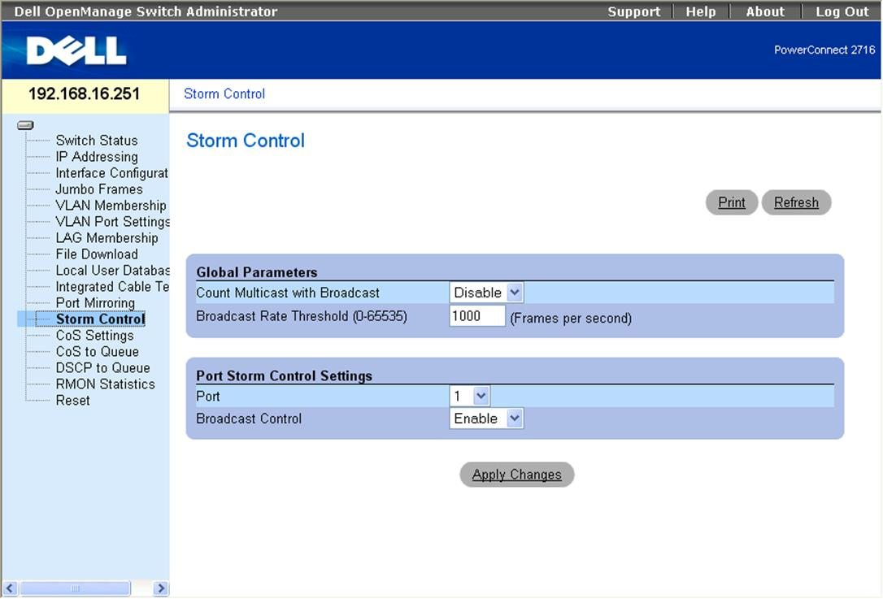
Configuring broadcast storm control settings on a Dell switch

Route Problems
If you can ping a host's default gateway and additionally ping some hosts on remote networks but not all, then there is a route problem. In most cases, this will be because a router has gone offline and there is no alternative path to that network. If routes between networks have been configured statically, it is possible that a certain IP route is missing or incorrectly configured. Use the route command to investigate the router's routing table.
Another possibility is that a security appliance such as a firewall is blocking communications.
 See Unit 5.3 / Authentication / Study Notes for more information about troubleshooting issues with security appliances.

Routing Loops
Routing loops happen when errors occur in a routing algorithm resulting in packets looping around an internetwork. In simple terms, if router A thinks that to get to network C it must pass packets to router B, whilst router B thinks that router A should handle packets destined for network C, the packets will shuttle back and forth between the two.
Most modern routing protocols, such as OSPF and IS-IS, avoid routing loops with built-in prevention protocols. Older routing protocols, such as RIP, are prone to routing loops. However, even with these older routing protocols, methods exist to help eliminate loops. The following methods are implemented by routers to avoid looping:
- Defining infinity - distance-vector protocols, like RIP, determine that routes that are more than fifteen hops away (accessible through more than 15 routers) are unreachable. Also, as a packet transits the internetwork, each router decrements the TTL value of the packet; once the value reaches zero (0), it is dropped. This does not eliminate routing loops, but does ensure packets do not loop forever.
- Split horizon - this common approach specifies that any route learned from a neighboring router cannot be propagated back to that neighbor. For example, if router A informed router B about a route to network C, then with split horizon, router B will not inform router A about updates to the routing table relating to network C.
- Holddown timer - in this technique, routers prevent updates to the routing table for a failed route. For example, if a router is notified that the route to network C has failed, it starts the holddown timer to enable other routers to reconfigure. If the router receives an update for the failed route that indicates a superior path to the destination network C, it updates its routing table and stops the timer. If the route is inferior - for example, the cost to the destination network C is higher than the failed route - the router does not update its routing table.
Indications of routing loops include abnormally high ICMP TTL traffic and very high network utilization outside of normal hours. Use a tool such as tracert to identify the path taken by a packet.

MTU/MTU Black Hole
When packets move across routers from one segment to another, it is possible that the MTU (Maximum Transmission Unit; that is, the maximum allowable frame size) may be different from one segment to another. In cases where the receiving segment has a lower MTU, it may not be possible for some packets to be forwarded. In such cases, depending on the IP header, the packet may be fragmented or it may be dropped and an ICMP message sent to the source. If the ICMP response cannot reach the source, for example if blocked by a firewall, the original packets are never re-sent, and so disappear from the network. A router that creates such a situation is known as an MTU/MTU black hole. This can be diagnosed and located by a combination of ping and tracert / traceroute commands.
For example, you can use ping with the -f and -l nn switches to simulate packets with a given MTU and therefore work out the maximum permissible packet size. The -f switch prevents routers from fragmenting the packets (breaking them into smaller chunks) and the -l switch sets the size of the packet in bytes. When working out the size to send, you need to know the smallest MTU used along the network path. For Ethernet, this is 1500 bytes but on a WAN it may be less. In Windows or Linux, you then need to subtract 28 bytes from that number as this is the size of the ICMP packet itself. Therefore, to test an Ethernet path, you would enter: ping x.x.x.x -f -l 1472.

Troubleshooting Services
To identify and resolve network service problems, you will need to remind yourself about the basic purpose and behavior of the various services we have discussed so far.

Troubleshooting Misconfigured DHCP
The Dynamic Host Configuration Protocol (DHCP) provides IP addressing autoconfiguration to client and server computers. If Windows machines are failing to obtain an IP configuration, the symptom will be inability to connect to other hosts. Upon closer inspection, you will verify the hosts' IP configurations. If APIPA (169.254.0.0/16) is being utilized, the client has failed to obtain a configuration from the server. You will need to establish why. Possible reasons include:
- DHCP server offline - restart the server.
- No more addresses available - create a new scope with sufficient addresses or reduce the lease period.
- The router between the client and DHCP server doesn't support BOOTP forwarding - either install RFC 1542 compliant routers or add another type of DHCP relay agent to each subnet or VLAN.
- If your DHCP servers go offline, users will continue to connect to the network for a period of time and thereafter start to lose contact with network services and servers. They may appear to still connect to the network, but will be restricted to the local subnet.
- If you reconfigure your DHCP servers and their scopes, the clients will gradually get reconfigured. You will need to ensure that you plan for the fact that not all clients' IP configurations will be updated when the server scopes are edited. You could do this by lowering the lease duration in advance of changes, forcing all clients to renew, or running parallel settings for a period.

Troubleshooting Misconfigured DNS
The Domain Name System (DNS) resolves Fully Qualified Domain Names (host name and domain suffix in the dotted format, such as www.gtslearning.com) into IP addresses. If your computers are experiencing DNS problems, symptoms will include inability to connect to a server by name, despite it being accessible by IP address. Note that you may still be able to establish sessions using the Net Use or Map Network Drive features of Windows, because these features can also utilize NetBIOS.
Having determined DNS as the cause, there are a number of possible reasons for the problem, which include:
- The client has been configured either with no DNS server address or the wrong DNS server address - reconfigure the DNS server address.
- The client has the incorrect DNS suffix - verify the DNS domain that the client is supposed to be in and check the Windows settings match.
Bear in mind that in both these first two situations, DHCP might be configuring these settings wrongly. Therefore, check the DHCP configuration at the DHCP server as well.
- The DNS server is offline - check and restart if necessary.
- If some DNS queries work from the client and others don't, then the problem is more complex - check the DNS service configuration itself. Use the nslookup utility to check that the service is working. Remember that if you have a DNS server problem, many users will be suffering rather than just one.
Linux and Windows systems all rely on DNS for name resolution and service discovery. In the absence of DNS servers, network client machines will be unable to logon or connect to services or servers. The symptoms will appear quite quickly as the name cache of clients is defined in DNS, and is usually just 1 hour. Reconfiguration of DNS should be planned and implemented carefully, as the service is such a cornerstone of any network that its absence, or misconfiguration, will doubtless cause major problems.

