UNIT 3.1 / TRANSPORT PROTOCOLS / STUDY NOTES

Transmission Control Protocol (TCP)
Transport protocols work at the next OSI model layer up from the network layer. IP provides addressing and routing functionality for internetworks. Protocols at the transport layer are concerned with effective delivery. At the transport layer, communications are often referred to as segments.
In the TCP/IP suite, the Transmission Control Protocol (TCP) provides a connection-oriented, guaranteed method of communication using acknowledgements to ensure delivery. TCP takes data from the application layer as a stream of bytes and divides it up into segments, each of which is given a header. The TCP segments become the payload of the underlying IP datagram.
TCP requires that a connection be established before hosts can exchange data.

TCP Three-way Handshake
A TCP connection is typically established to transfer a single file so a client session for something like a web page (HTTP) might involve multiple TCP connections being opened with the server. A connection is established using a three-way handshake:
- The client sends a SYN segment to the server with a randomly generated sequence number. The client enters the SYN-SENT state.
- The server, currently in the LISTEN state (assuming it is online), responds with a SYN/ACK segment, containing its own randomly generated sequence number. The server enters the SYN-RECEIVED state.
- The client responds with an ACK segment. The client assumes the connection is ESTABLISHED.
- The server opens a connection with the client and also enters the ESTABLISHED state.
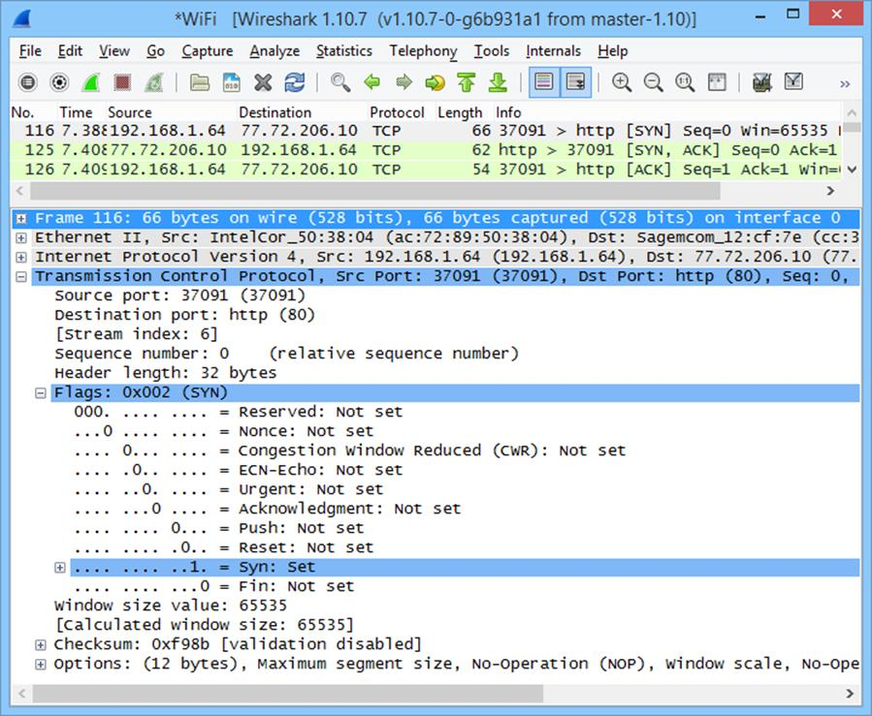
Observing the 3-way handshake with a protocol analyzer
 Servers can (usually) support thousands or even millions of TCP connections simultaneously.
The sending machine expects regular acknowledgements for segments it sends and, if a period elapses without an acknowledgement, it assumes the information did not arrive and automatically resends it. This overhead makes the system relatively slow. Connection-oriented transmission is suitable when reliability and data integrity are important.

TCP Segment Headers
The main headers in a TCP segment are:
Field | Explanation
Source port | TCP port of sending host.
Destination port | TCP port of destination host.
Sequence number | The ID number of the current segment (the sequence number of the last byte in the segment).
Ack number | The sequence number of the next segment expected from the other host (that is, the sequence number of the last segment received +1).
Data length | Length of the TCP segment.
Flags | Type of content in the segment (ACK, SYN, FIN, and so on).
Window | The amount of data the host is willing to receive before sending another acknowledgement (used for flow control).
Checksum | Ensures validity of the segment. The checksum is calculated on the value of not only the TCP header and payload but also part of the IP header; notably the source and destination addresses. Consequently the mechanism for calculating the checksum is different for IPv6 (128-bit addresses) than for IPv4 (32-bit addresses).
Urgent Pointer | If urgent data is being sent, this specifies the end of that data in the segment.
Options | Allows further connection parameters to be configured. The most important of these is the Maximum Segment Size. This allows the host to specify how large the segments it receives should be, minimizing fragmentation as they are transported over data link frames.
Another important function of TCP is handling flow control to make sure the sender does not inundate the receiver with packets. The main mechanism used for this is called the sliding window. The window field in the header represents the number of bytes starting from the last acknowledged byte that a host is prepared to receive before it will send an acknowledgement.

Closing a Connection
There are also functions for resetting a connection and (in some implementations) keeping a connection alive if no actual data is being transmitted (hosts are configured to timeout unused connections). To close a connection, the following basic steps are performed:
- The client sends a FIN segment to the server and enters the FIN-WAIT1 state.
- The server responds with an ACK segment and enters the CLOSE-WAIT state.
- The client receives the ACK segment and enters the FIN-WAIT2 state. The server sends its own FIN segment to the client and goes to the LAST-ACK state.
- The client responds with an ACK and enters the TIME-WAIT state. After a defined period, the client closes its connection.
- The server closes the connection when it receives the ACK from the client.
Some implementations may use fewer steps by combining them into one operation.
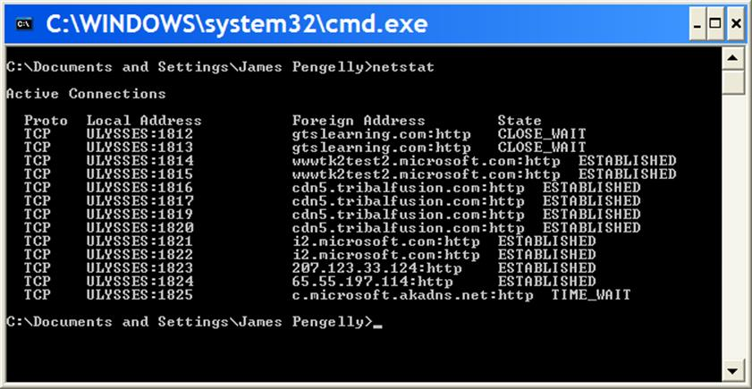
Observing TCP connections with the netstat tool

User Datagram Protocol (UDP)
The User Datagram Protocol (UDP) is a connectionless, non-guaranteed method of communication with no sequencing or flow control. There is no guarantee regarding the delivery of messages or the sequence in which packets are received. When using UDP, the application layer must control delivery reliability, if this is required.
UDP is suitable for applications that send small amounts of data in each packet and do not require acknowledgement of receipt. It is used by application layer protocols that need to send multicast or broadcast traffic (TCP supports unicast only). It may also be used for applications that transfer time-sensitive data but do not require complete reliability, such as voice or video. The reduced overhead means that delivery is faster.
The table below shows the structure of a UDP datagram.
Field | Explanation
Source port | UDP port of sending host.
Destination port | UDP port of destination host.
Message length | The size of this UDP message.
Checksum | Verify the datagram.
The header size is 8 bytes compared to 20 bytes (or more) for TCP.

TCP/IP Ports
A server machine may be running multiple services or communicating with multiple hosts in parallel. This means that incoming packets must be directed to the appropriate service or application. Any application or process that uses TCP or UDP for its transport is assigned a unique identification number called a port. Ports specify the path of communication between the client and server part of the application. Port numbers for some server applications are pre-assigned by the Internet Assigned Numbers Authority(IANA) and do not change. IANA assigns processes to port numbers 0 through 1023. These port assignments are documented at gtsgo.to/ksl0p. Vendors can register ports 1024 through 49,151. The following table contains some of the "well known" and registered port numbers.
# | TCP / UDP | Process | Description
20 | TCP | ftp-data | File Transfer Protocol - Data
21 | TCP | ftp | File Transfer Protocol - Control
22 | TCP | ssh | Secure Shell
23 | TCP | telnet | Telnet
25 | TCP | smtp | Simple Mail Transfer Protocol
53 | TCP / UDP | domain | Domain Name System
67 | UDP | bootps | BOOTP / DHCP Server
68 | UDP | bootpc | BOOTP / DHCP Client
69 | UDP | tftp | Trivial File Transfer Protocol
80 | TCP | http | HTTP
110 | TCP | pop3 | Post Office Protocol
123 | UDP | ntp | Network Time Protocol
143 | TCP | imap | Internet Mail Access Protocol
161 | UDP | snmp | Simple Network Management Protocol
162 | UDP | snmp-trap | Simple Network Management Protocol Trap
443 | TCP | https | HTTP Secure
445 | TCP | smb | Server Message Block
1720 | TCP | h323hostcall | H.323 Call Signaling
2427 | UDP | mgcp-gateway | Media Gateway Control Protocol Gateway
2727 | UDP | mgcp-callagent | Media Gateway Control Protocol Client
3389 | TCP | rdp | Remote Desktop Protocol
5004 | UDP | rtp | Real-Time Protocol
5005 | UDP | rtcp | Real-Time Control Protocol
5060 | TCP / UDP | sip | Session Initiation Protocol
5061 | TCP / UDP | sips | Session Initiation Protocol Secure
The remaining ports (up to 65,535) are designated for private or dynamic use.
A client application or process is dynamically assigned a port number greater than 1024 by the operating system when there is a request for service. Client ports are also referred to as ephemeral ports.
Port numbers are used in conjunction with an IP address to form a socket. A socket provides an end-point to a connection and two sockets form a complete path. A socket works as a bi-directional pipe for incoming and outgoing data. Examples of socket numbers are shown in the table below.
IP Address | Port Number | Socket Number
10.155.22.99 | 1028 | 10.155.22.99:1028
172.16.16.10 | 21 | 172.16.16.10:21

netstat
netstat can be used to investigate open ports and connections on the local host. These connections are established by checking for ports that are active or merely listening for connection attempts. The following switches can be used:
- -a displays all the connections and listening ports.
- -b shows the process that has opened the port.
- -e displays Ethernet statistics.
- -n displays ports and addresses in numerical format. Skipping name resolution speeds up each query.
- -s shows per protocol statistics.
- -pproto displays connections by protocol (TCP or UDP or TCPv6 / UDPv6). When used with -s, this switch can also filter the statistics shown by IP, IPv6, ICMP, and ICMPv6.
- -r shows the routing table.
The utility can also be set to run in the background by entering netstat nn, where nn is the refresh interval in seconds (pressCtrl+C to stop).
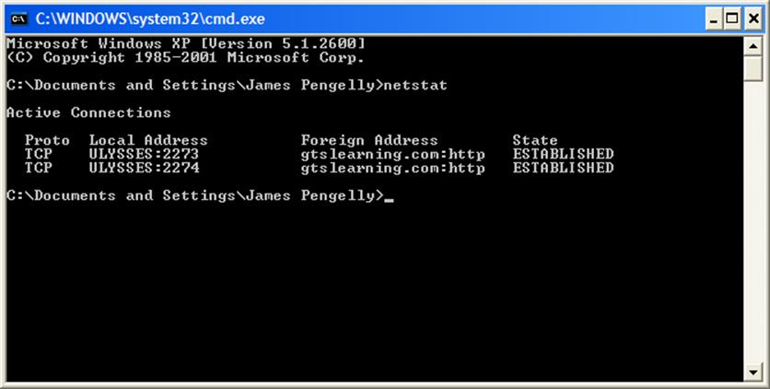
Displaying open connections with netstat
Linux supports a similar utility with slightly different switches.

