UNIT 2.5 / ROUTING / STUDY NOTES

Routing Basics
The process of routing takes place when a host needs to communicate with a host on another IP network or in another subnet. IP is able to determine that the target host is on a different IP network by deriving the network address from the full IP source and destination addresses and comparing them. The network address is obtained by masking the full IP address against a network prefix or subnet mask.
In IPv4, the network prefix can be increased (to make more network numbers available) at the expense of the number of host IDs left available for each network. The network prefix can be expressed in slash notation as a number of bits (172.1.0.0/20 for instance) or as a dotted decimal subnet mask (255.255.240.0 for instance).
In IPv6, the interface ID is always 64 bits and the network prefix is only given in slash notation. Prefixes are allocated in a hierarchical manner, with the smaller prefix blocks (which contain more networks) going to internet registries, who then allocate mid-size blocks to ISPs, who then allocate the blocks with the largest network prefixes to end users. End users themselves may then be left with a block to use to subnet their network.
In either protocol, IPv4 or IPv6, once the IP layer has established that the destination host is on a different IP network, routing must take place.

End Systems and Intermediate Systems
All IP hosts are, in essence, capable of functioning as routers. However, most workstation and server computers are configured with a single network adapter connected to only one network; although potentially capable of routing, they are not equipped with the necessary interfaces and knowledge of the location of other networks. Hosts with no capacity to forward packets to other IP networks are referred to as End Systems (ES). Routers that interconnect IP networks and can perform this packet forwarding process are known as Intermediate Systems (IS). On a router, information about the location of other IP networks is usually stored in a routing table of some sort. Early routers were manually configured with this routing information. These days, almost all routers use some sort of routing protocol to learn about remote networks and the most efficient route to those networks.

Routing Tables and Path Selection
Each entry in the routing table represents an available route to a destination network, and contains (at least) the following parameters:
- Destination network address and netmask - routes can be defined to specific hosts but are more generally directed to network IDs.
- Gateway / next hop address - the IP address of the next router along the path.
- Interface - the local port to use to route to this destination.
- Metric - a preference value assigned to the route, with low values being preferred over high ones. The value of the metric may be determined by different parameters, such as how far the next hop router is, how long it will take to route a packet to the subsequent routers, what bandwidth is available on the selected path, how large a packet can be sent without fragmentation, and so on.
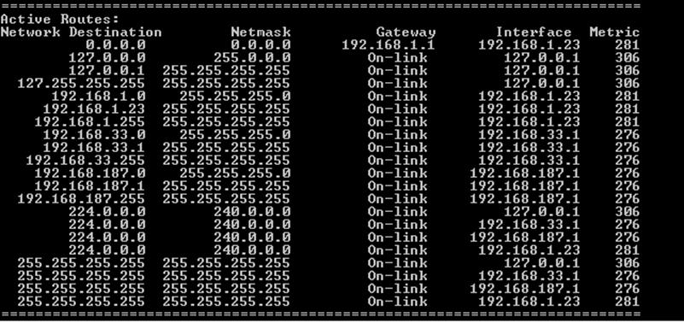
Routing table on a multi-homed Windows 7 PC
Different routing algorithms, as implemented in the various routing protocols, may use different metrics and make comparisons of available paths in different ways. However, the desired end result is always the same - to choose the optimal path for a specific packet at a given moment.

Packet Delivery
Once a router has received a packet, it goes through the same process that the source host did to calculate whether the packet needs to be routed to another router or whether the packet can be delivered locally to another interface. This is referred to as a directly connected route. In the case of a directly connected route, the router uses ARP (IPv4) or Neighbor Discovery (ND - IPv6) to determine the interface address of the destination host and merges the packet onto the appropriate interface.
If there is no directly connected route, the router consults its routing table to determine the next hop router. It inserts the next hop router's MAC address into a new frame (containing the original IP packet) and merges it onto the wire attached to the appropriate interface for the next hop router.
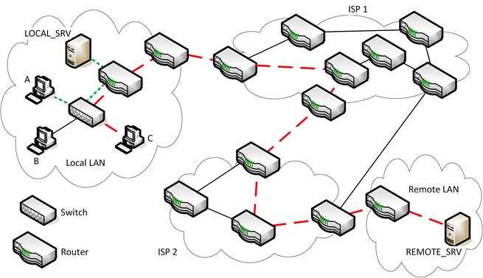
Routing internetwork
For example, in the network shown above, hosts A, B, and C can communicate without routing via the switch. Host A takes 1 hop to communicate with LOCAL_SRV via a directly connected interface on the LAN router. Note that the switch does not count as a hop. Host C takes multiple hops (9) to communicate with REMOTE_SRV, with traffic routed via two ISP's networks. Note the alternative routes that could be taken - do any have a lower hop count?
If no route exists, the packet is either forwarded to the default gateway of the router (also referred to as the default routeor gateway of last resort) or dropped (and the source host is notified that it was undeliverable).
 It is possible for two routers in sequence to be configured with a default gateway of each other; this is one way to connect three subnets together, though not the most efficient.
If the packet has been routed the Time to Live (TTL) is decreased by at least one. This could be greater if the router is congested. When the TTL is zero, the packet is discarded. This prevents badly addressed packets from permanently circulating the network.

UNIT 2.5 / ROUTING / STUDY NOTES

Routing Algorithms and Metrics

The routing protocol you implement depends upon a variety of factors. As different protocols support different routing algorithms, it is worth spending some time considering the different algorithms used.

Static Routes
The algorithms used for path selection can be categorized according to the topology and metrics that they use to build and update routing tables. Static routing is defined manually. You create the routing entries in the router's memory and they only change if you edit them. A static route is a good way of configuring the default route (to a router connected to the Internet for instance). Configuring static routing entries can be very useful in some circumstances but it can be problematic if the routing topology changes often as each route on each affected router would need to be updated manually.

Dynamic Routes
Most routing takes place using dynamic algorithms, encoded in a routing protocol. Routers use these protocols to exchange information about connected networks periodically and select the best available route to a particular destination. Some dynamic routing algorithm types include:

Hierarchical versus Flat
In hierarchical routing systems, certain routers form a routing backbone. Other routers are grouped into logical collections, sometimes called areas or domains. Backbone or border routers can communicate with routers in other domains, whilst internal routers are limited to communication with routers within the current domain or the border router(s) serving it. The hierarchical approach allows for route summarization (discussed later).
Non-hierarchical systems are referred to as flat; a situation in which all routers can inter-communicate with one another. Each network ID requires a separate entry in the routing table, which can be problematic in very large internetworks.

Distance Vector versus Link-state
Distance vector algorithms require that routers propagate their entire routing table periodically to their immediate neighbors. Distance vector algorithms provide for slower convergence (see below) than with link-state algorithms.
Routers implementing a link-state algorithm propagate information about only their own links to other routers on the internetwork. These smaller, frequent updates lead to more rapid convergence and more efficiently support larger networks. However, they are more processor intensive.
Some protocols use a hybrid of different methods to perform path selection more efficiently.

Convergence
Convergence is the process whereby routers running dynamic routing algorithms agree on routes through the internetwork. As the internetwork topology changes constantly (what with router failures, addressing changes, and unforeseen events), routers must be capable of adapting to these changes and communicating them quickly to other routers to avoid loops. A network where all the routers share the same topology is described as steady state. The time taken to reach steady state is a measure of a routing protocol's convergence performance.
 A "flapping" interface is one that frequently changes from online to offline and offline to online.

Routing Metrics
Different routing algorithms use different metrics to help determine the appropriate path to use. These metrics might include:
- Path length - the end-to-end cost of using a route (hop count). You might assign a value to a particular path between router A and B and between B and C. The end-to-end path length is the sum of A-to-B and B-to-C.
- Reliability - over a period of time, it might become obvious that some links between routers are more reliable than others. You can assign a value for this reliability that routers can assess when determining an effective path.
- Latency - it takes time for a packet to traverse an internetwork. Delay-based metrics measure transit time. This metric is most important if the route is used to carry time-sensitive data, such as voice or video.
- Bandwidth - metrics based on bandwidth look at the maximum achievable bandwidth on a link and do not consider the available bandwidth. This is a less efficient metric than delay-based metrics.
- Load (link utilization) - a metric that bases routing decisions on how busy a particular route is.
- MTU (Maximum Transmission Unit) - how large a packet can be sent without the need for fragmentation.
In IPv4, routers can be made responsible for calculating the Maximum Transmission Unit (MTU - or packet size) for a given interface and fragmenting and reassembling packets that are too big. In IPv6, the host is responsible for determining the MTU and routers cannot perform fragmentation.
- Price / costs - you can assign a monetary cost to various links and the router using a cost metric will try to select the cheapest link available. Useful for organizations routing on a budget!

Routing Protocols
For larger organizations it is simply not practical to configure routing tables manually. Aside from anything else, routing information is seldom static as routers are reconfigured, taken temporarily offline, and even decommissioned. Whilst many organizations can manage to maintain routing tables for these internal changes, when connected to the Internet, it becomes almost impossible. Consequently, router vendors provide support for routing protocols. These routing protocols use various algorithms and metrics to build and maintain routing tables to provide reasonably current routing information about the networks to which they are connected.
An Interior Gateway Protocol (IGP) is one that performs routing within a network under the administrative control of a single owner, also referred to as an Autonomous System (AS). An Exterior Gateway Protocol (EGP) is one that can perform routing between autonomous systems.
Some of the most popular routing protocols are listed in the table below.
Protocol | Type | Class | Transport
Routing Information Protocol (RIP) | Distance-vector | Interior Gateway Protocol (IGP) | UDP (port 520 or 521)
Enhanced Interior Gateway Routing Protocol (EIGRP) | Distance-vector (Hybrid) | Interior Gateway Protocol (IGP) | Native IP (88)
Open Shortest Path First (OSPF) | Link-state | Interior Gateway Protocol (IGP) | Native IP (89)
Intermediate System to Intermediate System (IS-IS) | Link-state | Interior Gateway Protocol (IGP) | Native data link (layer 2)
Border Gateway Protocol (BGP) | Distance-vector (Hybrid) | Exterior Gateway Protocol (EGP) | TCP (port 179)

Routing Information Protocol (RIP)
Routing Information Protocol (RIP) is a long established distance vector-based routing protocol. It uses a hop count metric to determine the distance to the destination network. Generally speaking, each router is assigned a hop count value of 1. RIP only considers a single route to a given destination network - that with the lowest hop count.
To help prevent looping, the maximum hop count allowed is 15. Consequently, this limits the maximum size of a RIP network as networks that have a hop count of 16 or higher are unreachable. RIP sends regular updates about the routing table to neighboring routers plus ad-hoc updates whenever changes occur. When a router receives an update from a neighbor, it updates the appropriate route in its own route table, increases the hop count by 1, and indicates the originator of the update as the next hop to the specified network. The router then propagates the update.
RIP uses the User Datagram Protocol (UDP) as the network transport protocol (port 520).
There are, in fact, three implementations of RIP. RIPv2 provides for a level of authentication between RIP routers and uses more efficient multicast transmissions rather than broadcasting updates. In addition, RIPv2 packets carry a subnet mask field and therefore support classless addressing. RIPng is an update to support IPv6. RIPng uses UDP port 521.
Because it is widely adopted, well understood, and simple, RIP is ideally suited to small networks with fairly limited failover routes. For more complex networks, with redundant paths, other network routing protocols should be considered.

Enhanced Interior Gateway Routing Protocol (EIGRP)
The Interior Gateway Routing Protocol (IGRP) was developed by Cisco to provide a routing protocol for routing within a domain, or autonomous system (that is, within a single organization). Limitations in IGRP, such as lack of support for classless addressing, led to the development of Enhanced IGRP (EIGRP). There are versions for IPv4 and IPv6. IGRP itself is now obsolete.
Like RIP, EIGRP is usually classed as a distance vector-based routing protocol. Unlike RIP, which is based on a simple hop count metric, EIGRP uses a metric composed of several administrator weighted elements, including reliability, bandwidth, delay, and load. EIGRP also supports multiple paths to the destination network, again, unlike RIP. EIGRP may also therefore be described as an advanced distance vector protocol or as a hybrid routing protocol. EIGRP builds on the strengths of RIP whilst providing for more efficient route selection, better administrative control, and better fault tolerance.
Unlike RIP, EIGRP is a native IP protocol, which means that it is encapsulated directly in IP datagrams rather than using TCP or UDP (it is tagged with the protocol number "88" in the protocol field of the IP header).

Open Shortest Path First (OSPF)
A hierarchical link-state routing protocol, Open Shortest Path First (OSPF) is better suited to large organizations with multiple redundant paths between various networks. It has high convergence performance compared to RIP. It was designed from the outset to support classless addressing.
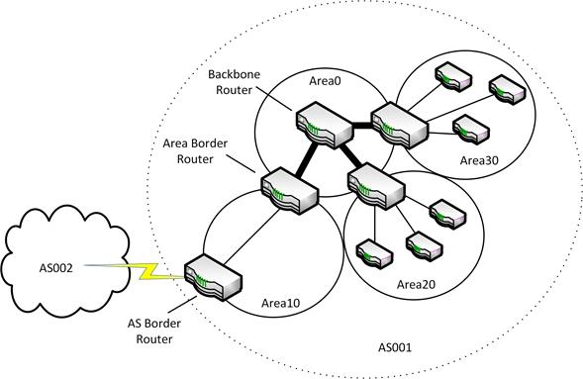
Typical OSPF topology
Networks and their connected hosts and routers within an autonomous system are grouped into OSPF areas. Routers within a given area share the same topological database of the networks they serve.
Routers that can connect to multiple areas are known as Area Border Routers. A backbone (always called Area 0) is created by the collection of border routers. This backbone is only visible to the border routers and invisible to the routers within a specific area. Routers use a Link State Advertisement (LSA) to update their routing tables. In a given area, routers exchange OSPF Hello messages, both as a form of keep-alive packet and in order to acquire neighbours with which to exchange routing information. These exchanges of routing information enable the routers to each build a topological routing tree (a shortest path tree) and keep it up-to-date. The use of areas to subdivide the network minimizes the amount of routing traffic that has to be passed around the network as a whole, improving convergence performance.
Messages are sent using OSPF's own datagram format. This is tagged as protocol number "89" in the IP datagram's protocol field. There are various packet types and a number of mechanisms to ensure sequencing and reliable delivery and to check for errors. OSPF also supports plain text or cryptographic authentication.

IS-IS
Intermediate System to Intermediate System (IS-IS) is another Interior Gateway Protocol intended for routing operations between devices that are part of the same autonomous system. It is a link-state routing protocol. In some ways, it is similar to OSPF and uses the same algorithms to determine optimum routes. Networks are also divided into areas, but there is no background area 0. Instead, routers are classified as Level 1 (L1), Level 2 (L2), or L1/2. L1 routers share information about routes within their own area only while L2 routers are border routers and connect areas via a backbone network. L1/2 routers can perform both functions.
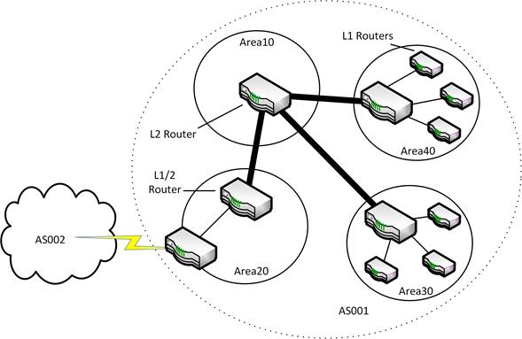
Typical IS-IS topology
Whilst OSPF is well suited to medium to large enterprises, the greater flexibility of IS-IS (not having to use area 0) means that it is often used by ISPs.

Shortest Path Bridging (SPB)
While not strictly a routing protocol, Shortest Path Bridging (SPB) is based on IS-IS. It uses extensions of the IS-IS protocol, defined in RFC 6329, to enable switches to gain information on available VLANs directly from the link state information maintained and distributed by IS-IS. This information is then used to establish layer 2 switching paths for each VLAN, thereby providing a replacement for Spanning Tree Protocol (STP) at layer 2.
SPB has several advantages over STP, particularly that it is faster to converge, and that it is able to make use of all available bandwidth in a switched mesh network. It can achieve this by using link aggregation to create a single logical link between two switches using multiple physical links, rather than blocking duplicate links as STP would.
SPB is standardized as IEEE 802.1aq.

Border Gateway Protocol (BGP)
The BorderGateway Protocol (BGP) is designed to be used between routing domains, or Autonomous Systems (AS), and as such is used as the routing protocol on the Internet, primarily between ISPs.
All the protocols we have discussed so far have been classed as Interior Gateway Protocols (IGP) used for communications between routers within an autonomous system. BGP is a type of Exterior Gateway Protocol (in fact, it replaced a protocol named EGP) for communications between routers in diverse autonomous systems. When BGP is used within an autonomous system, it is referred to as Interior BGP (IBGP) and when implemented between autonomous systems, it is referred to as Exterior BGP (EBGP).
The uses of autonomous systems are discussed in RFC 1930. Autonomous systems are designed to hide the complexity of private networks from the public internet. If all internet locations had to be propagated to all internet routers, the routing tables would become too large to process. Border (or edge) routers for each AS exchange only as much network-reachability information as is required to access other autonomous systems (the AS path), rather than networks and hosts within each AS. Autonomous System Numbers (ASN) are allocated to ISPs by IANA via the various regional registries.
BGP works with CIDR IP network prefixes (Network Layer Reachability Information [NLRI]). Route selection is based on multiple metrics including hop count, weight, local preference, origin, and community. BGP is not a pure distance-vector algorithm but uses a hybrid approach.
BGP works over TCP on port 179.
Remember that both subnetting and supernetting require the use of a classless routing protocol (one that does not determine the network mask on the basis of the first octet in the IP address). Routing protocols that support classless addressing include RIPv2, EIGRP, OSPF, IS-IS, and BGPv4.

Administrative Distance and Route Redistribution
A complex network may need to run more than one routing protocol.
Where a router is configured to run multiple routing protocols, it uses a metric called Administrative Distance (AD) to determine which protocol to "trust" when presented with alternative routes to a network. Default AD values are coded into the router but can be adjusted by the administrator if necessary:
Source | AD
Local interface / Directly connected | 0
Static route | 1
BGP | 20
EIGRP | 90
OSPF | 110
IS-IS | 115
RIP | 120
Unknown | 255
This means, for example, that a static route will always be preferred to anything other than locally connected networks and that a route discovered by OSPF would be preferred to one reported by RIP. The value of 255 for unknown routes means that they will not be used.
 Note that the term "administrative distance" is misleading. It is not specifically connected with router administration, nor is it a distance in any real sense. It is an index of routing protocol reliability.
When a router learns routes from multiple routing protocols, it can also optionally be configured to pass on the routes learned from one routing protocol to another. For example, routes learned from OSPF could be passed on to other autonomous systems via BGP. This process is known as route redistribution. It can be configured on a protocol-by-protocol basis and this must usually be done manually as account must be taken of the differing metrics used by the different protocols.

IPv4 and IPv6 Internet Routing
Internet routers must be able to locate any host on the Internet. As there are millions of networks and hosts, it is impossible to do this by storing routes to each of them. Instead, an internet core router will consolidate the route to a group of networks, as identified by their shared network routing prefix, to a single routing table entry. This is referred to as route aggregation or route summarization.
Classless IPv4 routing uses a mix of flat and hierarchical structures to make more efficient use of the limited address space (compared to the old method of classful address allocation). The system is based on the Classless Interdomain Routing (CIDR) specification.
High-level network routing prefixes (or CIDR blocks), which are 8 bits in length (/8s), are allocated by IANA to Regional Internet Registries (RIR), such as ARIN (America) and RIPE (Europe). A few are still held privately by companies such as IBM, Xerox, HP, or AT&T or by government agencies such as the DoD. You can view the assignments at gtsgo.to/yqu0j.
The registries then allocate blocks to national and local registries. Actual ISPs are generally allocated blocks with prefixes of 20 bits or less. Any routing over that boundary (that is, a /21 network or higher) takes place solely within the ISP's network rather than over the general internet. The ISP's network is referred to as an Autonomous System.
The ISPs subdivide their allocations into different sized blocks for different customer requirements, ranging from dynamically allocated addresses for home users, through fixed single IP addresses for small businesses, to smaller and larger ranges for medium sized and large enterprises.
At each level, a router serving a particular group of networks needs only to be advertised by a routing prefix of a given length, greatly reducing the number of routes that need to be stored in memory.
IPv6 follows the same hierarchical structure, with the advantage of planning an efficient addressing topology from the start and having a larger address space to work with. The full network prefix of an IPv6 address is 64 bits long. This is divided up into the following general hierarchy:
- The globally unique unicast address range is indicated by the 2000::/3 address space (the first 3 bits). Ranges from this address space are allocated to RIRs in blocks from /3 to /32, as listed at gtsgo.to/48het.
- ISPs received allocations from their registry in the space from /32 to /35.
- End users receive allocations from their ISP in the /48 to /64 range.
- End users can subnet their networks using the remainder of the network prefix left to them (if any).

High Availability Routing
Since routers are vital to the connectivity of a network, their failure can lead to loss of service. In many environments, this constitutes an unacceptable risk, and systems must be implemented in order to ensure that the network can continue to operate in the event of a router failure.
In a mesh network topology, alternate routes can be found to bypass failed routers or faulty connections. However, routing protocols take time to converge and during this convergence time packets may be dropped. Also, end sites are typically served by a single router, configured as the default gateway. While it is possible to configure hosts with multiple default gateways for fault tolerence, this does not work well in practice as it requires a greater degree of complexity in the hosts' routing algorithms than is typically implemented on an end system host.

Hot Standby Router Protocol (HSRP)
To address this problem Cisco developed the proprietary Hot Standby Router Protocol (HSRP), standardized in 1998 as RFC 2281. HSRP allows for multiple physical routers to serve as a single default gateway for a subnet. To do this, each router will have an interface connected to the subnet, with its own unique MAC address and IP address. In addition, they will also be configured to share a common virtual IP address and a common MAC address. The group of routers configured in this way is known as a standby group. They communicate among themselves using IP multicasts and choose an active router based on priorities configured by an administrator. The active router responds to any traffic sent to the virtual IP address. Of the remaining routers in the standby group, the router with the next highest priority is chosen as the standby router. The standby router monitors the status of the active router and takes over the role if the active router becomes unavailable, also triggering the selection of a new standby router from the remaining routers in the group.

Virtual Router Redundancy Protocol (VRRP)
An open standard protocol known as Virtual Router Redundancy Protocol (VRRP) was developed in 2004. The current version is VRRP version 3, defined in RFC 5798, which adds support for IPv6. VRRC is very similar to HSRP, the differences being mainly in terminology and packet formats. In VRRP, the active router is known as the master and all other routers in the group are known as backup routers. There is no specific standby router; instead, all backup routers monitor the status of the master and in the event of a failure a new master router is selected from the available backup routers based on priority.
One advantage of VRRP over HSRP is that it does not require each router interface to be assigned a unique IP address. It is possible to configure VRRP routers to use only the virtual IP address. This can be useful on subnets where address space utilization is high.

Installing and Configuring Routers
A router is the system that implements the functions described above. There are many ways of implementing a router as hardware or software.

NOS and Appliance Routers
The relatively complex tasks performed by a router mean that they tend to be processing intensively. A router may be a dedicated appliance with a port to each of the networks or it may be a Network Operating System (NOS) server with multiple interface cards (multi-homed). Routers very often also support the functions of a firewall.
A router designed to connect a private network to the Internet is called an edge router or border router. These routers can perform framing to repackage data from the private LAN frame format to the WAN internet access frame format. Edge routers designed to work with DSL or cable modems are called SOHO Routers (Small Office or Home Office).
Routers designed to service medium to large networks are complex and expensive appliances. They feature specialized processors to handle the routing and forwarding processes and memory to buffer data. Most routers of this class will also support plug-in cards for WAN interfaces.
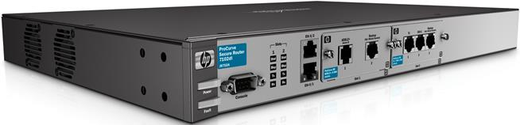
HP ProCurve router with 2xEthernet, ADSL, and T1 interfaces (also note the console port on the left) (Image © 2011 Hewlett-Packard Development Company, L.P)
 See Unit 4.5 / Remote Access / Study Notes for more information on configuring remote (WAN) links.

Router Placement
Routers serve both to join physically remote networks and subdivide a single network into multiple subnets. Border or edgerouters are typified by distinguishing external (internet-facing) and internal interfaces. These devices are placed at the network perimeter.
The graphic below shows a simplified example of a typical network configuration. A WAN router provides access to the Internet. Basic switches provide ports and Virtual LANs (logical groupings of clients) for wired and (via an access point) wireless devices. Traffic between logical networks is controlled by a router (or layer 3 switch).
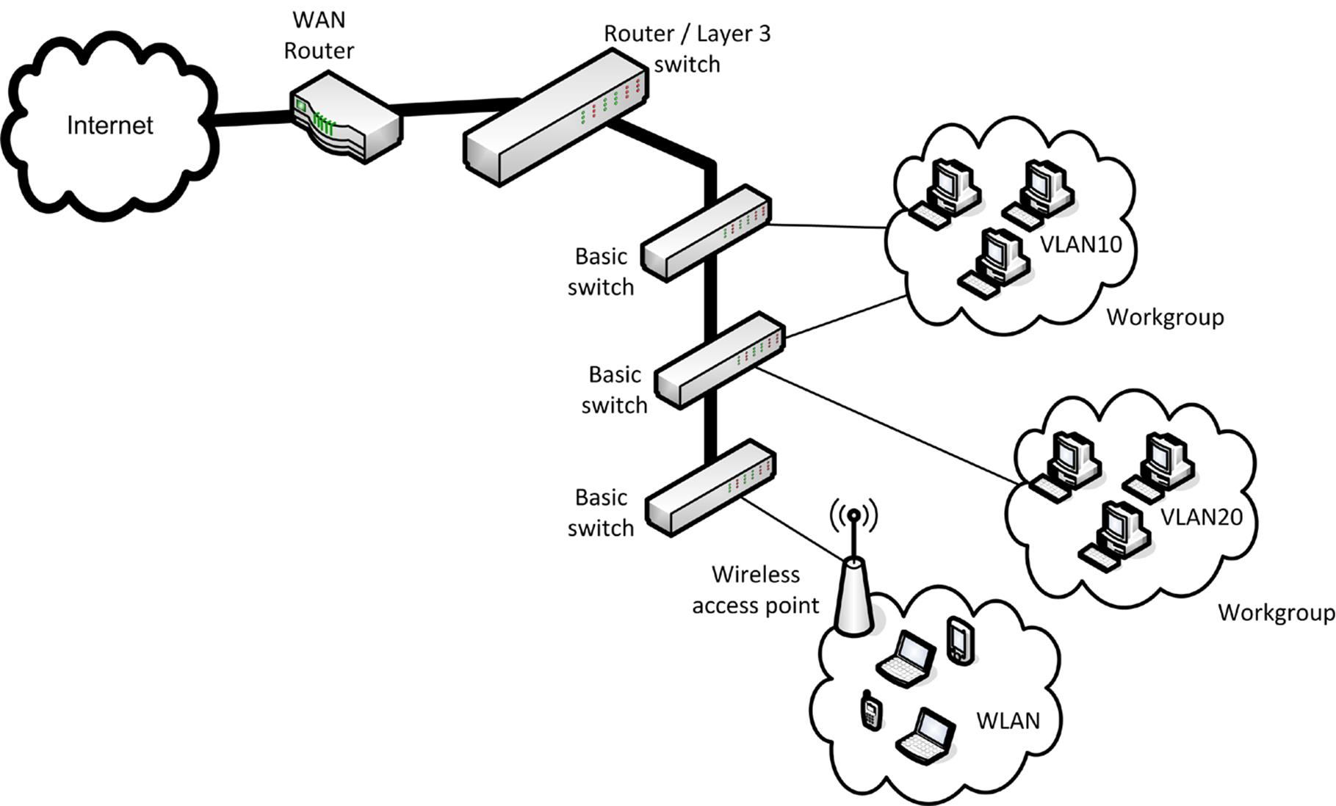
Typical network configuration
Traffic between VLANs must be routed. In this scenario, it is possible to use a router with a single interface (a "one-armed router" or "router on a stick") with the interface configured to be part of all the VLANs it serves. Passing traffic between a router appliance and the switches is relatively inefficient however. Consequently, enterprise networks usually use a Layer 3 switch, which is an appliance that can establish the VLANs and perform routing between them.

Router Configuration and Loopback Interfaces
As router appliances do not have a screen or keyboard they are configured locally either via a serial connection known as a console port or (more usually) remotely over the network using a protocol such as SSH or Telnet. These protocols can be used to communicate with the router via the IP address of any configured interface. However, as any given physical interface could suffer a hardware fault or be temporarily unavailable for various reasons, it is considered best practice to create a virtual interface, known as a loopback interface, in the router's operating system and assign it an IP address for use in remotely managing the router. This is a way of giving the router an internal IP address, not connected to any physical network, that is therefore not reliant on a specific network being available.
A software router is configured using the appropriate tools in the underlying NOS. As well as the configuration of the routing functions, the performance and security of the underlying server should be considered too.
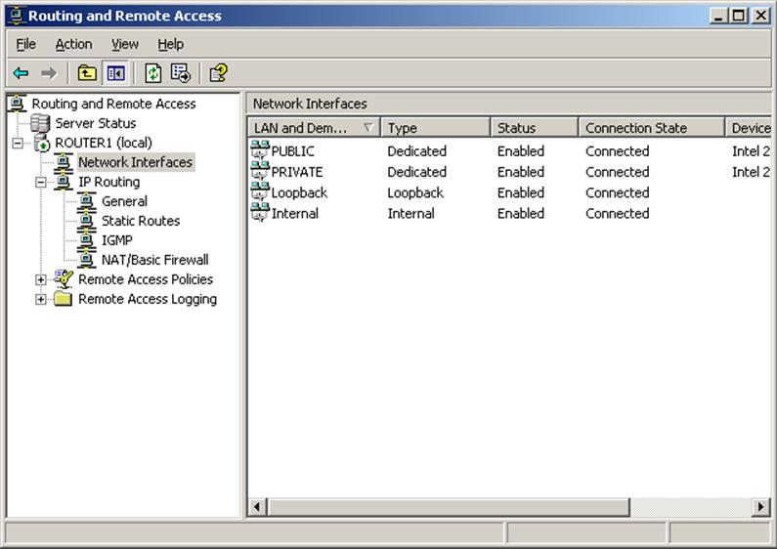
Configuring Routing and Remote Access on Windows Server

Routing Troubleshooting Tools
A number of command line tools can be used to troubleshoot routing issues on Windows and Linux hosts.

route
A host's routing table contains information about routes to other hosts. A router for a complex network would normally have a very large routing table populated dynamically by the routing protocol. An end system will usually have a simple routing table, configured with a few default entries. For example, the default entries for a Windows host are:
- Default route (0.0.0.0).
- Loopback address.
- Host's subnet address.
- Host's own address.
- Multicast address.
- Broadcast address.
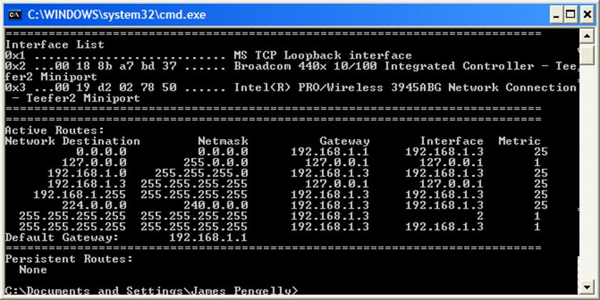
Default routing table for a Windows host
Utilities are available to view and modify the routing table. For example, both UNIX / Linux and Windows support the routecommand. The syntax is as follows:
route [-f -p] ADD DestinationIP MASK Netmask GatewayIP METRIC MetricValue IF Interface
...where:
- DestinationIP is a network or host address.
- Netmask is the subnet mask for DestinationIP.
- GatewayIP is the router to use to contact the network or host.
- MetricValue is the cost of the route.
- Interface is the adapter the host should use (used if the host is multi-homed).
For example:
route add 192.168.3.0 mask 255.255.255.0 192.168.5.1 metric 2
Routes added in this manner are often stored in memory and require reloading if the machine is restarted. A route can be permanently configured in the Registry using the -p switch.
If you are experiencing problems contacting a remote network, try adding the route to that network manually.
The tool also allows for routes to be deleted (DELETE), modified (CHANGE), and displayed (PRINT).
The Linux version of route is similar to the Windows tool in usage though the syntax is quite different and the CHANGE parameter is not supported.
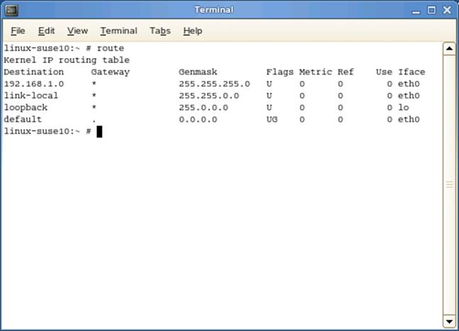
Linux route command
Under Windows, the graphical Routing and Remote Access management tool is also available. Most Linux distributions would include tools to do this as well.

tracert and pathping

The tracert ICMP utility is used from a Windows host to trace the route taken by a packet as it "hops" to the destination host on a remote network. It can be used either with an IP address or host and domain name. It returns the IP address (or name) of each router used by the packet to reach its destination.
If the host cannot be located, the command will eventually timeout but it will return every router that was attempted.
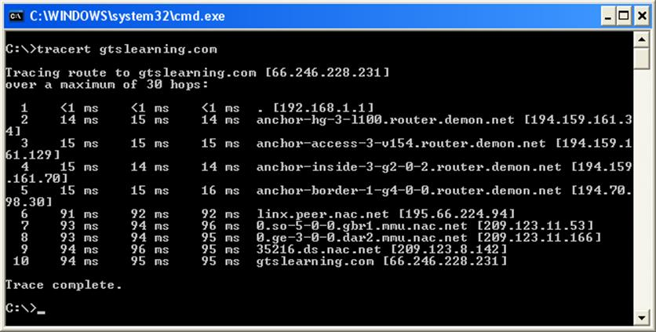
Using tracert in Windows
The output shows the number of hops, the ingress interface of the router or host (that is, the interface from which the router receives the ICMP packet), and the time taken to respond to each probe in milliseconds (ms). If no acknowledgement is received within the timeout period, an asterisk is shown against the probe.
tracert can be used with a number of switches, which must precede the target IP address or host.
tracert -6 www.microsoft.com
You can use the -d switch to suppress name resolution, -h to specify the maximum number of hops (the default is 30), and -w to specify a timeout in ms (the default is 4000). The -j option allows you to specify preferred routers (loose source routing). When used with host names (rather than IP addresses), tracert can be forced to use IPv6 rather than IPv4 by adding the -6 switch.
pathping performs a tracert then pings each hop router a given number of times for a given period to determine latency more accurately.
 ICMP is often blocked by firewalls and routers so the output from tools such as tracert and pathping is not always completely accurate.

traceroute and mtr
traceroute is supported on Linux and router OS (such as IOS) but not on Windows. traceroute performs a similar function to tracert but uses UDP probes rather than ICMP by default. An ICMP probe can be performed using traceroute -I (case-sensitive). The traceroute -6 or traceroute6 commands are used for IPv6 networks.
mtr (short for "My Trace Route") provides similar functionality to pathping for Linux-based operating systems.

Looking Glass Site
A Looking Glass site is one that hosts a server that exposes its routing table to public queries via HTTP. Some looking glass servers can be accessed via Telnet.
An ISP can use these to verify that information about routes to its networks is being properly propagated to the routers of other ISPs. You could also use a looking glass server to troubleshoot problems accessing a particular website. If a site is available from one location but not another, you can use the looking glass server to work out the route(s) from the site to a particular IP address.

Troubleshooting Routing Loops
The tracert / traceroute, pathping, and mtr commands can be used to diagnose many common routing problems. A routing loop, for example, is a condition caused by an incorrectly configured routing table on a router, whereby packets circulate on a network, repeatedly following the same path, until their TTLs reach zero.
Consider a simple network with multiple subnets connected to two routers (A and B) which are also directly connected to one another. Router A also has an interface that is connected to the Internet. Very little configuration is needed in this scenario. All that is required is for router A to have static routes to the subnets that are connected to router B and its default route set to point to the ISP's router, and for router B to have its default route set to point to router A.
However, suppose that through accidental misconfiguration, router A's default route is pointed at router B instead of the ISP. In this case, all internal traffic on the network will be routed correctly. Packets addressed to destinations outside the network will not reach their destination though, as router A will incorrectly route them to router B, which will in turn (correctly) route them back to router A. The packets will bounce back and forwards between the routers, consuming bandwidth, until they are eventually dropped when their TTLs reach zero.
Such a condition can easily be diagnosed from the output of any of the tracert group of commands, as the output will show the packets being arriving at router A, then B, then A, and so on. More complex routing loops can involve multiple routers, but in any case the repeating pattern should be easily identifiable in the output of the tracert command.

