UNIT 2.4 / IPV6 ADDRESSING / STUDY NOTES

IPv6 Address Format
In IPv4, the addressing scheme is based on a 32-bit binary number. 32 bits can express 232 unique addresses (in excess of four billion). However, the way in which addresses have been allocated has been inefficient, leading to wastage of available addresses. Inefficiencies in the addressing scheme and growing demand for addresses in Asia mean that the available IPv4 address supply is close to exhaustion.
Network Address Translation (NAT) and private addressing have provided a "stopgap" solution to the problem. IPv6 provides a long-term solution to the problem of address space exhaustion. Its 128-bit addressing scheme has space for 340 undecillion unique addresses. Even though only a small part of the scheme can currently be allocated to hosts, there is still enough address space within that allocation for every person on the planet to "own" approximately 4000 addresses. As well as coping with the growth in ordinary company networks and internet access subscribers, IPv6 is designed to meet the demands of billions of handheld and personal devices with internet connectivity. Currently, that principally means phones but the designers of IPv6 envisage a world of wireless internet connectivity for a huge range of appliances (the "Internet of Things"). For example, an advertising hoarding could be made "active" so you can link to the product via your phone.
Despite being in development for well over a decade, IPv6 has still not been widely deployed. But as the problems with existing IPv4 solutions multiply, the next couple of years are almost certain to see IPv6 become the mainstream for corporate networks and the web.

IPv6 Packets
An IPv6 packet consists of two or three elements: the main header, one or more optional extension headers, and the payload. The IPv6 packet format is detailed in RFC 2460 but the key features are as follows:
Field | Size | Explanation
Version | 4 bits | Used to indicate which version of IP is being used (0110 for IPv6).
Traffic Class | 8 bits | Describes the packet’s priority.
Flow Label | 20 bits | Used for QoS management, such as for real-time A/V data. This is set to 0 for packets not part of any delivery sequence or structure.
Payload Length | 16 bits | Indicates the length of the packet payload, up to a maximum of 64 KB; if the payload is bigger than that, this field is 0 and a special Jumbo Payload (4 GB) option is established.
Next Header | 8 bits | Used to describe what the next extension header (if any) is, or where the actual payload begins
Hop Limit | 8 bits | Replaces the TTL field in IPv4 but performs the same function.
Source Address | 128 bits | The originating address.
Destination Address | 128 bits | The target address.
Extension headers replace the Options field in IPv4. There are several pre-defined extension headers to cover functions such as fragmentation and reassembly, security (IPsec), source routing, and so on.

Octal and Hexadecimal Numbering Systems

To interpret IPv6 addresses, you must understand hexadecimal notation and the concept of base numbering systems. To start with the familiar; decimal numbering can also be referred to as base 10. Base 10 means that each digit can have one of ten possible values (0…9). A digit positioned to the left of another has ten times the value of the digit to the right. For example, the number 255 can be written out as (2x10x10)+(5x10)+5.
Binary is base 2 so a digit in any given position can only have one of two values (0 or 1) and each place position is the next power of 2. The binary value 11111111 can be converted to the decimal value 255 by the following sum: (1x2x2x2x2x2x2x2)+(1x2x2x2x2x2x2)+(1x2x2x2x2x2)+(1x2x2x2x2)+(1x2x2x2)+(1x2x2)+(1x2)+1.
An octal number is base 8. With octals, the digits 8 and 9 are unused. Any value above 8 is shifted one position to the left. For example, the value 255 in decimal is 377 in octal (3x8x8)+(7x8)+7.
Octals are not widely used in configuration dialogs as there is scope for confusing them with decimal values, though in Linux, file permissions are often written in octal format. Many values in computing are represented in octets (or bytes) however. Hexadecimal notation (or hex) is a convenient way of referring to the long sequences of bytes used in IPv6. Hex is base 16 with the possible values of each digit represented by the numerals 0…9 and the characters A, B, C, D, E, F.
 To avoid confusion with decimal values, octals can be written with a leading 0 (0377 for instance) while hex values can be written with a leading 0x (0xFF for instance).
Every hex digit lines up neatly with four binary digits (a nibble), so conversion is a straightforward matter of dividing the binary digits into groups of four, then converting each group individually. Use the following table to help to convert between decimal, binary, and hexadecimal values.
Decimal | Hexadecimal | Binary | Decimal | Hexadecimal | Binary
0 | 0 | 0000 | 8 | 8 | 1000
1 | 1 | 0001 | 9 | 9 | 1001
2 | 2 | 0010 | 10 | A | 1010
3 | 3 | 0011 | 11 | B | 1011
4 | 4 | 0100 | 12 | C | 1100
5 | 5 | 0101 | 13 | D | 1101
6 | 6 | 0110 | 14 | E | 1110
7 | 7 | 0111 | 15 | F | 1111

IPv6 Address Compression
IPv6 addresses comprise eight 16-bit numbers (double-byte or double-octet) with each double-byte number expressed as 4 hex digits. For example, the binary address:
- 0010 0000 0000 0001 0000 1101 1011 1000 0000 0000 0000 0000 0000 0000 0000 0000 0000 1010 1011 1100 0000 0000 0000 0000 1101 1110 1111 0000 0001 0010 0011 0100
…can be represented in hex notation as:
- 2001:0db8:0000:0000:0abc:0000:def0:1234
Even this is quite cumbersome, so where a double-byte contains leading zeroes, they can be ignored. In addition, onecontiguous series of zeroes can be replaced by a double colon place marker. Thus the address above would become:
- 2001:db8::abc:0:def0:1234
Note that you can only use double colon compression once in a given address. For example:
- 2001:db8::abc::def0:1234
...is not valid as it is ambiguous between:
- 2001:db8:0000:0abc:0000:0000:def0:1234 and 2001:db8:0000:0000:0abc:0000:def0:1234.
Where IPv6 addresses are used as part of a URL (web address), as both formats use colon delimiters to mean different things, the IPv6 address must be contained within square brackets. For example:
- http://[2001:db8::abc:0:def0:1234]/index.htm
 The IPv6 address format and addressing schemes are fully described in RFC 4291.

IPv6 Addressing Schemes
An IPv6 address is divided into two main parts: the first 64 bits are used as a network ID while the second 64 bits designate a specific interface.
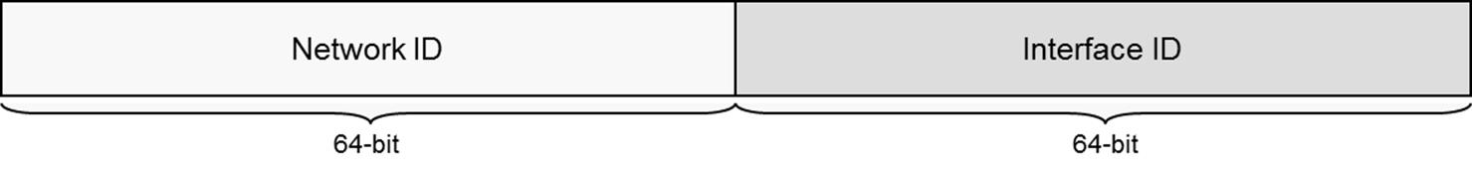
In IPv6, the interface identifier is always the last 64 bits; the first 64 bits are used for network addressing
Network addresses are written using CIDR notation, where /nn is the length of the routing prefix in bits. Within the 64-bit network ID, as with CIDR, the length of any given network prefix is used to determine whether two addresses belong to the same IP network. For example, if the prefix is /48, then if the first 48 bits of an IPv6 address were the same as another address, the two would belong to the same IP network. This means that a given organization's network can be represented by a network prefix 48 bits long and they then have 16 bits left in the network ID to subnet their network. For example, 2001:db8:3c4d::/48 would represent a network address while 2001:db8:3c4d:01::/64 would represent a subnet within that network address.
Like IPv4, IPv6 defines a number of addressing schemes. These are unicast, multicast, and anycast.
There is no concept of broadcast addressing in IPv6. Eliminating the use of broadcasts saves network bandwidth. Functions that would have used broadcasts in IPv4 use special multicast addresses in IPv6.

Unicast Addressing
As with IPv4, a unicast address identifies a single network interface. IPv6 unicast addressing is scoped; a scope is a region of the network. Global scopes provide the equivalent of public addressing schemes in IPv4 while link-local schemes provide private addressing.

Global Addressing
Globally scoped unicast addresses span the Internet and are the equivalent of public IPv4 addresses. The parts of a global address are as follows:
- The first 3 bits (001) indicate that the address is within the global scope. Most of the IPv6 address space is unused. The scope for globally unique unicast addressing occupies just 1/8th of the total address space. In hex, globally scoped unicast addresses will start with a 2 (0010) or 3 (0011).
- The next 45 bits are allocated in a hierarchical manner to regional registries and from them to ISPs and end users.
- The next 16 bits identify site-specific subnet addresses.
- The final 64 bits are the interface ID.
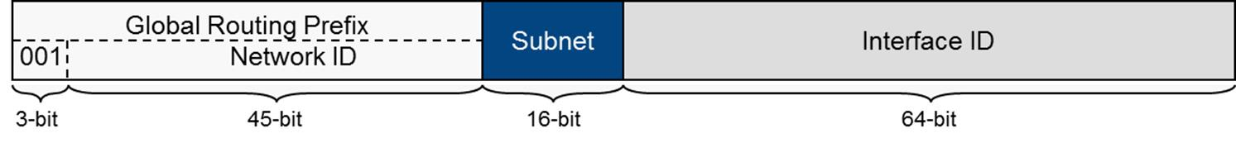
IPv6 global unicast address format

Interface ID / EUI-64
The interface ID can be determined using two techniques. One is by using the interface's MAC address. This is known as a MAC-derived address or interface identifier. As a MAC address is currently 48 bits (6 bytes), a (relatively) simple translation mechanism allows driver software to create a 64-bit interface ID (an EUI-64) from these 48 bits. The conversion mechanism is defined in RFC 4291. Essentially, the digits fffe are added in the middle of the address and the U/L bit is flipped. For example, the MAC address 00608c123abc would become the EUI-64 address 02608cfffe123abc, which when expressed in double-bytes becomes 0260:8cff:fe12:3abc, or more accurately 260:8cff:fe12:3abc (dropping the leading zero). In the second technique (described in RFC 4941), the client device uses a pseudo-random number for the interface ID. This is known as a temporary interface ID or token. There is some concern that using interface identifiers would allow a particular host to be identified and closely monitored when connecting to the Internet and using a token mitigates this to some degree.

Link-local Addressing
Link-local addresses are used by IPv6 for network housekeeping traffic. Link-local addresses span a single subnet (they are not forwarded by routers). Nodes on the same link are referred to as neighbors. Link-local addresses start with a leading fe80 while the next 54 bits are set to zero and the last 64 bits are the interface ID.
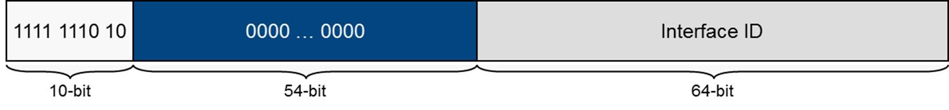
IPv6 link-local unicast address format
The equivalent in IPv4 is Automatic Private IP Addressing (APIPA) and its 169.254.0.0 addresses. However, unlike IPv4, an IPv6 host is always configured with link-local addresses (one for each link), even if it also has a globally unique address.
A link-local address is also appended with a zone index (or scope_id) of the form %1 (Windows) or %eth0 (Linux). This is used to define the source of the address and make it unique to a particular link. For example, a given host may have links to a loopback address, Ethernet, and a VPN. Each of these links may use the same link-local address, so each is assigned a zone ID to make it unique. Zone indices are generated by the host system, so where two hosts communicate, they may be referring to the link using different zone IDs.

Multicast Addressing
A multicast address identifies multiple network interfaces. Unlike IPv4, IPv6 routers must support multicast. The parts of a multicast address are subdivided as follows:
- The first 8 bits indicate that the address is within the multicast scope (1111 1111 or ff).
- The next 4 bits are used to flag types of multicast if necessary (they are set to 0 otherwise).
- The next 4 bits determine the scope; for example, 1 is node-local (to all interfaces on the same node) while 2 is link-local.
- The final 112 bits define multicast groups within that scope.
Broadcast addresses are not implemented in IPv6. Instead, hosts use an appropriate multicast address for a given situation. The well-known multicast addresses are ones reserved for these types of "broadcast" functionality. They allow an interface to "broadcast" to all interfaces or routers on the same node or local link. Some of the well-known multicast addresses are shown below (the complete list is at gtsgo.to/b7ba2).

Address | Target
ff02::1 | All link-local nodes
ff02::2 | All link-local routers
ff02::1:2 | All link-local DHCP agents
In IPv4, IP address resolution to a specific hardware interface is performed using ARP. ARP is "chatty" and requires every node to process its messages, whether they are relevant to the node or not. IPv6 replaces ARP with the Neighbor Discovery (ND) protocol.
Each unicast address for an interface is configured with a corresponding solicited-node multicast address. It comprises the prefix ff02::1:ff plus the last 24 bits of the unicast address. The solicited-node address is used by ND to perform address resolution. It greatly reduces the number of hosts that are likely to receive ND messages (down to one in most cases) and is therefore much more efficient than the old ARP broadcast mechanism.

Anycast Addressing
An anycast address also identifies multiple addresses. Anycast is used where a message must be sent to any member of a group but not necessarily to all of them. The packet is sent to the member of the group physically closest to the transmitting host. Anycast is principally used for routing protocol traffic.

Reserved Addresses
The 0000::/8 block (that is, IPv6 addresses where the first bits are 0000 0000) is reserved for special functions. Within this block, there are two special addresses defined:
- Unspecified address (0:0:0:0:0:0:0:0) - a host that has not obtained a valid address. This is often expressed as ::
- Loopback address (0:0:0:0:0:0:0:1) - used for testing (for the host to send a packet to itself). This is often expressed as ::1.

IPv6 Address Prefixes
Use the following table to help to recognize some of the commonly used classes of IPv6 address by prefix notation or leading hex digits:
Type | Prefix | Leading Hex Characters
Global unicast | 2000::/3 | 2, 3
Link-local unicast | fe80::/64 | fe80
Multicast | ff00::/8 | ff
Multicast (local-link) | ff02::/16 | ff02::1 (all nodes), ff02::2 (all routers), ff:02::1:2 (DHCP relay)
Solicited-node Address | ff02::1:ff00:0/104 | ff02::1:ff
Unspecified | ::/128 | ::, 0::0
Loopback | ::1/128 | ::1
Teredo | 2001::/32 | 2001
6to4 | 2002::/16 | 2002
Documentation / Examples | 2001:db8::/32 | 2001:db8
Globally unique unicast addresses are also widely referred to as "/48s".

IPv6 Address Autoconfiguration
As with IPv4, you can either assign a static IPv6 address or use an automatic addressing scheme. Static address configuration would generally be reserved to routers and possibly servers.

Stateless Address Autoconfiguration
Unlike IPv4, IPv6 addresses do not need to be assigned from a server, such as a DHCP server, and instead rely on a mechanism known as Stateless Address Autoconfiguration (SLAAC). This process is fully described in RFC 4862 but is generally as follows:
- The host generates a link-local address and tests that it is unique using the Neighbor Discovery (ND) protocol.
- The host listens for a Router Advertisement (RA) or solicits a router using ND. Routers send out advertisements periodically to enable clients to determine in which network they reside. The router can either provide a global network address, direct the host to a DHCPv6 server to perform stateful autoconfiguration, or perform some combination of stateless and stateful configuration.

Neighbor Discovery Protocol
The Neighbor Discovery (ND) protocol performs some of the functions on an IPv6 network that ARP and ICMP perform under IPv4. ND is defined in RFC 4861. The main functions of ND are:
- Address autoconfiguration - enables a host to configure IPv6 addresses for its interfaces automatically and detect whether an address is already in use on the local network.
- Prefix discovery - enables a host to discover the known network prefixes that have been allocated to the local segment. This also allows next-hop determination (whether a packet should be addressed to a local host or router).
- Local address resolution - allows a host to discover other nodes and routers on the local network (neighbors).
- Redirection - enables a router to inform a host of a better route to a particular destination.

Multicast Listener Discovery Protocol
The Multicast Listener Discovery (MLD) protocol performs some of the same functions for IPv6 as IGMP does for IPv4. MLD is defined in RFC 3810.

ICMPv6
IPv6 uses an updated version of ICMP, defined in RFC 4443. The key new features are:
- Error messaging - ICMPv6 supports the same sort of destination unreachable and time exceeded messaging as ICMPv4. One change is to introduce a Packet Too Big class of error. Under IPv6, routers are no longer responsible for packet fragmentation and reassembly so the host must ensure that they fit in the MTUs of the various links used.
- Informational messaging - again, ICMPv6 supports ICMPv4 functions such as echo and redirect plus a whole new class of messages designed to support ND and MLD, such as router and neighbor advertisements and solicitations.

DHCPv6
DHCPv6 can serve the same sort of purpose as for DHCP under IPv4. DHCPv6 is defined in RFC 3315. The format of messages is different but the process of DHCP server discovery and address leasing is fundamentally the same. As IPv6 does not support broadcast, clients use the multicast address ff:02::1:2 to discover a DHCP server. DHCPv6 uses ports 546 (clients) and 547 (servers) rather than 67 and 68 as with DHCPv4.
In theory, DHCP servers no longer need to play a role in the basic address assignment process for IPv6 clients. However, DHCPv6 servers can be used to assign supplemental information such as DNS configuration and default gateway to clients and some networks may prefer to deploy stateful configuration rather than using SLAAC.

Migrating to IPv6
Given the number of devices currently running IPv4, switching to IPv6 is not going to be simple. However, there are two strategies to help make the transition easier.

Private Network Migration Strategies
Dual-stack hosts can run both IPv4 and IPv6 simultaneously and communicate with devices configured with either type of address. Windows XP / Vista / 7 and Windows Server plus current versions of UNIX/Linux implement dual-stack IP.
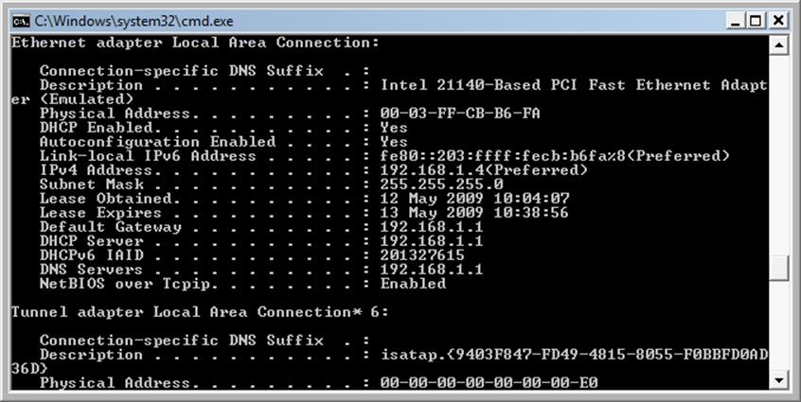
Dual-stack IP under Windows - note the use of the MAC address in forming the IPv6 interface
A dual-stack router can translate between IPv6 and IPv4. One technology is ISATAP. Under ISATAP (Intra-Site Automatic Tunnel Addressing Protocol) a dual-stack router takes an IPv6 packet and rewrites it as an IPv4 packet. The ISATAP router allows for a network with mixed IPv4 and IPv6 hosts but cannot be used for routing between networks. ISATAP hosts use the link-local range fe80::5efe:w.x.y.z, where w.x.y.z is a dotted decimal IPv4 address.
Dual-stack hosts may also make use of IPv4 mapped addresses. An IPv4 mapped address is expressed ::ffff:192.168.0.1 (that is, 80 zeroes followed by 16 ones and then the 32-bit IPv4 address, expressed by convention in dotted decimal). This sort of address is never assigned to hosts but used by IPv4/IPv6 routers to forward traffic between IPv4 and IPv6 networks.

Internet Tunnelling Migration Strategies
Secondly, tunnelling can be used to deliver IPv6 packets across the IPv4 internet. In 6to4 automatic tunnelling (RFC 3056), no host configuration is necessary to enable the tunnel. 6to4 addresses start with a leading 2002. Essentially, when 6to4 is implemented, the IPv6 packets are inserted into IPv4 packets and routed over the IPv4 network to their destination. Routing decisions are based on the IPv4 address until the packets approach their destinations, at which point the IPv6 packets are stripped from their IPv4 carrier packets, and forwarded according to IPv6 routing rules.
6to4 supports only public IPv4 addresses (that is, those NOT behind a NAT device). Microsoft also provides support for Teredo tunnelling by Windows hosts. Teredo tunnels IPv6 packets as IPv4-based UDP messages over port 3544. Using UDP rather than TCP allows tunnelling through NAT devices. A compatible open source implementation of Teredo, known as Miredo, is available for UNIX / Linux operating systems.
It is also possible to tunnel IPv4 through an IPv6 network, in which case the process is known as 4to6 or 4in6 tunnelling, as defined in RFC 2473. However, given that the most likely transit network for tunnelling between sites is the Internet, which is based on IPv4, this type of tunnel is currently of limited use.

