UNIT 2.3 / DHCP AND APIPA / STUDY NOTES

IPv4 Address Autoconfiguration
Originally, all the parameters required by TCP/IP were configured manually. This can be referred to as static IP addressing. Every machine is allocated an appropriate IP address, a subnet mask, and a default gateway (router) for its network. Static IP addressing is relatively complex and if any of the values are entered incorrectly, communications are affected and the cause of the problem has to be isolated, which can be difficult.
For example, a very common problem is accidental configuration of duplicate IP addresses. When TCP/IP loads on a Windows host, it checks that there is no other machine with the same IP address on the local network. If it encounters a duplicate, it disables the protocol and the machine will be unable to communicate. Ensuring each machine is configured with a unique IP address can become a tedious responsibility for the administrator of a large network. Errors are disastrous for the network users as only the first machine holding the duplicate IP address can connect to the network.
Over the years, several mechanisms have been employed to provide a client autoconfiguration service for IP.

BOOTP
One of the first autoconfiguration mechanisms was Reverse ARP (RARP). This allows a host to obtain an IP address from a server configured with a list of MAC:IP address mappings. RARP can only be used to obtain an IP address, which is inadequate for most implementations of IP. Consequently, the Bootstrap Protocol (BOOTP) was developed as a means of supplying a full set of configuration parameters (IP address, subnet mask, default gateway, DNS addresses, and so on) to a host. The additional parameters are provided in an executable boot file downloaded to the host using Trivial File Transfer Protocol (TFTP).
BOOTP is still used in some circumstances to provide addressing information to diskless workstations and print devices.
The main drawback of BOOTP is that it depends on a static configuration file mapping IP addresses to MAC addresses. This drawback was addressed by the development of BOOTP into the Dynamic Host Configuration Protocol (DHCP).

Dynamic Host Configuration Protocol
The Dynamic Host Configuration Protocol (DHCP) provides an automatic method for allocating an IP address, subnet mask, and optional parameters, such as the default gateway and Domain Name Server (DNS) address. DHCP is defined in RFC 2131. All the major operating systems provide support for DHCP clients and servers. DHCP servers are also embedded in many SOHO router / modems.
A host is configured to use DHCP by specifying in the TCP/IP configuration that it should automatically obtain an IP address.

DHCP Client Initialization
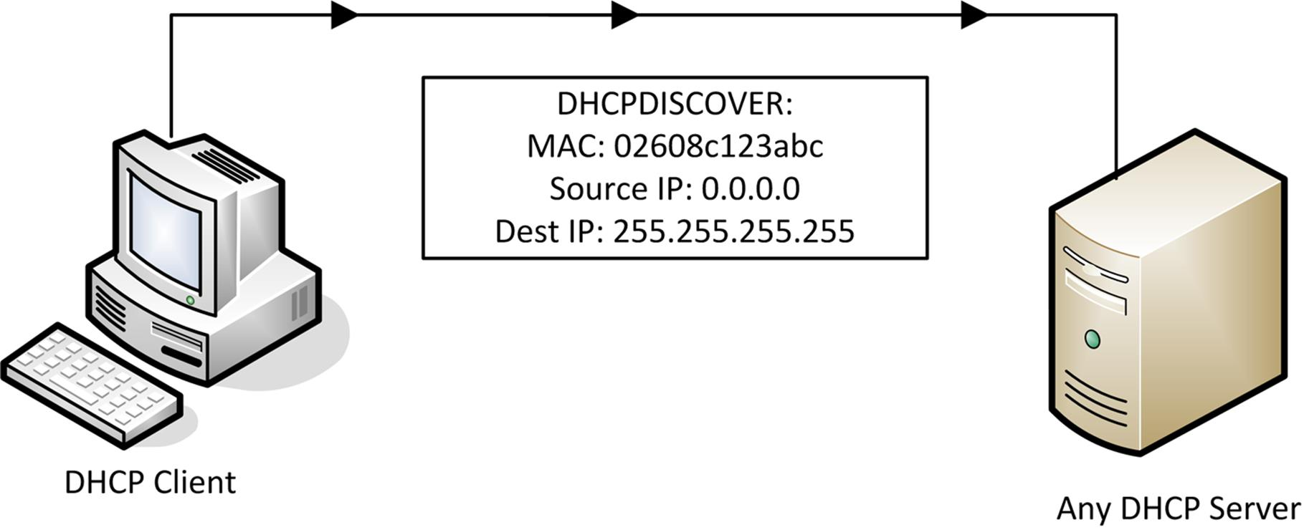
- When a DHCP client initializes, it broadcasts to find a DHCP server. This is called a DHCPDISCOVER packet. All communications are sent using UDP, with the server listening on port 67 and the client on port 68.
- The DHCP server responds to the client with an IP address and other configuration information, as long as it has an appropriate IP address available. The IP addressing information is offered for a period of time. This packet is also broadcast and is called a DHCPOFFER.
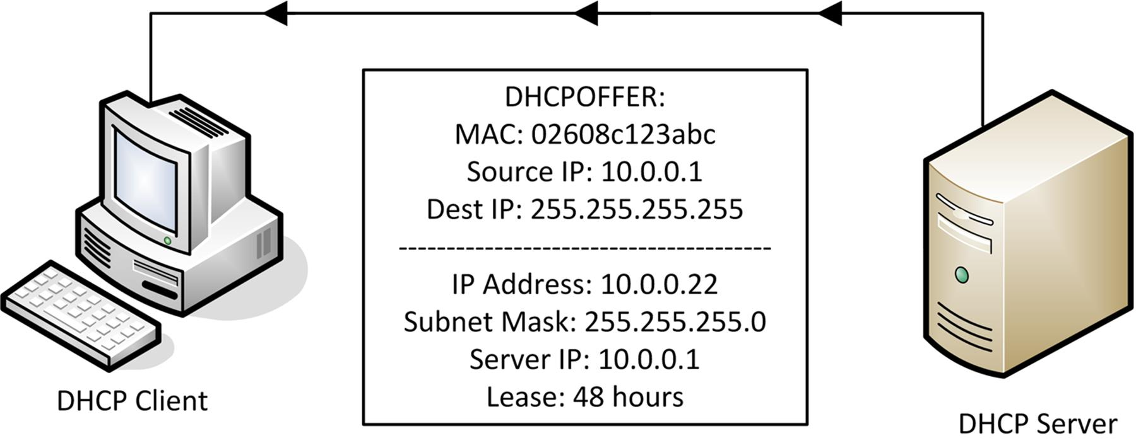
 The DHCPOFFER is broadcast at layer 3 because the client doesn't have an IP address yet. It may be delivered as unicast at layer 2 however (using the client's MAC address).
- The client may choose to accept the offer using a DHCPREQUEST packet - also broadcast onto the network.
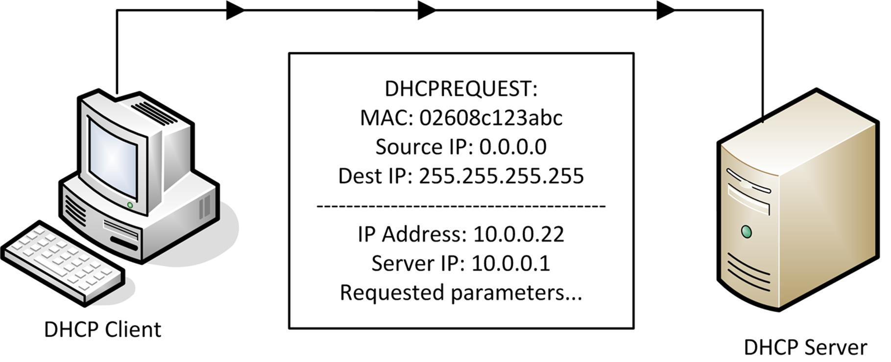
- Assuming the offer is still available, the server will respond with a DHCPACK packet. The client broadcasts an ARP message to check that the address is unused. If so it will start to use the address and options; if not, it declines the address and requests a new one.
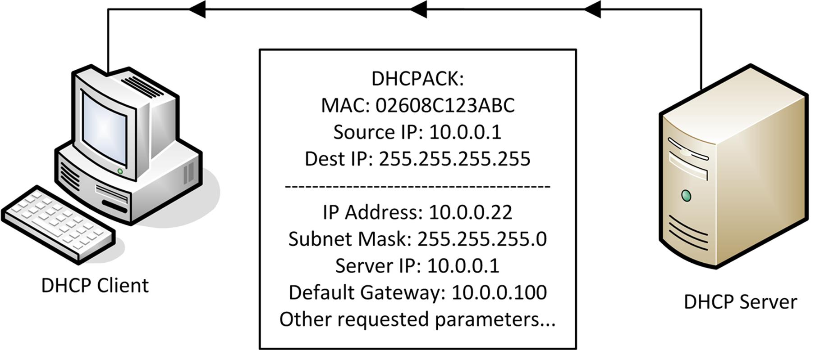
The address is leased and, after a designated period, the client must theoretically release the IP addressing information. This process does not normally take place since the client can renew or rebind the lease.

APIPA
Automatic Private IP Addressing (APIPA) was developed by Microsoft as a means for clients configured to obtain an address automatically that could not contact a DHCP server to communicate on the local IP network. If a host does not receive a response to a DHCPDISCOVER broadcast within a given timeframe, it randomly selects an address from the range 169.254.1.0 - 169.254.254.255. It then performs an ARP broadcast to check that the address is currently unused; if it is in use, the host selects another address, and repeats the broadcast, and so on.
 These addresses are from one of the address ranges reserved for private addressing (169.254.0.0/16). The first and last subnets are supposed to be unused.
This type of addressing is referred to as link-local in standards documentation (RFC 3927). Link-local addressing mechanisms can also be implemented on other client OS's, such as Bonjour for the Mac OS X platform or Avahi for Linux.

Configuring DHCP
DHCP is normally provided as part of the network operating system or through an appliance such as a switch or router. A DHCP server must be allocated a static IP address and configured with the following information:
- A range of IP addresses and subnet mask to allocate (its scope).
- A lease period plus renewal (T1) and rebinding (T2) timers.
- Other optional information to allocate, such as default gateway and DNS server address(es).
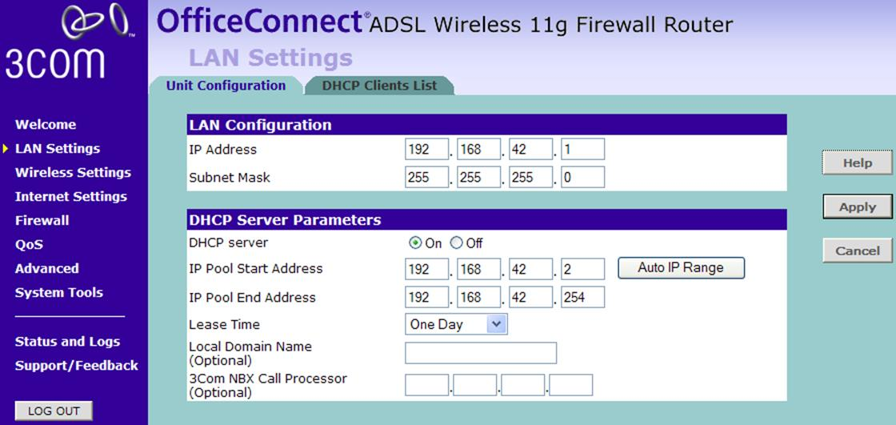
Configuring DHCP on a multifunction Wi-Fi DSL router
Note that not all DHCP servers support the same capabilities. The multifunction device shown above only supports a single IP address range while the Windows DHCP service supports far more options, including creating static and dynamic address reservations.

DHCP Scopes
A scope is a range of IP addresses that a DHCP server can allocate to clients. To define a scope, you must provide a start and end IP address, along with a subnet mask. The subnet mask given must be such that the entire range of addresses is contained within a single subnet. The DHCP server will then allocate the scope to this subnet.
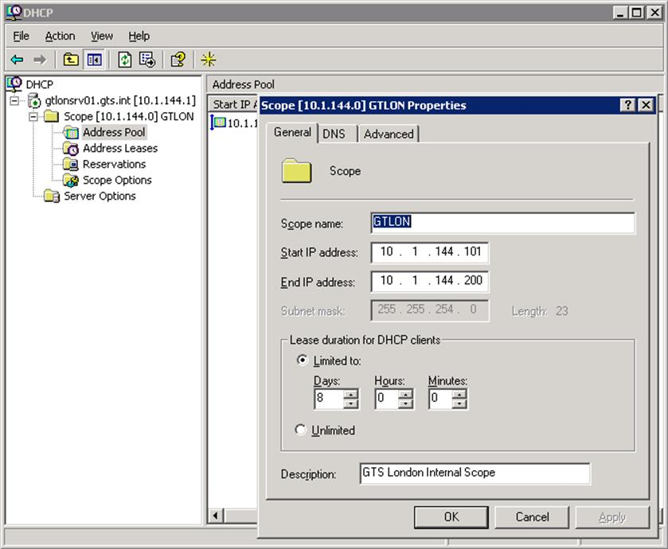
Configuring DHCP on Windows Server 2003
The server maintains a 1-to-1 mapping of scopes to subnets. That is, no scope can cover more than one subnet and no subnet can contain more than one scope. This is because in situations where a server provides IP configuration for multiple subnets, it must choose the scope to service each request based on the subnet from which the request originated.
There is no mechanism for a client to choose between multiple servers. Therefore, if multiple DHCP servers are deployed (for fault tolerance for instance) they must be configured with non-overlapping scopes. DHCP for multiple subnets is usually handled by configuring relay agents to forward requests to a central DHCP server.

DHCP Leases
Along with the scope, you also need to define a lease period. A long lease period means the client does not have to renew the lease as frequently but the DHCP server's pool of IP addresses is not replenished. Where IP addresses are in short supply, a short lease period provides a means of utilizing addresses from computers that are not in use.
The client can renew the lease when at least half the lease period has elapsed (T1 timer) so that it keeps the same IP addressing information.
If the original DHCP server does not respond to the request to renew the lease, the client attempts to rebind the same lease configuration with any available DHCP server. By default, this happens after 87.5% of the lease duration is up (T2 timer). If this fails, the client reinitializes and continues to broadcast to discover a server.
A Windows client can be forced to release a lease using a command such as ipconfig.

DHCP Options
When the DHCP server provides IP settings to a client, it must supply at a minimum an IP address and subnet mask. Depending on the configuration of the network, it may also provide other IP-related settings, known as DHCP options. Each option is identified by a tag byte or decimal value between 0 and 255 (though neither 0 nor 255 cannot be used as option values).
Some widely used options include:
- The default gateway (IP address of the router).
- The IP address(es) of DNS servers.
- The DNS suffix (domain name) to be used by the client.
- Other useful server options, such as time synchronization (NTP), file transfer (TFTP), or VoIP proxy.
A set of default (global) options can be configured on a server-wide basis. Default options can be overridden by setting scope-specific options. It is also possible to set user-specific options based on a class ID. Different options can also be set for reserved IP addresses.

DHCP Reservations
While DHCP provides central management of IP configuration, a disadvantage is that the standard dynamic allocation method does not guarantee that any given client will retain the same IP address over time. In most cases this is not a problem; for example, as long as a desktop PC has a valid IP address for its subnet, it does not generally matter what that IP address actually is. However, there are some cases where it would be advantageous for certain hosts, such as network printers or wireless access points, to retain their IP addresses.
One solution is to configure these devices statically, using IP addresses outside the DHCP scope. While this solution works, it loses the advantages of central configuration. An alternative approach is to create a DHCP reservation. This is a mapping of a MAC address to a specific IP address. When the DHCP server receives a request from the given MAC address, it always provides the same IP address. This is also referred to as static or fixed address assignment.
Automatic allocation refers to an address that is leased permanently to a client. This is distinct from static allocation as the administrator does not pre-determine which particular IP address will be leased.

DHCP Relay and IP Helper
Normally routers do not forward broadcast traffic. This would mean that to contact a DHCP server, each broadcast domain (such as a switch or VLAN) must be served by its own DHCP server. On a large network, this would mean provisioning and configuring a large number of DHCP servers. To avoid this scenario, a DHCP relay agent can be configured to provide forwarding of DHCP traffic between subnets. Routers that can provide this type of forwarding are described as RFC 1542compliant.
The DHCP relay intercepts any broadcast BOOTP / DHCP frames, applies a unicast address for the appropriate DHCP server, and forwards them on the interface for the subnet containing the server. It also performs the reverse process of directing responses from the server to the appropriate client subnet.
The ip-helper command can be configured on Cisco routers to allow set types of broadcast traffic (including DHCP) to be forwarded to a particular interface. This supports the function of the DHCP relay agent.

