UNIT 2.2 / IPV4 ADDRESSING / STUDY NOTES

IPv4 Addressing Schemes
As described earlier, the combination of an IP address and subnet mask can be used to describe a network ID and a host ID. These parameters allow an internetwork to be divided into logically separate IP networks and each network to be divided into subnetworks (or subnets). "Addressing schemes" describes different ways of configuring IP addressing to suit different types and sizes of networks.

Broadcast, Multicast, and Unicast
IPv4 uses a number of mechanisms with which to communicate with other hosts. When an IPv4 host wants to send a packet to another single host, it uses a unicast packet, addressed to the destination host. If, however, the local host needs to communicate with multiple hosts, it can do so either by using a broadcast, in which the destination address is all hosts on the local network, or else by using a multicast address, which represents a group of computers, programmed to respond to a particular address.
The broadcast address of an IP network is one where the host bits are all set to 1. Multicast must take place using specially configured addresses and protocols.

Broadcast Domains versus Collision Domains
A broadcast domain is one where all the hosts receive the same broadcast packets. Broadcast domain boundaries are established at the network layer (layer 3) by routers. Routers do not forward broadcast packets. At layer 2, broadcasts are delivered using the "group" MAC address (ff:ff:ff:ff:ff:ff).
Recall that at layer 2 there is also the concept of a collision domain. In early Ethernet (using hubs to connect nodes), unicast and broadcast traffic was received by every node attached to a hub. The nodes are all in the same collision domain. With switches, each port is in its own collision domain. This makes the concept of a collision domain somewhat redundant for wired Ethernet using switches. Collision domains are no longer a performance barrier, but broadcast domains can be. If every port on a switch is in the same broadcast domain, this can lead to a large amount of broadcast traffic, making the network inefficient.
This sort of problem can be addressed by configuring VLANs on the switch (or switches). If VLANs are implemented, the broadcast domain will normally be restricted to interfaces connected to the same VLAN. This does mean that users attached to different switches (but the same VLAN) can be in the same broadcast domain.
If a VLAN contains multiple subnets, nodes will receive broadcast traffic for all the subnets. This would be a very complex configuration however. Normally the network would be designed with a 1:1 mapping between VLANs and subnets.

Classful Addressing
The classful addressing scheme was employed in the 1980s, before the use of subnet masks to identify the network ID portion of an address was developed. Classful addressing allocates a network ID based on the first octet of the IP address. The network IDs are divided into three classes, defining different sizes of IP network.
Class A network addresses support large numbers of hosts - over 16 million. However, there are only 126 of them. There are 16 thousand Class B networks, each containing up to about 65,000 hosts. Finally class C networks support only 254 hosts each, but there are over 2 million of them.
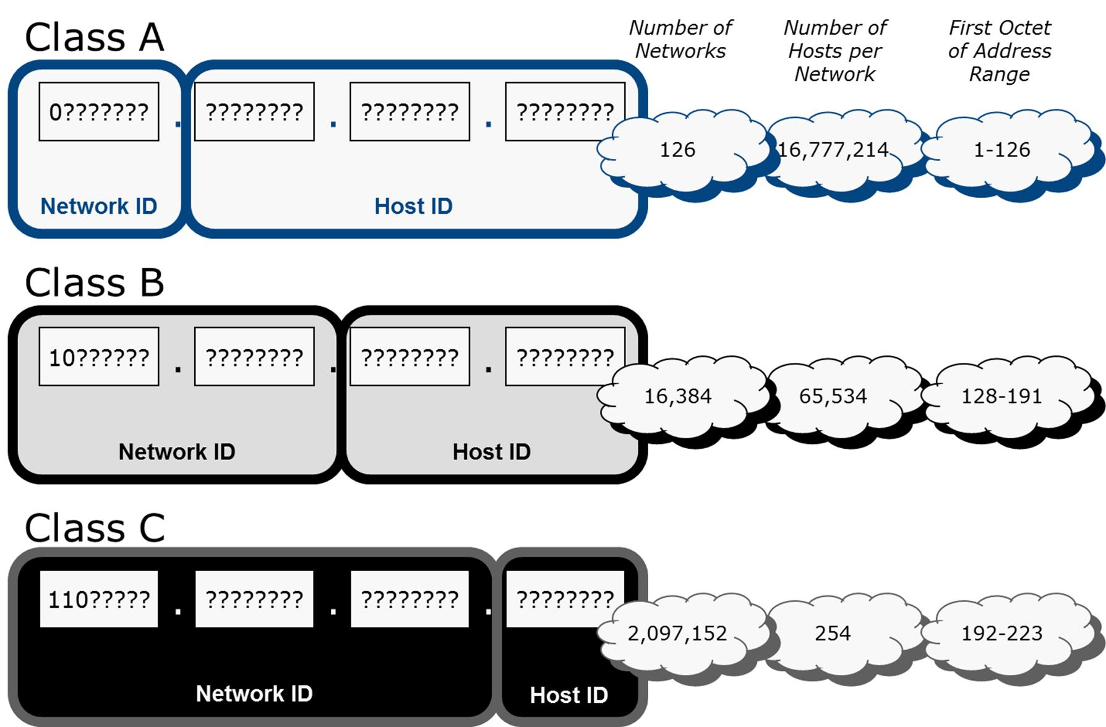
Choosing an address class
When considering classful addressing, it is important to be able to identify the address class from the first octet of the IP address. The table below shows how to identify an address class from the first octet of the IP address in decimal:
First Octet | Class
1-126 | Class A
128-191 | Class B
192-223 | Class C
 Alternatively, rather than worry about different address class ranges (i.e. A is 1 to 126), just remember the rule that all class A networks start with a binary 0, all class B start with a binary 10, and class C start with a binary 110.
While nominally part of Class A, 127.0.0.0 is reserved and cannot be assigned to ordinary hosts. It is used for the loopback address; a special address used to check that TCP/IP is correctly installed.

Class D and E Addresses
There are two additional classes of IP address (D and E) that utilize the remaining numbers. Class D addresses (224.0.0.0 through 239.255.255.255) are used for multicasting; Class E addresses (240.0.0.0 through 255.255.255.255) are reserved for experimental use and testing.

Private Addressing
A private network will typically use a private addressing scheme to allocate IP addresses to hosts. These addresses can be drawn from one of the pool of addresses defined in RFC 1918 as non-routable over the Internet:
- 10.0.0.0 to 10.255.255.255 (Class A private address range).
- 172.16.0.0 to 172.31.255.255 (Class B private address range).
- 192.168.0.0 to 192.168.255.255 (Class C private address range).
- 169.254.0.0 to 169.254.255.255 (APIPA / link-local autoconfiguration). This range is used by hosts for autoconfiguration (selecting a link-local address). The first 256 addresses and last 256 addresses should not be used by hosts though.
Any organization can use these addresses on private LANs without applying to a registrar and multiple organizations can use these ranges simultaneously. Internet access can be facilitated for hosts using the private addressing scheme in two ways:
- Through a router configured with a single or block of valid public IP addresses; the router translates between the private and public addresses using a process called Network Address Translation (NAT).
- A proxy server that fulfills requests for internet resources on behalf of clients.

Subnetting and Classless Addressing
An IP network address can represent an organization on the Internet, but most companies need to subdivide their networks into different logical groups. These groups are referred to as subnetworks or subnets. Organizations need to do this for a number of reasons:
- It is inefficient to have very large numbers of computers on the same IP network. A single IP network in this sense is a single broadcast domain; excessive broadcast traffic is created when there are many hosts on the same network. Large networks use VLANs to isolate broadcast domains and create subnets to map to each VLAN.
- Physically distinct networks, such as Token Ring and Ethernet, should be logically separated as different subnets.
- Many organizations have more than one site and WAN links between them. The WAN link normally forms a separate subnet.
- It is useful to divide a network into logically distinct zones for security and administrative control.
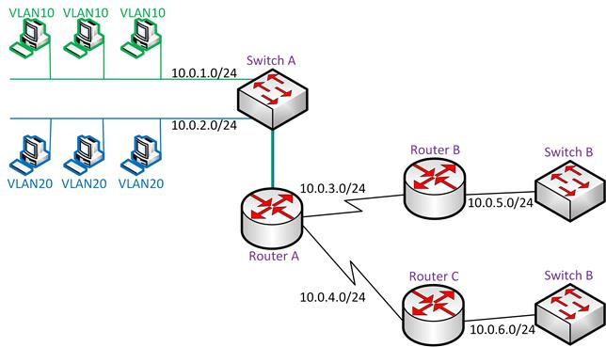
Subnet design
For example, in the diagram above, the subnet design allocates separate subnets (10.0.1.0 and 10.0.2.0) for the two VLANs configured on Switch A and for the serial WAN links configured between Router A and Routers B and C (10.0.3.0 and 10.0.4.0). Routers B and C also have a subnet each for their local networks (10.0.5.0 and 10.0.6.0).

Subnetting
The introduction of subnetting (in 1985) replaced the idea of a classful IP address with one associated with a subnet mask. The default subnet masks correspond to the three classes of unicast IP address (A, B, and C):
Class | Mask
Class A | 255.0.0.0
Class B | 255.255.0.0
Class C | 255.255.255.0
The default masks comprise whole octets. These default masks can be modified to allow a single network to be divided into a number of subnets. To do this, additional bits of the IP address have to be allocated to the network address rather than the host ID.

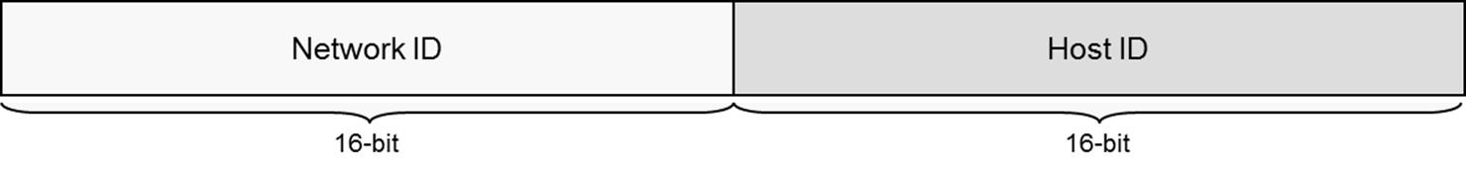
Internetwork addressing (Class B address)
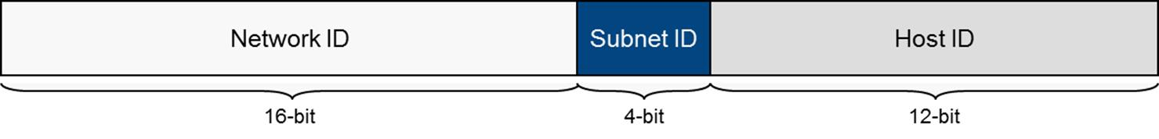
Subnet addressing
The whole network is still referred to by the network ID (by routers external to the network) and the default mask: 172.1.0.0 / 255.255.0.0 for example. However, routers within the network add bits to the mask to differentiate the subnets.
For example, if the network designer added 4 bits to the mask, it would mean a subnet mask of 20 bits (the 16 bits of the default class B mask plus the 4 bits you added). In dotted decimal, the mask would be 255.255.240.0.
Remember that the "1"s in a mask are always contiguous. This means that each octet in decimal will always be one of the following:
Number of Mask Bits | Decimal Equivalent
1 (10000000) | 128
2 (11000000) | 192
3 (11100000) | 224
4 (11110000) | 240
5 (11111000) | 248
6 (11111100) | 252
7 (11111110) | 254
8 (11111111) | 255

Classless Addressing
In a classless scheme, the network ID does not depend on the class of the IP address number but on the number of bits set to 1 in an associated network prefix. The idea that the netmask should align along a particular octet boundary has been discarded completely.
For example, when expressed in binary, the subnet mask 255.255.240.0 contains 20 ones followed by 12 zeroes. Therefore, the network prefix, expressed in slash notation, is 172.1.0.0/20.
Wherever a 1 appears in the binary mask, the corresponding digit in the IP address is part of the network or subnet address. When you are planning what your mask will be, remember this rule. Allocate more bits in the mask if you need more subnets. Allocate fewer bits in the mask if you need more hosts per subnet.
Most configuration dialogs require you to input a subnet mask in dotted decimal format. Some may require you to enter the network address and prefix in slash notation however.
While routers have performed classless routing for years, the class terminology is still very widely used. Even under classless addressing, the old classes are often used as names for the default subnet masks; a Class A network is /8, a Class B network is /16, and a Class C network is /24.

Planning an IPv4 Addressing Scheme
A network designer will need to plan the IP network addressing scheme carefully. Before choosing a scheme, consider the following factors:
- Whether you need a public or private addressing scheme.
- How many IP networks and subnetworks you need.
- How many hosts per subnet.
There are some additional constraints to consider when planning an addressing scheme:
- Network ID cannot be 127 - this address is reserved for loopback testing.
- Network and / or host IDs cannot be all 1s in binary - this is reserved for broadcasts.
- Network and / or host ID cannot be all zeroes in binary - 0 means "This Network".
- Host ID must be unique on the IP network or subnet.
- Network ID must be unique on the Internet (if using a public addressing scheme) or on your internal system of networks (if using a private addressing scheme).
When performing subnet calculations, it helps to remember that each power of two is double the previous one:
22 | 23 | 24 | 25 | 26 | 27 | 28
4 | 8 | 16 | 32 | 64 | 128 | 256
The process of designing the scheme is as follows:
- Work out how many subnets are required (remembering to allow for future growth) then round this number up to the nearest power of 2. For example, if you need 12 subnets, the next nearest power of 2 is 16. The exponent is the number of bits you will need to add to your default mask. For example, 16 is 24 (two to the power of four), so you will need to add 4 bits to the default network prefix.
- Next work out how many hosts each subnet must support and whether there is enough space left in the scheme to accommodate them. For example, if your network address (172.1.0.0 for instance) is in the /16 range and you use 4 bits for subnetting, you have 32 - 20 = 12 bits for hosts in each subnet. The number of hosts per subnet can be expressed using the formula 2n-2, where n is the number of bits you have allocated for the host ID. 12 bits is enough for 4094 hosts in each subnet.
 Remember that we subtract 2 because each subnet's network address and broadcast address cannot be assigned to hosts.
Just for comparison, if you have a /24 (or Class C) network address and try to allocate 16 subnets, there will only be enough space left for 14 hosts per subnet (24-2). You can make more efficient use of the space by deploying Variable Length Subnet Masks (VLSM). In this case, you assign network prefixes of different lengths to different subnets. For example, you could create some /26 subnets with up to 50 hosts and some /30 subnets with just two hosts (for WAN links perhaps).
- Now work out the subnets. The easiest way to find the first subnet ID is to deduct the least significant octet in the mask (240 in the example) from 256. This gives the first subnet ID, which, in full, is 172.1.16.0/20.
- The subsequent subnet IDs are all the lowest subnet ID higher than the one before - 32, 48, 64 and so on.
- Work out the host ranges for each subnet. Take the subnet address and add a binary 1 to it for the first host. Take the next subnet ID and deduct two binary digits from it. In our case, this is 172.1.16.1 and 172.1.31.254 respectively. Repeat for all subnets.

Public Internet Addressing
When an organization wants to connect to the Internet, it must apply for a range of public IP addresses via its Internet Service Provider (ISP).

Classful Addressing
In the classful addressing system, an organization was allocated a network address from a suitable class (A, B, or C). With the introduction of subnetting, depending on the class of IP address, some of the octets were fixed but the remaining portion could use any valid addressing scheme. For example, an organization might be allocated the network address 128.248.0.0 where it can allocate the third and fourth octets as it desires.
Under this classful system, almost all Class B addresses became allocated. This shortage of network addresses prompted the development of IP version 6, which uses a much larger address space. However, the deployment of IPv6 has been enormously protracted, so a series of stopgap measures have been introduced over the years. The earliest were the use of subnetting and private address ranges to hide the complexity of private local networks from the wider internet. Another significant measure was the introduction of supernetting or Classless Interdomain Routing (CIDR) in 1993.

Supernetting
Supernetting was designed to solve two major problems of the classful addressing scheme as more and more networks joined the Internet through the early 1990s. The first was that network addresses (specifically, Class B addresses) were becoming very scarce and the second was near exponential growth in internet routing tables.
Supernetting is described in RFC 4632. Essentially, it uses bits normally assigned to the network ID to mask them as host or subnet bits.
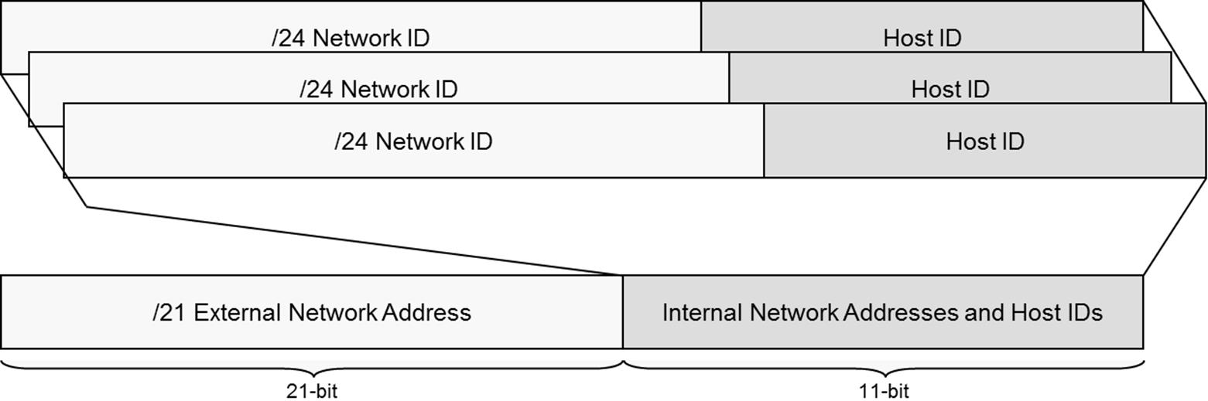
Supernetting
For example, rather than allocate a class B (or /16) network address to a company, several contiguous class C (or /24) addresses could be assigned. Eight /24 network addresses gives 2032 hosts. However, this would mean complicated routing with many entries in the route tables, because there are now eight IP networks. Classless Inter-Domain Routing(CIDR) is used to collapse these routing entries into single entry.
If the network addresses assigned to a company were 192.32.168.0 through to 192.32.175.0 and we wished to view this as one network, we would only consider the first 21 bits of the address.
Net ID | Binary
192.32.168.0 | 11000000.00100000.10101 000.00000000
192.32.169.0 | 11000000.00100000.10101 001.00000000
192.32.170.0 | 11000000.00100000.10101 010.00000000
192.32.171.0 | 11000000.00100000.10101 011.00000000
192.32.172.0 | 11000000.00100000.10101 100.00000000
192.32.173.0 | 11000000.00100000.10101 101.00000000
192.32.174.0 | 11000000.00100000.10101 110.00000000
192.32.175.0 | 11000000.00100000.10101 111.00000000
The network address could also be expressed in classless notation as 192.32.168.0/21, meaning that the network prefix contains 21 bits (count the 1s in the example below).
As with subnetting, an ANDing process is used to determine whether to route or not. If the ANDed result reveals the same network ID as the destination address, then it is the same network. In the table below, the first two IP addresses belong to the same network (the second is the broadcast address for the network) but the third is in a different one:
Address | Binary
Mask: 255.255.248.0 | 11111111.11111111.11111000.00000001
IP: 192.32.168.1 | 11000000.00100000.10101000.00000001
IP: 192.32.175.255 | 11000000.00100000.10101111.11111111
IP: 192.32.176.1 | 11000000.00100000.10110000.00000001
Routers external to the network just use the /21 prefix, so the complexity of the LAN subnets is hidden and doesn't need to clog up their routing tables. The LAN's internal routers use the /24 prefix, or could even multiple prefixes to create subnets of different sizes (Variable Length Subnet Masking).
Supernetting allows for a more flexible, hierarchical system of network addressing, with efficient routing between networks on the Internet.

Multicast and IGMP
The Internet Group Management Protocol (IGMP) is an internet protocol, operating at the network layer that provides a way for an IP host to report its multicast group membership to adjacent routers. Multicasting allows one computer on the Internet (or private IP network) to send content to other computers that have identified themselves as interested in receiving the originating computer's content (that have joined a multicast group). Software distribution and video conferencing applications may use multicasting and IGMP.
Network devices between the client group and multicast server must all be IGMP-compatible (including routers, switches, and network cards). The original version of IGMP (RFC 1112) defines two messages: a query message sent by routers (queriers) and a report message sent by hosts. A host issues a report message to join a group and subsequently in response to queries; the router periodically issues queries to confirm that there are active members of each group. If it receives no replies within a given period, it stops forwarding traffic for that group.
IGMPv2 (RFC 2236) adds the option for a host to explicitly leave a multicast group; the router then queries whether there are any members left in the group. IGMPv3 (RFC 3376) adds the option to select from different sources when determining group membership.
To join a group, each host is configured with a multicast IP address in addition to its standard address. The full IPv4 multicast address space (224.0.0.0/4) is divided into three main allocations:
- 224.0.0.0 - 224.0.0.255 - reserved for "well known" multicast groups for network control and routing protocol traffic.
- 224.0.1.0 - 238.255.255.255 - a global scope for multicasting on the Internet.
- 239.0.0.0 / 239.255.255.255 - a range for "administratively-scoped" multicasting within a private network or autonomous system.
Multicasting on the Internet requires a service provider with a multicast-enabled router network. The Multicast Backbone (MBONE) network once maintained by some of the universities is now defunct.
IGMP is only used to configure group membership and propagate that information between multicast routers. A separate class of multicast routing protocols (Distance Vector Multicast Routing Protocol [DVMRP], Protocol Independent Multicast [PIM], Multicast Border Gateway Protocol [MBGP]), or Multiprotocol Label Switching (MPLS) manage forwarding and Quality of Service.
At the data link layer, multicasts are delivered using a specially designated OUI belonging to IANA [01:00:5E] in the MAC address. Switches capable of recognizing IGMP traffic ("IGMP snooping") are also beneficial otherwise the traffic is broadcast to all hosts.

