UNIT 2.1 / INTERNET PROTOCOL / STUDY NOTES

Internet Protocol Address Format
At the network layer, the Internet Protocol (IP) provides packet addressing and routing for all higher level protocols within the TCP/IP suite. It provides best effort delivery of an unreliable and connectionless nature. Delivery is not guaranteed and a packet might be lost, delivered out of sequence, duplicated, or delayed.
There are two versions of IP; version 4 is currently in widespread use and is the version discussed in the following few topics. IPv6 introduces a much large address space and different means of configuring clients and is discussed elsewhere.

IPv4 Packet Structure
IP packets (or datagrams) encapsulate data from the transport layer, adding a number of fields.
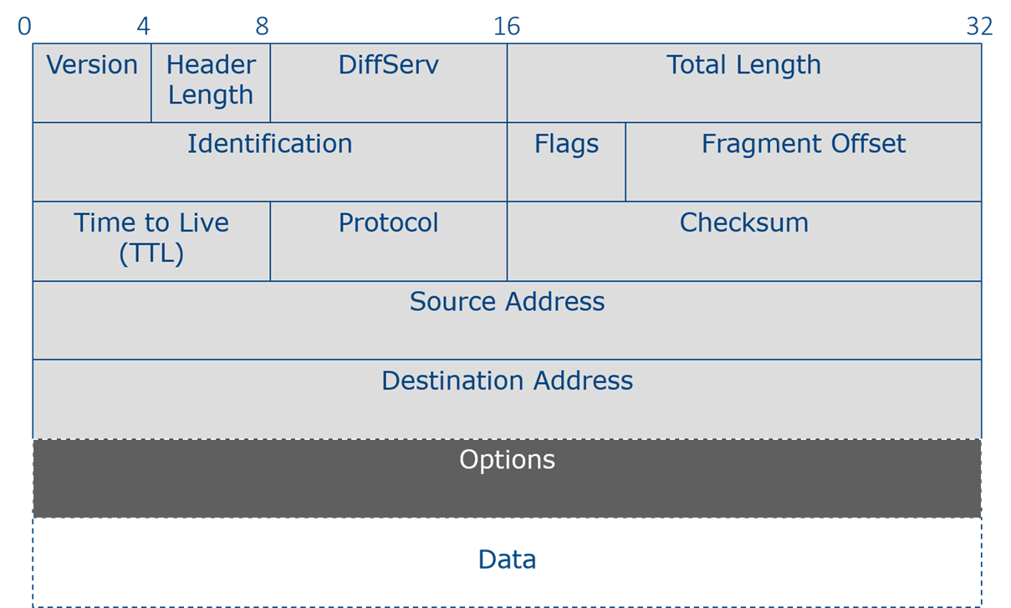
IPv4 headers
The most important of these are shown in the table below:
Field | Explanation
Version | The version of IP used (4).
Header / Total Length | The size of the header (typically 20 bytes) and total length of the packet; the maximum theoretical size is 65,535 bytes but actual packets would typically be much smaller.
DiffServ | This field provides a basic Class of Service mechanism.
ID / Flag / Fragment Offset | Fields to indicate whether the packet has been fragmented for transport over the underlying data link protocol.
Time to Live | The number of seconds a packet is allowed to stay on the network before being discarded; otherwise packets could endlessly loop around an internet. While TTL is defined as a unit of time (seconds), in practice, it is interpreted as the number of hops allowed. A router will decrease the TTL by at least 1 when it handles the packet.
Protocol | Indicates the protocol used in the payload. This is usually TCP or UDP but there are many other options, including ICMP, IGMP, and GRE.
Checksum | A field used to verify the packet's integrity upon arrival at the destination.
Source IP address | Identifies the sender of the packet by IP address.
Destination IP address | Identifies the destination of the packet by IP address.
Options | Additional fields can be specified, though this is not often the case in practice. The best known are the use of source routing (to predetermine the route a packet should take through the internetwork) and recording through which gateways the packet passes.
Data | The packet's payload, containing the segment from the transport layer.

IPv4 Address Structure
All networks must have a way of uniquely identifying individual computers. This identifier may be in the form of a name or number. At the TCP/IP Internet layer (the OSI network layer), a unique number, known as the IP address, is used to identify each host. The IP address provides two pieces of information:
- The network number (network ID) - this number is common to all hosts on the same IP network.
- The host number (host ID) - this unique number identifies a host on a particular IP network.
An IP address is 32 bits long and is used within an IP packet to define the source and destination of the packet. In its raw form it appears as: 11000110001010010001000000001001
The 32 bits are subdivided into four groups of 8 bits (1 byte) known as octets. The above IP address could therefore be rearranged as: 11000110 00101001 00010000 00001001
This representation of an IP address makes human memorizing of the number almost impossible (much less entering it correctly into configuration dialogs). To make IP addresses easier to use, they are usually displayed in dotted decimal notation. This notation requires each octet to be converted to a decimal value. The decimal numbers are separated using a period. Converting the above number to this notation gives: 198.41.16.9.

Converting Between Binary and Decimal Format
The following examples demonstrate the process of converting between binary and decimal notation. The base of any number system tells us two things: how many different values any given digit can have and the factor by which the value of a digit increases as we move from right to left in a number. Thus, in normal base 10 (or decimal) numbers, a digit can take any one of ten different values (0 through 9), and the values of the different place positions within a number, moving from right to left, are units (ones), tens, hundreds, thousands, and so on.
In base 2 (binary), digits can only take one of two different values (0 and 1). The place values are powers of 2 (2^1=2, 2^2=4, 2^3=8, 2^4=16, and so on). Consider the octet "11101101" represented in base 2: The table below shows the place value of each digit in the octet:
128 | 64 | 32 | 16 | 8 | 4 | 2 | 1
1 | 1 | 1 | 0 | 1 | 1 | 0 | 1
128 x 1 | 64 x 1 | 32 x 1 | 16 x 0 | 8 x 1 | 4 x 1 | 2 x 0 | 1 x 1
Therefore, the decimal equivalent is: 128 + 64 + 32 + 0 + 8 + 4 + 0 +1 = 237.
You can use the same sort of method to convert from decimal to binary. For example, the number 199 can be converted as follows: 199 = 128 + 64 + 0 + 0 + 0 + 0 + 4 + 2+ 1

128 | 64 | 32 | 16 | 8 | 4 | 2 | 1
128 x 1 | 64 x 1 | 32 x 0 | 16 x 0 | 8 x 0 | 4 x 1 | 2 x 1 | 1 x 1
1 | 1 | 0 | 0 | 0 | 1 | 1 | 1
If all the bits in an octet are set to 1, the number obtained is 255 (the maximum possible value). Similarly, if all the bits are set to 0, the number obtained is 0 (the minimum possible value). Therefore, theoretically an IPv4 address may be any value between 0.0.0.0 and 255.255.255.255. However, some addresses are not permitted or are reserved for special use.

Subnet Masks
An IP address represents both a Network ID and a Host ID. A subnet mask (or netmask) is used to distinguish these two components within a single IP address. It is used to "mask" the host ID portion of the IP address and thereby reveal the network ID portion.
Where there is a binary 1 in the mask, the corresponding binary digit in the IP address is part of the network ID. The relative sizes of the network and host portions determines the number of networks and hosts per network a particular addressing scheme can support.
 The 1s in the mask are always contiguous. For example, a mask 11111111 11110000 00000000 00000000 is valid but 11111111 00000000 11110000 00000000 is not.
Although you enter the mask in decimal, the computer "thinks" in binary terms. Until you are totally comfortable working with subnet masks, try to think in binary terms, switching the number to decimal only at the last moment to enter into the configuration dialog.

Masking an IP Address (ANDing)
The network ID portion of an IP address is revealed by "ANDing" the subnet mask to the IP address. The rules for a logical AND are shown in the table:
1 | AND | 1 | = | 1
1 | AND | 0 | = | 0
0 | AND | 1 | = | 0
0 | AND | 0 | = | 0
This table shows that when two ones are ANDed together, the result is a 1. Any other combination produces a 0.
For example, to determine the network ID of the IP address "172.30.15.12" with a subnet mask of "255.255.0.0", the dotted decimal notation of the IP address and subnet mask must first be converted to binary notation. The next step is to AND the two binary numbers. The result can be converted back to dotted decimal notation to provide the network ID.
IP address (172.30.15.12) | 10101100 | 00011110 | 00001111 | 00001100
Mask (255.255.0.0) | 11111111 | 11111111 | 00000000 | 00000000
Network ID (172.30.0.0) | 10101100 | 00011110 | 00000000 | 00000000

Routing Decision
When two computers attempt to communicate via IPv4, the protocol compares the source and destination address in each packet against a subnet mask. If the masked portion of the source and destination IP addresses match, then the destination interface is assumed to be on the same IP network. For example:
Source IP (172.30.15.12) | 10101100 | 00011110 | 00001111 | 00001100
Mask (255.255.0.0) | 11111111 | 11111111 | 00000000 | 00000000
Destination IP (172.30.16.101) | 10101100 | 00011110 | 00010000 | 01100101
In the example above, IP concludes the destination IPv4 address is on the same IP network and would try to deliver the packet locally.
If the masked portion does not match, IP assumes the packet must be routed to another IP network. For example:
Source IP (172.30.15.12) | 10101100 | 00011110 | 00001111 | 00001100
Mask (255.255.0.0) | 11111111 | 11111111 | 00000000 | 00000000
Destination IP (172.31.16.101) | 10101100 | 00011111 | 00010000 | 01100101
In this case, IP concludes the destination IPv4 address is on a different IP network and would forward the packet to a router rather than trying to deliver it locally.

ipconfig / ifconfig
The ipconfig program is used to verify TCP/IP configuration on Windows based systems. ipconfig includes the following options:
- ipconfig without any switches will display the IP address, subnet mask, and default gateway (router) for all network interfaces to which TCP/IP is bound.
- ipconfig /all displays all of the TCP/IP configuration parameters for each interface to which TCP/IP is bound, including whether or not the Dynamic Host Configuration Protocol (DHCP) is enabled for the interface and the interface's hardware (MAC) address.
- ipconfig /renew Interface forces a DHCP client to renew the lease it has for an IP address.
- ipconfig /releaseInterface releases the IP address obtained from a DHCP Server, so that the interface(s) will no longer have an IP address.
- ipconfig /displaydns displays the Domain Name System (DNS) resolver cache.
- ipconfig /flushdns clears the DNS resolver cache.
- ipconfig /registerdns registers the host with a DNS server (if it supports dynamic updates).
 See Unit 2.3 / DHCP and APIPA / Study Notes for more information about DHCP and Unit 3.2 / Name Resolution / Study Notes for DNS.
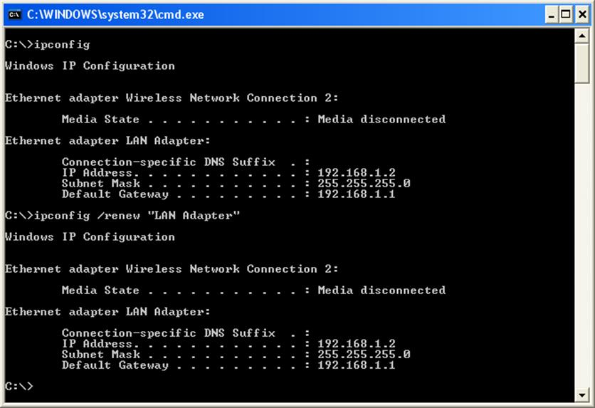
Using ipconfig
UNIX and Linux hosts provide a command called ifconfig which provides similar output to Windows' ipconfig program.
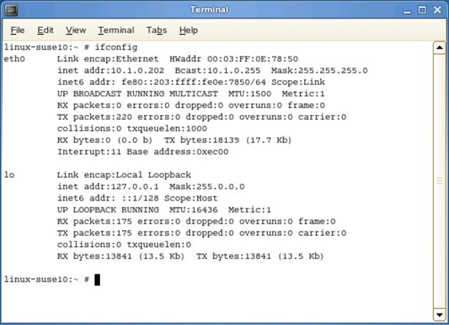
Using ifconfig
Note some differences between the Windows and Linux commands:
- ifconfig can also be used to bind an address to an adapter interface, set up communication parameters, and enable or disable the adapter.
- The Windows switches for configuring the adapter with DHCP and DNS are not supported by ifconfig.
- The ifconfig command output does not show the default gateway (use route instead). It does show traffic statistics though.

IP Routing Basics
The subnet mask is used by IP to identify whether the source and destination addresses in a packet are on the same IP network or subnetwork. If the destination address has a different network ID, the packet must be sent via one or more routers. The default gateway is the IP address of a router on the same IP network as the host. Messages destined for other IP networks are sent to the default gateway address by the source host.
When a message is sent using IP, the following steps occur:
- IP will attempt to establish a connection with the destination host by IP address:
  - The subnet mask of the host is applied to the source IP address to determine the network address of the source host.
  - The subnet mask of the host is applied to the destination IP address to determine the network address of the destination host.
- The destination network address is compared with that of the source:
  - If the two hosts are on the same IP network, TCP/IP uses ARP messaging to locate the destination interface. The response to this broadcast includes the hardware (MAC) address of the destination interface and the message can then be sent.
  - If the two machines are on different IP networks, TCP/IP uses ARP messaging to locate the default gateway (router). This machine responds with its MAC address and the message is then sent to the gateway.
- It is possible that due to limitations in the underlying network, IP may fragment the packet into more manageable pieces (to fit within the Maximum Transmission Unit [MTU] of the data link protocol frame).
If this is the case, IP assigns a new header to each fragment containing:
  - A flag to indicate whether more fragments follow.
  - A fragmentidentifier to help group fragments together.
  - An offset to assist the destination host in reconstructing the fragments into the original packet.
- IP then calculates a checksum (to use for error detection) and sends the packet. A data link protocol (such as Ethernet) encapsulates this into one or more frames and transmits them over the network.
- If the packet has been routed, at the gateway, the Time to Live (TTL) is decreased by at least one. This could be greater if the router is congested. When the TTL is zero, the packet will not be forwarded to another router. This prevents badly addressed packets from permanently circulating the network.
- The router then determines what to do with the packet by repeating the steps described from the second step on. If the message is destined for yet another network, the process is repeated to take it to the next stage and so on.
Routes to other IP networks can be manually configured or learned by a routing protocol. Discovered routes are held in a routing table. The more sophisticated routers can share information about known networks and possible paths to them. This information allows them to choose the best routes to any given destination and select alternate routes if one of these is unavailable. The ability to learn routes provides the robust system described earlier.

ICMP and ping
The Internet Control Message Protocol (ICMP) is used to report errors and send messages about the delivery of a packet. It can also be used to test and troubleshoot connectivity issues on IP networks. ICMP messages are generated under error conditions in most types of unicast traffic but not for broadcast or multicast packets.

ICMP Error Types
An ICMP message is encapsulated within a single IP packet. ICMP messages are categorized into various types. The most commonly encountered are described below.

Echo Request / Reply
These are used for testing a connection with the ping utility. If a request message reaches the destination host, it generates a reply and sends it back to the source. If the request message does not reach its destination, an appropriate error message is generated.
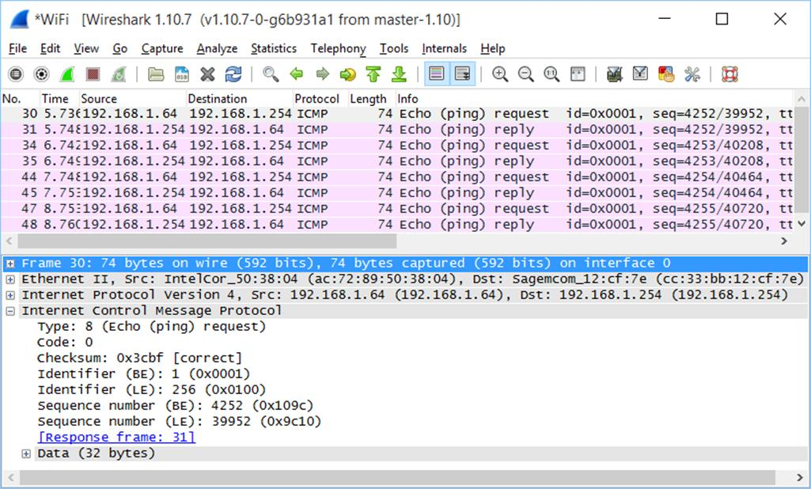
Exchange of ICMP requests and replies

Destination Unreachable
This class of message indicates that a local host or a host on a remote network (or a protocol or port on a host) cannot be contacted. This might be caused by some sort of configuration error or by a host or router not being available.

Time Exceeded
This is used when the Time To Live (TTL) of a packet reaches zero. The TTL field in a packet has a maximum value of 255 and this value is reduced by one every time the packet crosses a router. The TTL is eventually reduced to zero if the packet is looping (because of a corrupted routing table) or when congestion causes considerable delays. The router then discards the packet and a warning packet is sent back to the source host.

Redirect
Most hosts channel all remote communications through the default gateway. If there are in fact multiple routers and a more efficient route can be identified, the default gateway can send a redirect message to the host to update its routing table. Note that the router still delivers the original message.

ping
The ping program sends a configurable number and size of ICMP packets to a destination host. The utility can be used to provide essential information when troubleshooting a TCP/IP network. To use ping, open a command prompt and enter the command ping followed by either the HostName or IPAddress of the remote computer.
If ping is successful (as in the first attempts shown in the screen capture), it responds with the message Reply fromIPAddress and the time it takes for the server's response to arrive. The millisecond measures of Round Trip Time (RTT) can be used to diagnose latency problems on a link.
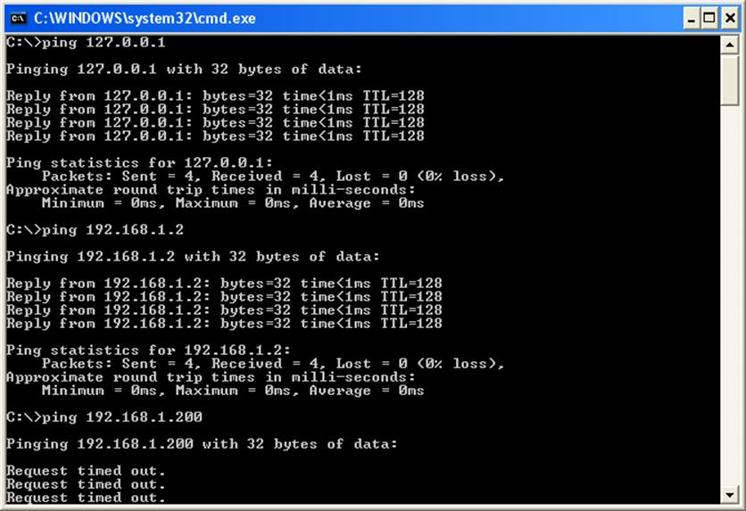
Using ping within Windows
See Unit 3.4 / Applications and Services / Study Notes for more information about latency and network performance.
If ping is unsuccessful (as shown in the last attempt), one of two messages are commonly received:
- Destination unreachable - there is no routing information (that is, the local computer does not know how to get to that IP address). If the host is on the same IP network, check physical cabling, infrastructure devices such as the switch, and TCP/IP configuration. If the host is on another IP network, check the TCP/IP configuration and router.
- No reply (Request timed out) - the host is unavailable or cannot route a reply back to your computer.
Be aware that ICMP traffic is often blocked by firewalls, making a response such as request timed out inevitable.

Interpreting ping Output
The following steps outline the procedures for verifying a computer's configuration and for testing router connections:
- Ping the loopback address (ping l27.0.0.l) to verify TCP/IP is installed and loaded correctly. The loopback address is a reserved IP address used for testing purposes.
- Ping the IP address of your workstation to verify it was added correctly and to check for possible duplicate IP addresses.
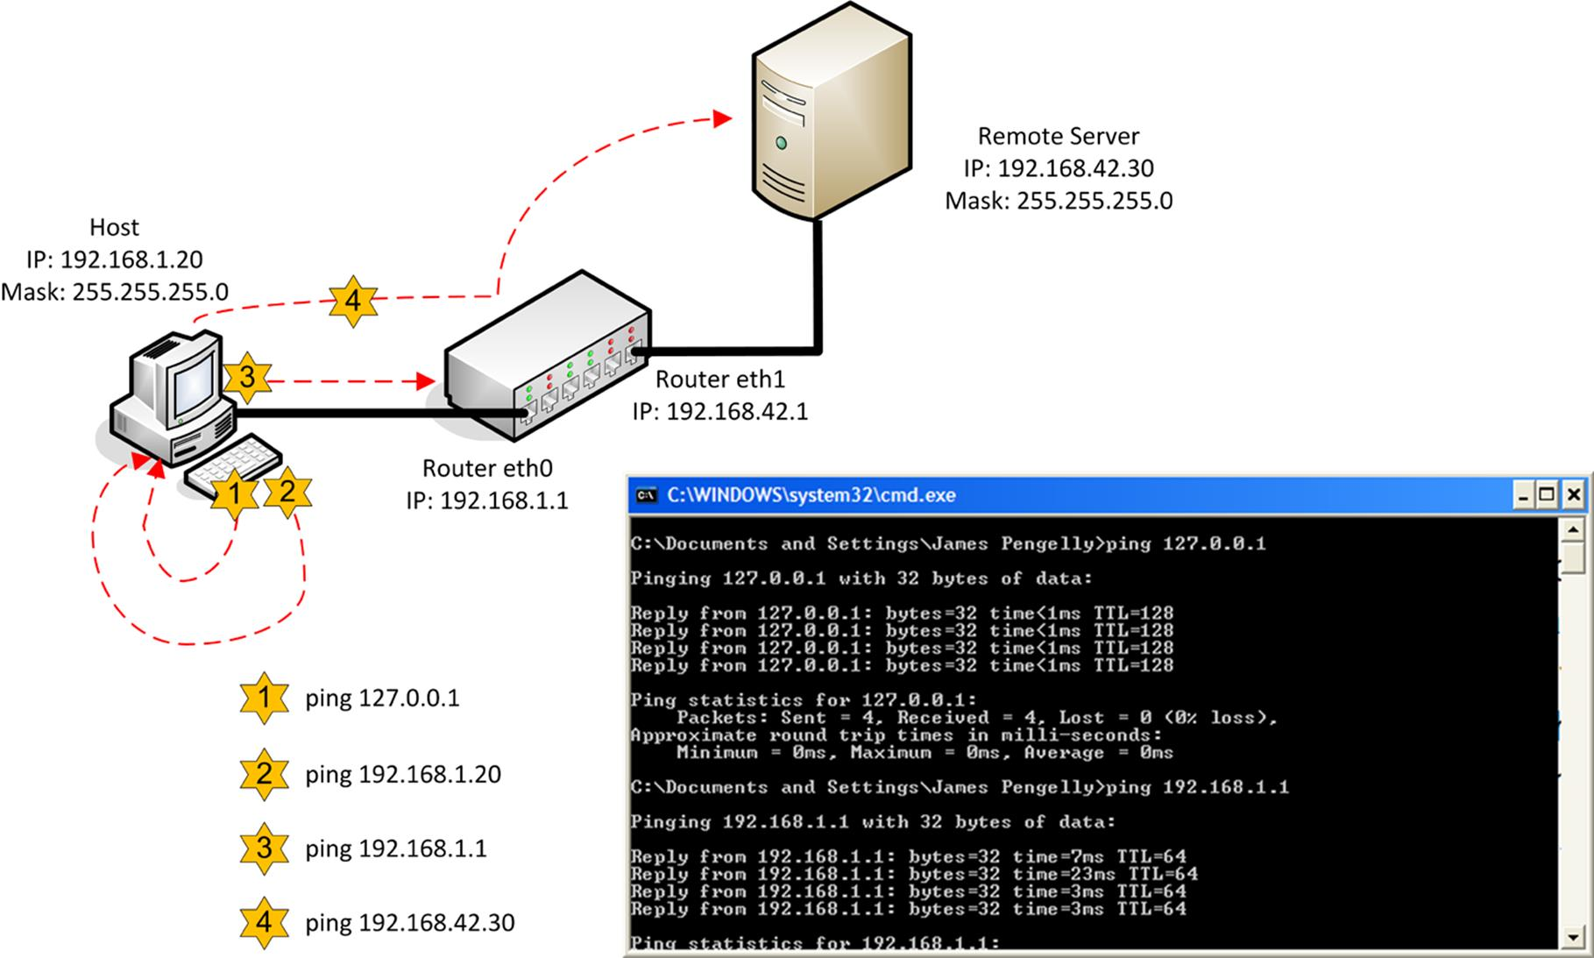
Troubleshooting with ping
- Ping the IP address of the default gateway to verify it is up and running and that you can communicate with a host on the local network.
- Ping the IP address of a remote host to verify you can communicate through the router.
The trick with ping is understanding the messages that you receive when there is a problem.
- If you cannot ping the loopback address, the protocol is not correctly installed on the local system.
- If a local host cannot be pinged, then verify the sending host's IP configuration - IP address, subnet mask, and so on.
- If the previous tests are successful, but a remote IP address cannot be contacted, check the default gateway parameter on the local host. If correct, utilize the tracert program to investigate the route being taken. Also, consider manually adding the route using the route command.
- If you can successfully perform all tests, but cannot ping by computer name, then this suggests a name resolution problem.

ping Switches
ping can be used with a number of switches. You can adjust the TTL (-i) and timeout (-w) and force the use of IPv4 (-4) or IPv6 (-6) when pinging by host name. With IPv4, you can also use loose (-j) or strict (-k) source routing (sending packets via a predetermined route). The -a switch performs name resolution. Also, -t continues to ping the host until interrupted (Ctrl+C).
Note that ping has different syntax when used under Linux. By default, the command executes until manually halted, unless run with the number of packets appended at the end. Also, use ping6 rather than ping -6 to force the use of IPv6 communications in Linux.

