UNIT 1.4 / INFRASTRUCTURE AND DESIGN / STUDY NOTES

Network Infrastructure Implementations
To categorize the size and nature of individual networks, the industry has developed terms that broadly define the scope of different types of network.

Local Area Network (LAN)
A Local Area Network (LAN) covers a wide range of different sizes of network but is mostly confined to a single geographical location. Some typical examples of LANs would include:
- Home / residential network - with an internet router and a few computers plus mobile devices and gaming consoles and printers.
- SOHO (Small Office Home Office) - a business-oriented network possibly using a centralized server in addition to client devices and printers but often still using a single internet router/switch/access point to provide connectivity.
- SME (Small and Medium Sized Enterprise) - a network supporting tens of users. Such networks would use structured cabling and multiple switches and routers to provide connectivity.
- Enterprise LAN - a larger network with hundreds or thousands of servers and clients. Such networks would require multiple enterprise-class switch and router appliances to maintain performance levels.
The term Campus Area Network (CAN) is sometimes used for a LAN that spans multiple nearby buildings. The term Wireless Local Area Network (WLAN) is used for networks based on Wi-Fi. Open (public) WLANs are often referred to as hotspots.

Wide Area Network (WAN)
A Wide Area Network (WAN) is a network of networks, connected together by long distance links. A typical enterprise WAN would connect multiple sites, possibly in different countries. A WAN could link two or more large LANs or could be used to mean remote workers connecting to an enterprise network via a public network such as the Internet. You should also be familiar with the terminology of internet, intranet, and extranet.
- Internet - the Internet is a worldwide network of networks based on the TCP/IP protocol. The Internet is not owned by a single company or organization. The uncapitalized term "internet" (or "internetwork") is also used to describe any series of interconnected IP networks.
- Intranet - an intranet uses the same technologies as the Internet but it is owned and managed by a company or organization. An intranet is typically implemented as a LAN or WAN.
- Extranet - an extranet is an intranet that is also accessible to selected third-parties, such as customers or suppliers.
The term Metropolitan Area Network (MAN) is sometimes used to mean something a bit smaller than a WAN; a city-wide network encompassing multiple buildings.

Personal Area Network (PAN)
The terms Personal Area Network (PAN) and Wireless PAN (WPAN) have gained some currency over the last few years. They refers to the fact that a person might establish close-range network links with a variety of devices, such as smartphones, tablets, headsets, and printers. As digital and network functionality continues to be embedded in more and more everyday objects and appliances (the "internet of things") and clothing the use of PANs will only grow. The following technologies can be used to establish a PAN:
- Infrared (IrDA or IR) supports speeds up to about 4 Mbps and ranges up to about 1m or 3 feet. Infrared communication requires line-of-sight and can be easily interrupted by someone walking between the communicating devices or even by bright sunlight. IrDA is not widely supported by modern peripherals and computer systems.
- Bluetooth uses radio communications and supports speeds of up to 3 Mbps. It does not require line-of-sight and supports a maximum range of 10m (30 feet), though signal strength will be very weak at this distance. Most PAN devices are based on Bluetooth connectivity.
- Near Field Communications (NFC) is a very short range radio link based on Radio Frequency IDs (RFID). NFC works at up to 4cm at data rates of 106, 212, and 424 Kbps. NFC sensors and functionality are starting to be incorporated into smartphones. NFC is mostly used for contactless payment readers. It can also be used to configure other types of connection (pairing Bluetooth devices for instance) and for exchanging information, such as contact cards.

Planning an Enterprise Campus Network
The terms "campus" or "enterprise network" cover a wide range of different types of site: a whole building, a floor in a building, multiple buildings close together, or multiple buildings some distance apart for instance. Consequently Cisco (for instance) no longer attempt to define a campus network based on the properties of the site but as "the integrated elements that comprise the set of services used by a group of users and end-station devices that all share the same high-speed switching communications fabric".

List of Requirements
When planning a campus or enterprise network installation or upgrade project, the first task is to establish the customer's list of requirements. Customer requirements will usually be to support business goals. Make sure you understand the customer's business. A company operating in the financial industry will have different requirements and priorities to one in an industrial sector. You should consult with the customer to establish the following information:
- What is the business goal that the network or network upgrade is going to support? If possible, try to capture this in a single statement, such as "Deliver best-in-class customer support", "Provide a secure environment for product development", or "Reduce ongoing costs".
- Determine the factors that will show whether the project has succeeded or failed. Identify clear deliverables (such as showing Return On Investment [ROI] or proving that better network response times and throughput have boosted customer satisfaction levels).
- Establish the scope of the project. For example, is it an install of a new cable network or an upgrade or extension of an existing network, a plan to connect a new site, roll out a wireless network, a security upgrade, and so on.
- Understand how the business is organized, in terms of departments and managerial hierarchy, IT support, physical sites, and so on.
- Identify stakeholders; these are people in the company who will determine the success of the project and may be closely involved with it (finance, executive, IT administrators, and software developers for instance). Try to learn about or anticipate any internal controversies, preferences, or prejudices (office politics) that might impact the project.
- Establish the project budget, including costs for new infrastructure and equipment and new ongoing costs, such as new support roles or training.
- Start to plan a schedule for the work to proceed. Upgrades and to a lesser extent new installations are likely to be disruptive to normal network service levels. You will need to be able to plan work to minimize the disruption to existing network users. As well as determining a realistic completion date, if the project is complex you should specify dates for intermediate milestones, such as completing cabling work, installing and testing switching, connecting clients and servers, and testing application performance.

Security Considerations
Historically, security considerations might have been secondary to those of cost and performance. Now, no one can design a network installation or upgrade without making security a paramount consideration. The need for security needs to be clearly explained to the customer. Expenditure on security appliances and features needs to be justified in case the customer questions "unnecessary" costs.

Environment Limitations
As well as meeting the commercial requirements, the network plan must take account of the limitations imposed by the environment. As mentioned above, you will need to know the physical scope of the installation or upgrade. There may be special site factors to take account of, such as requiring cable shielding against interference. Additional devices may need to be connected wirelessly where there is no scope to install new cable. Conversely, the environment may be unsuitable for wireless networking.
Understand what applications are (or will be) deployed on the network and their associated traffic flows and Quality of Service (QoS) and bandwidth requirements. This is necessary so that you can determine a logical and physical topology that provides the required service levels to different departments and sites. Identify what external use will be made of the network, such as remote access for employees, services for authenticated partners and customers (an extranet), and publicly available (unauthenticated) services. Again, this will impact the logical and physical topology for the network and have a major impact on planning how the network will be kept secure.
You must also take account of relevant regulations required by building control or other local and national legislation.

Compatibility Requirements
If you are upgrading or extending an existing network you will need to plan how to integrate with or replace existing cabling and devices. Note that you will have to make a strong business case for replacing existing infrastructure. You will need to obtain documentation about the existing network, including its logical and physical topology and the specification and configuration of existing cabling, switches, routers, wireless access points, and servers.

Device Types / Requirements
Identify what end-user devices will be used to access the network. As well as PCs and laptops (possibly using a mix of different operating systems), there may need to be access for smartphones and tablets. Some companies operate a Bring Your Own Device (BYOD) policy, allowing users to access the network using personal devices. This can complicate performance and security planning.

Equipment Limitations
As a network designer, your job is to select the most appropriate technology given the customer requirements (such as business objective and budget) and network design goals (such as scalability, availability, and security). Other factors might impact on choice of technology. For example, the customer may have existing equipment from one vendor. Selecting a different vendor might cause problems with interoperability and require extra staff training.
Installing or upgrading network infrastructure such as cabling and switches is expensive. Consequently it is important that infrastructure design be scalable and adaptable.
- Scalability means that additional users or devices can be added to the network without having to significantly re-design or re-engineer the existing infrastructure. For example, if a department expands to require two floors, network traffic within the expanded department can be accommodated by the existing cable and switching infrastructure without reducing performance.
- Adaptability (or flexibility) means that new or changed services and applications can be accommodated with a minimum of disruption to the existing physical and logical topology. For example, if the customer wants to switch from a traditional telephone system to Voice-over-IP, an adaptable network will be able to accommodate this without requiring the installation of new cable.
To accommodate these goals, Cisco recommend designing a campus network with four layers of hierarchy: access, distribution, core, and data center.
- Access - allowing end-user devices, such as computers, printers, and smartphones to connect to the network. Another important function of the access layer is to prevent the attachment of unauthorized devices.
- Distribution - provides fault-tolerant interconnections between different access blocks and either the core (see below) or other distribution blocks. The distribution layer is often used to implement traffic policies, such as routing boundaries, filtering, or Quality of Service (QoS).
- Core - provides a highly available network backbone. Devices such as clients and server computers should not be attached directly to the core. Its purpose should be kept simple: provide redundant traffic paths for data to continue to flow around the access and distribution layers of the network.
- Data center - hosts network services (such as authentication, addressing, and name resolution), application servers, and data.
 You can think of a network design with a core as like a star topology. A "flat" design with only distribution and access layers is more like a mesh (or partial mesh). It is more complex to grow a mesh-like network, because the number of interconnects required grows exponentially as you add sites.
At each layer of the hierarchy, functions are provided as modular blocks, each of which should be capable of being specified and designed separately from the overall network. For example, you might have access and distribution blocks for client devices for each floor of a building, blocks for the data center, others for WAN access, internet access, or remote access, and a block for network management and administration functions.
Developing these functions using standard modules makes them easier to secure, easier to manage, and easier to troubleshoot. Each module starts with a list of the requirements it must fulfil. This allows for the development of a logical network topology. The implementation of each module in a physical network topology (the placement of cabling and selection and placement of devices) can then be developed from the logical topology taking account of site, environmental, and budgetary factors.

Planning a SOHO Network
The notes above describe some typical planning considerations for a medium or large LAN or campus network. Many networks are smaller however and may not use such structured systems. These types of networks are often referred to as Small Office Home Office (SOHO). Installing and maintaining these SOHO networks present different challenges to the enterprise LAN environment.
Customer requirements will generally be functional rather than technical; that is, they will state the goals the customer wants to achieve, not necessarily the components to be used in achieving them (internet access, sharing office / accounts information, distributing information to partners and customers, and so on). The result of this process will be a list of requirements, which will form part of the functional specification. You are likely to have to prompt the customer about other vital requirements, such as backup and security. Obviously the resources are unlikely to be there for enterprise grade solutions to these problems, so you must be familiar with more of the consumer-level products.
One SOHO scenario is supporting small businesses or self-employed homeworkers. The other is supporting corporate teleworkers (or perhaps small regional offices). In this second scenario, there is likely to be a standard corporate policy for setting up remote sites in a consistent way. This will often take more account of data security and issues such as health and safety.

Wired / Wireless Considerations
SOHO networks are less likely to use a structured cabling scheme. Many SOHO networks will be based around a single internet router, server computer, and several workstations, possibly all located within the same room. The main challenge is usually joining up the location selected for the majority of the equipment with the location of the Internet access line (demarc).
If this is the case, remember that the official standards for data cabling tend to be quite conservative. You may be able to run patch cable to 20 or 50m (rather than the official "2 lengths up to 5m each") between a DSL internet router and a LAN switch without compromising the performance required for a SOHO network. You need to be able to test to the customer's specific requirements.
 Do not interpret this as an opportunity to be slipshod. Wiring must still conform to the relevant building and electrical safety codes. You must ensure that the wiring is not a trip hazard. It must still be installed so that it performs at the level expected by the client.
The other obvious solution for connecting SOHO devices is wireless. For many SOHO networks, the bandwidth available for WLANs will be adequate. However, as another alternative to installing new data cabling, Ethernet over Powerline products can make use of existing power circuits. Power is typically delivered as a 50-60 Hz alternating current, at between 100-240 volts, varying from country to country. Powerlineoverlays a higher frequency carrier signal on the lines and uses this to transfer data. This is similar in concept to DSL over phone lines, except that in the case of power lines the original "signal" being carried on the lines is at a higher voltage.
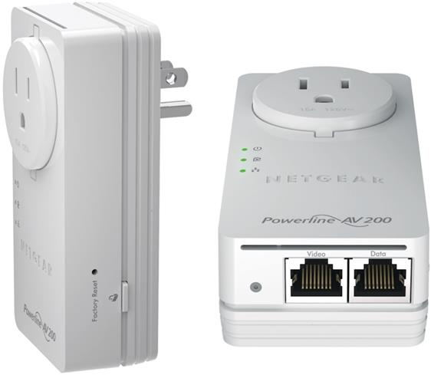
Netgear Powerline AV200 adapters providing two Ethernet ports and a pass-through power outlet (Image © 2012 NETGEAR)

IEEE 1905.1
The Homeplug Powerline Alliance (www.homeplug.org) is one of the leading sponsors of the IEEE 1905.1-2013 standard, also referred to by some vendors as Hy-Fi. This provides a simple means for SOHO networks to integrate Ethernet and Wi-Fi networks with Ethernet over Powerline and Ethernet over HDMI network links. The standard is described as a "convergent digital home network for heterogeneous technologies".
The standard allows 1905.1-compatible devices using different MAC/PHY layer links to discover one another and autoconfigure the best available link for a particular application (also allowing for failover if one link goes down) or use bonded links to maximize bandwidth. For example, an IP-enabled smart TV could automatically select between Wi-Fi and Ethernet over HDMI as the best link to a media streaming server. If the Wi-Fi link went down or its link bandwidth dropped, it could switch over to the HEC link more-or-less seamlessly.
The High Definition Media Interface (HDMI) version 1.4 used for interconnecting audio and video input and output devices specifies a 100 Mbps Ethernet channel (HEC). In principle this would allow two devices connected by an HDMI cable to make an IP connection. HEC is not widely supported at the time of writing.

Device Types / Requirements
Most SOHO networks will be based on the use of consumer-level devices. These networks have the same basic requirements as enterprises for switches and wireless access points, routing, and firewalls but these functions will generally be incorporated within a single appliance.
Similarly, phone and fax might be implemented by ordinary consumer lines or by a small PBX. There are also very cost-effective VoIP solutions available for small businesses.
The network itself might be based on peer-to-peer file sharing or could feature a simple server network for file sharing and email or perhaps a "one box" server solution, such as Windows Small Business Server (SBS) or Home Server (both now replaced by Windows Server 2012 Essentials). The point is that the network is unlikely to have multi-gigabit bandwidth requirements and can use low-cost interconnections.

Equipment Limitations
Consumer-level appliances can be quite sophisticated in terms of features. For example, even a basic DSL router may come with a firewall that can implement port forwarding, an access point that can support 10 or so connections, and a remote management interface to allow support professionals to connect to it over the Internet.
What consumer devices lack is the things that make enterprise models expensive; scalability, fault tolerance, and security. In the SOHO space, fault tolerance is less likely to be failover internet links to multiple ISPs and more likely to mean having a spare DSL router configured with the ISP's connection settings. These aren't limitations so much as different requirements. With the one box solutions, if the box fails then you get a new one. But if the business grows substantially, then there has to be investment in a whole new class of devices.

Environment Limitations
As discussed above, there may be limited opportunities to run new cabling in a typical home or leased small office. The other critical factor is provisioning a means of making an offsite data backup to protect against theft, fire, and natural disaster risks. The bandwidth of most urban internet links makes using "cloud" services for remote backup feasible but this may be more challenging in rural environments.
A suitable location must be identified to install the networking device(s) and server (if used). In an enterprise network, there will be a dedicated telecommunications room. For a SOHO network, a small network cabinet may be installed, or it may be acceptable to use desktop devices either on a desk or a shelf. There is obviously not the same scope for factors such as temperature, humidity, and dust to be controlled. It is also more likely that critical devices, such as the DSL router, will be exposed to user accidents, such as mugs of coffee or domestic pets. User training is likely to be the best way of overcoming these environmental limitations.

Compatibility and Security Considerations
Configuring devices for compatibility often involves a trade-off with performance. Having stated that the sorts of device types that will be required for a SOHO network are "cheap" (compared to enterprise-class versions) most small business owners and self-employed people do not want to spend money unnecessarily. If they have a 5-year old computer with an 802.11g wireless adapter and perceive that "It works" they will not want to upgrade without a clear case being made that an upgrade is necessary. As mentioned above, there may be a requirement for devices at a remote site to be compatible with a corporate network. This will generally mean supporting the same authentication and remote access protocols. Network Access Control (NAC) solutions enable the corporate network to enforce "health policies" against devices connecting from outside, to mitigate against any lax attitudes remote workers might try to take as regards patch management and A-V software updating.

Planning an Industrial Control System
An embedded system is a computer system that is designed to perform a specific, dedicated function. These systems can be as small and simple as a microcontroller in an intravenous drip-rate meter or as large and complex as an industrial control system managing a water treatment plant. Embedded systems might typically have been designed to operate within a closed network; that is one where the elements of the network are all known to the system vendor and there is no connectivity to wider computer data networks. Where embedded systems need to interact within a computer data network, there are special considerations to make in terms of the network design, especially as regards security.
One famous example of an attack on an embedded system is the Stuxnet worm. This was designed to attack the management software running on Windows PCs to damage the centrifuges used by Iran's nuclear fuels program. NIST Special Publication 800-82 covers some recommendations for implementing security controls for ICS and SCADA (gtsgo.to/79lce).
The use and control of embedded devices in networks is generically referred to as an Industrial Control System (ICS). There are two main types of ICS: SCADA (Supervisory Control and Data Acquisition) systemsand Distributed Control Systems (DCS).

SCADA (Supervisory Control and Data Acquisition)
Supervisory Control and Data Acquisition (SCADA) systemsare typically deployed to manage large-scale, multiple-site devices and equipment spread over geographically large areas. The plant devices and equipment are referred to as field devices. A field device supports some type of interface allowing it to communicate with the control system. There are broadly two types of interface:
- Remote Terminal Unit (RTU) - these are usually simple devices with limited programmability. They are primarily designed to communicate with the control system reliably over long distances (in a WAN).
- Programmable Logic Controller (PLC) - these are more sophisticated devices capable of a wider range of functions and with more storage and processing and networking capabilities. PLCs are often associated with use in a LAN.
Field devices are also equipped with sensors that can report information and alerts back to the centralized control system (or ICS server). Based on the feedback from the sensors, the control system may be able to adjust the function of a device automatically or allow a human supervisor to override its function in some way (open a valve, increase the speed at which a fan spins, and so on).

DCS (Distributed Control Systems)
Distributed Control Systems (DCS) are often used to manage industrial processes, fabrication and manufacturing, controlling automated assembly lines, refining, power generation and transmission, and so on. In contrast to SCADA, DCS are likely to be single site systems.

TCP/IP Protocol Suite
On top of the physical and data link infrastructure design lie the application and communication protocols. Protocols are procedures or rules used by networked computers to communicate. For communication to take place, the two computers must have a protocol in common. Often, several protocols used for networking are designed to work together. This collection of protocols is known as a protocol suite.
Another commonly used term is protocol stack. This term describes a collection of protocols and the logical order in which they work together.
A number of protocol suites have been used for LAN and WAN communications over the years. However, the overwhelming majority of networks have now converged on the use of the TCP/IP (Transmission Control Protocol/Internet Protocol) suite. Most network implementations you will be required to undertake will depend on the use of TCP/IP.

TCP/IP Layer Model
The TCP/IP protocol maps to a four-layer conceptual model: Application, Transport, Internet, and Link (or Network Interface). This model is referred to as the Internet Protocol Suite or the DoD (Department of Defense) model or the ARPA model. Each layer in the Internet Protocol Suite corresponds to one or more layers of the OSI model.

Link Layer / Network Interface
The link (or network interface) layer is the equivalent of the OSI physical and data link layers as it defines the host's connection to the network media. This layer comprises the hardware and software involved in the interchange of frames between hosts. The technologies used can be LAN-based (Ethernet or Wi-Fi) or WAN-based (T-carrier, ISDN, or DSL for instance).

Internet Layer
The internet (or more precisely internetwork) layer provides addressing and routing functions. It uses a number of protocols, notably the Internet Protocol (IP) and Address Resolution Protocol (ARP), to facilitate the delivery of packets.
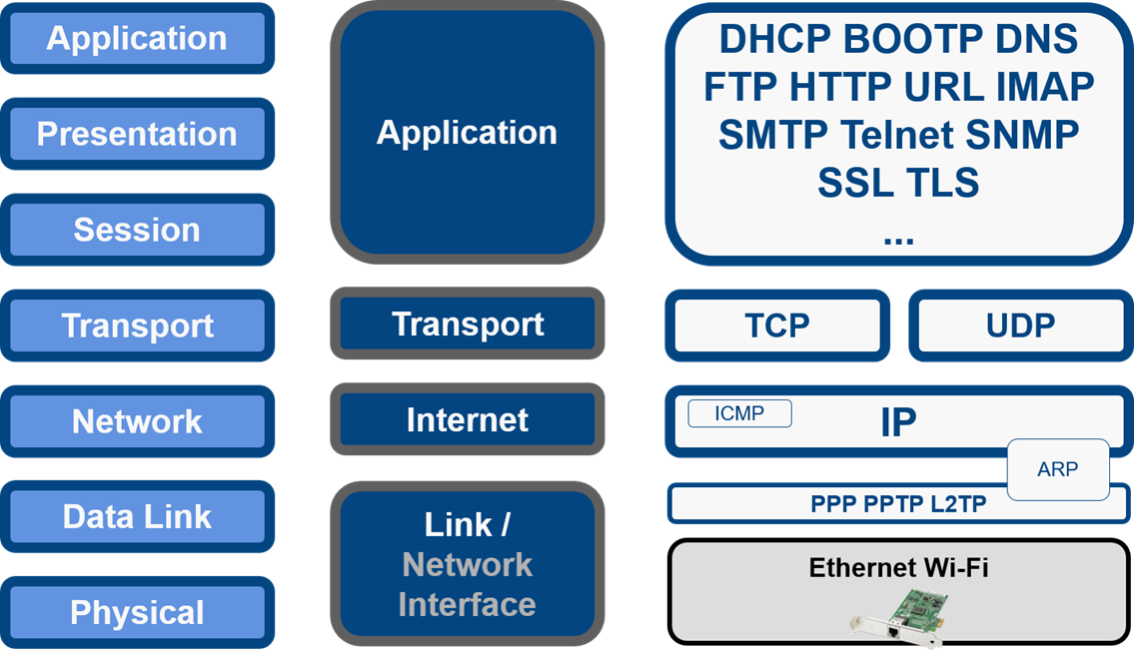
OSI and TCP/IP
ARP is sometimes thought of as working at the data link layer (layer 2) in OSI terms because it needs to reference hardware (MAC) addresses and is not routable. On the other hand, a layer 2 protocol such as Ethernet does not require ARP to function, while a layer 3 protocol such as IP does (at least, in any practical sense). The best solution is to think of ARP as a layer 2.5 protocol and leave it at that.

Transport Layer
The transport layer provides communication between the source and destination hosts and breaks application layer information into packets. TCP/IP provides two methods of data delivery:
- Connection-oriented delivery using the Transmission Control Protocol (TCP).
- Connectionless delivery using User Datagram Protocol (UDP).

Application Layer
This is the layer at which many TCP/IP services (high level protocols) can be run (such as FTP, HTTP, and SMTP).

Packet Switching
The original research underpinning TCP/IP was performed in the late 1960s and early 1970s by the Advanced Research Projects Agency (ARPA), which is the research arm of the US Department of Defense (DoD). The DoD wanted to build a network to connect a number of military sites. The prototype was a research network called ARPANET, first operational in 1972. This connected four university sites using a system described as a packet switching network.
Prior to this development, any two computers wanting to communicate had to open a direct channel (known as a circuit). If this circuit were broken, the computers would stop communicating immediately. Packet switching introduces the ability for one computer to forward information to another. To ensure information reaches the correct destination, each packet is addressed with a source and destination address and then transferred using any available pathway to the destination computer.
A packet switching protocol is described as "robust" because it can automatically recover from communication link failures. It re-routes data packets if transmission lines are damaged or if a router fails to respond, utilizing any available network path.
The figure below shows an example of an internet system. A packet being sent from Network A to Network D may be sent via Network C (the quickest route). If this route becomes unavailable, the packet is routed using an alternate route (for example, A-F-E-D).
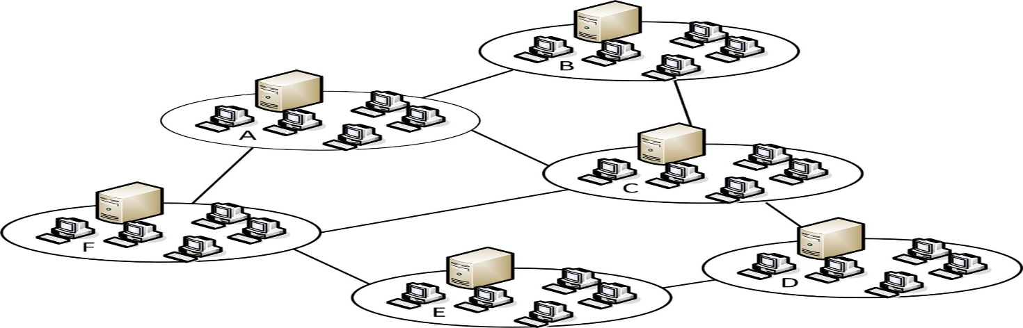
Packet switching networks
Data is divided into small chunks or packets. Sending large chunks of information has always presented problems. The facilities within the new protocol to divide large messages into numerous small packets meant that a single packet could be resent if it was lost or damaged during transmission, rather than the whole message.

TCP/IP and Internet Standards
The major network software vendors now include TCP/IP within their products, but it remains an open standard to which anyone can suggest modifications and enhancements. TCP/IP and the Internet are inextricably linked. Although no organization owns the Internet or its technologies, a number of organizations are responsible for the development of the Internet and consequently TCP/IP.

Internet Society (ISOC)
The purpose of ISOC (www.isoc.org) is to encourage the development and availability of the Internet. It provides organizational resources to the Internet Architecture Board (IAB).

Internet Architecture Board (IAB)
The IAB (www.iab.org) is the technical committee of ISOC and is responsible for setting internet standards and publishing these standards as RFCs (Request for Comment). Among other responsibilities, the IAB governs the following groups:
- Internet Engineering Task Force (IETF [www.ietf.org]) - focuses on solutions to internet problems and the adoption of new standards.
- Internet Assigned Numbers Authority (IANA [www.iana.org]) - manages allocation of IP addresses and maintenance of the top-level domain space. IANA is currently run by Internet Corporation for Assigned Names and Numbers (ICANN).
IANA allocates addresses to regional registries who then allocate them to local registries or ISPs (Internet Service Provider). The regional registries are APNIC (Asia/Pacific), ARIN (North America and Southern Africa), LACNIC (Latin America), and RIPE NCC (Europe, Northern Africa, Central Asia, and the Middle East).

Request for Comments (RFC)
TCP/IP standards are not developed by a committee but rather by consensus. The process for adopting internet standards revolves around the production of documents called Request for Comments (RFC). The standards for TCP/IP are published via these RFCs. Some RFCs describe network services or protocols and their implementation while others summarize policies. An older RFC is never updated. If changes are required, a new RFC is published with a new number. It is always important to verify you have the most recent RFC on a particular topic. Not all RFCs describe standards. Some are designated "informational" while others are "experimental". The official repository for RFCs is at www.rfc-editor.org and they are published in HTML format at tools.ietf.org/html.

