UNIT 1.2 / ETHERNET / STUDY NOTES

Transmission Media
The transmission medium is the physical channel through which signals travel to allow nodes to communicate with one another (to create a circuit). All network signaling uses electromagnetic radiation of one type or another (electrical, light, or radio signals). Different types of transmission media can be classified as cabled or wireless:
- Cabled - a physical signal conductor is provided between two nodes. Examples include cable types such as copper or fiber optic. Cabled media can also be described as bounded media.
- Wireless - uses free space between nodes (no signal conductor), such as microwave radio. Wireless media can also be described as unbounded.

Bandwidth
One important characteristic of a transmission medium is its bandwidth. One definition of bandwidth is the range of frequencies available to the communications channel. When used to discuss channel capacity like this, bandwidth is measured in units of time (hertz) representing the number of signaling cycles that can be completed per second. This can be measured in different multiples, from cycles propagating once per second (1 Hz) to those propagating thousands (KHz), millions (MHz), billions (GHz), or trillions of times per second (THz). If the medium supports a range of frequencies from 0 to 100 MHz, it has 100 MHz channel bandwidth. As another example, if a wireless radio transmits in the frequencies between 5040 MHz and 5060 MHz, it has 20 MHz bandwidth.
Having a greater range of frequencies available allows the medium to carry more information per second. Consequently, rather than referring to "channel width", the term bandwidth is also often used in data communications just to mean the data rate or the amount of information that can be transferred per second. When speaking about the data rate, you need to distinguish baud rate and bit rate.

Baud Rate versus Bit Rate
A signal transmitted over a communications channel consists of a number of "events" referred to as symbols. A symbol could be something like a pulse of higher voltage in an electrical current or the transition between the peak and the trough in an electromagnetic wave. The number of symbols that can be transmitted per second is called the baud rate. The baud rate is measured in Hertz (or MHz or GHz).
The bit rate is the amount of information that can be transmitted, measured in bits per second (bps), or some multiple thereof. In order to transmit information more efficiently, a signaling method might be capable of representing more than one bit per symbol. In this case, the bit rate will be higher than the baud rate.
The data rate is determined by a combination of signaling speed (baud), distance, and noise.

Distance
Each type of media can consistently support a given data rate only over a defined distance. Some media types support higher data rates over longer distances than others. Attenuation and noise affect the maximum supported distance of a particular media type.
- Attenuation is the loss of signal strength, expressed in decibels (dB). dB expresses the ratio between two measurements (in this case signal strength at origin and signal strength at destination). For example, -3dB/km of attenuation represents 50% loss of signal strength for every kilometer the signal has to travel.
- Noise is anything that gets transmitted within or close to the channel that isn't the intended signal. This serves to make the signal itself difficult to distinguish, causing errors in data and forcing retransmissions. This is expressed as the Signal to Noise Ratio (SNR).

Copper Cable
Copper cable is used to carry signals over electrical conductors. The cable between two nodes creates an electrical circuit between the interfaces on the nodes. There are two main types of copper cable: twisted pair and coaxial (coax). Electrical signals are susceptible to interference and dispersion. There is some degree of impedance in the copper conductor, signals can "leak" easily from the wire, and noise can also leak into the wire. This means that copper cable suffers from high attenuation, meaning that the signal loses strength over long links.

Fiber Optic Cable
Fiber optic cable carries very high frequency radiation in the infrared light part of the electromagnetic spectrum. Even though high frequencies are used they are very closely contained within the optical media and can propagate more easily. The light signals are also not susceptible to interference or noise from other sources. Consequently fiber optic cable supports higher bandwidth over longer links than copper cable.

Wireless Radio
Radio Frequency (RF) waves can propagate through the air between sending and receiving antennas. This requires much more power than with electrical signals passing over copper conductors however. The use of the radio part of the electromagnetic spectrum is regulated by national governments and (to some extent) standardized internationally by the International Telecommunications Union (ITU). Use of many frequency bands requires a license from the relevant government agency. Wireless radio networking products operate in the high-frequency (microwave), unregulated "Industrial, Scientific, and Medical (ISM)" bands (2.4 and 5 GHz) but there is a limit on power output and there is also often substantial interference, which means range is limited. Also, each product must work within a fairly narrow frequency range, allowing bandwidths in the MHz ranges only.

Signaling and Modulation

Computers can only process information in a digital format. This means that the information is represented using only discrete binary values (ones and zeroes). Many transmission media and networking products support simple digital signaling. Some transmission media only support analog signaling, requiring a more complex modulation scheme to represent the digital information as it is transmitted over the analog channel.

Digital Signaling
Digital signaling uses a simple transmission technique called line coding, which is essentially a series of discrete pulses. The pulses could be implemented by high and low voltages or by on/off light transmissions to represent the ones and zeroes of binary digital data. This makes the transmission less susceptible to interference and it makes it easier to regenerate the transmission over longer distances.
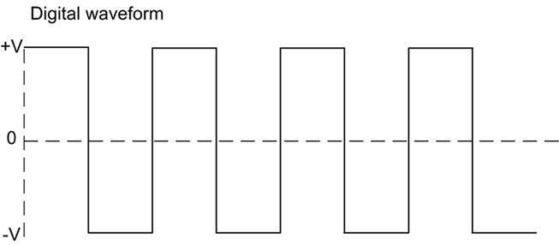
A digital waveform is characterized by a series of discrete pulses
Digital signaling typically uses baseband transmission, meaning that the complete bandwidth of the media is available to a single transmission channel.
When an analog input (such as speech) needs to be converted to digital, the input is sampled to derive discrete binary values. When sampling like this, you have to balance quality with available bandwidth. For example, telecommunications links are based on 64 Kbps channels because that is the bandwidth requirement for carrying digitized voice calls. This is worked out as a result of the following calculation, derived from the Nyquist theorem that the sampling rate must be twice the signal bandwidth.
- The voice frequency range is (or assumed to be) 4000 Hz. This must be sampled at twice the rate (8000 Hz or 8 KHz) to ensure an accurate representation of the original analog waveform.
- The sample size is 1 byte (or 8 bits). Therefore, 8 KHz x 8 bits = 64 Kbps.

Analog Signaling and Modulation
Analog signaling is characterized by a continually changing wave rather than discrete pulses. It uses properties of electromagnetic waves to carry information by a process called modulation. Modulation means a property of the wave is varied by the sender and then measured (de-modulated) by the receiver. A modulated wave carrying information is also referred to as a carrier wave.
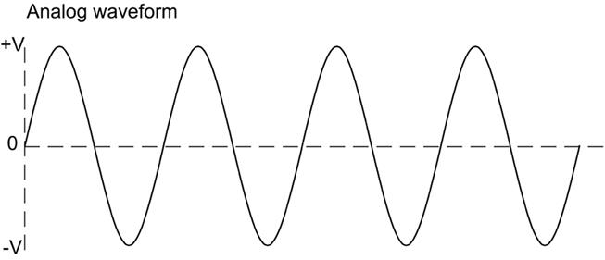
An analog waveform is a continually changing wave
The properties of an analog waveform are as follows:
- Wavelength - the distance between two peaks or troughs in the wave.
- Frequency - the oscillations per second of the wave, measured in Hertz. An oscillation or cycle is one complete transition (from crest-to-crest or trough-to-trough for instance). Frequency is inversely proportional to wavelength; so high frequency waves have shorter wavelengths compared to low frequency waves.
- Amplitude - the height or power of the wave. As a wave travels, its energy dissipates and the amplitude of the wave attenuates. As the amplitude diminishes, it becomes more susceptible to noise and reception problems.
- Phase - the angle of the wave at a particular moment.
For example, high and low amplitude could be used to represent the 1s and 0s of digital data. Phase and frequency can similarly be used to encode digital data in the wave as a signal. This process is easily subject to interference. It is also difficult to boost an analog signal, as amplifying it will also amplify any interference affecting it.

Multiplexing, Broadband, and Baseband
To make optimum use of the transmission media, it is often desirable to use it to create multiple channels. The technique by which division of a transmission medium into multiple discrete channels is accomplished is called multiplexing. Conversely, de-multiplexing is the means by which each channel is extracted from the media and processed by the receiver. The devices that put data into separate channels for transmission over the media are called multiplexers (muxes). De-multiplexers perform the reverse process.
Broadband transmission can divide the available bandwidth of the media into discrete communication channels using Frequency Division Multiplexing (FDM). For example, if the overall frequency range of the media is 100 MHz, you could create 5 channels each with 20 MHz bandwidth.
Baseband circuits can also carry multiple channels but using a different method of multiplexing. Time Division Multiplexing (TDM) means allocating each channel a window or slot during which it can use the media. Each channel uses the whole bandwidth of the media but has to wait its turn to be granted access.

Media Access Control
A multiple access area network has to be able to share the available communications capacity between the various nodes that use it. This means that networks need ways of determining when nodes are allowed to communicate and to deal with possible problems, such as two devices attempting to communicate simultaneously. Media Access Control (MAC) is the methodology used to determine when nodes are allowed to communicate using the network.

Contention and Collision Domains
In a contention-based system, each network node within the same collision domain competes with the other connected nodes for use of the transmission media. When two nodes transmit at the same time, the signals are said to collide and neither signal can reach its destination. This means that they must be re-sent, reducing available bandwidth. The collisions become more frequent (geometrically) as more nodes are added to the network and consequently the effective data rate (or throughput) reduces too.
Protocols governing contention and media access are called Carrier Sense Multiple Access(CSMA) protocols:
- Carrier sense - detect activity on the media.
- Multiple access - multiple nodes using the same media.
Use of these protocols enforces limitations on the minimum and maximum lengths of cable that can be used and the size of packets transmitted. Each packet must fill the cable segment before the end of transmission is reached or a packet could be sent and involved in a collision and lost without the sending node being aware of it. There are two types of CSMA protocols: CSMA/CD - with collision detection - and CSMA/CA - with collision avoidance.

CSMA/CD (with Collision Detection)
Ethernet's CSMA/CD protocol defines methods for detecting a collision on different types of media. In most cases this is when a signal is present on the interface's transmit and receive lines simultaneously. On detecting a collision, the node broadcasts a jam signal. Each node that was attempting to use the media then waits for a "random" period (backoff) before attempting to transmit again.

CSMA/CA (with Collision Avoidance)
The CSMA/CA protocols use schemes such as time-sliced accessing or requests to send data to gain access to the media. Nodes listen to the media before transmitting and only transmit if the media is clear. A node wanting to transmit, but detecting activity, must wait and try later. This reduces the number of collisions but adds overhead in terms of extra control signaling. The IEEE 802.11 Wi-Fi standard uses CSMA/CA.
 See Unit 4.3 / Installing Wireless Networks / Study Notes for more information about CSMA/CA and wireless technologies.

Switched Networks
Contention-based access methods do not scale to large numbers of nodes within the same collision domain. This problem is overcome by using switches. A switch establishes a "temporary circuit" between two nodes that are exchanging messages. Using a switch means that each switch port is in a separate collision domain. This means that collisions can only occur if the device attached to the port is operating in half-duplex mode and that the collisions affect only that port.

Half-duplex and Full-duplex
Older hub-based networks operate half-duplex transmissions. This means that a node can transmit or receive, but cannot do both at the same time. Modern appliances, such as switches, allow for full-duplex transmissions, where a device can transmit and receive simultaneously.

Broadcast Domains
Within a collision domain on a shared medium, any given node will see all the traffic transmitted within that domain. It will only normally choose to process traffic that is specifically addressed to it though. This is referred to as unicast traffic; traffic that is addressed by the sender to a single recipient.
It is useful to have a mechanism to transmit the same traffic to multiple nodes. This is referred to as broadcast traffic. This is accomplished using a special type of destination address. Nodes that share the same broadcast address are said to be within the same broadcast domain.
Broadcast traffic introduces efficiencies in some circumstances but inefficiencies in others. If the broadcast domain is very large, the amount of broadcast traffic will be correspondingly great and consume a disproportionate amount of bandwidth. This becomes an important factor in designing a network that works efficiently.
A collision domain is established by a devices operating at layer 1 or layer 2 of the OSI model, such as a hub, bridge, or switch. All devices attached to a hub will be part of the same collision domain; devices on either side of a bridge are in separate collision domains. Using switches effectively eliminates the concept of a collision domain entirely.
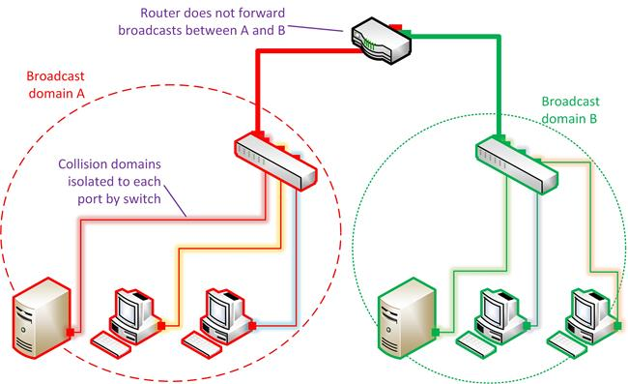
Collision and broadcast domains on a switched network - the switches isolate collision domains to each port while the router does not forward broadcasts
Broadcast domains are normally established by routers, operating at layer 3 of the OSI model. A broadcast domain could contain multiple collision domains but the reverse is not true. A single collision domain can only be associated with one broadcast domain.
See Unit 2.2 / IPv4 Addressing / Study Notes and Unit 2.5 / Routing / Study Notes for more information on IP and routing and Unit 1.3 / Hubs, Bridges, and Switches / Study Notes for topics on hubs, bridges, and switches.

Ethernet Frames
Many technologies have been developed to enable local networks using different media and media access methods and subsequently fallen by the wayside leaving Ethernet as the only mainstream cabled LAN product. Ethernet supports a variety of media options and is based upon inexpensive equipment. It was created in the 1960s at the University of Hawaii for its ALOHA network and was first used commercially by DEC, Intel, and Xerox (DIX) in the late 1970s. It was standardized by IEEE as 802.3 (gtsgo.to/cto60) in 1983.
Ethernet has a logical bus topology but is usually wired in a physical star topology, baseband signaling, and the CSMA/CD method for media access control.
The basic format of an Ethernet frame is as follows:
Construction of an Ethernet frame

Preamble
The preamble is used for clock synchronization. It consists of 8 bytes of alternating 1s and 0s with two consecutive 1s at the end. This is not technically considered to be part of the frame.

Addressing
The destination and source address fields contain the MAC addresses of the receiving and sending nodes. Ethernet network adapters have a unique hardware or physical address known as the Media Access Control(MAC) address. A MAC address is 48 bits long (6 bytes).

Frame Length and Payload
The official 802.3 standard defines a 2-byte length field to specify the size of the data field (also called the payload). This payload can normally be between 46 and 1500 bytes. The upper limit of the payload is also referred to as the Maximum Transmission Unit (MTU).
However, most Ethernet products follow the original DIX specification (referred to as Type II frames) and use the field to indicate the type of network layer protocol contained in the frame (IP or IPX for instance). These Ethertypes are values of 1536 or greater (anything less than that is interpreted as the data length). For example, IPv4 is coded as the hex value 0x0800 (or 2048 in decimal) while IPv6 is 0x86DD.
 802.3 Ethernet frames use a Logical Link Control (LLC) header to identify the protocol type. It can be further extended with a Subnetwork Access Protocol (SNAP) field to specify proprietary protocols. These headers take up part of the space normally reserved for data (reducing it to up to 1492 bytes). Consequently these frame types are not widely used.
To comply with CSMA/CD, the minimum length of an Ethernet frame is 64 bytes so the payload must be at least 46 bytes. If this is not the case it is automatically padded with redundant data.
The maximum size of any type of Ethernet frame is normally 1518 bytes (excluding the preamble).
The IEEE 802.1Q Virtual LAN (VLAN) standard specifies use of a 32-bit (4-byte) tagging field inserted between the source address and length fields. This makes the maximum allowable frame size 1522 bytes. This increase in frame size is implemented by the 802.3ac amendment to the Ethernet standard.
Construction of an 802.1Q / 802.3ac (VLAN tagged) Ethernet frame
802.1Q frames are normally only used by switches. The tag field can be used to identify the VLAN to which the frame belongs and to assign an IEEE 802.1p frame priority level.
 VLANs are a means of dividing a single physical network into multiple logically distinct networks. See Unit 1.3 / Hubs, Bridges, and Switches / Study Notes for details. IEEE 802.1p is a means of prioritizing some types of traffic over others as part of a Quality of Service (QoS) mechanism. QoS and 802.1p are discussed in Unit 3.4 / Applications and Services / Study Notes.
Some Gigabit and 10G Ethernet products support jumbo frames with much larger MTUs. Such products are not standardized however making interoperability between different vendors problematic.
Jumbo frames are discussed in some more detail in the topic on Storage Area Networks. See Unit 3.6 / Cloud and Virtualization / Study Notes for details.

Error Checking
The error checking field contains a 32-bit (4-byte) checksum called a Cyclic Redundancy Check (CRC) or Frame Check Sequence (FCS). The CRC is calculated based on the contents of the frame; the receiving node performs the same calculation and, if it matches, accepts the frame. There is no mechanism for retransmission if damage is detected nor is the CRC completely accurate at detecting damage; these are functions of error checking in protocols operating at higher layers.

Legacy Ethernet Standards
Ethernet media specifications are named using a three-part convention. This describes:
- The bit rate (Mbps).
- The signal mode (baseband or broadband).
- A designator for the media type.
For example, 10BASE-T denotes an implementation that works at 10 Mbps, uses a baseband signal, and uses twisted pair cabling.
 All types of Ethernet actually use baseband transmissions, so you will only see specifications of the form xBASE-y.
Many types of Ethernet use Unshielded Twisted Pair (UTP) rated to a particular "Cat" standard or fiber optic cabling (SMF or MMF). Cable types and specifications are covered in more detail in Unit 4.2 / Installing Cable / Study Notes.

10BASE-2
10BASE-2 (or Thinnet) is one of the earliest Ethernet standards. Unlike subsequent standards, it uses a physical bus topology. 10BASE-2 uses coaxial cabling. In a single segment, each node is attached to the same run of bus cable using a BNC T-connector. The bus cable must be terminated by resistors at each end and one end must be grounded.
10BASE-2 Specification
Maximum segment cable length | 185m (607 feet)
Minimum cable length | 0.5m (1.5 feet)
Maximum nodes per segment | 30
Maximum segments | 5
Maximum repeaters | 4
Maximum mixing segments (with nodes) | 3
Thinnet was often used with 10BASE-5 (Thicknet). Thicknet uses a different grade of coax and supports longer segment lengths (up to 500m) and more nodes per segment. Consequently, in a typical installation, up to 3 Thinnet segments (with computers attached as nodes) could be linked (via devices called repeaters) using up to 2 Thicknet segments. These limitations were described as the 5-4-3 rule. The overall cable length for all segments cannot exceed 925m.
10BASE-2 would not be deployed on new networks but you may be called upon to maintain it in legacy installations.

10BASE-T
10BASE-T Ethernet uses 4-pair unshielded or shielded twisted pair copper wire cabling. A pair consists of two insulated wires wrapped around one another. One pair is used to transmit (Tx) and one pair to receive (Rx), while the other two pairs reduce crosstalk and interference.
10BASE-T networks are physically wired as a star. The logical topology is a bus:
- When a hub is used the transmission media are shared between all nodes as all communications are repeated to each port on the hub.
- When a switch is used, a temporary virtual circuit is created between each node utilizing the full bandwidth available.
With compatible network adapters and switches, 10BASE-T supports full-duplex operation. Hub-based Ethernet supports half-duplex only.

10BASE-T Specification
Maximum segment cable length | 100m (328 feet)
Minimum cable length | 0.5m (1.5 feet)
Maximum segments | 1024
Maximum hubs between nodes | 4
The 10BASE-T Ethernet specification imposes its own restrictions regarding the network design. In 10BASE-T, a segment is defined as the link between two nodes (typically between a workstation and the hub or switch).
10BASE-T would not be deployed on new networks but you may be called upon to maintain it in legacy installations.

Fast Ethernet
When it came to update the 10BASE-T Ethernet standard, the IEEE 802.3 committee decided on an approach that ensured backward compatibility. Its discussions resulted in the IEEE 802.3u specification, which is known as Fast Ethernet. Fast Ethernet is based on the same CSMA/CD protocols that define traditional Ethernet but reduces the duration of time each bit is transmitted by a factor of ten by using higher frequency signaling and improved encoding methods. This raises the bit rate from 10 Mbps to 100 Mbps. Data can move between Ethernet and Fast Ethernet devices without requiring protocol translation, as Fast Ethernet maintains the old error control functions, frame format, and length. Fast Ethernet can use twisted pair or fiber optic cable.
Specification | Cable | Maximum Distance
100BASE-TX | UTP (Cat 5) | 100m (328 feet)
100BASE-FX | MMF (62.5/125) / 1300nm | 412m (1312 feet) / half-duplex  2000m (6562 feet) / full-duplex
There are a couple of defunct standards defining use over Cat 3 cable (100BASE-T4 and 100BASE-T2). The set of copper standards can collectively be referred to as 100BASE-T.
Fast Ethernet allows only one or two hubs, though this does not apply if the hubs are stacked using a proprietary backplane (the stack counts as one device). The standards documentation also defines two classes of hubs; Class I hubs are used to connect different media (twisted pair and fiber optic for instance) and only one device per network is allowed if this type of hub is used. In most modern networks however the restriction is overcome by using switches in place of hubs.
Fast Ethernet also introduced an autonegotiation protocol to allow devices to choose the highest supported connection parameters (10 or 100 Mbps and half- or full-duplex). 10BASE-T Ethernet specifies that a node should transmit regular electrical pulses when it is not transmitting data to confirm the viability of the link (Link Integrity Test). Fast Ethernet codes a 16-bit data packet into this signal advertising its service capabilities (speed and half- or full-duplex). This is called a Fast Link Pulse. Fast Link Pulse is backward-compatible with 10BASE-T but not mandatory, as it is under Gigabit Ethernet and later. A node that does not support auto negotiation can be detected by one that does and sent ordinary link integrity test signals (or Normal Link Pulses).
Fast Ethernet would not be deployed on new networks but you may be called upon to maintain it in legacy installations.

Modern Ethernet Standards
While the standards listed previously are obsolete, the subsequent versions of Ethernet remain very much in use.

Gigabit Ethernet
Gigabit Ethernet builds on the standards defined for Ethernet and Fast Ethernet. The bit rate is 10 times faster than with Fast Ethernet. The Gigabit Ethernet standard over fiber (LX and SX) is documented in IEEE 802.3z. The various fiber standards are collectively known as 1000BASE-X. The IEEE also approved 1000BASE-T, a standard utilizing Cat 5e or Cat 6 copper wiring. This is defined in IEEE 802.3ab.
Specification | Cable | Maximum Distance
1000BASE-T | UTP (Cat 5e or Cat 6) | 100m (328 feet)
1000BASE-SX | MMF (62.5/125) / 850nm  MMF (50/125) / 850nm | 220m (721 feet)  550m (1640 feet)
1000BASE-LX | SMF (9/125) / 1310nm  MMF (62.5/125 or 50/125) / 1300nm | 5km (3.1 miles)  550m (1800 feet)
For 1000BASE-T, Cat 5 is also acceptable (if properly installed) but Cat 5 cable is no longer available commercially. Unlike Ethernet and Fast Ethernet, Gigabit Ethernet uses all four pairs for transmission and so is much more sensitive to crosstalk. A standard was created using only two pairs (1000BASE-TX) but was not successful commercially.
In terms of network design, Gigabit Ethernet is implemented using switches, so only the restrictions on cable length apply. Gigabit Ethernet would be the mainstream choice for most new network installations. The main decision would be whether to use copper or fiber cable. Fiber cable would give better upgrade potential in the future while copper cable would be cheaper to install.

10G(igabit) Ethernet
10G Ethernet multiplies the nominal speed of Gigabit Ethernet by a factor of 10. 10G is not deployed in many office networks however as the cost of 10G network adapters and switches is high. The major applications of 10G Ethernet are:
- Increasing bandwidth for server interconnections and network backbones, especially in data centers and for Storage Area Networks (SAN).
- Replacing existing switched public data networks based on proprietary technologies with simpler Ethernet switches (Metro Ethernet).
10G Ethernet is standardized under a number of publications with letter designations (starting with 802.3ae), which are periodically collated (the current one being IEEE 802.3-2012).
Specification | Cable | Max Distance
10GBASE-T | UTP (Cat 6) and F/UTP (Cat 6A) | 55 and 100m
10GBASE-SR | MMF / 850nm | 300-400m
10GBASE-LR | SMF (9/125) / 1310nm | 10km (6.2 miles)
10GBASE-ER | SMF (9/125) / 1550nm | 40km (25 miles)
10G works only with switches in full-duplex mode.
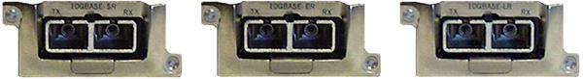
HP transceivers (network ports) for 10GBASE-SR / ER / LR (fiber optic) links
The 10GBASE-"R" standards all have WAN specifications (10GBASE-SW, 10GBASE-LW, and 10GBASE-EW) that allow interoperability with SONET infrastructure.
See Unit 4.4 / WAN Technologies / Study Notes for more information on WAN technologies.

MAC Addressing
The transceiver component responsible for physically connecting the node to the transmission medium is implemented in a network adapter, network adapter card, or Network Interface Card / Controller(NIC). At the data link layer, the NIC is also responsible for organizing data into frames and providing each interface with a hardware address. Note that a NIC may have more than one interface (multi-port).
Each Ethernet network interface has a unique hardware address known as the Media Access Control(MAC) address. This may also be referred to as the Ethernet Address (EA) or (in IEEE terminology) the Extended Unique Identifier (EUI).

MAC Address Format
A MAC address consists of 48 binary digits (6 bytes). The format of the number differs depending on the system architecture. It is often displayed as 6 groups of 2 hexadecimal digits with colon or hyphen separators or no separators at all (for example, 00:60:8c:12:3a:bc or 00608c123abc) or as 3 groups of 4 hex digits with period separators (0060.8c12.3abc for instance).
Hexadecimal uses digits 0-9 and letters A, B, C, D, E, and F to represent the 16 possible values of each hex digit See Unit 2.4 / IPv6 Addressing / Study Notes for more information on the hex numbering system.
The IEEE gives each card manufacturer a range of numbers and they hard code every interface produced with a unique number from their range. This is called the "Burned In Address". The first six hex digits (3 bytes or octets), also known as the Organizationally Unique Identifier (OUI), identify the manufacturer of the adapter. The last six digits are a serial number.
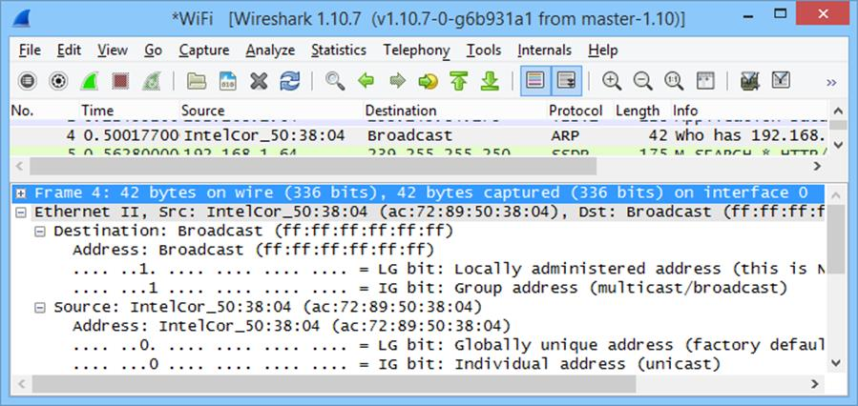
Captured Ethernet frame showing the resolved OUI and I/G and U/L bits in the destination (broadcast) and source addresses
An organization can decide to use locally administered addresses in place of the manufacturers' universal coding systems. This can be used to make MACs meaningful in terms of location on the network but adds a significant administrative overhead. A locally administered address is defined by changing the U/L bit from 0 to 1. The rest of the address is configured using the card driver or network management software. It becomes the network administrator's responsibility to ensure that all devices are configured with a unique MAC.
The I/G bit of a MAC address determines whether the frame is addressed to an individual node (0) or a group (1). The latter is used for broadcast and multicast transmissions. A MAC address consisting entirely of 1s is the broadcast address and received by all nodes within the same broadcast domain.
An EUI-64 is a 64-bit hardware address. A translation mechanism allows a 48-bit MAC address to be converted to an EUI-64. See the topic on IPv6 in Unit 2.4 / IPv6 Addressing / Study Notes for more information.

Unicast and Broadcast
When a sending interface addresses a single receiving interface, this is referred to as a unicast transmission. In the figure following, the node with MAC address 0206.0000.6666 sends a frame of data addressed to 0206.0000.1111 (the server). The server recognizes its own MAC address and copies the frame for processing. The other hosts ignore the frame, as the destination address does not match their own.
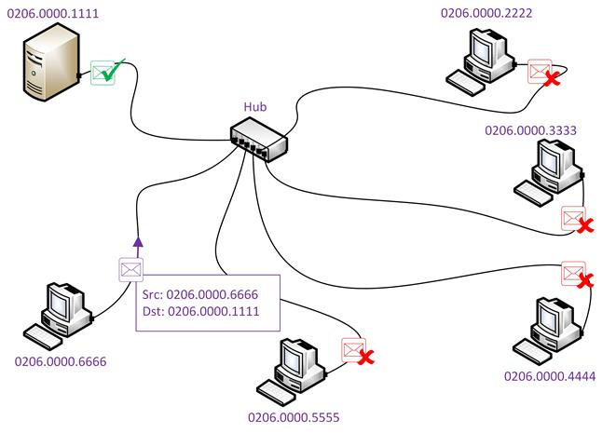
Checking the destination address of a frame
Under certain circumstances, it is necessary for a computer to broadcast data to all computers on the network. The computer broadcasting the data uses a broadcast "hardware" address of ff:ff:ff:ff:ff:ff

Address Resolution Protocol (ARP)
When two machines communicate using TCP/IP, an Internet Protocol (IP) address is used at the network layer to identify each machine. However, transmission of data must take place at the physical and data link level using the hardware / MAC address of the interface. The TCP/IP suite includes the Address Resolution Protocol (ARP) to perform the task of resolving an IP address to a hardware address.

Local Address Resolution
When both sending and receiving hosts are on the same local network (connected to the same hub for instance), local address resolution takes place as follows:
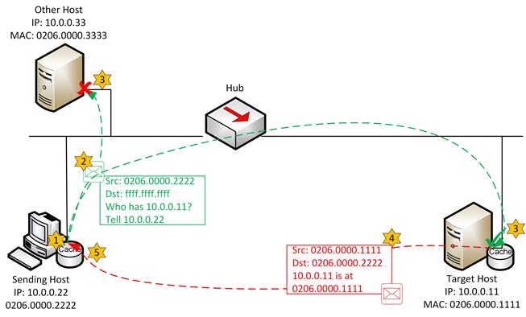
Local address resolution
- When the destination IP address has been determined to be a local address, the source host checks its ARP cache for the required hardware address (MAC address) of the destination host.
- If not present in cache, ARP builds a request, which is then broadcast onto the network.
- The broadcast is processed by all the hosts on the local segment but unless the request contains its own IP address, most hosts ignore it.
- If the target host recognizes its own address, it updates its cache with the MAC address of the source host. It then replies to the source host.
- The source host receives the reply, updates its cache table, and communication is established.

Remote Address Resolution
If the host is on a remote network, then the local host must use a router (its default gateway) to forward the packet. Therefore, it must determine the MAC address of the gateway using ARP.
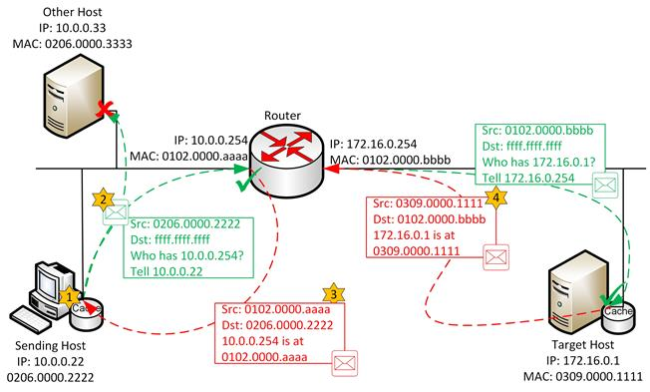
Remote address resolution
- When the destination IP address has been determined to be a local address, the sending host determines the IP address of its default gateway (router). The sending host then examines its ARP cache for the necessary IP address / MAC address mapping of the gateway.
- If the mapping for the gateway address is not found in the cache, it broadcasts an ARP request for the default gateway's IP address (but NOT the IP address of the remote destination host).
- Hopefully, the router will respond to the request by returning its hardware address. The sending host then forwards the packet to the default gateway to deliver to the remote network and the destination host.
- At the router, IP determines whether the destination is local or remote. If local, it uses ARP for the address resolution. If remote, it checks its route table for an appropriate gateway to the remote network.

ARP Cache
ARP broadcasts can generate considerable traffic on a network, which can reduce performance. To optimize this process, the results of an ARP broadcast are held in a cache initially. If the entry is used within the timeout period, the entry is held in the cache for a few minutes before it is deleted. Entries in the ARP cache are automatically timed out in case a hardware address changes (for example, if a network card is replaced).
The timeout for the ARP cache varies by operating system and version and can often be configured manually.
The cache is an area reserved in memory that contains the IP address and the associated hardware address. Before an ARP broadcast is performed, the cache is always checked for the correct MAC address. Broadcasting is reduced further as the host receiving an ARP request always extracts the IP address and hardware address of the source host and places this information in its ARP cache before transmitting an ARP reply.

arp
The arp utility can be used to perform a number of functions related to the ARP cache.
- arp -a (or arp -g) views the ARP cache contents; use with IPAddress to view the ARP cache for the specified interface only.
- arp -s IPAddressMACAddress adds an entry to the ARP cache. Under Windows, MACAddress needs to be entered using hyphens between each hex byte.
- arp -d * deletes all entries in the ARP cache; can also be used with IPAddress to delete one entry only.
The above illustrates some uses of the command under Windows. Syntax for Linux and UNIX is often different. Check the help for the utility on the system you are using to learn about switches and arguments available.

MAC Address Lookup Table
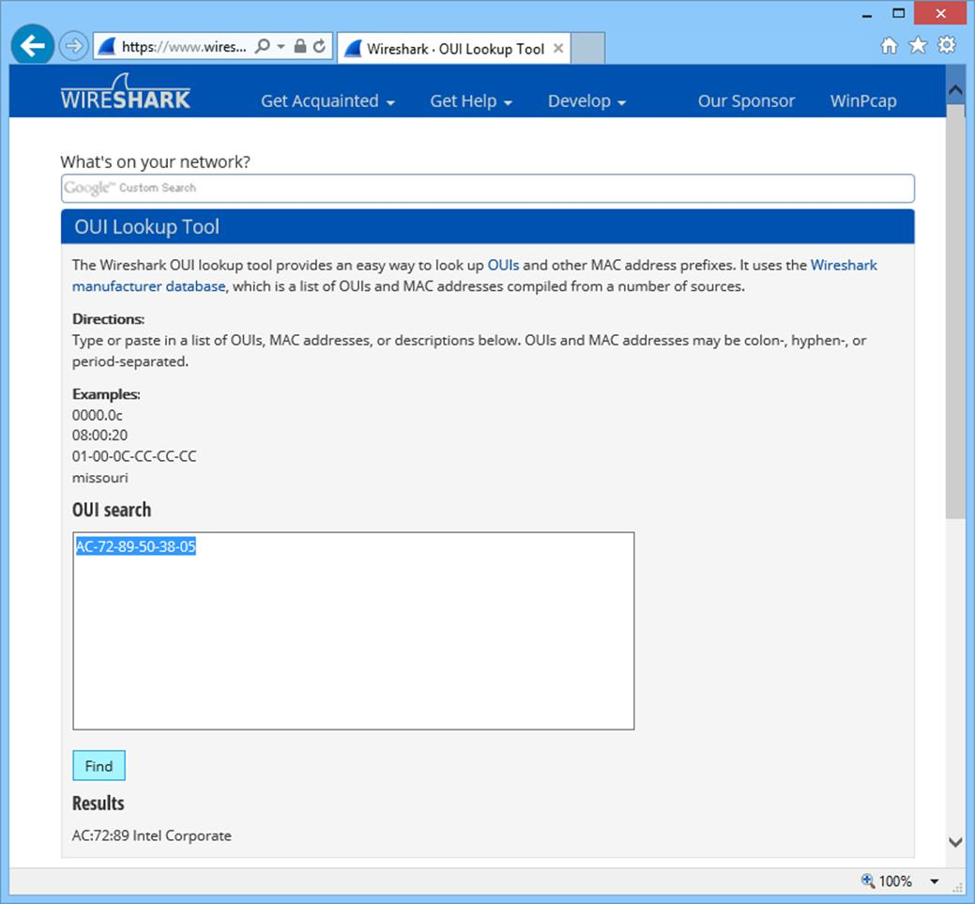
Finding the network adapter vendor from a MAC address using Wireshark's OUI Lookup Tool
A MAC Address Lookup Table (or OUI Lookup Table) enables you to identify the manufacturer or a network adapter from the OUI value coded in its MAC address.
 You might also need to query the MAC address table of a switch to find the MAC address or addresses associated with a particular port. This could be performed at the switch's command line interface using a command such as show mac address-table. Refer to Unit 1.3 / Hubs, Bridges, and Switches / Study Notes for more information about switches.

Protocol Analyzers

A protocol analyzer (or packet sniffer or network analyzer) performs frame capture and analysis. The analyzer can be implemented on special hardware (as part of a cable tester for instance) or installed as software on a PC host. There isn't really much of a distinction between a packet sniffer and protocol analyzer. You can think of a packet sniffer as something that only captures frames (without doing any decoding, filtering, or analysis) but almost all the tools available have some sort of analysis functionality built-in, making the terms pretty much interchangeable.
Protocol analyzers can decode a captured frame to reveal its contents in a readable format. You can choose to view a summary of the frame or choose a more detailed view that provides information on the OSI layer, protocol, function, and data.
The capabilities of different products vary widely, but in general terms protocol analyzers can perform the following functions:
- Identify the most active hosts on the network, which aids in balancing traffic on networks.
- Isolate hosts producing erroneous packets and rectify the problem.
- Filter traffic and capture packets meeting certain criteria (capturing traffic to and from a particular device for instance).
- Baselining - the activity on a network is sampled periodically to establish normal levels of activity. The baseline is then used to compare against activity when a problem is suspected or as a basis for network expansion plans.
- Generate frames and transmit them onto the network to test network devices and cabling.
- Monitor bandwidth utilization by hosts, applications, and protocols.
- Trigger alarms when certain network conditions fall outside "normal levels".
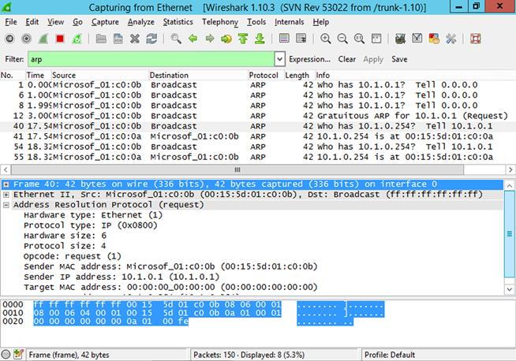
Wireshark protocol analyzer

Promiscuous Mode and Sniffing Switched Ethernet
By default, a network interface only processes packets that are directed to that card (unicast or multicast traffic) or broadcast messages. Most packet sniffers can make a network adapter work in promiscuous mode, so that it processes all unicast traffic within the Ethernet broadcast domain, whether it is intended for the host machine or not.
While this approach works for a hub, where all traffic is repeated on every port, on a switched network, the switch makes decisions about which port to forward traffic to, based on the destination address and what it knows about the interfaces connected to each port. This means that to capture unicast traffic intended for other hosts, the sniffer needs to be connected to a suitably configured spanning port (mirrored port).
There are various, less legitimate techniques available to sniff switched traffic, such as arp spoofing. See Unit 5.1 / Vulnerabilities and Threats / Study Notes for more details. Switches and mirrored ports are discussed in Unit 1.3 / Hubs, Bridges, and Switches / Study Notes.
 Most Ethernet adapters and drivers support the function of a protocol analyzer working in promiscuous mode. When it comes to sniffing wireless traffic and the monitor mode equivalent of promiscuous mode, the situation is more complex. Many wireless adapter chipsets and/or drivers do not allow monitor mode and so prevent the capture of management frames and traffic not addressed to the host.

