UNIT 1.1 / TOPOLOGIES AND THE OSI MODEL / STUDY NOTES

Key Features of Networks
A network is two or more computer systems linked together by some form of transmission medium that enables them to share information. It does not matter whether the network contains two or thousands of machines; the concept is essentially the same.
A network will provide services to its users. Historically, these services have included access to shared files, folders, and printers plus email and database applications. Modern networks are evolving to provide more diverse services, including web applications, Voice over IP, and multimedia conferencing.

Network Boundaries
A network at a given location is often described as a Local Area Network (LAN). Networks in different geographic locations but with shared links are called Wide Area Networks (WAN).
 LAN and WAN are only two of the terms used to describe networks of different scales and sizes. See Unit 1.4 / Infrastructure and Design / Study Notes for more on this topic.

Network Components
The following terms are used to describe components of the network:

Node, Stations, and Hosts
A node is any device that can communicate on the network via one or more network interfaces. Consequently the term node can be used to describe endpoint devices, such as computers, laptops, servers, IP phones, smartphones, or printers, and connecting or forwarding devices, such as switches and routers. A node on a wireless network is often called a station.
The term host is often used in TCP/IP networking to mean an end system device, such as a computer, with a unique address on the network.

Transmission Media
A link between network nodes is created using some form of transmission (or physical) media. Typically, this takes the form of a cable but wireless media using technologies such as radio can provide the same function.

Local Network Devices, Segments, and Backbones
Relatively few networks are based on directly connecting computers together. Rather than making hosts establish direct links with one another, each host is connected to a central node, such as a switch or wireless access point. The central node provides a forwarding function, receiving the communication from one node and sending it to another.
A central device such as a switch implies that the connected nodes are part of the same physical network and use the same type of transmission media. The term switching is used for this forwarding function taking place within the same physical network. The addresses of interfaces within the same network are described as local addresses.
The term segment can be used to refer to a specific physical region of a network, though the scope of a segment depends on the exact technology in use. One typical usage now is to describe the link between a computer and a switch. Another usage is to refer to a region of the network where all the nodes use the same type of transmission media and have the same bandwidth.
A network is typically divided into segments either to cope with the physical restrictions of the network media used or to improve performance (or both). From the point-of-view of performance, communications between segments need to be carefully controlled. A backbone describes a fast link between other segments of a network. The backbone carries all the communications occurring between nodes in separate segments.

Routing Devices and Subnets
Local and remote networks can be joined using nodes such as routers that can make distinctions between logically separate networks. Such networks may use different types of transmission media and network protocols. A network of hosts all installed in the same building may still be subdivided into separate logical networks, often referred to as subnetworks (or subnets). In a network of networks, each interface must have a network address in addition to a local address.

Typical Network Layout
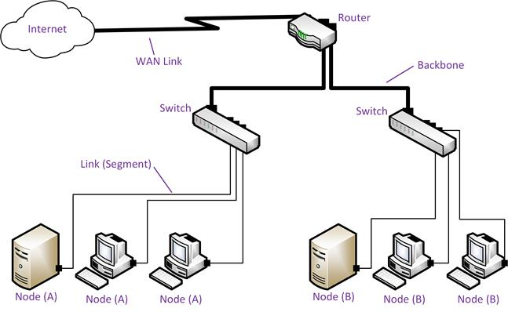
Positioning network components
The graphic above illustrates how the network components described above might be positioned. The whole network is connected to the wider internet via a router. The router is also used to divide the network into two subnets (A and B). Within each subnet, a switch is used to allow nodes to communicate with one another and (through the router) the other subnet and the Internet. The link between each node and the switch is a segment. High bandwidth backbone segments are used between the router and the Internet and the router and the two switches.

Network Protocols
A protocol is a set of rules enabling systems to communicate by exchanging data in a structured format. Two of the most essential functions of a protocol are to provide addressing (describing where data should go) and encapsulation (describing how data should be packaged for transmission). The basic process of encapsulation is for the protocol to add fields in a header to whatever data (payload) it receives from an application or other protocol. A network will involve the use of many different protocols. For example, the concept of local and network addressing for switching and routing within and between networks is usually performed by different protocols.
Network clients are computers (or software) that allow users to request shared resources or applications on servers. Client computers are often referred to as workstations, though sometimes that term is reserved for particularly powerful client computers. A server provides shared resources on the network and allows clients to access this information. There are a number of different types of server:
- Network Servers provide services that allow clients to join the network, such as name resolution, authentication, or proxies.
- File and Print Servers share resources amongst clients.
- Application Servers provide centralized processing. Some examples include:
  - Virtual applications (desktop software hosted on a server rather than installed to a client machine).
  - Web applications (accessed via a web browser).
  - Database platforms such as SQL Server and Oracle accessed directly or through a web application.
- Messaging Servers provide email, chat, and/or conferencing functionality.
- Media Servers host streaming Audio/Video (A/V) applications.
On a small network, one machine might provide some, or even all, of these functions. In larger networks, machines may be dedicated to a subset of these functions.

Server-Based Networks
Clients and servers can be organized into two different logical topologies: server-based or peer-to-peer. A server-basednetwork uses a dedicated central server (or servers) to provide access to resources. Security is managed centrally by a system administrator who determines access to these resources. Every client can talk to the server, but they cannot talk to one another.
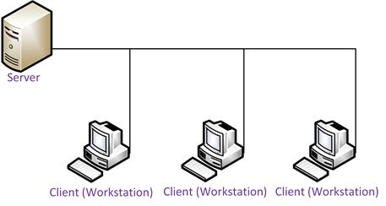
Server-based network
The first server-based Network Operating System (NOS) for PCs was developed by Novell and appeared as NetWare in 1985. Now the most widely used server NOS are Microsoft Windows Server and UNIX / Linux.
The main strengths of a server-based system include the following:
- Performance - the clear distinction between server and client means that the server hardware and software can be optimized to support many clients simultaneously and provide fast response and high data throughput.
- Security - all major server-based systems provide sophisticated security.
- Administration - services are centralized making them easier to manage than decentralized "peer-to-peer" systems.
- Scalability - server-based systems are designed to support a wide range of organization sizes. Often additional servers are added to increase capacity.

Peer-to-Peer Networks
For larger organizations, the investment in a server-based system is appropriate but for small organizations it can be expensive. Peer-to-peer networks were developed as a low cost alternative in the early 1990s. Desktop or workstation versions of Microsoft Windows support small numbers of computers in a peer-to-peer configuration and Linux and Apple Mac OS X are also suitable for this use.
A peer-to-peer system does not have a dedicated server. Each computer on the system is a "peer" of the others and each may act as both a client and a server. This means that every user may share folders on his or her hard disk and also share peripherals, such as printers and scanners.
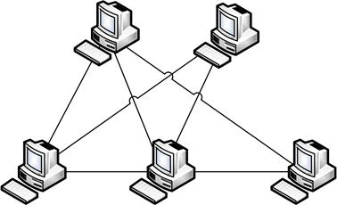
Peer-to-peer network
While this is cheaper initially, the disadvantages include the following:
- Peer-to-peer systems typically use machines of a lower specification than dedicated servers. The overhead of acting as a workstation as well as a server affects performance.
- Peer-to-peer networks are difficult to manage because they are based on the concept that each user is responsible for his or her own machine. For example, it is possible that one user might switch off his or her machine while another is using resources on that machine.
- Lack of security. The security relies on each user controlling access to the resources on his or her own PC. As well as (relatively) uncontrolled access to resources, this can mean that data does not get backed up properly.
Client/server and peer-to-peer topologies describe different ways of providing access to network resources. A network topology can also describe the physical or logical structure of the network. This type of topology is described in terms of nodes and links.
- The physical network topology describes the placement of nodes and how they are connected by the network media. For example, in one network nodes might be directly connected together via a single cable; in another network, each node might connect to a switch via separate cables. These two networks have different physical topologies.
- The logical topology describes the flow of data through the network. For example, given the different physical network topologies described above, if in each case the nodes can send messages to one another, the logical topology is the same. The different physical implementations (directly connected via a cable versus connected to the same switch) achieve the same logical layout.

Point-to-Point and Point-to-Multipoint Links
In the simplest type of topology, a single link is established between two nodes. This is called a point-to-point (or one-to-one) connection. Because only two devices share the connection, they are guaranteed a level of bandwidth.
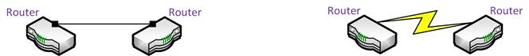
Point-to-point links - the routers on the left are physically connected via a cable while the "blaze" lighting symbol connecting the routers on the right represents a logical link (not necessarily a single cable)
A point-to-point link can be a physical or logical topology. For example, on a WAN, two routers might be physically linked via multiple intermediate networks and physical devices but still share a logical point-to-point link, where each can only address the other router. With either a physical or logical topology, it is the 1:1 relationship that defines a point-to-point link.
On a local network, physical point-to-point links are more likely to be implemented using switching devices.
A point-to-multipoint link is any connection between three or more devices. This means that a single device can address multiple devices in a one-to-many relationship. Multipoint links can be implemented by several different types of physical and logical topologies, described below.
Multipoint links imply that the bandwidth of the transmission media is shared between all the nodes participating in the link.
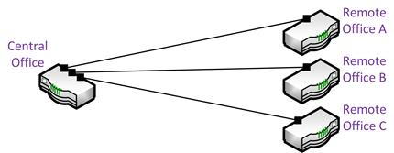
Point-to-multipoint link between a central office and remote sites
 The terms "point-to-point" and "point-to-multipoint" are most often used in connection with WAN (see Unit 4.4 / WAN Technologies / Study Notes) and wireless (see Unit 4.3 / Installing Wireless Networks / Study Notes) network topologies.

Bus Topology
A physical bus topology with more than two nodes is a true multipoint or shared access topology. All nodes attach directly to a single main cable via cable taps. The signal travels down the bus in both directions from the source and is received by all nodes connected to the cable. The bus is terminated at both ends of the cable to absorb the signal when it has passed all connected devices.
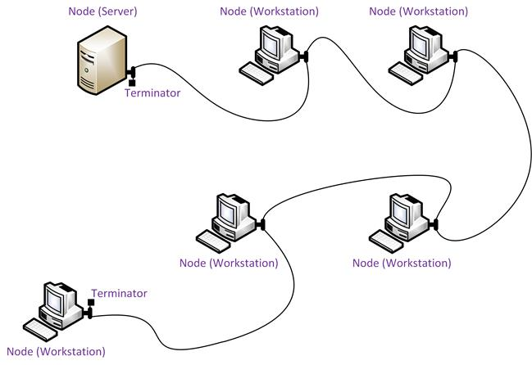
Physical bus topology
 A bus network does allow cables to be connected using a device called a repeater. Two lengths of cable joined by a repeater is considered one length of cable for the purpose of the bus topology. A repeater is a passive device and would not be considered a network node in the way that a hub, switch, or router would.
This type of physical bus topology is no longer in widespread use. Bus networks are comparatively difficult to reconfigure (adding or removing nodes can disrupt the whole network), impose limitations on the maximum number of nodes on a segment of cable, and are difficult to troubleshoot (a cable fault could be anywhere on the segment of cable). Perhaps most importantly, a fault anywhere in the cable means that all nodes will be unable to communicate.
The logical bus topology however remains the basis of most local networks.

Star Topology
In a star network, each endpoint node is connected to a central forwarding nodes, such as a hub, switch, or router. The central node mediates communications between the endpoints.
The star topology is the most widely used physical topology. It is easy to reconfigure and easy to troubleshoot, because all data goes through a central point, which can be used to monitor and manage the network. Faults are automatically isolated to the media, node (network card), or the hub, switch, or router at the center of the star.
You may also encounter the hub and spoke topology. This is the same layout as a star topology. The hub and spoke terminology is used when speaking about WANs with remote sites.

Physical Star - Logical Bus Topology
A physical star network can be used to implement a logical bus topology. Each node in a star-wired logical bus topology behaves as though it will be sharing the network medium with other nodes.
When a device such as a hub is used at the center of the star, transmissions are still repeated to each node. Logically the topology works like a single cable bus and the bandwidth is still shared between all nodes, which are all contending for the same network media. This means that some of the limitations of a physical bus topology are retained.
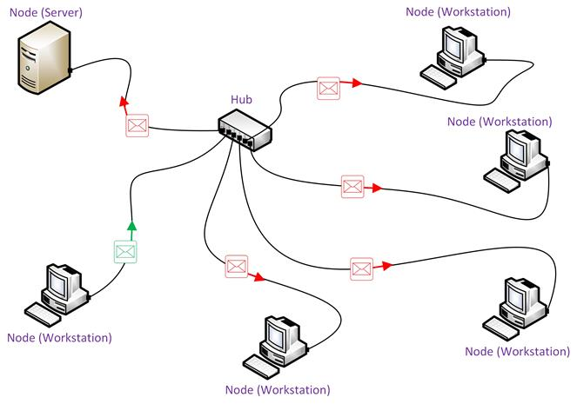
Star topology with a hub at the center of the star
When a device such as a switch is used at the center of the star, point-to-point links are established between each node as required. The logical topology is still a bus but the way the switch operates allows each node to use the full bandwidth of the link.
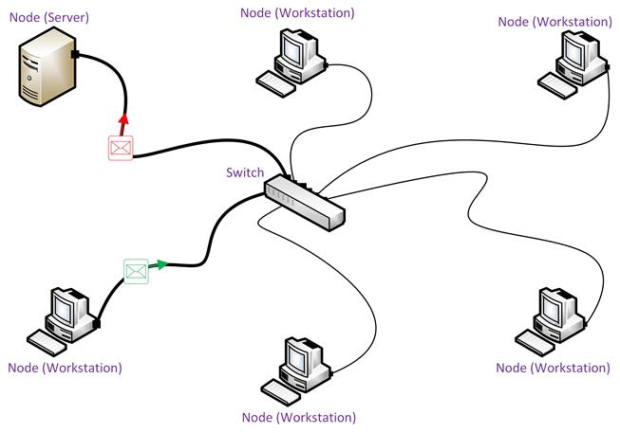
Star topology with a switch at the center of the star
The functions of hubs and switches and the differences between them are discussed in more detail in Unit 1.3 / Hubs, Bridges, and Switches / Study Notes.

Ring Topology
In a physicalring topology, each node is wired to its neighbor in a closed loop. A node receives a transmission from its upstream neighbor and passes it to its downstream neighbor until the transmission reaches its intended destination. Each node can regenerate the transmission, improving the potential range of the network.
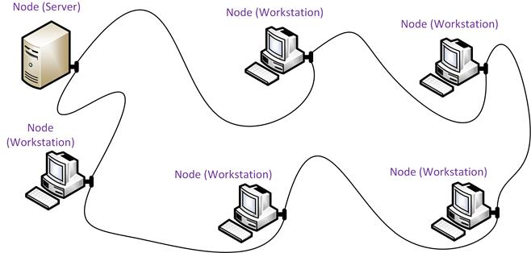
Ring topology
The physical ring topology is no longer used on LANs but it does remain a feature of many WANs. Two ring systems (dual counter-rotating rings) can be used to provide fault tolerance. These dual rings allow the system to continue to operate if there is a break in one ring.

Star-wired Ring Topology
You may still encounter networks based on a logical ring topology, such as IBM's Token Ring product. Token Ring is wired in a star topology (the device at the center of the star is called a Media (or Multistation) Access Unit [MAU]). Unlike a hub, an MAU is wired to connect each node in a ring. Consequently the whole topology is usually referred to as a star-wired ring. Access to the media is controlled by a token, passed around the ring between neighbors.
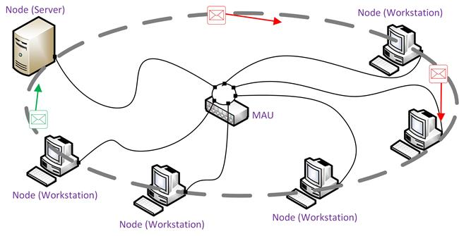
Star-wired ring topology

Mesh Topology
Mesh network topologies are commonly used in WANs, especially public networks like the Internet. In theory, a mesh network requires that each device has a point-to-point link with every other device on the network (fully connected). This approach is normally impractical however. The number of links required by a full mesh is expressed as n(n-1)/2, where "n" is the number of nodes. For example, a network of just 4 nodes would require 6 links, while a network of 40 nodes would need 780 links! Consequently, often a "hybrid" approach is used with only the most important devices interconnected in the mesh, perhaps with extra links for fault tolerance and redundancy. In this case, the topology is referred to as a partial mesh.
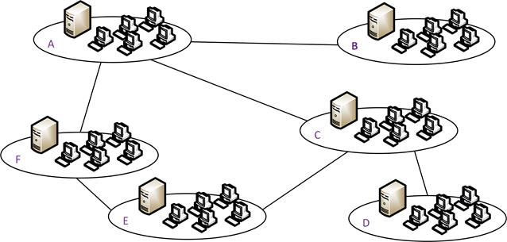
Partial mesh - each site is linked but not always directly to every other site
Mesh networks provide excellent redundancy, because other routes, via intermediary devices, are available between locations if a link failure occurs.

Hybrid Topologies
As noted above, two different physical and logical topologies are often combined within the same network as a hybrid topology to benefit from the advantages of both topologies. Hybrid physical topologies may also be used to extend networks. For example, a tree topology is a means of connecting star networks using a bus "backbone" or "trunk".
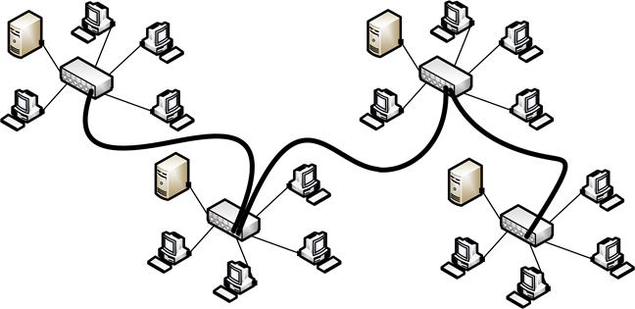
Tree topology
Not all real-world networks are completely peer-to-peer or completely client-server. Some networks use a mixture of both approaches.

The OSI Model
The International Organization for Standardization (ISO) developed the Open Systems Interconnection (OSI)reference model in 1977. It was designed to aid understanding of how a network system functions in terms of both the hardware and software components by separating the function of such components to discrete layers. The model was published in 1983 as ISO 7498.
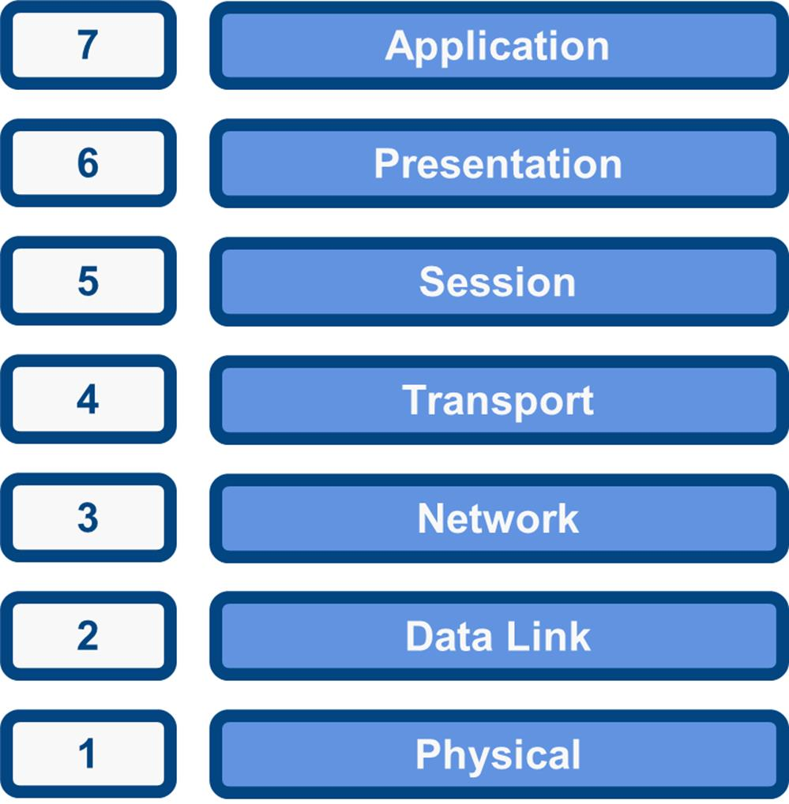
The OSI model
To remember the seven layers, use the following mnemonic: All People Seem To Need Data Processing.
As the complexity of computer hardware and software increases, the problem of successfully communicating between these systems becomes more difficult. Dividing these difficult problems into "sub-tasks" allows them to be readily understood and solved more easily. Using this layered approach means that a vendor can work on the design and debugging for a particular layer without affecting any of the others.
Each layer performs a different group of tasks required for network communication. Although not all network systems implement layers using this structure, they all implement each task in some way. The OSI model is not a standard or a specification; it serves as a functional guideline for designing network protocols, software, and appliances and for troubleshooting networks.

Encapsulation and De-encapsulation
For two computers to communicate they must be running the same protocol. Each layer communicates with its equivalent (or peer) layer on the other computer via the lower layers of the model. Each layer provides services for the layer above and uses the services of the layer below.
When a message is sent from one computer to another, it travels down the stack of layers on the sending computer, reaches the receiving computer using the transmission media, and then passes up the stack on that computer. At each level (except the physical layer), the sending node adds a header to the data payload, forming a Protocol Data Unit (PDU). This process is known as encapsulation.
On a typical local network for example, on the sending node, data is generated by an application such as HTTP, which will include its own application headers. At the transport layer, a TCP header is added to this application data. At the network layer, the TCP segment is wrapped in an IP header. The IP packet is put into an Ethernet frame at the data link layer then the stream of bits making up the frame is transmitted over the network at the physical layer.
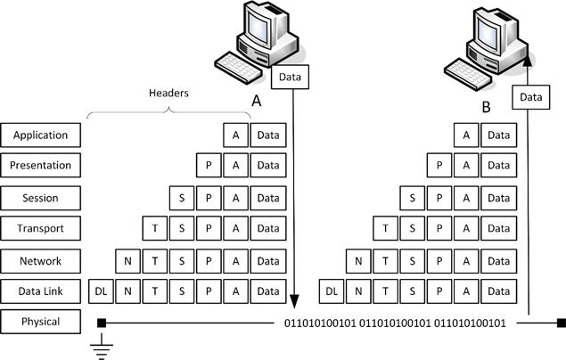
Encapsulation and de-encapsulation
The receiving node performs the reverse process (de-encapsulation or decapsulation). For example, it receives the stream of bits arriving at the physical layer and decodes an Ethernet frame. It extracts the IP packet from this frame and resolves the information in the IP header then does the same for the TCP and application headers, eventually extracting the application data for processing by a software program.

The OSI Model and Network Protocols
The OSI model is only intended to be a conceptual framework for discussing and designing protocols. As a result, the computer industry often struggles to categorize various protocols and networking technologies into the model.
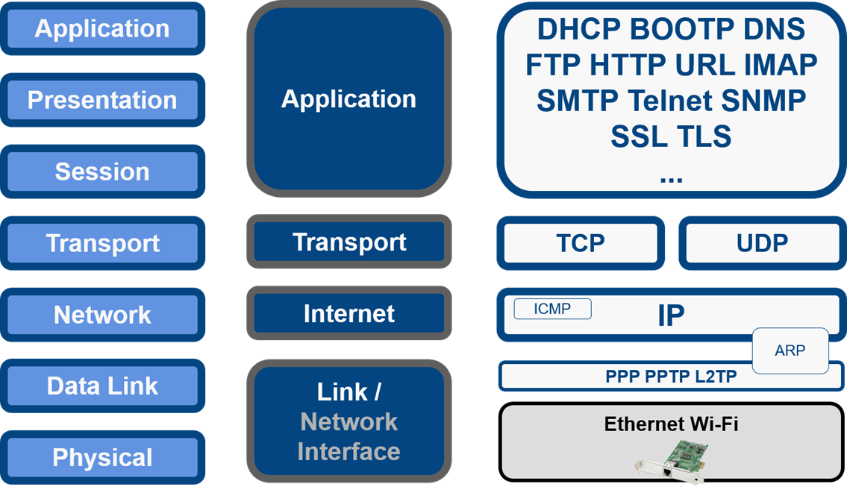
OSI reference model and TCP/IP
The example above demonstrates how the OSI model (a theoretical model) compares with the TCP/IP protocol stack (a real system). The TCP/IP and OSI models were developed concurrently and show only limited agreement. Some of the OSI layers are performed by a single protocol, some layers are performed by several protocols, and some protocols cover several layers.
This reflects the emphasis on performance and efficiency in "real world" networking. Each layer of encapsulation consumes processing power and bandwidth as each header consists of a number of bytes that must be transmitted and decoded in addition to the application data. Consequently, actual protocol stacks tend to be simpler than the OSI model.

The OSI Model
The International Organization for Standardization (ISO) developed the Open Systems Interconnection (OSI)reference model in 1977. It was designed to aid understanding of how a network system functions in terms of both the hardware and software components by separating the function of such components to discrete layers. The model was published in 1983 as ISO 7498.
The OSI model
To remember the seven layers, use the following mnemonic: All People Seem To Need Data Processing.
As the complexity of computer hardware and software increases, the problem of successfully communicating between these systems becomes more difficult. Dividing these difficult problems into "sub-tasks" allows them to be readily understood and solved more easily. Using this layered approach means that a vendor can work on the design and debugging for a particular layer without affecting any of the others.
Each layer performs a different group of tasks required for network communication. Although not all network systems implement layers using this structure, they all implement each task in some way. The OSI model is not a standard or a specification; it serves as a functional guideline for designing network protocols, software, and appliances and for troubleshooting networks.

Encapsulation and De-encapsulation
For two computers to communicate they must be running the same protocol. Each layer communicates with its equivalent (or peer) layer on the other computer via the lower layers of the model. Each layer provides services for the layer above and uses the services of the layer below.
When a message is sent from one computer to another, it travels down the stack of layers on the sending computer, reaches the receiving computer using the transmission media, and then passes up the stack on that computer. At each level (except the physical layer), the sending node adds a header to the data payload, forming a Protocol Data Unit (PDU). This process is known as encapsulation.
On a typical local network for example, on the sending node, data is generated by an application such as HTTP, which will include its own application headers. At the transport layer, a TCP header is added to this application data. At the network layer, the TCP segment is wrapped in an IP header. The IP packet is put into an Ethernet frame at the data link layer then the stream of bits making up the frame is transmitted over the network at the physical layer.
Encapsulation and de-encapsulation
The receiving node performs the reverse process (de-encapsulation or decapsulation). For example, it receives the stream of bits arriving at the physical layer and decodes an Ethernet frame. It extracts the IP packet from this frame and resolves the information in the IP header then does the same for the TCP and application headers, eventually extracting the application data for processing by a software program.

Physical Layer
The physical layer (PHY) of the OSI model is responsible for the transmission and receipt of bits from one node to another node. It specifies the following:
- Physical network topology.
- Mechanical specifications for the network medium, such as cable specifications, the medium connector and pin-out details (the number and functions of the various pins in a network connector), or radio transceiver specifications.
- The process of transmitting and receiving signals from the network medium including modulation schemes and timing / synchronization.
Devices operating at the physical layer include:
- Transceiver - the part of a network interface that sends and receives signals over the network media.
- Media Converter - converts one media signaling type to another.
- Repeater - amplifies the signal to extend the maximum allowable distance for a media type.
- Hub - a multiport repeater, deployed as the central point of connection for nodes wired in a star topology.
- Modem - a device that converts between digital and analog signal transmissions.

Data Link Layer
The data link layer is responsible for transferring data between nodes on the same network segment. For incoming data, it organizes the 1s and 0s (bits) from the physical layer into structured units called frames. Each frame contains a network layer packet as its payload. The data link layer adds control information to the payload in the form of header fields. These include a source and destination hardware address and error checking values. Other information (not shown in the figure) includes the frame length and network layer protocol identifier.
Construction of a frame
Some network products use multiple different frame types. For example, Ethernet specifies four frame types. The basic structure remains the same but each frame type contains a slightly different header structure. Devices must communicate using the same frame type.
The data link layer is only capable of very basic error checking, include truncated frames and those recognized through use of Cyclic Redundancy Checks (CRC) as damaged. There is no function to acknowledge or retransmit damaged frames. That function is handled at higher layers of the OSI model. Another function of the data link layer can be to control the data flow, preventing fast transmitters from overwhelming slow receivers with data. Note that this function is not unique to the data link layer however; it can be performed at other layers too.
Another important function at the data link layer is determining how multiple nodes can share access to the network media, establishing the logical network topology. For example, a bus-based topology uses contention as a media access method. A ring-based topology uses a token-passing access method.

IEEE 802 Standards
Over the years, a number of protocols, standards, and products have been developed to cover technologies working at the physical and data link layers of the OSI model. The most important of these are the IEEE 802 standards, published by the LAN / MAN Standards Committee(www.ieee802.org) of the Institute of Electrical and Electronics Engineers (IEEE). The IEEE is a professional body that oversees the development and registration of electronic standards.
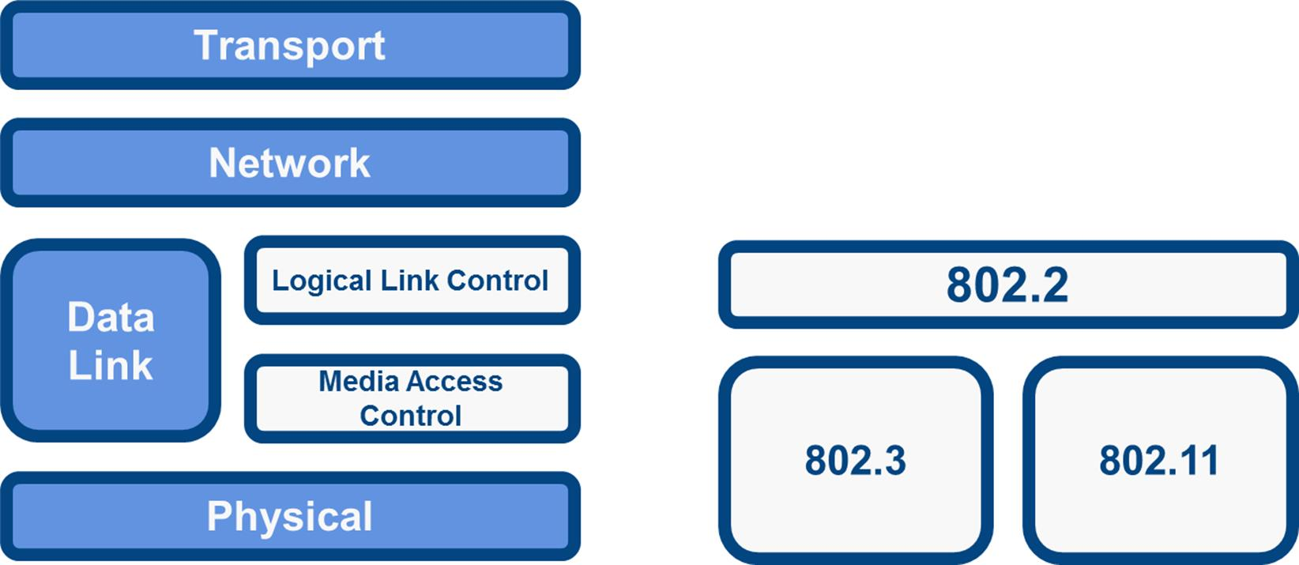
Comparison of IEEE 802 and the OSI model
There are a number of separate working groups within the LAN / MAN Standards Committee developing different standards. These are collectively known as 802.x. The IEEE splits the functions of the data link layer into two sub-layers. These two sub-layers are known as Media Access Control (MAC) and Logical Link Control (LLC).

IEEE 802.2 (Logical Link Control)
The IEEE 802.2 standard for the Logical Link Control (LLC) sub-layer is used with other 802 protocols, such as 802.3 and 802.11. The LLC protocol provides a standard network layer service interface regardless of which MAC sub-layer protocol is used.

IEEE 802.3 (Ethernet) and the MAC Sub-layer
The Media Access Control (MAC) sub-layer defines the way in which multiple network interfaces share a single transmission medium. It covers the following:
- Logical topology - bus or ring.
- Media access method - contention or token passing.
- Addressing - the hardware address of the network interface.
- Error detection.
- Frame format.
The IEEE 802.3 standard specifies protocols that implement the functions of the MAC sub-layer plus signaling and media specifications at the physical layer. IEEE 802.3 is based on the Ethernet networking product, developed by the DIX consortium (Digital Equipment Corporation [DEC], Intel, and Xerox). While the product name is not used in 802.3 standards documentation, it is otherwise universally referred to as Ethernet.
Ethernet is now the only widely supported standard for cabled LANs. Legacy products such as ARCNET and Token Ring may persist in networks that are difficult to upgrade or reconfigure. The IEEE 802.11 series of standards (Wi-Fi) are used to implement Wireless Local Area Networks (WLAN).

Layer 2 Devices
Connectivity devices found at the data link layer include:
- Network adapter (or Network Interface Card [NIC]) - joins a host computer to network media (cabling or wireless) and enables it to communicate over the network by assembling and disassembling frames.
- Bridge - joins two network segments while minimizing the performance reduction of having more nodes on the same network.
- Basic switch - a multiport bridge that creates links between nodes more efficiently.
- Wireless Access Point (AP) - allows nodes with wireless network cards to communicate and joins wireless networks to wired ones.

Network Layer
The network layer is responsible for moving data around a network of networks, known as an internetwork or internet. While the data link layer moves data using hardware addresses within a single network segment, the network layer moves information around an internetwork using logical network and host IDs. The networks are often heterogeneous; that is, use a variety of different physical layer media and data link protocols.
The network layer transfers information between networks by examining the destination network layer address or logical network address, and routing the packet through the internetwork using intermediate systems (routers).
Selection of the path or route to the destination network address is determined dynamically or statically. The packet moves, hop by hop, through the internetwork to the target network. Once it has reached the destination network, the hardware address can be used to move the packet to the target node. This process requires each logically separate network to have a unique network address.
 The general convention is to describe Protocol Data Units (PDU) packaged at the network layer as packets or datagrams and distinguish messages packaged at the data link layer by calling them frames and those at the transport layer by calling them segments. "Packet" is also used to describe PDUs at any layer.
The main appliance working at layer 3 is the router. Other devices include Layer 3 switches (combining the function of switches and routers) and basic firewalls.
 Network addressing and routing using the Internet Protocol are covered in detail in Module 2.

Transport Layer
The first three layers of the OSI model are primarily concerned with moving frames and datagrams between nodes and networks. At the transport layer (also known as the end-to-end or host-to-host layer) the content of the packets starts to become significant.
Any given host on a network will be communicating with many other hosts using many different types of networking data. One of critical functions of the transport layer is to identify each type of network application by assigning it a port number. For example, data from the HTTP web browsing application can be identified as port 80 while data from an email application can be identified as port 143. At the transport layer, on the sending host, data from the upper layers is packaged as a series of segments and each segment is tagged with the application's port number. The segment is then passed to the network layer for delivery. The host could be transmitting multiple HTTP and email segments at the same time. These are multiplexed using the port numbers onto the same network link.
In fact, each host assigns two port numbers. On the client, the destination port number is mapped to the service that the client is requesting (HTTP on port 80 for instance). The client also assigns a random source port number (47,747 for instance). The server uses this client-assigned port number (47,747) as the destination port number for its replies and its application port number (80 for HTTP) as its source port. This allows the hosts to track multiple "conversations" for the same application protocol.
At the network and data link layers, the port number is not significant - it becomes part of the data payload and is "invisible" to routers and switches working at the network and data link layers. At the receiving host, each segment is extracted from its frame and then identified by its port number and passed up to the relevant handler at the upper session and application layers. Put another way, the traffic stream is de-multiplexed.
The transportlayer is also responsible for ensuring reliable data delivery so that packets arrive error-free and without loss. The transport layer can overcome any lack of reliability in the lower level protocols. This reliability is achieved using acknowledgement messages that inform the sender the data was successfully received. The kinds of problems that may occur during the delivery of the data are non-delivery and delivery in a damaged state. In the first case, the lack of acknowledgement results in the retransmission of the data and, in the second case, a Negative Acknowledgement(NACK)forces retransmission.
The transport layer also accomplishes reliable delivery through other mechanisms:
- Orderly connection establishment and teardown - under normal circumstances a single connection is created between computers. However, multiple connections can be established to improve throughput.
- Segmentation - breaking PDUs from the session layer into a segment format where sequence numbers are used by the receiver to rebuild the message correctly.
- Flow control - enables one side to tell the other when the sending rate must be slowed.
These features are typical of connection-oriented protocols. Connectionless protocols operate without such mechanisms and are therefore faster, but less reliable.
Devices working at the transport layer (or above) include multilayer switches (incorporating load balancing) and security appliances such as more advanced firewalls and Intrusion Detection Systems (IDS).
See Unit 3.1 / Transport Protocols / Study Notes for more information about the functions of protocols working at the transport layer.

Upper Layers
The upper layers of the OSI model are less clearly associated with distinct "real world" protocols. These layers collect various functions that provide useful interfaces between software applications and the network layer.

Session Layer
Most application protocols require the exchange of multiple messages between the client and server. This exchange of such a sequence of messages is called a session or dialog. The session layer represents the dialog control functions that administer the process of establishing the dialog, managing data transfer, and then ending (or "tearing down") the session.
Sessions can work in three modes:
- One-way / simplex - only one system is allowed to send messages; the other receives only.
- Two-Way Alternate (TWA) / half-duplex - the hosts establish some system for taking turns to send messages, such as exchanging a token.
- Two-Way Simultaneous (TWS) / duplex - either host can send messages at any time.
The session layer can also provide a synchronization service for long transactions in which checkpoints are inserted into the data stream (dialog separation). If a problem occurs, only the data transferred after the last checkpoint is resent.

Presentation Layer
The presentation layer transforms data between the format required for the network and the format required for the application. For example, the presentation layer is used for character set conversion. The communicating computers may use different character coding systems (such as American Standard Code for Information Interchange [ASCII] and Unicode); the peer presentation layers agree to translate the data into one of the formats or they will both translate the data into a third format. The presentation layer can also be conceived as supporting data compression and encryption (scrambling a message so that it can only be read in conjunction with a valid "key"). However, in practical terms these functions are often implemented by encryption devices and protocols running at lower layers of the stack.

Application Layer
The application layer provides support services to applications requiring network resources. One of the most utilized services provided by the application layer is file transfer. Different file systems may use entirely different file naming conventions and data syntax and the application layer must overcome these differences. Other services provided include network printing, electronic mail, directory lookup, and database services.
It is important to distinguish between network application protocols and the software application code (programs and shared programming libraries) that runs on computers. Software programs and operating systems make use of Application Programming Interfaces (API) to call functions of the relevant part of the network stack. Examples of APIs include:
- Network card drivers could use the Network Driver Interface Specification (NDIS) API to implement functions at the data link layer.
- The Sockets / WinSock APIs implement transport and session layer functions.
- High-level APIs implement functions for services such as file transfer, email, web browsing, or name resolution.

OSI Model Summary
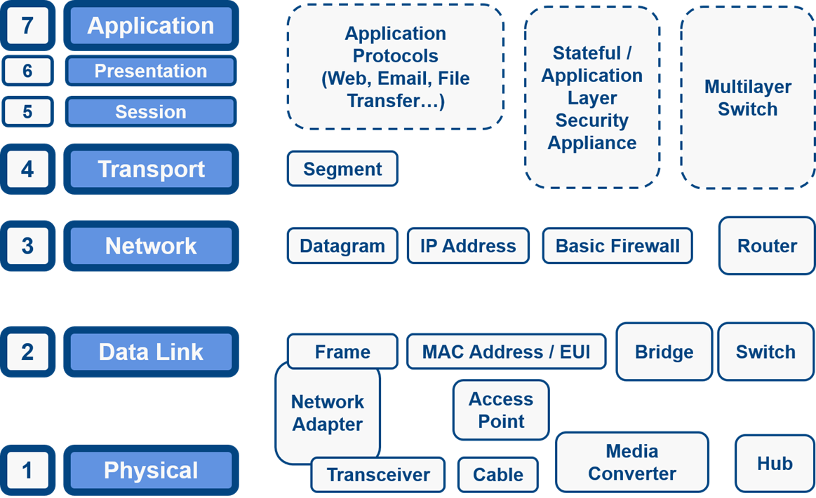
Devices and concepts represented at the relevant OSI model layer

