UNIT 1.5 / POLICIES AND BEST PRACTICES / STUDY NOTES

Objectives
On completion of this unit, you will be able to:
- Summarize safe working practices and policies.
- Understand the importance of incident response policy.
- Identify appropriate policies to ensure data security, effective privilege management, and employee use of computer and network systems.

Syllabus Objectives and Content Examples
This unit covers the following exam domain objectives and content examples:
- 3.5 Identify policies and best practices.
Privileged user agreement • Password policy • Onboarding/offboarding procedures • Licensing restrictions • International export controls • Data Loss Prevention • Remote access policies • Incident response policies • BYOD • AUP • NDA • System life cycle (Asset disposal) • Safety procedures and policies

Procedures and Standards
Running an efficient network is not just about installing cabling and network devices. The administration, documentation, and management of the network is a critical task. As well as procedures for technical staff to follow to perform updates, maintenance, and troubleshooting, network administration requires policies to guide end users of the network services. As a vital component of a company's IT infrastructure, employees must understand how to use computer and network systems securely and safely and be aware of their responsibilities. To support this, an organization needs to create proper documentation, to help staff to understand and fulfill their responsibilities and follow proper procedures.
The value of a comprehensive policy is that it removes any uncertainty that employees may have about what to do in a given situation. For example, if you work for a large company and meet someone you do not recognize in your work area, should you smile and say hello or smile, say hello, ask them where they want to be, and then escort them to that place? If there is a company security policy saying that visitors to the workplace must be escorted at all times, it will be much easier for employees to take it upon themselves to "police" this sort of circumstance.

Standards and Best Practice
Policy is an overall statement of intent. In order to establish the correct working practices, three different mechanisms can be put in place:
- Standard - a standard is a measure by which to evaluate compliance with the policy.
- Procedure - a procedure (often referred to as a Standard Operating Procedure [SOP] or an Internal Operating Procedure [IOP]) is an inflexible, step-by-step listing of the actions that must be completed for a given task. Most critical tasks should be governed by SOPs.
- Best practice - guidelines exist for areas of policy where there are no procedures, either because the situation has not been fully assessed or because the decision-making process is too complex and subject to variables to be able to capture it in a procedure. Best practice guidance may also describe circumstances where it is appropriate to deviate from a specified procedure.

Safety Procedures
As a network technician, you must comply with local Health and Safety codes and regulations. This affects both the way you work and the way you manage equipment in the workplace, whether that is an office or data center. Safety policies should be clearly set out for you in an employee handbook or work orders, but you can consider the following general advice...

Tool Safety
When handling tools, you must be aware of risks that could arise from carelessness or improper use.
- Do not work on electrical systems (especially an energized circuit) unless you have a good understanding of the risks and appropriate safety procedures.
- Disconnect the power to a circuit if you must handle it, and always test live parts with a multimeter to ensure that no voltage is present.
- Always use properly insulated tools and never grip a tool by its metal parts.
- Take care not to touch any part of a circuit with both hands to reduce the risk of a serious shock (the "hand in pocket" rule - this reduces the chance that the current will pass through your chest and cause a heart attack).
- Be aware that the tools used to prepare cables and connectors can have sharp edges or could crush your fingers if used carelessly.
- Use proper tools and safety equipment when working with lasers, such as when installing fiber optic cabling.

Electrical Safety
A connection to ground (or earth) provides a return path for electrical current. This is a safety feature; if an electrical connection short circuits into the metal chassis, a ground wire ensures that the current flows to earth rather than electrocuting someone handling the faulty device.
Some power circuits contain a ground wire. If the circuit does not contain a ground wire, any electrical devices with metal cases (or any metal objects that could come into contact with electrical wires) must be bonded to the building's earth system. This particularly includes rack systems and cable trays. Do not disconnect the ground wire. If it has to be removed, make sure it is replaced by a competent electrician.

Fire Safety
All public and commercial buildings should comply with local fire codes. This will mean having fire/smoke alarms, emergency escape routes and procedures, and possibly fire extinguisher systems. It is vital that any network installation work you do does not compromise fire safety:
- Do not block fire exits or escape routes with boxes or equipment.
- Do not run cables where they could be trip or fire hazards.

Lifting Equipment
Lifting a heavy object in the wrong way can damage your back, but lifting and manual handling risks are not limited to particularly heavy objects. An object that is large or awkward to carry could cause you to trip over or walk into something else. An object that has sharp or rough edges or contains a hot or corrosive liquid could cause you to cut or hurt yourself. If necessary, you should obtain protective clothing (gloves and possibly goggles).
To lift a heavy object safely, plant your feet around the object with one foot slightly toward the direction in which you are going to move. Bend your knees to reach the object while keeping your back as straight as is possible and comfortable and your chin up. Find a firm grip on the object then lift smoothly by straightening your legs - do not jerk the object up. Carry the object while keeping your back straight. To lower an object, reverse the lifting process; keep your chin up and bend at the knees. Take care not to trap your fingers or to lower the object onto your feet.
If you cannot lift an object because it is too awkward or heavy, get help. If you need to carry an object for some distance, make sure that the route is unobstructed and that the pathway (including stairs or doorways) is wide and tall enough.

Material Safety Data Sheet (MSDS)
Suppliers of chemicals or materials treated with chemicals are required to identify the hazards (or dangers) of the substances they supply. If a chemical is dangerous, the supplier must provide information about the hazards that it presents; some hazard information will be provided on labels, but the supplier must also provide more detailed hazard information on a Material Safety Data Sheet (MSDS). An MSDS will contain information about ingredients or composition, health hazards, precautions, fire-fighting measures, and first aid information, and how to recycle any waste product or dispose of it safely. You may need to refer to an MSDS in the course of installing cabling.

ElectroStatic Discharge (ESD)
An ElectroStatic Discharge (ESD) occurs when a surface with low potential difference is brought near a surface with high potential difference. This can cause a spark to leap between the two surfaces. The spark is not dangerous to human health (it is high voltage but low current) but can cause serious damage to electronic circuits, such as CPUs and system memory modules.
Where possible, handle vulnerable components by holding the edges of the plastic mounting card and avoid touching the surfaces of the chips themselves. Using an anti-ESD wrist strap can dissipate static charges more effectively. The wrist band should fit snugly around your wrist to maximize contact with the skin. Do not wear it over clothing. The wrist strap ground is made either using a grounding plug that plugs into a wall socket or a crocodile clip that attaches to a grounded point or an unpainted part of the computer's metal chassis. An anti-ESD service mat is also useful. Sensitive components can be placed on the mat safely.

Incident Response Policies
Incident management or incident response procedures are the actions and guidelines for dealing with security incidents. An incident is where security is breached or there is an attempted breach; NIST describes an incident as "the act of violating an explicit or implied security policy." Incident management is vital to mitigating risk. As well as controlling the immediate or specific threat to security, effective incident management preserves an organization's reputation.
However, incident response is also one of the most difficult areas of security to plan for and implement because its aims are often incompatible:
- Re-establish a secure working system.
- Preserve evidence of the incident with the aim of prosecuting the perpetrators.
- Prevent reoccurrence of the incident.
The actions of staff immediately following detection of an incident can have a critical impact on these aims, so an effective policy and well-trained employees are crucial. They help to calm nerves in the aftermath of an incident. Incident response is also likely to require coordinated action and authorization from several different departments or managers, which adds further levels of complexity.

Computer Security Incident Response Team (CSIRT)
Larger organizations will provide a dedicated Computer Security Incident Response Team (CSIRT) as a single point-of-contact for the notification of security incidents. The members of this team should be able to provide the range of decision making and technical skills required to deal with different types of incidents. The team needs a mixture of senior decision makers (up to director level) who can authorize actions following the most serious incidents, and managers and technicians who can deal with minor incidents on their own initiative.

First Responder
When a suspicious event is detected, it is critical that the appropriate person on the CSIRT be notified so that they can take charge of the situation and formulate the appropriate response. This means that employees at all levels of the organization must be trained to recognize and respond appropriately to actual or suspected security incidents. A good level of security awareness across the whole organization will reduce the incidence of false positives and negatives.
The person dealing with an incident once it has been reported is referred to as the first responder. For the most serious incidents, the entire CSIRT may be involved in formulating an effective response.

Security and Data Policies
Policies and standard procedures are also vital tools in ensuring data security. Part of the task lies in creating effective privilege management policies and procedures, and part in ensuring that information assets are classified and handled correctly by staff members at all levels of the company hierarchy.

Non-Disclosure Agreement (NDA)
A Non-Disclosure Agreement (NDA) is the legal basis for protecting information assets. A contract of employment is highly likely to contain NDA clauses. NDAs are also used between companies and contractors and between two companies.

Privileged User Agreement (PUA)
A privileged user is one who is given rights to administer a resource. There might be different levels of privilege, ranging from responsibility for managing a particular data set, through departmental IT services administrators, and up to company-wide service administrators. The "Rules of Behavior" for these employees may be set out in the contract terms or in a separate Privileged User Agreement (PUA).
Separation of duties is a means of establishing checks and balances against the possibility that critical systems or procedures can be compromised by rogue use of access permissions. Several different policies can be applied to enforce separation of duties:
- The principle of least privilege means that a user is granted sufficient rights to perform their job and no more.
- Provisioning dual accounts means that administrators have separate accounts for management and general use. The administrator must use the privileged account only to perform specific job tasks.
- Standard Operating Procedures (SOP) mean that an employee has no excuse for not following protocol in terms of performing this type of critical operation.
- Shared authority means that no one user is able to action or enable changes on his or her own authority. At least two people must authorize the change.
- Effective auditing means that decisions and changes are recorded and can be scrutinized independently of the person that made the decision.
- Mandatory vacations mean that employees are forced to take their vacation time, during which someone else fulfils their duties.
- Job rotation (or rotation of duties) means that no one person is permitted to remain in the same job for an extended period. For example, managers may be moved to different departments periodically, or employees may perform more than one job role, switching between them throughout the year. Job rotation is also seen as beneficial in terms of developing skills and experience.

Personally Identifiable Information (PII)
The rise in consciousness of identity theft as a serious crime and growing threat means that there is an increasing impetus on government, educational, and commercial organizations to take steps to obtain, store, and process Personally Identifiable Information (PII) more sensitively and securely. PII is data that can be used to identify, contact, or locate an individual (or in the case of identity theft, to impersonate them). A Social Security Number (SSN) is a good example of PII. Others include name, date of birth, email address, telephone number, street address, biometric data, occupation, and so on. Some types of information may be PII depending on the context. For example, when someone browses the web using a static IP address, the IP address is PII. An address that is dynamically assigned by the ISP may not be considered PII. These are the sort of complexities that must be considered when laws are introduced to control the collection and storage of personal data.
Staff should be trained to identify PII and to handle personal or sensitive data appropriately. This means not making unauthorized copies or allowing the data to be seen or captured by any unauthorized persons. Examples of treating sensitive data carelessly include leaving order forms with customers' credit card details in view on a desk or putting a credit card number in an unencrypted notes field in a customer database.

Data Loss Prevention
In a workplace where mobile devices with huge storage capacity proliferate and high bandwidth network links are readily available, attempting to prevent the loss of data by controlling the types of storage devices allowed to connect to PCs and networks can be impractical. Users must of course be trained about document confidentiality and make sure that they are aware that unencrypted communications are not secure. This should also be backed up by HR and auditing policies that ensure staff are trustworthy. "Soft" measures such as these do not protect against user error or insider threats however.
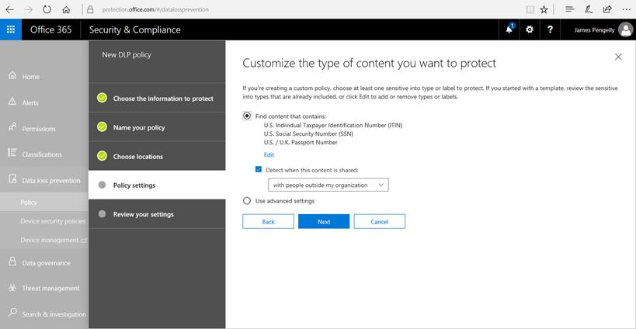
Creating a Data Loss Prevention policy in Office 365. Screenshot used with permission from Microsoft.
Data Loss Prevention (DLP) products scan content in structured formats (such as a database with a formal access control model) or unstructured formats, such as email or word processing documents. These products use some sort of dictionary database or algorithm (regular expression matching) to identify confidential data. The transfer of content to removable media (or by email or IM or even social media) can then be blocked if it does not conform to a predefined policy.

International Export Controls
The laws that a country enforces to control imports and exports can have an impact on network and security management. This is especially the case where the organization has offices in multiple countries.
One area in export control relevant to ICT is the concept of dual use. Dual use is technology that can have both civilian and military/secret service applications. The most obvious example of dual use is exports that could be used in the manufacturing of nuclear or chemical weapons. In ICT, dual use principally means scanning tools, hacking tools, and malware. Governments are increasingly monitoring and regulating the transfer of this kind of software. If a particular class of product appears on a control list, a company must gain authorization to export (or import) it. In the US, the principal office responsible for this is the Bureau of Industry and Security (bis.doc.gov), who administer the Export Administration Regulations (EAR). Technologies identified as having a specific military application can be governed by the Bureau of Political Military Affairs' Directorate of Defense Trade Controls (DDTC gtsgo.to/qatos), who manage the International Traffic in Arms Regulations (ITAR).
The other major impact of export controls lies in the collection and processing of PII. Most countries have introduced data protection legislation to allow citizens to control the use that is made of information they give to companies and charities. A common feature of this type of legislation is to prevent personal data from being transferred to a different legal jurisdiction, where the controls on its proper use may not be strongly enforced. This can be a particular problem for companies that use cloud services as the hosts processing the data may not be in the same country as the organization itself or the subject. Organizations handling personal information must put safeguards in place to ensure that it is stored, processed, and transmitted in accordance with the appropriate legislation.
The US has complex data protection and privacy regulations, deriving from different Federal and State laws. In terms of international exports and transfers, the main area of interest is between the US and European Union (EU). The EU is introducing a new General Data Protection Regulation (GDPR) framework, covering all aspects of data and privacy for all member states. Previously EU-US data transfers were covered by compliance with the Safe Harbor scheme, but that was ruled invalid and is being replaced by a new framework called Privacy Shield.

Licensing Restrictions
Software licensing agreements can be complex and keeping track of usage requires investment in license management and auditing software. Some of the activities involved in ensuring compliance with license agreements include:
- Identifying unlicensed and unauthorized software installed on clients, servers, and virtual machines. Ideally privilege management and change controlled instances would prevent this from happening. Best intentions are not enough however so periodic inspections are required to ensure continued compliance. It is particularly important to audit field devices (laptops and mobiles).
- Identifying per-seat or per-user compliance with licensed software. The complex nature of client access type licensing means that many companies over-allocate seats compared to what their license agreement allows. There is also the complexity of managing software over multiple sites (and possibly also different countries) and remote devices.
- Preparing for vendor audits - most license agreements specify that the vendor may undertake a Software License Compliance (SLC) audit. This means that the vendor or their nominated third party may access the customer's systems to audit license usage.
- Ensuring compliance with the terms of open source licensing. If open source code is reused (whether in commercial or in-house software), the product must be distributed in compliance with the terms of the original open source license.
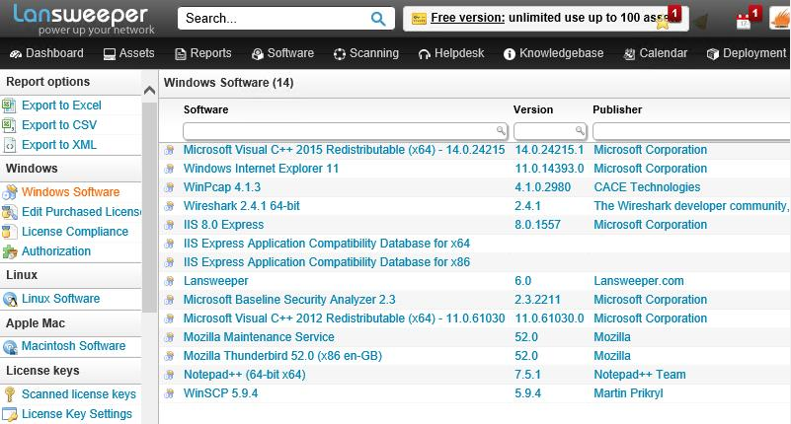
Use tools such as Lansweeper network inventory management (lansweeper.com) to keep track of software license usage.

System Lifecycle (Asset Disposal)
Data security is an important consideration when it comes to disposing of assets such as servers and workstations at the end of their system lifecycles, when they are no longer useful to the organization. Hard drive sanitation refers to fully erasing hard disks. More generally, remnant removal refers to decommissioning various media, including flash drives, tape media, CD and DVD ROMs, and so on. The problem has become particularly prominent as organizations recycle their old workstations or servers, either by donating them to charities or by sending them to a recycling company, who may recover and sell on parts. The problem also applies to network printers, which often have installable hard disks to use to cache print jobs.
There are at least three reasons that make remnant removal critical:
- An organization's own confidential data could be compromised.
- Third-party data that the organization processes could be compromised, leaving it liable under Data Protection legislation (in addition to any contracts or Service Level Agreements signed).
- Software licensing could be compromised.
The main issue is understanding the degree to which data on different media types may be recoverable. Data "deleted" from a magnetic-type disk (such as a hard disk) is not erased. Rather, the sectors are marked as available for writing and the data they contain will only be removed as new files are added. Similarly, using the standard Windows format tool will only remove references to files and mark all sectors as useable. In the right circumstances and with the proper tools, any deleted information from a drive could be recoverable.
Data remnants can be dealt with either by destroying the media or by purging it (removing the confidential information but leaving the media intact for reuse). There are several different ways of either purging or destroying media:
- Overwriting/disk wiping - disk wiping software ensures that old data is destroyed by writing to each location on the media, either using zeroes or in a random pattern.
- Pulverizing/degaussing - a magnetic disk can be mechanically shredded or degaussed (exposing the disk to a powerful electromagnet disrupts the magnetic pattern that stores the data on the disk surface) in specialist machinery.
- Disk encryption - this method encrypts all the information in a volume, so that any remnants could not be read without possession of the decryption key.
Optical media cannot be reformatted. Discs should be destroyed before discarding them. Shredders are available for destroying CD and DVD media. All paper documents should be shredded before disposal. Apart from ensuring personal data is not leaked, this is because even quite innocuous information (such as employee telephone lists, diary appointments, and so on) can help an attacker with impersonation attacks.

Password Policy
A password management policy instructs users on best practice in choosing and maintaining passwords. More generally, a credential management policy should instruct users on how to keep their authentication method secure (whether this be a password, smart card, or biometric ID). The credential management policy also needs to alert users to different types of social engineering attacks.
The "soft" approach to training users can also be backed up by "hard" policies defined on the network. System-enforced policies can help to enforce credential management principles by stipulating particular requirements for users. Password protection policies mitigate against the risk of attackers being able to compromise an account and use it to launch other attacks on the network.

Strong Passwords
The following rules enforce password complexity and make them difficult to guess or compromise:
- Length - the longer a password, the stronger it is:
  - A typical strong network password should be 12-16 characters.
  - A longer password or passphrase might be used for mission critical systems or devices where logon is infrequent.
- Complexity - varying the characters in the password makes it more resistant to dictionary-based attacks:
  - No single words - better to use word and number/punctuation combinations.
  - No obvious phrases in a simple form - birthday, username, job title, and so on.
  - Mix upper and lowercase (assuming the software uses case-sensitive passwords).
  - Use an easily memorized phrase - underscored characters or hyphens can be used to represent spaces if the operating system does not support these in passwords.
- Do not write down a password or share it with other users.
If users must make a note of passwords, at the very least they must keep the note physically secure. They should also encode the password in some way. If the note is lost or stolen it is imperative that the password be changed immediately and the user account closely monitored for suspicious activity.
- History and aging - change the password periodically (password aging) and do not reuse passwords:
  - User passwords should be changed every 60-90 days.
  - Administrative passwords should be changed every 30 days.
  - Passwords for mission critical systems should be changed every 15 days.
Another concern is personal password management. A typical user might be faced with having to remember tens of logons for different services and resort to using the same password for each. This is unsecure, as your security becomes dependent on the security of these other (unknown) organizations. Users must be trained to practice good password management (at the least not to re-use work passwords).

Employee Policies
Human Resources (HR) is the department tasked with recruiting and managing the organization's most valuable and critical resource: people. Personnel management policies can be conceived as applying in three phases:
- Recruitment (hiring) - locating and selecting people to work in particular job roles. Security issues here include screening candidates and performing background checks.
- Operation (working) - it is often the HR department that manages the communication of policy and training to employees (though there may be a separate training and personal development department within larger organizations). As such, it is critical that HR managers devise training programs that communicate the importance of security to employees.
- Termination or separation (firing or retiring) - whether an employee leaves voluntarily or involuntarily, termination is a difficult process, with numerous security implications.
Operational policies include privilege management, data handling, and incident response, as discussed earlier. One function of HR is to communicate these policies to employees, including any updates to the policies. Another function is to enforce disciplinary measures (perhaps in conjunction with departmental managers).

Onboarding and Background Checks
Onboarding at the HR level is the process of welcoming a new employee to the organization. The same sort of principles also apply to taking on new suppliers or contractors. Some of the tasks that most impact security during the onboarding process are as follows:
- Background check - this process essentially determines that a person is who they say they are and are not concealing criminal activity, bankruptcy, or connections that would make them unsuitable or risky. Employees working in high confidentiality environments or with access to high value transactions will obviously need to be subjected to a greater degree of scrutiny.
- Identity and Access Management (IAM) - create an account for the user to access the computer system, assign the appropriate privileges, and ensure the account credentials are known only to the valid user.
- Asset allocation - provision computers or mobile devices for the user or agree the use of BYOD devices.
- Training/policies - schedule appropriate security awareness and role-relevant training and certification.

Offboarding/Exit Interviews
An exit interview (or offboarding) is the process of ensuring that an employee leaves a company gracefully. In terms of security, there are several processes that must be completed:
- IAM - disable the user account and privileges. Ensure that any information assets created or managed by the employee but owned by the company are accessible (in terms of encryption keys or password-protected files).
- Retrieving company assets - mobile devices, keys, smart cards, USB media, and so on. The employee will need to confirm (and in some cases prove) that they have not retained copies of any information assets.
- Returning personal assets - employee-owned devices need to be wiped of corporate data and applications. The employee may also be allowed to retain some information assets (such as personal emails or contact information), depending on the policies in force.
The departure of some types of employees should trigger additional processes to re-secure network systems. Examples include employees with detailed knowledge of security systems and procedures and access to shared or generic account credentials. These credentials must be changed immediately.

Acceptable Use Policy
An Acceptable Use Policy (AUP) (or Fair Use Policy) sets out what someone is allowed to use a particular service or resource for. Such a policy might be used in different contexts. For example, an acceptable use policy could be enforced by a business to govern how employees use equipment and services, such as telephone or Internet access, provided to them at work. Another example might be an ISP enforcing a fair use policy governing usage of its Internet access services.
Enforcing an acceptable use policy is important to protect the organization from the security and legal implications of employees (or customers) misusing its equipment. Typically, the policy will forbid the use of equipment to defraud, defame, or to obtain illegal material. It is also likely to prohibit the installation of unauthorized hardware or software and to explicitly forbid actual or attempted intrusion (snooping). An organization's acceptable use policy may forbid use of Internet tools outside of work-related duties or restrict such use to break times.

Network Policies
The equipment used to access the Internet in the workplace is owned by the employer. Many employees expect relatively unrestricted access to Internet facilities for personal use. In fact, employees' use of the social networking and file sharing poses substantial risks to the organization, including data breach, threat of virus infection or systems intrusion, lost work time, copyright infringement, and defamation. If an employee breaks copyright laws or libels someone using an organization's equipment, the organization itself could be held liable.
To avoid confusion, an employee's handbook should set out the terms under which use of web browser, email, social networking, and P2P software is permitted for personal use, and what penalties infringements could incur. Employers are within their rights to prohibit all private use of Internet tools.
Users should be aware that any data communications, such as email, made through an organization's computer system are liable to be stored within the system, on servers, backup devices, and so on. Consequently, users should not use computers at work to send personal information (for their own security if nothing else).

Bring Your Own Device (BYOD)
A mobile deployment model describes the way employees are provided with mobile devices and applications. Some companies issue employees with corporate-owned and controlled devices and insist that only these are used to process company data. Other companies might operate a Bring Your Own Device (BYOD) policy. BYOD means that the mobile is owned by the employee but will have to meet whatever profile is required by the company (in terms of OS version and functionality). The employee will have to agree on the installation of corporate apps and to some level of oversight and auditing. Very often BYOD devices are registered with enterprise management software and configured with sandboxed corporate workspaces and apps.
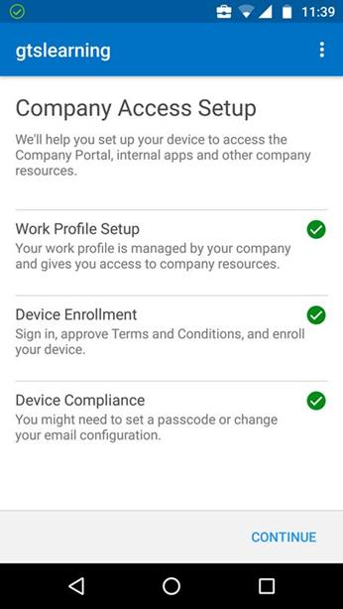
Enterprise management software can be used to segment corporate data from personal data on BYOD devices.
Other portable devices such as unauthorized smartphones/tablets, USB sticks, media players, and so on pose a considerable threat to data security as they make file copy so easy. Camera and voice recording functions are other obvious security issues. Network access control/endpoint security and data loss prevention solutions can be of some use in preventing the attachment of such devices to corporate networks. Some companies may try to prevent staff from bringing such devices on site. This is quite difficult to enforce though.

Remote Access Policies
Where employees are assigned the right to connect to the corporate network from a remote location using a Virtual Private Network (VPN), their use of remote access privileges must be governed by technical and policy controls. The integrity of the client computer and public network link presents many issues:
- Malware protection - the computer may not be accessible to network systems used to update and enforce malware protection. This may have to be left to the end-user. If a worm or Trojan is installed, network security may be compromised.
- Security information - authentication information may be stored on the client (saving a password for instance), making the network vulnerable if the computer is stolen.
- Data transfer - files copied to the client may no longer be properly secured, raising the potential that confidential information could be stolen along with the device.
- Local privileges - the user of a remote computer might be configured with administrative privileges but have no understanding of how such privileges can be exploited or misused. They might install unauthorized software on the machine or make it more vulnerable to malware by browsing the web using their administrative account.
- Weak authentication - relying on a username and password combination is simply not secure enough in a remote access scenario. Two-factor authentication using smart cards or biometric recognition in addition to a PIN or password should be enforced. If this is not an option, a strong password policy must be enforced and users made aware of the very real risks of writing down or sharing their password.
- Untrusted networks - the user might configure weak authentication on a home wireless network or use a public access point, raising the risk of sniffing and Man-in-the-Middle attacks.
The principal solution to remote access security problems is to educate remote users about security risks and their responsibilities. Enforcement can be provided by having remote devices audited periodically to ensure that anti-virus, firewall, and OS/browser/application patches are being kept up to date and to check that unlicensed software has not been installed. It is also wise to limit what remote users can access on the local network and to severely restrict the rights of remote computer accounts. The principle of least privilege should be applied. Technologies such as Remote Desktop provide an opportunity to lock down the user's privileges more than they would have been in the past. Technicians can provide support and assistance without having to go offsite or conversely without the machine having to be brought onsite.
See Unit 5.5 / Configuring Remote Access / Study Notes for more information about configuring remote access technologies and protocols securely.

